CHEMICAL ENGINEERING TRANSACTIONS  VOL. , 2023 | A publication of
The Italian Association
of Chemical Engineering
Online at www.cetjournal.it

Guest Editors: David Bogle, Flavio Manenti, Piero Salatino
Copyright © 2023, AIDIC Servizi S.r.l.
ISBN 979-12-81206-04-5; ISSN 2283-9216

Renewable Energy from Whisky Distillery By-products
Francis O. Olanrewaju^{a,}*, Gordon E. Andrews^{b}, Herodotus N. Phylaktou^{b}, Hu Li^{b}, Steve Smithª, Jim Maxfieldª, Richard Wakemanª
ªClean Burner Systems (CBS), Unit 3, Parkfield Business Park, Rugby Western Relief Rd., Rugby, CV21 1QJ, UK
^{b}School of Chemical and Process Engineering, Faculty of Engineering and Physical Sciences, University of Leeds, LS2 9JT, UK
francis.olanrewaju@cleanburnersystems.com; sonictreasure@gmail.com

Whisky distillery by-products draff and pot ale (PA) have an energy content that potentially can be used to decarbonize distillery heating. Draff consists of wet grains which are the residue of the first stage of whisky production. PA is the liquid residue that results from the first stage of the distillation at malt distilleries. The yearly production of distillery by-products was estimated to have increased by 27,000 tonnes (dry) in 2014. It is not feasible to store distillery by-products because of their bio-chemical nature and high volumes. Therefore, distillery by-products need to be removed from the site as they are produced. The most economical way to dispose of distillery by-products is by using them as feed stock for bioenergy. Some distilleries send draff and pot ale to AD plants, but to be useful they have to be dried and the use of fossil fuels for this makes the process uneconomical and the carbon emissions have to be deducted from any green biogas that is produced. This work showed for the first time that distillery draff could be air-gasified. The restricted ventilation Cone calorimeter method was used. An FTIR that was calibrated for 60 species was used to carry out the speciation of the product gases. The experimentally determined optimum gasification equivalence ratio (Ø) and gasification thermal efficiency for the gasification of draff were 4.5 and 90% respectively.

Keywords : Draff, gasification, decarbonisation, equivalence ratio, FTIR

  - Introduction
Draff is the soaked grains that results from the first stage of whisky production in distilleries. Gandy and Hinton (2018) reported that draff contains about 80% moisture. Draff is rich in protein, carbohydrates and fibre. Distillery draff is mainly used by Scottish farmers as feedstock for cattle. In 2015, 115 distilleries were licensed to produce Scotch whisky (Gandy and Hinton, 2018). White et al. (2020) reported a distillery draff yield of 2.5 kg per liter of whisky. Distilleries can produce up to 2x10⁶ liters of alcohol (l_{alc}) per year. A distillery with a capacity of 2x10⁶ l_{alc} produces about 5x10³ tonnes of draff yearly. The total production of whisky in Scotland increases annually due to new distilleries. Consequently, the quantity of distillery draff that is produced increases annually. The annual increase in the volume of draff produced is neither commensurate with the growth in the agricultural sector nor the demand for draff as feed stock for cattle. Therefore, accumulation of draff can occur at the production sites if alternative routes for its disposal are not found. Draff storage is undesirable due to environmental pollution and release of Green House Gases (GHG) such as methane from the draff decomposition.
The utilisation of distillery draff as feed stock for cattle is at a cost to distilleries as distilleries have to pay farmers to collect the draff. Furthermore, draff constitutes a long-term problem for distilleries due to the decreasing cattle head in the UK. The most profitable way to dispose of distillery draff and achieve partial or total decarbonisation of distilleries is by distillery process integration (converting the by-product into biogas to supply process heat). Compared to the use of biodigesters, gasification is a relatively cheap and fast method to generate biogas from high-moisture content solid wastes. AD plants have poor (<30%) conversion efficiencies of biomass energy into gaseous fuel energy, as there is a second product of digestate that is used as a farm animal feed, but contains a significant proportion of the original energy in the biomass.
Air-gasification is a thermo-chemical conversion process that involves the partial oxidation of biomass/fuel in a limited supply of air. The aim of this work, therefore, was to investigate the possibility of air gasifying distillery draff and to establish the optimum conditions for the process. Olanrewaju et al. (2022) investigated the gasification of agricultural crop residues on the cone calorimeter. Werle (2015) utilized a laboratory scale fixed bed reactor to investigate the gasification of dried sewage sludge. As at the time of carrying out this work, no known investigation has been carried out on the gasification of distillery draff. It is necessary to determine the gasification conditions (air flux, heat flux and equivalence ratio) for distillery draff experimentally. These parameters are required to design efficient industrial gasifiers for draff.
  - Methodology
A sample of draff was provided by Inchdairnie distillery. The analytical techniques used with this sample were: Simultaneous Thermal Gravimetric Analyzer (NETZSCH STA 449F3), Thermo Scientific Elemental Analyzer 2000, Parr 6200 bomb calorimeter. Thermogravimetric analysis (TGA) (proximate analysis) was carried out to determine the moisture content, Volatile Matter (VM), Fixed Carbon (FC) and ash content of the draff. CHNS-O analysis (ultimate analysis) of the draff sample was done on the Thermo Scientific Elemental Analyzer 2000 while the calorific value (Cv) of the sample was determined by bomb calorimetry.
The gasification test rig is shown in Figure 1. It consisted of the restricted ventilation cone calorimeter, Agitent Data logger, Gasmet Fourier Transform Infra-Red (FTIR) gas analyzer (CR2000) and Servomex paramagnetic oxygen analyzer. The use of the restricted ventilation cone calorimeter for investigating the gasification of biomass was developed by Irshad et al. (2014) and used by Andrews et al. (2019) and Mustafa et al. (2019) to demonstrate the gasification of pine wood and was adapted for the current work. A cone calorimeter heats the biomass using electrical radiant heat using a conical electrical heater that gives a uniform radiant flux across the 100 mm² test surface. The specimen holder sits on a load cell so that the mass gasification rate can be determined. The equivalence ratio of the gasification was varied by changing the air flow to the air sealed enclosure around the test specimen. The elemental analysis of the draff was used to determine the stoichiometric Air-Fuel Ratio (AFR). The draff mass loss rate and the air flow enabled the measured AFR to be determined and hence the gasification equivalence ratio could be determined.
The samples were prepared by placing lumps of draff in 100x100x20 mm aluminum foil. The weight of the sample was measured. The draff sample was placed in the cone calorimeter sample holder. The exposed, upper surface of the sample was left in its rough state as shown in Figure 2. The gasification was carried out at the air fluxes: 6.1, 9.0, 11.2, 12.9, 14.3, and 16.3 g/m².s. The radiant heat flux that was used during the test was 70 kW/m². This is much higher than the 35 kW/m² advocated by Irshad (2014) for pine wood. A relatively high heat flux was required for draff due to the high moisture content as well as the sticky nature of the biomass.

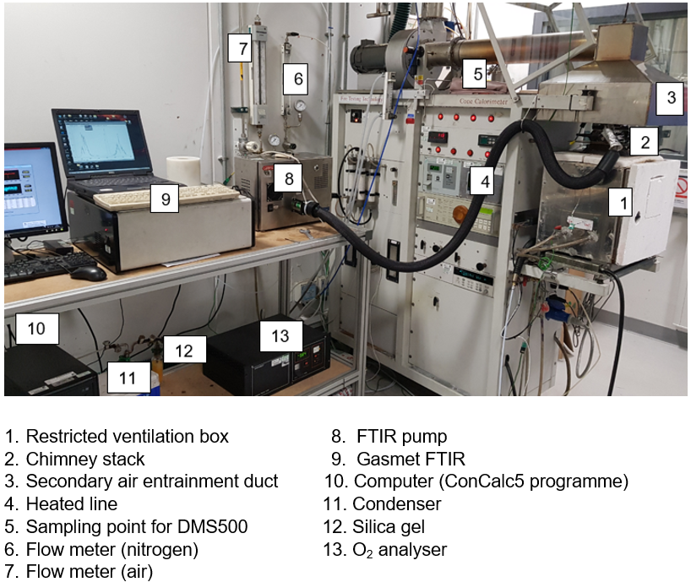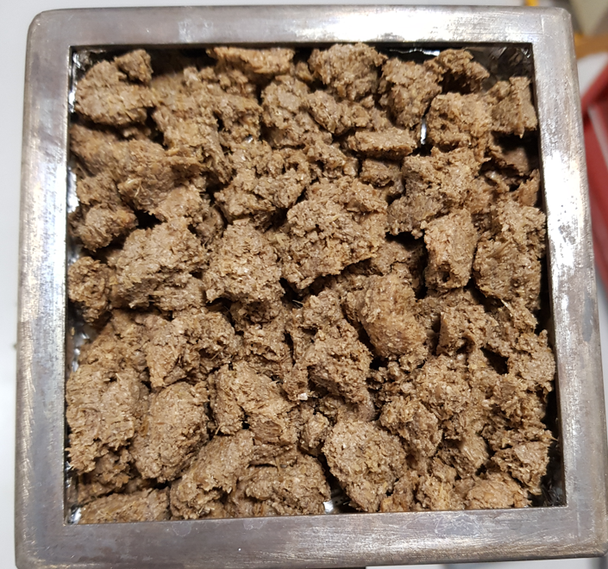
Figure 1: Gasification test rig (Cone calorimeter) Figure 2: Draff sample for gasification (sample weight 82 g)
The restricted ventilation cone calorimeter was used in this study. The sample was placed in the sealed air box (1) shown in Figure 1. The air supply to the box was controlled so that the metered equivalence ratio Ø could be varied by varying the air flow. The gasification chamber was lined with insulating fibre board such that the internal dimensions of the box were 0.33 m long, 0.275 m wide and 0.305 m high. The mode of gasification that occurred in the chamber was fixed bed, updraught gasification.

    - Determination of stoichiometric and metered Air-Fuel Ratio (AFR)
The carbon and oxygen balance method of Chan and Zhu (1996) was utilized to calculate the stoichiometric Air-Fuel Ratio (AFR) of the bio-waste from the result of the elemental analysis. (The stoichiometric AFR is the mass of air required for the complete combustion of 1 kg of fuel.) The gasification equivalence ratio (Ø) was determined from the mass loss rate of the test sample and the metered air flow into the gasifier. The equivalence ratio of the gasifier was the ratio of the stoichiometric AFR by mass to the measured/metered AFR (Equation 1). The metered AFR was estimated from Equation 2.
$ϕ=\frac{stoichiometric AFR}{metered AFR}$ (1)
$metered AFR=\frac{metered air flow, g/s}{mean mass loss rate, g/s}$ (2)
The equilibrium constant ($K$) for the water-gas shift reaction was utilized to estimate the concentration of hydrogen in the sampled gas (Equations 3 and 4) (Choi and Stenger, 2003).
$CO+H_{2}O⇌{CO}_{2}+H_{2} ∆H_{298}^{o}=-41.1 \frac{kJ}{mol}$ (3)
$K=\frac{\left[{CO}_{2}\right]\left[H_{2}\right]}{\left[CO\right]\left[H_{2}O\right]}$ (4)
$\left[{CO}_{2}\right]$, $\left[H_{2}\right]$, $\left[CO\right]$, and $\left[H_{2}O\right]$ in Equation 3 represent the concentrations of the product gases: carbon dioxide, hydrogen, carbon monoxide, and water vapour, respectively. The value of $K$ in Equation 4 was 3.5, corresponding to an equilibrium temperature of 1,738 K Chan and Zhu (1996).

    - Determination of the Hot Gases Efficiency (HGE)
The Hot Gases Efficiency (HGE) for the gasification of draff was estimated from the Higher Heating Values (HHV) and sensible heats of the product gases (Equation 5) (Kirsanovs and Zandeckis, 2015).
$HGE=\frac{Σ\left(HHV of the product gases+sensible heat of the gases\right) \left(\frac{MJ}{kg draff}\right)}{HHV of draff \left(\frac{MJ}{kg draff}\right)}$ (5)
The numerator of Equation 5 was calculated by multiplying the HHV of the gaseous components (MJ/kg species) by the corresponding Emission Index (EI) of the species (kg species/kg draff). The resulting product was added to the sensible heat of each of the species (20 ºC was used as the reference temperature). Finally, the two terms in the numerator were summed up for all the species.
  - Results and discussion
    - Analytical test results for distillery draff
The analytical test results (ultimate analysis and proximate analysis) for the tested draff sample are presented in Tables 1 and 2.
Table 1: Ultimate analysis results for distillery draff
Element | N | C | H | S | O
Weight, % | 2.37 | 30.04 | 12.27 | 0.00 | 55.32
Table 2: Proximate analysis results for distillery draff
Component | Moisture | Volatile Matter (VM) | Fixed Carbon (FC) | Ash
Weight, % | 73.39 | 23.36 | 3.18 | 0.07
The stoichiometric AFR of draff was estimated from the ultimate analysis results as 5.34. The relatively high percentage of oxygen in distillery draff (compared to the biomass residues previously investigated by Andrews et al. (2019)) is due to the presence of ethanol and other organic compounds in draff. Table 2 also depicts the relatively high moisture content of the tested draff sample (73.4%). The gasification input energy increases with the moisture content of the biomass due to the energy that is required to dry the biomass prior to gasification. The determined bulk density and HHV of the draff sample were ≈ 410 kg/m³ and 5.23 MJ/kg respectively.
    - Mass Loss Rate (MLR) and normalised mass loss profiles of distillery draff
Figures 3 and 4 depict the Mass Loss Rate (MLR) and the normalised mass loss profiles respectively of distillery draff for the investigated air flux conditions. Figure 5 depicts the normalised mass loss profile for the 14.3 g air/m²s condition. Five (5) stages were observed in the normalised mass loss profile of draff (Figure 5) unlike the case for sweet sorghum crop residue which had four (4) stages (Olanrewaju et al., 2022).

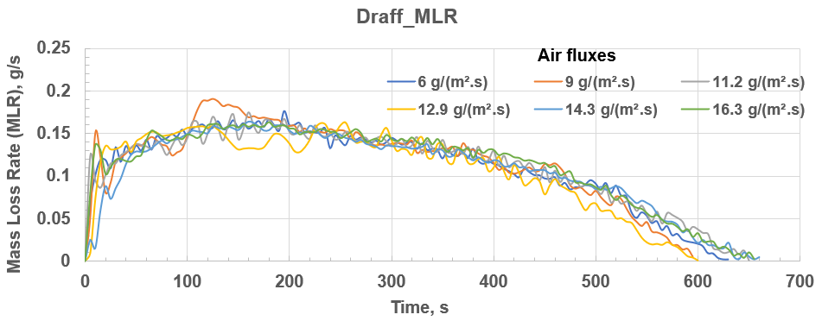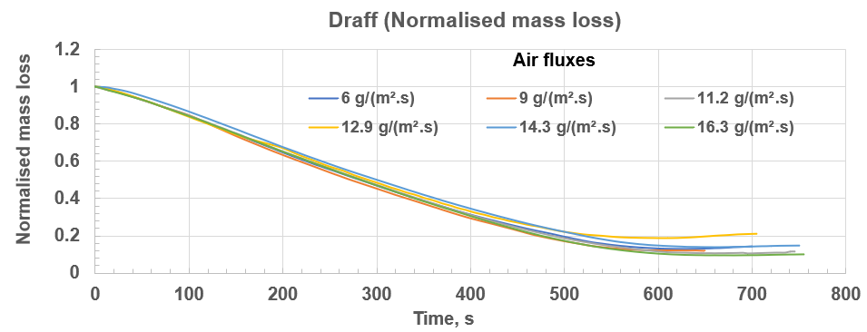
Figure 3: Plot of Mass Loss Rate (g/s) versus time (s) Figure 4: Plot of normalised mass loss versus time (s)
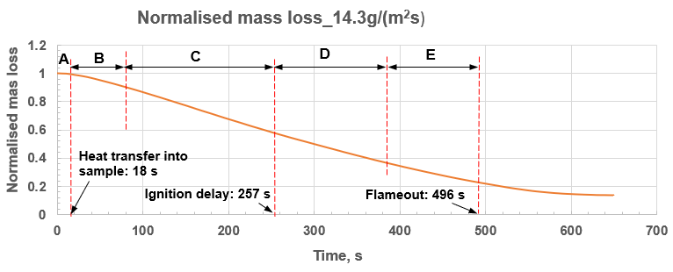
Figure 5: Delineation of the stages in the gasification of distillery draff
Figure 5 shows that for the 14.3 g air/m²s condition, after the start of the test there was negligible mass loss for 18 s. This was the period of heat transfer into the sample (stage A). Stage A was followed by stage B during which evaporation of moisture from the draff occurred. Though some volatile compounds were released from the sample in stage B, the gas released was predominantly water vapour. The total hydrocarbons (THC) profile in Figure 6a shows that prior to the start of pyrolysis (t < 80 s), some volatile hydrocarbons were released (these were the low molecular weight hydrocarbons such as methane). The profile for water vapor in Figure 6b also shows a decrease in gradient prior to the start of pyrolysis (thermal decomposition). The observed decrease in gradient about 70 s after the start of the test symbolised the onset of pyrolysis (increase in the rate of release of volatiles while the rate of evaporation of water decreased). As the heating of the sample continued, thermal decomposition of the draff began after about 80 s into the test (stage C). The CO and THC emissions from the draff increased during the pyrolysis stage as shown in Figure 6a. Consequently, the rate of mass loss in stage C in Figure 4 is greater than in stage B. The sample eventually auto-ignited after 257 s, which time marked the beginning of stage D, the flaming oxidation period. Stage D was followed by stage E, the period of smouldering oxidation. The intensity of the flame reduced continuously in stage D until the flame went out after 496 s, indicating that the release of flammable components from draff had ceased. The remaining mass was a biochar with the ash fraction as part of the remaining mass.
Photographs of draff during pyrolysis, and after auto-ignition are given in Figures 7 and 8 respectively for the 16.3 g/m²s air flux condition. Figure 7a depicts the residue after the end of gasification. The mass of the residue was 3.2 g which is about 10% of the initial mass, as shown in Figure 4. Tar deposits were not observed at the bottom of the aluminium foil. At relatively high gasification temperatures, tar is not formed, and this enhances the efficiency of biomass gasification.

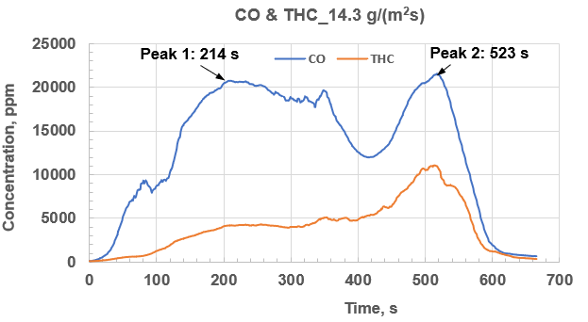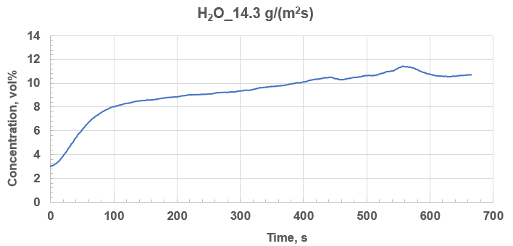
(a) (b)
Figure 6: Plots of concentrations of selected product gases against time (s) (a) CO and THC in ppm (b) H2O in vol%
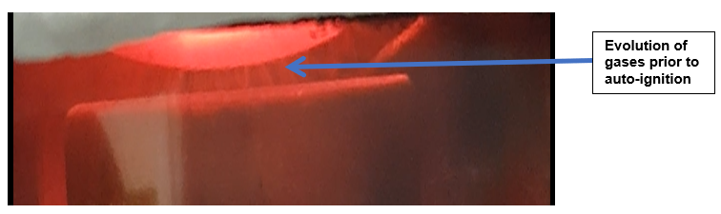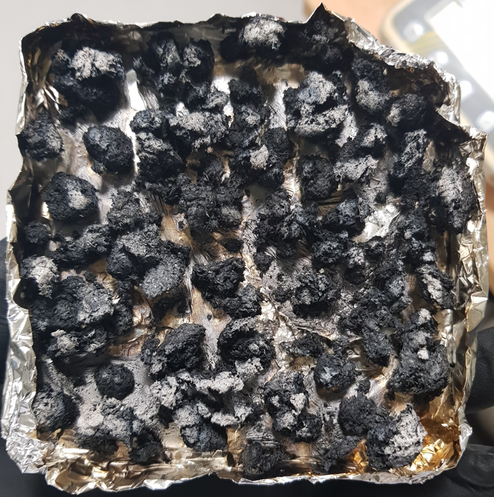
(a) (b)
Figure 7: Gasification of distillery draff (a) Pyrolysis stage (b) Draff gasification residue
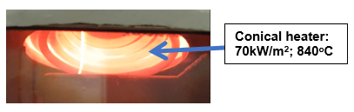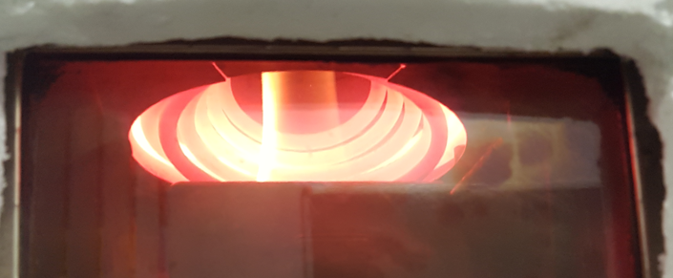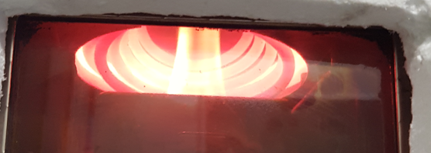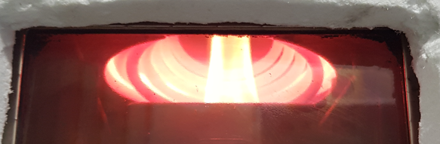
(a) (b) (c) (d)
Figure 8: Flame development at different times after ignition (a) 20 s (b) 60 s (c) 120 s (d) 150 s
The results confirm that it is possible to gasify distillery draff. As draff is a high-moisture content bio-waste, it is likely that other wet biomass wastes, such as farm manure, could be gasified.
    - Yield of combustible gases and Hot Gases Efficiency (HGE) for the gasification of draff
The yield of the combustible gases CO, total hydrocarbons (THC) and H₂ in g gas/kg draff for the tested conditions are shown in Figure 9. The THC was computed as the methane equivalent of the FTIR measured hydrocarbon products. Figure 9 shows that the total yield of the combustible gases peaked at an equivalence ratio, Ø of 4.5. Therefore, the optimum Ø for the gasification of the tested distillery draff is 4.5. Werle (2015) reported an optimum Ø of 5.56 for the gasification of dried sewage sludge. The disparity in the values of the optimum Ø for distillery draff and the previously investigated agricultural crop residues (Olanrewaju et al., 2022) is due to the relatively high moisture content of the tested draff sample. Figure 10 compares the HGE values for draff to those of selected agricultural crop residues and pine wood. The experimentally determined optimum maximum HGE for the gasification of distillery draff was ≈ 90%. This compares quite well with the optimum HGE for sweet sorghum stalk residue of 81%. The maximum HGE for the gasification of draff occurred at the optimum Ø, 4.5 which corresponds to an air flux of ≈ 9 g/m²s. The experimentally determined gasification parameters (air flux, heat flux and Ø) for draff will be utilised in the future to design an industrial gasifier for distillery bio-wastes.

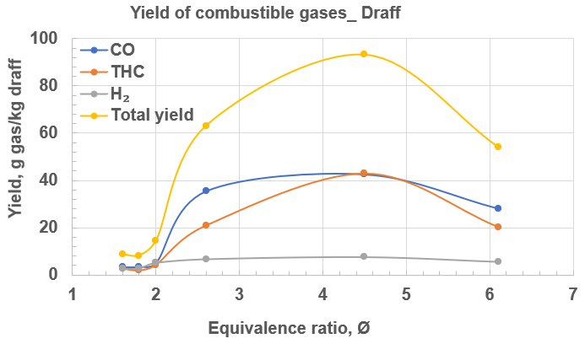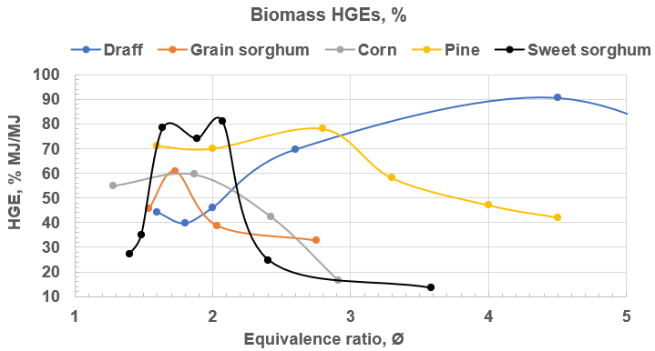
Figure 9: Yield of combustible gases for draff Figure 10: HGE values for draff and selected biomasses
  - Conclusions
The possibility of gasifying distillery draff, which is a high-moisture content waste biomass, was investigated in the current work using the restricted ventilation cone calorimeter method. It was shown that draff gasifies at a relatively high heat flux of 70 kW/m². The experimentally determined optimum air flux, equivalence ratio, Ø and HGE for the gasification of distillery draff are 9 g/m²s, 4.5 and 90% respectively. The optimum Ø for the investigated draff sample compares well to the reported value of 5.56 for dried sewage sludge. The experimentally determined gasification conditions for draff will be used in the future to design an efficient industrial biomass gasifier for industrial decarbonization. The CO peak that occurred during the pyrolysis stage of the gasification indicated the best gasification condition and this could be used for gasifier optimization.
Acknowledgments
This work was supported by the UK Department of Business, Energy and Industrial Strategy (BEIS): BATGasGD Phase 1 (TRN 2564/08/2020), Clean Burner Systems, Rugby, UK and the University of Leeds, Leeds, UK.
References
Andrews G.E, Irshad A., Phylaktou, H.N., Gibbs B.M., 2019, Solid Biomass to Medium CV Gas Conversion with Rich Combustion, Proceedings of ASME Turbo Expo 2019: Turbomachinery Technical Conference and Exposition GT2019, ASME Technical Paper GT2019-90196, Phoenix, Arizona, USA.
Chan S.H., Zhu J., 1996, Exhaust Emission Based Air-Fuel Ratio Model (I): Literature Reviews and Modelling, SAE International paper no. 961020, 1996, doi.org/10.4271/961020.
Choi Y., Stenger H.G., 2003, Water gas shift reaction kinetics and reactor modeling for fuel cell grade hydrogen. J Power Sources 2003, 124(2), 432–9. doi.org/10.1016/S0378-7753(03)00614-1.
Gandy S., Hinton S., 2018, Whisky by-products in renewable energy, Ricardo Energy & Environment, Didcot, UK.
Irshad A., Alarifi A.A., Thompson S., Melton G.J., Andrews G.E., Phylaktou H.N., Gibbs B.M., 2014, Use of the Cone Calorimeter for Investigating Biomass Gasification Staged Combustion, 22nd European Biomass Conference and Exhibition, Paper 2AO.4.1, Hamburg, Germany, 388–98.
Kirsanovs V., Zandeckis A., 2015, Investigation of Biomass Gasification Process with Torrefaction Using Equilibrium Model, Energy Procedia, 72, 329-336.
Mustafa B.G., Kiah M.H.M., Irshad A., Andrews G.E., Phylaktou H.N., Li H., Gibbs B. M., 2019, Rich biomass combustion: Gaseous and particle number emissions, Fuel, 248, 221– 31. doi.org/10.1016/j.fuel.2019.03.027.
Olanrewaju F.O., Andrews G.E., Li H., Phylaktou H.N., Mustafa B.G., Kiah M.M.H., 2022, Investigation of the heat release rate and particle generation during fixed bed gasification of sweet sorghum stalk, Fuel, 332, doi./10.1016/j.fuel.2022.126013.
Werle S., 2015, Gasification of a Dried Sewage Sludge in a Laboratory Scale Fixed Bed Reactor, Energies, 8, 8562-72, doi:10.3390/en8088562.
White J.S., Stewart K.L., Maskell D.L., Diallo A., Traub-Modinger J.E., Willoughby N.A., 2020 Characterization of Pot Ale from a Scottish Malt Whisky Distillery and Potential Applications, ACS Omega, dx.doi.org/10.1021/acsomega.9b04023.

