CHEMICAL ENGINEERING TRANSACTIONS  VOL. , 2023 | A publication of
The Italian Association
of Chemical Engineering
Online at www.cetjournal.it

Guest Editors: David Bogle, Flavio Manenti, Piero Salatino
Copyright © 2023, AIDIC Servizi S.r.l.
ISBN 979-12-81206-04-5; ISSN 2283-9216

Stability of Diethyl Carbonate in the presence of acidic and basic solvents
Kouessan Aziaba^{a,}*, Florian M. Možinaª, Magdalena Teufner-Kabas^{b}, Florian Kabas^{b}, Christian Jordanª, Michael Harasekª,
ª Thermal Process Engineering - Computational Fluid Dynamics, Institute of Chemical, Environmental & Bioscience Engineering, TU Wien, Getreidemarkt 9, 1060 Vienna, Austria
^{b}kleinkraft OG, Turnergasse 27/5, 1150 Vienna, Austria
kouessan.aziaba@tuwien.ac.at
Reducing carbon dioxide (CO₂) emissions is an inevitable measure for fighting anthropogenic climate change. Carbon Capture and Utilization (CCU) technologies are gaining rising attention as an additional contributor to reaching the Paris Agreement goals. Giving CO₂ a value as a feedstock to be refined into chemicals to be used in industry is a crucial aspect of making these technologies interesting for vast industrial sectors. The synthesis of diethyl carbonate (DEC) is recognized as a promising prospect for the successful implementation of CCU. DEC is considered a fully biodegradable, low-toxic solvent, which can be synthesized from CO₂ and ethanol in the presence of a catalyst. DEC may be a non-toxic alternative to other solvents such as toluene or methyl isobutyl ketone (MIBK).

The optimization of DEC synthesis is one aspect that is under investigation today. For the exploration of DEC's applicability, an extensive amount of data is beneficial. Many applications of solvents involve the presence of acids and bases. Hence, an interest in DEC in various environments is reasonable. The decomposition of DEC after contact with water, different acids and bases at room temperature, and the boiling point was determined experimentally to characterize chemical stability. Further, the influence of sodium chloride and a cerium-based catalyst used in DEC synthesis was investigated.

  - Introduction
The application of CO₂-refinery processes is considered an essential contribution towards more sustainable strategies in the chemical industry. As a part of CO₂-refinery, CCU re-introduces carbon dioxide back into industrial cycles and is regarded as a promising tool in fighting anthropogenic climate change. The direct synthesis of DEC is considered to be a promising product of such an application which uses CO₂ as a feedstock. Another commonly positively perceived property of the reaction is the fact that the side product is water. The reaction of the direct synthesis of DEC is portrayed in equation 1.

$$C_{2}H_{5}OH+CO_{2}↔C_{5}H_{10}O_{3}+H_{2}O$$ | (1)

DEC is currently used in lithium-ion batteries, organic synthesis and extraction procedures and has also been used in combustion engines, successfully reducing emissions.[1] However, new applications for DEC must be further investigated to exploit its full potential as a green chemical. Many physical and chemical properties have already been described, but data about chemical stability is limited.[2] One weakness of DEC is its susceptibility to hydrolysis under acid or alkaline conditions. An extraction process was developed by Yang et al. [3] applying DEC to recover phenols from coal tar processing wastewater from an alkaline stripping solution. However, the stripping process is limited to about 8 minutes due to the imminent degradation of DEC in the organic phase. Experimental data on DEC decomposition after exposure to different aqueous phases of various acidities were reported by Raiguel et al. [4]. A "salting out"-effect was described. Dissolved inorganic salts like NaCl in an aqueous phase are observed to stabilize DEC. Due to the decrease in solubility, hydrolysis is slowed down. The decomposition of DEC is mainly dominated by its acid- or base-catalyzed hydrolysis leading to the main reaction products carbon dioxide and ethanol. Other degradation mechanisms have also been observed since diethyl ether and chloroethane were detected as reaction products. Al-Shamary et al. [5] investigated multiple dialkyl carbonates, observing an enhancement of the degradation in the presence of cationic micelles. Anionic micelles are reported to reduce hydrolysis rates.

To pave the way for further research about applications for DEC, this work focuses on the chemical stability of DEC after being in contact with various acidic and basic solutions. The presence of CeO_{2,} a catalyst, as well as the presence of NaCl shall also be monitored.

  - Materials and Methods
Different acids (HCl, H₂SO₄, H₃PO₄, formic acid, acetic acid) and bases (NaOH, KOH, Na₂CO₃) have been obtained for the investigations. DEC degradation has been calculated according to equation 2.

$$Degradation \left[\%\right]= \frac{m_{DEC,0}-m_{DEC}}{m_{DEC,0}}*100$$ | (2)

The experimentally determined data shall be accompanied with theoretical ethanol (EtOH) formation and mass loss due to CO₂. The theoretical ethanol formation was calculated according to equation 3.

$$m_{EtOH,theoretical}= \frac{m_{DEC,0}-m_{DEC}}{M_{DEC}}*2*M_{EtOH}$$ | (3)

CeO₂ which is used in the direct synthesis of DEC from CO₂ as a catalyst, is neither soluble in water nor DEC. However, no data about its interference with DEC degradation was available. [6]

3ml of DEC were mixed with each of these solutions with a volume ratio of 1:1. When a two-phase system developed, phases were separated at the end of the experiment. Afterwards, DEC and EtOH were quantified with a GC-FID (gas chromatograph equipped with a flame ionization detector) as described in 2.2. It was assumed that DEC evaporation loss was negligible due to its high boiling point. For each substance, four experiments were carried out at ambient pressure, which differed in temperature and the presence or absence of 0,125 g of CeO₂. The influence of sodium chloride (NaCl) dissolved in the aqueous phase on chemical stability was investigated with the same solutions as above, except for HCOOH which was used as a pure compound. NaCl concentration in the aqueous phase was 250 g/l. The resulting phases were filtered before every analysis if a catalyst was applied. The net weight of the mixture before and after the experiment was documented. When the catalyst was present, it was assumed that it accumulated only in the aqueous phase. If a separation of the product into two phases was observed, it was necessary to collect three samples of each product containing a sample of the aqueous, organic and a mixture of both phases. Emulsions were drawn into a syringe to rest for 15 minutes until phase separation had taken place.

    - Materials
The experiments were carried out in three-neck round bottom flasks equipped with glass plugs and thermometers. The thermometers were inserted through a septum into the sample in the flask. The flasks were placed in an aluminum bowl filled with a sand bed to enable a homogeneous heat transfer. The samples were stirred with a magnetic stirrer for 24 (HCOOH for 64) hours and, if necessary, heated to boiling point through a sand bed. To prevent losses due to evaporation, a Liebig cooler was installed. A thermometer was connected, and the boiling temperature was read as soon as reflux occurred and the cooler's inner surface.

Diethyl carbonate (DEC, 99,9 %) was purchased from Carl Roth. Phosphoric acid (H₃PO₄, p.a., Lachema), fuming hydrochloric acid (HCl, 37 %, Sigma-Aldrich), potassium hydroxide (KOH, Neuber's Enkel), formic acid (HCOOH, >= 99 %, Merck), and acetic acid (HAc, 99,8 %, EMD Millipore) were obtained and solved in water to mix 0.5 M solutions of each compound. Potassium hydroxide (KOH, platelets), sodium carbonate (NaOH, beads), sodium chloride (NaCl, grains) and sulphuric acid (H₂SO₄) were obtained from the in-house laboratory stock and diluted in H₂O to form 0.5 molar solutions as well. HCOOH and HAc were also applied as pure compounds additionally.
    - Analytics
Gas chromatography coupled with a flame ionization detector (GC-FID) was used to analyze the samples. GC-FIDs are highly reliable analytic instruments for the purpose of detection and quantification of volatile organics. Samples were injected automatized from an autosampler (AOC 5000, Shimadzu), and 0,5 μl was set as the injection volume. Each sample was measured once. Dioxane was injected regularly before and between measurements to minimize carryover from the injector and column. Calibration curves for the quantification of DEC and ethanol were prepared by analyzing standards containing DEC and EtOH.

  - Results
    - Experiments
All chromatogram peaks have been checked manually and assigned to a substance by retention time for qualitative information about chemical stability. For quantitative information about chemical stability, the degradation of DEC was determined. The formation of EtOH as a decomposition product was considered unsuitable for the characterization of chemical stability because evaporation losses occurred during experiments. As documented in Figure 1, it can be seen that DEC may be involved in a reverse reaction with H₂O as described in the introduction.

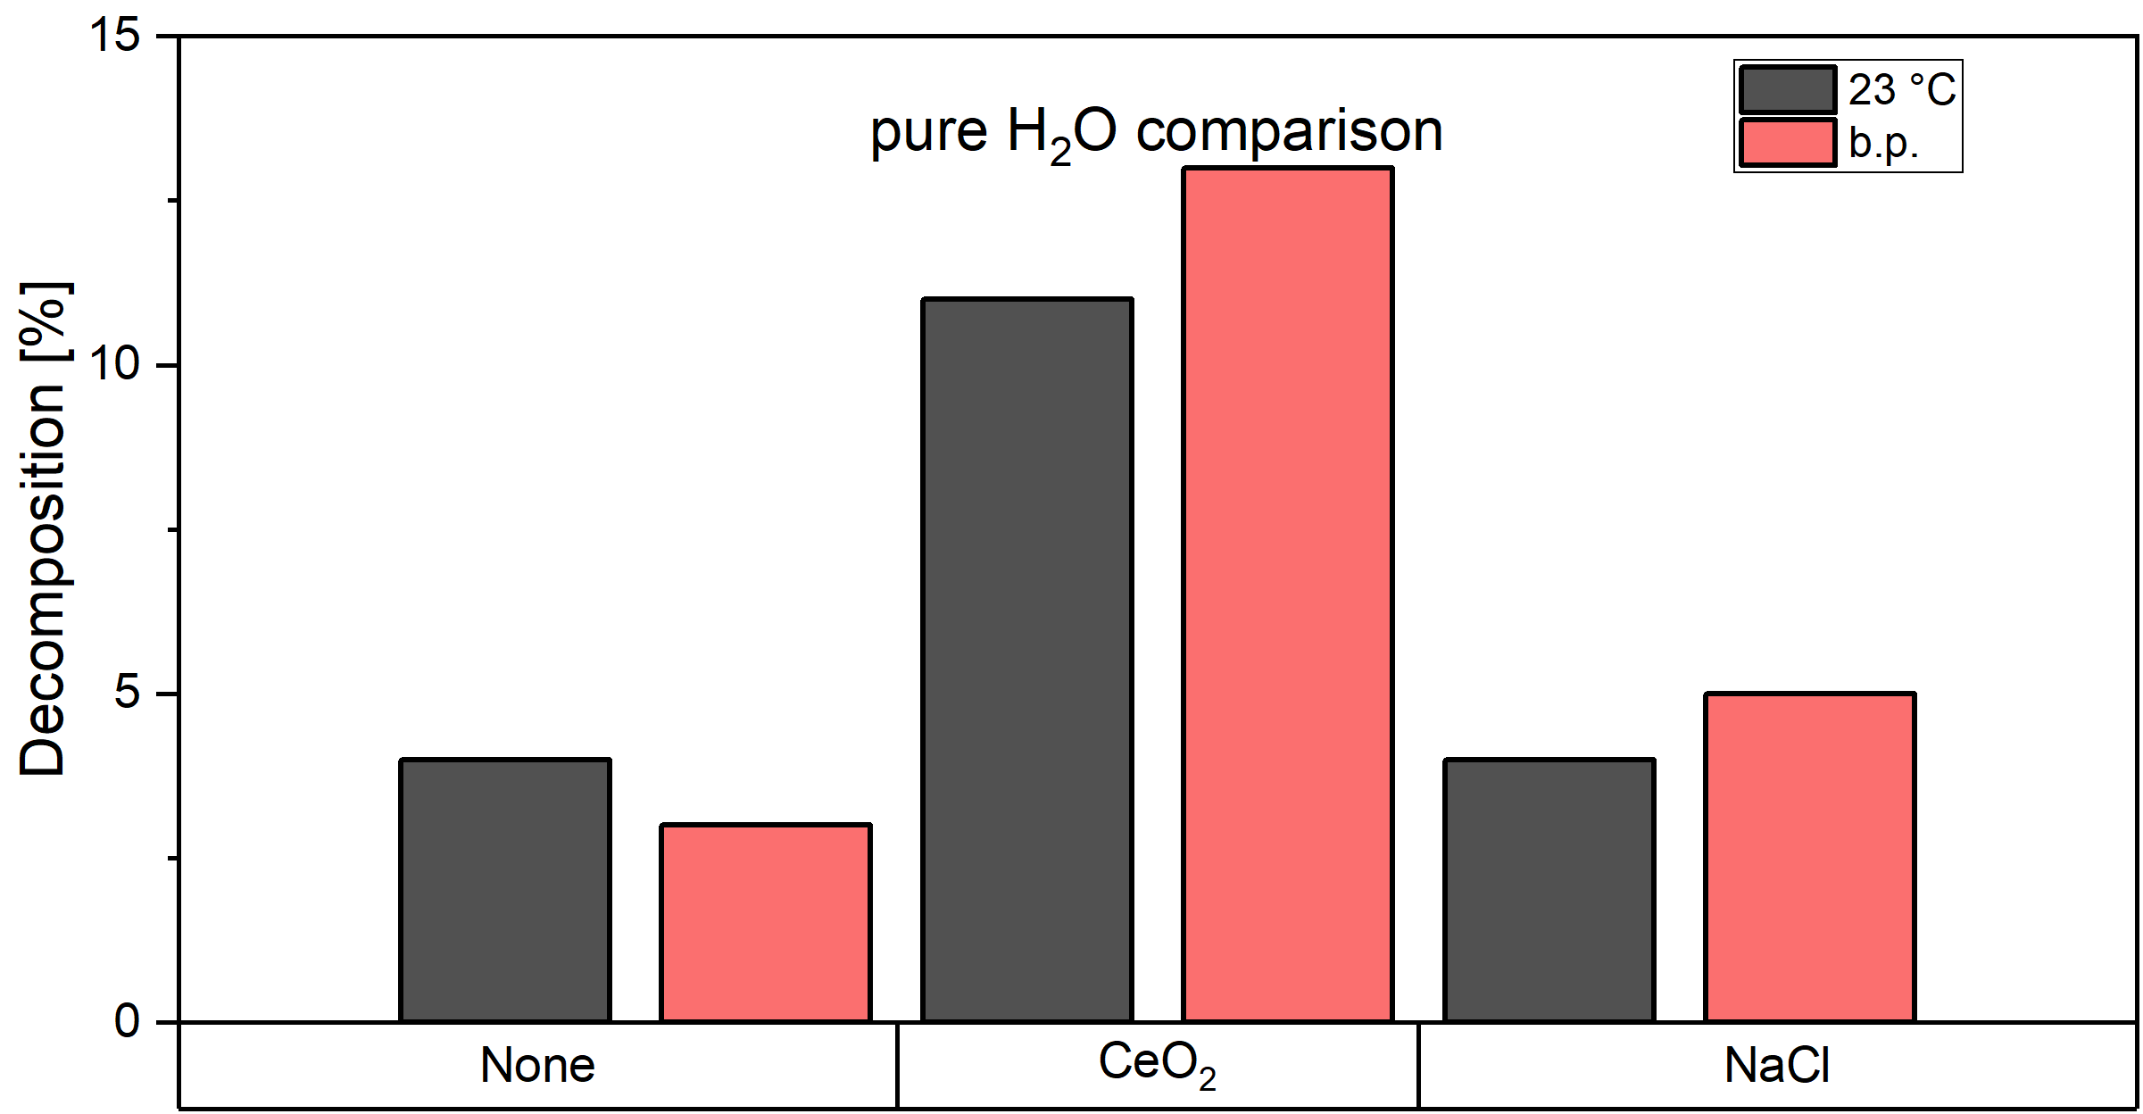
Figure 1: DEC degradation of a binary DEC-Water system in dependence on added CeO₂ or NaCl
Temperature does not seem to have a significant effect on the decomposition of DEC as long as there is no CeO₂ involved. Mentioning the catalyst CeO₂, the simultaneous presence of it and elevated temperatures seem to boost the degradation of DEC on a comparably low scale. Even though NaCl is added to prevent decomposition processes, it becomes lightly visible that this effect is observed to be inverse at elevated temperatures. It is not clear why the decomposition of DEC is enhanced in this case. This may be connected with the difference in the boiling points which also vary due to the different mixtures. Therefore, more experiments with varied amounts of salt would be required. The presence of acidic compounds in the solution reveals a different dynamic which is portrayed in Figure 2.
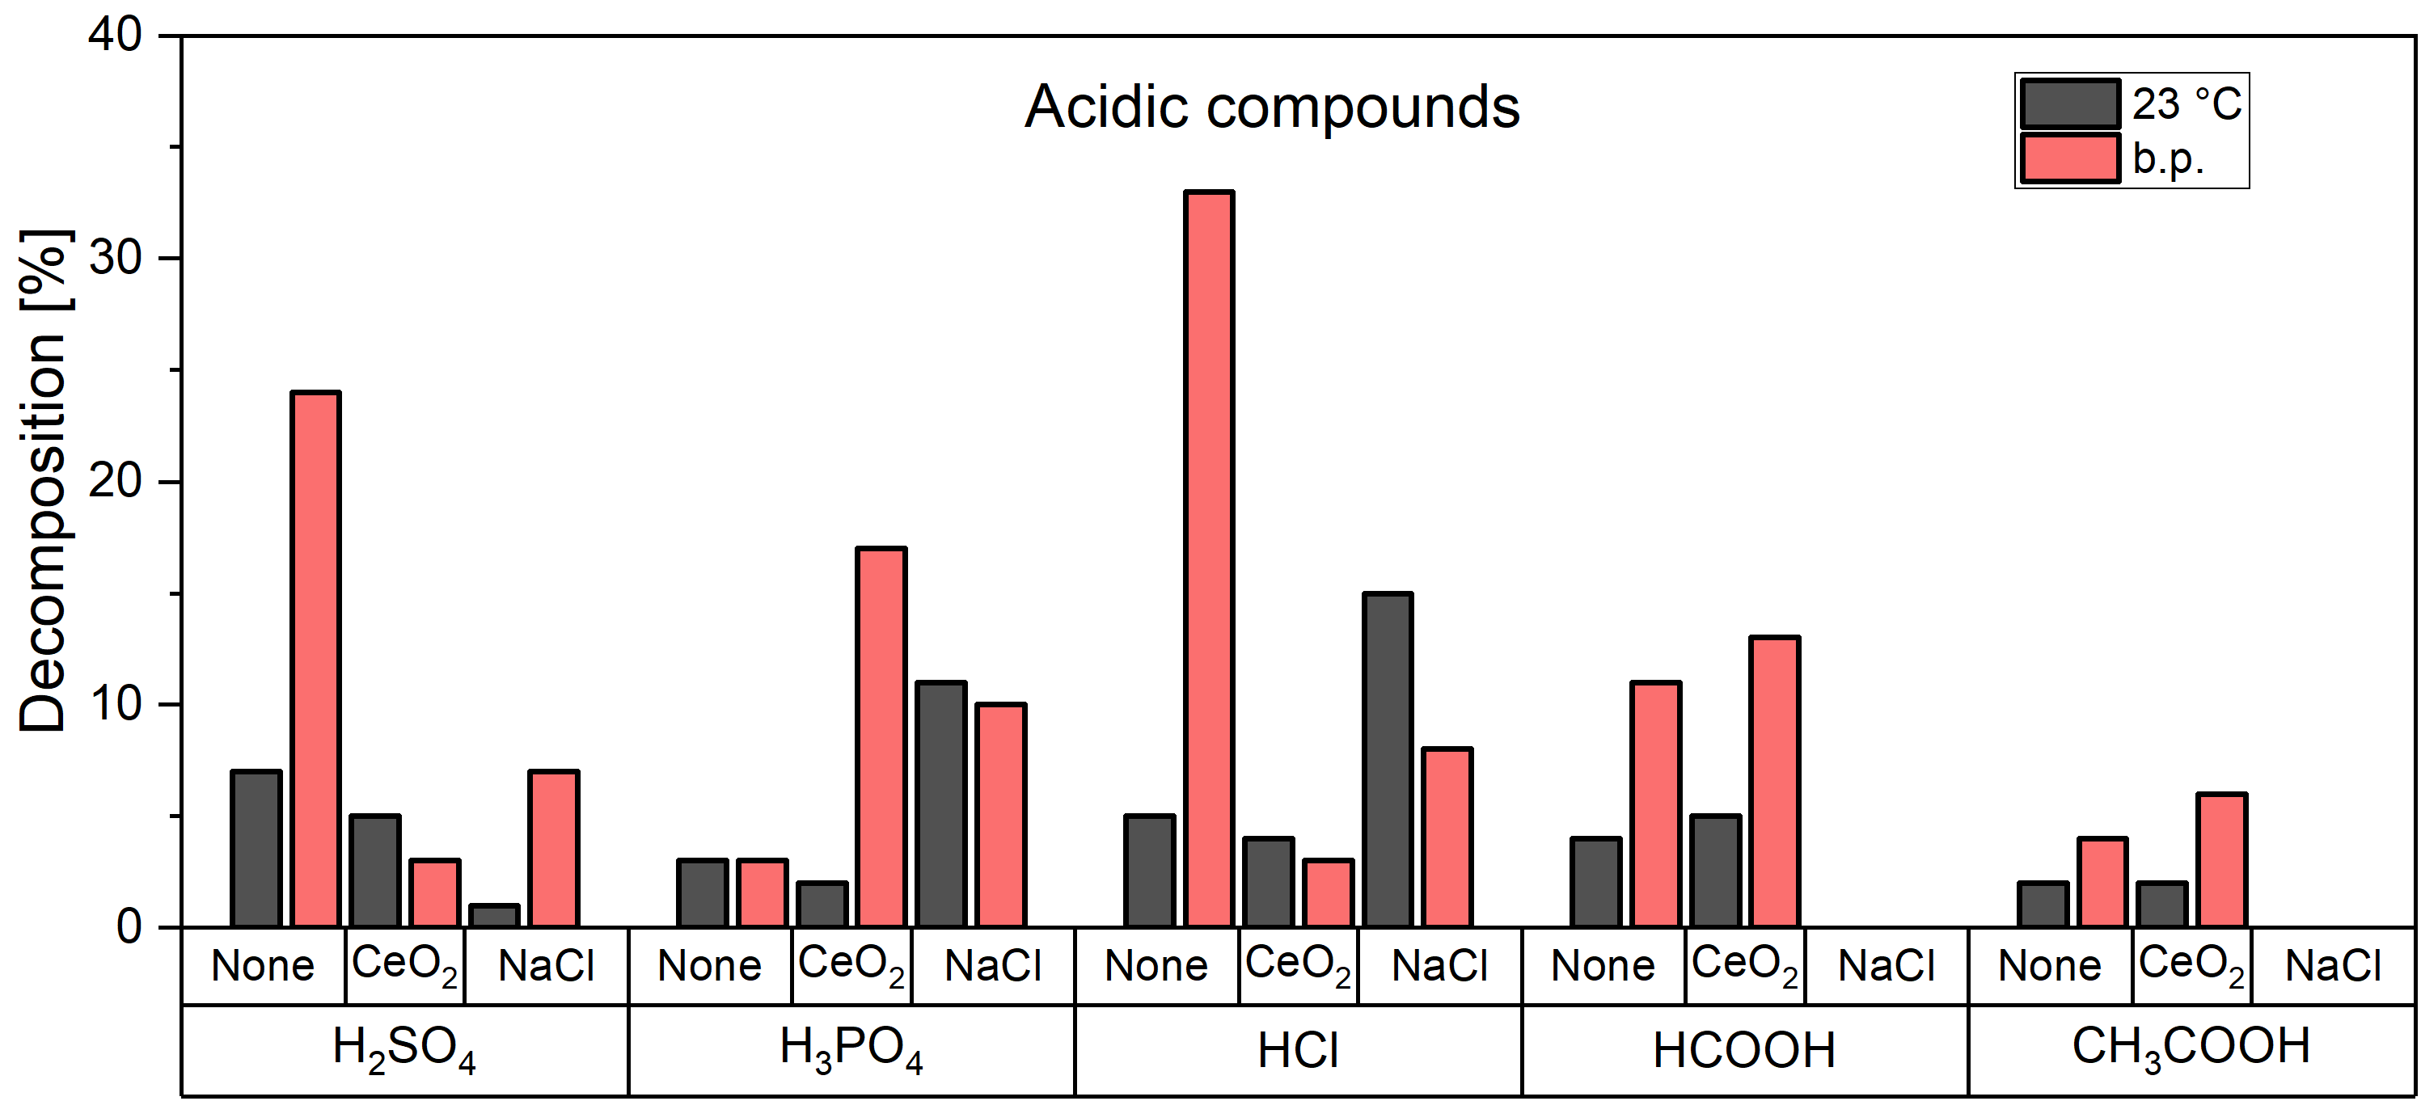
Figure 2: DEC degradation of a binary DEC-Acid (0.5 M) system in dependence of added CeO₂ or NaCl with H₂SO₄, H₃PO₄, HCl, HCOOH and HAc used as acids
The highest degradation is observed to occur in contact with HCl, followed H₂SO₄, H₃PO₄, HCOOH and HAc in a decreasing sequence. The values pK_{A} and pK_{B} (acid dissociation- and base dissociation constant) are commonly accessed parameters to obtain an enhanced understanding of a solution's acidiy and basicity. Therefore, it is also consulted to observe DEC's degradation in the presence of acids and bases. Comparing DEC's degradation in contact with the acids mentioned earlier with the pK_{A} – values from the literature reveals that the degradation at higher temperatures follows the same trend as the pK_{A} – value [7]. The influence of CeO₂ and NaCl does not seem to follow any trends or patterns since it appears to be quite arbitrarily which reagent delivers the strongest decomposition in contact with DEC. Starting with H₃PO_{4,} which mainly shows the highest degradation of DEC in the presence of salt, increasing the temperature seems to improve the activity of the catalyst and increases the DEC degradation. Interestingly, the same effect is not seen in the same way with any of the other tested acidic compounds. The comparably weaker organic acids HCOOH and HAc deliver lightly higher degradations of both – ambient temperature and on the b.p. (boiling point) if CeO₂ is used. The application seems to avoid degradation completely. The general effect observed on the contact of DEC with acidic compounds is a comparably fair degradation where no presence of a catalyst is needed. The presence of salt, which shall incorporate an inhibitor's function as mentioned in 1.1., seems indifferent to the various acidic compounds. Similar to the presence of NaCl in binary DEC solutions with water it is unclear why no trend was observed. Therefore, further investigation with various acid concentrations and amounts of NaCl would be necessary. With many possible applications to be carried out in an alkaline environment the interest into the influence of basic compounds on DEC was present as well. Therefore, the recorded results are displayed in Figure 3.

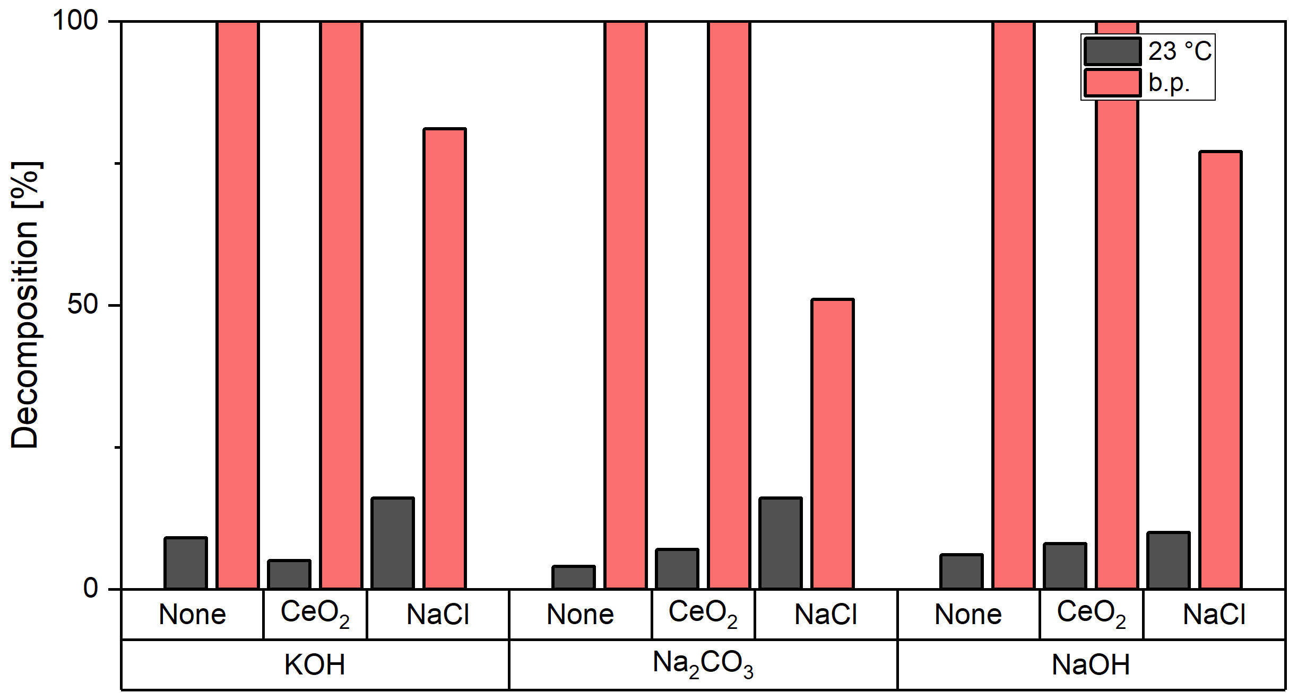
Figure 3: DEC degradation of a binary DEC-base (0.5 M) system in dependence of added CeO₂ or NaCl with KOH, NaOH and Na₂CO₃ used as acids
The decomposition of DEC already takes place at ambient temperatures. Even though the presence of CeO₂ and NaCl seems to have a moderate influence, it is not easily determined in which direction the trend of their effect leads. Temperature appears to be the most influential parameter for the decomposition of DEC. It can be stated that the exposure of DEC with all applied basic compounds leads to a complete decomposition that could be partially prevented with NaCl. The decomposition seems also to follow the trend following the pK_{B}-values of which KOH's and NaOH's pK_{B}-values are comparably low over the one of Na₂CO₃. NaCl usually dissolves in a fully solvated state in water. Comparably strong ions Na⁺ and Cl⁻ may attract some of the water molecules, leaving fewer molecules behind. This results in limited availability of water to hydrolyze DEC. [4]

    - Ethanol losses
The mass losses during the experiments were recorded and are displayed in Figure 4. Since the majority of the mass loss was associated with ethanol losses, the losses due to CO₂ were neglected.

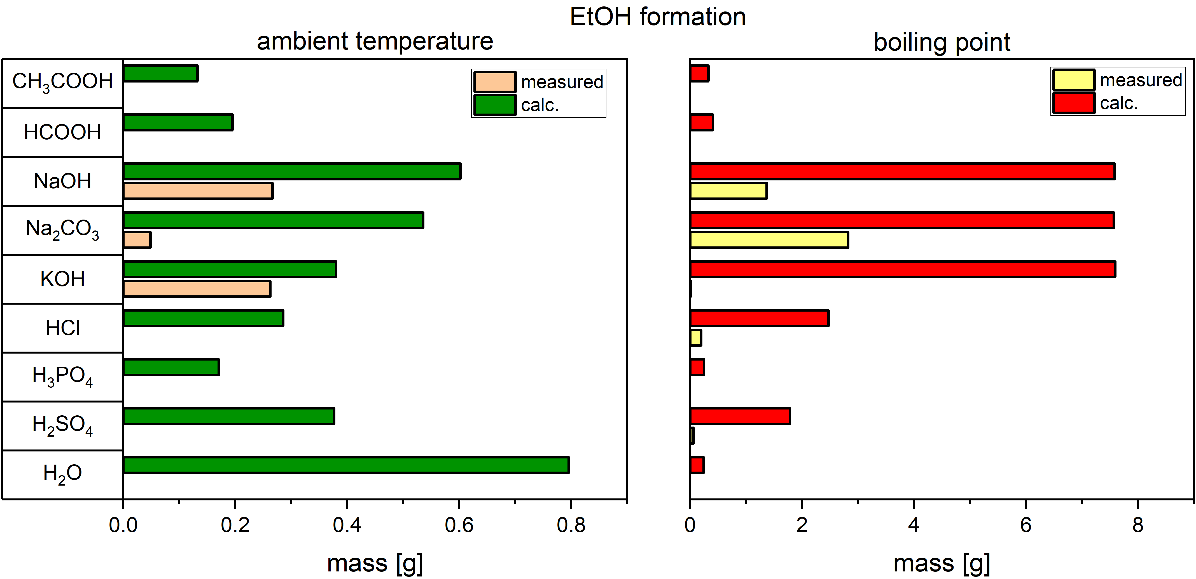
Figure 4: calculated theoretical and measured EtOH formation after experiments with various chemicals on ambient and elevated temperatures
The low boiling point of ethanol was estimated to be the reason for this. It was assumed for calculations that DEC loss was negligible since DEC has a higher boiling point than water and ethanol. However, this assumption is most likely not exact. Consequently, results are estimated to be influenced by an unknown error.

  - Conclusions
The experimental trial has clearly shown that decomposition of DEC can occur in various settings. At low temperatures degradation of DEC does not follow any obvious trends. However, the degradation mostly accelerated significantly at higher temperatures. The influence of catalyst was rather random and requires more experiments to be described in more detail. Enhanced chemical stability by adding NaCl was observed at high levels of DEC degradation, the influence of salt at lower degradation rates fluctuated. The expressiveness of the results for quantitative information about chemical stability are limited due to the rather facile setup and limited number of experiments. Exchanging the setup with a tightly sealed system which can also be exposed to elevated pressure, could have improved the expressiveness of the results but would also create the necessity for further possibly complex equipment such as a level sensor. Nevertheless, it was still possible to obtain information about DEC's behaviour in acidic and basic solutions. DEC is apparently more susceptible to base-catalyzed than acid-catalyzed hydrolysis. The strength of the acid or base increased DEC degradation at boiling temperature. Nonetheless, since the decomposition products of DEC are mostly considered to be CO₂ and water, the effort which must be taken to cope with the resulting compounds is comparably low. Further, the idea of a reduction of the decomposition considering the limited availability of water for a reverse reaction fuels the idea that DEC may be a promising alternative to other electrolyte additives.
Nomenclature
b.p. – boiling point

FID – flame ionization detector
GC – gas chromatograph
pK_{A} – acid dissociation constant
pK_{B} – base dissociation constant
CeO₂ – cerium oxide
DEC – diethyl carbonate
HAc – acetic acid
HCl – hydrochloric acid
HCOOH – formic acid
H₂O – water
H₂SO₄ – sulfuric acid
H₃PO₄ – phosphoric acid
KOH – potassium hydroxide
NaCl – sodium chloride
Na₂CO₃ – sodium carbonate
NaOH – sodium hydroxide
m_{EtOH, theoretical} – calculated mass EtOH, g
m_{DEC} – mass of DEC after experiment, g
m_{DEC, 0} – mass of DEC fed to experiment, g
m_{EtOH, theoretical} – ambient temperature, K
M_{EtOH} – molar mass of EtOH, g/mol
m_{DEC, 0} – molar mass of DEC, g/mol

Acknowledgments
This research was subsidized by city of Vienna funds via the Vienna Business Agency (WAW), grant number 2761267. Further, the authors acknowledge the funding support of K1-MET GmbH, metallurgical competence center. The research program of the K1-MET competence center is supported by COMET (Competence Center for Excellent Technologies), the Austrian program for competence centers. COMET is funded by the Federal Ministry for Transport, Innovation, and Technology; the Federal Ministry for Digital and Economic Affairs; the provinces of Upper Austria, Tyrol, and Styria; and the Styrian Business Promotion Agency (SFG).
References
[1] K. Shukla, V.C. Srivastava, Diethyl carbonate: Critical review of synthesis routes, catalysts used and engineering aspects, RSC Adv. 6 (2016) 32624–32645. https://doi.org/10.1039/c6ra02518h.
[2] S. Huang, B. Yan, S. Wang, X. Ma, Recent advances in dialkyl carbonates synthesis and applications, Chem. Soc. Rev. 44 (2015) 3079–3116. https://doi.org/10.1039/C4CS00374H.
[3] X. Yang, B. Wang, H. Luo, S. Yan, J. Dai, Z. Bai, Efficient recovery of phenol from coal tar processing wastewater with tributylphosphane/diethyl carbonate/cyclohexane: Extraction cycle and mechanism study, Chem. Eng. Res. Des. 157 (2020) 104–113. https://doi.org/10.1016/J.CHERD.2020.03.005.
[4] S. Raiguel, L. Gijsemans, A. Van Den Bossche, B. Onghena, K. Binnemans, Solvent Extraction of Gold(III) with Diethyl Carbonate, Cite This ACS Sustain. Chem. Eng. 8 (2020) 13713–13723. https://doi.org/10.1021/acssuschemeng.0c04008.
[5] M.N. Al-Shamary, H.A. Al-Lohedan, M.Z.A. Rafiquee, F. El-Ablack, Z.A. Issa, Micellar effect upon the rate of alkaline hydrolysis of carboxylic and carbonate esters, J. Saudi Chem. Soc. 21 (2017) S193–S201. https://doi.org/10.1016/J.JSCS.2014.01.002.
[6] G.G. Giram, V. V. Bokade, S. Darbha, Direct synthesis of diethyl carbonate from ethanol and carbon dioxide over ceria catalysts, New J. Chem. 42 (2018) 17546–17552. https://doi.org/10.1039/C8NJ04090G.
[7] J. Trygg, P. Trivedi, P. Fardim, controlled depolymerisation of cellulose to a given degree of polymerisation, Cellul. Chem. Technol. Cellul. Chem. Technol. 50 (2016) 557–567.

