CHEMICAL ENGINEERING TRANSACTIONS  VOL. , 2023 | A publication of
The Italian Association
of Chemical Engineering
Online at www.cetjournal.it

Guest Editors: David Bogle, Flavio Manenti, Piero Salatino
Copyright © 2023, AIDIC Servizi S.r.l.
ISBN 979-12-81206-04-5; ISSN 2283-9216

Safety Evaluation of Hydrogen Pipeline Transport: An Approach Based on Machine Learning
Abhishek Subedi^{a,b}, Alessandro Campari^{b,}*, Biraj Singh Thapaª, Nicola Paltrinieri^{b}
ª Department of Mechanical Engineering, Kathmandu University, Dhulikhel, Nepal
^{b} Department of Mechanical and Industrial Engineering, NTNU, Trondheim, Norway
alessandro.campari@ntnu.no
The issue of global warming imposes a change of paradigm in the energy sector to mitigate the human impact on the environment. In this perspective, hydrogen can be produced through water electrolysis and used in fuel-cell systems with near-zero pollutant emissions. Nevertheless, the distribution system represents one of the main bottlenecks for a future transition to a hydrogen economy. The possibility of transporting hydrogen through the existing pipeline network is economically attractive. Nevertheless, most pipeline steels are prone to hydrogen-induced damage, and their mechanical properties are degraded by hydrogen gas to an extent that could result in sudden component failures. Hydrogen embrittlement can be responsible for undesired releases with potentially catastrophic consequences. This study evaluates the safety of existing European natural gas pipelines for hydrogen transport through machine learning tools. The material susceptibility to hydrogen embrittlement is predicted under different working conditions in order to prevent loss of material integrity and eventual releases. This study aims at bridging the gap between safety and material science, as it can optimize predictive maintenance of hydrogen pipelines, thus promoting the widespread utilization of hydrogen in the forthcoming years.
  - Introduction
Hydrogen is considered one of the most promising energy carriers for a sustainable future in the energy sector (IEA, 2019). The need to face climate change by adopting clean and sustainable fuels is the key factor driving the increasing hydrogen utilization in the forthcoming years. This clean and versatile energy carrier can be produced from water electrolysis through renewable sources and efficiently used in fuel cells and conventional energy systems. It has the potential to decarbonize energy-intensive processes in transportation, the manufacturing industry, and power generation. Furthermore, hydrogen can address the intermittency of most renewable energy sources by storing and transporting surplus energy. The need to distribute affordably and safely vast amounts of hydrogen over long distances requires an extensive infrastructure like the existing pipeline network. At present, there are 973,000 km of operating natural gas pipelines around the world, and approximately 12.5% of the total is in Europe (Pluvinage, 2021). The use of the existing pipelines for hydrogen distribution is a cost-effective option and several research projects are investigating this possibility (Topolsky et al., 2022). However, most pipeline steels are prone to hydrogen-induced material degradations. Hydrogen penetrates the metal surface, permeates the lattice, and accumulates near internal defects and zones with high triaxial stress, thus facilitating crack initiation and propagation. Even if hydrogen embrittlement (HE) is a long-known phenomenon, it is still responsible for several industrial failures with potentially catastrophic consequences (Campari et al., 2023a). A recent study from the EU Agency for Cooperation of Energy Regulators highlights that there is no clear understanding regarding the relationship between steel grades and hydrogen embrittlement susceptibility (ACER, 2021). This study aims to develop a machine learning (ML) approach to evaluate the influence of various susceptibility factors and to predict HE effects in several low-alloy steels. The purpose is to identify suitable materials for hydrogen transport via pipelines. A database has been created from several sources in the scientific literature and used to train and evaluate the ML model. The next section provides an overview of the safety issues associated with hydrogen transport pipelines. Then, the methodology adopted is explained, focusing on the description of the database and the ML models. Finally, the results are presented and critically discussed to make recommendations for advancement in safety science through the risk-informed design of new pipelines and predictive maintenance of the existing infrastructure. The overall objective of this study is to bridge the gap between material science and operational safety in the emerging hydrogen industry. In this way, it will be possible to optimize predictive maintenance strategies of hydrogen transport and storage equipment, thus promoting its widespread utilization in the long term.
  - Hydrogen transport pipeline
Gaseous hydrogen transportation includes three options: trucks, trains, and pipelines. The International Energy Agency analyzed the most viable methods for hydrogen transport and distribution, reaching the conclusion that pipelines are the most cost-effective delivery option for large amounts of H₂ over distances larger than 500 km (IEA, 2019). In addition, the unbalanced distribution of production and end-use sites can be reconciled through an extensive pipeline network. Pipeline steels, classified by the American National Standards Institute, differ in microstructure, strength, and presence of micro-alloying elements. In Europe, 70% of the natural gas pipeline network is made of Grade B, X46, and X52 (Pluvinage, 2021). However, the advancements in manufacturing techniques, grain engineering, and control of the chemical composition have stimulated the utilization of more performant steels in terms of strength, formability, and ductility. X60, X65, X70, X80, X100, and X120 are new pipeline steel grades developed for oil and gas transport in harsh environments. The American Petroleum Institute (API) has established that the Yield Strength (YS) to Ultimate Tensile Strength (UTS) ratio should be lower than 0.93 for pipeline applications (Tang and Stumpf, 2008). The Carbon Equivalent (CE) is a parameter related to the chemical composition of the steel and indicates its weldability and toughness. The European Industrial Gases Association limits the CE of pipeline steels for hydrogen applications to 0.35 (EIGA, 2014). The microstructure influences the strength, toughness, and ductility of the materials. The importance of microstructural features for hydrogen-assisted degradation in pipeline steels has been largely investigated (Ohaeri et al., 2019). Table 1 presents the most significant characteristics of pipeline steels.
Table 1: Material properties of pipeline steels (API, 2018)
Material | YS (MPa) | UTS (MPa) | YS/UTS | CE | Microstructure
Grade A | 210 | 335 | 0.63 | n.g. | Ferritic
Grade B | 245 | 415 | 0.58 | 0.39 | Ferritic
X42 | 290-495 | 415-655 | 0.73 | 0.40 | Ferritic, pearlitic
X46 | 320-525 | 435-655 | 0.78 | n.g. | Ferritic, pearlitic
X52 | 360-530 | 460-760 | 0.73 | 0.30 | Ferritic, pearlitic
X56 | 390-545 | 490-760 | 0.75 | 0.22 | Ferritic, pearlitic
X60 | 415-565 | 520-760 | 0.77 | 0.36 | Ferritic, pearlitic, austenitic
X65 | 450-600 | 535-760 | 0.81 | 0.44 | Ferritic, pearlitic
X70 | 485-635 | 570-760 | 0.84 | 0.43 | Ferritic, bainitic, pearlitic, martensitic, austenitic
X80 | 555-705 | 625-825 | 0.87 | 0.41 | Ferritic, bainitic, martensitic, austenitic
X90 | 625-775 | 695-915 | 0.87 | 0.37 | Ferritic, bainitic, martensitic, austenitic
X100 | 690-840 | 760-990 | 0.87 | 0.46 | Ferritic, bainitic, martensitic
X120 | 830-1050 | 915-1145 | 0.91 | 0.40 | Ferritic, bainitic, martensitic

In hydrogen environments, most ferritic steels are prone to hydrogen embrittlement degradation, which manifests itself as a reduction in tensile and fracture properties and an enhancement in fatigue crack growth rate. HE relies on the synergistic effect of three factors: environment, material, and load. The environmental severity depends on the hydrogen partial pressure, the temperature, and the hydrogen purity. On the other hand, the material susceptibility is influenced by the chemical composition, the microstructure, the yield and ultimate tensile strength, the presence of welds and heat-affected zones (HAZs). Finally, the loading conditions depend on the presence of stress concentrators (e.g., notches or cracks), the strain rate, and the frequency and amplitude of cyclic loads (Campari et a., 2023b). In general, low-grade steels are considered less susceptible to hydrogen embrittlement due to their lower strength and higher ductility. Nevertheless, this strength dependence is not valid for cyclic loads, and no consensus has been reached regarding the most suitable steels for hydrogen pipeline applications (Somerday and San Marchi, 2007). In any case, all steel grades are susceptible to HE, even if to different extents, and should be carefully assessed in the design phase and inspected and maintained while in operation.
  - Methodology
The machine learning prediction of HE effects in pipeline steels consist of two main steps: the database creation and pre-processing and the training and evaluation of the ML classifiers. The methodology adopted is described in the following section.
    - Database creation and pre-processing
The database has been collected from peer-reviewed journals and publicly released reports, such as the “Technical Reference for Hydrogen Compatibility of Materials” (San Marchi and Somerday, 2012). It includes the results of in-situ slow strain rate tests conducted on low-alloy steels. The database consists of 132 tests and 35 features (10 categorical and 25 numerical). The data have been pre-processed to ensure the clean and consistent format required for the machine learning classification. The Embrittlement Index (EI) has been identified as the target to predict. EI is defined by the following equation:
$$EI=\frac{{RA}_{ref}-{RA}_{H_{2}}}{{RA}_{ref}}∙100=\frac{{\left[{\left(A_{i}-A_{f}\right)}/{A_{f}}\right]}_{ref}-{\left[{\left(A_{i}-A_{f}\right)}/{A_{f}}\right]}_{H_{2}}}{{\left[{\left(A_{i}-A_{f}\right)}/{A_{f}}\right]}_{ref}}∙100$$ | (1)
RA_{ref} and RA_{H2} are the reduced area at fracture in a reference environment (air or inert gases) and hydrogen, respectively. A_{i} and A_{f} are the initial and final fracture areas, respectively. The report NASA/TM-2016–218602 (NASA, 2016) has provided a basis for the classification of material susceptibility, which has been adopted in this study to make the following classification: “Unsuitable” (U) and “Potentially suitable” (PS) for hydrogen service. The U label indicates EI values higher than 50% and comprehends materials that are not recommended for hydrogen applications under the specified testing conditions. In contrast, the PS label represents EI values lower than 50%. The missing values have been filled in by assuming an ambient temperature of 22 °C, strain rate of 10⁻⁴ s⁻¹, stress concentration factor of 5.5 for notched specimens, nominal chemical composition, and average yield and ultimate tensile strengths in accordance with ASME B31.12 (ASME, 2019).
    - Machine learning classification
Three ML algorithms, i.e., Random Forest (RF), Artificial Neural Network (ANN), and AdaBoost (AB), have been trained to predict the HE susceptibility of materials and their prediction capabilities have been evaluated and compared. The training and evaluation process is shown in Figure 1.
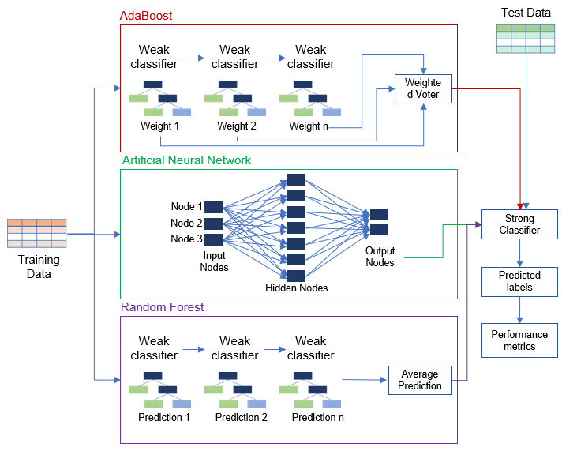
Figure 1: Flow diagram of the machine learning model based on RF, ANN, and AB classifiers
The database is divided into training and evaluation databases in a ratio of 70:30. The 70% dataset is used to train three classification algorithms, while the 30% dataset is fed into the trained model to test its performance. RF and AB are extensions of the Decision Tree where several trees are ensembled and trained on random data subsets. These trees are called weak classifiers because they iteratively get trained based on their misclassifications. Both RF and AB ensure low correlation among decision trees by generating a random subset of features. However, while in the Random Forest algorithm all the weak learners have the same importance, AdaBoost weights the weak classifiers based on their accuracy and performance (Praveena, 2017). Thus, in the latter case, better-performing classifiers have more influence on the final classification. A strong classifier is obtained by the combination of the weak classifiers. In contrast, ANN is a representation of the human brain's functioning and establishes a non-linear mapping between features and targets. There are input layers, hidden layers, and output layers composed of neurons. These neurons are interconnected based on their significance for the classification task. The advantage of ANN over other algorithms is that it does not impose any constraints on training data. It can learn from the training data and independently predict new outcomes (Shanmugasundar et al., 2021).
  - Results and discussion
The performance of the classifiers has been assessed by three evaluation metrics: accuracy, precision, and recall. Accuracy refers to the fraction of correct predictions. Precision indicates the fraction of true positive predictions, while recall indicates the proportion of positive labels that have been correctly predicted (Tamascelli et al., 2020). True positive (TP) and true negative (TN) indicate the correct predictions of “Potentially suitable” and “Unsuitable” materials, respectively. Likewise, false positive (FP) and false negative (FN) indicate the mislabelled “Unsuitable” and “Potentially suitable” materials, respectively. The evaluation metrics of these three algorithms are reported in Table 2.
Table 2: Accuracy, precision, and recall for Random Forest, AdaBoost, and Artificial Neural Network models
Evaluation metric | Formula | RF | AB | ANN
Accuracy | $$\frac{TP+TN}{TP+TN+FP+FN}$$ | 0.840 | 0.845 | 0.775
Precision | $$\frac{TP}{TP+FP}$$ | 0.842 | 0.844 | 0.773
Recall | $$\frac{TP}{TP+FN}$$ | 0.840 | 0.845 | 0.775

The confusion matrices for the three classification algorithms are represented in Figure 2:
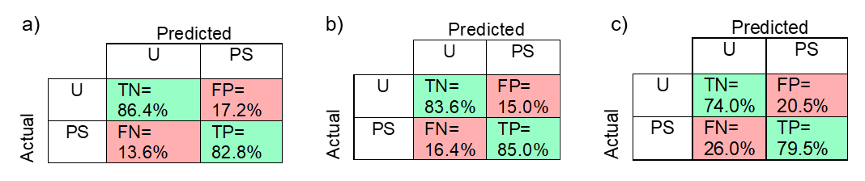
Figure 2: Confusion matrices for a) Random Forest, b) AdaBoost, and c) Artificial Neural Network models
The Random Forest algorithm could correctly classify 84% of the evaluation database, whereas AdaBoost is the most competitive with 84.5% accuracy. On the other hand, Artificial Neural Network could correctly classify only 77.5% of the evaluation datasets. In all cases, the values of accuracy, precision, and recall are similar. It is expectable since the model has been trained and evaluated on a balanced dataset; in other words, the share of “Unsuitable” and “Potentially suitable” labels are comparable. It is worth mentioning that not all the evaluation metrics have the same importance. The incorrect prediction of an “Unsuitable” material, classified as a “Potentially suitable” one, has more implications than vice versa. This misclassification underestimates the hydrogen effect on the metal, thus leading to an improper material selection for pipeline applications and increasing the risk of failure. Hence, FP results should be minimized, and, consequently, precision is the most significant evaluation metric for this specific application. Considering the nature of the dataset, RF and AB have been identified as effective machine-learning techniques, compared to the ANN classifier. Despite the metrics, it is crucial to understand that HE depends on several other factors, such as internal defects, orientation during testing, and material’s anisotropy, which are not quantifiable through features in the database. In addition, a thorough assessment of fracture toughness and fatigue performance is needed for a decisive evaluation of materials based on HE susceptibility. Table 3 ranks the pipeline steels based on the percentage of U labels that have been predicted and indicates the share of these materials in the European pipeline network (Pluvinage, 2021).
Table 3: Ranks of materials based on their susceptibility towards HE
Rank | Material | Share in the European pipeline network | “Unsuitable” predictions | Hydrogen compatibility
1 | X100 | 0% | 89% | Extremely Low
2 | X70 | 9% | 79% | Extremely Low
3 | X52 – Grade B | 25% – 20% | 50% | Low
4 | X80 | 0% | 48% | Medium – Low
5 | X65 | 7% | 25% | Medium – High
6 | X60 | 23% | 22% | Medium – High
7 | 42CrMo4 | 0% | 18% | High
8 | X42 – X120 | 8% – 0% | 0% | Very High

X100 has been identified as the pipeline material most prone to hydrogen-induced ductility loss. In contrast, X42 and X120 are the most suitable low-alloy steels for hydrogen pipelines since none of the tests in the dataset has a U label. However, the ranking is based on a limited number of tests and further developments of the present approach are needed; hence, these findings should not be considered definitive. Even if high-grade steels, such as X100 and X120, have been developed for natural gas transportation in harsh environments, their suitability in hydrogenated environments is not necessarily promising. The most used materials in the existing pipeline infrastructure, i.e., Grade B and X52, exhibit low hydrogen compatibility, depending on the specific operating conditions. This result further establishes the need to thoroughly evaluate the material’s features before drawing a definitive conclusion regarding the identification of the most suitable materials for hydrogen applications. Figure 3 shows the Norwegian cross-border pipeline network, highlighting the hydrogen compatibility of the existing infrastructure (operated by Gassco AS). Information regarding the construction materials is not available for most of these pipelines, since protected by industrial secrecy.

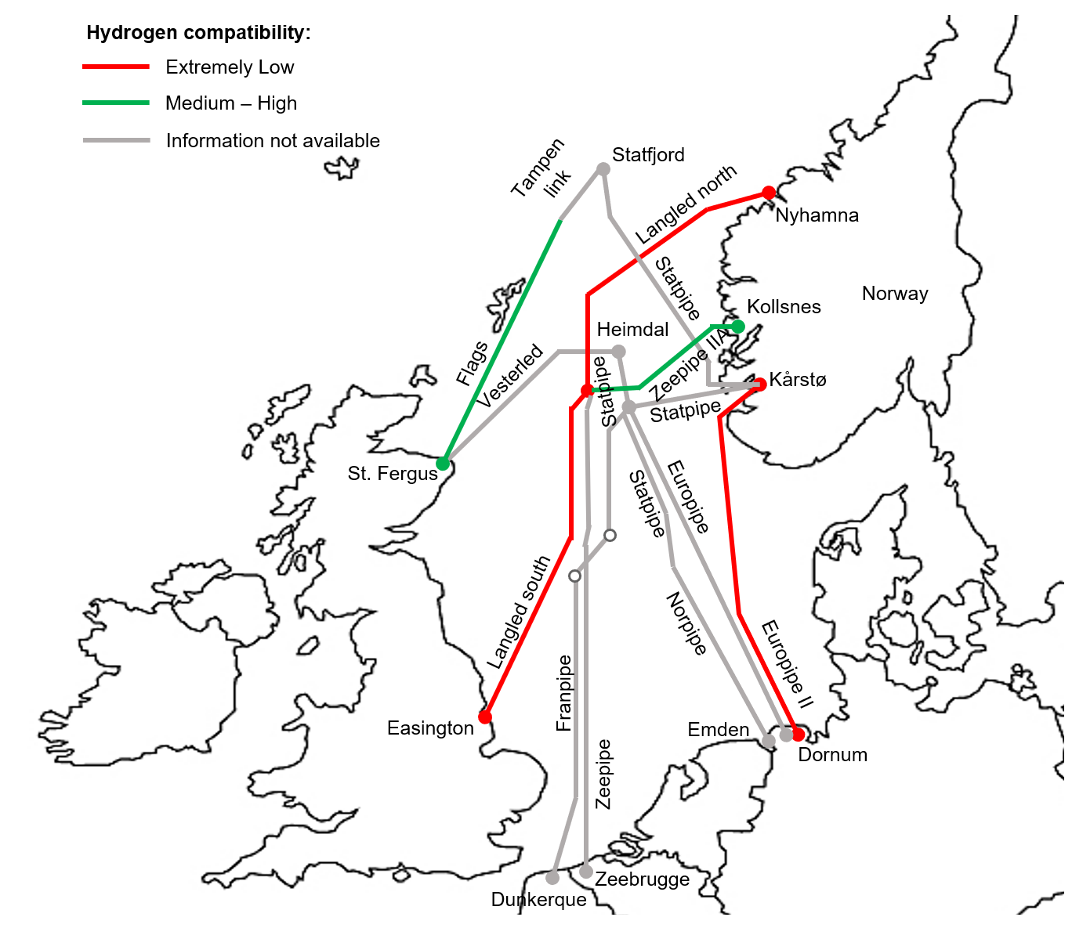
Figure 3: Map of the Norwegian cross-border pipeline network, assessed for hydrogen compatibility
In addition, information regarding the terminals connected, the total pipeline length and the construction material is provided in Table 4. As a result, Zeepipe (connecting Norway to Belgium) is potentially suitable for hydrogen transport. In contrast, both Langled (connecting Norway to England) and Europipe II (connecting Norway to Germany) have been designed for natural gas and cannot be used to transport H₂ gas.
Table 4: Cross-border gas pipelines originating from Norway with publicly disclosed materials
Pipeline | Terminals | Length | Material | H₂ compatibility
Europipe II | Kårstø (NO) – Dornum (GE) | 658 km | X70 | Extremely Low
Langeled North – Langeled South | Nyhamna (NO) – Easington (UK) | 1170 km | X70 | Extremely Low
Statpipe – Tampen Link – Flags | Kårstø – St. Fergus (UK) | 781 km | X65 | Medium-High
Zeepipe II A – Zeepipe | Kollsnes (NO) – Zeebrugge (BE) | 1112 km | X65 | Medium-High

  - Conclusions
Three ML algorithms, namely Random Forest, AdaBoost, and Artificial Neural Network have been employed to evaluate the HE susceptibility of pipeline steels. A database has been created, using the results of in-situ tensile tests conducted in hydrogenated environments. A 70% sub-database was used to train the algorithms, while the remaining 30% was used to test them. The nature of the dataset, the target to predict (i.e., the Embrittlement Index), and the comparative analysis of the algorithms have identified Random Forest and AdaBoost as the most applicable and efficient supervised learning techniques for this specific application. These algorithms were 84% and 84.5% accurate in predicting EI. Pipeline materials have been ranked based on the HE susceptibility. Finally, the cross-border pipelines connecting Norway with the rest of Europe, have been assessed for their hydrogen compatibility. As a result, adapting the natural gas pipeline network for hydrogen transport requires several modifications in the existing architecture and a thorough evaluation of the impact of hydrogenated environments on fracture toughness and fatigue performance.
Acknowledgments
This work was undertaken as a part of the “Safe Hydrogen Fuel Handling and Use for Efficient Implementation 2” (SH₂IFT-2) project, and the authors would like to acknowledge the financial support of the Research Council of Norway (Grant No. 327009).
References
ACER, 2021, Transporting Pure Hydrogen by Repurposing Existing Gas Infrastructure: Overview of existing studies and reflections on the conditions for repurposing.
API, 2018, API 5L Line Pipe, Washington, USA.
ASME, 2019, ASME B31.12 – Hydrogen Piping and Pipelines, New York, USA.
Campari A., Nakhal A.J., Ustolin F., Alvaro A., Ledda A., Agnello P., Moretto P., Patriarca R., Paltrinieri N., 2023a, Lessons Learned from HIAD 2.0: Inspection and Maintenance to Avoid Hydrogen-Induced Material Failures, Comput. Chem. Eng., 173.
Campari A., Ustolin F., Alvaro A., Paltrinieri N., 2023b, A Review on Hydrogen Embrittlement and Risk-based Inspection of Hydrogen Technologies, Int. J. Hydrog. Energy.
EIGA, 2014, Hydrogen Pipeline Systems, Bruxelles, Belgium.
IEA, 2019, The Future of Hydrogen - Seizing today’s opportunities.
NASA, 2016, NASA/TM-2016–218602 – Hydrogen Embrittlement, Huntsville, USA.
Pluvinage G., 2021, Mechanical properties of a wide range of pipe steels under influence of pure hydrogen or hydrogen blended with natural gas, Int. J. Press. Vessels Pip., 190.
Praveena M., 2017, A Literature Review on Supervised Machine Learning Algorithms and Boosting Process, Int. J. Comput. Appl., 169, 32-35.
San Marchi C., Somerday B.P., 2012, Technical Reference for Hydrogen Compatibility of Materials, USA.
Shanmugasundar G., Vanitha M., Čep R., Kumar V., Kalita K., Ramachandran M., 2021, A Comparative Study of Linear, Random Forest and AdaBoost Regressions for Modeling Non-Traditional Machining, Process, 9.
Somerday B.P., San Marchi C., 2007, Effects of Hydrogen Gas on Steel Vessels and Pipelines, USA.
Tamascelli N., Arslan T., Shahd S.L., Paltrinieri N., Cozzani V., 2020, A Machine Learning Approach to Predict Chattering Alarms, Chem. Eng. Trans., 82, 187-192.
Tang Z., Stumpf W., 2008, The effect of microstructure and processing variables on the yield to ultimate tensile strength ratio in a Nb-Ti and a Nb-Ti-Mo line pipe steel, Mater. Sci. Eng. A, 490, 391–402.
Topolski K., Reznicek E.P., Erdener B.C., San Marchi C., Ronevich J.A., Fring L., Simmons K., Guerra Fernandez O.J., Hodge B.M., Chung M., 2022, Hydrogen Blending into Natural Gas Pipeline Infrastructure: Review of the State of Technology, Denver, USA.

