CHEMICAL ENGINEERING TRANSACTIONS  VOL. , 2023 | A publication of
The Italian Association
of Chemical Engineering
Online at www.cetjournal.it

Guest Editors: David Bogle, Flavio Manenti, Piero Salatino
Copyright © 2023, AIDIC Servizi S.r.l.
ISBN 979-12-81206-04-5; ISSN 2283-9216

A Project to Context Decarbonization Analysis (PCDA) to select the best energy transition solution fit for funding
Maria Valeria Erminiª*, Valeria Bernardiniª, Marco Vernaª, Luca G. Campanaª, Arzu Abdullaeva^{b} , Luigi Fiorentino^{b}, Gianluca Florio^{b}
ª GENESIS Italy Viale Castello della Magliana 68 00148 Roma ITALY
^{b} TECHNIP ENERGIES ITALY – BAKU Office Uzeyir Hajibayov Street 62, Baku, Azerbaijan AZ1095 mariavaleria.ermini@technipenergies.com

An Energy Transition (ET) solutions screening has been performed in a near-Europe (EU) geography (Central Asia) to assess the sustainability of investment opportunities on green technologies in line with Environmental, Social and Governance (ESG) criteria, EU climate ambition, market trends and Technology Readiness Level (TRL). Several configurations, namely a technological solution contextualized in its Life Cycle Assessment (LCA) perspective by the overall value chain, have been studied, analysed and compared through a Carbon Energy Environmental and Cost Model (CEE&C) in a Project to Context Decarbonization Analysis (PCDA). The outcome of this study allowed to select the best set of ET Solution fit for the Central Asia context and attractive for climate funding framework.

7 typical ET technologies with 3 to 6 different decarbonization scenarios for a total of 40+ configurations have been considered, ranked and tested against strategic stakeholders’ engagement criteria (industrial partner, state investments, feedstock provider, off-taker, financing institutions) and economic and financial criteria (project authorizations, feedstock guarantee, fiscal incentives, etc.). Key Performance Indicators (KPIs) considered for the ranking of configuration are Product Carbon Footprint (CTG), Greenhouse Gas (GHG) avoidance, Levelized Cost of Carbon (LCOC) by project Capital Expenditures (CAPEX) and LCOC by cost efficiency.

Our proposed paper intends to show how the results of the CEE&C model with the LCOC in a PCDA study can support stakeholders and investors to implement their geographical decarbonization ambition and strategy.
  - Introduction
Climate Change is driving the ET and it’s posing risks and opportunities for European and non-European businesses and companies, of either small, medium, or large size, that have to adapt quickly to the market evolution.
The global industry interest is raising for the following key challenges (Figure 1):
- Physical climate risks as key element of asset management and new investments.
- More and more challenging product carbon intensity benchmark.
- Energy market shift towards carbon free energy, availability, and costs.
- Carbon Border Adjustment Mechanism (CBAM) impact on the raw material and business services.
- Climate finance trends, risks and opportunities and funding access for ET solutions.

Figure 1: Actions Flow Diagram
Current indicators and key performance metrics are not suitable to forecast the mid or long term, to allow companies the adjustment of their business trajectories. A new way to integrate technical economical and carbon information is needed to adapt to the climate change challenge and take the great opportunity of the ET.

A country ET Screening opportunity has been rolled out by the Authors to:
- Identify possible green projects to be studied in line with a Company’s technology strategy and market trends.
- Align with strategic stakeholders to engage in the project structure (industrial partner, state investments, feedstock provider, off-taker, financing institutions).
- Define key element to secure economic success (project authorizations, feedstock guarantee, fiscal incentives, etc.).
    - Methodology
In this study, the shortlisted configurations have been studied, analyzed and compared through a CEE&C Model in a PCDA. Modelling Economic and Financial (MEF) tool has been used to develop differential economic analysis for all the analyzed configurations. The calculated CAPEX and Operational Expenditure (OPEX) values have been incorporated with a sound basis of detail to the CEE&C model and verified against the EU Innovation Fund (IF) Levelized Cost of Product (LCOP) model.

The shortlisted options were preliminarily assessed basing on an energy and climate screening criteria designed to identify the primary energy factors and GHG contributors via key energy and CO₂ equivalent (CO_{2eq}) emission indicators by Scope (absolute and intensity KPIs).

Energy impact criteria is assessed by considering:
- Energy and fuel streams by type and origin.
- Energy (heat, steam, electric energy) and fuel consumption and emissions.

Climate impact criteria is consequently assessed on the above data through a high level GHG analysis methodology based on the International GHG Protocol through the following steps:
- Definition of GHG boundary and appropriate geographical Emission Factors (EF).
- Development of a comprehensive GHG analysis including Scope 1 direct GHG emissions and Scope 2 indirect GHG emissions.
    - Simplified Carbon Energy Environment & Cost Abatement Model- CEE&C Description
The CEE&C Model is a LCA environmental, energy and climate footprint model with associated costs model that can sustain a decarbonization and ET strategy. Through the CEE&C model, it is possible to identify the primary contributors to the project GHG impact and to valorise an optimal ET solution in a carbon footprint reduction strategy.

The CEE&C model provides a quick assessment of the ET technology into different systems (fossil fuel scenarios) and compare different sustainability solutions. The model is aligned to the GHG Protocol and best international standards (EU Emission Trading System (ETS); EU Taxonomy; UK Department for Environment, Food and Rural Affairs; United States Environmental Protection Agency; Intergovernmental Panel on Climate Change). It includes the feasibility data (basic design) into a preliminary climate energy environmental and cost screening criteria designed to identify the primary contributors and consolidate results in a performance reduction strategy.

The model allows to map the CAPEX/OPEX, as well as the carbon footprint and LCOC abatement for different project scenarios, in the context of emissions reduction through displacement, efficiency, or CO₂ removal. LCOC measures how much CO_{2e} can be reduced by a specific investment or policy, considering relevant factors related to geography and specific asset. The LCOC calculation model provides total investment costs per ton of emissions reduced.

The model considers two different LCA boundaries in a wider project to context decarbonization assessment:
- Unit boundary (such as technology).
- System boundary for the decarbonization (such as ET integration in an existing industrial area and fossil fuel substitution).
For more details, refer to Figure 2 as an example of case study for green hydrogen.
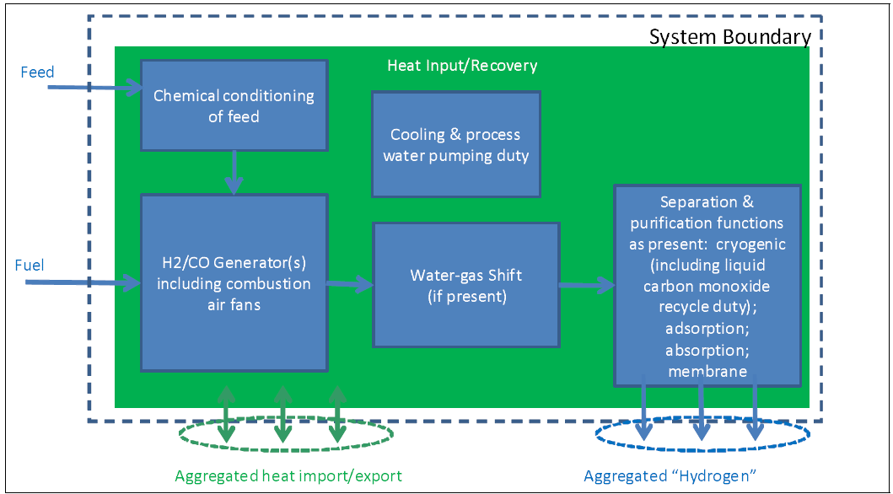
Figure 2: system boundaries of the hydrogen product benchmark from guidance document n°9 on the harmonized free allocation methodology for the EU-ETS post 2012 (European Commission, 2011)

The results of the model can be integrated in the carbon abatement cost analysis in support of the client’s decarbonization strategy, providing insights into the highest value for carbon reduction, the ranking of costs and benefits for decarbonization options and the potential shortfalls in policy or portfolio goals.
The output of the model is a set of KPIs including key environmental, energy and carbon indicators by absolute avoidance, intensity, and cradle-to-gate/cradle-to-grave, as well as the LCOC abatement relevant and requested today by institutions and advisors to access to climate finance and funding opportunities.
    - Modelling Economic & Financial (MEF) Tool - Description
Detailed profitability analysis and a differential cash flow analysis are performed for all the analysed configurations. Main profitability indicators like Internal Rate of Return (IRR), Net Present Value (NPV) and Pay-Out Time (POT) are calculated from the differential cash flow projections relevant to each configuration, on the basis of the assumptions detailed in the following points. All the economic bases and assumptions used to develop the differential economic analysis are based on information provided by the client and market study developer.

Economic Bases and Assumptions:
- Project economic life.
- Differential operating rate & stream factor.
- Total investment cost (TIC) estimate.
- Differential total installed cost (CAPEX).
- Differential pre - operating expenses (POE).
- Differential initial working capital.
- Disbursement curves (relevant to the estimated CAPEX and POE).
- Working capital (based on evaluation basis).
- Feedstocks and products price structure.
- Utilities and catalysts and chemicals operating costs.
- Fixed operating costs (such as land lease, personnel, general overheads, maintenance, industrial insurance).
- Taxation.
- Depreciation methodology and residual value.
- Discount rate.
Table 1: Profitability Indexes Definition
Profitability Indicators | Description
Internal Rate of Return (IRR) | It is the discount rate at which the present value of cash inflows equals the present value of cash outflows or, in other words, it is the discounting rate at which the Net Present Value is zero.
Net Present Value (NPV) | It is defined as the algebraic sum of the values obtained by discounting, separately for each year, the difference of all cash outflows and inflows accruing throughout the life of the project at a fixed discounting rate. This difference is discounted to the point to which the implementation of the project is supposed to start.
Pay-Out Time (POT) | It is defined as the period (number of years) necessary to recover all the invested capital based on a free and discounted cash flow, starting from the beginning of the industrial operation.

  - Case Study Description
As part of the dedicated study, 7 ET Technologies with 3 to 6 different decarbonization scenarios (in total 40+ configurations) have been considered, ranked and tested against:
- Return On Investment (ROI) of innovation activities.
- Revenue/profit growth from new low carbon/carbon net products.
- Strategic stakeholders’ engagement criteria (industrial partnership, state investments, feedstock provider, off-taker, financing institutions).
- Economic and financial criteria (project authorizations, feedstock guarantee, fiscal incentives, etc.).
- GHG Avoidance.
- Final Product Carbon Intensity.
- LCOC by project CAPEX.
- LCOC by cost efficiency.

14 Configurations were identified in the first ranking and 7 Configurations shortlisted in the final ranking process for further development. CEE&C has been used to support the ranking of configuration with the main KPIs of CTG, GHG Avoidance, LCOC by project CAPEX and LCOC by cost efficiency.
    - Input data to the CEE&C Model
Input data to the Model as follow:
- Climate impact criteria
- Definition of GHG boundary and EF.
- Development of a comprehensive GHG analysis including Scope 1 direct GHG emissions, Scope 2 indirect GHG emissions and Scope 3 emissions (upstream).
- Climate impact criteria
- Energy and fuel streams by type and origin.
- Energy (heat, steam, electric energy) and fuel consumption and emissions.
- Environmental impact criteria
- Materials (feedstock, raw materials, chemicals…) by type and origin.
- Water streams by type, origin, consumption and emissions data.
- Effluents and waste management data.
- Environmental impact criteria
- Cash flow analysis, based on economic data and assumption.
    - Output to the CEE&C Analysis
The output of the model, as shown in Figure 3, is a LCA environmental energy & climate footprint with associated costs and a levelized cost of carbon indicator (cost efficiency criteria):
- Product carbon footprint vs GHG avoidance.
- LCOC by project CAPEX vs GHG avoidance.
- LCOC by cost efficiency for funding access.

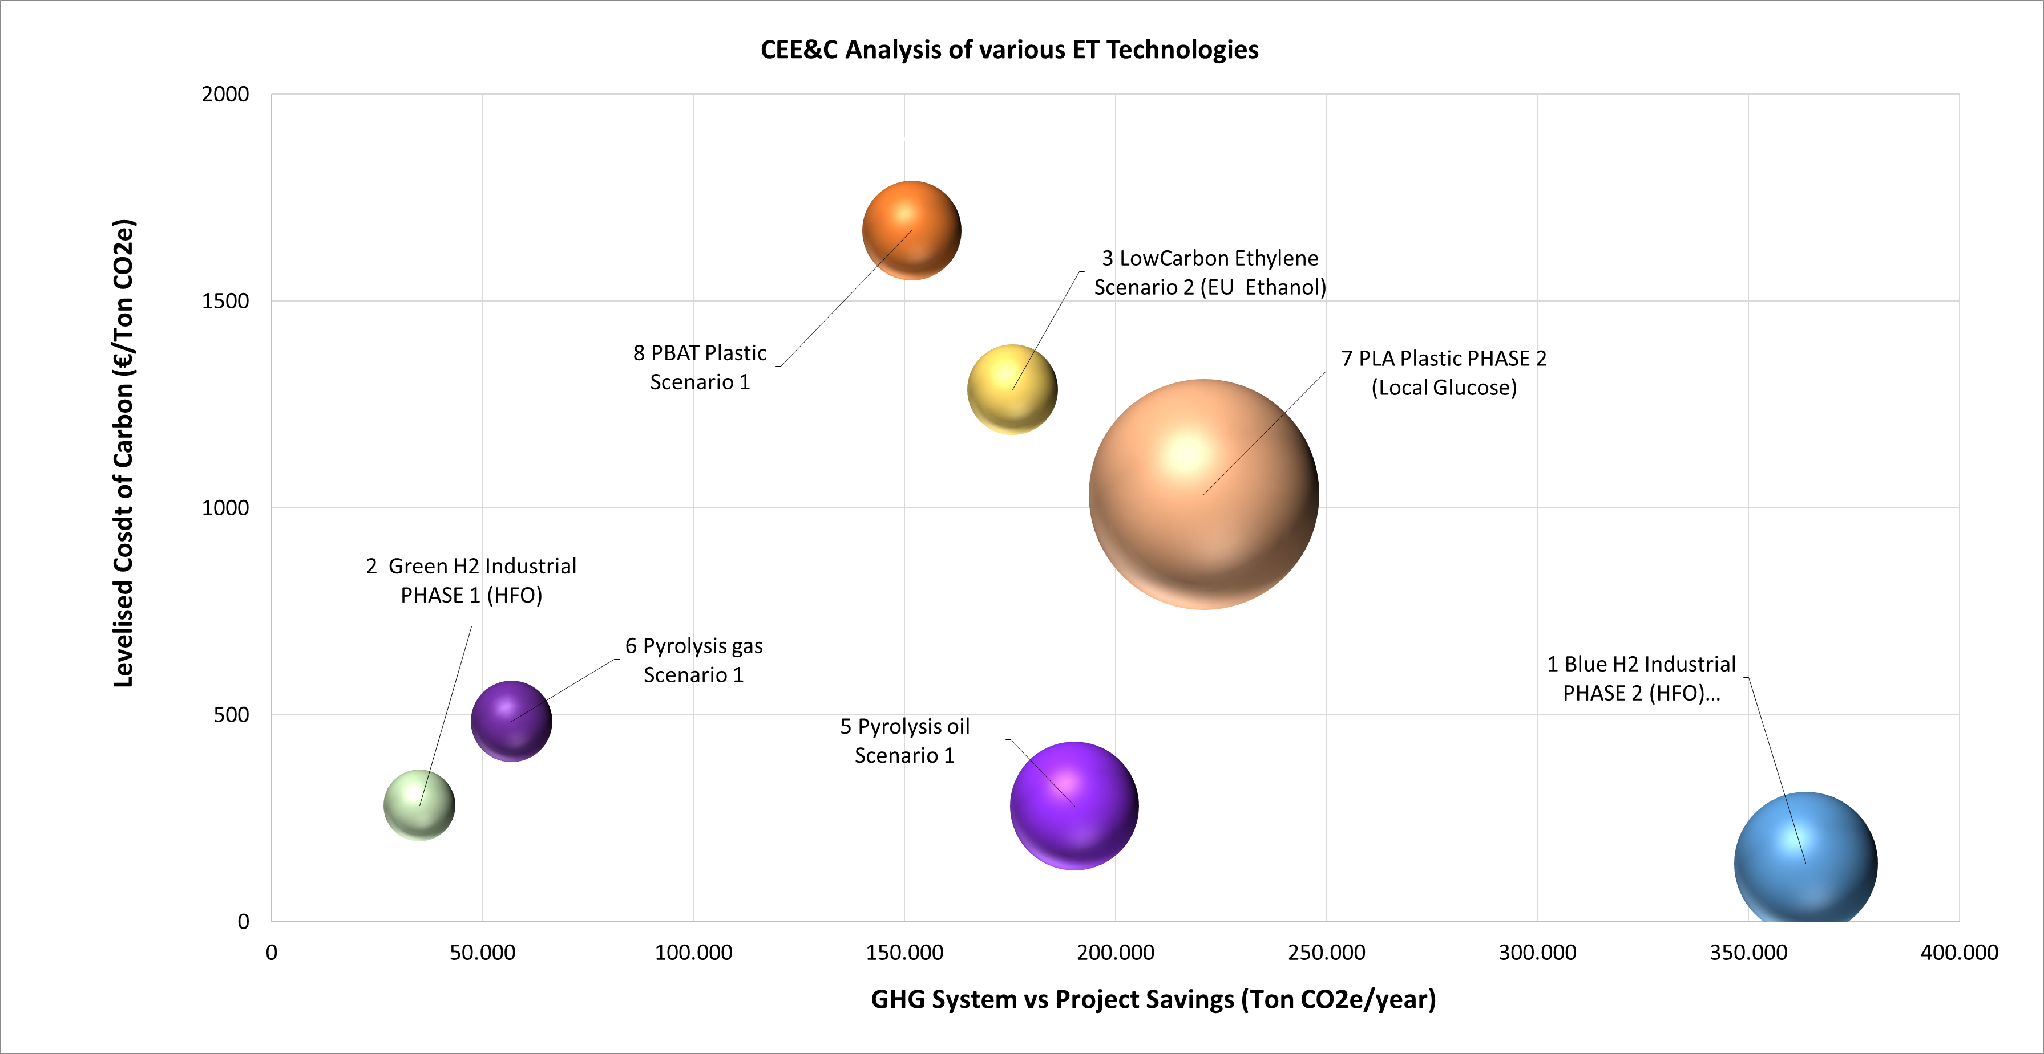
Figure 3: Output of the CEE&C Analysis

The resulting graph allows to plot and rank the best configurations against targeted financial and environmental KPI, which is particularly effective for a screening of climate finance opportunities and selection of optimum carbon footprint reduction strategy.
Output indicators for the study are also valorised in the following KPIs for each of the selected opportunities:
- Best product price.
- Levelized cost of carbon abatement.
- Carbon price.
- GHG savings.

The results of the carbon abatement and cost study can be used to sustain the project or product decarbonization strategy; as driver in the climate finance screening (EU/Non-EU countries) and as an integrated output in the EU climate finance and funding opportunities (such as the IF).
  - Conclusions
The Carbon Energy Environmental and Cost Model has been applied to perform a technological screening in a Project to Context Decarbonization Analysis. The output of the CEE&C and LCOC models has been integrated with other KPIs to identify the possible green projects to be studied in line with the company’s technology strategy and market trend and to align with strategic stakeholders in order to engage them in the project structure (industrial partner, state investments, feedstock provider, off-taker, financing institutions).

The model has also allowed to define key elements to secure economic success (project authorizations, feedstock guarantee, fiscal incentives, etc.) and to select the solution with most attractive economic profitability.

The objective of the CEE&C and LCOC screening is to place, for each market stream, the configuration in terms of product carbon performances, providing a snapshot of the most appealing ET configurations in terms of GHG avoidance over a 20-year timeframe is provided. The model also allows to contextualize the OPEX and carbon pricing impact and to focus on climate finance accessibility.

In conclusion, the CEE&C and LCOC analysis is not only aimed at ranking technologies but ET configurations in the decarbonization context.
For the selected option at the end of the Study the plan is the development of a Front-End Engineering and Design (FEED) and a more accurate Cost Estimate (CE) and to align with the country investors and financing institution. Similar studies with the CEE&C model results (LCOC in a PCDA) can support climate ambitions, stakeholders needs and investors expectation in the geographical Decarbonization ambition and strategy.
Nomenclature
CAPEX – Capital Expenditure LCOC – Levelized Cost of Carbon

CEE&C – Carbon Energy Environmental & Cost Model
CE – Cost Estimate
CTG – Product Carbon Footprint
ET – Energy Transition
FEED – Front End Engineering Design
GHG – Greenhouse Gas
IF – Innovation Fund
IRR – Internal Rate of Return
KPI – Key Performance Indicators
LCA – Life Cycle Assessment
LCOP – Levelized Cost of Product
IRR – Internal Rate of Return
MEF – Modelling Economic & Financial Tool
NPV – Net Present Value
OPEX – Operational Expenditure
PCDA – Project to Context Decarbonization Analysis
POE – Pre-Operating Expenses
POT – Pay-Out Time
ROI – Return on Investment
TIC – Total Investment Cost
Acknowledgments
Valeria Bernardini: Conceptualization, Methodology, Supervision, Software, Validation.
Maria Valeria Ermini: Data curation, Formal analysis, Writing - original draft.
Marco Verna: Conceptualization, Supervision, Software, Validation, Writing – review, Project administration.
Luca G. Campana: Resources, Supervision, Project administration.
Arzu Abdullaeva: Data curation, Writing - review & editing.
The authors would like to thank Helen Coleman, Luigi Fiorentino, Gianluca Florio, Samir Mammedov for the opportunity provided, the constant support and their thorough review of the results.
The authors would also like to acknowledge the significant work and effort undertaken by all the involved Technip Energies technology experts.
References
European Commission, 2009, Best Available Techniques (BAT) Reference Document for Energy Efficiency, European Commission – Joint Research Centre – Institute for Prospective Technological Studies, Luxembourg, <eippcb.jrc.ec.europa.eu/sites/default/files/2021-09/ENE_Adopted_02-2009corrected20210914.pdf>
European Commission, 2015, Best Available Techniques (BAT) Reference Document for the Refining of Mineral Oil and Gas, European Commission – Joint Research Centre – Institute for Prospective Technological Studies, Luxembourg <eippcb.jrc.ec.europa.eu/sites/default/files/2019-11/REF_BREF_2015.pdf>
European Commission, EU Emission Trading System (EU ETS) Revision for phase 4 (2021-2030) <climate.ec.europa.eu/eu-action/eu-emissions-trading-system-eu-ets/revision-phase-4-2021-2030_en>
European Commission, 2022, EU Grants: InnovFund Relevant Cost Methodology: V1.0 <ec.europa.eu/info/funding-tenders/opportunities/docs/2021-2027/innovfund/guidance/relevant-cost-methodology_innovfund_v1.0_en.pdf>
European Commission, 2011, Guidance Document n°9 on the harmonized free allocation methodology for the EU-ETS post 2012. Sector-specific guidance
European Commission, The Green Deal Industrial Plan <commission.europa.eu/strategy-and-policy/priorities-2019-2024/european-green-deal/green-deal-industrial-plan_en>
IEA, 2022, Global Energy and Climate Model, Paris <www.iea.org/reports/global-energy-and-climate-model>
IEA, 2022, Renewable Energy Market Update Outlook for 2022 and 2023 <iea.blob.core.windows.net/assets/d6a7300d-7919-4136-b73a-3541c33f8bd7/RenewableEnergyMarketUpdate2022.pdf>
IRENA, 2018, Hydrogen from renewable power: Technology outlook for the energy transition, International Renewable Energy Agency, Abu Dhabi <www.irena.org/-/media/Files/IRENA/Agency/Publication/2018/Sep/IRENA_Hydrogen_from_renewable_power_2018.pdf?rev=817ffa3e16dd4aebb89098bdf69be6a8
Technip Energies, 2023, Technip Energies Technology Handbook <edition.pagesuite.com/html5/reader/production/default.aspx?pubname=&pubid=9f345b4c-683a-40dc-b3b4-dbb8fce57a5b>

