CHEMICAL ENGINEERING TRANSACTIONS  VOL. , 2023 | A publication of
The Italian Association
of Chemical Engineering
Online at www.cetjournal.it

Guest Editors: David Bogle, Flavio Manenti, Piero Salatino
Copyright © 2023, AIDIC Servizi S.r.l.
ISBN 979-12-81206-04-5; ISSN 2283-9216

New synergy concept of CO₂ and green hydrogen geological storage in the Baltic offshore structure
Kazbulat Shogenov ^{a,b}*, Alla Shogenova ^{a,b}
ªTallinn University of Technology, Department of Geology, Ehitajate tee 5, 19086 Tallinn, Estonia
^{b}SHOGenergy,www.shogenergy.eu
*corresponding kazbulat.shogenov@taltech.ee
New techno-economic and techno-ecological concept of a synergy of CO₂ geological storage (CGS), CO₂ use, hydrogen (H₂) production from different eco-friendly renewable energy recovery technologies and underground H₂ storage (UHS) in Cambrian Deimena Formation sandstones in different compartments of the E6 structure offshore Latvia is presented for the first time. The Baltic offshore scenario is ambitious and innovative, proposed new technologies, synergy with renewable energy (geothermal, solar, wind and sea current), large storage capacity, including CO₂ storage and use captured by a CCUS clusters of emission sources from energy production, cement industry and bio-emissions from Estonia, Latvia and Lithuania. The concept aimed to decrease the artificial impact of climate change by avoiding CO₂ emissions to the atmosphere and implementing circular economy principles. It will increase public and policymakers’ acceptance of new underground CO₂ and energy storage technologies. The proposed synergy solution for CGS and energy storage projects will make such a business economically feasible and attractive for investors. Our study demonstrates a new era, the next generation of cost-competitive, self-supporting conceptual techno-ecological examples of a possible synergy of storage concepts with renewable energies combined using circular economy approaches.
  - Introduction
The human civilization of the 21st century today faces serious challenges: wars, environmental, energy and economic crises. The demand for energy and our planet Earth’s sources (fossil fuels, metals and minerals) today is the highest in the known history of mankind (Zhang et al., 2022). Only in the last decade, a global community has begun to refocus its priorities on renewable and carbon-neutral technologies for energy production, circular economy for resource use and climate change control concepts. Carbon-neutral technologies are supported by the European Commission's circular economy action plan (CEAP), the main building block of the European Green Deal, Europe’s new agenda for sustainable growth (EC, 2020). There is no doubt that the dependence of 21st-century society on combustible fuel is so intense and renewable energy efficiency is so insignificant according to civilization's needs, that it is critical importance to find a key concept to win this fight against global crises. The aim of this study is to find and propose the key concept which will support a transition from fossil fuels emitting CO₂ to the next generation of energy production. The concept must be techno-ecological, eco-friendly, self-supporting, cost-competitive, economically feasible and even beneficial and, very desirable, circular economic. We presented here such a concept - the synergy of CO₂ and energy storage with renewable energy production combined using circular economy approaches.
  - Review of technologies
In this paragraph, all proposed technologies applied to the synergy concept are briefly reviewed with possible benefits, challenges, and uncertainties (Table 1).
    - CO₂ Capture, Use and Geological Storage (CCUS) + bio-CCS (BECCS)
CCUS technology is one of the most effective measures to fight and slow down global climate change during the transitional period from fossil fuels to future energy concepts. CCUS is one of the key technology areas able to put energy systems in the world in a sustainable way to meet international climate goals and reach net zero carbon targets (Table 1). CCUS contributes nearly 20 % (including BECCS) of the cumulative reduction in CO₂ emissions worldwide considering current national energy- and climate-related policy commitments (IRENA, 2022).
Combining bioenergy production with CCUS can lead to net negative emissions as carbon stored by photosynthesizing biomass growth is captured rather than released into the atmosphere (BECCS). BECCS is considered a key CO₂ removal approach to keep global atmospheric CO₂ concentrations below 500 ppm and avoid climate change (IEA, 2020). Today, CCUS is a high-priority area supported worldwide. However, there are a number of challenges that exist to date (Table 1).
    - Geothermal energy recovery during CGS – CO₂ Plume Geothermal (CPG)
Geothermal energy is a renewable energy resource that we can receive from the underground without the production of harmful polluting gases. It is not intermittent like solar and wind power, which means it can be used permanently at any time of the day and year (Table 1). This is a perpetual stable energy source, reliable and allows its use as a baseload power provider to the electrical grid. There are two principal types of geothermal energy: (1) the traditional hydrothermal, which mines heat using the in-situ geothermal waters and (2) Enhanced Geothermal Systems (EGS) – petrothermal, where alternative methods are used to mine the heat. To develop electricity from hydrothermal resources, wells are drilled into a geothermal reservoir, which can be defined as any underground aquifer, which can be used for the purpose of heat production. The wells bring the geothermal water to the surface, where its heat energy is converted into electricity at a geothermal power plant (IEAGHG, 2010).
The use of supercritical CO₂ as a working fluid in geothermal systems was first proposed for EGS (CO₂-EGS) in low-permeability, hot crystalline basement rocks. Research conducted at Los Alamos National Laboratories and Lawrence Berkeley National Laboratories examined the use of supercritical CO₂, instead of water, as the geothermal working fluid, with favorable results. CO₂ has many surpluses for EGS (Table 1): minimized parasitic losses from pumping and cooling; carbon sequestration; supercritical CO₂ has high mobility and high thermal expansibility compared to water, resulting in the formation of a strong thermosiphon, which eliminates the need for parasitic pumping power requirements; CO₂ can dissolve fewer minerals than water, which greatly reduces corrosion of systems. The thermosiphon effect increases the electric power production efficiency of the geothermal system compared to water-based geothermal systems. These power systems can be modularized, built off-site at low cost, and moved as needed. Lower temperatures and fewer permeable formations than are viable with water can be used, increasing areas where geothermal energy can be produced. The new approach is distinguished from CO₂-based EGS and referred to it as a CPG system, which has a significantly larger CO₂ sequestration potential than that of EGS (Randolph & Saar, 2011). CPG involves injecting supercritical CO₂ into deep, naturally porous, permeable geologic reservoirs overlain by low-permeability caprock formations often prevalent worldwide. There, the CO₂ displaces native formation fluid (brine or hydrocarbons), as in standard CGS or EOR, and is heated by the natural in-situ heat and geothermal heat flux. A portion of the heated CO₂ is piped back to the surface and sent through an expansion device, powering an electrical generator, or a heat exchanger to provide heat for direct use and/or binary power systems. The CO₂ is then re-injected into the reservoir (Table 1).
    - Solar, wind and sea currents energy recovery
During the last two decades, the installed global capacity of offshore wind energy increased from 67 megawatts (MW) in 2000 to almost 23 gigawatts (GW) in 2018, planning to rise to 228 GW in 2018 and nearly 1000 GW in 2030 (IRENA, 2019). The part of renewable energy must rise from around 18 % of total final energy consumption (in 2015) to around two-thirds by 2050. A variety of floating designs have been developed to overcome the depth constraint and to take full advantage of wind resources. The three main concepts for floating foundations are spar-buoy, semi-submersible and tension leg platform.
- When applied to solar energy technologies, the outcome of techno-ecological synergy produces both technocentric products as well as support for sustainable flows of ecosystem goods and services (CCUS, water-use efficiency and habitat for species) that may mitigate global environmental change. Such hybrid renewable energy systems are particularly attractive if they are located in remote places where grid extension and fuel are costly—improving grid reliability (a technological synergistic outcome) while reducing total life-cycle costs. It was found in a total of 16 solar energy techno-ecological synergies (win¹⁶) and 20 techno–ecological synergistic outcomes (win²⁰). The scale of ecological outcomes extends from local to global scales (Shogenov & Shogenova, 2021). As with wind, solar energy is still an intermittent and unstable source.
- Opportunities of ocean currents energy sources are now in the trend of research and pretend to become the third largest source of renewable energy on the planet in the list of the main renewables after solar and wind options. The benefit of this option is that water flows in oceans and seas have a permanent direction and are more stable than wind and solar energy. The speed of water flows may vary by five. It means that a big turbine should be used with a slow-moving, but high-torque generator. Two-staged turbine concept could be constructed from concrete. One 50-meter Equinox Ocean Current Turbine is going to produce up to 3 MW. This kind of equipment is competitive in aspects of energy production versus cost. More benefits and challenges of these renewable technologies could be found in Table 1.
Table 1: Benefits, barriers and possible annual revenues of technologies implemented in the synergy concept (IRENA, 2022; IPCC, 2022; Offshore Energy, 2022; Zivar et al., 2021; Krevor et al., 2023; Phadke 2021)
Technology | Benefits | Challenges | Cost per unit by 2030
CCUS (+BECCS) | Able to reduce industrial emissions directly and remove CO₂ that cannot be avoided. | High technology costs; low public acceptance; weak legal framework; need for complex research in each case. | 100−200 €/t CO₂  (in EU ETS)- revenues for not emitted and negative emissions.
CPG  (CO₂ Plume Geothermal) | Not intermittent; with time all the injected CO₂ is stored underground; increased electric power production; minimized water use; increases prospects in dry and lower temperature areas; power systems are very compact, reducing costs. | CO₂ is more expensive and more difficult to work with than water. | 3.3 €/kWh  (Estimated by TeraCOH, 2018)
Solar energy | The cost of technology is falling down every year. | Volatility or intermittent. | 20−80 €/MWh
Wind energy | The price of electricity generated by offshore wind is going down every year and will be as onshore by 2030. Multiple turbines could be mounted on a single floating foundation. | Volatility or intermittent. | 30 €/MWh
Sea currents energy | Water flows have a permanent direction,  more constant and predictable; more stable than wind and solar energy; turbines can be installed by small, relatively simple vessels under the water. | Waves’ speed may vary from 4−9 km/h (2−5 knots  in water speed);  Not yet mature technology. | Cost will be compatible  with offshore wind energy  30 €/MWh
H₂ energy | 1 m³ of H₂ produces 12.7 MJ of energy; has 2.5−3 times more energy content than natural gas; H₂ could be produced and stored; seasonal-based energy storage application | A large amount of energy is needed to produce the H₂; high cost for H₂ production. | 1−2 €/kg of H₂ or 30-60 €/MWh
Geo-PB/UHS  (Geological Power Bank/  Underground  Hydrogen Storage) | A huge capacity for energy storage; lower cost; safety due to the absence of contact of H₂ with oxygen. | Risks are similar to CGS; the need to use a cushion gas; H₂ can be dissolved in the aquifer waters; lower density of H₂ compared to CO₂; biochemical, microbial and geochemical reactions of H₂ with minerals; monitoring of H₂ storage is not matured; avoiding or considering water coning, gas fingering and capillary hysteresis phenomenon. | 1 €/kWh
    - Hydrogen (H₂) production
H₂ energy has a large potential. The combustion of 1 m³ of H₂ produces 12.7 MJ of energy. It has 2.5−3 times more energy content than natural gas, making it the fuel with the most energy content per unit mass (Table 1). It could be produced using thermochemical, electrolytic, biological, and solar water-splitting processes (Zivar et al., 2021). A big amount of energy is needed to produce the H₂ for future use, more than the energy produced by the H₂. At first glance, this is not logical to produce energy by spending on another energy source. However, the main idea of H₂ energy is seasonal-based energy storage application, or using excess energy/electricity, which is impossible to save or permanently store now. In periods of the year when the users don’t need all produced energy (such as summer), the H₂ could be produced and stored as a buffer to fulfill high-demand periods of the year (such as winter). Due to the possibility to store the H₂, we call the storage of H₂ - energy storage. There are different options to store the H₂ on the ground facilities (Züttel, 2004). But all these options can store insignificant amounts of H₂ that are not economically feasible. Another prospective option Underground Hydrogen Storage (UHS) is described in the next section.
    - Underground Hydrogen Storage (UHS) or “Geological Power Bank” (Geo-PB)
UHS which we call here Geological Power Bank (Geo-PB), has the potential for a huge capacity for energy storage and lower cost (Table 1). The Geo-PB project's main challenge is finding suitable geological formations with good petrophysical properties, such as aquifer traps, depleted oil or gas reservoirs, salt or hard rocks caverns. The formation must be covered with an impermeable cap rock to provide a gas trap (similar to natural gas or CO₂ storage requirements). The storage site investigation routine, benefits, and risks are very similar to the ones for CGS. However, several specific points are existing. The benefits of UHS: (a) only 1 % per cycle of injected H₂ might be lost during operations, while 0,4 % of injected H₂ of the first cycle can be lost due to the solution into the aquifer waters; (b) the presence of cushion gas improves the efficiency of the storage site; (c) laboratory experiments showed that the permeability of the cap rock decreased after injecting the mixed hydrogen and natural gas stream into the rock samples; (d) the presence of salt in the aquifer waters in the storage site decreases hydrogen solubility in the brine (Shogenov et al., 2022).
  - New Synergy Concept
The recently proposed concept considers, in addition to the utilization of CO₂ captured from fossil fuels combustion the capture of bio-CO₂ to realize the phenomenon of negative emissions and enhance the effect of global climate mitigation.
Considering the geological, regulatory and public acceptance situation in Estonia, Latvia and Lithuania, the best candidate for CGS and UHS in the region is the E6 offshore structure located 37 km from the Latvian coast (port of Liepaja), where it is planned to build an offshore drilling rig. The structure is an anticline fold bounded on three sides by faults and consists of two different compartments divided by an inner fault. The total area of the structure is 600 km². The area of the larger southern part E6-A is 553 km² and was considered for CGS and CPG. Prospective for CGS and CPG in E6-A in the depths of 848−876 m (uppermost interval) Cambrian Wuliuan Stage Deimena Formation consists of oil-bearing quartz sandstones with subordinate claystone layers. The reservoir overlies the shales of the Kybartai Regional Formation and is sealed by large thick Silurian-Ordovician shale cap rock 400–1000 m thick (Figure 1a). The reservoir temperature is 36 ºC. The same Cambrian reservoir in the smaller northern compartment E6-B of 47 km², separated/shifted down by an inner fault from E6-A proposed for Geo-PB (Shogenov et al., 2013; Shogenov et al., 2022).
E6 structure circular economy concept of the closed cycle of processes proposed includes five phases: (1) CO₂ transport by ships to the rig, (2) CO₂ injection for CGS and CPG, (3) H₂ production, (4) UHS, (5) H₂ transport by the same ships to the customers (Figure 1b).
- It is planned to transport captured CO₂ from power and cement plants from Latvia to the port of Liepaja by pipelines and fossil CO₂ and bio-CO₂ from waste-to-energy plants in Lithuania to Klaipeda port by pipelines. Then, CO₂ will be transported by ships to the offshore E6 rig. Fossil and bio-CO₂ from Estonian power plants and factories will be transported by pipelines and ships directly from Estonian ports to the E6 rig (Shogenov & Shogenova, 2021).
- Received liquid CO₂ will be then injected into the Cambrian Wuliuan Stage Deimena Formation in E6-A. Warm CO₂ will be recovered from this storage formation to receive geothermal energy and will be reinjected back into the formation. Part of CO₂ will be stored in the Deimena formation forever, implementing the CGS concept and provoking a continuous demand for newly captured CO₂ for CPG.
- Wind energy turbines (offshore floating plant) and solar energy panels (cover all free space of the rig) are installed nearby and at the rig, respectively. Sea currents underwater turbines will be installed close to the rig under the water.
- Received techno–ecological energy from geothermal, solar, wind and sea currents sources will be collected in the so-called circular system “Power banking” or rigs’ network and will be used to cover the energy needs of the rig (electricity, CO₂ injection, re-injection, etc.) and to produce H₂.
- Most of the produced H₂ that will not be sold directly, will be stored underground at E6-B for later sale, simulating the concept of a “Geological Power Bank”.
- Contracted H₂ volumes will then be transported to the consumers onshore by the same ships which delivered CO₂ to the rig. In the case of using hydrogen-powered ships, these ships will also be refueled with hydrogen.
The storage capacity of CO₂ in the E6-A was estimated in our previous research with different levels of reliability, demonstrating a result average of 365 Mt in an optimistic approach (Shogenov et al., 2013). H₂ storage capacity in E6-B was estimated recently at 119 kt (Shogenov et al., 2022).
Implementation of such a concept will need the development of a new generation of ships, working on hydrogen with technical parameters suitable for both CO₂ and H₂ transport. The rig will be fully operational using green renewable energies and will not use any fossil fuels for its operation.
Some of the possible economic benefits will include:
1) Storage of bio-CO₂ emissions (negative emissions). More than 2 Mt bio-CO₂ produced in Estonia and Lithuania in 2021 with an annual cost of around 200 M€ (100 €/t CO₂). For the projected 2030–2050 CO₂ cost of 200 €/t – around 400 M€ annually.
2) H₂ production and storage: According to IEA (2019) the cost of H₂ produced in China using solar and wind energy is about $ 2–2.3/kgH_{2,} and the lowest cost is reached in combination with solar and wind energy (IEA, 2019), while general cost range is estimated as $ 3–6.55/kgH₂.
The new projects developed now in Norway and Asia are planning to reach 1–2 $/kg (Table 1). Considering that final costs are estimated as 3–7.5 $, one large ship with a capacity of 80–100 kt can cost 160–200 M € at a price of 2 €/kg. Considering CO₂ storage of about 10 Mt of captured per year could be possible for 30 years, 8–10 ships per month could be needed. The total economic benefits should be modelled and could make billions of €/year.
The key concept proposed in this study is the synergy of all available effective technologies in one place, in one project: renewable energy recovery – solar, wind, sea currents and geothermal energy, production and underground storage of energy (hydrogen energy – H₂) and geological storage of CO₂ (CGS), as a part of CCUS. This synergy concept can maximize efficiency, minimize the carbon footprint of the full value chain CCUS process and demonstrates the “win x” situation (where “x” is a number of additional benefits of the project).
We demonstrated an example of the project supporting a win⁸ situation (that is, a win-win scenario with a minimum of eight potential benefits). The concept includes eight innovative elements of techno-ecological synergy: (1) CGS, (2) CPG, (3) solar energy, (4) wind energy, (5) sea currents energy, (6) H₂ production, (7) Geo-PB and (8) ship transport of produced H₂ by ship to onshore consumers. The main point of our concept is that the proposed cycle is closed, demonstrating the principles of circular economy, which will increase the economic benefits and total efficiency of the concept.
We also consider that CO₂ stored in this concept could be captured during energy production from fossil fuels and biomass and waste-to-energy combustion, so-called bio-energy – Bio-CCS or BECCS technology. BECCS can provide a “negative emissions” phenomenon, which greatly increases the efficiency of CCUS.
Implemented in the proposed concept technologies are novel and crucial in fighting global warming and reaching carbon neutrality by 2050. All these technologies together CGS or CCUS (including BECCS), UHS and renewables (geothermal, solar, wind and sea currents energy), can contribute 20 %, 10 % and 25 % respectively, or in total 55 % to the total CO₂ abatement needed by 2050 (IRENA, 2022).
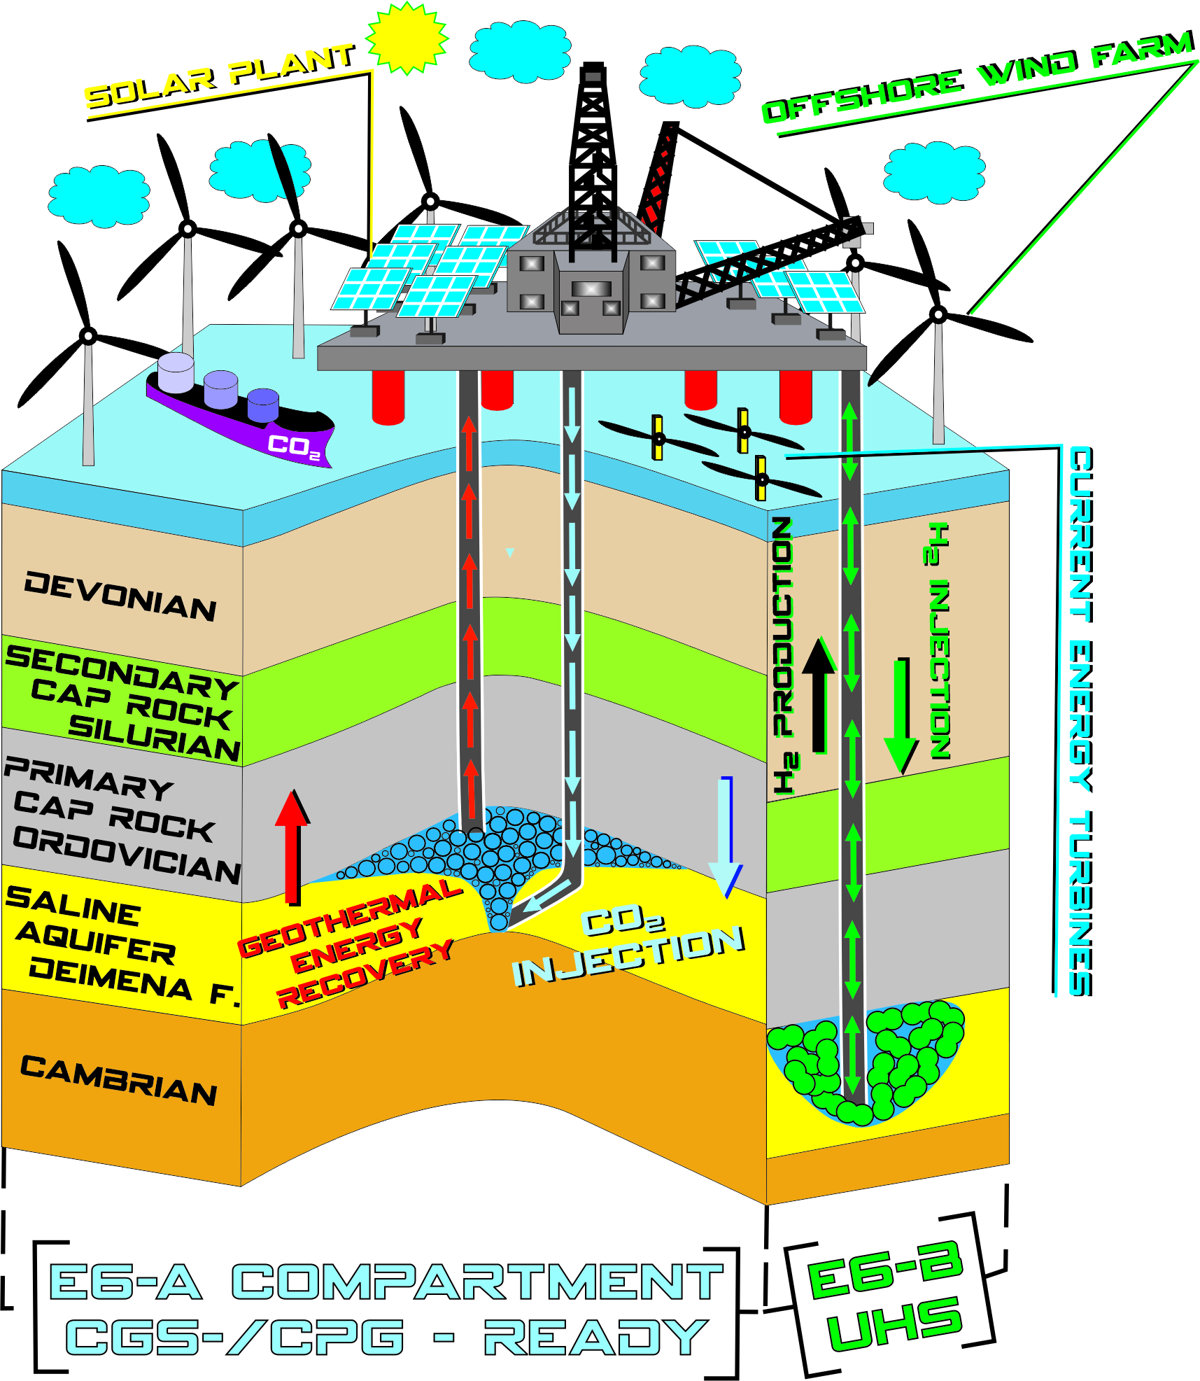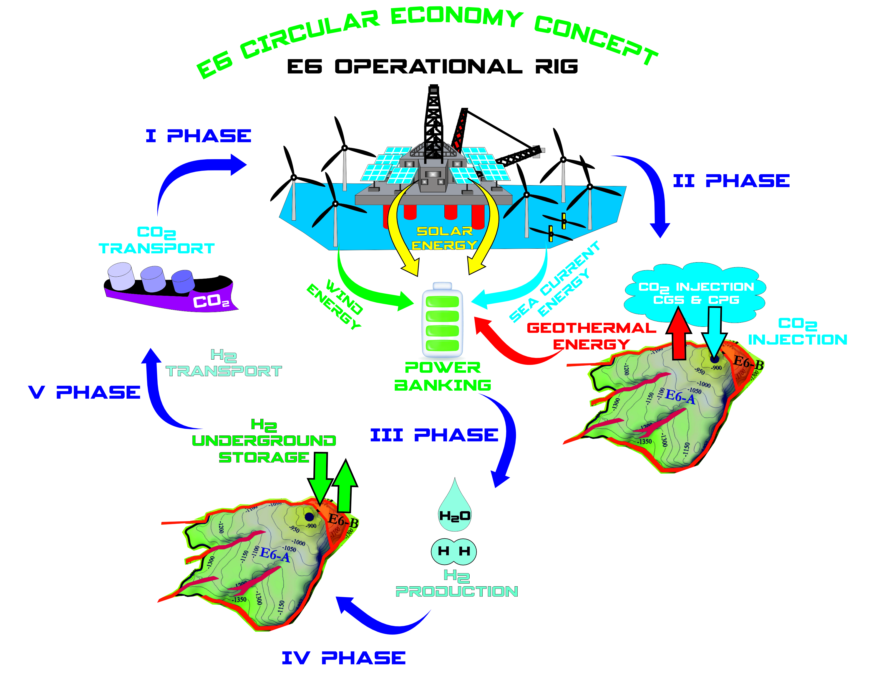
a
b
Figure 1: (a) Demonstrative geological cross-section of the concept; (b) E6 structure energy and CO₂ storage hub circular economy concept workflow of the closed cycle of processes proposed, demonstrating five phases
Conclusions
A five-phase circular economy concept of E6 geological structure energy and CO₂ storage hub was developed in this study. The workflow is techno-ecological, eco-friendly, self-supporting, cost-competitive, and economically feasible. It consists of (1) CO₂ transport by ships to the rig, (2) CO₂ injection for CGS and CPG, (3) H₂ production, (4) Geo-PB, and (5) H₂ transport by the same ships to the customers. The concept is supporting a win⁸ situation - innovative elements of techno-ecological synergy in one site: (1) CGS, (2) CPG, (3) solar energy, (4) wind energy, (5) sea currents energy, (6) H₂ production (7) Geo-PB and (8) H₂ transport to consumers. The proposed cycle is closed, demonstrating the principles of circular economy, which will increase the total efficiency of the concept. CGS and CPG are planned in the E6-A compartment of the E6 geological structure with an average storage capacity of 365 Mt in an optimistic approach and Geo-PB is planned in E6-B with an H₂ storage capacity of 119 kt.
Our study demonstrates the new generation of concepts of optimization of the efficiency of underground energy and CO₂ storage projects. It includes four renewable energy options, and negative-emissions technologies making it self-supporting and circular economic. We believe that this synergy solution will increase the public and policymakers’ acceptance of new CGS and energy storage technologies. As well as will become an example for oil, gas, energy and CCUS players in the market. It will show the attractiveness of this kind of business to investors and will push the development of new technologies, energy transition and mitigation of climate change.
Acknowledgments
This study is supported by the CCUS ZEN project which has received funding from the European Union’s Horizon Europe research and innovation programme under grant agreement No 101075693 and by the COST Action CA21127 – TrANsMIT supported by COST (European Cooperation in Science and Technology).
References
EC, 2020, Circular economy action plan <https://environment.ec.europa.eu/strategy/circular-economy-action-plan_en> accessed 06.04.2023.
IEA, 2019, The Future of Hydrogen, G20, Japan <link> accessed 15.05.2023.
IEA, 2020, CCUS in Clean Energy Transitions, IEA, Paris https://www.iea.org/reports/ccus-in-clean-energy-transitions, License: CC BY 4.0.
IEAGHG, 2010, Geothermal Energy and CO₂ Storage, 2010/TR3, August, 2010.
IPCC, 2022, Climate Change 2022: Impacts, Adaptation and Vulnerability. Contribution of Working Group II to the Sixth Assessment Report of the Intergovernmental Panel on Climate Change [H.-O. Pörtner, D.C. Roberts, M. Tignor, E.S. Poloczanska, K. Mintenbeck, A. Alegría, M. Craig, S. Langsdorf, S. Löschke, V. Möller, A. Okem, B. Rama (eds.)]. Cambridge University Press. Cambridge University Press, Cambridge, UK and New York, NY, USA, 3056 pp., doi:10.1017/9781009325844.
IRENA, 2019, Future of wind: Deployment, investment, technology, grid integration and socio-economic aspects, A Global Energy Transformation paper), International Renewable Energy Agency, Abu Dhabi.
IRENA, 2022, World Energy Transitions Outlook 2022: 1.5 °C Pathway, International Renewable Energy Agency, Abu Dhabi.
Krevor S., de Coninck H., Gasda S.E., et al., 2023, Subsurface carbon dioxide and hydrogen storage for a sustainable energy future, Nature Reviews Earth & Environment 4(2), 102–118. https://doi.org/10.1038/s43017-022-00376-8
Offshore Energy, 2022 <https://www.offshore-energy.biz/ocean-current-energy-is-the-third-source> accessed 10.05.2023.
Phadke S., 2021, Underground hydrogen storage: The 1 $/kWh Grid Scale Energy Storage Technology, LinkedIn, accessed 16.05.2023.
Randolph J., Saar M., 2011, Coupling carbon dioxide sequestration with geothermal energy capture in naturally permeable, porous geologic formations: Implications for CO₂ sequestration, Energy Procedia. 4. 2206−2213. 10.1016/j.egypro.2011.02.108.
Shogenov K., Shogenova A., 2021, Innovative synergy CCUS and renewable energy project offshore Baltic using CO₂ emissions from the cement industry, Available at SSRN: <https://ssrn.com/abstract=3812387> or <http://dx.doi.org/10.2139/ssrn.3812387>.
Shogenov K., Shogenova A., Vizika-Kavvadias O., 2013, Potential structures for CO₂ geological storage in the Baltic Sea: case study offshore Latvia, Bulletin of the Geological Society of Finland, 85(1), ISSN: 0367-5211, 65–81.
Shogenov K., Shogenova, A., Šliaupa S., 2022, Underground Hydrogen Storage in the Baltic Countries: Future Outlook for Latvia and Estonia, 83rd EAGE Annual Conference & Exhibition: 83rd EAGE Annual Conference & Exhibition, Madrid, 6-9 June 2022. European Association of Geoscientists & Engineers, 1−5, DOI: 10.3997/2214-4609.202210772
TeraCOH, 2018, <http://www.terracoh-age.com> accessed 06.2020.
Zhang, A., Yang, J., Luo, Y., Fan, S., 2022. 2060: Civilization, Energy, and Progression of Mankind on the Kardashev Scale. 10.21203/rs.3.rs-2114282/v1.
Zivar, D., Kumar, D., Foroozesh, J., 2021, Underground hydrogen storage: A comprehensive review, International Journal of Hydrogen Energy, 46(45), 23436−23462.
Züttel A., 2004, Hydrogen storage methods, Naturwissenschaften, 91(4), 157−172.

