CHEMICAL ENGINEERING TRANSACTIONS  VOL. , 2023 | A publication of
The Italian Association
of Chemical Engineering
Online at www.cetjournal.it

Guest Editors: David Bogle, Flavio Manenti, Piero Salatino
Copyright © 2023, AIDIC Servizi S.r.l.
ISBN 979-12-81206-04-5; ISSN 2283-9216

Risk assessment for hydrogen fuelling stations: Public perception versus reality
Ning Huan^{a,}*, Toshiyuki Yamamotoª, Hitomi Sato^{b}, Dimitrios Tzioutzios^{c}, Roser Sala^{d}, Lila Goncalves^{d}, Wojciech Kosman^{e}, Katarzyna Stolecka-Antczak^{e}
ªInstitute of Materials and Systems for Sustainability, Nagoya University, Nagoya 464-8603, Japan
^{b}Institutes of Innovation for Future Society, Nagoya University, Nagoya 464-8603, Japan
^{c}Department of Mechanical and Industrial Engineering, Norwegian University of Science and Technology (NTNU), Trondheim 7034, Norway
^{d}Socio-Technical Research Centre, Centro de Investigaciones Energéticas, Medioambientales y Tecnológicas (CIEMAT), Universitat Autònoma de Barcelona, Barcelona 08193, Spain
^{e}Silesian University of Technology, Akademicka 2a, Gliwice 44-100, Poland
huan.n@outlook.com
Deploying hydrogen fuelling facilities plays a critical role in providing easy access to refuelling services for hydrogen fuel cell products. This study aims to uncover how people from different countries perceive accident risk from hydrogen fuelling stations (HFSs) and discern the gap between general cognition and reality. A cross-country investigation was simultaneously implemented in Japan, Spain, and Norway in December 2022 to observe the public’s risk attitude towards technical procedures of HFS operations, i.e., hydrogen production, transportation, storage, and dispensing. A total of 2,500 participants from the three countries completed the web-based questionnaires, evaluating their level of perceived risk towards HFSs in terms of risk probability and consequence. The investigation results demonstrated differentiated risk perception towards HFSs across countries, stimulating a reflection on the essential elements of societal risk perception. Moreover, this study emphasises the gap between cognitive and actual risk by employing event tree analysis of standard HFS equipment. The empirical frequencies of failure, e.g., the rupture and leakage occurring at the compressors, trailers, vessels, dispensers, and pipes, are summarised as a baseline. The comparative results indicate that the public tends to overestimate the risks of hydrogen transportation and underestimate the risks of production, identifying perceptual inaccuracies and suggesting directions for future hydrogen knowledge dissemination from a practical point of view.
  - Introduction
With growing concern on promoting the sustainable energy transition towards a low-carbon economy worldwide, hydrogen has been widely recognised as a promising multi-functional renewable energy carrier for achieving industrial decarbonisation targets. Green hydrogen is produced sustainably, utilising renewable energy and resources, such as water electrolysis. Hydrogen fuel cells can convert its chemical energy back into electricity and have been widely applied in various sectors, including transportation, power generation, and heating (İnci, 2022), due to their high efficiency, zero carbon emissions, and versatility (Ajanovic and Haas, 2021).
Hydrogen fuelling stations (HFSs) are essential infrastructure for hydrogen fuel cell applications, serving as physical facilities that provide equipment and locations for hydrogen refuelling (Alazemi and Andrews, 2015). As of 2019, there were 375 HFSs in operation worldwide, compared to 320 in 2017. The majority of these stations are accessible to the public. As reported by Apostolou and Xydis (2019), by the end of 2018, Europe had the highest number of HFSs, totalling 170, followed by Asia with 130, with most of them located in Japan. The Americas ranked third with over 70 stations, primarily concentrated in the USA.
As the construction of HFSs accelerates worldwide, their safety concerns have started to attract increasing attention. Vereš et al. (2022) suggested that the potential hazard sources at the HFS include on-site production units, e.g., electrolysers, compressors, dispensers, pipes, and delivery systems. Nonetheless, most of the existing studies have been devoted to analysing and controlling the actual risk with emphasis on improving hydrogen safety, and limited attention has been paid to risk perception towards HFSs. As users of hydrogen fuelling services, the public’s awareness and perception of this emerging technology are essential considerations in the planning and deploying HFSs. Public support is a significant social force in integrating HFSs into local communities. Therefore, in recent years, many scholars have begun investigating the public’s evaluation of HFSs, e.g., in terms of public acceptance (Ono and Tsunemi, 2017), and the intention to act towards local hydrogen facilities (Huijts et al., 2013).
In this study, we adopt a cross-national research perspective to investigate public perception of risk associated with HFSs, which is also deemed as a major source of negative emotions towards HFS installation. The findings serve as a foundation for understanding the perceived risk and the gap with reality, as well as a key behavioural basis for enhancing public acceptance towards hydrogen applications.
  - Investigation of public risk perception
This section introduces the cross-country survey conducted to collect the public risk perception towards HFSs, and the statistical results of the survey.
    - Survey design and implementation
Regarding the categories of HFSs, on-site and off-site HFSs are widely regarded as two representative forms of hydrogen stations. The main difference is whether they are equipped with electrolytic production equipment for hydrogen. Considering the limited public awareness of HFSs, this survey began by introducing the two categories above and their main differences to participants, followed by an overview of the four operational processes of hydrogen stations: hydrogen production, transportation, storage, and dispensing, as in Figure 1.
The literature includes research on measuring the public’s perceived risk towards HFSs. For example, in the study conducted by Huijts et al. (2015), perceived risk was considered as a holistic evaluation. This study intends to further reveal the connotations of risk from different perspectives. Thus, based on the background information provided, we guided respondents to answer their risk assessment of each process. Specifically, this survey described risks as accidents that may cause physical injury and property damage to nearby residents. Following the risk dimensions suggested by Wilson et al. (2019), perceived risk in this study is measured in terms of probability and consequence using five-level Likert scale questions.
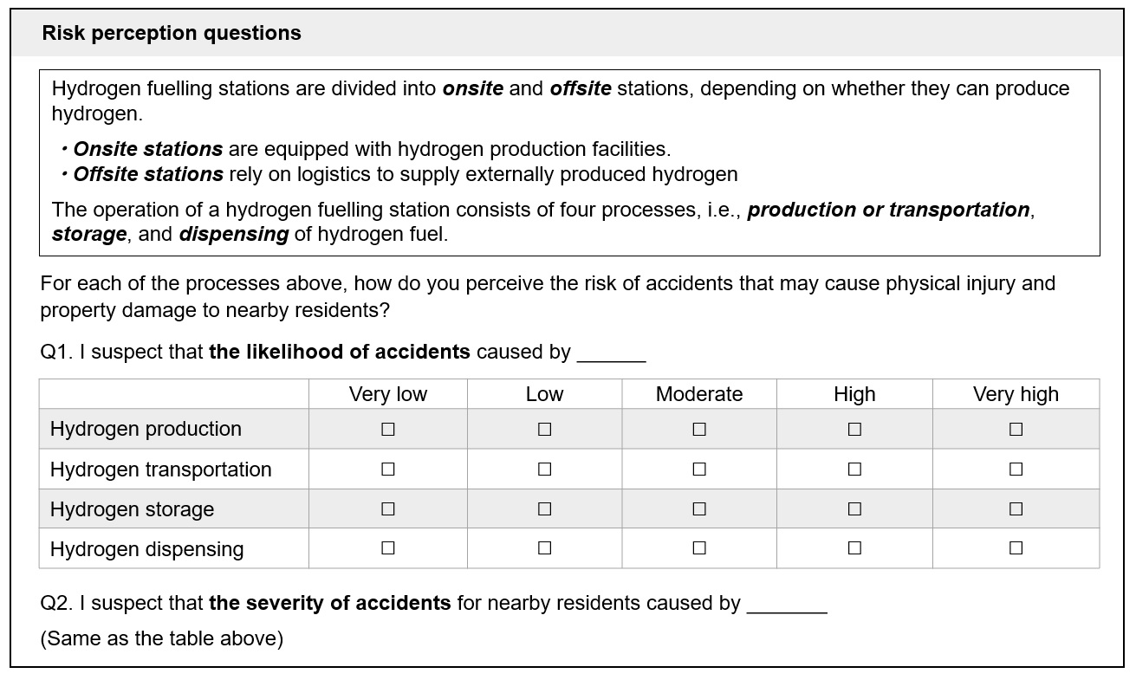
Figure 1: Questionnaire design
The web-based questionnaire survey was implemented in Japan (JP), Spain (ES), and Norway (NO) in December 2022. The sample sizes in the three countries mentioned above are 1000, 1000, and 500, respectively. To ensure that the sampling conforms to the demographic characteristics of the local population, constraints were imposed on the sample sizes for gender and age groups, as shown in Table 1.
Table 1: Sample size per age group
Age group | Japan |  | Spain |  | Norway
 | Male | Female | Male | Female | Male | Female
18-19 | 15 | 14 | 14 | 14 | 9 | 9
20-29 | 78 | 74 | 74 | 72 | 51 | 49
30-39 | 94 | 89 | 97 | 97 | 52 | 49
40-49 | 118 | 114 | 127 | 122 | 52 | 49
50-59 | 101 | 100 | 109 | 110 | 50 | 47
60-69 | 100 | 103 | 79 | 85 | 41 | 40
    - Statistics of attitudinal responses
Regarding the perceived accident probability of the four operational processes, the average percentages of Japanese respondents who perceive the risk levels of HFSs as low, moderate, and high are 16.6%, 65.0%, and 18.4%, respectively. In Spain, the percentages are 44.8%, 38.8%, and 16.4%; in Norway, they are 42.6%, 42.1%, and 15.3%, respectively, as shown in Figure 2.
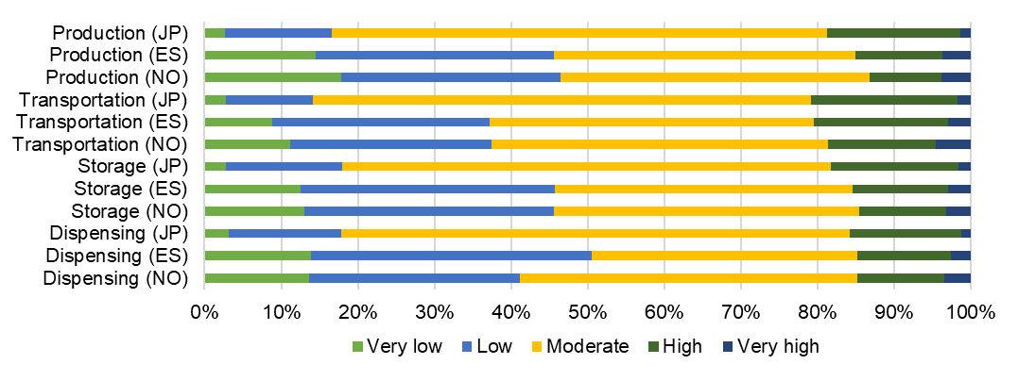
Figure 2: Perceived accident probability of respondents from the three countries
Compared to the Japanese population, the general public in the two European countries is more optimistic about the likelihood of accidents at HFSs. The Japanese population holds a noticeably neutral stance on the risk. Overall, the percentages with a negative attitude in the three countries are consistently below 20%, indirectly indicating a relatively high acceptability of HFSs (Huijts et al., 2019). With respect to the perception differences between processes, the general trend is that transportation is perceived as the most likely one to involve accidents, while production is considered as the least likely one. In the same format, Figure 3 presents the results for the measurement of perceived consequences.
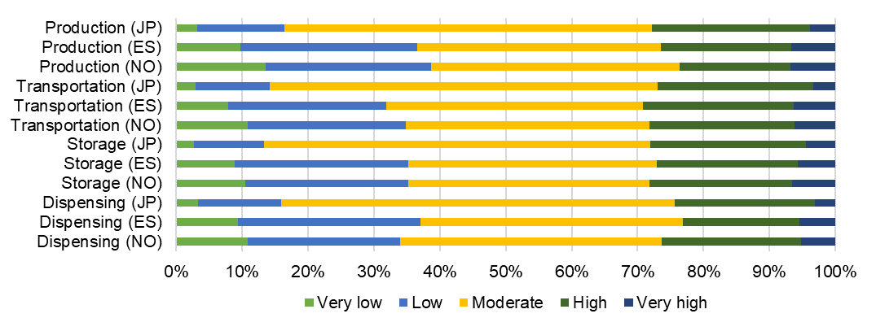
Figure 3: Perceived accident consequence of respondents from the three countries
The proportions of respondents who perceive accident consequences as low, moderate, and high are 15.0%, 58.2%, and 26.8% in Japan, 35.2%, 38.4%, and 26.4% in Spain, and 35.6%, 37.8%, and 26.6% in Norway, respectively. A similar pattern of European optimism was detected for consequences. Also, it could be observed that the public’s perception of the consequences is higher than that of the perceived accident probabilities.
  - Comparison of public perception and empirical risk
    - Empirical risk analysis
The failure probability of various components in HFSs is summarised in light of failure types (Pan et al., 2016), as in Table 2. Generally, rupture and leakage of the equipment are typically defined respectively as catastrophic and minor levels of failure. Moreover, failures in pipework, such as the full-bore rupture of a flexible hose, are also considered a minor-level failure in this study.
Table 2: Typical failure event frequency
Equipment | Operational process | Failure description | Failure level | Frequency/year
Reaction vessel of electrolyser | Production | Rupture | Catastrophic | 5.00*10⁻⁶
 |  | Leakage | Minor | 1.00*10⁻⁴
Compressor (6 h per day) | Production & Storage | Rupture | Catastrophic | 1.90*10⁻³
 |  | Leakage | Minor | 1.90*10⁻²
Tube trailer | Transportation | Rupture | Catastrophic | 1.10*10⁻⁵
 |  | Leakage from fittings | Minor | 2.20*10⁻⁴
Low- and high-pressure vessels | Storage | Rupture | Catastrophic | 2.00*10⁻⁶
 |  | Leakage from fittings | Minor | 4.00*10⁻⁵
Dispenser (50 vehicles per day) | Dispensing | Rupture | Catastrophic | 1.00*10⁻⁵
Pipe between electrolyser to compressors | Production & Storage | Full bore rupture of flexible hose | Minor | 1.00*10⁻⁵
Pipe between tube trailer to compressors | Transportation & Storage | Full bore rupture of flexible hose | Minor | 3.00*10⁻⁵
Pipe between storage vessels to dispensers | Dispensing & Storage | Full bore rupture of flexible hose | Minor | 1.50*10⁻⁵
According to the failure event frequency of each piece of equipment, the total frequencies of catastrophic and minor failures potentially occurring in each operational process are calculated and reported in Table 3, along with the equipment that constitutes the primary source of hazard.
Table 3: Statistical results for failure frequency of each operational process
Operational process | Catastrophic failure |  | Minor failure
 | Frequency | Main source | Frequency | Main source
Production | 1.91*10⁻³ | Compressor | 1.91*10⁻² | Compressor
Transportation | 1.10*10⁻⁵ | Tube trailer | 2.50*10⁻⁴ | Tube trailer
Storage | 1.90*10⁻³ | Compressor | 1.91*10⁻² | Compressor
Dispensing | 1.00*10⁻⁵ | Dispenser | 1.50*10⁻⁵ | Pipe between storage vessels to dispensers
From a realistic point of view, not all failures necessarily result in accidents. Another necessary risk factor is ignition, whether it is immediate ignition or delayed ignition. The former may cause a jet fire, while the latter may result in the release of flammable gas accumulating to an explosive concentration, leading to a flash fire or even an explosion. Based on the event trees depicted in Figure 4 (Pan et al., 2016), the empirical risk probabilities of the four operational processes are shown in Table 4.
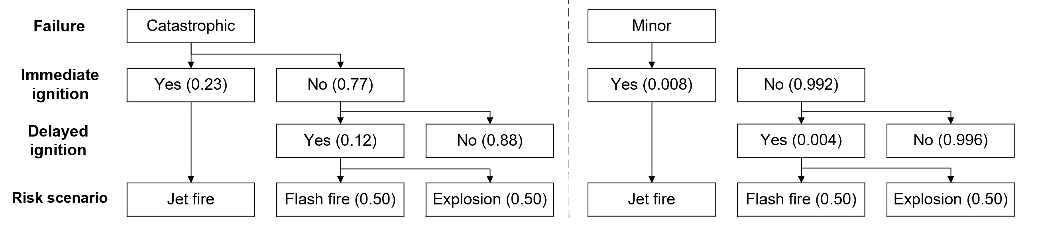
Figure 4: Event trees of rupture and leakage failure
Table 4: Estimated accident scenario probabilities for each operational process
Operational process | Caused by catastrophic failure |  | Caused by minor failure |  | Total
 | Jet fire | Flash fire or explosion | Jet fire | Flash fire or explosion | Jet fire | Flash fire or explosion
Production | 4.38*10⁻⁴ | 8.80*10⁻⁵ | 1.53*10⁻⁴ | 3.79*10⁻⁵ | 5.91*10⁻⁴ | 1.26*10⁻⁴
Transportation | 2.53*10⁻⁶ | 5.08*10⁻⁷ | 2.00*10⁻⁶ | 4.96*10⁻⁷ | 4.53*10⁻⁶ | 1.00*10⁻⁶
Storage | 4.37*10⁻⁴ | 8.79*10⁻⁵ | 1.53*10⁻⁴ | 3.79*10⁻⁵ | 5.90*10⁻⁴ | 1.26*10⁻⁴
Dispensing | 2.30*10⁻⁶ | 4.62*10⁻⁷ | 1.20*10⁻⁷ | 2.98*10⁻⁸ | 2.42*10⁻⁶ | 4.92*10⁻⁷
    - Risk ranking of operational processes
Given the estimated risk probabilities, the actual risk ranking from high to low is production and storage, followed by transportation, with dispensing being the lowest. Figure 5 presents the ranking of risk perception based on the survey data. Around half of the respondents cannot perceive the differences in risk among these processes, with 68.0%, 40.3%, and 48.6% of samples in Japan, Spain, and Norway expressing similar perceptions of risk probability. This percentage increases to 72.0%, 47.0%, and 49.8% regarding the perceived consequences.
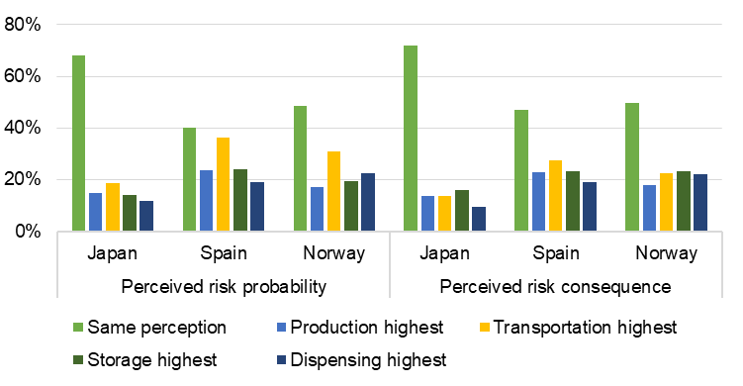
Figure 5: Proportion of assessing each operational process as having the highest risk
Moreover, the respondents in all three countries perceive transportation as the technical procedure with the highest accident risk, accounting for 18.6%, 36.2%, and 31.0%, respectively. Spanish respondents also consider transportation-related accidents to have the most severe consequences, with a percentage of 27.0%. In contrast, Japanese and Norwegian respondents believe that storage-related ones have the most severe effects, with percentages of 16.0% and 23.4%, respectively. Figure 6 depicts these perceived and actual risk rankings.
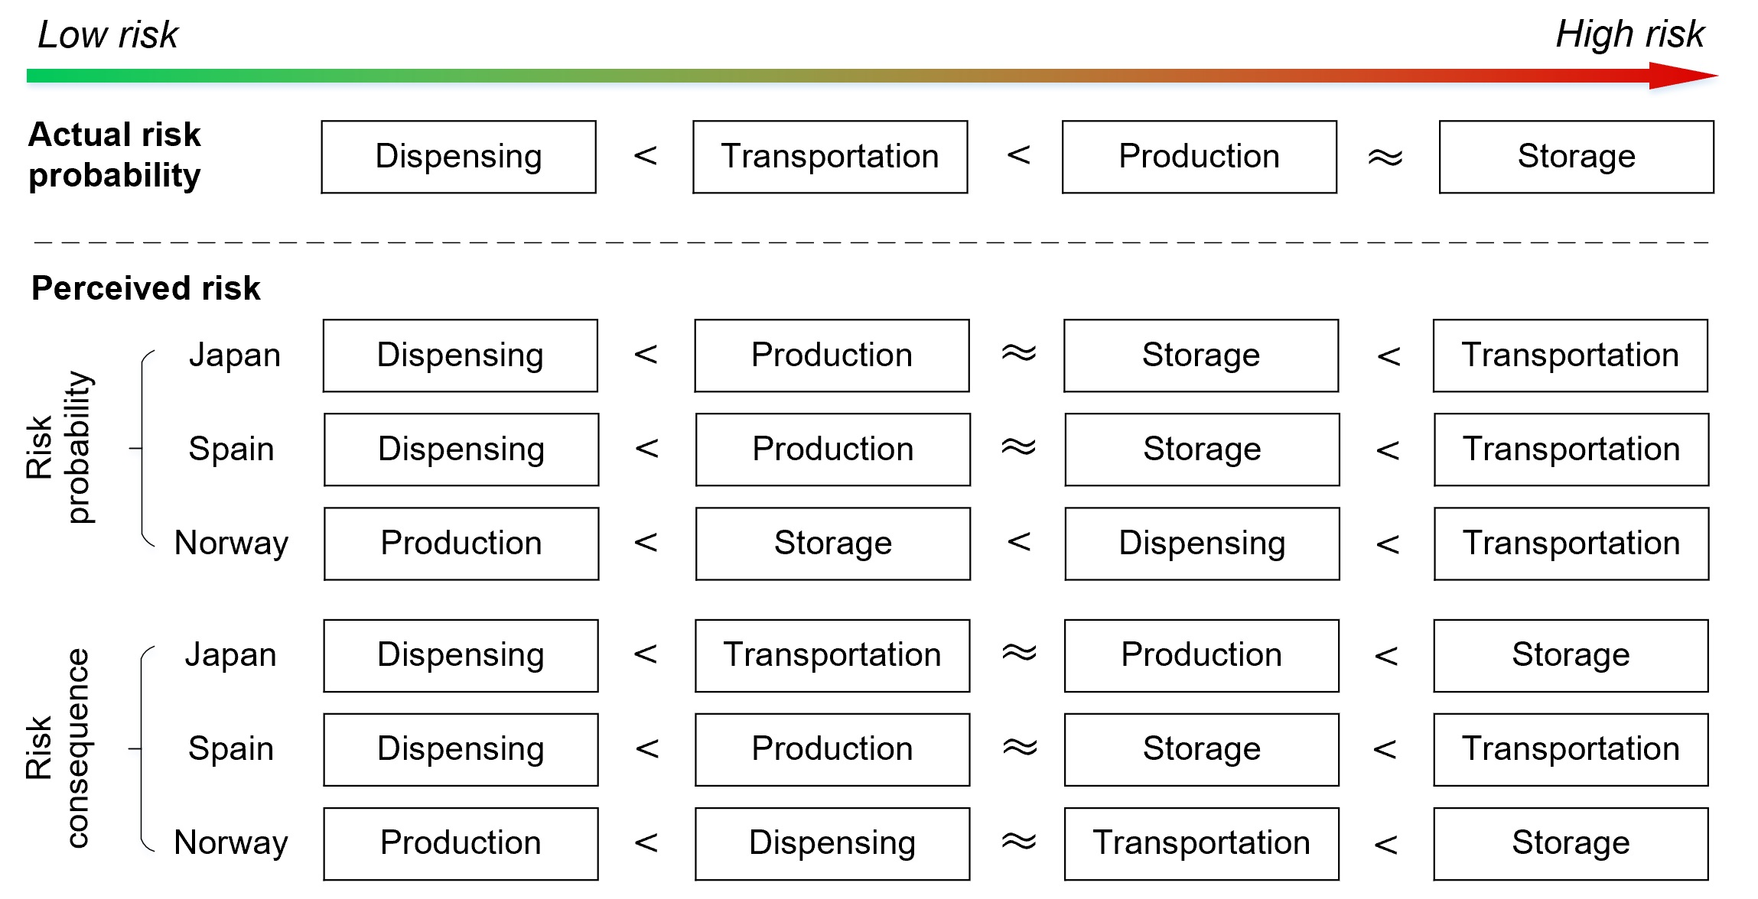
Figure 6: Overall comparison of perceived and actual risk
There are differences in risk likelihood perception among people from different countries, but overall, a similar trend is observed. By comparing it with actual risks, the following observations can be made. a) Approximately half of the public can perceive the differences in risk associated with different operational processes, which may result in differentiated acceptance of on-site and off-site HFSs. b) People tend to overestimate the risk probability of transportation-related accidents and underestimate that of hydrogen production-related accidents, which is speculated to be related to the higher exposure of the public to transportation-related accidents and relatively limited exposure to those of other processes. c) People generally perceive that the consequences of hydrogen storage-related accidents are the greatest while underestimating that of hydrogen production. In reality, accidents in the production and storage processes are similar, both mainly from compressors. d) Public perception of risks regarding hydrogen dispensing is consistent with the actual situation, with pipework being the main source of accidents. However, the risk probability and consequence are at relatively low levels.
  - Conclusions
Based on the comparison of public perception and actual risks, this study found that hydrogen transportation is the technical procedure of HFS operations that the public is most concerned about, despite its lower empirical risk compared to hydrogen production and storage. In this regard, researchers and practitioners should adopt different strategies to enhance public acceptance and hydrogen technology safety due to the perception gaps. As the process that the public is most frequently exposed to, transportation is a window that reflects the safety of hydrogen application, mainly shaping the image of HFSs in the public’s perception. Improving transportation safety and promoting knowledge, such as incorporating safety technology promotions on the bodies of heavy-duty trucks, can be an effective measure to increase public acceptance of hydrogen energy.
This study also explored risk perception differences in three countries, and the results suggest that hydrogen technology promotion demands consideration of the local public’s psychological perception. The high proportion of neutral attitudes reflects the lack of public confidence in HFS safety, also implying an excellent opportunity to raise social awareness of HFSs and related technologies to gain broad public support. This could effectively reduce public concerns and hence is of great societal significance for the future adoption of hydrogen energy.
Acknowledgments
This work was supported by JST SICORP Grant Number JPMJSC21C5, Japan, through the European Interest Group (EIG) CONCERT-Japan platform (Grant Number 334340).
References
Ajanovic A., Haas R., 2021, Prospects and impediments for hydrogen and fuel cell vehicles in the transport sector. International Journal of Hydrogen Energy, 46(16), 10049–10058.
Alazemi J., Andrews J., 2015, Automotive hydrogen fuelling stations: An international review. Renewable and Sustainable Energy Reviews, 48, 483–499.
Apostolou D., Xydis G., 2019, A literature review on hydrogen refuelling stations and infrastructure. Current status and future prospects. In Renewable and Sustainable Energy Reviews, 113, 109292.
Huijts N. M. A., De Groot J. I. M., Molin E. J. E., Wee B. V., 2013, Intention to act towards a local hydrogen refueling facility: Moral considerations versus self-interest. Transportation Research Part A: Policy and Practice, 48, 63–74.
Huijts N. M. A., De Groot J. I. M., Molin E. J. E., Wee B. V., 2015, The evaluation of hydrogen fuel stations by citizens: The interrelated effects of socio-demographic, spatial and psychological variables. International Journal of Hydrogen Energy, 40(33), 10367–10381.
Huijts N. M. A., De Groot J. I. M., Molin E. J. E., 2019, A positive shift in the public acceptability of a low-carbon energy project after implementation: The case of a hydrogen fuel station. Sustainability, 11(8): 2220.
İnci M., 2022, Future vision of hydrogen fuel cells: A statistical review and research on applications, socio-economic impacts and forecasting prospects. Sustainable Energy Technologies and Assessments, 53, 102939.
Ono K., Tsunemi K., 2017, Identification of public acceptance factors with risk perception scales on hydrogen fueling stations in Japan. International Journal of Hydrogen Energy, 42(16), 10697–10707.
Pan X., Li Z., Zhang C., Lv H., Liu S., Ma J., 2016, Safety study of a wind–solar hybrid renewable hydrogen refuelling station in China. International Journal of Hydrogen Energy, 41(30), 13315–13321.
Vereš J., Ochodek T., Koloničný J., 2022, Safety Aspects of Hydrogen Fuelling Stations. Chemical Engineering Transactions, 91, 49–54.
Wilson R. S., Zwickle A., Walpole H., 2019, Developing a broadly applicable measure of risk perception. Risk Analysis, 39 (4), 777–91.

