 CHEMICAL ENGINEERING TRANSACTIONS  VOL. , 2023 | A publication of  
The Italian Association
of Chemical Engineering
Online at www.cetjournal.it

Guest Editors: David Bogle, Flavio Manenti, Piero Salatino
Copyright © 2023, AIDIC Servizi S.r.l.
ISBN 979-12-81206-04-5; ISSN 2283-9216

A mathematical tool for optimising carbon capture, utilisation, and sequestration plants for e-MeOH production
Federico d’Amore^{a,b,}*, Paolo Colbertaldo^{b}, Matteo C. Romano^{b}
ªCAPE-Lab – Computer-Aided Process Engineering Laboratory, Department of Industrial Engineering, University of Padova, via Marzolo 9, 35131 Padova PD (Italy)
^{b} GECoS – Group of Energy Conversion Systems, Politecnico di Milano, Department of Energy, via Lambruschini 4, IT-20156 Milano (Italy)
federico.damore@unipd.it
Carbon capture, utilisation, and sequestration is key for the decarbonisation of hard-to-abate industries, as it allows avoiding the direct release of CO₂ to the atmosphere and generating carbon-based products. However, for these products to be truly carbon-neutral, intermittent renewable electricity must be deployed at scale, leading to the necessity of optimising flexible plants with potential for local buffer storages, geological sequestration, and conversion units. The scope of this work is to provide a mathematical framework for the economic optimisation of a carbon capture, utilisation, and sequestration system, to decarbonise a cement plant located in the Puglia region (Italy), via CO₂ geological confinement and/or power and CO₂-to-methanol conversion. The final aim is to determine the optimal sizing and cost of the process units of the plant, depending on economic conditions such as the methanol sale price and different perspective costs scenarios. The main outcome is an economic convenience of geological sequestration, as opposed to utilisation, while a long-term scenario would allow for a cost-effective production of methanol when the sale price is above 550 €/t.
  - Introduction
CO₂ capture and geological sequestration (CCS) is considered as an important set of technologies to decarbonise industry, particularly hard-to-decarbonise sectors such as cement (Voldsund et al., 2019; d’Amore et al., 2021), and to achieve future climate goals (IPCC, 2023). Alternatively, carbon capture and utilisation (CCU) is an option to convert CO₂ streams into useful products (Hepburn et al., 2019; d’Amore et al., 2023). CCU may play an important role in future carbon management and circular carbon economy, as the CO₂ can be combined with green H₂ (i.e., produced through electrolysis of H₂O fed with renewable electricity) to produce synthetic ‘e-chemicals’ or ‘e-Fuels’, such as e-Methanol (e-MeOH) (Pérez-Fortes et al., 2016). Designing flexible value chains able to perform both CO₂ permanent confinement and CO₂ conversion and utilisation (carbon capture, utilisation, and sequestration - CCUS) represents an opportunity to decrease the costs of a purely CCS-driven chain, via revenues from the sale of climate neutral carbon-based e-Fuels (d’Amore and Bezzo, 2020).
This study proposes a mathematical tool for the cost-optimal design of a CCUS system producing e-MeOH. A given stream of CO₂, separated from the flue gases of a cement plant, is either sent to permanent geological sequestration (i.e., CCS) or to chemical conversion alongside green H₂ into e-MeOH (i.e., CCU). The green H₂ is produced through electrolysers fed with renewable electricity (wind farm and/or photovoltaic plant), and the intermittent load of renewables is tackled by considering the possibility to install buffer local storage capacities for electric energy (i.e., batteries), H₂, and/or CO₂. The proposed CCUS modelling framework is tested on an exemplificative geographic case study located in the Puglia region (Italy), which is optimised for a year-long operation with a time resolution of 1 h. The ultimate objective is to assess the economic conditions (e.g., e-MeOH sale price) that determine the exploitation of a CCS- and/or CCU-driven chain; hence, the optimal sizing and cost of the process units of the CCUS plant.
  - Plant description
The CCUS plant (Figure 1) is based on a cement plant with an oxy-fuel combustion CO₂ capture system (90% capture rate) with air separation unit (ASU). Given the captured CO₂ output from the cement plant [#q9, Figure 1], the process units can be selected and sized accordingly, as a result of the optimisation; these units can comprise: (i) geological sequestration [#q13] for CO₂ permanent storage (i.e., CCS); (ii) a low-temperature electrolysis system (ELs) (65% electricity-to-LHV efficiency) to produce green H₂ [#q3] and a chemical plant (i.e., CCU) to generate e-MeOH [#q15]; or (iii) a combination of CCS and CCU units (i.e., CCUS). Renewable electricity can be provided by a photovoltaic plant (PV) and/or wind turbines (WTs), and their intermittency can be tackled by installing local storage systems of electric energy (i.e., battery energy storage - BES), H₂, and/or CO₂. The electric energy demand of ELs, ASU, CCU, and CO₂ capture plant can be fulfilled also via backup grid electricity [#P2grid, #P3grid, #P6grid, and #P7grid, respectively], while any excess renewable electricity can be exported to the grid [#P4]. The O₂ co-produced from the electrolysers [#q16] can be exploited to decrease the ASU capacity, while any excess O₂ [#q23] can be exported. The H₂O requirement of the ELs [#q1] is provided through make-up H₂O [#q18] and recycled H₂O from the CCU plant [#q17].
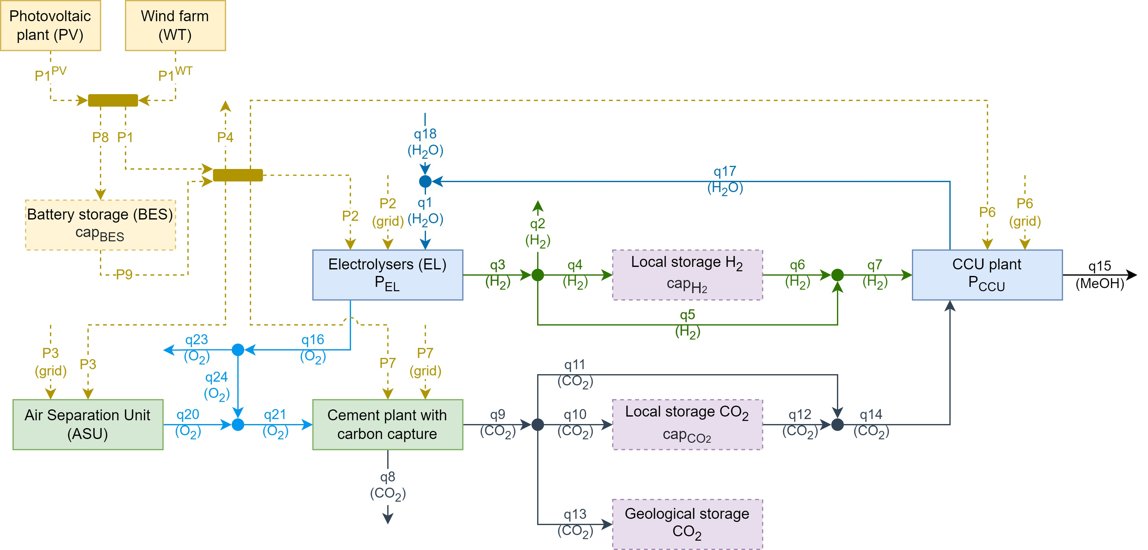
Figure 1. Simplified CCUS plant flowsheet.
  - Plant optimisation model
The mathematical problem is formulated as a mixed-integer linear programming (MILP) one, with the objective of minimising the total annual cost TAC [€/year] of the CCUS plant, given by the contribution over process units k of annualised expenditures CAPEX_{k} [€/year], variable costs fOPEX_{k} [€/year] and vOPEX_{k} [€/year], and carbon tax C_{tax} [€/year], decreased by the revenues REV [€/year] from products (such as e-MeOH):
$$\left\{\begin{aligned}objective=min⁡(TAC) \\ TAC=\sum_{k}{({CAPEX}_{k}+{fOPEX}_{k}+{vOPEX}_{k})}+C_{tax}-REV\end{aligned}\right.$$ |  | (1)
The process units k are the photovoltaic plant k={PV}, wind turbines k={WT}, electrolysers k={EL}, CO₂ utilisation plant k={CCU}, electricity storage in batteries k={BES}, local H₂ storage k={$H_{2}^{sto}$}, local CO₂ storage k={${CO}_{2}^{sto}$} and geological CO₂ sequestration k={${CO}_{2}^{seq}$}. Investment costs CAPEX_{k} of Eq.(1) are calculated as:
$$CAPEX=\sum_{k}{{CAPEX}_{k}}$$ |  | (2)
$${CAPEX}_{\{PV,WT,EL,BES,H_{2}^{sto}\}}=N_{\{PV,WT,EL,BES,H_{2}^{sto}\}}∙U_{\{PV,WT,EL,BES,H_{2}^{sto}\}}^{cost}∙AF_{\{PV,WT,EL,BES,H_{2}^{sto}\}}$$ |  | (3)
$${CAPEX}_{CCU}=\sum_{r}{\left({cap}_{CCU,r}∙U_{CCU,r}^{cost}∙AF_{CCU}\right)}$$ |  | (4)
where $U_{k}^{cost}$ [€/appropriate unit] and AF_{k} [%/year] are the unitary cost and the annuity factor of process unit k, respectively (Table 1), while N [appropriate unit] of Eq.(3) represents the relevant scaling variable. CAPEX_{k} for local and permanent CO₂ storage are not evaluated, as this stages account only for operative costs. A linearisation of the unitary cost curve for the e-MeOH reactor is included in Eq.(4) through set r (Figure 2).
Table 1: Economic parameters for unit operations k, for short-term (ST) and long-term (LT) perspective.
 | $${\text{U}}_{\text{k}}^{\text{cost}}$$ |  |  | AF_{k} |  | C1_{k}
k | ST | LT | Unit | [%] |  | [%/year] | Reference
WT | 1075 | 920 | [€/kW_{el}] | 8.7% |  | 2.0% | Ram et al. (2020)
PV | 570 | 320 | [€/kW_{el}] | 8.7% |  | 3.0% | Ram et al. (2020)
EL | 800 | 400 | [€/kW_{el}] | 13.6% |  | 2.5% | Ram et al. (2020)
CCU | 451 | 451 | [€/t e-MeOH/year] | 7.8% |  | 3.0% | Pérez-Fortes et al. (2016)
BES | 300 | 100 | [€/kWh_{el}] | 6.7% |  | 2.0% | Ram et al. (2020)
$${\text{H}}_{\text{2}}^{\text{sto}}$$ | 9600 | 3500 | [€/t H₂] | 7.8% |  | 1.0% | Ram et al. (2020)
$${\text{CO}}_{\text{2}}^{\text{sto}}$$ | 10 | 10 | [€/t CO₂] | - |  | - | Ram et al. (2020)
$${\text{CO}}_{\text{2}}^{\text{seq}}$$ | 50 | 30 | [€/t CO₂] | - |  | - | d’Amore et al. (2021)
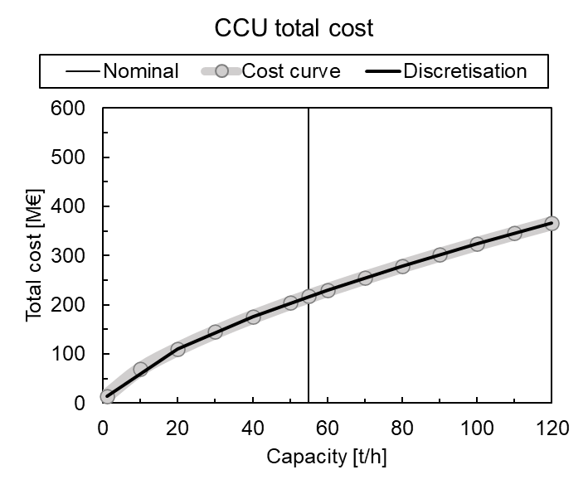 |  |  |  |  | 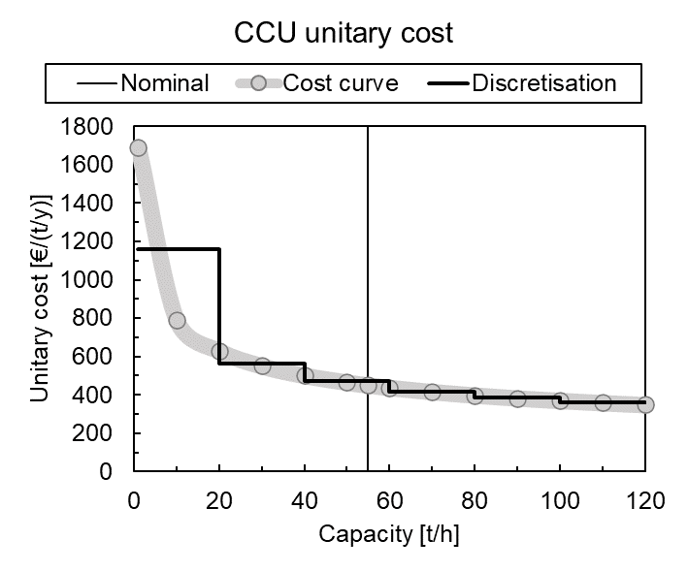
(a) |  |  |  |  | (b)
Figure 2. e-MeOH reactor cost curve discretisation derived from Pérez-Fortes et al. (2016): (a) total cost [M€]; and (b) unitary cost [€/(t e-MeOH/y)].
Fixed operating costs fOPEX_{k} of Eq.(1) are evaluated as a fixed percentage C1_{k} [%/year] (Table 1) from total (i.e., not annualised) CAPEX_{k} of Eq.(2) for each unit k:
$${fOPEX}_{k}∙AF_{k}={C1}_{k}∙{CAPEX}_{k}$$ | $$∀k$$ | (5)
Variable operating costs vOPEX_{k} of Eq.(1) are evaluated for process units k as:
$$vOPEX=\sum_{k}{{vOPEX}_{k}}+\sum_{t}{[({P3}_{t}^{grid}+{P7}_{t}^{grid})∙p_{t}^{EE}]}$$ |  | (6)
$${vOPEX}_{EL}=\sum_{t}{({q18}_{t}∙p^{H_{2}O}+{P2}_{t}^{grid}∙p_{t}^{EE})}$$ |  | (7)
$${vOPEX}_{CCU}=\sum_{t}{({P6}_{t}^{grid}∙p_{t}^{EE})}$$ |  | (8)
$${vOPEX}_{H_{2}^{sto}}=\sum_{t}{(q4_{t}∙4/3600∙p_{t}^{EE})}$$ |  | (9)
$${vOPEX}_{{CO}_{2}^{sto}}=\sum_{t}{({q10}_{t}∙U_{{CO}_{2}^{sto}}^{cost})}$$ |  | (10)
$${vOPEX}_{{CO}_{2}^{seq}}=\sum_{t}{({q13}_{t}∙U_{{CO}_{2}^{seq}}^{cost})}$$ |  | (11)
In particular, Eqs.(6-8) take into account the H₂O (i.e., q18_{t}) and grid electricity consumptions of the ELs, ASU, CCU, and cement plant, and respective unitary costs (i.e., ${\text{p}}^{{\text{H}}_{\text{2}}\text{O}}$ [€/t H₂O] for H₂O and ${\text{p}}_{\text{t}}^{\text{EE}}$ [€/MWh] for grid electricity). The electric energy consumption of H₂ storage is evaluated through Eq.(9) depending on the inlet H₂ flow rate q4_{t}, while CO₂ temporary storage and permanent sequestration costs of Eqs.(10,11) are evaluated according to their inlet CO₂ flowrates (i.e., q10_{t} and q13_{t}, respectively) and unitary costs (i.e., ${\text{U}}_{{\text{CO}}_{\text{2}}^{\text{sto}}}^{\text{cost}}$ and ${\text{U}}_{{\text{CO}}_{\text{2}}^{\text{seq}}}^{\text{cost}}$, respectively) reported in Table 1. The costs associated to the application of a carbon tax (i.e., c_{tax} [100 €/t CO₂]) on the indirect CO₂ emissions associated to grid electricity, plus those associated to the direct release of CO₂ to the atmosphere from the cement plant (i.e., q8_{t}), are evaluated as:
$$C_{tax}=c_{tax}∙\left\{\sum_{t}{\left[\left({P2}_{t}^{grid}+{P3}_{t}^{grid}+{P6}_{t}^{grid}+{P7}_{t}^{grid}\right)∙E_{ind,t}+q8_{t}\right]}\right\}$$ | $$∀k$$ | (12)
where E_{ind,t} [t CO₂/MWh] is the carbon intensity of the electric grid. Revenues REV of Eq.(1) derive from the sale of e-MeOH (i.e., REV^{MeOH} [€/year]) and excess H₂ (i.e., ${\text{REV}}^{{\text{H}}_{\text{2}}}$ [€/year]), and from the savings determined by the use of the O₂ produced by the ELs in (partial) substitution of that generated in the ASU (i.e., ${REV}^{O_{2}}$ [€/year]), being p^{MeOH} [€/t e-MeOH], ${\text{p}}^{{\text{H}}_{\text{2}}}$ [€/t H₂], and ${\text{p}}^{{\text{O}}_{\text{2}}}$ [€/t O₂] the sale prices of e-MeOH, H₂, and O₂, respectively:
$$REV={REV}^{MeOH}+{REV}^{H_{2}}+{REV}^{O_{2}}$$ |  | (13)
$${REV}^{MeOH}=\sum_{t}{({q15}_{t}∙p^{MeOH})}$$ |  | (14)
$${REV}^{H_{2}}=\sum_{t}{({q2}_{t}∙p^{H_{2}})}$$ |  | (15)
$${REV}^{O_{2}}=\sum_{t}{(q{23}_{t}∙p^{O_{2}})}$$ |  | (16)
  - Assumptions, constraints, and case studies
This study optimises the design and operation of a CCUS plant under the following assumptions: (i) the entire amount of H₂ (if any) produced by the ELs is sent to CCU, i.e., H₂ cannot be exported to other users (q2_{t}=0). This constraint prevents the results being affected by the choice in the H₂ price; (ii) any excess of renewable electricity can be exported to the grid (P4_{t}≥0), but it is assumed that a strictly positive export would not produce any revenues, assuming that the grid is highly penetrated with renewables and the electricity price in high-wind and high-sun periods (i.e., when excess electricity is produced in the assessed plant) is near-zero. A maximum 10% threshold is set on the contribution of grid electricity imported in the operation of the CCUS process units; (iii) any O₂ export (q23_{t}) is monetised at a fixed price of 50 €/t of O₂; and (iv) the model is optimised for a baseline e-MeOH selling price of 450 €/t of e-MeOH (i.e., representative of the current market price increased by the contribution of a carbon tax of 100 €/t of CO₂). Cases hindering the installation of the CCU route are tested upon variations (i.e., increases) of this price beyond 450 €/t of e-MeOH, to assess the CCS vs. CCU competitiveness.
The model is tested on the following case studies: (i) the optimisation of the CCUS plant is based on an exemplifying geographic location, namely Puglia (Italy), and the mathematical model is optimised by utilising geographic-specific data (with hourly resolution) in terms of solar (JRC, 2022) and wind (Renewables Ninja, 2023) relative generation, electricity price (ENTSO-E, 2023), and indirect CO₂ emissions from the grid based on hourly electric mix (ISPRA, 2022); (ii) unitary material and installation costs are based on two scenarios: a short term perspective (ST) and a long-term one (LT) (Table 2). As electricity prices and indirect emissions are characterised by a high degree of uncertainty, this study assumes the same values of these for ST and LT cases; and (iii) the model is optimised by considering a limit of 30% on the minimum load of the CCU plant.
  - Results
The MILP model was optimised with GAMS software via CPLEX solver (350k continuous variables and 7 discrete ones). The results highlight that CCS is the best solution in a ST perspective for the entire range of investigated e-MeOH prices with TAC of 62.2 M€/y, dominated by geological sequestration costs (38.3 M€/y, i.e. 62%). CCU becomes cost-effective in a LT scenario for an e-MeOH price higher than 550 €/t (Figure 3a). In particular, the CCU plant costs 326.0 M€/y, with significant contributions of PV (77.3 M€/y, i.e. 23.7%), WT (113.7 M€/y, i.e. 34.9%), and ELs (81.7 M€/y, i.e. 25.1%), being TAC compensated by revenues from e-MeOH sale. As for the levelised cost of renewable electricity (LCOE) and that including BES (LCOE’), in ST these result equal to 45.9 and 82.9 €/MWh_{el}, respectively, while in LT they decrease to 29.1 and 51.9 €/MWh_{el} (-37%) in the CCS plant, and to 31.5 and 36.6 €/MWh_{el} (-31% and -56%) in the CCU one (Table 2). The optimal e-MeOH plant obtained under a LT cost perspective exhibits a levelised cost of H₂ (LCOH) of 2.6 €/kg (it was verified that this plant is not affected by the choice in the maximum use of grid electricity). In ST, the optimal CCS plant involves the installation of 54.3 MW_{el} of PV, 62.1 MW_{el} of WT, and 66.8 MWh_{el} of BES, against 2.2 GW_{el} of PV, 1.1 GW_{el} of WT, and 1.3 GWh_{el} of BES in the LT CCU plant; this plant has 1.2 GW_{el} of ELs installed (with a capacity factor of 49%), a 80 t/h e-MeOH reactor (with a capacity factor of 80%), and local H₂ and CO₂ storages of 5 kt and 6 kt, respectively (Table 2). ST scenarios involve a significant export of renewable electricity to the grid (31% export), against a higher internal use of renewables in the LT CCU plant (only 5% export).
Figure 3b shows a comparison in terms of CO₂ balance among a base reference system consisting in the cement plant without CO₂ capture and a conventional MeOH plant (computed with specific emission of 470 kg CO₂/t MeOH and producing the same amount of product as in the e-MeOH CCU plant) (Ingham, 2017), the CCS plant resulting from this study, and the CCU one. In the base case, direct and indirect emissions from conventional cement and MeOH plants without CO₂ capture are 1.15 Mt/y, which is higher than the total CO₂ generated in the CCS and CCU cases (862.7 Mt/y, i.e. -25.1%). Moreover, in the CCS ad CCU cases, the great majority of this CO₂ (766.2 Mt/y) is sent to permanent geological storage and to e-MeOH production, respectively. As a result, the CCS and CCU cases allow for a reduction 91.3% in the total direct and indirect CO₂ emissions with respect to the conventional base case.
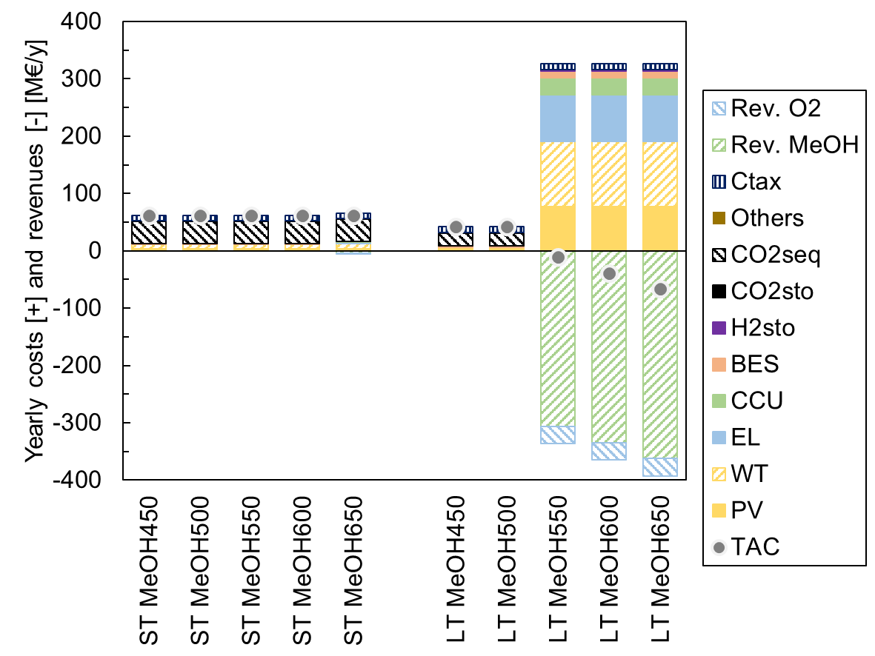 | 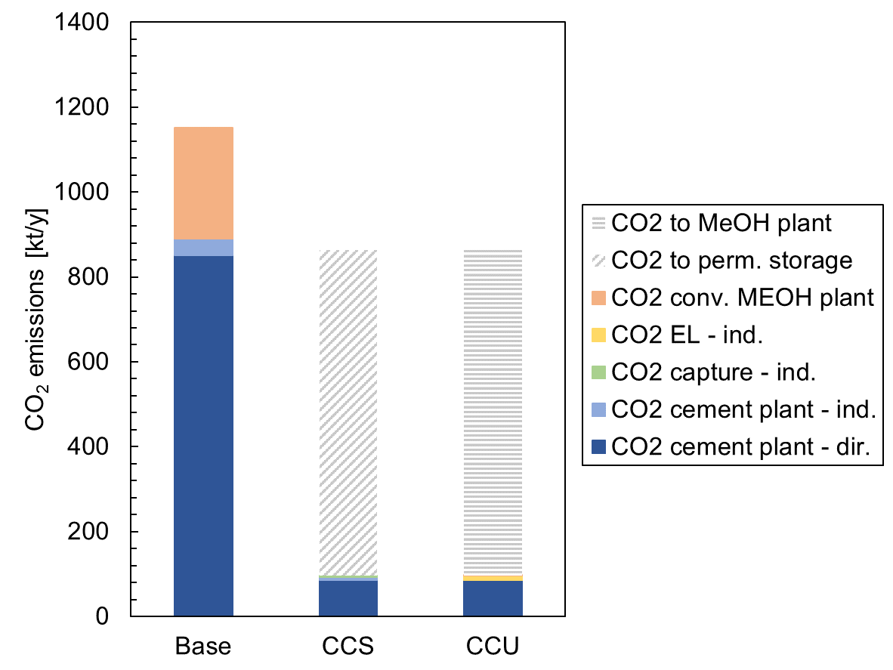
(a) | (b)
Figure 3. (a) Economic results: yearly cost and revenues and TAC [M€/y]. (b) CO₂ balance of optimal CCS and CCU plants, compared with reference cement plant and MeOH plant (i.e., Base) (Pérez-Fortes et al., 2016).
Table 2: Technical results: plant design, mass and electric balance, and performance indicators.
 | Description | Unit | ST-450 | ST-550 | LT-450 | LT-550
 | Scenario | ST/LT | ST | ST | LT | LT
 | MeOH price | [€/t] | 450 | 550 | 450 | 550
Plant design | Capacity PV | [MW_{el}] | 54.3 | 54.3 | 99.6 | 2254.1
 | Capacity WT | [MW_{el}] | 62.1 | 62.1 | 25.3 | 1054.1
 | Capacity EL | [MW_{el}] | 0.0 | 0.0 | 0.0 | 1245.0
 | Capacity CCU | [t MeOH/h] | 0.0 | 0.0 | 0.0 | 80.0
 | Capacity BES | [MWh_{el}] | 66.8 | 66.8 | 243.3 | 1284.3
 | Capacity H₂ storage | [t H₂] | 0.0 | 0.0 | 0.0 | 5347.2
 | Capacity CO₂ storage | [t CO₂] | 0.0 | 0.0 | 0.0 | 6239.8
Mass balance | CO₂ captured (Q9) | [t CO₂/y] | 766249 | 766249 | 766249 | 766249
 | CO₂ avoided | [t CO₂/y] | 754915 | 754915 | 757658 | 757573
 | CO₂ to CCS (Q13) | [%] | 100.0% | 100.0% | 100% | 0.0%
 | CO₂ to CCU (Q14) | [%] | 0.0% | 0.0% | 0.0% | 100.0%
 | Direct CO₂ emission (Q8) | [t CO₂/y] | 85139 | 85139 | 85139 | 85139
 | Indirect CO₂ emission | [t CO₂/y] | 11334 | 11334 | 8591 | 8676
 | H₂ produced (Q3) | [t H₂/y] | 0 | 0 | 0 | 104394
 | MeOH export (Q15) | [t MeOH/y] | 0 | 0 | 0 | 557462
 | O₂ to cement plant (Q24) | [t O₂/y] | 0 | 0 | 0 | 232060
 | O₂ export (Q23) | [t O₂/y] | 0 | 0 | 0 | 603089
Electric balance | Total renewable electricity | [MWh_{el}/y] | 242980 | 242980 | 211879 | 6065901
 | Total grid electricity imported | [MWh_{el}/y] | 26998 | 26998 | 23542 | 38142
 | Grid/tot electricity ratio | [%] | 10.0% | 10.0% | 10.0% | 0.6%
 | PV el. pow. out (P1PV) | [MWh_{el}/y] | 79266 | 79266 | 145217 | 3287542
 | WT el. pow. out (P1WT) | [MWh_{el}/y] | 163714 | 163714 | 66661 | 2778359
 | Renewable el. export (P4) | [%] | 30.8% | 30.8% | 14.3% | 5.1%
Performance indicators | Carbon capture rate | [%] | 90.0% | 90.0% | 90.0% | 90.0%
 | Carbon avoidance rate | [%] | 88.7% | 88.7% | 89.0% | 89.0%
 | Capacity factor renewables | [%] | 23.8% | 23.8% | 19.4% | 20.9%
 | Capacity factor rene. net | [%] | 16.5% | 16.5% | 16.6% | 19.9%
 | Capacity factor PV | [%] | 16.6% | 16.6% | 16.6% | 16.6%
 | Capacity factor WT | [%] | 30.1% | 30.1% | 30.1% | 30.1%
 | Capacity factor EL | [%] | 0.0% | 0.0% | 0.0% | 49.1%
 | Capacity factor CCU | [%] | 0.0% | 0.0% | 0.0% | 79.5%
 | Equivalent cycles BES | [cycles/y] | 192 | 192 | 94 | 176
 | LCOE (levelised, PV, WT) | [€/MWh_{el}] | 45.9 | 45.9 | 29.0 | 31.5
 | LCOE' (levelised, PV, WT, BES) | [€/MWh_{el}] | 82.9 | 82.9 | 51.9 | 36.6
 | LCOH (levelised cost of H₂) | [€/kg H₂] | - | - | - | 2.6
  - Conclusions
This article proposed an optimisation framework for the design of a carbon capture, utilisation, and storage (CCUS) plant for the production of e-Methanol (e-MeOH) from green H₂ (derived from low-temperature electrolysis fed with renewables) and CO₂ (derived from carbon capture at a cement plant). The chosen geographic setting was located in the Puglia region (Italy), to represent a case study for the installation and operation of renewable electricity plants, namely a photovoltaic plant and/or a wind farm, and of local storage systems for electricity (in the form of batteries), hydrogen, and carbon dioxide.
When the costs of process units were accounted on a short-term perspective, the main outcome was a general economic convenience of geological sequestration (i.e., CCS), as opposed to utilisation (CCU), while a long-term (i.e., lower investment costs) scenario would allow for a cost-effective production of e-MeOH when the sale price was above 550 €/t, which corresponded to a levelised production cost of green H₂ (as an intermediate product) of 2.6 €/kg. The resulting optimal CCS and CCU plants were shown to ensure a good performance in terms of carbon avoidance with respect to benchmark MeOH production, even though a more thorough analysis (e.g., based on life cycle assessment criteria) may lead to different outcomes, especially when considering the significant deployment of renewables and batteries in the CCU plant.
The proposed modelling framework is of general validity and future work will involve testing it on different geographic locations, to assess the competitiveness of CCS, CCU, and CCUS pathways under different renewable energy profiles and market prices.
References
d’Amore, F., Bezzo F., 2020, Optimizing the design of supply chains for carbon capture, utilisation and sequestration in Europe: a preliminary assessment, Front. Energy Res., 8, 190.
d’Amore, F., Romano, M.C., Bezzo, F., 2021, Optimal design of European supply chains for carbon capture and storage from industrial emission sources including pipe and ship transport, Int. J. Greenh. Gas Control, 109, 103372.
d’Amore, F., Nava, A., Colbertaldo, P., Visconti, C.G., Romano, M.C., 2023, Turning CO₂ from fuel combustion into e-Fuel? Consider alternative pathways, Energy Conv. Manage., 289, 117170.
ENTSO-E, 2023, Transparency platform, <https://transparency.entsoe.eu/>, accessed 17.05.2023.
Hepburn, C., Adlen, E., Beddington, J., Carter, E.A., Fuss, S., Mac Dowell, N., Minx, J.C., Smith, P., Williams, C.K., 2019, The technological and economic prospects for CO₂ utilization and removal, Nature, 575, 87-97.
Ingham, A., 2017, Reducing the carbon intensity of methanol for use as a transport fuel, Johnson Matthey Technol. Rev., 61, 297-307.
IPCC, 2023, Climate change 2022: Impacts, adaptation and vulnerability, <https://www.ipcc.ch/report/ar6/wg2/>, accessed 16.04.2023.
ISPRA, 2022, Indicatori di efficienza e decarbonizzazione del sistema energetico nazionale e del settore elettrico, <https://www.isprambiente.gov.it/it/pubblicazioni/rapporti/indicatori-di-efficienza-e-decarbonizzazione-del-sistema-energetico-nazionale-e-del-settore-elettrico>, accessed 17.05.2023.
JRC, 2022, Photovoltaic geographic information system, <https://re.jrc.ec.europa.eu/pvg_tools/en/>, accessed 17.05.2023.
Pérez-Fortes, M., Schöneberger, J.C., Boulamanti, A., Tzimas, E., 2016, Methanol synthesis using captured CO₂ as raw material: Techno-economic and environmental assessment, Appl. Energy, 161, 718-732.
Ram, M., Galimova, T., Bogdanov, D., Fasihi, M., Gulagi, A., Breyer, C., Micheli, M., Crone, K., 2020, Powerfuels in a Renewable Energy World - Global volumes, costs, and trading 2030 to 2050, LUT University and Deutsche Energie-Agentur GmbH (dena), Lappeenranta, Berlin.
Renewables Ninja, 2023, <https://www.renewables.ninja/>, accessed 17.05.2023.
Voldsund, M., Gardarsdottir, S.O., De Lena, E., Pérez-Calvo, J.F., Jamali, A., Berstad, D., Fu, C., Romano, M., Roussanaly, S., Anantharaman, R., Hoppe, H., Sutter, D., Mazzotti, M., Gazzani, M., Cinti, G., Jordal, K., 2019, Comparison of technologies for CO₂ capture from cement production - Part 1: Technical evaluation, Energies, 12, 559.

