CHEMICAL ENGINEERINGTRANSACTIONS  VOL. ,2023 | A publication of
The Italian Association
of Chemical Engineering
Online at www.cetjournal.it

Guest Editors: David Bogle, Flavio Manenti, Piero Salatino
Copyright © 2023, AIDICServiziS.r.l.
ISBN979-12-81206-04-5; ISSN 2283-9216

Solution to agricultural machinery powering problems
using DIY photovoltaics
Bartolomeo Cosenzaª, Michele Miccio^{b *}, Carmelo Greco^{c}
ªDipartimento di Ingegneria Civile e Industriale. Università degli studi di Pisa, Largo Lucio Lazzarino, 56122 Pisa (PI), Italy.
^{b}Dipartimento di Ingegneria Industriale (DIIn), Università degli Studi di Salerno, via Giovanni Paolo II 132, 84084 Fisciano (SA), Italy
^{c}I.I.S.S. “Gioeni-Trabia”, Palermo, Italy
* Corresponding Author: mmiccio@unisa.it

The contribution of this work is the realization and the field testing of a photovoltaic system in agriculture following the Do-It-by-Yourself (DIY) approach, i.e., a system easy to be assembled from commercially available components, portable off-site and recharging the battery directly when working. This solution allows the daily work of a simple agricultural machine to be carried out with the advantage of no interruption and, in addition, the saving of any electricity cost associated to battery recharging. The design and the realization of the DIY photovoltaic apparatus are described, which turns out quite cheap. The resulting economic advantages are analyzed, with reference to a geographical collocation and the typical agricultural practice in Sicily.
  - Introduction
The production of electricity is the basis of human activities: from the world of productivity to everyday life, everything is conditioned using energy. Unfortunately, the energy crisis is becoming a crucial problem and an economy based on fossil fuels solves neither energy security nor the climate crisis. The problems connected to energy dependence, combined with environmental issues, have shown how much it is necessary to intervene promptly to guarantee energy independence. It is, therefore, necessary to increase investments (Armaroli and Balzani, 2007) leading to an increasingly massive use of renewable energies. More and more countries have recently decided to invest in the renewable energy sector. In this way, a journey of liberation from fossil fuels begins, to be less and less dependent on other countries for energy supplies (Panwar et al. 2011; Sayigh, 2022). However, investing is not enough. Each investment must be supported by adopting a more responsible and conscientious lifestyle. This work focuses on the use proposed by the authors of photovoltaics (PV), the best renewable resource supplied daily by the sun (Barker and Bing, 2005), which does not need to be extracted, processed, transported, or burned to produce energy (Foster et al., 2009), in few words a renewable energy. After the advent of PV, even the professional role of the chemical engineer is redefined, no longer tied to fossil energies, but able to offer new attractive challenges and opportunities. The PV applications (Stanojevic, 2021) range from the production of electricity on a large scale to that of a single-family house up to small-scale DIY systems. As an example of the latter case, the authors proposed a PV-driven tool for powering personal computers and household appliances (Cosenza et al, 2023).
Solar PV systems present many advantages when they are integrated into the building structure envelope and have a significant influence on the indoor air temperature of dwelling buildings due to the thermal resistance modification. Akata (2021) presents the effect of roof-integrated PV (RIPV) on building indoor air in the African tropical climate. More recently Opoku et al. (2023) proposed to unlock the potential of solar electric vehicles for post-Covid recovery and growth in the transport sector in Ghana.
PV also finds applications in rural contexts and agricultural sectors. The significant increase in wages in agriculture has led to a significant abandonment of cultivated land. Labor is scarce and many crops are at risk. Companies have created increasingly efficient mechanical tools, offering valid help to farmers. There is a vast range of battery-operated machines, especially those equipped with car batteries: olive harvesters, motor hoes, wheelbarrows, lawnmowers, etc. The battery represents the heart of the electrical system of every machine. Supplying energy to the battery, therefore, becomes essential and represents a serious problem for those who work in areas where electricity is not available. A battery can run flat even more than once during the day with considerable logistical problems and significant loss of time to devote to work, sometimes even hours. The working day is therefore reduced and the fuel costs necessary for travel are added to the energy costs. Hassanien et al. (2016) reviewed the solar energy application technologies in the environmental control systems of greenhouses with PV and solar collectors, as well as the PV water pumping for irrigation, and discuss the economic analyses and the challenges for this technology. PV agriculture is in fact the combination of PV power generation and agricultural activities and represents a natural response to supply green and sustainable electricity for agriculture (Xue, 2017).
There are several application modes of PV agriculture such as PV agricultural greenhouse, PV breeding, PV wastewater purification, PV water pumping, and new-concept rural solar power station. PV agriculture can evidently increase the economic benefits of farmers and significantly improve the environment due to emissions reduction. Nacer et al. (2016) proposed a feasibility analysis of grid-connected PV energy systems in Algerian dairy farms considering technical and economic requirements with the aim to design an optimal solar system satisfying the farms' electric needs for each Algerian region. Yano and Cossu (2019) describe important aspects of greenhouse cultivation, electricity demand in greenhouses, state-of-the-art of greenhouse PV systems, and PV shading effects on plants, presenting prospects for energy-sustainable greenhouse PV technologies. Altouni et al. (2021) proposed a development and performance evaluation of a PV-powered induction cooker (PV-IC), promoting clean production in rural areas.
Replacing agricultural machinery powered by fossil fuel with PV electric machinery could be an option to attain agricultural sustainability. For this reason, Lombardi and Berni’s (2021) work focuses on a multifunctional all-electric battery-powered tractor, evaluating the preferences of potential consumers towards the attributes of the electric tractor compared to the conventional ones. An innovative approach to combine solar PV gardens with agricultural production and ecosystem services was proposed by Semeraro et al. (2022). Botero-Valencia et al. (2022) presented a low-cost climate station for smart agriculture applications with PV energy and wireless communication. The system monitors the charge state of the main battery and the energy generated by the PV module to act as a reference cell for solar energy generation capability and “agrivoltaic” potential in the installation area. More recently a joint design-operation linear optimization framework for a solar energy system with heat storage was developed by Mohebi and Roshandel (2023) to fulfill the agricultural greenhouse heating load. Kazem et al. (2023) presented a review of the application of PV-thermal systems, such as dryers for the agricultural sector, as a mean to reduce fossil fuel consumption and limit global warming. Yan et al. (2023) investigated the competitiveness of various system configurations to transport water from water resources to agricultural irrigation systems driven by the output power of agricultural PV. Habib et al. (2023) considered Diesel engines and electricity-operated pumps inefficient and costly, and proposed technical modeling of solar PV water pumping system and evaluation of system performance and their socio-economic impact.
In the following the issue of machine-aided olive harvesting is presented, highlighting the critical aspects regarding the organization and management of the work. The solution proposed by the authors to respond to the needs of farmers will then follow, with a description of the DIY photovoltaic system and its positive effects on work.
2. The olive harvest
The olive harvest is of extraordinary importance for the Italian economy. Italy is one of the major players in the international olive oil sector and among the most important producers in the Mediterranean basin, where 3/4 of global production is concentrated. The techniques used in the harvesting season are of decisive importance for agricultural enterprises, because they determine a significant commitment in terms of costs and manpower and can affect the final quality of the product.
Over the years, thanks to the evolution of technology, more and more people have switched from manual harvesting with a rake to mechanized harvesting with an olive harvester. The mechanized tools simulate the most common manual harvesting methods, relieving the operator of the physical effort traditionally required for completely manual interventions. In this way it needs less effort and collection times are accelerated. For olive farms, automating operations with mechanical tools means drastically reducing harvest times and labor costs. The most widespread and used mechanized tools for harvesting are undoubtedly the harvesters, special rakes equipped with prongs which, by moving among the branches of the olive trees, manage to cause the detachment of the ripe drupes. Currently, most of the olive harvesters on the market are electrically powered (Figure 1).
The solution presented in this paper appears very convenient because it is reasonably inexpensive, easy to maintain and versatile.
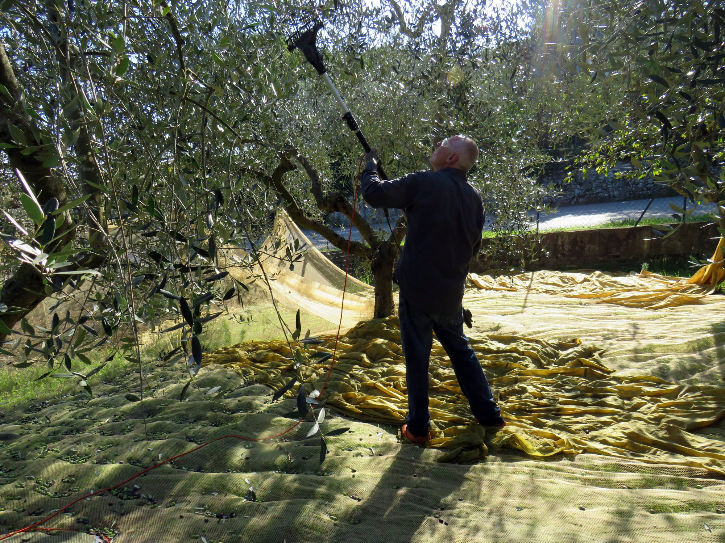
Figure 1: Olive harvesting with a hand-held, battery-equipped harvester.
The battery therefore becomes the heart of the electrical system of every machine, with the purpose of storing and supplying direct current to the user. There are machines with motors of increasing power on the market, ranging from a voltage of 12 V, for those who have few plants to harvest, to go up to 36 V (the latter allow faster work). Power can be supplied by a shoulder battery, which the operator carries on his back, or by a cable connected to a normal car battery. In the first case, the operator is much freer to move around the field, but at the end of the working day the back suffers a lot. In the second case, however, the operator gets less tired but the cable (usually between 10 and 15 m) can slow down his movements a little. There are also other types of harvesters, as motorized olive harvesters, which are extremely powerful and efficient. These models are not used much because they are heavy and produce a rather loud noise. Finally, there are pneumatic olive harvesters on the market, in which the power is transmitted by the pressurized air produced by a compressor (petrol-powered). The great advantage of these models is that high power is combined with freedom of movement, but the power supply system is certainly more complex than an electric battery or an internal combustion engine. To date, the most used harvester models remain battery-powered ones, especially car-type batteries. Here, a hand-held, battery-powered olive harvester of 140 W nominal power is considered.
When working in the countryside or in places far from inhabited centers, where obviously there is no mains electricity to draw on, the key problem becomes supplying energy to the battery to recharge it and put agricultural tools into operation. The charge duration of a battery that powers the olive harvester varies from 2 hours (if already used many times) to 8 hours (if new) of continuous use. Having to change the battery is certainly a problem, especially, as often happens, if the place where the olives are harvested is far from the place where the battery can be recharged. The farmers with whom the authors started this type of experimentation are from the Bagheria area, in Palermo, Sicily. The places of the olive harvest in Bagheria are: Bellacera, Monte Consona, and Monte Porcara. The farmers have confirmed that, once the battery has run down, going home to replace it with one that has been put on charge or (even worse from the point of view of wasted time) to recharge it, can lead to the loss of several hours of work or, worse, directly to the stop of the working day. Furthermore, this going forward and returning from the countryside involves a considerable waste of petrol, especially if the countryside is in the mountains, and a greater risk to safety. In fact, these country roads are not paved and are often difficult to travel with cars or lambrettas. In addition, returning home to provide for the battery is experienced as stress by the farmers and does not contribute to making the harvesting work serene.
A solution would be to carry one or more spare batteries. With only one spare battery (per person) the problem is not completely resolved, as the working day is extended by a few hours, but it is not possible to exploit all the hours of light because even the spare battery runs out. Carrying more than one spare battery (per person) could solve the problem of energy autonomy, but it would create another one, that of weight and size. The transport of three or four batteries of about 15 kg each, necessary to guarantee the olive harvesting operation for a farmer throughout the day, is an extremely difficult, almost prohibitive, undertaking.
3. PV system for olive harvester
The solution to the above problem proposed by authors is that of a low-cost PV system (Petrova et al., 2009), which acts as a support for the battery of the harvester. The PV system, while continuously supplying electricity to the battery, allows agricultural work to be carried out, such as that of the olive harvest analyzed here, without interruptions, with a zeroing of the electricity costs for recharging the battery itself. The hand-held olive harvester requires a portable PV system taking advantage of solar energy.
It is possible to work in two modes. The first mode is using a double battery; in this way the charge of one battery is used and at the same time the second one is undergoing recharging with the PV system. Then, when the battery farmer is working with runs out, the farmer changes it and can continue to work. The second method is using just one battery and keeps it always under charge, while having the agricultural implement in operation (Figure 2). In this case, a wheelbarrow or a two-wheel cart should be used to facilitate handling and moving the PV powering system.

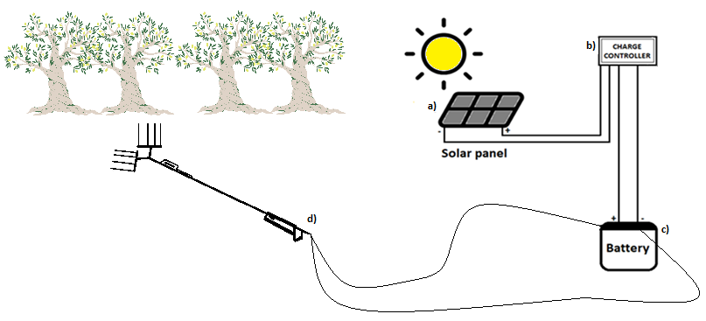
Figure 2: Scheme of the hand-held olive harvester supported by the DIY PV system. The components are a) Solar panel; b) Charge controller; c) Battery; d) Hand-held olive harvester.
The DIY PV system realized by authors consists of a solar PV panel, a charge regulator, and a conventional car battery (price €80). The photovoltaic panel is a device that allows the direct conversion of solar radiation into electricity, exploiting the photoelectric effect, and is the basic element of the PV system. Improving the efficiency of PV panels without increasing costs is a research field in physics, chemical and energy engineering. To date, the maximum efficiency of a commercial PV panel is around 20%. In the present case an online commercially available photovoltaic panel (Figure 3) has been adopted, which is thin, light and able to flex solar, with a photovoltaic conversion surface of about 0.5 m², a nominal output power of 75 W, output voltage as 5V/12-18V, at a price of 40 €.

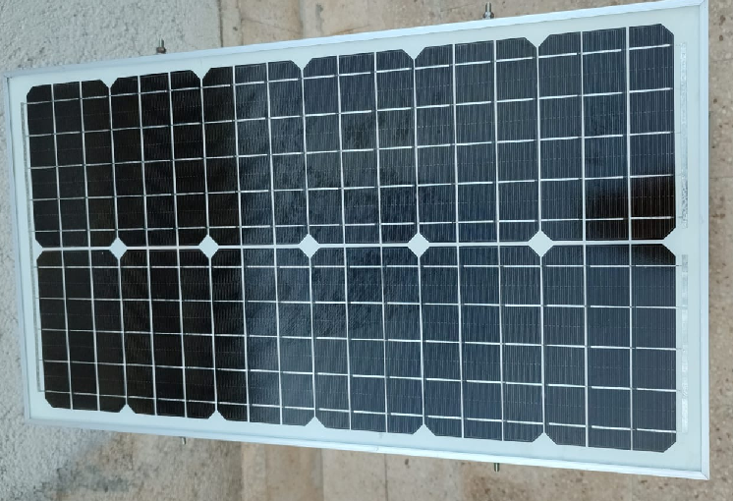
Figure 3: A thin, light and able to flex PV solar panel, with conversion surface of about 0.5 m², 75 W nominal output power, 5V/12-18V output voltage, price €40.
The charge controller allows to supply the right degree of current to the battery, protecting it from excessive discharge or charge. It is inserted between the battery and the solar panel and will stop sending electricity to the battery once this latter has been fully charged; therefore, it protects the battery from overcharging or reverse polarity. In this way it is possible to prolong life of battery. A commercially online available charge controller was adopted (Figure 4).

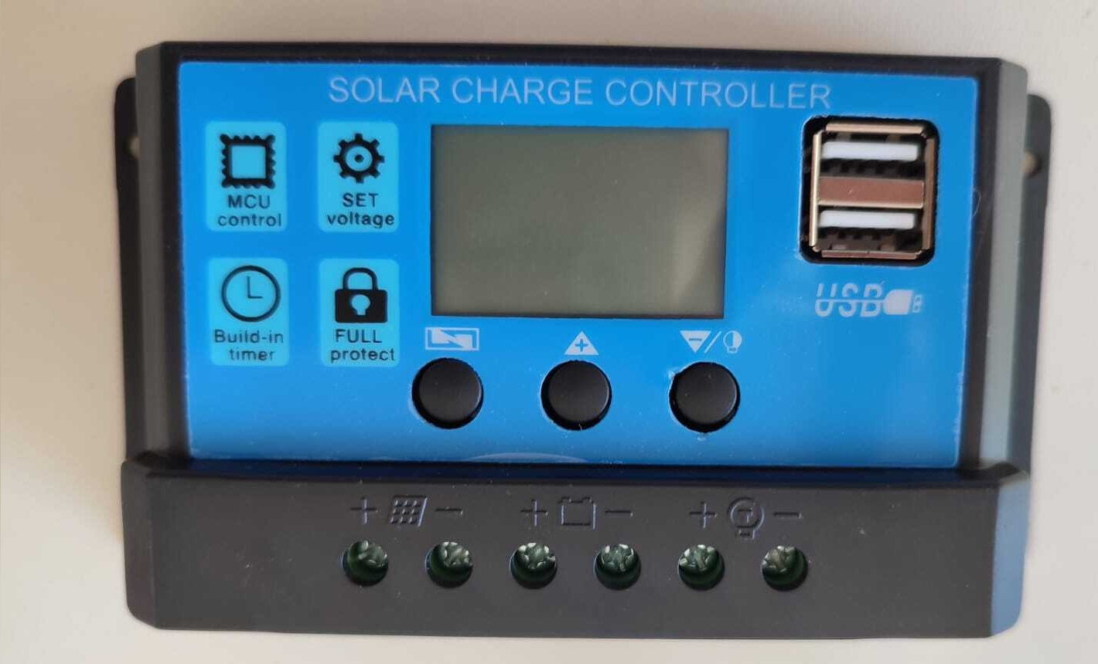
Figure 4: The charge controller adopted for DIY PV system, price €10.
Table 1 lists all the components of the developed DIY photovoltaic system and reports the price of each one as well as the total cost, which turns out quite cheap.
Table 1: Components of the photovoltaic system and related prices
Components | Price
Solar panel 75 W output | €40
Battery 60 Ah | €80
Charge controller | €10
Switches, cables and minor accessories | €30
Total cost | €160

A more elaborate version of the system would provide, thanks to the adoption of a further component such as an inverter, the possibility of producing electricity at a voltage of 220 V. This is the case in which, for example, the operation of a water pump is required.
4. Results
In simple economic terms, an increased income results for the farmer who is enabled to work more hours in daylight and, therefore, to harvest a larger number of olives. Before introducing PV system, the farmer could harvest in ideal conditions (i.e., trees full of olives and not far from each other) about 100 kg of olives in one hour. In a working day of almost 4 h (this is the average duration of the charge of a battery of 60 Ah in use by the farmer) the harvested quantity was about 400 kg. The working day always lasted a little longer because, as mentioned above, once discharged the battery, the harvesting proceeded manually for a while. However, the quantity of 400 kg is always considered as a reference because work is almost never done in ideal conditions (the trees are not always overflowing with olives and are often far from each other and therefore some time is lost when moving from tree to tree). Since in Sicily a quintal of freshly harvested olives is valued on average around 60 €, the yield of a day's work for each farmer was, before introducing the PV system support, around 240 €/d. With the support of the PV system, things have changed for the better. On sunny or partly cloudy days in the months of September and October (i.e., the season of olive harvesting), during this experimentation lasting 18 days in 2022, the harvest has increased significantly, reaching an average collection of around 750 kg/day, thus increasing the daily income to around 450 €/day. Furthermore, as reported by the farmers, with the use of PV the work proceeds more serenely because, at least on days when there is sun or little cloud, there is no psychological stress because the battery can run out.
5. Conclusions
A DIY PV system has been developed starting from easily available commercial components and introduced as a support means for a conventional battery-operated olive harvester. This solution to the problems the farmers previously faced due to the limited autonomy of the battery powering the agricultural implement has also made it possible to cancel the cost of electricity for recharging the battery itself, and above all to carry out agricultural work without interruptions. Also, the cost of petrol for transportation has been reduced since the farmer was no longer needed to return home from the fields to recharge the battery. Furthermore, the benefits are not limited to the above ones, as avoiding total discharge of the battery extends its life.
Being able to work without interruption, on sunny or slightly cloudy days and in the months of September and October 2022, the farmers were allowed to maximize the olive harvest, with obvious economic advantages. The farmers have expressed full gratitude for this solution found by the authors and have decided not only to continue using the photovoltaic system but also to extend it to other agricultural tools or applications, thus making work in the fields more sustainable. The use of this prototype will be offered to more and more farmers and not just limited to the olive harvest. In fact, it is possible to create a PV system for various types of agricultural machinery, even those that work at voltages other than 12 V, such as 24 or 48 V. In these cases, the developed photovoltaic system is to be complemented by a small voltage booster.
References
Akata, A.M., 2021, The effect of roof integrated photovoltaic (RIPV) on building indoor air in African tropical climate. J. Renew. Energy Environ., 9 (1), pp. 53-62.
Altouni A., Gorjian S., Banakar A., 2021, Development and performance evaluation of a photovoltaic-powered induction cooker (PV-IC): An approach for promoting clean production in rural areas, Cleaner Engineering and Technology, 6.
Armaroli N., Balzani V., 2007, The future of energy supply: challenges and opportunities, Angew Chem Int Edit 46, 52-66.
Barker P.P., Bing J.M., 2005, Advances in solar photovoltaic technology: an applications perspective, Conference Paper. In: Presented at IEEE Power Engineering Society Summer Meeting.
Botero-Valencia J.S., Mejia-Herrera M., Pearce J. M., 2022, Low cost climate station for smart agriculture applications with photovoltaic energy and wireless communication, Hardware X, 11.
Cosenza B., Miccio M., Greco C., 2023, Implementation and Experimentation of a Low-cost DIY Photovoltaic System, Chemical Engineering Transactions, 100, 601-606.
Foster R., Ghassemi M., Cota A., 2009, Solar energy: Renewable energy and the environment. 1st Edition. Eds: Cota A, Foster R, Ghassemi M. Taylor & Francis eBooks, CRC Press.
Habib S., Liu H., Tamoor M., Zaka M. A., Jia Y., Hussien A.G., Zawbaa H. M., Kamel S., 2023, Technical modelling of solar photovoltaic water pumping system and evaluation of system performance and their socio-economic impact, 9 (5).
Hassanien R., Hassanien E., Li M., Lin W.D., 2016, Advanced applications of solar energy in agricultural greenhouses, Renewable and Sustainable Energy Reviews, 54, 989-1001.
Kazem H. A., Al-Waeli A.H., Chaichan M.T., Sopian K., Ahmed Said Al, Busaidi A. S. A., Gholami A., 2023, Photovoltaic-thermal systems applications as dryer for agriculture sector: A review Case Studies in Thermal Engineering, 47.
Lombardi G.N., Berni R., 2021, Renewable energy in agriculture: Farmers willingness-to-pay for a photovoltaic electric farm tractor, Journal of Cleaner Production, 313.
Mohebi P., Roshandel R. 2023, Optimal design and operation of solar energy system with heat storage for agricultural greenhouse heating, Energy Conversion and Management: X.
Nacer T., Hamidat A., Nadjemi O., Bey M., 2016, Feasibility study of grid connected photovoltaic system in family farms for electricity generation in rural areas, Renewable Energy,96 Part A, 305-318.
Opoku R., AhunuB., Ayetor G. K.K., Ayitey D.T., Uba F., Asiedu N., Obeng G.Y., 2023, Unlocking the potential of solar electric vehicles for post-COVID recovery and growth in the transport sector in Ghana, Scientific African, 20,
Panwar N., Kaushik S, Kothari S., 2011, Role of renewable energy sources in environmental protection: a review, Renew Sust Energ Rev 15, 1513-1524.
Petrova-Koch V., Hezel R., Goetzberger A., 2009, High-Efficient Low-Cost PV, in Springer Series in Optical Sciences (SOOS, 140).
Sayigh A., 2022, Sustainable Energy Development and Innovation, Selected Papers from the World Renewable Energy Congress (WREC) 2020, Springer, in Innovative Renewable Energy.
Semeraro T, Scarano A., Santino A., Emmanuel R., Lenucci M., 2022, An innovative approach to combine solar photovoltaic gardens with agricultural production and ecosystem services, Ecosystem Services, 56.
Stanojevic B., 2021, Application of photovoltaic technology in the use of solar energy, Annals of Environmental Science and Toxicology , 5 (1), 094-098.
Xue J., 2017, Photovoltaic agriculture - new opportunity for photovoltaic applications in China, Renew. Sustain. Energy Rev,73,1-9.
Yan Y., Wang Y., Yan J., Liu Z., Liao Q., Wang B., 2023, Tech-economic modeling and analysis of agricultural photovoltaic-water systems for irrigation in arid areas are, Journal of Environmental Management, 338.
Yano A., Cossu M., 2019, Energy sustainable greenhouse crop cultivation using photovoltaic technologies, Renewable and Sustainable Energy Reviews, 109, 116-137.

