|  |  |
| --- | --- |
| cetlogo ***CHEMICAL ENGINEERING TRANSACTIONS***  ***VOL. , 2023*** | A publication of  aidiclogo_grande |
| The Italian Association  of Chemical Engineering  Online at www.cetjournal.it |
| Guest Editors: David Bogle, Flavio Manenti, Piero Salatino  Copyright © 2023, AIDIC Servizi S.r.l. **ISBN** 979-12-81206-04-5; **ISSN** 2283-9216 | |

Innovative Treatment of Digestate and Biogas Upgrade using *Chlorella vulgaris*

Shabnam Mirizadeh, Margherita Pettinato, Bruno Fabiano, Attilio Converti and Alessandro Alberto Casazza\*

Department of Civil, Chemical and Environmental Engineering, University of Genoa, via Opera Pia 15, 16145 Genoa, Italy

alessandro.casazza@unige.it

In the era of energy transition, the research efforts are devoted to find sustainable solutions to enable the transition to a decarbonised energy and production system, by renewable energy sources promoting products circularity, green technologies and safer processes. Anaerobic digestion is a bioprocess involving organic substrate breakdown by various microbial species in the oxygen absence. It yields two valuable products: digestate and biogas. Digestate can be used as fertilizer after stabilization and reduction of its polluting load. Through an upgrading process, biogas can be converted into biomethane, a widely utilized resource in energy and transportation. In this study, a non-conventional method has been investigated to achieve simultaneous biomethane production and reduction of digestate polluting power using *Chlorella vulgaris*, resulting in two valuable products. A 6-liter anaerobic digester was fed with simulated municipal organic waste every 3 days. Biogas was fed into a photobioreactor, where *C. vulgaris* was cultivated under mixotrophic conditions, utilizing CO2 from biogas as a carbon source. Biogas was converted into biomethane with over 90% methane content, while digestate was treated in the same photobioreactor, reducing its chemical oxygen demand (COD) by up to 80%. Using CO2 from biogas, maximum cell concentration of 1.332 g/L, maximum specific growth rate of 0.091 day-1 and biomass productivity of 0.057 gBS/L d were obtained at 70 µmol/m2 s. Biogas was analyzed by gas chromatography, and digestate was assessed for suspended solids, total solids, and COD. After cultivation, biomass was harvested, dehydrated, and characterized for total lipids and calorific value. Combining both approaches transforms waste into valuable biomethane and microalgal biomass, supporting the zero-waste objective.

1.Introduction

Waste reduction programs aim to reduce the amount of waste generated by primarily promoting sustainable consumption practices, such as using reusable bags and containers, purchasing products with minimal packaging, and opting for durable and repairable items over disposable ones. These programs have the ultimate goal of fostering a more environmentally conscious approach to consumption and minimizing the overall amount of waste produced (Fercoq et al., 2016). Summarizing, sustainable solutions aim at creating a balance among economic, social, and environmental factors to ensure long-term sustainability. Sustainable waste management solutions focus on reducing waste, minimizing environmental impact, and maximizing economic benefits through methods such as recycling, composting, waste reduction programs, and anaerobic digestion (Mortier et al., 2016). Nevertheless, sustainability implies further to find the most economical and safest way producing and using energy, promoting product [circularity](https://www.sciencedirect.com/topics/engineering/circularity) and the avoidance of unnecessary losses, by damage to property and environment. The process industry is facing new challenges under the pressure exerted by three fundamental drivers, i.e., climate change, energy transition and digitalization. In this regard, many new processes are being researched, which given green energy, will be beneficial to reduce greenhouse gases and enhance sustainability, but of which hazards are rather unknown. (Pasman et al., 2023). Anaerobic digestion is a process that has gained increasing attention as a sustainable method for managing organic waste while generating renewable energy and can be successfully exploited also in SMEs of given sectors, e.g the dairy one (Maffini et al., 2023). The process involves breakdown of organic matter, such as food waste, animal manure, and agricultural residues, in the absence of oxygen to produce biogas, which can be used as a source of renewable energy (Braber, 1995). One of the most significant advantages of anaerobic digestion is that it provides a sustainable solution for managing organic waste, which would otherwise end up in landfills contributing to greenhouse gas emissions and pollution. Additionally, biogas produced through anaerobic digestion can be used to generate electricity, heat or fuel for transportation, which can help reduce our reliance on fossil fuels and mitigate climate change (Whiting and Azapagic, 2014). However, it is important to note that the efficiency and effectiveness of anaerobic digestion depend on various factors such as the type of feedstock, temperature, pH, as well as the design and operation of the system. Therefore, careful planning and management are crucial to ensure optimal performance and avoid potential issues such as odours and nutrient imbalances (Panigrahi and Dubey, 2019). Additionally, biogas production facilities are associated to an increasing number of accidents. Moreno et al. (2016) reported that more than 200 accidents were in the biogas sector from 1998 and 2018, with an increasing rate higher than that of biogas production, involving also plant upgrading. Hazards related to biogas supply chain include factors related to the intrinsic properties of the chemicals involved in the process, like flammability and explosivity of methane, and toxicity and corrosiveness of hydrogen sulphide, human factors, organizational factors, since likewise in the process sector (Fabiano et al., 2022) maintenance and operational errors represent relevant contributors to the unwanted occurrence of hazardous scenarios. Biogas upgrading is the process of cleaning and purifying biogas to remove impurities such as carbon dioxide, hydrogen sulfide, water vapor, and trace contaminants to produce a high-quality biomethane. The resulting biomethane can be directly injected into the natural gas grid, used as a vehicle fuel, or compressed for storage and distribution (Aghel et al., 2022). The biogas upgrading process typically involves several steps, including compression, dehydration, and removal of impurities. There are several methods for upgrading biogas, including pressure swing adsorption, water scrubbing, and membrane separation (Grande, 2011).

The benefits of biogas upgrading are numerous. First, it increases the energy content of biogas, making it a more valuable and versatile fuel. Second, it improves the quality of biogas, making it suitable for use in applications that require high-purity methane, such as traction of natural gas vehicles. Third, upgrading biogas reduces greenhouse gas emissions by replacing fossil fuels with renewable biomethane. Overall, biogas upgrading is an important step in the production of renewable energy from organic waste since it allows for the efficient use of biogas, reduces greenhouse gas emissions, and provides a sustainable alternative to fossil fuels (Sun et al., 2015). Biogas upgrade using microalgae is a novel and promising approach to clean and purify biogas while simultaneously producing biomass as a valuable co-product. This process involves the use of microalgae, which are photosynthetic microorganisms that can capture and utilize carbon dioxide from biogas and other waste streams (Converti et al., 2009a). Microalgae are usually grown in photobioreactors, which are closed systems providing optimal conditions for growth and photosynthesis. As the microalgae grow, they consume carbon dioxide and other impurities from biogas, producing oxygen and biomass as a co-product. The resulting biomass can be used as a high-value feedstock for the production of biofuels, animal feed, or other bioproducts. Additionally, the purified biogas can be directly injected into the natural gas grid or used as a fuel for transportation (Casazza et al., 2020). Digestate, which is the residual material produced from anaerobic digestion of organic waste, has a high polluting power that can be reduced using microalgae prior to its release into the environment. It in fact contains high levels of nutrients, such as nitrogen and phosphorus, as well as trace contaminants, which would pose a risk to the environment if not properly managed. Microalgae are able to reduce digestate polluting power because they can consume and utilize nutrients and contaminants contained in it as carbon source (Chong et al., 2022). In this study, *Chlorella vulgaris* was used both for biogas upgrading and for reducing the polluting impact of digestate from anaerobic digestion of organic fraction of municipal solid waste (OFMSW) due to its easy cultivation in various environments, even raw wastewater, and significant lipid content. Two photosynthetic photon flux densities (PPFD) (70 and 40 µmol/m2 s) were tested, and the collected samples were characterized in terms of microalgal biomass concentration and COD reduction.

2.Materials and Methods

**2.1 Microorganism and chemicals**

*Chlorella vulgaris* CCAP 211 was obtained from the Culture Collection of Algae and Protozoa (CCAP) (Argyll, UK), and CCAP's specifications were followed to reactivate it. The inoculum was prepared in Bold's Basal Medium (BBM), a nutrient-rich culture medium commonly used for growing microalgae (Converti et al., 2009b). Cells were incubated in a 1-L Erlenmeyer flask for 7 days under aeration and constant light conditions (70 7tµmol/m2 s). The culture was carried out at a temperature of 20 ± 2 ºC to ensure optimal growth conditions to the microalga.

**2.2 Anaerobic digestion**

The simulated OFMSW was used as a substrate for the anaerobic digestion process. It was stabilized through dehydration and partial sanitization, eliminating both water (residual moisture of 5-8%) and potential bacterial load. Feeding was conducted every 84 hours (twice a week) by mixing 10 g of material in 200 mL of deionized water. An equal volume of digestate was removed from the digester prior to feeding. The system, depicted in Figure 1 (on the left), had a total volume of 6 liters with working volume of 5 liters and was provided with a mechanical agitation system activated every 4 hours at 120 rpm for 15 minutes. The temperature inside the digester was maintained at 35 ± 1 °C by circulating water from a thermostatic bath at 40 ± 3 °C through an internal and external coil arrangement. The pH was maintained within the range of 6.9 to 7.1 by adding 1 M NaOH when necessary. The collected digestate was stored at 4 °C and later used as part of *C. vulgaris* culture medium.

**2.3. Growth of *Chlorella vulgaris* in the presence of digestate using different light intensity**

Cultures were carried out in fed-batch mode using *C. vulgaris* in 250-mL bubble columns (Figure 1 on the right) containing BBM enriched with 50% of digestate, previously centrifuged at 7500 rpm for 10 minutes to remove most of the solid residues. Carbon dioxide was supplied by continuous aeration (0.04% CO2 v/v) and by daily addition of 200 mL of biogas (30% CO2 v/v). In the second case, to avoid the sedimentation of cells, agitation was ensured by a magnetic stirrer. *C. vulgaris* was inoculated so as to ensure an initial concentration of 0.2 g of dry biomass per liter of medium (gBS/L). Experiments at different PPFDs (70 and 40 µmol/m2 s) and temperatures (25, 27, and 29 °C) were performed under the same conditions as described above. The growths were compared with control growths using only BBM as a medium. After runs (21 days), biomass was collected by centrifugation (5 min at 3500 rpm) and freeze-dried.

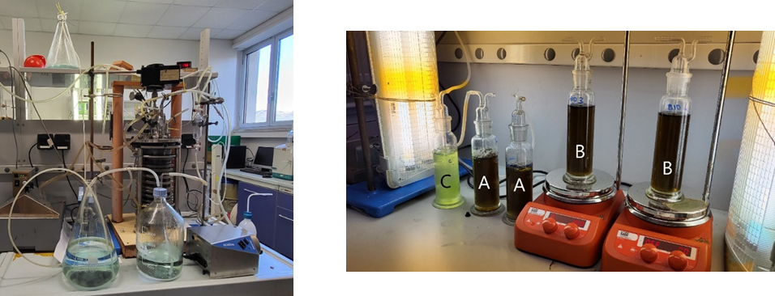

*Figure 1:*  *6-L bioreactor used for OFMSW anaerobic digestion (left hand side). C. vulgaris cultures in 0.25-L bubble columns (C = control run, A = growth with digestate and continuous air supply, B = growth with digestate and biogas) (right hand side).*

***2.4* Analyses**

Cultures of *C. vulgaris* were periodically examined using an optical microscope, and biomass concentration was quantified daily using a spectrophotometer (Lambda 25 UV/VIS, PerkinElmer) at a wavelength of 625 nm, using the following calibration curve (Eq. 1):

${ABS}_{625}=4.203 x$ (1)

where ABS625 is the absorbance value at a wavelength of 625 nm and *x* is the concentration of dry biomass expressed in gDB/L.

After each run, supernatants coming from the centrifugation step were filtered through a cellulose acetate membrane with 0.45 µm pore diameter and used for COD determination. The analysis was performed following the methodology described by Spennati et al. (2021). Samples were assessed using a spectrophotometer (Macherey-Nagel Compact photometer PF-12Plus) at a wavelength of 620 nm, and the absorbance was correlated to the COD using the calibration curve:

${ABS}_{620}=0.0004 y$ (2)

where *y* is the value of COD expressed in mgO2/L.

Biogas composition before and after the CO2 removal was characterized by gas chromatographic analysis using a microGC (CP2002, Chrompack).

3. Results and Discussions

In all growths with 50% digestate in BBM, it was observed that biomass concentration was influenced by the presence of a highly stressful environment. An inhospitable context led not only to a decrease in microalgal concentration but also to the formation of cellular aggregates observed by optical microscopy.

The growth curves of *C. vulgaris* in the presence of digestate and CO2 from biogas as carbon source are compared to control runs in Figure 2.

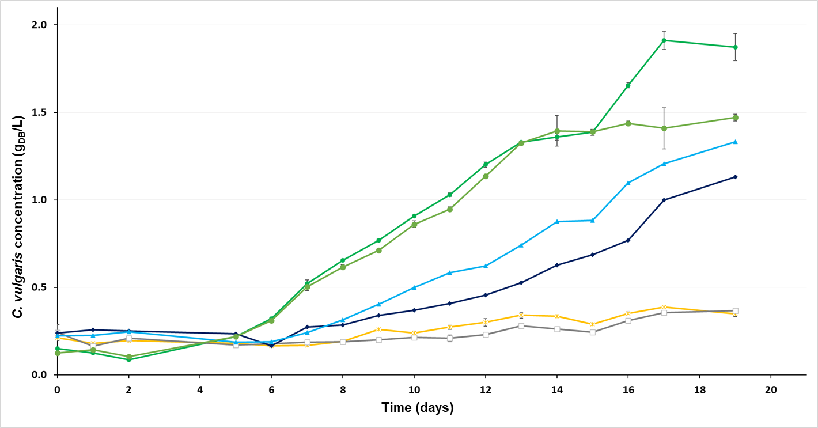

*Figure 2: C. vulgaris growth curves at 25 °C. control run,* ⯅ *run with CO2 from biogas and* □ *run with CO2 from air at PPFD = 70 µmol/m2 s. control run, run with CO2 from biogas and* **X** *run with CO2 from air at PPFD = 40 µmol/m2 s.*

It can be seen that growths in the presence of biogas as a source of CO2 showed a trend comparable to that of the controls for both 70 and 40 µmol/m2 s lighting conditions. Growth kinetic parameters are gathered in Table 1.

*Table 1: Growth kinetic parameters at 25 °C (µ = specific growth rate, Cmax = maximum concentration reached during growth, µmax = specific growth rate calculated at the time of reaching Cmax, and ν = biomass productivity).*

|  |  |  |  |  |
| --- | --- | --- | --- | --- |
| Run | *µ*  (days-1) | *Cmax*  (gBS/L) | *µmax*  (days-1) | *ν*  (gBS/L d) |
| Control (70 µmol/m2 s) | 0.133 | 1.979 | 0.162 | 0.091 |
| Control (40 µmol/m2 s) | 0.120 | 1.489 | 0.120 | 0.074 |
| CO2 from air (70 µmol/m2 s) | 0.022 | 0.366 | 0.022 | 0.007 |
| CO2 from air (40 µmol/m2 s) | 0.026 | 0.385 | 0.035 | 0.010 |
| CO2 from biogas (70 µmol/m2 s) | 0.083 | 1.332 | 0.091 | 0.057 |
| CO2 from biogas (40 µmol/m2 s) | 0.080 | 1.130 | 0.085 | 0.053 |

The lack of growth in the continuously aerated cultures, confirmed by the very low values of all growth kinetic parameters listed in Table 1, can be attributed to the high oxygenation provided by air bubbling, which allowed the proliferation of contaminating organisms such as ciliates and rotifers, i.e., protozoa and metazoa that feed on unicellular algae such as *C. vulgaris* (Figure 3).

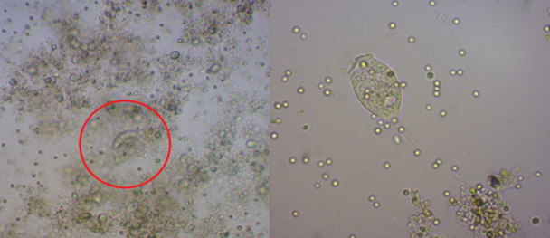

*Figure 3:**Optical microscope images showing the presence of a rotifer (on the left) and Vorticella sp. (on the right) in the culture with 50% digestate and air as carbon source carried out at PPFD of 70 µmol/m2 s.*

Reduction of digestate polluting power

The analyses on the reduction of digestate polluting power focused on the decrease of COD, taking as a reference the initial COD value of the digestate (3000 mgO2/L) obtained from continuous anaerobic digestion of OFMSW performed in the 6 L bioreactor.

As can be seen in Figure 4, a significant reduction of COD occurred in all experiments, with a maximum reduction of no less than 94% in run carried out with digestate and CO2 provided by continuous air supply, in which the COD decreased from 3000 to 182 mgO2/L after 20 days of *C. vulgaris* growth.

**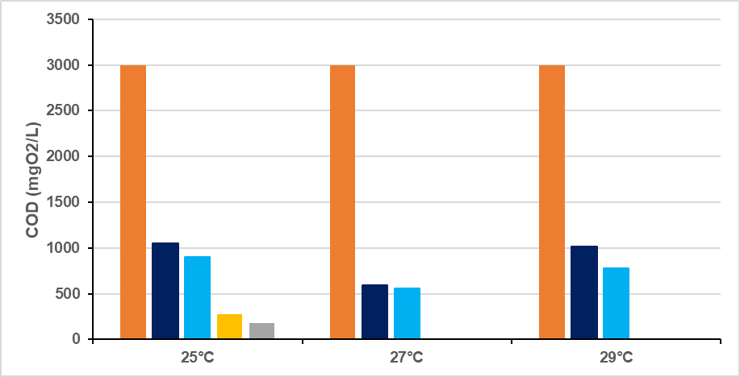**

*Figure 4: Reduction of chemical oxygen demand (COD) during C. vulgaris growth using different PPFD values and CO2 sources ( digestate, CO2 from air at 70 and 40 µmol/m2 s, CO2 from biogas at 70 and 40 µmol/m2 s).*

Table 2 shows the percentages of methane present in the biogas before and after the treatment with *C. vulgaris*, the remaining percentage being made up of carbon dioxide. As can be seen, the percentage of methane leaving the microalgal growth system was always higher than the entering one, resulting in a consequent reduction of carbon dioxide content. In general, methane concentrations of over 90% were always observed, with a maximum of 97% reached in the growth carried out at 25 °C and 70 µmol/m2 s.

*Table 2: Percentage of methane at the inlet and outlet of the microalgal growth system and percentage of removed carbon dioxide.*

|  |  |  |  |  |
| --- | --- | --- | --- | --- |
| Run | CH4 inlet  (%) | CH4 outlet  (%) | CO2 removal  (%) | CH4 upgrade  (%) |
| Control (70 µmol/m2 s) | 80.41 | 95.34 | 83.20 | 76.22 |
| Control (40 µmol/m2 s) | 79.15 | 96.72 | 89.08 | 84.27 |

4. Conclusions

The results obtained in this study confirm the possibility of using *Chlorella vulgaris* for the treatment of digestate obtained from anaerobic digestion of the organic fraction of municipal solid waste, as well as for the simultaneous upgrading of biogas to biomethane. The presented process solution aims at reducing environmental pollution and plant/process hazards compared to other biogas upgrading alternatives, potentially contributing to transition to carbon neutral and circular economy. The growth of *C. vulgaris* in the presence of digestate and biogas as a source of CO2 was excellent at the optimal temperature for the microalga (25 °C) under both selected lighting conditions (PPFD = 70 and 40 µmol/m2 s). At the same time, *C. vulgaris* allowed the reduction of digestate polluting power, achieving a decrease in chemical oxygen demand between 65 and 94% in all tested conditions. In addition, all growths allowed biogas upgrading, reaching final methane percentages of up to 97% and a removal of CO2 close to 90%.

Acknowledgments

The authors gratefully acknowledge partial funding by INAIL within the framework of the call BRIK/2021/ID3 (project DRIVERS Approccio combinato data-driven ed experience driven all’analisi del rischio chimico).

References

Aghel B., Behaein S., Wongwises S., Shadloo M.S., 2022, A review of recent progress in biogas upgrading: With emphasis on carbon capture, Biomass and Bioenergy, 160, 106422.

Braber K., 1995, Anaerobic digestion of municipal solid waste: a modern waste disposal option on the verge of breakthrough, Biomass and Bioenergy, 9, 365-376.

Casazza A.A., Spennati E., Converti A., Busca G. 2020, Production of carbon-based biofuels by pyrolysis of exhausted *Arthrospira platensis* biomass after protein or lipid recovery, Fuel Processing Technology, 201, 106336.

Chong C.C., Cheng Y.W., Ishak S., Lam M.K., Lim W.J., Tan I.S., Show P.L., Lee K.T., 2022, Anaerobic digestate as a low-cost nutrient source for sustainable microalgae cultivation: A way forward through waste valorization approach, Science of the Total Environment, 803, 150070.

Converti A., Casazza A.A., Ortiz E.Y., Perego P., Del Borghi M., 2009b, Effect of temperature and nitrogen concentration on the growth and lipid content of *Nannochloropsis oculata* and *Chlorella vulgaris* for biodiesel production, Chemical Engineering and Processing: Process Intensification, 48, 1146-1151.

Converti A., Oliveira R.P.S., Torres B.R., Lodi A., Zilli M., 2009a, Biogas production and valorization by means of a two-step biological process, Bioresource Technology, 100, 5771-5776.

Fabiano, B., Pettinato, M., Currò, F., Reverberi, A.P., 2022, A field study on human factor and safety performances in a downstream oil industry, Safety Science, 2022, 153, 105795.

Fercoq A., Lamouri S., Carbone V., 2016, Lean/Green integration focused on waste reduction techniques, Journal of Cleaner Production, 137, 567-578.

Grande C.A., 2011, Biogas upgrading by pressure swing adsorption, In: Biofuel's Engineering Process Technology (dos Santos Bernardes, M.A.), IntechOpen Limited, London, UK.

Maffini A., Morando M., Saba A.G., Bonvicini G., Fabiano B. 2023. Valorization of biomass from dairy wastes: integrated resources and energy recovery. Chemical Engineering Transactions, 98, 99-104.

Moreno V. C., Papasidero S., Scarponi, G. E, Guglielmi D., Cozzani V., 2016, Analysis of accidents in biogas production and upgrading, Renewable Energy, 96, 1127-1134.

Mortier N., Velghe F., Verstichel S., 2016, Organic recycling of agricultural waste today: Composting and anaerobic digestion, Biotransformation of Agricultural Waste and By-Products, In: Biotransformation of Agricultural Waste and By-Products (Poltronieri, P., D'Urso, F., Eds.), Chapter 4, Elsevier, 69-124.

Panigrahi S., Dubey B.K., 2019, A critical review on operating parameters and strategies to improve the biogas yield from anaerobic digestion of organic fraction of municipal solid waste, Renewable Energy, 143, 779-797.

Pasman H., Sripaul E.,Khan F., Fabiano B., 2023, Energy transition technology comes with new process safety challenges and risks, Process Safety and Environmental Protection, 177, 765-794.

Spennati E., Mirizadeh S., Casazza A.A., Solisio C., Converti A., 2021, *Chlorella vulgaris* and *Arthrospira platensis* growth in a continuous membrane photobioreactor using industrial winery wastewater, Algal Research, 60, 102519.

Sun Q., Li H., Yan J., Liu L., Yu Z., Yu X., 2015, Selection of appropriate biogas upgrading technology-a review of biogas cleaning, upgrading and utilisation, Renewable and Sustainable Energy, 51, 521-532.

Whiting A., Azapagic A., 2014, Life cycle environmental impacts of generating electricity and heat from biogas produced by anaerobic digestion, Energy, 70, 181-193.