|  |  |
| --- | --- |
| cetlogo ***CHEMICAL ENGINEERING TRANSACTIONS***  ***VOL. , 2023*** | A publication of  aidiclogo_grande |
| The Italian Association  of Chemical Engineering  Online at www.cetjournal.it |
| Guest Editors: David Bogle, Flavio Manenti, Piero Salatino  Copyright © 2023, AIDIC Servizi S.r.l. **ISBN** 979-12-81206-04-5; **ISSN** 2283-9216 | |

HS3 Solvent Aspen Plus Model Validation Using Tiller Pilot Plant Data

Matteo Gilardia,b,\*, Filippo Bisottia,\*, Hanna K. Knuutilac, Davide Bonalumib

a SINTEF Industry – Process Technology, Sem Sælands vei 2A, 7491, Trondheim (Norway)

b Politecnico di Milano, Department of Energy, Via Lambruschini, 4A, 20156, Milano (Italy)

c Department of Chemical Engineering, Norwegian University of Science and Technology, NTNU, Trondheim, 7491, Norway

corresponding authors: [matteo.gilardi@sintef.no](mailto:matteo.gilardi@sintef.no), [filippo.bisotti@sintef.no](mailto:filippo.bisotti@sintef.no)

Abstract

The HS3 solvent is an innovative blend for CO2 capture made up of a primary (3-amino-1-propanol, AP) and a tertiary (1-(2-hydroxyethyl) pyrrolidine, PRLD) amine studied in the H2020-funded Realise project. The thermodynamic framework has already been validated using experimental observations. The proposed thermodynamic model has been built into Aspen Plus V11 using the ENTRL (Electrolyte Non-Random Two Liquid) package and, then, finalized by including a mass transfer model and kinetics. The resulting full flowsheet simulation model has been validated using experimental measurements from Tiller semi-industrial pilot plant (Trondheim, Norway). The experimental campaign succeeded in demonstrating lower energy requirement and liquid recirculation compared to conventional monoethanolamine (MEA) at 30% w/w. The present contribution aims at presenting the validation procedure of the developed model over experimental data from the large-scale facility at Tiller and showing that the HS3 solvent is a promising blend to mitigate energy consumption in the CO2 capture process. All KPIs of the CO2 capture plant (CO2 capture rate, CO2 flow released in the stripper and temperature profiles inside the two columns) are predicted with an Absolute Average Relative Deviation (AARD) lower than 5% and with an Average Relative Deviation (ARD) close to zero. This statistical analysis demonstrates that the developed HS3 Aspen model can be used for simulation, energy analysis, and techno-economic assessment purposes.

* 1. Introduction

The decarbonization of several industrial sites is an essential step towards a net-zero emission scenario within the next 25 years. Carbon capture from industrial flue gases and its storage or utilization is gaining interest as a viable option to significantly mitigate the environmental impact of CO2 emissions from power generation (natural gas and coal-fired facilities) and industrial sources (Rochelle, 2009) such as chemical industries, refineries, cement producers, steel and metallurgic farms. Even if CO2 absorption with amines is already a mature technology, its large-scale deployment is still limited due to the high energy demand for the regeneration of the solvent. Thus, it is crucial to characterize and test alternative amine formulations to lower the operating costs of carbon capture (Vitillo et al., 2017; Pellegrini et al., 2021). In this context, a new blend called HS3 made up of a primary amine (3-amino-1-propanol, AP) and a tertiary amine (1-2-hydroxyethyl-pyrrolydine, PRLD) has been characterized within the European project Realise, included in the H2020 funding program. This blend combines the high CO2 uptake capacity provided by PRLD with the fast absorption rate of AP. This solvent has already been tested successfully both on a laboratory scale (Vapor-Liquid Equilibrium, namely VLE, and heat of absorption measurements) and on a large pilot scale at Tiller (webpage - Tiller CO2 laboratory, SINTEF, Norway). Pilot-scale data have been collected for a CO2 capture full process (absorption and desorber) for two different CO2 contents in the flue gas: 5.5 vol% and 11.9 vol% (both on a dry basis) representative of flue gas compositions from natural gas combustion and coal-fired power plant or waste-to-energy facilities, respectively. The experimental campaign took three months and consists of 54 runs and the design of experiments was set to properly cover the domain of main interest for industrial applications of the HS3 solvent, by optimizing operating conditions (i.e., minimum energy demand at different CO2 concentrations in the flue gas, optimal lean solvent loading and capture rate). Experimental evidence shows that HS3 reduces the solvent recirculation flow for a given flow (i.e., lower kgsolv/kgCO2 capt.) and it requires 15-20% less heat to be regenerated compared to benchmark MEA as reported in the Supplementary Material in (Gilardi et al., 2023). Currently, the research is focused on developing the HS3 model in a process simulator to catch solvent properties, design and optimize a CO2 capture plant, as well as to estimate its energy requirements and costs. A reliable and accurate model is required for the comparison between the total costs of a novel solvent, such as HS3, and a benchmark CO2 absorption plant.

* 1. Objectives and methods

This article deals with the development of a comprehensive ELECNRTL model (accounting for VLE, kinetics, and mass transfer) for the characterization of the innovative HS3 blend in Aspen Plus V11.0 and its validation over pilot-scale experimental observations collected at Tiller CO2 laboratory (Trondheim, Norway).

* + 1. Aspen Plus HS3 model development

HS3 has been modelled in Aspen Plus V11.0 by means of an ELECNRTL model, an activity-based thermodynamic package. This approach is an extension of the NRTL framework to also consider charged molecules interactions leading to non-ideal behaviours in the liquid phase (Lin et al., 2010). This approach is commonly adopted to model amine systems in Aspen Plus (Aspen Plus Documentation, 2019). The elementary reaction scheme has been defined in accordance with templates provided by AspenTech for similar amine blends. For each elementary reaction, the equilibrium constant is expressed using Aspen Plus compliant expressions. Parameters for these temperature-dependent constants are available in the literature for each of the listed reactions. Antoine expressions and Henry constants have been fitted to both in-house and published experimental vapour pressure and N2O solubility data (N2O analogy is exploited) for both pure amines. Both temperature-independent (GMELCC) and temperature-dependent (GMELCD) molecule-ion interaction parameters have been regressed as reported in (Gilardi et al., 2023). where an effective procedure to reduce the number of ELECNRTL interaction coefficients is addressed. The model tuning relied on in-house lab-scale experimental measurements for the HS3 blend. The formation enthalpies of AP and PRLD have been estimated using Gani’s group contribution method, while the formation enthalpies of protonated amines and carbamate have been regressed from the measured absorption heat for the two single amine systems. Further details on the procedure to develop the ELECNRTL equilibrium model for the new amine blend are available in (Gilardi et al., 2023). An Arrhenius-type kinetics has been implemented for global amine-H2O-CO2 reactions considering activation energies and exponential factors determined from previous studies for each amine (Henni et al., 2008; Liu et al., 2016). The diffusion coefficient of CO2 in the liquid mixture is calculated by the software using the Wilke-Chang method (Aspen Plus Documentation, 2019), which correlates diffusion coefficients to the viscosity of a liquid mixture. The Andrade model for liquid viscosity is tuned by means of in-house measurements.

* + 1. Model validation

The accuracy of the model is verified with a statistical analysis, using the Absolute Average Relative Deviation (AARD), Average Absolute Deviation (AAD - used only for VLE assessment), and Average Relative Deviation (ARD) defined as:

|  |  |
| --- | --- |
|  | (1) |
| $$AAD =\frac{1}{n} \sqrt{\sum_{i=1}^{n}{{\left(X_{model}-X_{exp}\right)}^{2}}}$$ | (2) |
| $$ARD [\%]=\frac{1}{n} \sum_{i=1}^{n}{\frac{X_{model}-X_{exp}}{X_{exp}}}⋅100$$ | (3) |

The ELECNRTL model accuracy in predicting heat absorption is estimated by comparing the reaction heat trends with loading at different temperatures with respect to the suggested experimental observations. The full model is finally validated on pilot-scale data. The reported flowsheet (Figure 1) reproduces the absorber and stripper units at the Tiller facility. It is a conventional post-combustion capture plant, but, for the validation, we focus on the single towers. The units are built in Aspen Plus using the rate-based model for both units. The full model (i.e., rate-based and kinetics) is adopted for the absorber. In the stripper, kinetics is disregarded, and only mass transfer limitations are accounted for. This assumption is often adopted since desorption reactions are fast enough (higher temperature) to make mass transfer the limiting step (Van Wagener and Rochelle, 2011). The pressure drop of the packing (Mellapak 2X) is calculated in Aspen Plus using the implemented subroutines. The model is validated on all 54 runs following the open-loop approach (absorber and stripper simulated separately). Table 1 provides more details on the assigned and compared variables for the validation of the HS3 solvent model.



Figure 1 – Flowsheet reproducing Tiller plant simulated in Aspen Plus V11: (A) absorber and (B) stripper.

Table 1: Summary of assigned and compared variables for HS3 Aspen PLUS model validation. The names of the streams refer to Figure 1. The packing (Mellapak 2X) is assigned for both columns.

|  |  |  |
| --- | --- | --- |
| **Unit** | **Input (assigned variables)** | **Output (compared variables)** |
| Absorber | * LEAN-SOL (T, P, flow, and composition) * SAT-GAS (T, P, flow, and composition) * ABS diameter (D = 0.20m) and packing height (H = 20m) | * Flow of captured CO2 * RICH-SOL loading * Temperature profile in ABS |
| Stripper | * RICHFEED (T, P, flow, and loading) * Reboiler duty * STRIP diameter (D = 0.15m) and packing height (H = 15m) * COND temperature | * Flow of released CO2 and specific reboiler duty (SRD) * LEANSOLV loading * Temperature profile in STRIP |

* 1. Results and comments

Section 3 reports the outcomes of the model validation in terms of relative deviations for each run at Tiller for the main key performance indicators (KPIs). Moreover, the ARD and the AARD are calculated. The first indicator should be as close to zero as possible to show the positive and negative deviations are well-balanced and there is no evident underestimation or overestimation. The second indicator defines how far the model prediction is from the corresponding experimental observations.

* + 1. VLE model testing over lab-scale data

The Aspen Plus VLE model for HS3 has been tested against equilibrium measurements (Figure 2). All VLE experimental data collected on the HS3 solvent within the Realise project have been equally weighted in the statistical test. Figure 2A contrasts the partial pressure of CO2 as predicted by the model and the experimental observations at different temperatures. The ELECNRTL model accurately represents the equilibrium conditions at all investigated temperatures and loadings (0.1 - 0.5) of interest for absorption and regeneration. The profiles show smooth trends. The AARDs for CO2 and H2O partial pressure are 16.5 % and 16.6 %, respectively. The AAD is 7 kPa for both partial pressures. Figure 2B and Figure 2C report absorption heat profiles at 60°C and 100°C, which are representative of the operating conditions characterizing the absorber and stripper, respectively. A statistical analysis of the results for the absorption heat predictions covering a range from 40°C to 100°C shows good agreement with the experimental data trend for the whole loading and temperature range of interest. The average calculated AARD over the investigated temperatures is 6.6%. Further details on the VLE model testing are available in (Gilardi et al., 2023).

Figure 2 – Comparison between the Aspen Plus model predictions (solid lines) and the experimental data (dots) for (A) CO2 partial pressure and (B, C) heat of absorption at different temperatures: 40°C (red), 60°C (light blue), 80°C (green), 100°C (yellow), and 120°C (grey). Data reported in (Gilardi et al., 2023).

* + 1. Open-loop validation

Figure 3 and Figure 4 depict the residual plots for the validation of the full ELECNRTL model for the absorber and stripper, respectively.

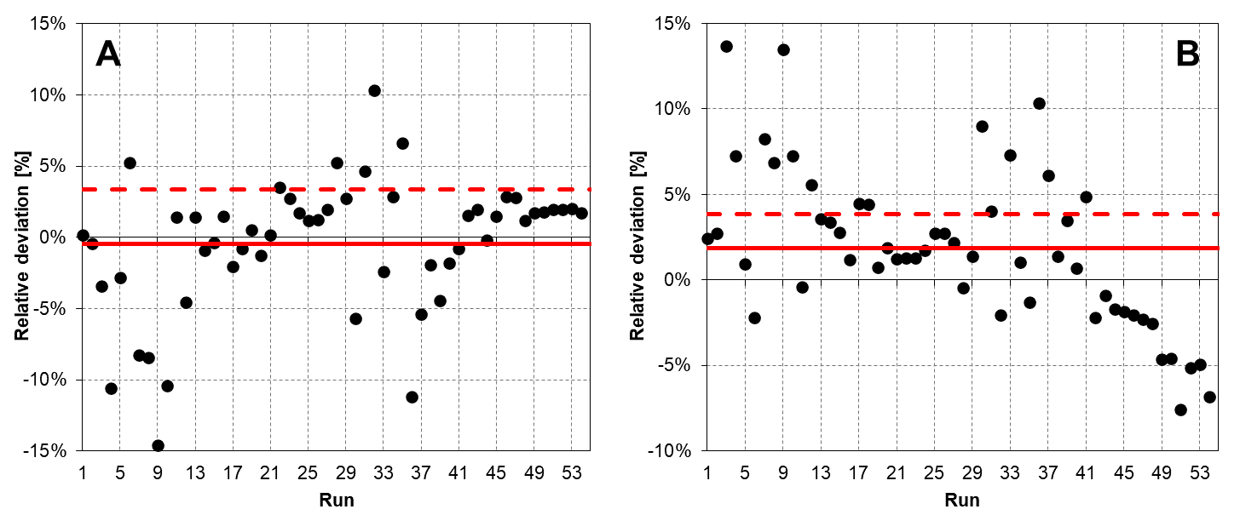

Figure 3 - Open-loop absorber model validation over the Tiller pilot plant data: relative errors (•), ARD% (—) and AARD% (- - -) for (A) CO2 captured flow and (B) rich loading of the solvent leaving the bottom of the column.

It is remarkable that the maximum observed AARD% is below 5%. For more than 80% of the runs, the relative deviation on captured CO2 flow is lower than 5%, while for almost 91% of the runs it is lower than 10% (Figure 3A). The model is also in agreement with measurements for the rich loading (Figure 3B). Higher discrepancies are observed for the desorbed CO2 flow: 67% and 89% of the runs exhibit a relative deviation below 5% and 10%, respectively (Figure 4A). These outcomes are still reasonable. The only exception is the lean loading (Figure 4B). However, the higher discrepancies observed for this indicator are associated with the low numerical values (range 0.05 – 0.15). Indeed, 73% of the runs show a deviation lower than 20%, which corresponds on average to an absolute error of 0.01 and 0.03 mol/mol for loading 0.05 and 0.15, respectively. A more detailed statistical analysis considering the effect of the inlet CO2 concentration on the measured deviations will be included in the following contribution. For the sake of completeness, we analyze the temperature profile inside the absorber and stripper. The model outcomes are compared to the experimental measurements. Figure 5 shows a few examples (two for 5.5% CO2 and two for 12% CO2 flue gas). We identified three temperatures associated with the highest influence on the process KPI: top (i.e., treated flue gas leaving the absorber), bottom (i.e., rich solvent), and peak temperatures. They influence the water wash design, heat recovery in the crossflow heat exchanger and reboiler duty, and amine kinetics and water balance, respectively. Those temperatures are globally well predicted for all runs. The AARD for the temperature profiles in the absorber and stripper are limited to 4.74% and 3.84%, respectively, including both all the data collected at 5.5% and 12% CO2 flue gas concentration. Table 2 provides a statistical analysis of all the runs.

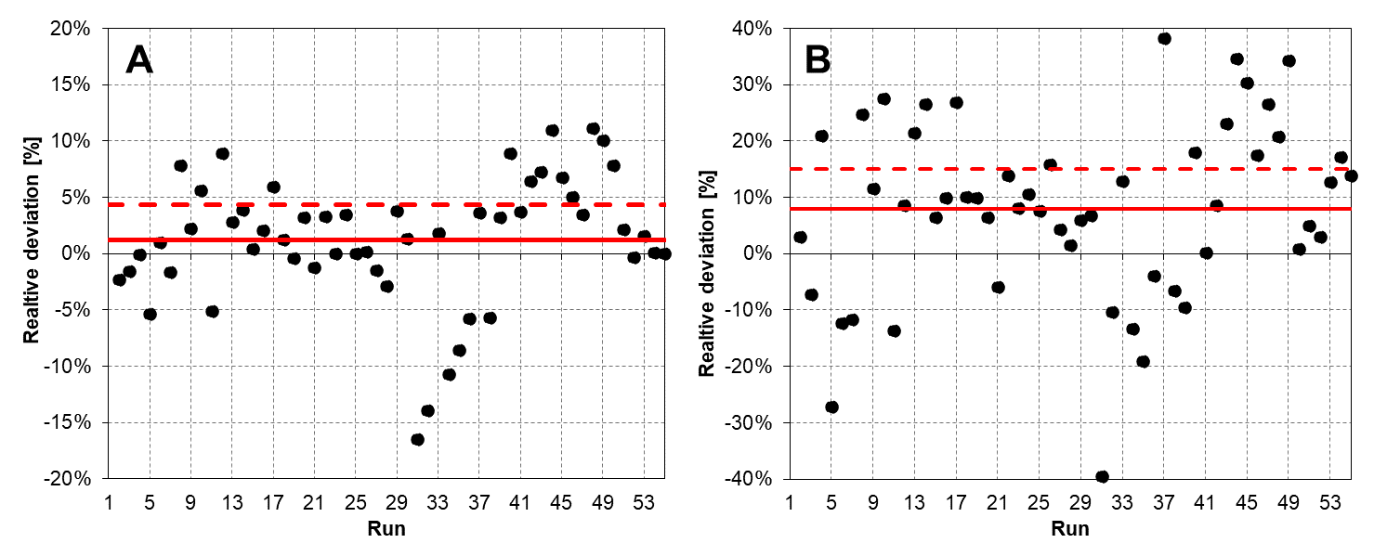

Figure 4 - Open-loop stripper model validation over the Tiller pilot plant data: relative errors (•), ARD% (—) and AARD% (- - -) for (A) CO2 desorbed flow and (B) lean loading of the regenerated solvent.

Table 2: Statistical analysis for the open-loop validation

|  |  |  |
| --- | --- | --- |
|  | AARD [%] | ARD [%] |
| CO2 capture (absorber) | 3.35 | -0.44 |
| CO2 released (stripper) | 4.38 | 1.18 |
| T profile absorber | 4.82 | 1.00 |
| T profile stripper | 3.54 | 2.22 |
| Lean loading | 15.1 | 8.00 |
| Rich loading | 3.84 | 1.85 |

Figure 5 - Examples of temperature profiles inside the absorber (1 –row) and stripper (2 –row) for a CO2 inlet gas content of 12 mol% (cases A and B) and 5.5 mol% (cases C and D). Experimental data (•) against model prediction: (—) liquid phase temperature and (- - -) vapour temperature using the rate-based model.

* 1. Conclusions and future developments

The present contribution shows how the HS3 solvent is developed and validated using measurements collected from the semi-industrial pilot plant located in Tiller (Trondheim, Norway). The proposed model for the innovative HS3 solvent considers thermodynamic equilibria of solvent in the presence of CO2, mass transfer, and kinetics using the ELECNRTL package in Aspen Plus V11. The validation is addressed following the open-loop approach. The input to each unit is assigned equal to the corresponding experimental observation, and deviations for the outputs are “confined” to the tested unit, hence, there is no mutual influence and error propagation. In other words, a deviation in one of the outputs in the absorber (for instance, rich loading) does not influence the stripper validation because the two units are kept disconnected. Thus, the open-loop method allows testing and estimating the accuracy of the model as it is for each unit. The validation shows that the proposed model can predict the performance of the system and the error in the predictions is lower than 5% for the main performance indicators (KPIs) such as capture rate, and specific reboiler duty (SRD, i.e., energy demand for the solvent regeneration). The model has been validated for two different flue gas compositions: 5% and 11% representative of exhaust from natural gas combustion turbines and coal-fired power plants and waste-to-energy facilities. The testing of the model on the closed loop is planned, as well as a more systematic analysis of the effect associated with the differences in inlet gas concentrations, which are the major sources of the calculated precision errors. This last step is relevant to check the reliability/robustness of the proposed model and to verify that the interconnection between absorber and stripper is consistent (i.e., error propagation does not cause larger deviations once the two subsystem interacts). Currently, the developed model looks to be suitable for design purposes and techno-economic assessment and it will be tested for a large-scale facility (oil refinery) to assess its trustworthiness for scale-up, comparison with benchmark solvent, and techno-economic assessment of the novel technology.

Acknowledgements

This work was performed within REALISE project. The project has received funding from the European Union's Horizon 2020 research and innovation program under grant agreement No 884266 (REALISE project). For more information refers to the project webpage - [Home | REALISE-CCUS (realiseccus.eu)](https://realiseccus.eu/)

The authors are grateful to Olaf Trygve Berglihn (SINTEF) and to Prof. Stefania Moioli (Politecnico di Milano) for their support on the set-up of the model validation procedure and useful discussion on thermodynamics and model development.

References

Aspen Plus®, 2019, Aspen Plus® V11.0 Documentation.

CO2 laboratory, Tiller. SINTEF, <www.sintef.no/en/all-laboratories/co2-laboratory-tiller/>, accessed June 2023.

Gilardi M., Bisotti F., Tobiesen A., Knuutila H.K., Bonalumi D., 2023, An approach for VLE model development, validation, and implementation in Aspen Plus for amine blends in CO2 capture: the HS3 solvent case study, International Journal of Greenhouse Gas Control, 126, 103911

Henni A., Li J., Tontiwachwuthikul P., 2008, Reaction Kinetics of CO2 in Aqueous 1-Amino-2-Propanol, 3-Amino-1-Propanol, and Dimethylmonoethanolamine Solutions in the Temperature Range of 298−313 K Using the Stopped-Flow Technique, Industrial & Engineering Chemistry Research, 47, 7, 2213–2220.

Lin Y., ten Kate A., Mooijer M., Delgado J., Fosbøl P.L., Thomsen K., 2010, Comparison of activity coefficient models for electrolyte systems, AIChE Journal, 56, 1334-1351.

Liu H., Li M., Idem R., Tontiwachwuthikul P., Liang Z., 2016, Analysis of solubility, absorption heat and kinetics of CO2 absorption into 1-(2-hydroxyethyl)pyrrolidine solvent, Chemical Engineering Science, 162, 120-130.

Pellegrini L.A., Gilardi M., Giudici F., Spatolisano E., 2021, New Solvents for CO2 and H2S Removal from Gaseous Streams, Energies, 14, 20, 6687.

Rochelle G., 2009, Amine Scrubbing for CO2 Capture, Science, 325, 5948, 1652-1654.

Van Wagener D.H., Rochelle G., 2011. Stripper configurations for CO2 capture by aqueous monoethanolamine and piperazine. Energy Procedia 4, 1323–1330.

Vitillo J.G., Smit B., Gagliardi L., 2017, Introduction: Carbon Capture and Separation, Chemical Reviews, 117, 14, 9521-9523.