CHEMICAL ENGINEERING TRANSACTIONS  VOL. , 2023 | A publication of
The Italian Association
of Chemical Engineering
Online at www.cetjournal.it

Guest Editors: David Bogle, Flavio Manenti, Piero Salatino
Copyright © 2023, AIDIC Servizi S.r.l.
ISBN 979-12-81206-04-5; ISSN 2283-9216

Performance analysis of the R290 variable geometry gas ejector application for other refrigerants
Rafal FINGAS^{*(a, b)}, Guillaume MASS^{(c)}, Giorgio BESAGNI^{(a)}
^{(a)} Department of Energy, Politecnico di Milano, Via Lambruschini 4a, 20156 Milano, Italy
^{(b)} Department of Thermal Technology, Silesian University of Technology, Konarskiego 22, 44‐100 Gliwice, Poland
^{(c)} Mechanical and Energy Department, INSA Hauts-de-France, Le Mont Houy, 59313, Valenciennes, France
* Corresponding e-mail: rafal.fingas@polimi.it

Ejector refrigeration systems are promising alternative to standard vapour compression refrigeration systems. They can be driven with low-grade heat or solar systems, which make them even more renewable solution aligned with global energy transition. By implementing the controllable ejector, it can adapt to variable operating conditions, ensuring the high efficiency of both the device and the overall performance of the system. However, as it is fluid-driven device, its geometry has to be designed for particular fluid and typically requires redesigning when being applied for new applications. The R290 variable geometry gas ejector has been thoroughly tested for various spindle positions which ensured its highly efficient operation at different conditions. In this study, the same geometry was tested for other natural refrigerants of similar thermodynamic properties, i.e.R600a and R1270. The CFD analysis was based on a set of operating points for ejector-based air conditioning system working during the summer period with characteristic temperatures at evaporator and condenser. The controllable ejector was simulated for all the points with similar motive and suction nozzle parameters and the critical temperature at the outlet was determined. The analysis showed that the ejector can be used with other refrigerants maintaining high efficiency without any changes in geometry but for lower number of spindle positions. The obtained critical temperature indicates that with all the tested refrigerants the ejector-based cycle is able to work for cooling purposes during typical summer conditions for a wide range of temperatures.
  - Introduction
The ejector-based refrigeration gained scientific attention after the harmful hydrofluoroolefins (HFO) refrigerants were decided to be banned by EU directive 517/2014 (2014), as scientists all around the world started to work on increasing the efficiency of refrigeration systems based on other refrigerants with lower impact on the environment, that due to their unfavorable thermodynamic parameters were characterized by lower efficiency when applied in the typical vapor-compression (VC) systems. One of the promising solutions to increase the performance of refrigeration systems are fixed-type ejectors, so the fluid-dynamics-driven components that uses high-pressure fluid to entrain and mix with low-pressure fluid, creating a mixture with a higher pressure at the outlet. The fluid introduced to the motive nozzle expands and accelerates to the supersonic speed, and thanks to the phenomena connected with the supersonic flow, it is able to mix thoroughly the two streams (i.e. motive and suction nozzle flows), and accelerate them in a constant cross-section mixer due to the supersonic shockwaves, so that eventually the pressure at the ejectors’ outlet is higher than that at the suction nozzle port. Its higher mass entrainment ratio, so the ratio of entrained fluid to the motive one, is maximal and constant in the on-design operation, when the primary flow is chocked, expands, and reduces the passage area for the secondary flow, which accelerates till supersonic condition. When increasing the outlet saturation temperature, it reaches the critical point T_{crit}, which is a point in which the primary flow is chocked, whereas the secondary one is affected by the outlet pressure value. Further increase at certain point makes the ejector working in backflow mode, so when the secondary fluid is no longer entrained. The operating curve of the ejector is presented in Figure 1.
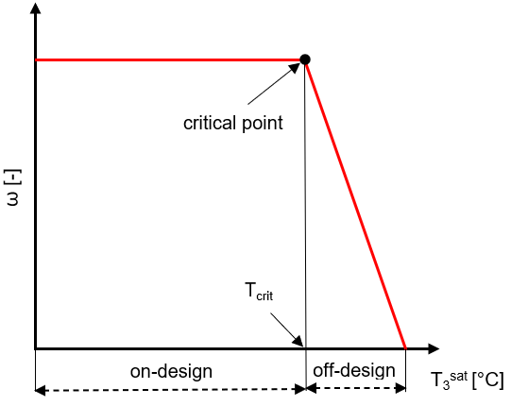
Figure 1: Ejector operating curve
The fixed-type ejector is reliable and simple device without moving parts, but due to the lack of possibility to control it, it’s hard to maintain its high efficiency and in most of the cases its geometry must be redesigned every time it is switched to different refrigerant, which is very time-consuming process. As far as the refrigerants are concerned, the ejectors showed their capability to improve the VC systems performance when applied with natural refrigerants, so the refrigerants that are widely available in the nature, like ammonia, carbon dioxide, air or hydrocarbons. The latest, being characterized by Ozone Depletion Potential (ODP) equal 0, low Global Warming Potential (GWP) below 3 and being in the A3 safety group, have already been used with the refrigeration systems due to their favourable thermodynamic properties, but due the environmental and safety refrigerants charge limits they are usually being applied to the small-scale systems. Roman and Hernandez (2011) presented a theoretical behaviour of an ejector cooling system using as working fluids propane (R290), butane (R600), isobutane (R600a), R152a and R134a, stating that the R290 system was characterized by best performance and highest efficiency. Butrymowicz et al. (2014) in their experimental analysis showed that the isobutane ejector systems may effectively compete with absorption systems under temperature of the motive heat source lower than 80 °C. All of the above analysis however referred to fixed-type ejectors, and the authors underlined the fact that these devices lose their efficiency when working in an off-design conditions. One of the solutions to this problem is Variable Geometry Ejector (VGE), which by implementing the moving spindle in the primary nozzle can control the mass flow rate affecting the mass entrainment ratio and critical temperature. Thanks to that, it can adapt to the dynamic conditions of the refrigeration system and operate always at possible highest efficiency. A practical application of this approach has been provided by Pereira et al. (2014), who employed an R290 driven VGE, proving an improvement in COP as high as 85%. Besagni et al. (2020) made a thorough screening of possibility to use different fluid with VGE and selected the R290 as a working fluid for designing the VGE, as from their analysis it was having a best potential with higher COP (0.5–1.03) but lower T_{crit} (20.7–25.0°C). Then, Besagni et al. (2021a) performed a multiscale numerical analysis of the VGE R290 ejector for the refrigeration application, showing that the spindle positioning can be an effective way to control the ejector, changing its mass flow rates, critical temperature and maximizing the efficiency of the ejector for wide range of operation. Moving the spindle towards the mixing chamber increases the mass entrainment ratio, by reducing the motive nozzle mass flow rate, but decreased critical temperature, so also the condenser temperature. For instance, a +33% increase of the nozzle area ratio, enhanced the COP by an average +57.1% but lowered the average critical temperature by 6.7K. Due to some similarities of thermodynamical properties (affecting the fluid dynamics of flow) of other hydrocarbons to R290, i.e. of R600a and R1270, the gas ejector optimized for R290 may be working for with other fluid without the normally necessary time-consuming geometry optimization procedure. The application of VGE for other refrigerants with different critical points (92.4°C for R290 and R1270, 135°C for R600a) may be beneficial to use it in different climate conditions, due to changing the range of condenser temperature, as well as increase its possibility to utilize waste heat of different temperature levels. The aim of this study is to apply the already optimized for R290 geometry of VGE for other refrigerants, i.e. R600a and R1270, which are characterized by similar thermodynamical properties affecting the fluid dynamics, to evaluate the possibility of application of ejector with these refrigerants, analyze their systems’ range of application and evaluate the ejector efficiency using different spindle positions.
  - Numerical model of variable geometry ejector
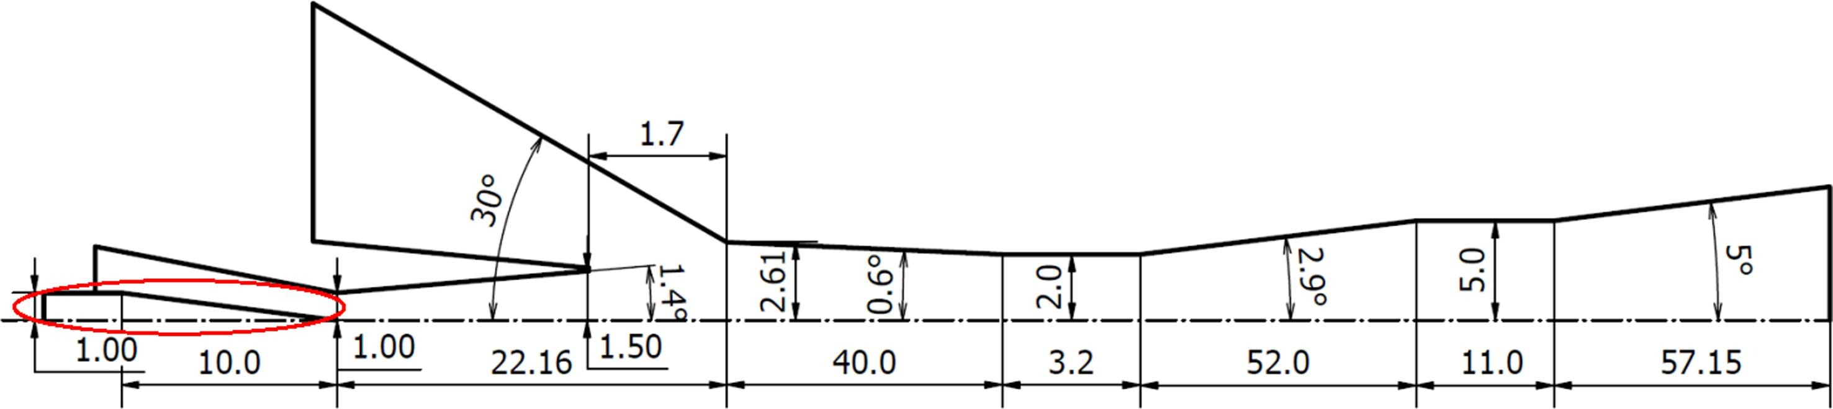
The VGE geometry used in this study is taken from work of Besagni et al. (2021a) and its geometry is presented in Figure 2. The motive nozzle throat cross sectional area of ejector is changed by an axially moved spindle (highlighted in red). The neutral position in which the spindle’s tip is placed right in the nozzle throat is named SP0. Moving the spindle towards the nozzle exit by 1 mm, we can reduce the nozzle throat area up to a position SP8, in which the throat is closed. In this study, only 3 needle positions, namely SP0, SP3 and SP5, to catch the character of the ejector operation while minimizing the necessary calculation time. Moreover, further decrease of the nozzle throat area up to position SP8 caused simulation instability and convergence problems, which are indications of possible unstable operation of the device's behaviour, which in its actual operation should be avoided.
Figure 2: Axisymmetric geometry of Variable Geometry Ejector with all the geometrical details and spindle highlighted in red.

To evaluate and compare the results of the numerical simulations, the two main performance parameters of ejectors were used, namely the mass entrainment ratio, being the ratio of suction mass flow rate to motive nozzle mass flow rate, and the coefficient of performance (COP) of the ejector based system, which is presented in Eq. 1, where the specific enthalpies numbers are referring to the numbers in specific points of the cycle presented in Figure 3.
$COP =ω \frac{h_{2}+h_{5}}{h_{1}+h_{4 }}$ | (1)
where $ω$ is mass entrainment ratio and h is specific enthalpy in J/kg.
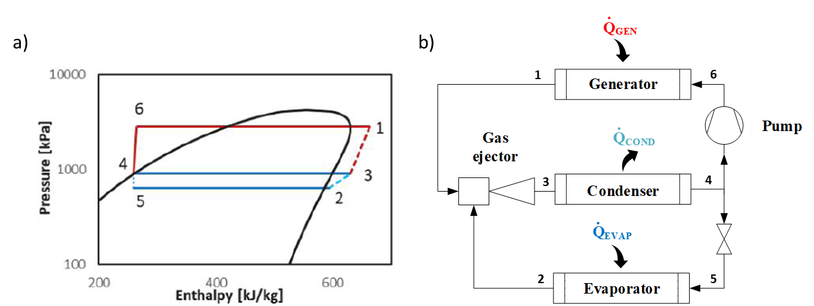
Figure 3: The ejector-based refrigeration cycle: a) representation on p-h diagram and b) schematic diagram of the cycle.
    - CFD model
In this study, the ANSYS Fluent finite volume code was utilized to model numerical behavior. The k-ω turbulence model, which was previously shown to have the best average relative error for on-design entrainment ratio and critical temperature in Besagni et al. (2021b) was employed. The inlets were modeled as pressure-inlets and the outlet as a pressure-outlet. A pressure-based solver was chosen for its rapid convergence and high stability. The mesh used was a 2D-axial symmetric structure with 110 cells in the y-direction, a maximum aspect ratio of 3, and y+ in the range of 30-200. Additionally, two cycles of refinement based on the Mach gradient criterion were applied during the simulation. Fluid properties were evaluated using the real-gas NIST database (Linstrom and Mallard, 2023).
  - Operating conditions
The system was evaluated under a variety of operating conditions to gain a comprehensive understanding of its performance. The motive fluid temperatures were set at 84.2°C, 94.3°C, and 104.3°C, which are relevant to real-world applications and can be generated using industrial waste heat or renewable sources. The secondary temperature was fixed at 14°C, which is the typical temperature for the evaporator operation in this type of refrigeration systems. These temperature inputs had a significant impact on the system's output. The fluids used in the study and their properties were sourced from the NIST library through ANSYS Fluent.
  - Results
The VGE was able to operate in all the analyzed points maintaining the possibility to control its motive nozzle flow, and by that its whole operation for three previously mentioned positions. The trend for both T_{crit} and COP is consistent across all tested working fluids, which only differ in their critical temperature and resulting COP. The movement of the spindle towards the nozzle exit results in decreasing the T_{crit} forcing the system work with lower condensing temperature to maintain the high possible mass entrainment ratio. For points a) and b) the decrease was almost the same for all three analyzed fluids differing with temperature level, whereas in case c) the R600a results present the highest critical temperature for SP0 equal to 41°C comparing to 32-33°C for R1270 and R290, but for higher SP positions the temperature was very similar for all three fluids. As far as the COP is concerned, its increase can be also observed with increase of SP positions, which is attributed to a slight increase in the mass entrainment ratio. The results of COP for case a) looking at the R1270 and R290 fluids are between 0.4-0.6, whereas the R600a performance was slightly lower, between 0.3-0.45. For case b), the COP for all three fluids slightly drop to 0.3-0.45 for R1270 and R290, whereas again for R600a the performance is the lowest, being in range of 0.2-0.35. Based on those results we can observe that the ejector performance in terms of its critical temperature for R600a is the highest comparing to R290 and R1270 is similar, which means it can be successfully applied for higher ambient temperature applications, however in terms of COP results for the ejector-based refrigeration systems; the R1270 is reaching maximal values among the three analyzed refrigerants. When analyzing the COP as a function of T₃^{sat}, so the outlet temperature of the ejector, we can observe the characteristics of ejector performance curve, in which for each of the SP positions for all fluids the increase of T₃^{sat}, for on-design operation maintains constant COP and mass entrainment ratio up to a critical point T_{crit}. Further decrease of T3sat makes the COP to decrease. The main outcome of this comparison is that the operation of VGE working with R600a is characterized by different range of outlet conditions operation, making it possible to operate at higher temperatures, The T_{crit} results for R600a running at SP0 position are equal to 30°C, 36°C and 41°C for cases a)-c) respectively. When the VGE operates with R290 and R1270, the T_{crit} are equal to 29°C, 33°C and 39°C for cases a)-c).
5. Conclusions
Overall, the results of this study show that the VGE can achieve high efficiency for all he examined fluids and maintains the ability to control its capacity when applied with other refrigerants thanks to the small differences between their properties. The obtained critical temperatures indicate that the ejector-based cycle can work for cooling purposes during summer conditions for a wide range of ambient temperatures. The research broadens the application potential of ejector systems by showing its adaptability to various systems and refrigerants. This versatility is valuable for different applications, including residential, commercial, and industrial sectors. The ability to utilize ejector technology with diverse refrigerants and ambient conditions enhances the scope of its application, making it a viable solution in numerous cooling scenarios.
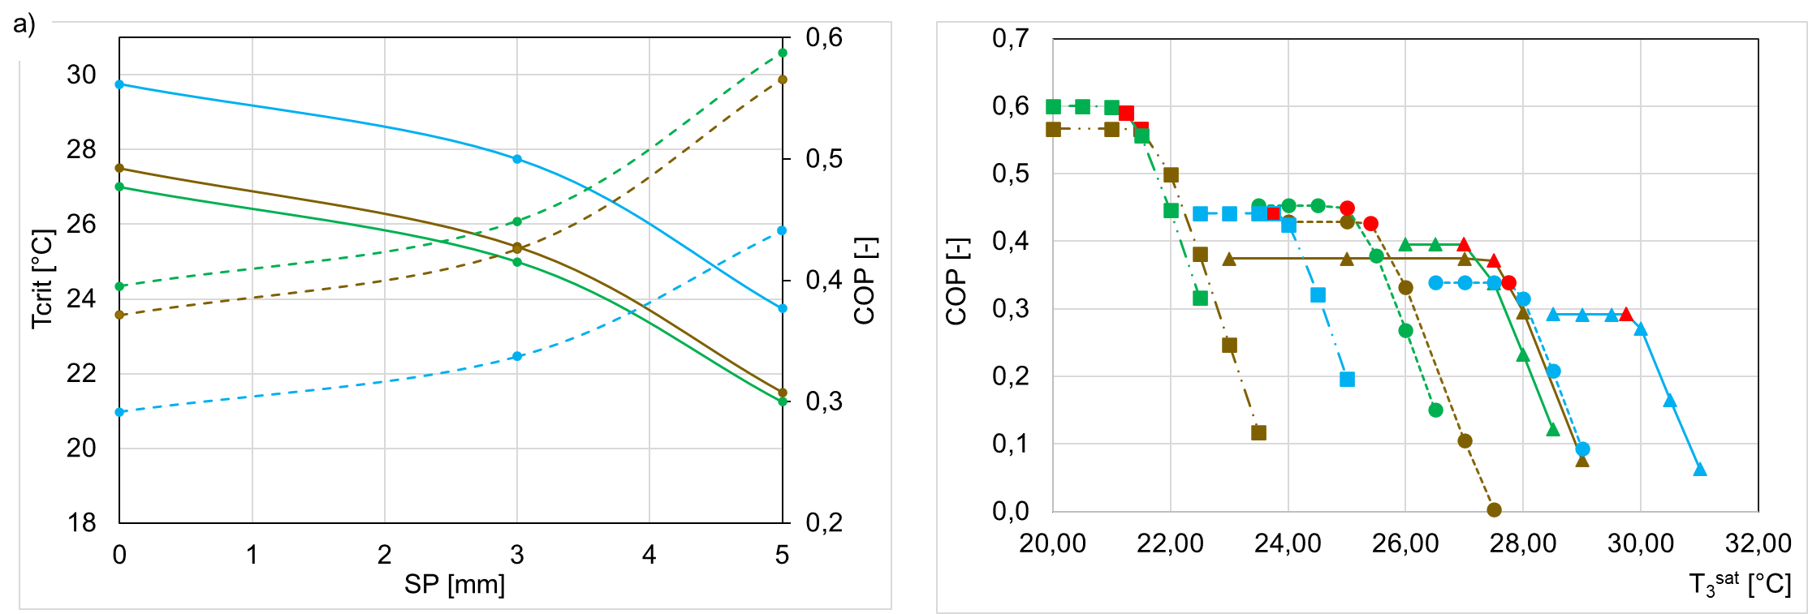
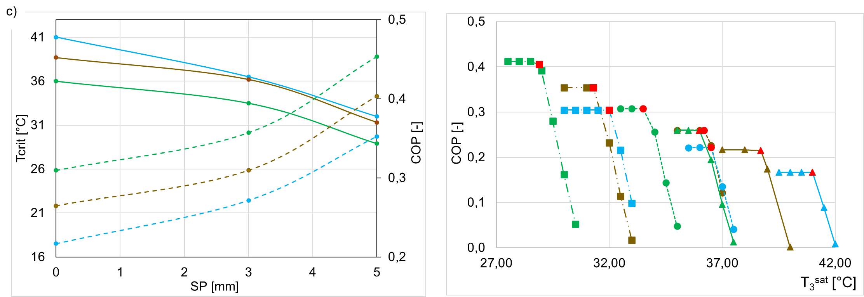
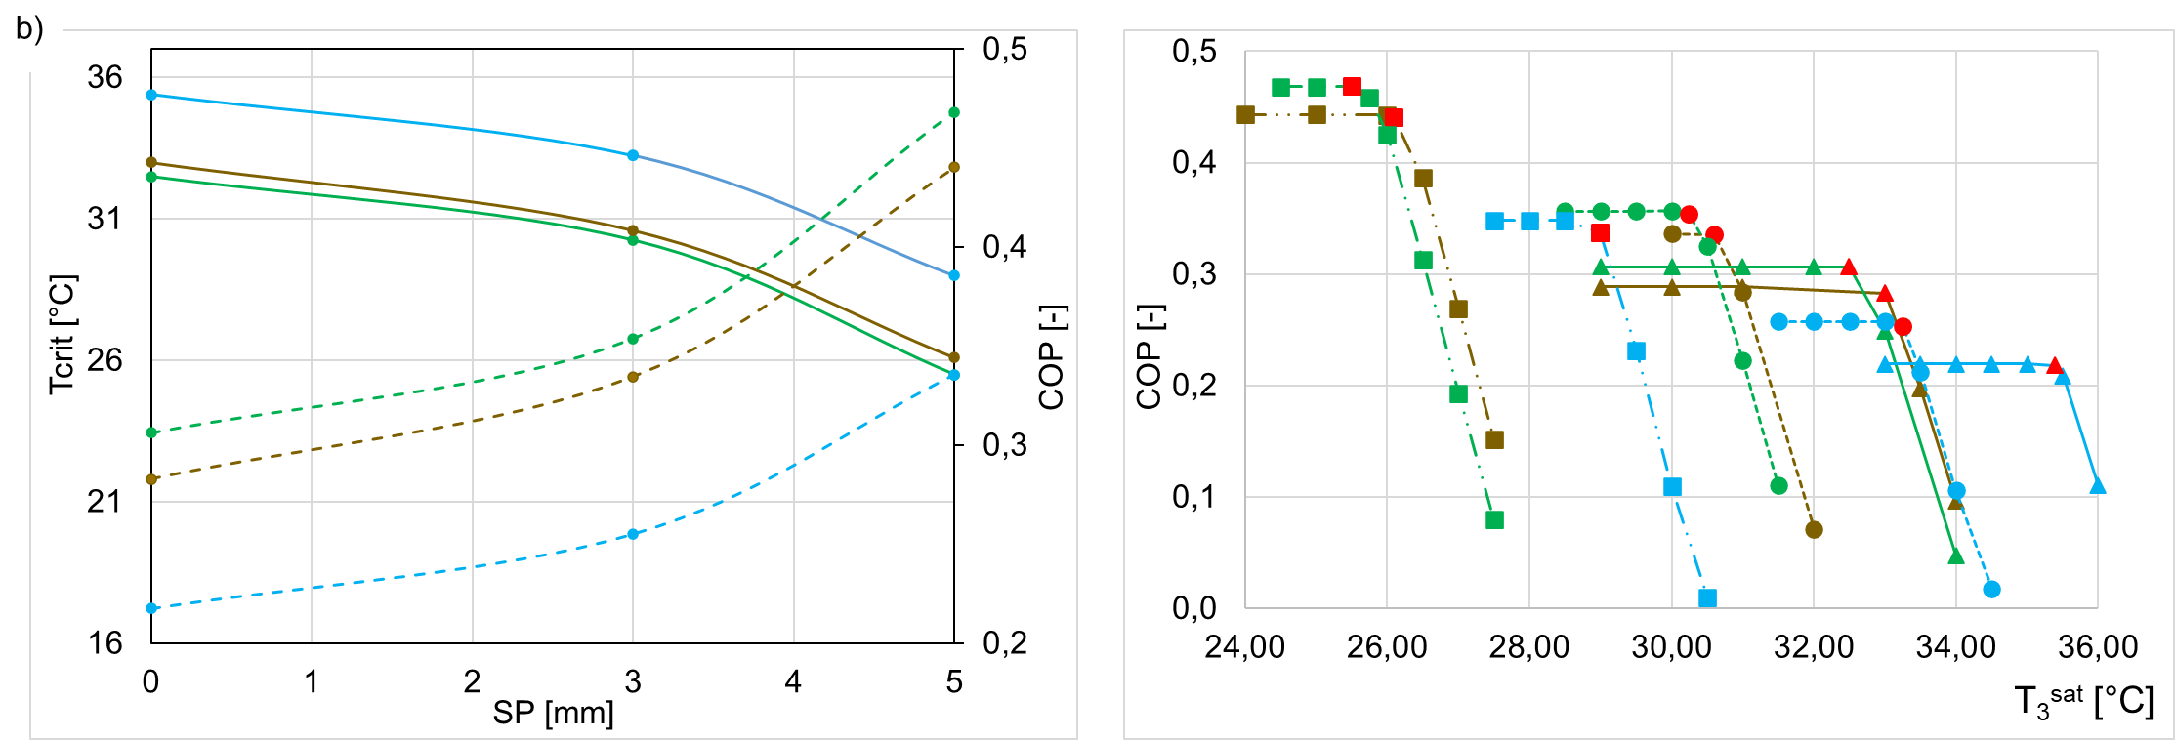
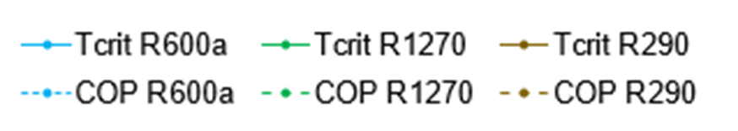
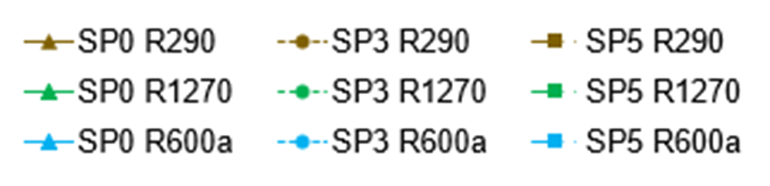
Figure 4: The results of VGE simulations for R290, R600a and R1270 for operating points: a) T_{MN} = 84.2°C, T_{SN} = 14°C, b) T_{MN} = 94.3°C, T_{SN} = 14°C, and c) T_{MN} = 104.3°C, T_{SN} = 14°C.
Nomenclature
Symbols
ṁ - mass flow rate, kg s⁻¹
h - specific enthalpy, kJ kg⁻¹
Ma - Mach number, -
P - static pressure, Pa
Q - thermal power, kW
T - temperature, °C
ω - mass entrainment ratio, -
Subscripts
cond - condenser
gen - generator
evap - evaporator
crit - critical
pump - pump
sat - saturation
Abbreviations
R290 - propane name for refrigerant
R1270 - propylene name for refrigerant
R600a - isobutane name for refrigerant
MN - motive nozzle
SN - suction nozzle

References
Besagni G., Cristiani N., Croci L., Guedon G.R. Inzoli F., 2021, Computational fluid-dynamics modelling of supersonic ejectors: Screening of modelling approaches, comprehensive validation and assessment of ejector component efficiencies, Applied Thermal Engineering, 186, p. 116431
Besagni G., Cristiani N., 2021, Multi-scale evaluation of an R290 variable geometry ejector, Applied Thermal Engineering, 188, p. 116612.
Besagni G., Cristiani N., Croci L., Guedon G.R. Inzoli F., 2021, Multi-scale evaluation of ejector performances: The influence of refrigerants and ejector design, Applied Thermal Engineering, 186, p. 116502,
Butrymowicz D., Smierciew K., Karwacki J., Gagan J., 2014, Experimental investigations of low-temperature driven ejection refrigeration cycle operating with isobutane, International Journal of Refrigeration, 39, p. 196-209
Linstrom P.J. and Mallard W.G., 2023, NIST Chemistry WebBook, NIST Standard Reference Database Number 69, National Institute of Standards and Technology, Gaithersburg, USA.
Pereira P.R., Varga S., Soares J., Oliveira A.C., Lopes A.M., de Almeida F.G., Carneiro J.F., Experimental results with a variable geometry ejector using R600a as working fluid, 2014, International Journal of Refrigeration, 46, pp. 77
Regulation (EU) No 517/2014 of the European Parliament and of the Council of 16 April 2014 on fluorinated greenhouse gases and repealing Regulation (EC) in 2014.
Roman R., Hernandez J. I., 2011, Performance of ejector cooling systems using low ecological impact refrigerants, International Journal of Refrigeration, 34, 7, p. 1707-1716,

