CHEMICAL ENGINEERING TRANSACTIONS  VOL. , 2023 | A publication of
The Italian Association
of Chemical Engineering
Online at www.cetjournal.it

Guest Editors: David Bogle, Flavio Manenti, Piero Salatino
Copyright © 2023, AIDIC Servizi S.r.l.
ISBN 979-12-81206-04-5; ISSN 2283-9216

Optimization of Leak Detectors’ Positioning in a Hydrogen Refueling Station
Alessandro Campari^{a,}*, Marco Bennici^{b}, Dimitrios Tzioutziosª, Yiliu Liuª
ª Department of Mechanical and Industrial Engineering, NTNU, Trondheim, Norway
^{b} Energy Department, Polytechnic University of Milan, Milan, Italy
alessandro.campari@ntnu.no
Hydrogen has the potential to promote sustainable road transport in the forthcoming years, thus significantly reducing the human impact on the environment. This energy carrier can be produced by renewable energy through water electrolysis and used in fuel cell-powered vehicles (FCVs) with elevated efficiency and no pollutant emissions. The number of FCVs being used around the world is rapidly increasing, reaching 34,804 vehicles and 540 refueling stations by the end of 2020. Nevertheless, hydrogen is highly flammable and can permeate and embrittle most metallic materials, making its containment extremely challenging. A leak in a hydrogen refueling station can rapidly escalate to a major disaster if not promptly detected and addressed. In this perspective, gas sensors play a critical role in detecting leakages and undesired hydrogen releases. When selecting a hydrogen gas detector, it is important to consider the environmental conditions in which it is expected to operate, its performance, reliability, and cost, as well as the optimal positioning within the refueling station. This study analyzes several hydrogen releases from a high-pressure storage tank to optimize sensor positioning, given a certain detection probability. This research contributes towards advancing the modelling of safety barriers in hydrogen refueling stations considering accident scenarios. In this vein, this study aims at expanding the current knowledge of facility operators and stakeholders for related risks, thus enabling the widespread utilization of hydrogen in road transport.
  - Introduction
The European Commission recently indicated hydrogen as a clean and sustainable fuel with the potential to decarbonize several industrial sectors in the forthcoming years (European Commission, 2018). This energy carrier can be produced from renewable energy by water electrolysis or steam reforming with carbon capture and storage (CCS) from natural gas with near-zero pollutant emissions. In addition, it can be used in fuel-cell systems or adapted internal combustion engines with elevated efficiency. At the end of 2020, the number of hydrogen-fueled vehicles (including passenger cars, trucks, and public transport) amounted to roughly 35,000, while 540 refueling stations were already operational all over the world (Samsun et al., 2021). In a few years, these numbers are expected to skyrocket due to government incentive-based policies and infrastructure investments aimed at improving the production capacity of hydrogen fuel and building an extensive network of refueling stations.
Despite its great potential, hydrogen has a broad flammability range (from 4% to 74% in air) and low ignition energy (0.019 mJ). In addition, it can permeate most materials due to its small molecular size and has the capability of embrittling metals, making containment systems more prone to unexpected failures and leaks (Kotchourko and Jordan, 2022). An unintended release in a hydrogen refueling station can rapidly escalate to a major accident if not promptly detected and controlled. This was the case of the incident in the refueling station in Kjørbo (Norway), where an undetected release from the high-pressure storage unit ignited, causing extensive damages to the facility (Campari et al., 2023). In this perspective, hydrogen gas sensors play a critical role in detecting leakages before they are ignited and result in fires or explosions. These safety devices should be reliable, have a low response time, detect hydrogen concentrations lower than 0.5%, and have low cost. Given the characteristics of the sensors in terms of accuracy, coverage area and optimal operating conditions, it is necessary to install them appropriately within the refueling station. Moreover, H₂ fuel-related infrastructure is currently in the early stages of implementation, and there is still limited operational experience from such facilities. In this regard, enhancing available knowledge about the installation, safety barriers are essential to effectively address associated risks, reduce the over-conservative limitations imposed by the existing safety codes, and ultimately facilitate a widespread rollout of hydrogen for road transport. This study contributes to this goal by analyzing the spatial configuration of sensors in a high-pressure storage tank to identify optimal apparatus positioning. Firstly, several release scenarios are simulated to understand the effect of buoyancy on hydrogen dispersion. Then, a genetic algorithm is used to determine iteratively the appropriate sensor placement to ensure the best detection capability.
  - Ultrasonic hydrogen gas detectors
The detection of hydrogen releases in open, well-ventilated areas is challenging since the gas is easily dispersed and transported far from the sensors by the wind and/or the buoyancy effect. In the case of concentration-based detectors, an outdoor release may remain undetected for hours since the hydrogen cannot accumulate in a sufficient amount to raise the alarm. On the other hand, ultrasonic gas leak detectors (UGLD) can sense the acoustic ultrasound generated by a release of pressurized gas. This pressure wave moves at the speed of sound from the leak to the detector, which in turn identifies the unintended release and sends a signal to the control system to report. In other words, an UGLD senses a leak almost instantaneously as it occurs, while a conventional sensor only responds when H₂ has formed a detectable vapor cloud (Walsh and Kelsey, 2017). The UGLD is designed to ignore audible noise and can only sense ultrasonic frequencies from 25 kHz to 70 kHz. Moreover, by decreasing the lower limit of the detectable sound spectrum, it is possible to increase the sensitivity to small leaks and the coverage area, without compromising detection accuracy due to background noise, which mostly belongs to audible frequencies. The amplitude of the ultrasonic sound produced by the sensor should be 20-30 dB lower than the audible noise level in the area; hence, approximately 65-75 dB in very noisy locations (Fecarotta and Janowski, 2021). Figure 1 represents the functioning principle of an ultrasonic sensor. As shown, a wave with higher amplitude is created from the hydrogen release and triggers the alarm when it exceeds a certain threshold.
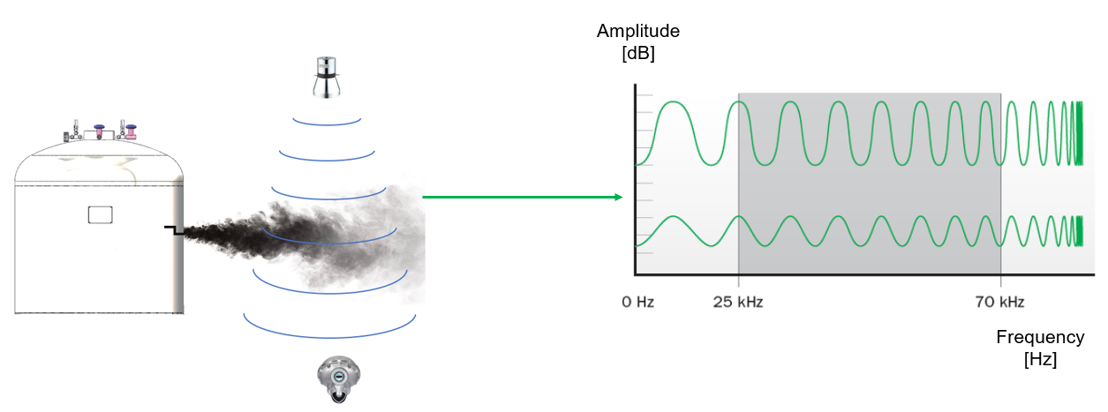
Figure 1: Functioning principle of an ultrasonic gas leak detector
The total response time of an UGLD can be calculated as follows (Moon et al., 2009):
$$T_{total}=T_{det}+T_{us}$$ | (1)
where $T_{det}$ represents the inherent detection delay in the UGLD ranging from 10 to 30 s, while $T_{us}$ is the time required for the ultrasound to reach the detector (in the order of ms). The sensor’s coverage area depends on the ultrasonic background noise, the minimum leak rate to be detected, and the pressure of the gas released. Hydrogen refueling stations are in the proximity of highways or other busy roads and can be classified as high-noise areas. In this case, the audible noise can range from 90 to 100 dB, while the ultrasonic background noise is below 78 dB. Minor gas releases have a leak rate lower than 0.1 kg/s, which can be used to calibrate the performance of a UGLD and indicates the smallest release the detector can sense. In addition, the minimum gas pressure which generates ultrasounds is around 2 bar for hydrogen (Fecarotta and Janowski, 2021). Under these conditions, the use of a UGLD is still possible but results in a lower coverage area. In general, a certain leak rate can be obtained from a variety of combinations of leak size and hydrogen pressure. The greater the hole size, the higher will be the leak rate and the subsequent pressure drop inside the tank, thus lowering the level of ultrasound.
  - Methodology
The positioning of the leak detectors for the high-pressure storage system of a hydrogen refueling station follows two steps. First, two release scenarios were simulated through the software HyRAM+ V5.0 (Ehrhart et al., 2022) to understand the characteristics of the hydrogen dispersion and the jet trajectory from the hole. Second, a genetic algorithm was used to select the minimum number of sensors and their optimal location for maximizing detection effectiveness.
3.1 Release simulations
Two release scenarios were deemed representative of the actual operating conditions of the pressurized storage tank. Scenario (a) simulates a large hole from an almost empty hydrogen tank (i.e., with low internal pressure). This release, if ignited, can result in a flash fire and is very challenging to detect for both concentration-based and ultrasonic gas sensors. In addition, scenario (b) simulates a pinhole in a pressurized hydrogen tank. The pressure within the tank corresponds to its design pressure, which is reached only after a complete filling. Compared to the previous case, this leak type is easier to detect but its ignition is significantly more likely. HyRAM+ V5.0 is a software toolkit for the risk assessment of hydrogen technologies. Only the consequences of unintended releases were considered since quantifying the probability of such events is out of the scope of this study. The algorithms and physics models implemented in HyRAM+ have been validated against experimental data and allow for a simplified simulation of ignited and unignited releases. For the trajectory of the plume, HyRAM+ follows a one-dimensional model, according to which the hydrogen flow can curve due to the buoyancy effects. A Gaussian profile is used as input for the one-dimensional dispersion model (Morales et al., 2019). The input parameters for the two release simulations are summarized in Table 1.
Table 1: Input parameters for the HyRAM+ simulations of two release scenarios
Variable | Unit | Scenario (a) | Scenario (b)
Tank pressure | bar | 5 | 700
External temperature | °C | -15 | -15
Hole diameter | mm | 6 | 1
Angle of the jet | ° | 90 | 90
Release phase | - | Gas | Gas

3.2 Genetic algorithm
The sensor should be properly placed on the tank surface to guarantee the highest detection capability while minimizing the number of sensors required. Genetic algorithms (GA) are frequently used to solve such optimization problems that cannot be effectively addressed by conventional optimization techniques. A GA is composed of a sequence of functions aimed at identifying the best-fitting option to achieve a pre-determined objective. For this study, the algorithm’s goal was to indicate the position of UGLDs ensuring a target detection performance level. In detail, the main functions of the GA for the optimization of the sensors’ positioning are:
- Initial population function – This function generates a set of possible solutions; in this case, the initial population is composed of a certain number of sensors located in different positions, which are identified by the coordinates (x, y, z) in a grid.
- Detection performance function – This function uses the initial population as input and determines the detection performance for each sensor’s configuration. It evaluates if each point of the tridimensional grid falls within the coverage area of at least one sensor and calculates the detection probability by dividing the number of detected nodes by the total number of nodes.
- Fitness function – This function takes the detection probability of each sensor’s configuration and compares it with the target performance; the lower the value of the fitness function, the closer will be the optimal configuration of UGLD on the tank.
- Mutate function – This function takes a spatial configuration as input and randomly adds or removes one of the sensors (with a 50% probability).
- Crossover function – This function considers two sets of sensors (the so-called “parents”) as inputs, taking half the sensors from the first parent and the other half from the second; it produces a random combination of these detector configurations (the “child” sensors’ set) as an output.
- Selection function – This function calculates the fitness functions for the “child” sensor combinations, compares them with the “parents” ones, and selects the set with the best fitness value.
Once the algorithm has implemented all these functions, the selection function chooses the best option and proceeds with the next generation in a loop until the target performance is achieved (Katoch et al., 2021). Table 2 summarizes the input data. The population size, the mutation rate, and the number of generations are input parameters for the GA, and they influence the accuracy of the results and the computation time. On the other hand, the tank diameter and height depend on the storage system installed in the refueling station. The detection diameter is a characteristic of the sensor and depends on the minimum flow rate to detect, the storage pressure, and the noise in the surrounding area.
Table 2: Input data for the genetic algorithm
Variable | Tank diameter | Tank height | Detection diameter | Target performance | Population size | Mutation rate | Generations
Value | 4 m | 5 m | 3 m | 100% | 50 | 0.1 | 100
  - Results and discussion
The simulations of the hydrogen dispersion scenarios (a) and (b) are plotted in Figure 2. The first scenario is characterized by a large hole (6 mm in diameter) in a hydrogen storage tank operating at 5 bar. The combination of low hydrogen pressure and low leak rate makes this release the most difficult to detect. Despite the small amount of gas released from an almost empty tank, it creates an ignitable mixture near the hole (the area within the white line) and can result in a flash fire. In contrast, the second scenario occurs from a small hole (1 mm in diameter) in a high-pressure tank operating at 700 bar (i.e., the maximum allowable pressure). In this case, the fuel released creates an ignitable mixture with the air up to nearly 6 m away from the pinhole. If ignited, this gas plume can form a jet fire and result in severe consequences for personnel and equipment nearby. Nevertheless, the high-pressure gas leak can be easily detected by ultrasonic sensors. In both cases, the gas plume remains perpendicular to the tank wall, but this can change due to the wind, which deviates the hydrogen flow from its original trajectory (Li et al., 2021).

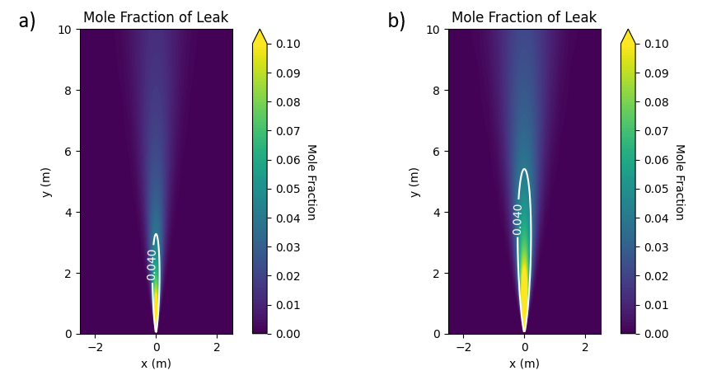
Figure 2: Hydrogen dispersion in the scenarios (a) and (b); the lower flammable limit is marked with a white line
Furthermore, Figure 3 depicts the plume trajectories on the z-axis. For release (a), the buoyancy effect is almost negligible, and the trajectory of the hydrogen plume is determined by the jet angle, which is, in turn, dependent on the position of the hole on the tank wall. In contrast, the trajectory of release (b) is slightly more influenced by the buoyancy effect, and a vertical deviation is noticeable about 2 m away from the hole. Despite this difference (mainly due to the different gas pressure, speed, and flow rate), it is reasonable to argue that the low molecular weight of hydrogen gas does not influence the release trajectory close to the storage tank. In the range of 3 m from the hole (which is also the detection diameter of the UGLD) the trajectory of the hydrogen leak is mainly determined by the momentum of the gas outflowing from the hole, which acts as a nozzle. Thus, considering the specific physical properties of hydrogen for the positioning of the sensors will not significantly modify the results. In addition, most ignition sources in a hydrogen refueling station are located at head height or below. Therefore, even if installing the sensors in the upper part of the tank seems logical, given the high buoyancy and upward dispersion of hydrogen gas, it will not be effective.

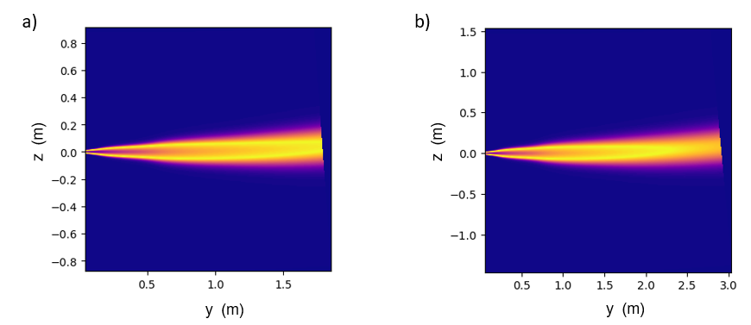
Figure 3: Trajectory of the hydrogen release in the scenarios (a) and (b)
Figure 4 shows the optimal location of the sensors obtained through the genetic algorithm. The red points on the tridimensional grid (left image) represent the nodes on the tank surface, each of which is a potential location for the sensors, while the black points indicate the optimized position of the UGLDs. The optimal sensor locations are also shown in the right images from different views of the tank.

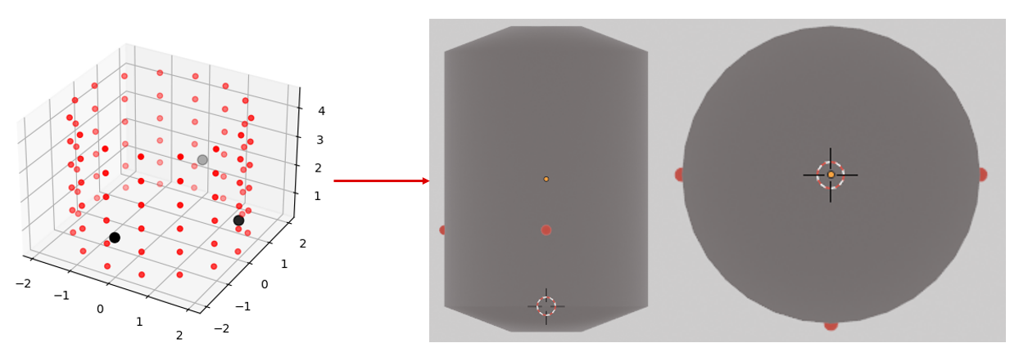
Figure 4: Sensors' location on the high-pressure storage tank
The GA output demonstrated that three UGLDs located on the external surface of a hydrogen storage tank are sufficient to guarantee 100% coverage area. Table 3 reports the coordinates of the three sensors. The location obtained through the optimization algorithm show that existing guidelines for enclosed ventilated spaces do not apply to outdoor H₂ storage systems. In mechanically ventilated enclosures, such as underground parking spaces or indoor production units, it is recommended to avoid placing sensors at ground level. In fact, hydrogen tends to accumulate near the ceiling due to buoyancy and, therefore, its concentration typically remains below alarm thresholds at floor level (Tchouvelev et al., 2021). In the case of a refueling station, hydrogen is stored outdoors and cannot accumulate. Moreover, the alarm of UGLDs is not triggered by the gas concentration. For these reasons, the ultrasonic sensors are not positioned on the top of the pressurized tank. The sound waves propagate through the air from the leak on the tank surface to the UGLD. Hence, the closer to the crack the sensor is, the lower will be the detection time. The gas detectors are installed in a way that ensures complete coverage of the tank’s surface and simultaneously facilitates personnel access for inspection and maintenance activities. In this study, a detection diameter of 3 m has been set as an input; this value is arguably over-conservative since the average detection diameter for a UGLD in a high-noise area ranges from 5 to 9 m. In this study, we assumed that each leak is detected by the closest sensor only. Nevertheless, a thorough calculation of the different propagation velocities of the sound wave through different physical media (i.e., air, hydrogen, or steel) is required to assess the detection effectiveness of the sensors placed on the opposite side of the tank. In addition, calculating the detection performance in the case of failure of one of the sensors is necessary to evaluate the resilience of the system.
Table 3: Coordinates of the sensors on the grid
 | x-axis | y-axis | z-axis
Sensor 1 | 0.0 | -2.0 | 1.5
Sensor 2 | -2.0 | 0.0 | 1.5
Sensor 3 | 2.0 | 0.0 | 1.5
Conclusions
UGLD can be used to detect leakages from pressurized hydrogen tanks in refueling stations. These sensors can effectively detect outdoor H₂ releases since they measure the ultrasound emitted from the high-pressure gas leaks without being affected by the wind, the leak direction, or the hydrogen dilution, like concentration-based detectors. The functioning of these sensors is based on sound propagation instead of mass movement; hence, they have lower response times and increased reliability. In this study, two hydrogen releases from a pressurized storage system have been simulated, considering the extreme cases of a full tank at 700 bar, an almost empty tank at 5 bar, and two different hole sizes. In addition, the positioning of the UGLDs has been optimized through a genetic algorithm that simulated a set of possible sensor locations and determined a spatial configuration which guaranteed the highest coverage area. The results demonstrated that only three sensors, appropriately positioned near the tank, are sufficient to detect compressed gaseous hydrogen releases, offering an additional safety barrier for H₂ refueling stations. Hence, UGDLs can complement existing detection systems in outdoor areas. They can drastically reduce the system’s response time, thus enhancing the operational safety of hydrogen refueling stations.
Acknowledgments
This work was undertaken as a part of the research project “Sustainability and Cost-Reduction of Hydrogen Stations through Risk-Based, Multidisciplinary Approaches” (SUSHy), and the authors would like to acknowledge the financial support of the Norwegian Research Council through the EIG CONCERT-Japan platform (Grant No. 334340).
References
Campari A., Nakhal A.J., Ustolin F., Alvaro A., Ledda A., Agnello P., Moretto P., Patriarca R., Paltrinieri N., 2023, Lessons Learned from HIAD 2.0: Inspection and Maintenance to Avoid Hydrogen-Induced Material Failures, Comput. Chem. Eng., 173.
Ehrhart B.D., Sims C., Hecht E.S., Schroeder B.B., Growth K.M., Reynolds J.T., Walkup G.W., 2022, HyRAM+ Version 5.0, <hyram.sandia.gov> accessed 28.04.2023.
European Commission, 2018, In-depth analysis in support of the Commission Communication COM(2018) 773 A Clean Planet for all.
Fecarotta C., Janowski A., 2021, Why Ultrasonic Gas Leak Detectors?, Proceedings of the 9th International Conference on Hydrogen Safety (ICHS 2021), Edinburgh, UK.
Katoch S., Chauhan S.S., Kumar V., 2021, A review on genetic algorithm: past, present, and future, Multimed. Tools Appl., 80, 8091–8126.
Kotchourko A., Jordan T., 2022, Hydrogen Safety for Energy Applications: Engineering Design, Risk Assessment, and Codes and Standards, Butterworth-Heinemann, Oxford, UK.
Li X., Xu Y., Li X., Jin Z., Qian J., 2021, Effect of wind condition on unintended hydrogen release in a hydrogen refueling station, Int. J. Hydrog. Energy, 46, 5537-5547, DOI: 10.1016/j.ijhydene.2020.11.036.
Moon C., Brown W.C., Mellen S., Frenz E., Pickering D.J., 2009, Ultrasound Techniques for Leak Detection, International Society of Automotive Engineers, 09NVC-0269.
Morales G.F., Ehrhart B.D., Muna A.B., 2019, SAND2019-8940 - HyRAM V2.0 User Guide, Albuquerque, USA.
Samsun R.C., Antoni L., Rex M., Stolten D., 2021, Deployment Status of Fuel Cells in Road Transport: 2021 Update.
Tchouvelev A.V., Buttner W.J., Melideo D., Baraldi D., Angers B., 2021, Development of risk mitigation guidance for sensor placement inside mechanically ventilated enclosures – Phase 1, Int. J. Hydrog. Energy, 46.
Ustolin F., Åsholt H. Ø., Zdravistch F., Ranveig N., Paltrinieri N., 2022, Computational Fluid Dynamics Modeling of Liquid Hydrogen Release and Dispersion in Gas Refuelling Stations, Chem. Eng. Trans., 86, 223-228.
Walsh P., Kelsey A., 2017, Research Report RR1123 - Fixed flammable gas detector systems on offshore installations: optimisation and assessment of effectiveness, Derby, UK.

