CHEMICAL ENGINEERING TRANSACTIONS  VOL. , 2023 | A publication of
The Italian Association
of Chemical Engineering
Online at www.cetjournal.it

Guest Editors: David Bogle, Flavio Manenti, Piero Salatino
Copyright © 2023, AIDIC Servizi S.r.l.
ISBN 979-12-81206-04-5; ISSN 2283-9216

Glycerol and glycerol/water gasification for the decarbonisation of industrial heat
José Ramón Quiñonez Arce*ª, Gordon E. Andrews^{b}, James D. Maxflieldª, Herodotos N. Phylaktou^{b}, Steve B. Smithª, Richard Wakemanª
ªClean Burner Systems, 11 Caputhall Road, Deans Industrial Estate, Livingston, EH54 8AS
^{b} School of Chemical and Process Engineering, University of Leeds, Woodhouse Lane, Leeds LS2 9JT
ramon.quinonez@cleanburnersystems.com
This research is aimed at using Gaseq equilibrium flame chemistry modelling, to demonstrate that wet waste crude glycerol could be air gasified to produce a Biomass Gasification Gas (BGG) for direct applications as a burner fuel for the decarbonisation of industrial heat. Glycerol is a typical biomass fuel in its composition and it is similar to the distillery waste pot ale (PA), which is about 87% water and 13% pot ale syrup (PAS). Both of these low-cost waste bio-fuels are not easy to burn in conventional burners due to their high viscosity, high boiling point and high water content. There is much agricultural waste and other industrial bio-liquid wastes that are also high in water content, including distillery waste draff, spent grains from the barley malting process and farming manure. Draff is typically 75% water. Consequently, this work investigated the influence of water on BGG composition for wet bio-waste, using glycerol/water mixtures as the demonstration of wet bio-waste. Gasification of biomass can be aided by adding steam to the air gasifier, due to the water gas shift reaction that reacts with steam and CO to produce more hydrogen. However, if the steam generator is a separate plant there are energy efficiency problems. In the present work, the gasifier is heated directly by an inline burner operating very lean and this will vaporise the water in the biomass and produce steam. The burner temperature controls the gasifier operating temperature and the yield of CO and H_{2,} as well as moving the peak energy content of the BGG to richer gasification equivalence ratio. Water in the fuel up to 60% was predicted to still achieve gasification, but the impact on equilibrium hydrogen was only a small increase with a larger decrease in CO. With BGG gas combustion in a boiler it would be possible to recover the heat of vaporisation of water through flue gas condensation and recovery of the heat using burner inlet air cooling.
  - Introduction
This work was carried out as part of the UK Green Distilleries programme on the decarbonisation of Scottish Whisky distilleries, where currently about two-thirds of distilleries are heated by NG burners and one-third by fuel oil burners. 97% of UK distilleries use steam boiler heating of distillation and the rest use the burner to directly heat the distillation unit. Scottish whisky distilleries have three main waste biomass: draff (75% water), PA (87% water) and spent lees (99% water). About 15% of the mass of barley processed in the malthouse is rejected as dark grains and culm with a typical NCV of 10 MJ.kg. At the farm the barley straw, which is a waste product for barley farmers, could be increased in production if there was a heat market for the extra straw. Currently most of the straw is chopped in the field for adding to the soil, where its decay is a source of methane emissions. Arnison et al. (2015) reported that Scotland in 2013 produced 538 kT Draff and 885 kT PA and 32 kT PAS (Pot ale with the water evaporated off) plus 254 kT of distillery dark grains. As the solid draff is only 107.6 kT dry the dark grains could be more important than draff as an energy source, especially as they are low in moisture (3-6% typically). In total there are 462 kT of dry biomass produced each year by Scottish Whisky distilleries and very little of this is used to produce heat or electricity. The potential energy content using 15 MJ/kg GCV is 6.93 PJ which is about 2 TWh. In 2021 there were 1.79 MT of baled barley straw produced per year in the UK, which has an energy of 27 PJ, using a GCV of 15 MJ/kg of barley straw. The energy from the barley straw is thus 3.9 times that of the other distillery bio-wastes and co-gasification of distillery bio-waste with barley straw is envisaged. The total energy use in the Scottish Whisky industry is about 6.3 PJ per year, based on a production of 211 ML of alcohol and an energy use per L of alcohol of 30 MJ/L. The above figures show that the use of waste biomass from distilleries and waste barley straw could easily achieve net zero in all distilleries, if the bio-waste can be used effectively for heat and the gasification method is considered to be the best technology to do this.

Crude glycerol is an external low-cost source of waste bio-oil mainly supplied from bio-diesel manufacture, which rejects 11% of the original seed oil as glycerol in the transesterification process used to manufacture bio-diesel. Crude glycerol could be used in the gasifier, mixed with distillery waste biomass. This paper models the gasification of glycerol as a bio-oil as its CH_{2.7}O composition is similar to other biomass such as miscanthus (CH_{1.6}O_{0.77}), and rapeseed straw (CH_{1.9}O). The global supply of crude glycerol in 2019/20 was 3,322MT which using the authors' measured GCV of crude glycerol of 13.1 MJ/kg is a 43.5PJ energy resource per year. The demand for glycerol is low and there is a surplus of supply over demand which leads to a low price in Europe of 0.07p/MJ, which is an order of magnitude lower cost energy source than the cheapest fossil fuel.

Vadenboa et al. (2018) have shown for Switzerland that spent barley grains alone have 73% of the energy of all the wood used for energy generation and all the above agricultural and distillery-related wastes have an energy content of 3.5 times that of the energy in all the wood used for heat and bio-electricity in Switzerland. Most of the farm and distillery bio-wastes have no current use in energy production and all are renewable and produced annually. Gasification of these bio-wastes for heat generation from BGG offers a significant route to decarbonisation for industrial plants with a high demand for heat. In the UK NG used for industrial heat is 200 TWh (55 PJ) and Vadenboa et al. (2018) showed that waste agricultural biomass (excluding distillery wastes) could provide 51PJ from gasification for Switzerland. This is similar to the total of distillery bio-waste, dark grains from the malt house and barley straw total of 34 PJ which could increase to 40 PJ if 14% of the global crude glycerol was used for bioenergy. Olanrewaju et al. (2019) and Saeed et al. (2015), for Nigeria and Pakistan respectively, have shown that waste agricultural biomass is a major potential energy resource for these countries, that is not exploited at present and both countries continue to burn waste biomass in the fields. This bio-waste energy route to decarbonisation features in no UK scenarios of industrial decarbonisation and the present work shows that using gasification of difficult-to-burn bio-waste is a viable route to decarbonisation.

In addition to the above bio-waste industrial sources of energy, there are further opportunities to use farming bio-waste for energy decarbonisation. According to the UK 2010 farm census, 31.3 million tonnes of dairy and beef cattle manure as undiluted slurry, and 35.7 million tonnes of dairy and beef cattle manure handled as solids were produced in the UK. Taking a GCV for the dry manure of 10 MJ/kg gives a total energy content of 186 TWh which could result in 112 TWh of heat with 60% gasification thermal efficiency. This is a much larger bio-energy resource than the total bio-waste from the distillery industry of 2 TWh. If the chicken and pig manure are added, around 300TWh of heat could be available, little of which is used today. The UK industrial heat demand is 100 TWh per year and hence manure could be a major route to decarbonise heat for industry. However, manure is always wet and gasifiers that can cope with a high water content are required. This work shows that the gasification of biomass with high water content is possible.

This project aims to decarbonise the whisky distillery industry by fuel switching from fossil fuels to wet bio-fuels for decarbonisation and to use bio-waste from the distillery process as part of the bio-energy source with the rest of the energy requirements provided by spent barley grains, waste barley straw and crude glycerol. The water in wet biomass consumes 2.58 MJ/kg of absorbed water in the evaporation process. It may be shown that 10% of the distillery energy requirements can be met from the gasification of wet draff, pot ale and spent lees, after evaporation of all the water. To meet all the distillery energy requirements dark grains from the malting process, barley straw and crude glycerol could be used in the gasifier, to achieve all the required energy for the distillery in the BGG burner. However, if the boiler flue output was condensing then the energy to evaporate the water in draff, pot ale and spent lees could be recovered with a major energy saving. This is being developed in the gasifier/ steam boiler system that is currently in development.
  - Methodology
This research investigates air gasification of wet biomass using chemical equilibrium modelling. An air gasifier to generate BGG as fuel for a burner in a steam boiler would be the overall heat generation system. Part of the overall air supply would be used in the gasifier and the rest in the steam boiler burner. By controlling this air flow split the equivalence ratio of the gasifier could be optimised for maximum BGG generation.

The gasifier needs to be heated to optimum operating conditions, especially during a cold start. For complete decarbonisation, this will be done using a green hydrogen preheater burner. Chemical equilibrium modelling is used in this work to investigate the gasifier heating, by treating the preheater as high-temperature air. Future work will use the products of lean combustion to generate the preheater temperature and this will reduce the oxygen content of the gasifier.

As discussed above many of the waste biomass resources, including draff, pot ale and crude glycerol have high water content. This work investigates the influence of water on BGG composition for wet bio-waste, using glycerol/water mixtures as the demonstration of wet bio-mass.

Equilibrium modelling is used to help identify the optimum operating conditions of the gasifier for maximum yield of energy in the BGG, which then optimises the gasification efficiency, as energy in the BGG as a ratio of energy in the biomass. This work uses equilibrium modelling to investigate the influence of gasifier air preheating (simulating the gasifier heating burner) and the addition of water to the biomass gasification feed material.
Various chemical equilibrium codes have been developed for combustion purposes. Two of the most well-known are the NASA CEA (McBride & Gordon, 1996) and Gaseq (Morley, 2005). These can predict chemical equilibrium properties such as the adiabatic flame temperature and the product composition. The addition of water was computed by adding the water to the fuel composition input to the equilibrium model. The software Gaseq was used for undertaking the equilibrium predictions of the blends of glycerol (C₃H₈O₃ or CH_{2.7}O) and water. The software calculates equilibrium using a method based on the minimization of the Gibbs free energy, following the NASA approach (McBride & Gordon, 1996) Due to space limitations it’s not possible to include the model calculation in this manuscript, however this procedure can be found in Chris Morley website (Morley, 2005). The software requires a thermodynamic dataset containing the species to be studied. The thermodynamics table developed by Burcat containing 3746 species in their polynomial form was used for the calculations (Burcat & Ruscic, 2005). All ions were removed from the original table as they were causing issues with the development of the computations.
The first study consisted in investigating a mixture of pure glycerol gasified in ambient air, using air preheating to generate temperatures from 300 to 1300K in 200K increments, for a span of Equivalence ratio, Ø, from 0.1 to 5.0. For the second study, glycerol was investigated as a mixture containing 50% water and 50% glycerol; and finally the water content was varied from 0-60% at 800K.
  - Results and discussion
Fig. 1a shows the equilibrium hydrogen composition of the rich burn gasified gas for 100% glycerol and Fig. 2a shows the results for a 50% glycerol and 50% water gasifier load, for air temperatures from 300K to 1300K. This shows that for peak hydrogen richer mixtures are required as the air preheat temperature increases. Fig. 2a shows the equilibrium hydrogen for a 50/50 mixture of glycerol and water in the gasifier. For the highest hydrogen, there is little increase in hydrogen production, but there is a small increase in the rich Ø for maximum hydrogen.
Fig. 1b shows peak CO for rich mixtures with a significant increase in the Ø for the peak CO as the air temperature is increased. At all air temperatures, the 50/50 water/glycerol mixture had a lower equilibrium CO of about 5%. There was no evidence in Fig. 2a of the hydrogen increasing, which would occur if the water gas shift reaction was effective. The equilibrium CO and hydrogen show that the peak BGG energy will occur at 4<Ø<9 increasing as the air temperature increases.
Fig. 1c and 2c show the adiabatic flame temperatures for glycerol and 50/50 water/glycerol. This shows that at all conditions the 50% water addition does, as expected reduce the flame temperature, but the richer the mixture the greater the influence of the air temperature.
Figs. 3a and 3b compare the equilibrium CO and hydrogen for glycerol and 50% water with 50% glycerol at 800K air temperature. This shows that the main effect of the water addition was to reduce the CO emissions with little change in hydrogen.
Figs. 4a and 4b show the impact of increased water in the water/glycerol mixture for the equivalence ratio for peak CO and hydrogen respectively. The effect of increasing water is to increase the CO slightly and to move the Ø for peak CO to leaner mixtures. For hydrogen, the effect is to increase the maximum hydrogen at richer mixtures. This is the trend that would occur if the water gas shift reaction was effective.
Figs 5a and 5b show the impact in water vapour in the products for a wet mixture compared to pure glycerol.
Figs. 6a and 6b show the composition of CO₂ as a function of Ø. There was reduced CO₂ for rich mixtures, but at high air temperatures, the CO₂ increased substantially. The effect of water in the mixture was to increase the CO₂ slightly. Figs. 7a and 7b show the equilibrium nitrogen from the air. This decreased nitrogen for richer mixtures was due to the higher hydrogen occupying a greater proportion of the volume.

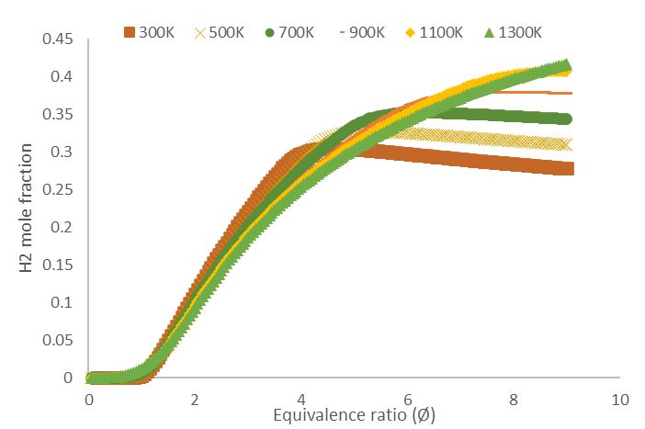  Fig. 1a) Products H₂ v ER for 300K – 1300K C₃H₈O₃ | 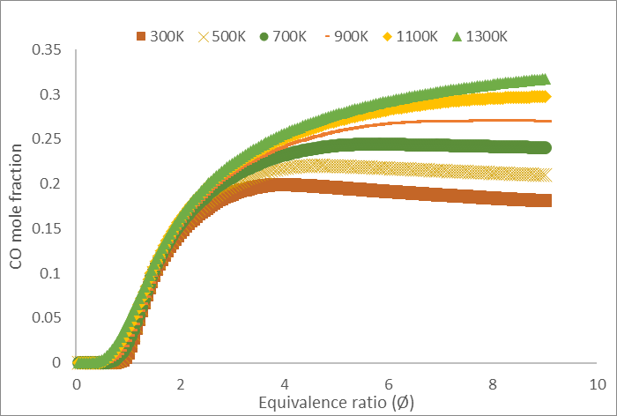  Fig. 1b) Products CO v ER for 300K – 1300K C₃H₈O₃
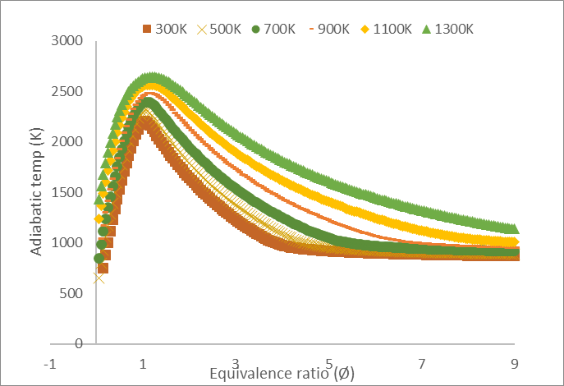  Fig. 1c) Adiab temp v ER for 300K – 1300K C₃H₈O₃ | 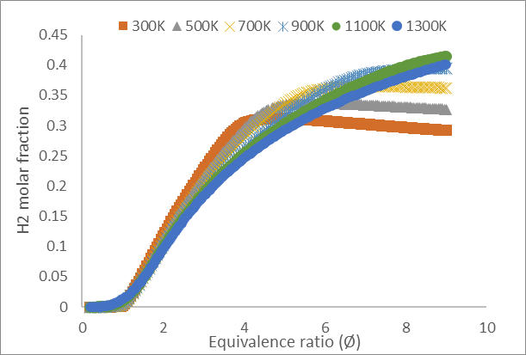  Fig. 2a) Products H₂ v ER for 300K – 1300K water / C₃H₈O₃ 50/50
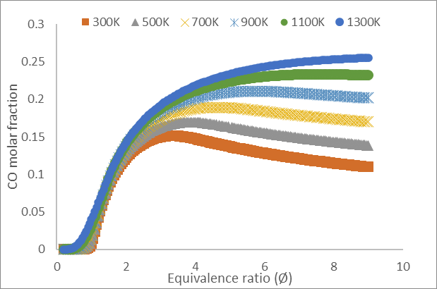  Fig. 2b) Products CO v ER for 300K – 1300K water / C₃H₈O₃ 50/50 | 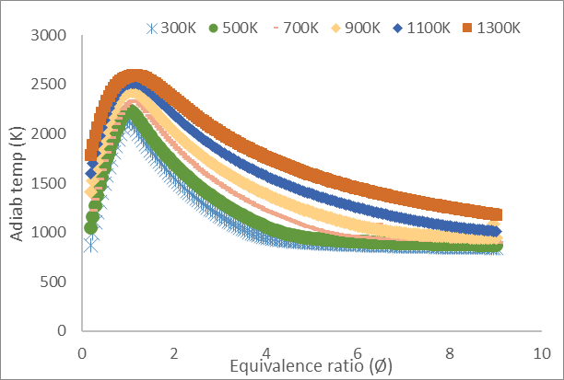  Fig. 2c) Adiab temp v ER for 300K – 1300K water / C₃H₈O₃ 50/50
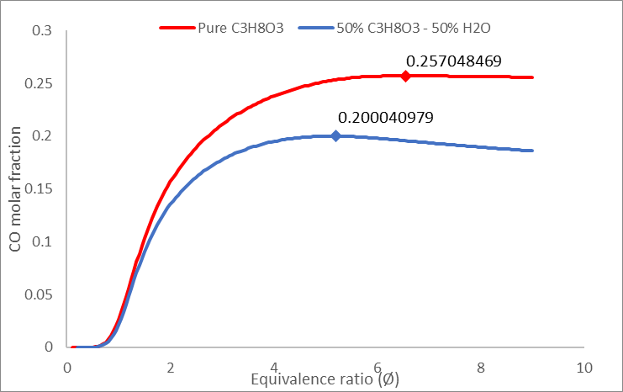  Fig. 3a) At 800K, Peak CO v ER for C₃H₈O₃ and 50/50 water/ C₃H₈O₃ | 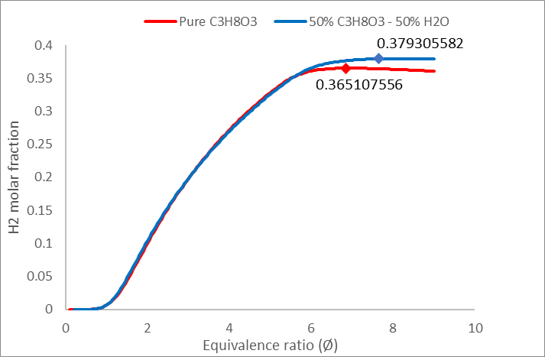  Fig.3b) At 800K, peak hydrogen for C₃H₈O₃ and 50/50 water/ C₃H₈O₃
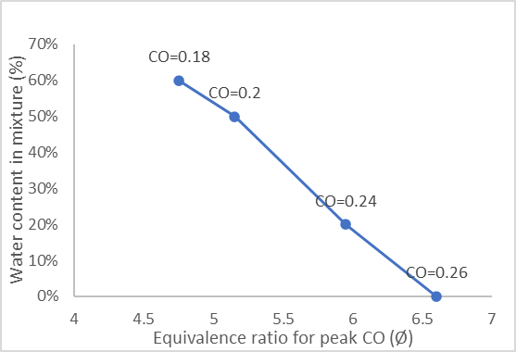  Fig. 4a) Ø for peak CO v % water content in mixture for 800K air temperature | 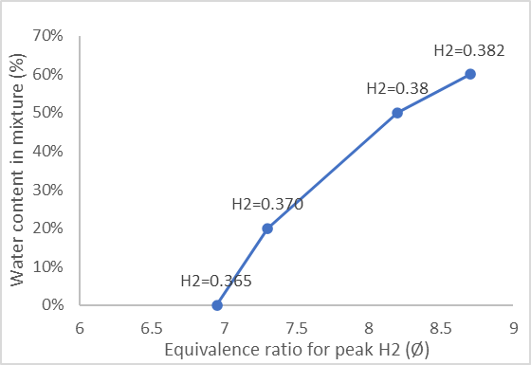  Fig. 4b) Ø for peak H2 v % water content in mixture for 800K air temperature.
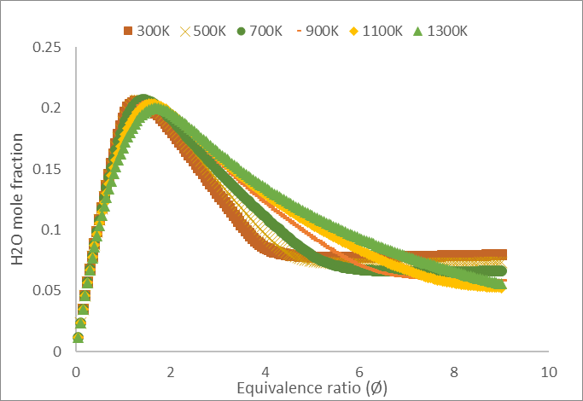  Fig. 5a) Products water vapour v ER for 300K – 1300K C₃H₈O₃ | 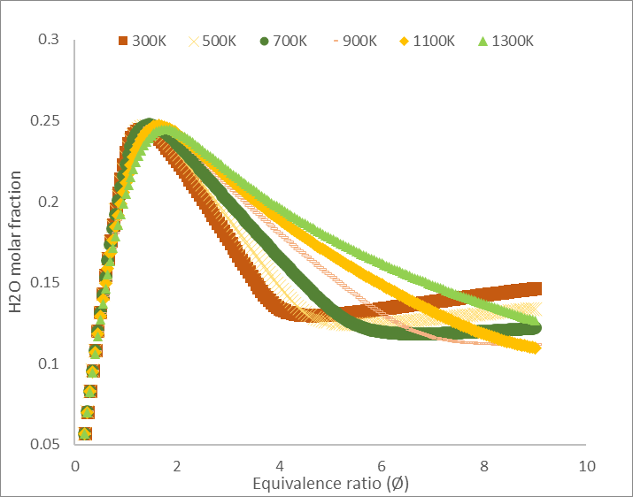  Fig. 5b) Products water vapour Ø for 300K – 1300K for 50% C₃H₈O₃/ 50% H₂O
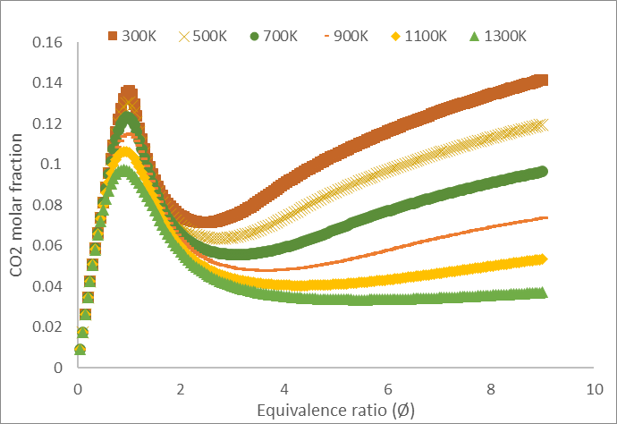  Fig. 6a) Products CO₂ v Ø for 300K – 1300K C₃H₈O₃ | 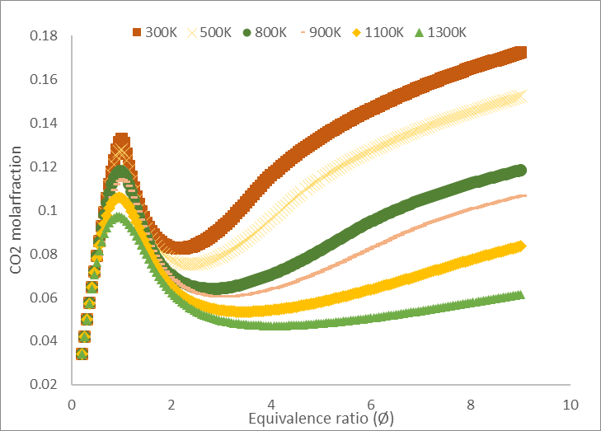  Fig. 6b) Products CO₂ v Ø for 300K – 1300K for 50% C₃H₈O₃ / 50% water
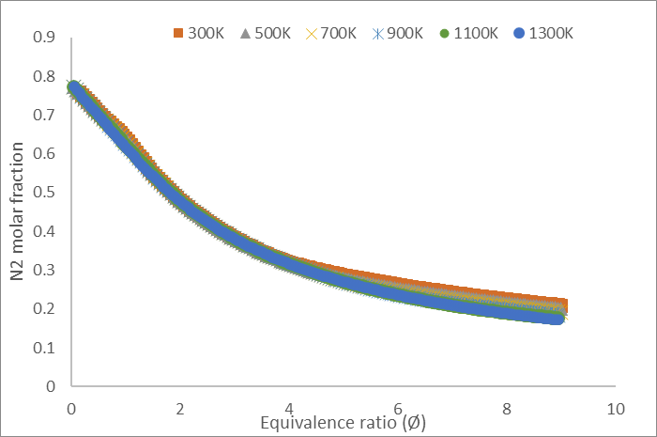  Fig. 7a) Products N₂ v Ø for 300K – 1300K C₃H₈O₃ | 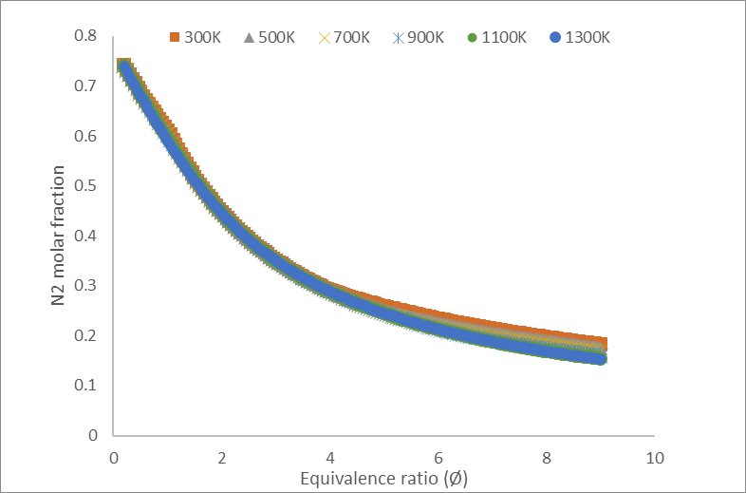  Fig. 7b) Products N₂ v Ø for 300K – 1300K for 50% C₃H₈O₃ / 50% water
These equilibrium predictions enable the composition of the BGG for particular operating conditions and one example is shown in Table 1 for glycerol and 50/50 water/glycerol mixtures at Ø=6 and 700K air temperature.
Table 1 Glycerol and 50/50 water/glycerol mixtures at Ø=6 and 700K air temperature.
Mixture | H₂% | CO% | CO₂% | H₂O% | N₂% | Flame Temp (K)
Pure glycerol | 37 | 24 | 8 | 7 | 25 | 1000
50/50 water/glycerol | 36 | 19 | 10 | 12 | 23 | 1000
  - Conclusions
There are sufficient bio-waste products in whisky distilleries, from the farm to the distillery to satisfy all the energy requirements of the distillery. There is more energy in bio-wastes in glycerol and farm manures and straw to decarbonise the whole of process heat in the UK. The bio-wastes have a high water content and gasification can cope with this, as the BGG gas composition is similar for glycerol and 50/50 water/glycerol.
One of the main findings of this paper is the prediction that a wet biomass mixture can be successfully gasified, and even though it does not show a major increase in H₂ production, the carbon savings are rather important.
Heating the gasifier air is a significant influence on the BGG composition and the Ø that the maximum energy in BGG occurs.
Gasification of industrial and farm bio-waste should be recognized as an important route to decarbonisation, that also has low operating costs, as much of the bio waste is free at distilleries or farms.
Nomenclature
BGG – Biomass gasification gas | Ø – Equivalence ratio | PA- Pot ale
GCV – Gross calorific value | T_{adiab} – Adiabatic temperature | PAS- Pot ale syrup
Acknowledgments
We thank the UK Government. Department of Business, Energy and Industrial Strategy (BEIS) for the award of a contract to undertake this work: BatGasDW: Batch Gasification of Distillery Waste.
References
Arnison, R and Carrick, R. 2015 – Ricardo -AEA, Circular Economy June 2015 Sector Study on Beer, Whisky and Fish Final Report. ZerowasteScotland.org.uk
Burcat, A., & Ruscic, B. (2005). Third Millennium Ideal Gas and Condensed Phase Thermochemical Database for Combustion with Updates from Active Thermochemical Tables.
Kaushal, M., Ahlawat, S., Makut, B. B., Goswami, G., & Das, D. (2019). Dual substrate fermentation strategy utilizing rice straw hydrolysate and crude glycerol for liquid biofuel production by Clostridium sporogenes NCIM 2918. Biomass and Bioenergy, 127, 105257–105257. https://doi.org/10.1016/j.biombioe.2019.105257
Marahrens, M. (2022). Billions wasted on biofuels Biofuels are a harmful and expensive distraction to road transport decarbonisation. Biofuels & Energy Transport & Environment. chrome-extension://efaidnbmnnnibpcajpcglclefindmkaj/https://www.transportenvironment.org/wp-content/uploads/2022/06/202206_Billions_wasted_on_biofuels_TE.pdf
McBride, B. J., & Gordon, Gordon. (1996). Computer Program for Calculation of Complex Chemical Equilibrium Compositions and Applications II. https://www.grc.nasa.gov/www/CEAWeb/RP-1311-P2.pdf
Morley, C. (2005). Gaseq. http://www.gaseq.co.uk/
Olanrewaju F., Andrews G., Li H., Phylaktou N. (2019). Bioenergy Potential in Nigeria. Chemical Engineering
Transactions, Vol. 74.
Saeed M.A., Irshad A., Satter, H., Andrews G.E., Phylaktou H.N. & Gibbs B.M. (2015). “Agricultural waste
biomass energy potential in Pakistan”. Proceedings of the Bioenergy Exhibition and Asian Bioenergy
Conference, ibsce, Shanghai, China.
Shams Yazdani, S., Mattam, A. J., & Gonzalez, R. (2010). Fuel and Chemical Production from Glycerol, a Biodiesel Waste Product. In Biofuels from Agricultural Wastes and Byproducts (pp. 97–116). https://doi.org/10.1002/9780813822716.ch6
Vadenboa, C., Toninib, D., Burgc, V., Fruergaard Astrupb, T., Theesc, O., Hellweg, S., Environmental optimization of biomass use for energy under alternative future energy scenarios for Switzerland. Biomass and Bioenergy 119 (2018) 462-472.
Wongjaikham, W., Wongsawaeng, D., Ratnitsai, V., Kamjam, M., Ngaosuwan, K., Kiatkittipong, W., Hosemann, P., & Assabumrungrat, S. (2021). Low-cost alternative biodiesel production apparatus based on household food blender for continuous biodiesel production for small communities. Scientific Reports, 11(1), 13827. https://doi.org/10.1038/s41598-021-93225-5

Equivalence ratio (Ø) is the stoichiometric ratio of the air/fuel to the actual air/ fuel, where Ø>1 is fuel rich and Ø<1 is fuel lean

