CHEMICAL ENGINEERING TRANSACTIONS  VOL. , 2023 | A publication of
The Italian Association
of Chemical Engineering
Online at www.cetjournal.it

Guest Editors:
Copyright © 2023, AIDIC Servizi S.r.l.
ISBN 979-12-81206-XX-X; ISSN 2283-9216

Hazards and Associated Risks of Hydrogen Vehicles in Underground Traffic Infrastructure
Vladimir Molkov*, Sergii Kashkarov, Srinivas Sivaraman, Dmitriy Makarov
Hydrogen Safety Engineering and Research Centre (HySAFER), Ulster University, Jordanstown, BT37 0QB, UK
v.molkov@ulster.ac.uk
This paper overviews some findings of the HyTunnel-CS project (www.hytunnel.net) on inherently safer use of hydrogen-powered vehicles in underground traffic infrastructure. The focus is on mitigation and prevention of hazards from blast wave and fireball following hydrogen tank rupture in a fire. It is demonstrated that hydrogen tank rupture in a fire is unacceptable and must be excluded. The criticism of the fire test protocol of GTR#13 is presented. It is underlined that hydrogen storage systems protected by thermally activated pressure relieve device (TPRD) do not exclude risk of tank rupture in a localised fire. The safety strategy for underground parking of hydrogen cars is described. The concept of explosion free in a fire self-venting (TPRD-less) tank is explained. The hydrogen safety engineering tools and QRA methodology developed in HyTunnel-CS are used for assessment of risk for incident scenarios of an onboard hydrogen storage tank rupture in Dublin tunnel fire. The risk is assessed in terms of fatalities per car per year, and cost per event. It is concluded that the fire-resistance rating (FRR) of the hydrogen storage tank should exceed 91 min to reduce the risk of a hydrogen-powered car in a tunnel fire to the acceptable level of 10⁻⁵ fatalities/vehicle/year. The ultimate safety solution to eliminate hazards and associated risks of hydrogen vehicles use in confined spaces is the application of the breakthrough safety technology of explosion free in a fire self-venting (TPRD-less) tank that was experimentally validated.
  - Introduction
This paper presents some of research findings of the HyTunnel-CS ‎project “Pre-normative research for safety of hydrogen driven vehicles and transport through tunnels and similar confined spaces”. The ambition of HyTunnel-CS is to underpin the allowance of hydrogen-powered vehicles to enter underground traffic infrastructure. This pre-normative research aims to close knowledge gaps ‎and technological bottlenecks in the provision of safety in the use of such vehicles in underground transportation systems.
From the wide spectrum of research problems solved in HyTunnel-CS, here we overview the mitigation and prevention strategies and engineering solutions for such hazards as blast wave and fireball after hydrogen tank rupture in a tunnel fire. The project has demonstrated, by using complementarities and synergies of theoretical, numerical, and experimental studies, that hydrogen storage tank rupture in a tunnel fire is an unacceptable event. One of the practical issues to be resolved is behaviour of high-pressure hydrogen storage tanks in real fires rather than simple compliance with the regulated fire test. The ultimate safety solution to eliminate hazards and associated risks of hydrogen vehicles use in confined spaces is the application of the breakthrough safety technology of explosion free in a fire self-venting (TPRD-less) tank. The technology was experimentally validated in several national and international projects coordinated by Ulster University. The above safety issues and results of their investigation in HyTunnel-CS are overviewed in this paper.
  - Real fires and GTR#13 fire test protocol
There are serious safety concerns about the fire test protocol of Global Technical Regulation on Hydrogen and Fuel Cell Vehicles No.13 (GTR#13) (Proposal for Amendments, 2022). The intensity of a fire is characterized by the specific heat release rate, HRR/A, which is the ratio of the heat release rate, HRR, to the projection area of the fire, A. Published during 1976-2017 data states that for gasoline/diesel fires this value is HRR/A=1-2 MW/m², see for example work of Heselden (1976) and study of Ingason and Li (2017). Unfortunately, ‎the Proposal for Amendments (2022) reduces the intensity of the standard localised fire test to HRR/A=0.2-0.5 MW/m² (suggested HRR/A=0.3 MW/m²‎) and, after 10 min of the localised fire, requires its increase to HRR/A=0.4-1.0 MW/m² (suggested HRR/A=0.7 MW/m²‎) during the engulfing stage of fire test. The reduced compared to gasoline/diesel fire HRR/A can result in dramatic incidents when a compressed hydrogen storage system (CHSS) that “successfully” passed the standard fire test will not withstand a real fire and rupture.
The fire resistance rating (FRR) of CHSS is the time from the start of fire to the moment of rupture. This would happen in cases when a TPRD is not exposed to the localised fire, is blocked from the fire during incident, or is not initiated due to its failure for whatever reason. Figure 1 demonstrates strong FRR dependence on the specific heat release rate value HRR/A (blue strip). It shows how the suggested by GRT#13 lower value of HRR/A‎ ”assists” in passing the fire test but creates a hazard of CHSS rupture in real fires. ‎Indeed, a fire of low intensity of 0.2 MW/m² will result in FRR of about 24 min (Figure 1a). This is much longer than duration of the localised fire stage of 10 min and thus TPRD, if it is initiated by this comparatively low intensity fire, can prevent the tank rupture by releasing hydrogen. However, if the localised fire intensity is higher, i.e., 1 MW/m², the tank would rupture already in 5-6 min, i.e., well before the TPRD is affected by the engulfing fire after 10 min of the test (Figure 1b). Conformable tanks with large aspect (length to diameter) ratio in fires with HRR/A=1 MW/m² have FRR as low as 2 min due to their thinner walls.

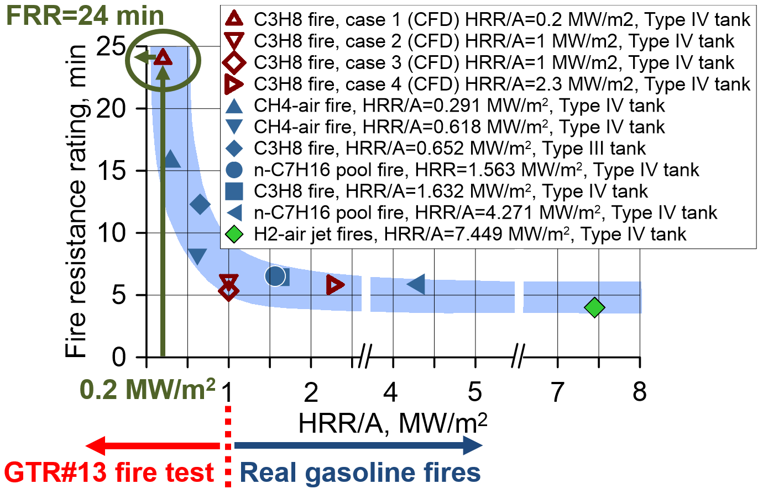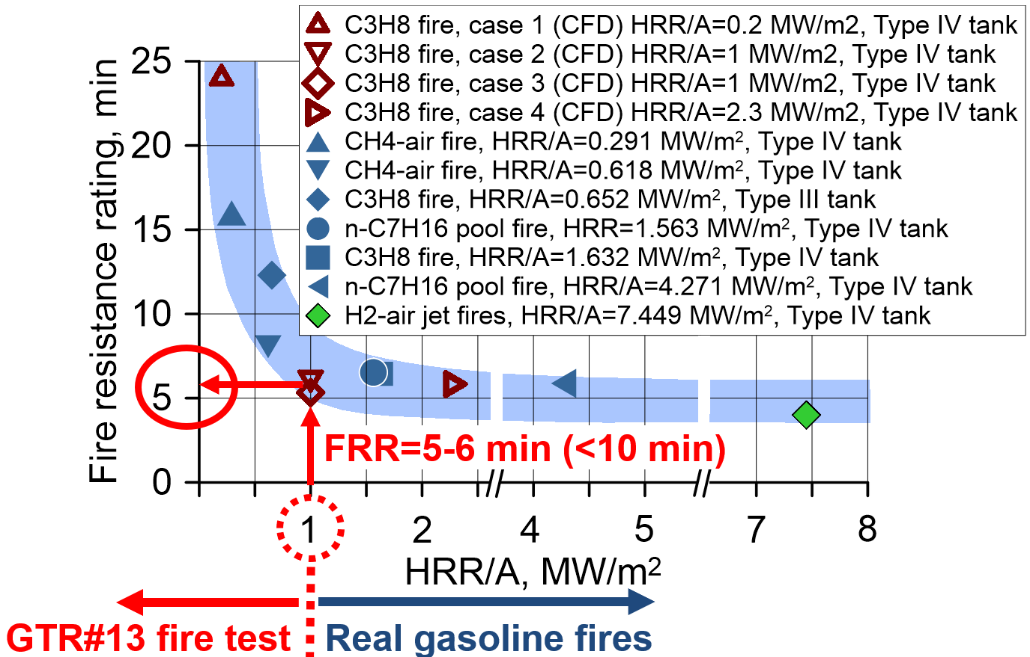
- (b)
Figure 1: (a) FRR=24 min for a storage tank in a fire of intensity HRR/A=0.2 MW/m². (b) FRR=5-6 min for the same storage tank in a real fire of intensity HRR/A=1 MW/m²
To exclude tank rupture during the localised stage of GTR#13 fire test, the HRR/A should be reduced, e.g., to 0.3 MW/m². This means that CHSS can pass the regulated fire test but would rupture in real fires of higher intensity. To make the GTR#13 fire test more relevant to real life conditions, it should be carried out at HRR/A≥1 MW/m² for both localised and engulfing fire stages. This would require development of hydrogen storage tanks with higher FRR. The question “What FRR of CHSS should be?” has a simple answer: “CHSS must withstand any fire without a rupture”.
  - Safety strategy for underground parking
The safety strategy for underground parking of hydrogen vehicles developed by HyTunnel-CS is as follows. The design of vehicle must avoid creation under the ceiling of underground parking of both: a flammable cloud for scenarios of unignited release of hydrogen and its combustion products with temperature ‎above 300 ºC for scenarios of jet fire from TPRD.
This safety strategy can be realised either through a proper design of a tank-TPRD system (Molkov et al., 2021) or using the breakthrough safety technology of explosion free in a fire self-venting (TPRD-less) tank (European Patent Application, 2018). For CHSS with TPRD, the reduction of TPRD diameter to avoid flammable cloud and hot combustion products above 300 ºC entering ventilation system can be achieved if the TPRD diameter is reduced, but not below that value which is necessary to exclude the rupture of this tank in a fire.
Unfortunately, available reduced models are not capable to assess safety of underground car parks with multiple ventilation openings and downward releases from TPRD. Thus, the implementation of the safety strategy suggested above can be done only by contemporary tools of hydrogen safety engineering, e.g., computational fluid dynamics (CFD). For example, the CFD simulations performed in HyTunnel-CS for underground parking of dimensions 23.5x3x45 m with ceiling height 2.1-3.0 m and air change per hour ACH=0-10 with downwards release demonstrated that the overall safest option is to direct release from TPRD at 45 degrees to the vertical.
  - Novel hydrogen safety engineering tools
The HyTunnel-CS allowed to develop new models and tools for hydrogen safety engineering. Here the dimensionless correlation for blast wave decay in a tunnel is presented.
The CFD model validated against experimental data, was used to perform a series of numerical experiments on high-pressure hydrogen tank rupture in a fire in tunnels of different cross-section area, length, and width to height ration. These numerical experiments were processed using methods of the similitude analysis. Thus, the dimensionless correlation for the blast wave decay after rupture of a tank in a fire in a tunnel was developed.
Figure 2a shows the conservative and the best fit correlations derived by numerical and theoretical studies at Ulster University (Molkov and Dery, 2020). The correlation was then validated against the unique experiments on the blast wave decay after hydrogen tank rupture in a real tunnel performed by CEA (Kudriakov et al., 2022) as shown in Figure 2b. CEA recommended to use the best fit rather than the conservative form of the correlation.

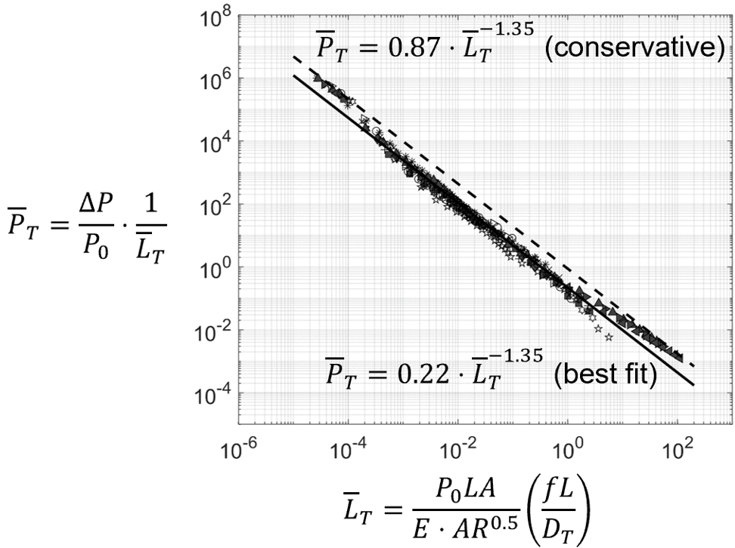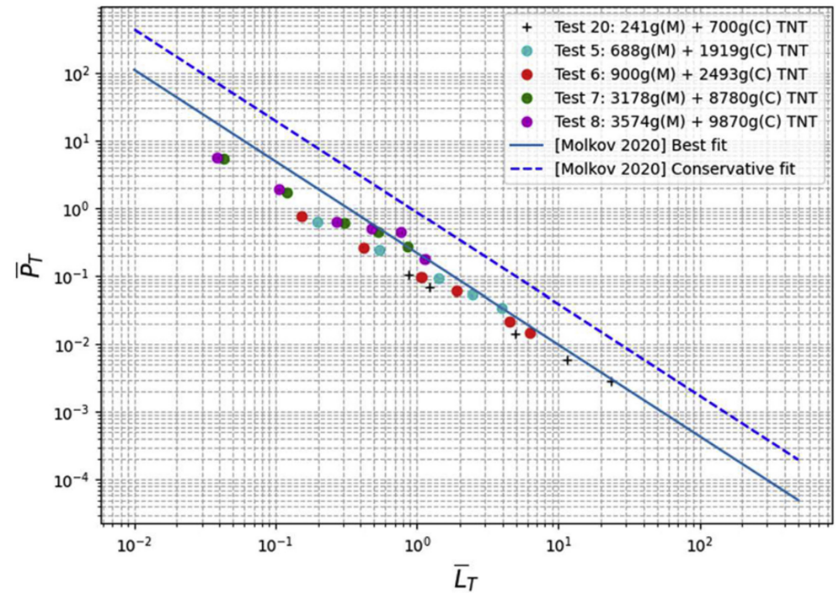
- (b)
Figure 2: (a) Dimensionless correlation for blast wave decay after tank rupture in a tunnel developed at Ulster University (Molkov and Dery, 2020). (b) Correlation validation in real tunnel tests performed by CEA (Kudriakov et al., 2022)
The experimentally validated correlation, which was derived by theoretical and numerical methods, can be used as a contemporary tool for hydrogen safety engineering and quantitative risk assessment of incident scenarios of hydrogen tanks rupture in a tunnel fire.
  - Example of QRA methodology application to the Dublin tunnel
The hydrogen safety engineering tools and methodology of quantitative risk assessment (QRA) developed in HyTunnel-CS were used for the assessment of risk for incident scenarios of an onboard hydrogen storage tank rupture in Dublin tunnel fire (Kashkarov et al., 2022). The QRA uses previously unavailable tools for assessment of consequences of incident scenarios for the new hazard, i.e., hydrogen tank rupture in a fire. The QRA includes analysis of fatality frequency, monetary losses, sensitivity analysis, and the Frequency-Number of fatalities (FN) curves analysis. The risk is assessed in terms of: (1) fatalities per car per year and (2) cost per event. The pressure effects from 70 MPa hydrogen tank rupture in a fire with states of charge 99% and 59%, when TPRD failed to be initiated in a localised fire or being blocked from a fire during an incident, are evaluated. It is concluded that FRR of the hydrogen storage tank should exceed 91 min to reduce the risk of a hydrogen-powered car tank rupture in a tunnel fire to the acceptable level of 10⁻⁵ fatalities/vehicle/year and cost of £300 per incident. The rise in the FRR to this level decreases societal risk to an acceptable level. The created FN fatalities curve demonstrated that the increase of the FRR can decrease the risk even below the acceptable level. The sensitivity study showed that the rupture of hydrogen tank within the tunnel is unacceptable for a range of reasons (input parameters). The sensitivity study also demonstrated that fire brigade response time is a critical factor for risk reduction and any delay can drastically increase the risk beyond the unacceptable level.
  - Breakthrough safety technology of explosion free in a fire self-venting (TPRD-less) tank
The ultimate safety solution to eliminate hazards and associated risks of hydrogen vehicles use in confined spaces is the application of the breakthrough safety technology of explosion free in a fire self-venting (TPRD-less) tank that was experimentally validated, including within HyTunnel-CS. This innovative safety strategy does not require TPRD. It ‎exploits the microleak-no-burst (μLNB) technology for reaction of CHSS to a fire (European Patent Application, 2018). The technology provides ‎melting of hydrogen-tight liner in a fire before hydrogen-leaky composite wall loses its load-bearing ‎capability. The melting of liner leads to microleaks of hydrogen through the composite wall. Hydrogen microleaks either ‎burn in tiny microflames without or with resin or quickly decays to concentrations below the lower flammability limit (LFL) if the ‎leak flow rate is below the flame quenching limit or above the blow-off limit. The important feature of the technology is that when a vehicle fire ‎is extinguished, these microleaks do not create flammable atmosphere around the tank surface and beyond, due to extremely small size ‎and discrete character of microleaks. Such release of hydrogen with concentration below LFL can be tackled by natural ventilation in enclosures like garages, hydrogen storage rooms on trains, ships, and planes. The μLNB technology mitigates the pressure peaking phenomenon. The main advantage of the technology is that it does not require TPRD, which failure rate in localised fire is high according to the conclusions of the FireCOMP project. TPRD response time to different fires and thus reliability in that fire is not available to stakeholders. Ultimately, the μLNB technology eliminates the CHSS rupture and thus the catastrophic consequences of incidents with tank ‎rupture: devastating blast waves, fireball, projectiles, etc. The implementation of the technology assures the achievement of lower level of risk in using hydrogen-powered vehicles compared ‎to fossil fuel ones.‎
The failure mechanism of a standard hydrogen storage tank in a fire suggested and verified at Ulster University is explained schematically in Figure 3. The standard tank has a liner, which limits hydrogen permeation to the regulated level, and load-bearing carbon fibre reinforced ‎polymer (CFRP) overwrap. The minimum regulated safety factor for burst pressure of tanks is currently ‎‎2.25 of nominal working pressure (NWP), i.e., at the start of the fire only 1/2.25=0.44 fraction of the CFRP wall thickness can withstand ‎NWP. The sufficient to bear the pressure load wall thickness fraction is shown in Figure 3 by the black dashed line‎. ‎Pressure inside the tank grows in time due to heat transfer from the fire through the wall to hydrogen. This results in ‎the increase of the wall thickness fraction needed to bear the increasing pressure load. Under thermal load of fire, the resin of composite degrades, fibre plies become loose in places where the resin of composite is decomposed and thus not any more able ‎to bear the pressure load. The resin degradation front propagates into the wall during the fire (red colour area in Figure 3). When the inward propagating resin decomposition (red colour area) meets the outward moving load-bearing wall thickness fraction (black dashed line), the tank ruptures (Time 3 in Figure 3).
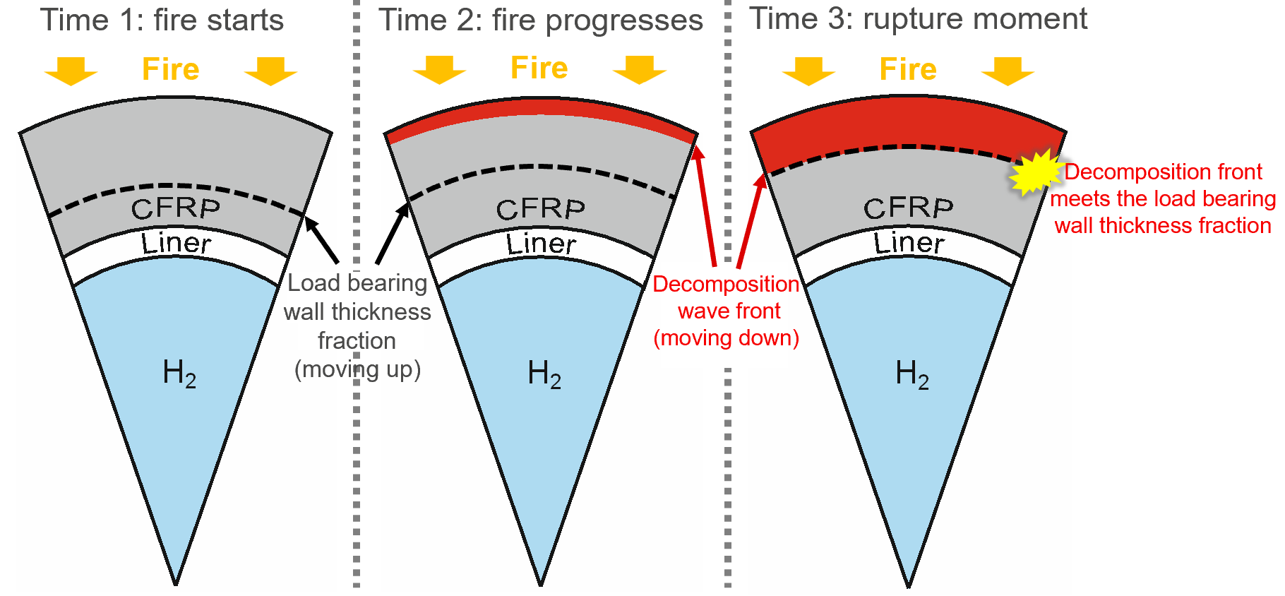
Figure 3: Failure mechanism of a composite tank in a fire
Figure 4 compares the performance of standard (a)‎ and μLNB (b) tanks in a fire. The difference between μLNB tank design and standard tank design is in the use of two composites ‎instead of one in the tank wall and the science-informed selection of their thermal and geometrical properties. The external part of the double-composite ‎wall is marked in Figure 4b as thermal protection layer (TPL). It has lower thermal conductivity compared to the internal part of the double-composite ‎wall marked as fibre-reinforced polymer (FRP) and can be load-bearing as well. The thermal parameters of the liner, TPL, FRP layers and their thicknesses ‎are defined to provide melting of the liner before the resin decomposition front meets the load-bearing fraction of the wall thickness, i.e., when the tank ruptures. Due to hydrogen leaks through the composite wall microchannels, pressure in the tank drops. At the same time, due to expansion, leaking hydrogen cools down the resin and thus prevents the ‎tank rupture by delaying the “meeting” of resin decomposition and load-bearing wall thickness fraction fronts. ‎

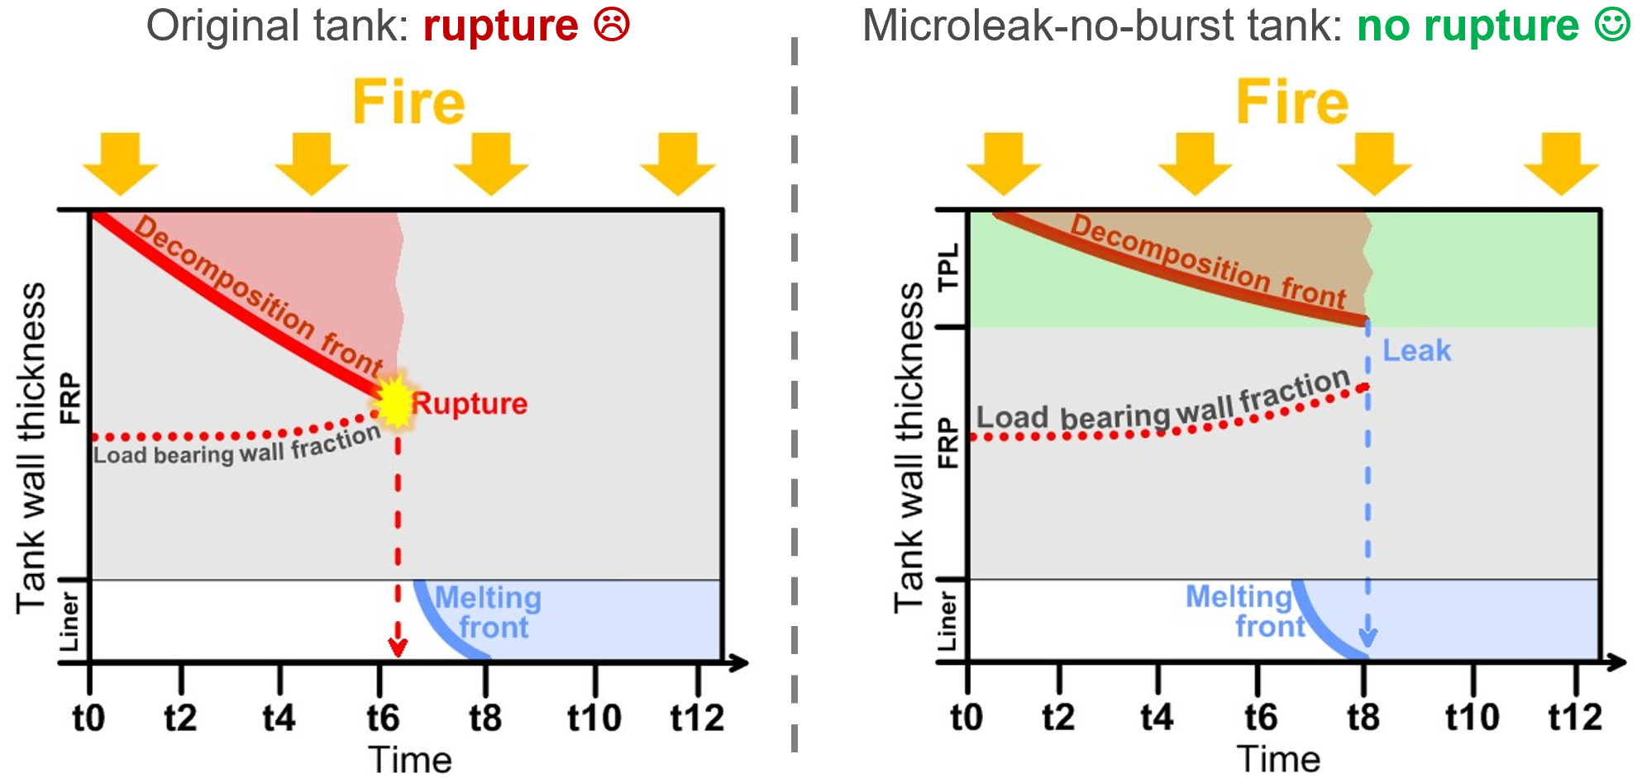
- (b)
Figure 4: Explanation of μLNB safety technology for composite Type IV tanks: (a) original tank, (b) μLNB tank performance in a fire‎ with time
Figure 5 shows snapshots of a validation fire test following the GTR#13 protocol, yet with realistic fire of HRR/A=1 MW/m² intensity, for μLNB tank prototype of NWP=70 MPa, and volume 7.5 L. The μLNB tank had the same volume, size and weight as the original (standard) tank (outer diameter of ‎liner was 161.0 mm for original tank and 160.7 mm for μLNB tank, outer diameters of the tanks were 186.9 mm and ‎‎186.1 mm respectively, i.e. slightly smaller for the μLNB tank). The original standard tank wall thickness made of one FRP was 13 mm. The LNB tank wall thickness was ‎‎even thinner: 12.7 mm. This and other μLNB tanks prototypes with different fibres and resins have successfully passed the regulated burst test, hydrostatic test and finally the fire test at realistic, not reduced, fire intensity. The μLNB ‎tank not only corresponds to the regulation requirements yet acquired unprecedent new safety performance, i.e., elimination of tank ‎rupture in a fire of any intensity and its catastrophic consequences in the form of blast wave, fireball, and projectiles.
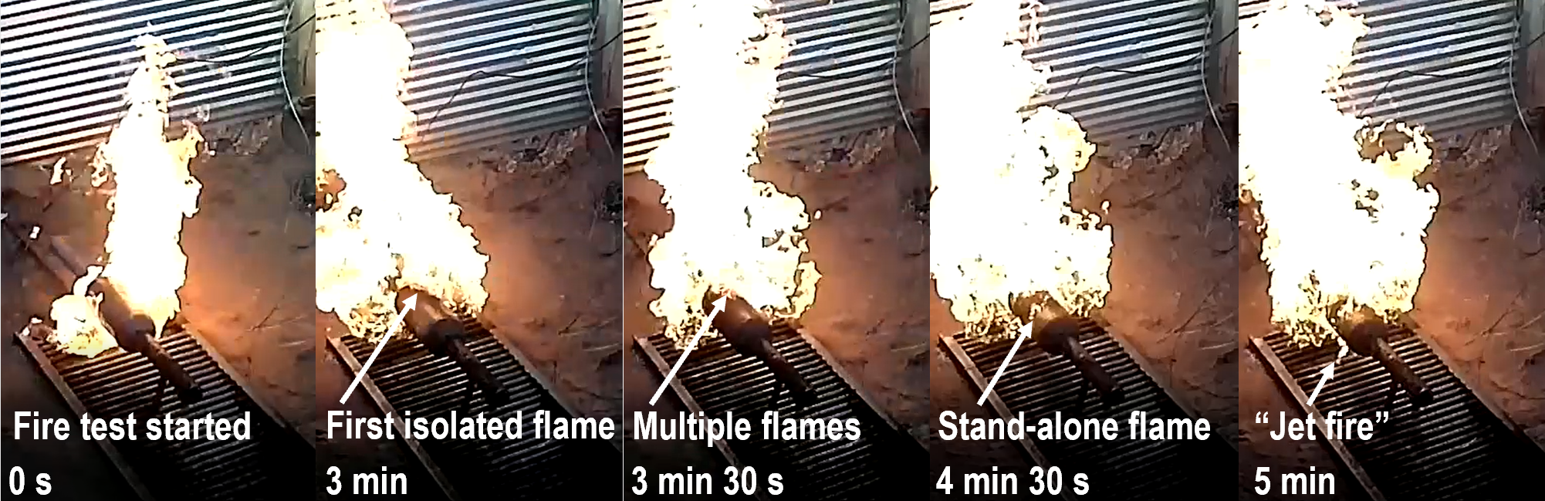
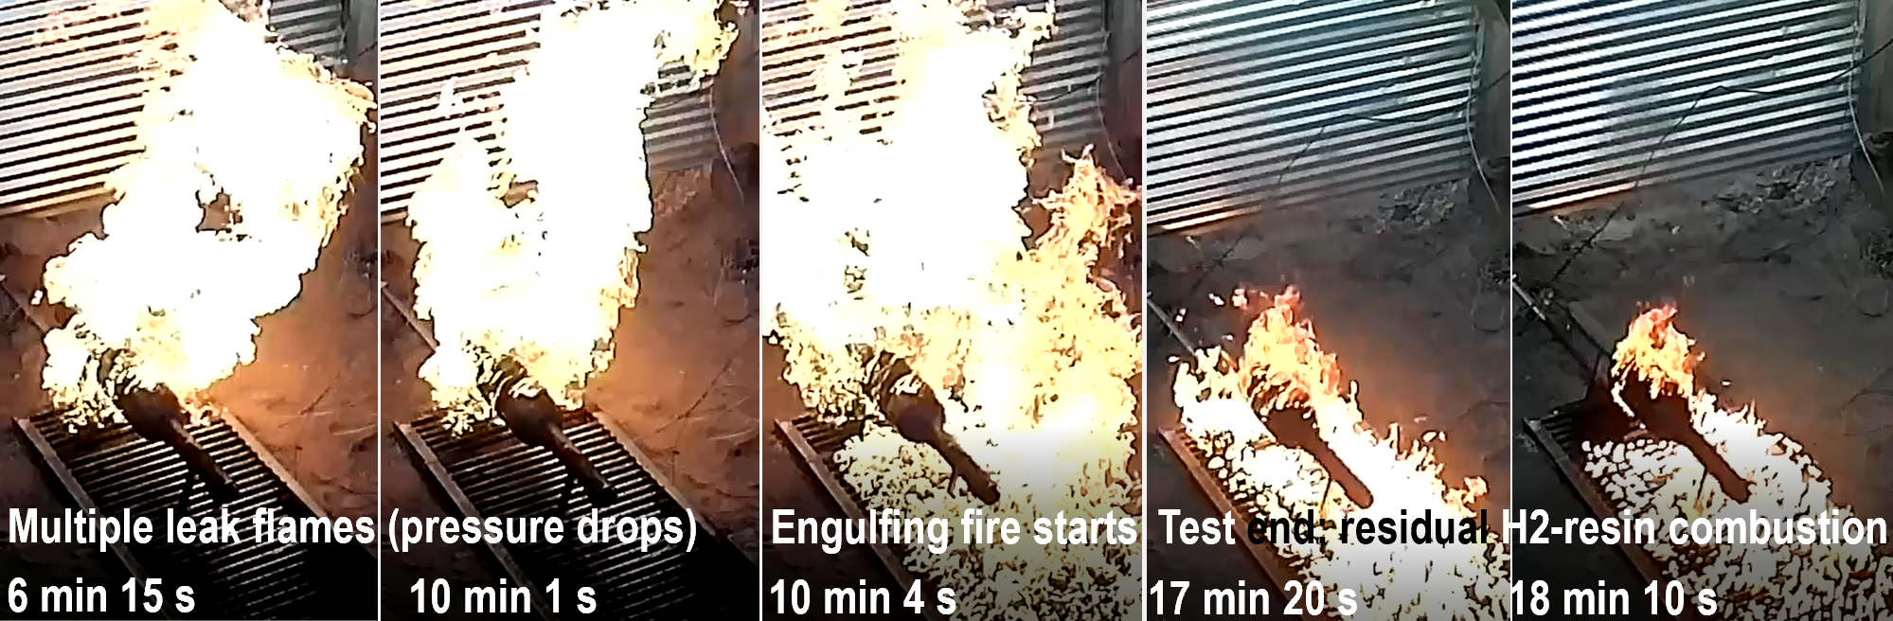
Figure 5: Snapshots of one of μLNB tank prototypes behaviour in a fire test with realistic HRR/A=1 MW/m²
  - Conclusions
The significance and impact of the pre-normative research project HyTunnel-CS includes but is not limited to the following. Stakeholders, including OEMs, have access to the beyond the-state-of-the-art “Recommendations for inherently safer use of hydrogen vehicles in underground transportation ‎systems”, including new engineering tools for the e-Laboratory of Hydrogen Safety. First responders are informed by “Harmonised recommendations for intervention strategies and tactics for first responders” that ‎provides conditions for their life safety and property protection. Hydrogen and relevant industries are provided with “Recommendations for the update of relevant RCS”, prepared under leadership of HyTunnel-CS partner NEN‎ (Dutch standard development organisation delivering the duties of the secretariate of CEN/CENELEC/JTC6 Hydrogen in Energy Systems). These and other deliverables of HyTunnel-CS can be found on the project website (www.hytunnel.net).
HyTunnel-CS explained the need to change the GTR#13 fire test protocol to reduce the current risk of hydrogen-powered vehicles even below the risk of current fossil fuel vehicles. The project developed and verified safety strategies for underground parking of hydrogen cars. Novel hydrogen safety engineering tools were developed, i.e., the dimensionless correlation for blast wave in a tunnel developed by theoretical and numerical studies at Ulster University and validated against tests in real tunnel by CEA. The project developed QRA methodologies, and an example of QRA methodology application to the Dublin tunnel is shortly presented in this paper.
HyTunnel-CS has validated further the breakthrough safety technology of explosion free in a fire self-venting (TPRD-less) CHSS. This innovative μLNB safety technology allows hydrogen-powered vehicles enter and park in any confined space at risk below the current risk for fossil fuel vehicles. It excludes CHSS rupture at realistic, e.g., equivalent to gasoline/diesel spill fires, of high intensity and was tested at HRR/A=1 MW/m², i.e., beyond suggested by GTR#13 (phase 2) HRR/A=0.3 MW/m² for the localised fire stage and 0.7 MW/m² for engulfing fire stage. The technology allows to achieve unprecedented level of safety of CHSS: no blast wave, no fireball, no projectiles, no long flames (microflames could be present instead), no formation of flammable hydrogen-air cloud under the ceiling of underground parking, no formation of hydrogen combustion products above 300ºC under the ceiling of enclosure, no pressure peaking phenomenon in storage enclosures with natural ventilation, no life and property loss due to tank rupture in a fire.
Acknowledgments
This research has received funding from the Fuel Cells and Hydrogen 2 Joint Undertaking (now ‎Clean Hydrogen Partnership) under the European Union’s Horizon 2020 research and innovation ‎programme under grant agreement No.826193‎ (HyTunnel-CS). This Joint ‎Undertaking receives support from the European Union’s Horizon 2020 research and innovation ‎programme, Hydrogen Europe, and Hydrogen Europe Research.‎
References
European (EPO) Patent Application No. 18706224.5. Application date 12.02.2018. Title: Composite vessel for hydrogen storage. ‎Applicant: University of Ulster. Earliest Priority No: 1702362.3. Earliest Priority Date: 14.02.2017. Priority Country: United ‎Kingdom. International (PCT) Application No: PCT/EP2018/053384. National/Regional Phase Entry Date: 05.09.2019.‎
Heselden A., 1976, Proceedings of the 2nd International Symposium on Aerodynamics and Ventilation of Vehicle Tunnels, Cambridge, UK, J1-1–J1-18.
Ingason H., Li Y.Z.‎, 2017, Fire Safety Journal, 91, 399–406‎.
Kashkarov S., Dadashzadeh M., Sivaraman S., Molkov V., 2022, QRA methodology of hydrogen tank rupture in a fire in a tunnel. 10th International Seminar on Fire and Explosion Hazards, Oslo, Norway, Paper ID51.
Kudriakov S., Studer E., Bernard-Michel G., Bouix D., Domergue L., Forero D., Gueguen H., Ledier C., Manicardi P., Martin M., Sauzedde F., 2022, Full-scale tunnel experiments: Blast wave and fireball evolution following hydrogen tank rupture, International Journal of Hydrogen Energy, 47, 18911-18933‎.
Molkov V., Dadashzadeh M., Kashkarov S., Makarov D.,‎ 2021, Performance of hydrogen storage ‎tank with TPRD in an engulfing fire, International Journal of Hydrogen Energy, 46, 36581-36597.‎
Molkov V., Dery W., 2020, The blast wave decay correlation for hydrogen tank rupture in a tunnel fire, ‎International Journal of Hydrogen Energy, 45, 31289-31302‎.
Proposal for Amendments 1 to Global technical regulation No. 13, Phase 2 (Hydrogen and fuel cell vehicles). Submitted by the IWG on hydrogen and fuel cell vehicles, GTR13-Phase 2. Informal document GRSP-71-09 (71st GRSP, 9-13 May 2022 agenda item 3). <unece.org/sites/default/files/2022-05/GRSP-71-09e.pdf> accessed 29.01.2023.

