|  |  |
| --- | --- |
| cetlogo ***CHEMICAL ENGINEERING TRANSACTIONS***  ***VOL. XX, 2023*** | A publication of  aidiclogo_grande |
| The Italian Association  of Chemical Engineering  Online at www.cetjournal.it |
| Guest Editors: xxxxxx  Copyright © 2023, AIDIC Servizi S.r.l. **ISBN** xxxxxxxxxxxxxxxxx; **ISSN** xxxx-xxxx | |

Well design challenges in Geothermal Energy applications

Daniele Farinaa,Vanessa S. Iorioa, Pasquale Manganoa, Domenico Santoroa,

Luca Dal Fornoa, Carla Sanasia

aEni S.p.A, San Donato Milanese (MI), Italy

[daniele.farina@eni.com](mailto:daniele.farina@eni.com)

Geothermal resources represent precious energy sources to ensure sustainable power generation. As proposed in the majority of the future sustainable energy scenarios, geothermal energy exploitation is going to play a significant role in the energy mix to meet carbon neutrality target. Upon the different technologies involved, geothermal wells constitute the core and turning point for proper fluid/heat mining.

Indeed, the number of suitable candidates for geothermal applications could be significantly enhanced by overcoming a series of wells related technological issues. Therefore, the object of this work is to provide a general overview of the principal challenges that characterized well design and construction in geothermal applications which are mainly related to the type of geological system and its relative temperature level.

As a matter of fact, reservoir temperature guides most of the choices referring to geothermal systems not only in the selection of the final energy application purpose (direct use, power generation, combined heat and power) but also in well design definition. Based on temperature range, geothermal fields are usually grouped in enthalpy classes (low, medium and high) referring to fields characterized by similar energy potential.

From a well design and construction perspective, the low and medium enthalpy classes, in the range of temperature lower than 150 °C, do not present specific criticalities. On the contrary, high enthalpy scenarios, for temperatures higher than 170 °C, present many challenges for most of the current drilling and completion technologies.

Even though some field applications exist in high/ultra-high enthalpy scenarios, they still present an elevated risk of failure. Therefore, dedicated studies shall be conducted for all the elements involved in the well construction process such as: drilling fluids, cement slurry, metallurgy, drilling and completion equipment to properly account for their specific technical limitations.

In this framework, a clear picture of the actual technical gaps constitutes the starting point for current and next research activities. In the close future, the growing interest in geothermal applications will surely boost the born and development of dedicated tools to unlock the enormous potential of geothermal energy.

# Introduction

Geothermal energy represents the primary energy source associated with the natural phenomena of subsurface generation and storage of heat flux coming from rocks radioactive decay and Earth's crust cooling down. On the Net Zero Emissions road by 2050, as forecasted by IEA, its exploitation is going to play an important role in the future energy mix as its contribution will increase from 94 TWh to 330 TWh by 2030. Geothermal energy usage, with respect to power generation purposes, is economically feasible in the presence of geothermal anomalies (thermal gradient higher than 3 °C/100 m) and suitable geological fields (source formation – hot water/vapor reservoir – cap rock system). Geothermal systems are usually divided into three enthalpy classes based on reservoir fluid temperature range: low (50 °C<T<100 °C), medium (100 °C<T<200 °C), and high enthalpy (T>200 °C) according to the *Bendritter and Cormy Classification (1990)* (Collin F., et al., s.d.). In high enthalpy fields, the temperature rating of Oil and Gas (O&G) well construction tools are exceeded, and their applicability is strongly limited. Consequently, all the elements involved in the well construction process must be addressed based on temperature profiles, productive flow rates, depth, type of environment and geothermal application purpose.

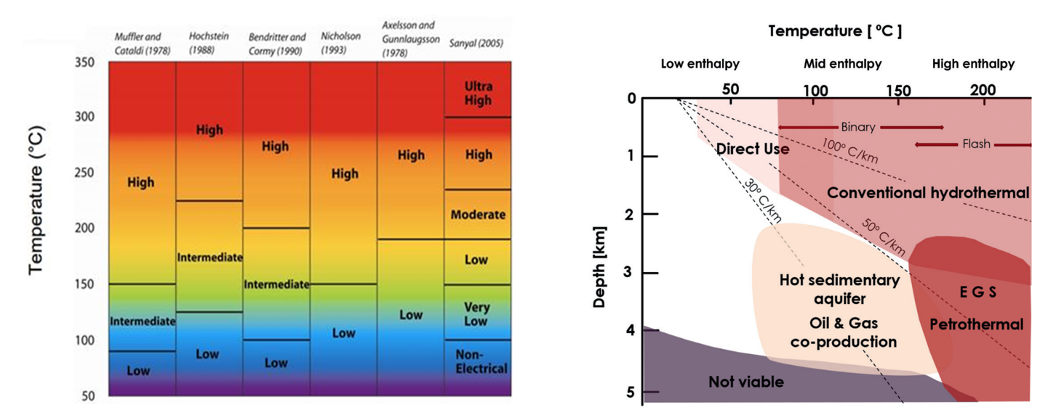

Figure 1: Main geothermal enthalpy classification (left) – Geothermal energy application (right) (Collin F., et al., s.d.)

# Well DRILLING in Geothermal application

Geothermal drilling is the construction of conduits to access heated formations for energy exploitation purposes. Geothermal drilling covers a wide range of applications, from shallow (up to 200-500 m deep) to deep reservoirs (>6000 m) (Brommer & O' Sullivan, 2020). The main areas of interest for geothermal energy exploitation are characterized by formations constituted by igneous (*granite, basalt, etc.)* and metamorphic rocks (*quartzite, etc.)* with high strengths and highly abrasion properties, heavily faulted/folded and fractured which may result in severe/total losses during drilling(Finger & Blankenship, 2010). Because of rocks hardness and abrasion properties more tripping in/out phases are normally required to replace the drilling bit subjected to fast wearing. Moreover, mud and cement losses could be easily experienced with higher frequency than in O&G wells. Geothermal wells also present problems associated with the presence of fluids at high pressure and temperature, that can turn instantly into steam during drilling. All these aspects may lead to higher risks and well costs strongly impacting geothermal project economics.

## Drill bit

Drilling a well in volcanic formations poses a challenge on drilling equipment, especially drill bits. These formations are characterized by high strengths and abrasion properties. Due to these characteristics, drill bit replacement is more likely to occur than in O&G wells. To withstand high temperatures, no elastomeric seals and heat-sensitive parts can be used near the bit. Polycrystalline Diamond Compact (PDC) or roller cone insert bits can be used for geothermal drilling. The latter usually present all-metal cone seals, bearings, and bellows for grease pressure compensation. In this application, innovative grease is used to sustain lubrication action at high temperatures (Stefanson, et al., 2018).

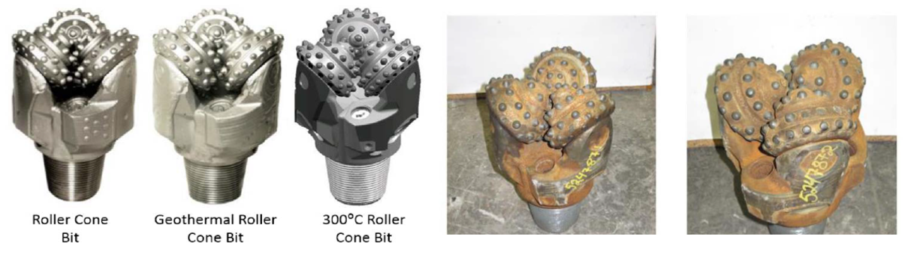

Figure 2 – Different Roller Cone Bit (right). Effect of temperature (300 °C) and bit wearing in IDDP-2 well (left) (Stefanson, et al., 2018)

# Drilling fluids

Traditional water-based muds have temperature limits from 80 to 130 °C, while oil-based mud can withstand temperatures up to 180-200 °C. In high enthalpy geothermal applications, muds become thinner and more unstable. Furthermore, long time exposure to high/ultra-high temperatures results in a loss of water components due to evaporation. This leads to a higher risk of weighting agent sagging phenomenon, especially in water-based mud. In addition, drilling fluid density varies with depth because of thermal expansion. This effect leads to a rising in wellhead pressure during stop of circulation or shut-in period. To overcome these limits dedicated mud design and equipment are used. Mud coolers can lower the surface fluid temperature of about 30 °C – 40 °C. Furthermore, drilling fluids tested up to 250 °C (Wise, et al., 2010) are commercially available with field applications up to 350 °C. These mud types are constituted of water, synthetic polymers, and SAG mitigators with good resistance to H2S and CO2 contamination. The use of water type drilling fluid results in a cheaper product and this aspect constitutes an important characteristic in case of total losses. Indeed, in those circumstances, water-based mud would work as sacrificial fluid, limiting total operating costs.

## Well Cement

In the construction of geothermal wells unconventional cements, usually lighter than conventional ones, are used. Most common cement formulation takes advantage of a combination of class G Portland cement mixed with 40% or more of silica flour, to counteract strength retrogression, and other additives (lubricant, retarders, etc.). These products are lab tested up to 250 °C (due to test equipment limitation), but in literature can be found rare field applications up to 300 °C. To counteract thermal-induced stresses, closed chambers, and tubular elongation, all casings are fully cemented up to surface. Furthermore, cement slurry must withstand acid environment in combination with elevated temperature. Especially in well production section, cement strength retrogression can be experienced leading to well integrity issues. On top of that, high temperature and water evaporation. increases the kinetics of cementing reaction reducing thickening time and making cement job operations challenging. In addition, fluid losses are likely to occur during cementing jobs. To compensate for this phenomenon, lighter cement slurries but also different cementing techniques (two stages or reverse circulation cement) are implemented (Hernandez & Nguyen, 2010).

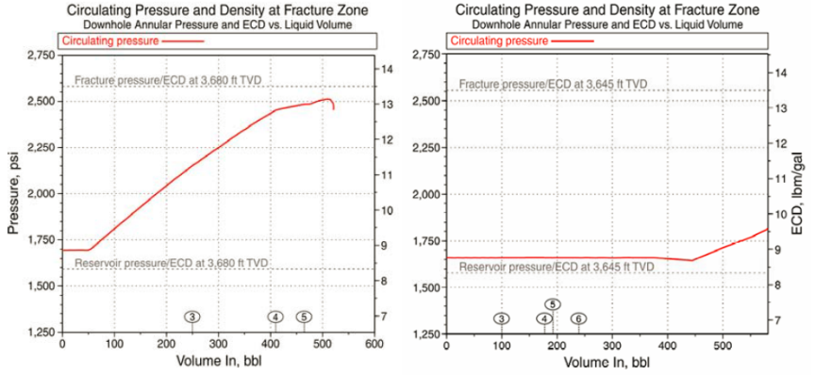

Figure 3 – Pressure profile in Standard cement job (left) vs Reverse Cement Circulation (right) (Hernandez & Nguyen, 2010)

## Directional drilling (MWD/LWD)

Utilization of directional drilling equipment are limited by high temperature. Above 150 – 180 °C, MWD (Measurement While Drilling) and LWD (Logging While Drilling) are not able to withstand such hot environment because of the presence of electronic components. Therefore, they cannot be easily utilized unless a specific cooling circulation system or thermal isolation is implemented to extend the maximum deployment temperature (Kruspe, 2018). Furthermore, no elastomeric seals can be used especially in PDM (positive displacement motor) tool because wearing issues on the rotor and stator limits its operative time and performance [Figure 4].

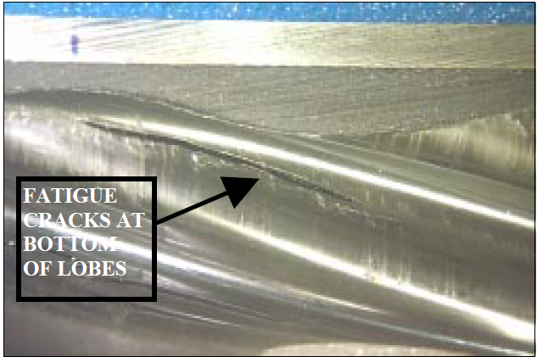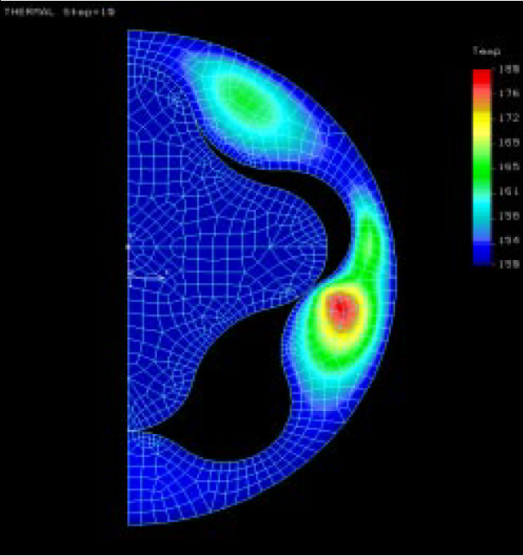

Figure 4 – Fatigue cracks and thermal hysteresis build up in PDM motors (Delpassand, 2017)

# Well COMPLETION in geothermal application

Well completion, in geothermal fields, aims to control and maximize as much as possible hot fluid production. Completion strategies can be significantly different with respect to Oil & Gas wells. Usually, bigger casings, sometimes without tubing string also, are commonly adopted to enhance hot fluid flow rate. The last production section can present liner/tie-back, slotted liner or open-hole solution depending on the reservoir characteristics. Furthermore, an expansion spool is usually installed on the permanent wellhead flange, to compensate for thermal elongation (Abdirasak Omar Moumin, 2013).

**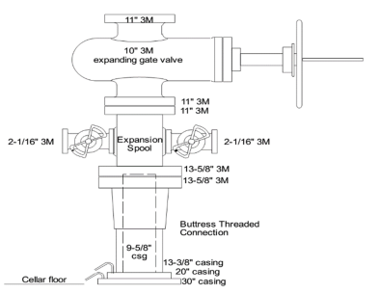**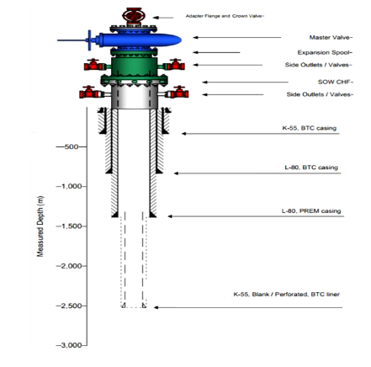

Figure 5: Typical Wellhead design (Abdirasak Omar Moumin, 2013)

Figure 6: Typical geothermal well completion schematic

**8. Materials and metallurgies**

In geothermal applications material selection is strongly influenced by temperature profile, harsh environment, fluid type and flow rate. Temperature effect and possible corrosion/erosion issues must be properly accounted trough software simulation and lab testing. Generally speaking, high temperature environment does not represent an issue for tubulars and ancillaries’ metallurgy. Alloy crystalline structure remains stable at temperature up to more than 400 °C, even if material derating and Bauschinger effect has experimented Figure 7. Furthermore, thermo-mechanical cycling cause fatigue degradation on steel equipment. On top of that, chemical composition of produced fluid has an enormous impact in terms of corrosion mechanism, tubular cracking and brittle failure. Therefore, in the presence of a corrosive environment is highly recommended to use sour service steel grades (e.g., L80 or T95) or CRA (e.g., 25Cr or 28Cr) for production casings.

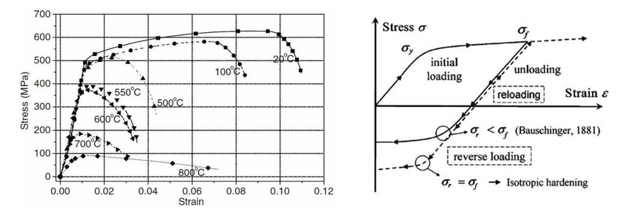

Figure 7 - Steel material derating (left) and Baushinger effect (right) (Yongfeng, et al., 2022)

# 

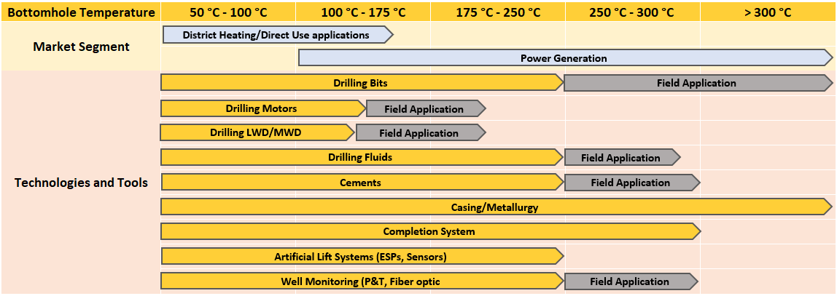

Figure 8 - Bottom Hole Temperature Limit for drilling and completion equipment. in Yellow the maximum testing temperature in grey the field application

# 9. Conclusions

Drilling and completion operations are fundamental to properly exploit geothermal energy content. Reservoir temperature basically constitutes one of the principal parameters which leads most of the choices regarding geothermal system. High enthalpy (T>200 °C) scenarios present a great potential in terms of renewable power production. This extreme condition presents many challenges that pose a limit on the use of current drilling and completion equipment and tools. Drill bits most likely encounter volcanic formations characterized by high strength and abrasive behavior resulting in a significant bit wearing. Drilling fluids degradation and sagging phenomena can be controlled by means of proper mud engineering and mud coolers adoption. Cement degradation and strength retrogression can be controlled by means of high silica flour content (>40%) in cement formulation. Drilling motor and LWD/MWD tools are applicable up to 175 °C, due to the presence of elastomeric and electronic parts. Different completion strategies can be used depending on reservoir characteristics. In any case, expansion spools are usually installed to compensate for thermal elongation during the production/shut-in period. Material selection represents one of the most important parts of the well design process. Indeed, casing columns must withstand significant thermal load (Buckling and Bauschinger effect) and the possible presence of a corrosion environment (CO2 and H2S) leading, generally, to the use of sour services grades for production casings.

Finally, an overview of the temperature application range is provided in Figure 8 distinguishing, for each tool, between laboratory tested temperature (in yellow) and field application temperature (in gray). Although some field applications exist in reservoirs with temperatures up to 350 °C, the available laboratory tests can certify and rate geothermal drilling and completion tools up to 250 °C. Consequently, this temperature value can be selected as the reference limit. In the close future, the development of dedicated technologies and tools will overcome actual technical and operational limits unlocking the full potential of geothermal resources.

# REFERENCE

Abdirasak Omar Moumin, 2013. Geothermal Well Design.

Agency, I. E., n.d. *IEA, Geothermal power generation in the Net Zero Scenario, 2000-2030, IEA, Paris.* [Online]   
Available at: https://www.iea.org/data-and-statistics/charts/geothermal-power-generation-in-the-net-zero-scenario-2000- 2030

Brommer, M. B. & O' Sullivan, J. M., 2020. The current status of deep Geothermal Energy.

Collin F., W., Marshall J., R. & Arlene F., A., n.d. Updating the classification of Geothermal Resources.

Delpassand, M., 2017. STATOR LIFE OF A POSITIVE DISPLACEMENT.

Finger, J. & Blankenship, D., 2010. Handbook of Best Practices for Geothermal Drilling.

Hernandez, R. & Nguyen, H., 2010. Reverse-Circulation Cementing and Foamed Latex Cement Enable Drilling in Lost

Circulation Zones.

Kalda, G. S. et al., n.d. Load Hystory and Buckling of the production casing in a high temperature geothermal well.

Kruspe, T., 2018. High Temperature 300°C Measurement While Drilling.

Stefanson, A. et al., 2018. A 300 Degree Celsius Directional Drilling System.

Wise, W. et al., 2010. HP/HT Well: Fluid Selection, Planning and Lessons Learned.

Yongfeng. K., Robello, S. & Vagish, K., 2022. Casing Failures in High Temperature Geothermal Wells: An Analytical Study