|  |  |
| --- | --- |
| cetlogo ***CHEMICAL ENGINEERING TRANSACTIONS***  ***VOL. XX, 2023*** | A publication of  aidiclogo_grande |
| The Italian Association  of Chemical Engineering  Online at www.cetjournal.it |
| Guest Editors: xxxxxx  Copyright © 2023, AIDIC Servizi S.r.l. **ISBN** xxxxxxxxxxxxxxxxx; **ISSN** xxxx-xxxx | |

A contribution to UHS – Overview of different approaches on well assessment in depleted reservoirs

Vanessa S. Iorioa \*, Federico Cracolicia, Lucia Torria, Giacomo Nutricatoa, Fabio Parrozzaa, Luigina M. F. Sabatinoa, Maria Elena Gennaroa

aEni S.p.A, San Donato Milanese (MI), Italy

[vanessa.silvia.iorio@eni.com](mailto:vanessa.silvia.iorio@eni.com)

Hydrogen is a carbon-free energy carrier, and it will become one of the main energy carriers in the future sustainable energy system. In an energy system based on renewable energy resources hydrogen will be the energy carrier that can be cost-efficiently transported and stored to deliver renewable energy from remote resource areas, at the right time and place to the energy demand.

Regarding the production of hydrogen from renewable energy sources, the problem of hydrogen storage arises. Underground hydrogen storage in salt caverns, deep aquifers, and depleted reservoirs for strategic or seasonal purposes is being considered today.

H2 storage in depleted reservoirs is surely the solution that maximizes the environmental and economic benefits, as it would allow the reuse of existing wells and infrastructures after their exploitation lifetime, minimizing emissions and investment/operating costs.

In this type of storage, well integrity plays a significant role. The wells must be able to withstand extreme conditions and various loads during the entire service life.

Considering the small size of the molecule of H2 and its strong diffusion, the impact of hydrogen on steel materials, elastomers, and cement shall be deeply evaluated, to avoid corrosion phenomena or stresses led by a combination of H2 at different temperatures and pressures.

The paper aims to assess the hydrogen impact on the different materials of wells (metals, elastomers, and cement), with a particular focus on finding technical gaps in materials installed in already existing wells.

This scope of work will be carried out through the analysis of data available in the literature and technical discussions with some of the Oil & Gas main Service Contractors.

At present, API steel alloys normally deployed in Underground Gas Storage facilities are not tested specifically for the storage of hydrogen or hydrogen-enriched natural gas mixtures.

As per literature analysis, streams with H2 concentration less than 0.5% look not to be critical for standard well equipment. On the other hand, when percentages of hydrogen get higher than 10%, only a few studies are available and it looks that the H2 effect cannot be considered negligible, leading to the consideration that well components in direct contact with the fluid shall be hydrogen resistant. However, due to the lack of available data, ad hoc tests are recommended.

# Well assessment for UHS

Generally, the completion design for typical natural gas underground storage can be used for hydrogen storage because the safety requirements are independent of the type of stored media. However, hydrogen interactions in UHS are a perplexing topic due to their foreign nature and therefore their behavior in the subsurface could be not predictable. In the subsurface, hydrogen can instigate several changes including and not limited to promoting mineral precipitation and dissolution in cement, corrosion of steel materials, and physical and chemical change in elastomers. However, the sealing effectiveness and corrosion resistance of all materials used for completion (steel alloys, cement, elastomers, and seals) have to be guaranteed (Tritto et. al., 2022).

It is well known that the interaction of steel alloys with hydrogen can have an impact on the material properties and performances due to hydrogen blistering, induced cracking, and embrittlement. This leads to mandatory compatibility tests of metallurgy with hydrogen to assess the limits of applicability.

The hydrogen interaction with cement can cause potential integrity issues. Therefore, an investigation is required into this interaction to quantify and mitigate potential integrity issues of UHS.

# Metallurgy

When metals are exposed to hydrogen, their mechanical properties can deteriorate because of corrosion events. Hydrogen can be introduced into the steel lattice either during construction (steel making or welding), as a result of corrosion (particularly in the presence of hydrogen sulphide), or directly through dissociation of gaseous hydrogen at the steel surface through Sieverts’ law.

Historically the effects of construction and corrosion-related hydrogen have been mitigated either through enhanced process controls (e.g. the use of low hydrogen welding techniques or “hydrogen bake-out” heat treatments) or through the use of tailored “sour service” steels with microstructures specifically designed to be resistant to hydrogen cracking. There are different mechanisms of hydrogen damage (Figure 1 and Figure 2):

* Hydrogen embrittlement (HE) or Hydrogen stress cracking (HSC): it happens when hydrogen and stress are simultaneously present in a susceptible material above a critical value. The presence of hydrogen in the bulk structure of the material makes it to be less ductile (i.e. more fragile) and with less resistance to tensile stress. For Hydrogen, embrittlement failure happens in specific conditions are required a critical concentration of hydrogen, the strength level and the microstructure of the steel/alloy must be susceptible to embrittlement, and stress above the threshold for HE must be present from residual stresses and/or applied stresses.
* Hydrogen-induced cracking (HIC): it happens when atomic hydrogen penetrates inside the material and recombines to form molecular hydrogen which allocates in material defects. This leads to changes in the internal stress condition of the material generating cracks sometimes visible as blisters on the material surface. This type of damage can occur at relatively low temperatures, and it does not require the presence of external stress.
* Hydrogen reactions: Hydrogen can react with metals to form hydrides. Hydrides are brittle phases that allow cracks to propagate in a brittle manner. Not all alloys are prone to form hydrides; for example, steel doesn’t easily form hydrides while e.g. vanadium, zirconium, and magnesium alloys do.
* 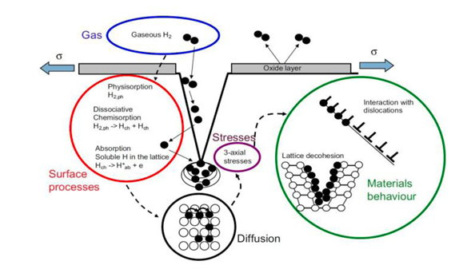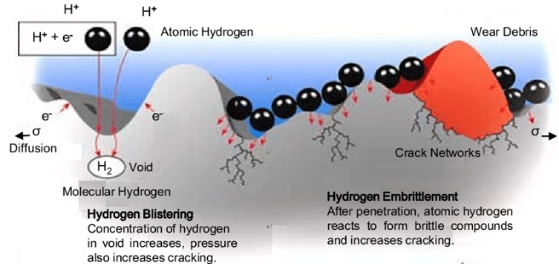High-Temperature Hydrogen attack: atomic hydrogen reacts with carbon inside the metal forming Methane and changing the original structure of materials.

Figure 1 – Blistering and embrittlement mechanisms of metals in H2 environment

Figure 2 – Stages of hydrogen interactions with steel

Among the listed effects the storage of Hydrogen can face is mainly Hydrogen embrittlement and Hydrogen-induced cracking. From the state of the art, there is evidence that some kinds of alloys are not affected by H2 at the specific conditions of pressure and temperature. According to different studies steel alloys for testing H2 damage must be the following API 5CT/ISO 11960. The grades considered suitable for H2S environment in all conditions in terms of ppH2S and temperature (see Table 1) could be used also in UHS.

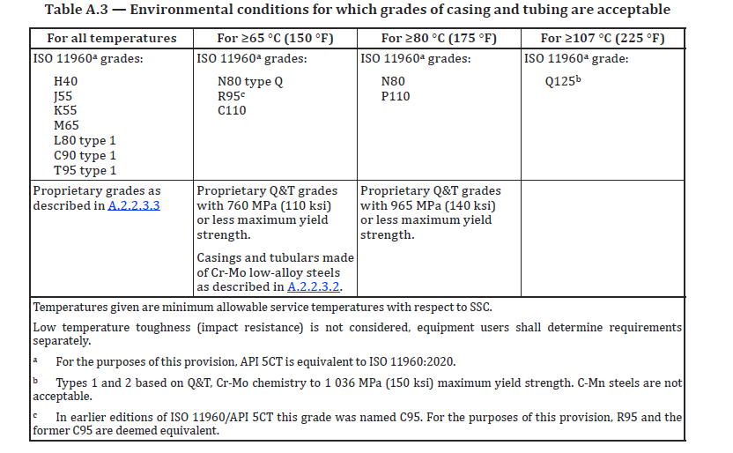

Table 1- ISO 15156 Environmental conditions for which grades of casing and tubing are acceptable

ASME B31.12 is the only existing code regarding pipelines for hydrogen service and poses strict limits to the maximum operating pressure and the design pressure depending on steel grade and material properties characterization, both for new and repurposed pipelines. ASME B31.12 code requires determining KIH (the threshold fracture toughness in presence of Hydrogen) and to characterize material fatigue behavior, with long-term testing (1000h) in high-pressure gaseous environments. This is very time-consuming, moreover, only a few laboratories can perform such tests. An alternative is proposed by Eni which envisions the use of electrochemical techniques. The hydrogen atmosphere is simulated by generating hydrogen molecules on the surface of the specimens in an electrochemical cell and diffusible H2 average concentration in the metal lattice is estimated by electrochemical oxidation to obtain hydrogen outgassing current. Fracture mechanics compact tension specimens are cathodically charged in an aqueous solution, providing hydrogen with a chemical activity comparable to the one in a pressurized gaseous atmosphere. Fracture mechanics tests are then performed to determine fracture toughness using of Jc fracture toughness.

The electrochemical charging allows a pre-characterization of materials so that the extensive and demanding tests required for their full qualification are applied only to the most promising ones with low probabilities of failure.

Tests were performed on API 5CT L80-1, J55, T95, and P110. Results showed that in the worst scenario, one material can be characterized in a couple of weeks.

All materials exhibited low or no differences when exposed to low hydrogen charging conditions, except for P110 steel which showed a reduction of the maximum load (Figure 3). High hydrogen charging affects all materials but, in particular, P110 steel shows a reduction of about 80% of the maximum load recorded during the test. The decrease in materials performance appears to be well correlated to pristine mechanical properties.

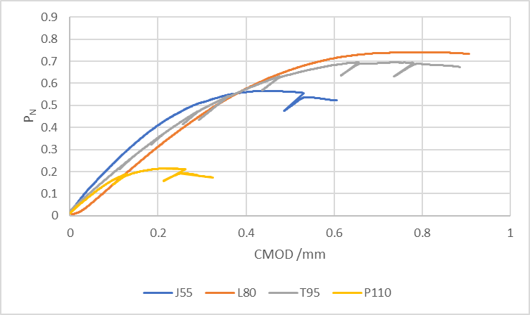

Figure 3 – Normalized load (PN) vs Crack Mouth Opening Displacement for J55, L80, T95, and P110

# Elastomers

From the state of the art, it still must be investigated whether the commonly used elastomers in UGS wells (NBR, HNBR, and FKM) can resist the diffusion of hydrogen (Table 2).

Although studies have been carried out on the behavior of elastomers subjected to different chemical agent/working conditions, (hereunder the comparative table on the compatibility of the most common elastomers with hydrogen), there is still a significant lack of understanding about rapid pressure decompression of elastomers with combined effects of temperature and pressure cycling and related metrics for damage assessment with elastomers.

|  |  |  |  |  |  |  |  |  |  |  |
| --- | --- | --- | --- | --- | --- | --- | --- | --- | --- | --- |
|  | **ACM** | **AU** | **CR** | **EPDM** | **FFKM** | **FKM** | **FVMQ** | **HNBR** | **NBR** | **VMQ** |
| Hydrogen gas | B | A | A | A | A | A | C | A | A | C |

Legend:

**A**: Very good suitability. Elastomers show little or no effect from exposure. Little effect on performance and physical properties. Very good resistance.

**B**: Good suitability. Some effects of exposure with some loss of physical properties. Some chemical swelling.

**C**: Limited suitability. Significant swell and loss of physical properties after exposure. Additional tests should be done.

Table 2 - Elastomers compatibility with H2 (Materials Chemical Compatibility Guide, 2012)

The process of hydrogen absorption in polymers is different from absorption in metals as the hydrogen molecule does not undergo disassociation in the polymer as it does in the metal. Thus, most effects are expected to be mechanical rather than chemical in nature as is sometimes observed with metals (embrittlement) or piezoelectric (species diffusion).

However, since commercial polymers, especially elastomers, commonly include many inorganic additives, chemical changes such as hydrating within the material are possible.

Damaging effects on the base polymer may include bubble or void formation, surface blistering, dilation, changes in modulus and strength, changes in friction and wear, and other changes associated with the absorption of a relatively high amount of hydrogen (Figure 4). Additionally, since the saturation hydrogen concentration in polymers is proportional to the exterior pressure, it is expected that the damaging effects are more significant at higher pressures. Other critical parameters include the rate of depressurization relative to the hydrogen diffusion in the material and temperature cycling effects.

A rather extreme example of these conditions is the so-called “explosive decompression” when the external pressure is suddenly or rapidly removed. In this situation, the internal pressure of any hydrogen absorbed within the polymer is no longer balanced by the external pressure and as a result, bubbles, surface blistering, or total part failure through exfoliation or de-cohesion can occur. To clarify, material degradation of this sort may occur any time the pressure drop is rapid compared to the diffusion of hydrogen within the material under study.

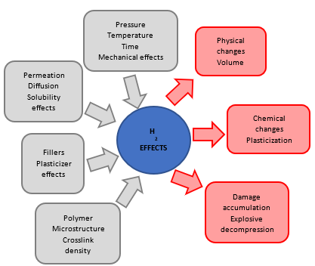

Figure 4 – Mechanisms of polymer degradation by hydrogen

More work still needs to be done to establish potential failure and degradation modes, determine compatibility, and establish testing methods and instruments for a multitude of in situ hydrogen tests. Within this recent focus on polymer hydrogen compatibility for infrastructure, several areas still require additional study including tribology, decompression damage (blistering), in situ mechanical property changes, and permeability. While decompression damage and permeability have had a fair number of studies devoted to them, there are only a relative handful of studies on hydrogen effects on tribological friction and wear. This gap needs to be addressed as polymers in hydrogen infrastructure applications are often used in dynamic seals where friction and wear damage are critical to understanding reliability, leakage, and lifetimes.

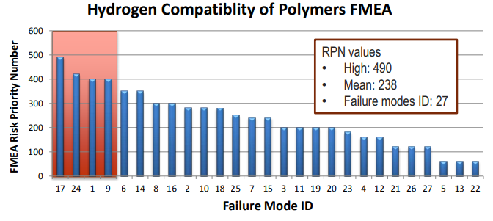

Figure 5 – Hydrogen compatibility of polymers FMEA

FMEA (Failure Mode and Effects Analysis) focused on three key functions/applications based on containing hydrogen with static seal, dynamic seal, and barrier.

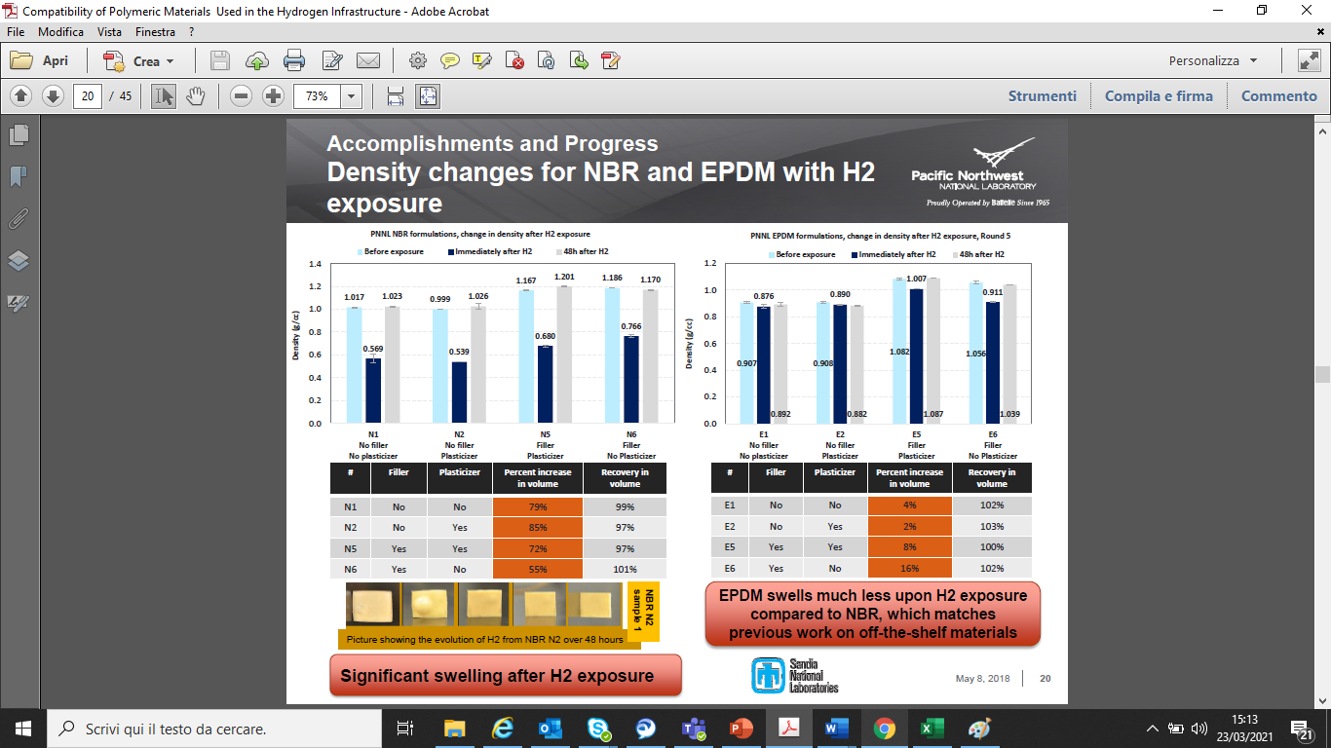Furthermore, the chemical composition of elastomers should be taken into consideration to study the interactions of filler and plasticizer in a hydrogen environment. Hereunder is showing an example of elastomer NBR property changes due to different chemical compositions.

**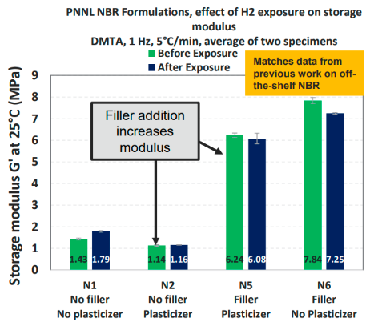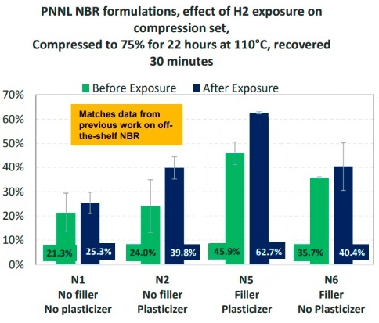**

Figure 6 – Compression Set changes for NBR with H2 Exposure (left). Storage Modulus changes for NBR with H2 Exposure (middle). Density changes for NBR with H2 exposure (right) (Compatibility of Polymeric Materials Used in the Hydrogen Infrastructure, 2018 and Simmons at all. 2021)

The graphs clearly show how a different chemical composition of the elastomers negatively or positively affects the physical characteristics of the element itself if subjected to a hydrogen environment.

This implies that further specific studies on the use of elastomers for UHS need to be investigated.

# Cement

From the literature, it looks that H2 migrations into cement cores are not critical thanks to the presence of water inside cement pores as hydrogen has very low solubility in water (Green et. al. 2007). Moreover, the alteration of the H2-cement reaction is very low (Jacquemet et. al., 2020). Anyway, it is possible to use additives (like latex particles, polyethylene, etc.) to prevent gas migration (Nelson, 1990).

In the previous experiments by Boersheim et. al., 2019, composite cores (metal + cement + reservoir rock) and cylindrical class G cement cores, placed in high saline synthetic brine, were exposed in an autoclave at 80 °C and 50 bar for 4 weeks to hydrogen atmosphere. For comparison, cement plugs were exposed to nitrogen. The results of this experiment were that both gases had minimal to no effect, furthermore, cement G samples exposed to hydrogen showed similar changes in porosity and permeability values.

In the paper by Iorio et. al., 2022, the first step for evaluating the interaction between main cement components and hydrogen was a thermodynamic study. Class G Cement was analysed, of which the main components are:

* Anhydrous phases - C3S: tricalcium silicate, C2S: dicalcium silicate, C3A: tricalcium aluminate, C4AF: Tetracalcium aluminoferrite
* Hydrated phases – CSH: calcium silicate hydrate, Portlandite Ca(OH)2, Ettringite (Ca6Al2(SO4)3(OH)12•26(H2O) and Katoite (Ca3Al2(SiO4)1.5(OH)6).

The result of this study shows that the reaction of cement can undergo in presence of Hydrogen is partial Fe2O3 reduction to Fe3O4. Considering the low amount of Fe2O3 cement matrix and the temperature range for H2 (less than 100 °C) storage, the potential reduction of Fe2O3 to Fe3O4 should not impact cement resistance and sealing capacity.

More information on the cement stability has been obtained by performing experimental tests and by characterization of the specimen after interaction with Hydrogen.

The identified cementitious slurries, which are currently mostly used in the casing primary cementing jobs in production phases of the O&G wells, are respectively:

* 1° Batch, Cement slurry with API class G HSR cement.
* 2° Batch, Cement slurry with a blend of API class G HSR cement + Silica 35% by weight of cement.

Even if hydrogen migration inside cement pores may be prevented by adding chosen organic polymers (as well as for other gases) (Nelson, 1990), the selected slurry does not include specific additives for the functional enrichment of the slurry itself; this choice was made to better evaluate the interaction between hydrogen and the main constituents of the cement sample.

For each aging batch, the samples were left inside the autoclave for 8 weeks, in contact with hydrogen in "dry" conditions (Iorio et. al., 2022) for batches 1° and 2°, and "wet" (Cracolici et. al., 2023) for batch 1°, at a temperature condition of 90°C and the maximum pressure that can be maintained by the instrumental set-up equal to 150 bar.

To ensure the correct humidity rate in “dry” conditions inside the autoclave, a small amount of distilled water was left on the bottom of the autoclave during the entire aging, without direct contact between the water and the samples.

In parallel to the H2 aging, twin samples were also aged in nitrogen at the same humidity and T&P conditions.

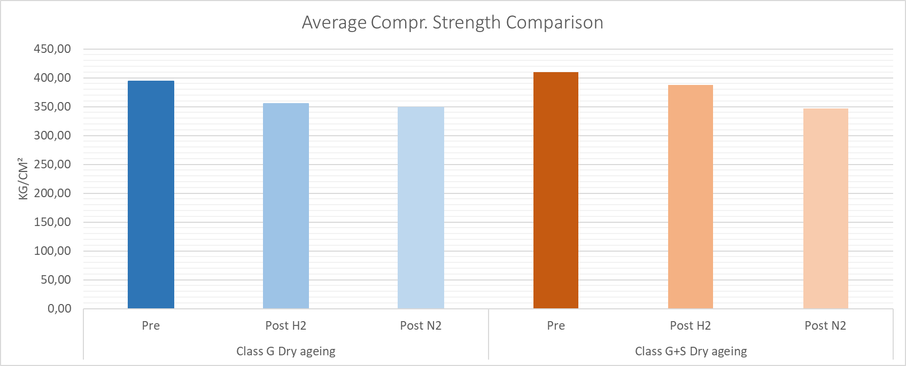

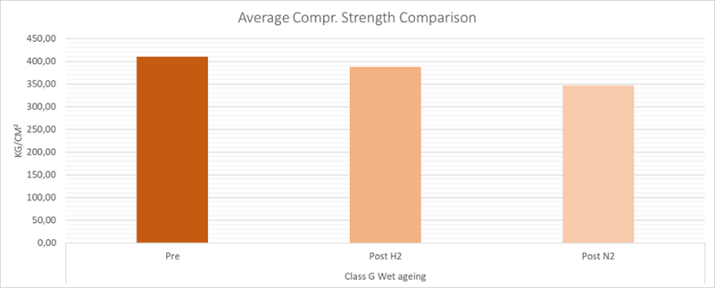

Figure 7– Average Compressive Strength Comparison for “dry” conditions (left) and “wet” conditions (right)

The results shown in both papers highlight that generally, hydrogen does not invalidate the performance of cement, in terms of mechanical resistance and sealing capacity.

Slight variations are indeed detected regarding the characteristics of the cement and the water in which it is immersed in the “wet” experimental aging, but these variations will have to be argued concerning the heterogeneity of the samples and real conditions of the storage well selected and associated pressure cycles.

Certainly, more tests will be needed to further investigate the comparison between the results obtained from different aging (wet and dry).

# O&G main Service Contractors

H2-focused workshops were organized with the target to have an open roundtable with the major main Service Companies Eni is working with.

During the workshops, on one hand, it was clear how knowledge is related mainly to literature or compared to similar oil and gas reservoirs, where often exist acidic gases (such as CO2 and H2S). On the other hand, only a few direct experiences are present.

H2 corrosion mechanisms of materials have been confirmed by all Services, but they have a different approach to avoid this issue. The most contrasting approach is for the choice of metallurgy, some Service Companies prefer to have a similar approach to the H2S environment with low alloy steel materials, but others have a similar approach to the CO2 environment, so they prefer Corrosion-Resistant Alloys (CRA) metallurgies.

While for elastomers and cement almost all the Service Companies agree to test required before applications.

|  |  |  |  |
| --- | --- | --- | --- |
|  | **METALS** | **ELASTOMERS** | **CEMENT** |
| **Service Company 1** | low alloy steel materials | HNBR | To test |
| **Service Company 2** | SPE 19555-MS Literature analysis | Test required | SPE 19555-MS Literature analysis |
| **Service Company 3** | Corrosion–Resistant Alloys (CRA). Others may require testing | Test required | Test required |
| **Service Company 4** | Corrosion – Resistant Alloys (CRA) | Test required | Test required |
| **Eni SpA** | Test required | Test required | Test required |

Table 5 – Different approaches for well materials choice

Conclusions

The possibility of storing hydrogen in depleted gas fields could be the main goal, to reuse existing facilities and wells without carrying out any heavy operations during the conversion. Functional requirements for hydrogen storage wells do not differ from natural gas storage wells, hence their designs are largely similar. The Service Companies have contrasting approaches, and it will be challenging for upcoming UHS projects. For this reason, the used materials and component design require detailed review, testing, and confirmation before an application.

Eni has already started these experimental investigations analyzing the compatibility of different cement slurries and metallurgies with hydrogen.

Tests on cement were conducted in an autoclave with hydrogen at 90° C and 150 bar for 8 weeks. Cement slurry with API class G HSR cement has been tested in "dry" conditions (Iorio et. al., 2022) and "wet" (Cracolici et. al., 2023), and cement slurry with a blend of API class G HSR cement + Silica 35% by weight of cement has been tested in "wet" (Cracolici et. al., 2023). The results in these conditions showed that hydrogen does not invalidate the performance of cement, in terms of mechanical resistance and sealing capacity. More tests will be needed to further investigate the comparison between the results obtained from different aging. In the same way, it will be necessary to carry out in-depth experimentation on specific cement for related underground storage sites.

Tests on metallurgies have been conducted with electrochemical charging on API 5CT L80-1, J55, T95, and P110. This test has allowed a pre-characterization of materials in a couple of weeks. P110 steel appeared to be the worst performer due to its fine martensitic microstructure and elevated mechanical properties and appears not to be appropriate for a hydrogen environment. J55, L80, and T95 steels decrease their ductility, however, this appears not to be an issue. The next steps will involve the use of electrochemical techniques to perform KIH tests, results in comparison with standard hydrogen pressure tests, and correlation between KIH and JH results.

The results obtained in Eni experimentations are the first important steps for de-risking the UHS activities, although more tests will be needed to further investigate all the well materials

References

Boersheim E.C., Reitenbach V., Albrecht D., Pudlo D., Ganzer L., 2019, Experimental Investigation of Integrity Issues of UGS Containing Hydrogen, SPE-195555-MS, Society of Petroleum Engineers.

Compatibility of Polymeric Materials Used in the Hydrogen Infrastructure, PNNL-SA-134164, June 21, 2018

Cracolici F., Iorio V. S., Parrozza F., Sabatino L. M. F., Previde Massara E., Consonni A., Viareggio A., Altimare C. W., Gori S., Colombo L., Racca S., Poloni R., 2023, Experimental Investigation of Cement Compatibility in Underground Hydrogen Storage in Depleted Reservoir, IPTC-22797-MS, International Petroleum Technology Conference

Green D.W., Perry R.H, Perry's Chemical Engineers' Handbook, 8th Edition, 2007

Iorio V. S., Cracolici F., Sabatino L. M. F., Previde Massara E., Consonni A., Parrozza F., Tritto C., De Simoni M., 2022, Cement to safeguard the wells integrity in Underground Hydrogen Storage: an experimental investigation, CEt AIDIC Vol 96 (2022) CET2296052, Chemical Engineering Transactions

Jacquemet N., Chiquet P., Grauls A., Hydrogen reactivity with a well cement - PHREEQC geochemical thermodynamics calculations, 1st Geoscience & Engineering in Energy Transition Conference, Nov 2020, Volume 2020, p.1 – 5

Nelson E.B. - Well Cementing, Elsevier Science Publisher - Schlumberger, Amsterdam 1st Edition - September 24, 1990

Reinicke K.M., Fichter C. 2010, Measurement Strategies to Evaluate the Integrity of Deep Wells for CO2 Applications, Sino-German Conference on Underground Storage of CO2 and Energy.

Simmons K.L., Kuang W., Burton S.D., Arey B.W., Shin Y., Menon N.C., Smith D.B., 2021, H-Mat hydrogen compatibility of polymers and elastomers, international journal of hydrogen energy 46

Tritto C., De Simoni M., Roccaro E., Pontiggia M., Panfili P., del Gaudio L., Visconti L., Iorio V. S., G. dell’Elcea, 2022, Underground Hydrogen Storage in depleted gas reservoirs: opportunity identification and project maturation steps, AIDIC Vol 96 (2022) CET2296053, CEt Chemical Engineering Transactions