|  |  |
| --- | --- |
| cetlogo ***CHEMICAL ENGINEERING TRANSACTIONS***  ***VOL. , 2023*** | A publication of  aidiclogo_grande |
| The Italian Association  of Chemical Engineering  Online at www.cetjournal.it |
| Guest Editors:  Copyright © 2023, AIDIC Servizi S.r.l. **ISBN** 979-12-81206-XX-X; **ISSN** 2283-9216 | |

Safety of Liquid and Cryo-Compressed Hydrogen: Overview of Physical and CFD Models Developed at Ulster University

Donatella Cirrone\*, Dmitriy Makarov, Vladimir Molkov

Hydrogen Safety Engineering and Research Centre (HySAFER), Ulster University, Jordanstown, BT37 0QB, Northern Ireland, UK

[d.cirrone@ulster.ac.uk](mailto:d.cirrone@ulster.ac.uk)

Transport and storage of liquid hydrogen (LH2) is currently the most attractive option for scaling up the hydrogen supply infrastructure. Hazards and associated risks for compressed gaseous hydrogen applications are relatively well investigated, yet there is less understanding of the hazards and associated risks for cryogenic hydrogen, including LH2. Validated models and tools are needed for hydrogen safety engineering of LH2 systems and infrastructure. This paper presents an overview of models developed and validated at HySAFER Centre of Ulster University, including within the PRESLHY project. These include models for assessment of hazard distances for incident scenarios. Experimental data have been used to validate the contemporary CFD models and build new correlations or reduced models. The analysed phenomena and relevant models are generally separated into three main pillars to assess consequences of incidents involving hydrogen: release and dispersion, ignition, and combustion. The developed and presented models are interconnected and can be used synergistically to provide a unified approach to the assessment of consequences of selected incident scenarios with LH2 starting from an initiating event. The models and tools aim to inform and underpin relevant Regulations Codes and Standards and assist stakeholders in performing hydrogen safety engineering.

* 1. Introduction

The scaling-up of the hydrogen supply infrastructure requires competitive techniques to store and transport large quantities of this energy carrier. Transport and storage of hydrogen as a liquid (LH2) is currently the most attractive solution to fulfil this need. The hazards and associated risks of new LH2 applications are not yet well understood in comparison with applications of compressed gaseous hydrogen. The European project PRESLHY (www.preslhy.eu) conducted pre-normative research for the inherently safer use of LH2 in non-industrial settings, addressing the knowledge gaps and open issues associated with behavior in accidental conditions. The research built on extensive experimental, theoretical and numerical studies addressing LH2 relevant phenomena: release and dispersion, ignition and combustion. One of the main outcomes of the project was the development and validation of predictive models and tools to assess consequences of incidents to underpin the development of incident prevention and mitigation strategies for LH2 systems. This paper presents an overview of the physical and CFD models developed and validated at Ulster University for the three main phenomena pillars. The final goal was to integrate models to the guidelines for inherently safer design of LH2 infrastructure, inform the relevant Regulations Codes and Standards and equip stakeholders with tools to perform professionally hydrogen safety engineering.

* 1. Release and dispersion
     1. Release source modelling for steady state and transient releases

Cryo-compressed hydrogen is generally stored at pressure up to 35 MPa. In the case of a release, an under-expanded jet is created as pressure at the nozzle exit is above atmospheric. The under-expanded jet theory developed at Ulster University calculates the mass flow rate and the jet parameters at the real nozzle exit, in particular density, required to calculate the hazard distance, i.e. the size of flammable envelope, by application of the similarity law. Release conditions are calculated for chocked flow at the nozzle exit, isentropic expansion and conservation of energy between the stagnation (tank) and release (nozzle exit) locations. It was observed that the Abel-Noble Equation of State (EoS) describes well the non-ideal behaviour of the gas at low temperatures for storage pressures up to 0.6 MPa. Figure 1a shows the calculated mass flow rate versus experimentally measured by Panda and Hecht (2017) for releases with temperature in the range 37-295 K and pressure up to 0.6 MPa. For storage pressures higher than 0.6 MPa, the high-accuracy Helmholtz energy formulations shall be used for the EoS, as implemented by the National Institute of Standards and Technology (NIST). The under-expanded jet theory and non-adiabatic blowdown model developed previously at Ulster University were further advanced to account for the NIST EoS and the strong effect of heat transfer not only through the storage tank wall but also through the walls of the discharge line subjected to the ambient temperature. The non-adiabatic blowdown model demonstrated to reproduce accurately the storage pressure and temperature dynamics in sixteen tests performed within PRESLHY project at initial pressure 0.5-20 MPa and temperature 80-310 K, through release nozzle diameter of 0.5-4.0 mm, as shown in Figure 1b-c.

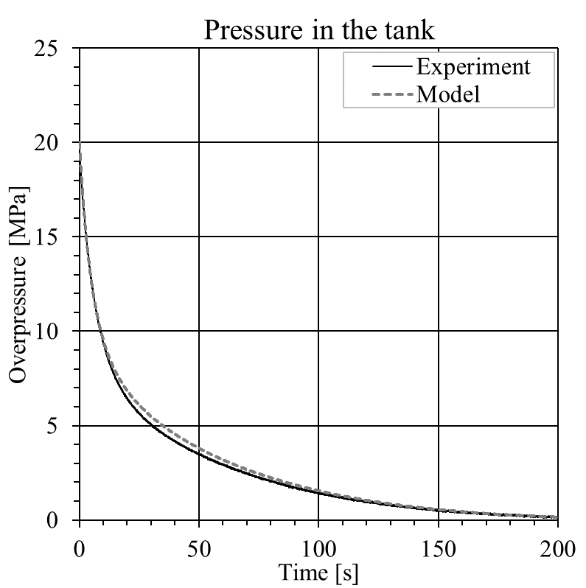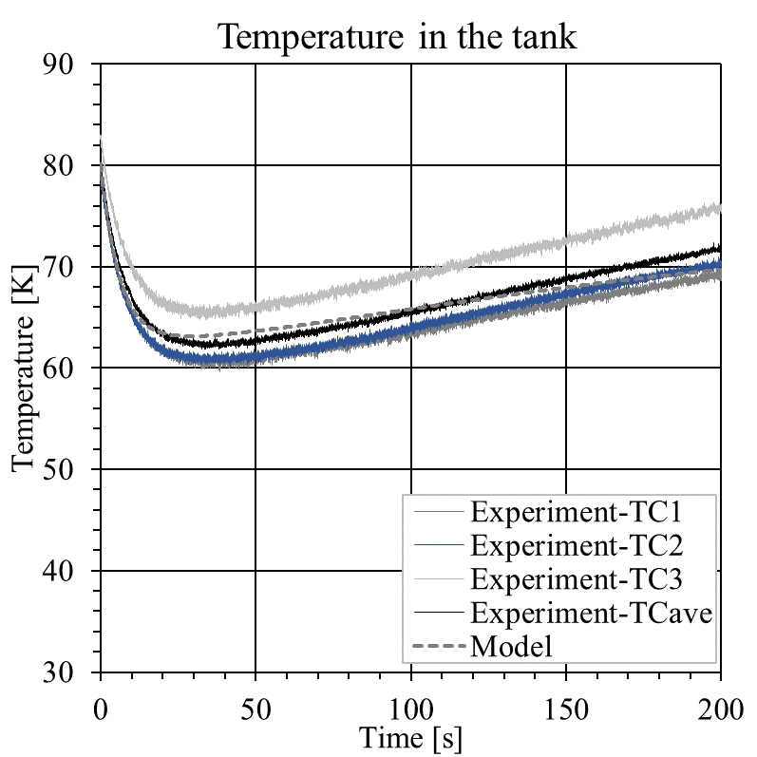

1. (b) (c)

Figure 1: Release source modelling for steady-state hydrogen releases (a). Modelling of non-adiabatic blowdown dynamics in the storage tank for transient hydrogen release with initial pressure and temperature of 20 MPa and 80 K, and nozzle diameter of 0.5 mm (b-c).

* + 1. The similarity law for concentration decay in momentum-dominated jets

The similarity law for under-expanded jets (Molkov, 2012) allows to calculate axial hydrogen concentration decay in momentum-dominated hydrogen jets:

|  |  |
| --- | --- |
| $C_{ax}=5.4 \sqrt{{ρ_{N}}/{ρ_{s}}} (d/x)$. | (1) |

where $ρ_{N}$ is the density of hydrogen at the nozzle exit (calculated using Ulster’s under-expanded jet theory), $ρ_{s}$ is the density of the surrounding air, *d* is the nozzle diameter and *x* is the distance from the release point. The similarity law was validated for hydrogen under-expanded jets with release temperature down to 80 K and pressure in the range 0.26–40 MPa in (Molkov, 2012). The similarity law validation was expanded in PRESLHY to releases with temperature as low as 50 K for pressure in the range 0.2-0.5 MPa through comparison with experiments by Hecht and Panda (2019), see Figure 2.



Figure 2: The similarity law and experimental data by Hecht and Panda (2019) on axial concentration decay in momentum-dominated under-expanded jets.

* 1. Ignition
     1. Determination of minimum ignition energy of hydrogen-air mixtures by spark ignition

The ignition and combustion of hydrogen in air is considered more hazardous compared to other fuels due to the lower minimum ignition energy (MIE) and the wider flammability range. Spark discharge is the most common type of electrostatic ignition hazard. A theoretical model was developed to accurately predict MIE for hydrogen-air mixtures with arbitrary initial composition and temperature, without relying on available experimental data as per methodologies available in literature. The MIE can be calculated as (Cirrone et al., 2023b):

|  |  |
| --- | --- |
| $E_{min}=\frac{1}{6}πd^{3}ρ_{u}c_{p,u}\left(T_{b}-T_{u}\right)$, | (2) |

where *d* is the critical flame kernel diameter, $ρ_{u}$ is the density, $c_{p,u}$ the specific heat at constant pressure and $T_{u}$ the temperature for the unburnt mixture, $T_{b}$ is the temperature of the burnt mixture. The critical flame kernel diameter is calculated as $d=2.5δ_{L}$, with $δ_{L}$ being the laminar flame thickness calculated using Blint’s definition (Poinsot and Veynante, 2005). The laminar flame thickness requires knowledge of the laminar burning velocity *Su* and properties of the hydrogen-air mixture, which are calculated by Chemkin software and correlations. The model is validated against PRESLHY experiments at ambient and cryogenic (down to 123 K) temperatures (Cirrone et al., 2023b). Results showed a slight increase of MIE for decreasing temperature of the mixture and that the effect of flame stretch and preferential diffusion shall be considered for accurate prediction.



Figure 3: Comparison of results from the developed model against PRESLHY experiments on hydrogen-air mixtures at initial temperature 173 K (Cirrone et al., 2023b).

CFD modelling has been used to complement and support the theoretical model for determination of MIE, by providing insights into the effect of the experimental apparatus features, e.g. the electrodes’ size and shape, the flame kernel development, etc. The CFD model employs chemical kinetics, including 13 chemical species and 37-step reduced chemical reaction for hydrogen-air combustion. The MIE is determined by progressively reducing the energy released in the spark channel and verify until which value released energy leads to ignition and formation of a flame kernel propagating outwards the spark channel. Figure 4a shows the ignition energies resulting in ignition or failure to ignite in simulations. Overall, it was found that simulations’ results well predict experimental measurements within the range of hydrogen concentrations in air 10-55 % by vol. Figure 4b shows the flame kernel growth from 45 to 500 μs via the temperature and OH mole fraction contours. The flame kernel starts to develop at 100 μs and then expands spherically.

Figure 4: Comparison of CFD calculations of MIE in hydrogen-air mixture with initial temperature 288 K against experiments in (Lewis and von Elbe, 1961; Ono et al., 2007; Proust, 2021) - left. Flame kernel growth for T=288K, H2=29% by vol. in air, MIE=15 μJ - right.

* + 1. Spontaneous ignition of cryogenic hydrogen

Sudden releases of high-pressure hydrogen may spontaneously ignite by the so-called “diffusion ignition” mechanism. Several experimental and numerical studies have been performed on spontaneous ignition for compressed hydrogen at ambient temperature. A Large Eddy Simulation (LES) model has been developed to investigate the effect of temperature decrease from ambient 300 K to cryogenic 80 K on the potential for spontaneous ignition by “diffusion mechanism” to occur in a T-shaped channel system after rupture of a burst disk (Cirrone et al., 2022d). The CFD model was first validated against experiments at atmospheric temperatures and then applied to cryo-compressed hydrogen. It was found that the pressure limit leading to spontaneous ignition of the cryo-compressed hydrogen at temperature 80 K is 9.4 MPa. This is more than 3 times larger than pressure limit for spontaneous ignition of 2.9 MPa in the same setup at ambient temperature of 300 K.

* 1. Combustion
     1. The dimensionless correlation for the flame length of cryogenic hydrogen jet fires

The dimensionless correlation for hydrogen jet flames allows to calculate the flame length of hydrogen jet fires.

The correlation was developed in 2012 at Ulster University for ambient temperatures and is valid for laminar and turbulent flames, buoyancy-controlled and momentum-dominated fires, expanded and under-expanded jet fires (Molkov, 2012). The flame length ($L_{f}$) normalized to the nozzle diameter ($d$) depends only on the dimensionless quantity $X$ defined by density ($ρ_{N})$, velocity $(u_{N})$ and speed of sound ($C_{N}$) at the nozzle exit, and density of the surrounding air ($ρ_{s}$):

|  |  |
| --- | --- |
| $X=\frac{ρ_{N}}{ρ_{s}}·{\left(\frac{u_{N}}{C_{N}}\right)}^{3}$. | (4) |

In PRESLHY project, the correlation has been applied to cryogenic tests with release temperature in the range 46-295 K (Panda & Hecht, 2017). Figure 5 shows that the correlation represents conservatively the experimental flame lengths measurements, with only few exceptions. The release temperature is found to greatly affect the resulting flame length. Considering as an example two releases with pressure 2 bar abs and nozzle diameter 1.25 mm, the decrease of temperature from 185 K to 46 K leads to an increase in calculated flame length from 0.40 m to 0.77 m. Consequently, the minimum hazard distance for humans increases from 1.4 m to 2.7 m.



Figure 5: The dimensionless correlation for hydrogen jet flames against experiments at ambient temperature in Molkov (2012) (symbol: crosses) and cryogenic temperature in Panda and Hecht (2017) (symbol: diamonds).

* + 1. Thermal radiation from cryogenic hydrogen jet fires

Jet flames originated by cryo-compressed ignited hydrogen releases can cause life-threatening conditions in their surroundings. A CFD model has been developed to accurately predict thermal hazards from a jet fire. The model was firstly validated against experiments with vertical cryogenic hydrogen jet fires with release pressures up to 0.5 MPa, release diameter 1.25 mm and temperatures as low as 50 K. Afterwards, it was validated against horizontal cryogenic jets at temperature 80 K, pressure up to 2 MPa abs and release diameters up to 4 mm (Cirrone et al., 2022b). Simulation results were compared against experimentally measured parameters as hydrogen mass flow rate, flame length and radiative heat flux at different locations from the jet fire. The CFD model reproduced experiments with 10-20% accuracy in the jet fire near-field, with only few exceptions. The CFD study demonstrated that for horizontal jet fires, the buoyancy of combustion products may have a significant mitigating effect on the reduction of hazard distances for horizontal jets as compared to vertical releases.

* + 1. Overpressure from delayed ignition of cryogenic hydrogen jets

The delayed ignition of a highly turbulent under-expanded hydrogen jet generates a blast wave able to harm people and damage property. An engineering tool has been developed to predict the pressure effects and to define the associated hazard distances (Cirrone et al., 2022a). The similitude analysis was applied to build a correlation using available data from 78 experiments in the wide range of hydrogen storage pressure of 0.5-65.0 MPa, temperature of 80-300 K and release diameter of 0.5-52.5 mm. The dimensionless blast wave overpressure generated by delayed ignition and follow-up deflagration or detonation of hydrogen jets at any location from the jet, ${{∆P}_{exp}}/{P_{0}}$, is correlated to the original dimensionless parameter composed of the product of the dimensionless ratio of storage pressure to atmospheric pressure, ${P_{s}}/{P_{0}}$, and the ratio of the jet release nozzle diameter to the distance from the centre of location of the fast-burning near-stoichiometric mixture on the jet axis (30% of hydrogen in the air by volume) to the location of a target (personnel or property), $d/{R_{w}}$:

|  |  |
| --- | --- |
| $\frac{{∆P}_{exp} }{P_{0}}= 5000∙{\left[{\left(\frac{P_{s}}{P_{0}}\right)}^{0.5}∙{\left(\frac{d}{R_{w}}\right)}^{2}\right]}^{0.95}$. | (5) |

The correlation can be used for the calculation of maximum blast wave overpressure for delayed ignition of under-expanded free hydrogen jet at arbitrary storage pressure, temperature, and release nozzle diameter.

* + 1. Pressure peaking phenomenon for ignited releases of cryogenic hydrogen in an enclosure

Releases of hydrogen gas in a confined space, e.g. hydrogen storage rooms in marine vessel, plane or rail carriages, are found to produce pressure dynamics with a distinctive peak that exceeds the steady-state release pressure level. This phenomenon is defined as the pressure peaking phenomenon (PPP) and can be observed for gases with density lower than air. The magnitude of the pressure peak depends mainly on the hydrogen release rate, enclosure vent size and volume. The PPP was first revealed theoretically at Ulster University in 2010 (Brennan et al., 2010). A CFD model has been developed to investigate the maximum overpressure and pressure dynamics during ignited hydrogen releases in a storage enclosure (Cirrone et al., 2022c). The CFD model was validated against large-scale experiments in a 15 m3 chamber performed by the University of South-Eastern Norway for releases at ambient temperature. The CFD model employed a volumetric source approach to reduce computational time and demonstrated good engineering accuracy in predicting experimental pressure peaks with deviation from −14% to +11% for various release and ventilation scenarios. After validation against experiments, the CFD model was employed to investigate the effect of cryogenic temperature in the storage on the overpressure dynamics in the enclosure. For a storage pressure equal to 11.78 MPa, it was found that a decrease of storage temperature from 277 K to 100 K causes a twice larger pressure peak in the enclosure.

* + 1. Characterization of blast wave and fireball from BLEVE of LH2 storage systems

LH2 is generally stored in double-wall, vacuum insulated tanks equipped with pressure relief devices (PRD). The PRD vents hydrogen to avoid the pressure build-up in a tank exchanging heat with the ambient, e.g. fire. If the PRD fails, or the structural integrity of the tank is compromised before the release of the stored hydrogen, a failure of the tank may happen, releasing the stored energy and producing a devastating blast wave, fireball and projectiles. A CFD approach has been developed to provide insights into the physical mechanisms leading to the generation of blast waves after LH2 storage tank rupture in a fire (Cirrone et al., 2023a). The thorough numerical analysis of BMW experiments (LH2 storage pressure in the range 0.2-1.13 MPa) allowed to conclude that the maximum pressure in the blast wave is generated by the gaseous phase starting shock enhanced by combustion reaction of hydrogen at the contact surface with air heated by the shock. The boiling liquid expanding vapour explosion (BLEVE) pressure peak follows the gaseous phase blast and is smaller in amplitude. The simulation results demonstrated that combustion at the contact surface contributes significantly to the generated blast wave, increasing the overpressure at 3 m from the tank up to 5 times. The developed CFD model can be used as a contemporary tool for hydrogen safety engineering, e.g. to assess hazard distances from LH2 storage.

* 1. Conclusions

This paper presented an overview of the models developed and validated by the authors to assess the hazards and consequences from incident scenarios involving LH2 and cryo-compressed hydrogen. The synergy and complementarities of physical and computational modelling are used to close the knowledge gaps and provide validated tools to assess relevant hazardous phenomena and incident scenarios. Experimental data from the literature and PRESLHY project were used for the validation of physical and CFD models. The under-expanded jet theory and non-adiabatic blowdown models developed at Ulster University accounting for NIST EoS can be used to accurately represent the release hydrogen sources at cryogenic temperature. Non-adiabatic blowdown modelling should account for the strong effect of heat transfer not only through the storage tank wall but also through the walls of the discharge line exposed to the ambient temperature. The similarity law for hydrogen concentration decay in momentum-dominated jets is proven to be applicable to cryogenic hydrogen releases. Reduced and CFD models were developed to determine the minimum ignition energy (MIE) by spark ignition in hydrogen-air mixtures at ambient and cryogenic temperatures. The models were validated against experiments and showed a slight increase of MIE for decreasing temperature of the mixture. Large Eddy Simulations (LES) model was applied to assess the lower pressure limit to trigger spontaneous ignition by the so-called ignition mechanism during sudden release of hydrogen into vent piping.

The dimensionless correlation for hydrogen jet flames developed at Ulster University for ambient temperatures is proven to be applicable for determination of hazard distances for cryogenic jet flames. The CFD study demonstrated that for horizontal jet fires, the buoyancy of combustion products may have a significant mitigating effect on the reduction of hazard distances for horizontal releases as compared to vertical releases. The application of similitude analysis to experimental data published by different research groups worldwide allowed to develop a unique correlation to predict the maximum overpressure generated by delayed ignition of hydrogen jets. The results of BLEVE rethinking allowed to understand and explain the pressure dynamics created by LH2 vessels rupture in a fire using BMW experimental data. The developed engineering models and correlations can be used for hydrogen safety engineering to assess consequences of incidents and develop mitigation strategies for LH2 systems. They inform and underpin relevant Regulations Codes and Standards.

Acknowledgments

This research has received funding from the Fuel Cells and Hydrogen 2 Joint Undertaking (now ‎Clean Hydrogen Partnership) under the European Union’s Horizon 2020 research and innovation ‎programme under grant agreement No. 779613‎ (PRESLHY), No.736648 (NET-Tools) and No. 101101381 (ELVHYS). ELVHYS project is supported by the Clean Hydrogen Partnership (CHP) and its members. University of Ulster in Horizon Europe Project ELVHYS is supported by UKRI grant number 10063519. Funded by the European Union. Views and opinions expressed are however those of the authors only and do not necessarily reflect those of the European Union or the CHP. Neither the European Union nor the CHP can be held responsible for them.

References

Brennan, S., Makarov, D., Molkov, V., 2010, Dynamics of flammable hydrogen-air mixture formation in an enclosure with a single vent. In Proceedings of the Sixth International Seminar on Fire and Explosion Hazards, Leeds, UK, 11–16 April 2010.

Cirrone, D., Makarov, D., Friedrich, A., Grune, J., Takeno, K., Molkov, V., 2022a, Blast wave generated by delayed ignition of under-expanded hydrogen free jet at ambient and cryogenic temperatures, Hydrogen, 2022,3, 433–449. doi.org/10.3390/hydrogen3040027

Cirrone, D., Makarov, D., Kuznetsov, M., Friedrich, A., Molkov, V., 2022b, Effect of heat transfer through the release pipe on simulations of cryogenic hydrogen jet fires and hazard distances, Int. J. Hydrogen Energy 47, 21596–21611. doi.org/10.1016/j.ijhydene.2022.04.276

Cirrone, D., Makarov, D., Lach, A.W., Gaathaug, A.V., Molkov, V., 2022c, The pressure peaking phenomenon for ignited under-expanded hydrogen jets in the storage enclosure: experiments and simulations for release rates of up to 11.5 g/s, Energies 15, 1–20.

Cirrone, D., Makarov, D., Molkov, V., 2022d, Spontaneous ignition of cryo-compressed hydrogen in a T-shaped channel system, Hydrogen 3, 348–360. https://doi.org/10.3390/hydrogen3030021

Cirrone, D, Makarov, D., Molkov, V., 2023a, Rethinking “BLEVE explosion” after liquid hydrogen storage tank rupture in a fire, Int. J. Hydrogen Energy 48, 8716–8730. doi.org/10.1016/j.ijhydene.2022.09.114

Cirrone, D., Makarov, D., Proust, C., Molkov, V., 2023b, Minimum ignition energy of hydrogen-air mixtures at ambient and cryogenic temperatures, Int. J. Hydrogen Energy, 1–15.

Hecht, E.S., Panda, P.P., 2019, Mixing and warming of cryogenic hydrogen releases, Int. J. Hydrogen Energy 44, 8960–8970. https://doi.org/10.1016/j.ijhydene.2018.07.058

Lewis, B., Elbe, G. von, 1961, Combustion, Flames and Explosions of Gases, Zeitschrift für Physikalische Chemie. Academic Press, New York. doi.org/10.1524/zpch.1963.36.3\_4.136

Molkov, V., 2012, Fundamentals of Hydrogen Safety Engineering I, free-download at www.bookboon.com.

Ono, R., Nifuku, M., Fujiwara, S., Horiguchi, S., Oda, T., 2007, Minimum ignition energy of hydrogen-air mixture: Effects of humidity and spark duration, J. Electrostat. 65, 87–93.

Panda, P.P., Hecht, E.S., 2017, Ignition and flame characteristics of cryogenic hydrogen releases, Int. J. Hydrogen Energy 42, 775–785.

Poinsot, T., Veynante, D., 2005, Theoretical and Numerical Combustion, Second Edition, R.T. Edwards Inc., Philadelphia, PA, USA.

Proust, C., 2021, PRESLHY D4.4 Summary of experiment series E4.1 results (Ignition parameters).