CHEMICAL ENGINEERING TRANSACTIONS  VOL. , 2023 | A publication of
The Italian Association
of Chemical Engineering
Online at www.cetjournal.it

Guest Editors: David Bogle, Flavio Manenti, Piero Salatino
Copyright © 2023, AIDIC Servizi S.r.l.
ISBN 979-12-81206-04-5; ISSN 2283-9216

Biosorption of Aqueous Pb(II) by a Metabolically Inactive Battery Recycling Plant Consortium: The Role of Paraclostridium bifermentans Microbial Strain
Patrick Y. Kpaiª, Evans M. N. Chirwa^{b}, Hendrik G. Brink^{c,}*
Department of Chemical Engineering, Faculty of Engineering, Built Environment and Information Technology, University of Pretoria, Pretoria, South Africa.

deon.brink@up.ac.za
A microbial consortium which was obtained from lead contaminated soil at a battery recycling plant in South Africa has been demonstrated to remove 90 % of Pb(II) from an 80 mg/L solution over a period of 7 days. The consortium was effective at precipitating Pb(II) from solution and was shown to remove approximately 50 % of Pb(II) at conditions of 80 and 500 ppm within the first 3 hours. Study shows that the identities of the precipitates vary for each microbial strain, as PbS and ${Pb}^{0}$ were the main species precipitated by P. bifermentans and PbO with either PbCl or ${Pb}_{3}{\left({PO}_{4}\right)}_{2}$ precipitated by K. pneumoniae. FTIR spectroscopy supported the chemisorption of Pb(II) onto functional groups as being responsible for this removal confirming biosorption being responsible for the initial phase of Pb(II) removal which acts as a vehicle for concentrating Pb(II) on the surface of the bacteria before bioprecipitation takes place. Functional groups identified in both the consortia and P. bifermentans are alkyl halides, phenols, aromatic, and alkene. Metabolically inactive consortium and P. bifermentans removed 54.44 mg/g and 27.39 mg/g of Pb(II) in 3 h respectively. The adsorption kinetics shows that two-phase pseudo-first-order kinetics represents the data better than pseudo-first-order and pseudo-second-order kinetics. These results provide further insights into the Pb(II) removal mechanisms required for eventual scaling of these processes.
  - Introduction
Due to the increasing concern about public health and environmental problems caused by lead contamination, developing highly efficient and stable treatment methods is necessary (Jeong et al., 2019). Lead is one of a limited class of elements that can be described as purely toxic (Tiwari et al., 2013). Lead causes environmental and health problems because of its stability in contaminated site and complexity of mechanism in biological toxicity, particularly hazardous for children leading to mental retardation when exist with abnormal concentration in body fluid (Tiwari et al., 2013). Lead exposure in plants causes necrosis, reduction in biomass and it inhibits growth (Bilal Shakoor et al., 2013). Lead poisoning causes brain damage and mental retardation of children (Moncrieff et al., 1964; Gibson et al., 1967). People with prolonged exposure to lead may be at risk for high blood pressure, heart disease, kidney disease, and reduced fertility (CDC, 2021). Lead targets tissues and organs including the heart, bones, intestines, kidneys, and the reproductive system, thus capable of disrupting metabolic processes and threaten lives (Seiler et al., 1994; Deng et al., 2006).
Conventional techniques such as membrane filtration, adsorption, chemical precipitation, ion exchange and electrodialysis are employed in addressing lead pollution from waste streams by converting Pb(II) ions to a less harmful state but requires supplementary treatment in the recovery of Pb (0) (Van Veenhuyzen et al., 2021). Most of these treatment techniques are advantageous due to high selectivity but are too costly in the treatment of waste streams with low Pb(II) concentrations (Fu and Wang, 2011). Adsorption has become one of the alternative treatments due to its low-cost, high performance and wide pH range, in recent years, the search for low-cost adsorbents that have metal-binding capacities has intensified (Leung et al., 2000). Biosorption is a process that utilizes biological materials as adsorbents (Volesky, 1994), and this method has been studied by several researchers as an alternative technique to conventional methods for heavy metal removal from wastewater (Ahluwalia and Goyal, 2007).
A microbial consortium which was obtained from lead contaminated soil at a battery recycling plant in South Africa has been demonstrated to remove 90 % of Pb(II) from an 80 mg/L solution over a period of 7 days (Brink et al., 2017). The main purpose of this study is to investigate the bioremediation removal effectiveness of the consortium and one of its isolated microbial strain (P. bifermentans) to determine its contribution to Pb(II) removal. This method of bio-removal could serve as a further step towards the design of a continuous reactor for large-scale implementation in various industries as a simple cost-effective method to remediate and regenerate Pb-containing effluents.
  - Materials and methods
    - Microbial culture
The microbial cultures preparation is described by Brink, Hörstmann & Feucht (2019) in study conducted by this research team on the determination of the minimum inhibitory concentration of a consortium obtained from a borehole at an automotive-battery recycling plant in South Africa. P. bifermentans was prepared from a battery recycling plant consortium frozen at -60 °C. The consortium and P. bifermentans were prepared under aerobic conditions in a batch reactor and were left to grow in a shaker-incubator for 24 h, 35 °C, and 120 rpm.

    - Metabolic activity measurement
Metabolic activity measurements were conducted with the aid of 3-(4,5-dimethylthiazol-2-yl)-2,5-diphenyl tetrazolium bromide (MTT) which is a yellow dye reduced to formazan crystals and the organic solvent dimethyl sulfoxide (DMSO) at a wavelength of 550 nm (Sigma Aldrich, St. Louis, MO, USA) (Hörstmann et al., 2020). For metabolic activity readings, 0.5 mL filtered (0.45 µm) of the sample was added to 0.2 mL MTT and 1.3 mL sterilized ultrapure water. Also, 0.5 mL unfiltered sample was added to 0.2 mL MTT and 1.3 mL sterilized ultrapure water. Dimethyl sulfoxide was added to the solution after an hour incubation to dissolve the formazan crystals (Van Veenhuyzen et al., 2021). A spectrophotometer was used in measuring light absorbed at 550 nm between the unfiltered and filtered samples to infer metabolic activity differences (Peens, 2018).
    - Lead removal experiments
The Pb(II) concentration in samples was measured using an atomic absorption spectroscopy (Perkin Elmer AAnalyst 400, Waltham, Massachusetts).
The adsorption capacity was calculated as:
$$q_{t}= \frac{\left(C_{o}- C_{f}\right)V }{W} (1)$$
Where $q_{t}$ is the adsorption capacity in mg/g, $C_{o}$ and $C_{f}$ are the initial and final concentrations in mg/L respectively, V is the volume of the solution in L, and W is the dry mass of adsorbent in g.

    - Adsorption kinetics
The sampled adsorptions were fit to a pseudo-first-order, two-phase pseudo-first order, and a pseudo-second order isotherms as described in Equation 2 (Tan and Hameed, 2017), Equation 3 (Wang et al., 2011), and Equation 4 (Tan and Hameed, 2017) respectively.

$Q\left(t\right)= Q_{e}\left[1-exp⁡(-k_{1}t)\right]$ (2)

$Q\left(t\right)= Q_{e, fast}\left[1-exp⁡(-k_{1,fast}t)\right]+ Q_{e,slow}\left[1-exp⁡(-k_{1, slow}t)\right]$ (3)

$Q\left(t\right)= \frac{Q_{e}^{2}k_{2}t}{1+ Q_{e}k_{2}t}$ (4)

Where $Q_{e}$ is the value of Pb(II) adsorbed at equilibrium in mg/g, t is time in min, $k_{1}$ and $k_{2}$ are the rate constants in 1/min and g/(mg min) for pseudo-first and pseudo-second order respectively. The sum of $Q_{e, fast}$ and $Q_{e, slow}$ in Equation (3) gives the overall equilibrium adsorption capacity.

    - FTIR analysis
Fourier-transform infrared (FTIR) spectra of the cultures were measured after four successive processes. The first measurement was taken after 24 h growth period of the bacteria. The second measurement was taken after 24 h oven drying of the bacteria at 74 °C. The third measurement was taken after the bacteria was exposed to 100 ppm of ${Pb\left({NO}_{3}\right)}_{2}$. The last measurement was taken 14 h after the addition of 100 ppm ${Pb\left({NO}_{3}\right)}_{2}$ to the cultures. An attenuated total reflection (ATR) attachment was used in recording spectra on a Perkin Elmer Spectrum 100 FTIR spectrometer.
  - Results and discussion
    - Lead removal experiments
As shown in figure 1, metabolically inactive consortium and P. bifermentans removed 54.44 mg/g and 27.39 mg/g of Pb(II) in 3 h respectively. A passive process was responsible for Pb(II) removal from the solution as metabolic activity was not detected using MTT. Black or grey precipitate was not evident in the 14 h period, which indicates that PbS or Pb (0) was not formed. The Initial and final pH readings for the consortium and P. bifermentans were 4.64 – 4.92 and 4.63 – 4.74 respectively.

a. | b.

Figure 1: Graph of Pb(II) removal by the (a) consortium and (b) P. bifermentans in mg/g against time in minutes.
    - Adsorption kinetics
It was found that two-phase pseudo-first-order fits had the highest coefficients of determination (average $R^{2}$ = 0.989) which might be due to the separation of fast and slow adsorption rates into different compartments, thereby allowing better representation of a heterogeneous surface (Van Veenhuyzen et al., 2021). Also, pseudo-second-order kinetics was found to represent data slightly better than pseudo-first-order kinetics. This may show that there is an abundance of adsorption sites relative to Pb(II) ions in the solution (Wang and Guo, 2020; Guo and Wang, 2019). It was found in all the kinetic models that the consortium had a higher adsorption capacity and faster adsorption rates than its microbial strain P. bifermentans.

a.  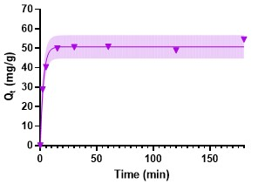 | b.  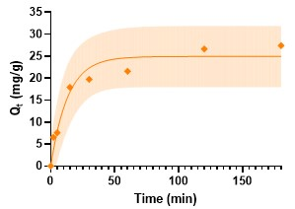
Figure 2: Pseudo-first order kinetics of Pb(II) onto metabolically inactive (a) consortium and (b) P. bifermentans.
a.  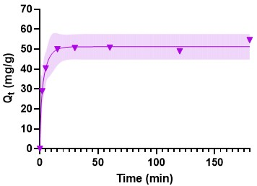 | b.  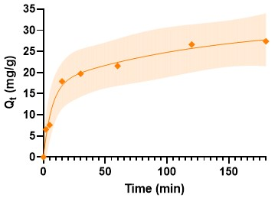

Figure 3: Two – phase pseudo - first order kinetics of Pb(II) onto metabolically inactive (a) consortium and (b) P. bifermentans.
a.  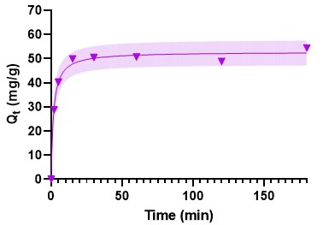 | b.  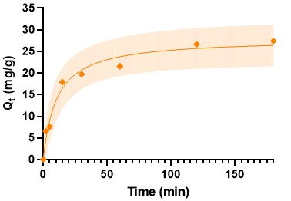
Figure 4: Pseudo – second order kinetics of Pb(II) onto metabolically inactive industrial (a) consortium and (b) P. bifermentans.
Table 1: Kinetic parameters for the adsorption of Pb(II) solution onto metabolically inhibited consortium and P. bifermentans.
Adsorbent | Pseudo-first order |  | Two-phase pseudo-first order |  | Pseudo-second order
 | $$Q_{e}$$  (mg/g) ( | $k_{1}$ $R^{2}$ | $Q_{e,fast}$ $Q_{e,slow}$ | $k_{1,fast}$ $k_{1,slow}$ $R^{2}$ | $Q_{e}$ | $k_{2}$ $R^{2}$
Consortium | 50.71 | 0.373 0.988 | 20.62 30.54 1. | 113 0.208 0.993 | 52.82 | 0.012 0.991
P. bifermentans | 24.92 | 0.075 0.949 | 17.13 14.02 0.14 | 9 0.0079 0.985 | 27.94 | 0.003 0.977

    - FTIR analysis
FTIR analysis for functional groups revealed the presence of functional groups in the samples. The wavelength and functional group obtained from the spectra are presented in Table 2. No difference was observed in any of the spectra which shows that the surface characteristics of the consortium and P. bifermentans remain unchanged and oven drying at 74 °C for 24 h did not rupture the cell wall.

Wavelength  (${cm}^{-1})$ | Bond | Functional Group | Reference
Consortium / P. bifermentans
504  553  640 – 799  1019 - 1214 | C-I  C-Br  C-Cl  C-O | Alkyl Halides  Alkyl Halides  Alkyl Halides  Phenols | Meenambal et al., 2012  Meenambal et al., 2012  Meenambal et al., 2012  Rushikesh et al., 2018
P. bifermentans  1406 | C=C | Aromatic | Rushikesh et al., 2018
1620 | C=C | Alkene | Rushikesh et al., 2018

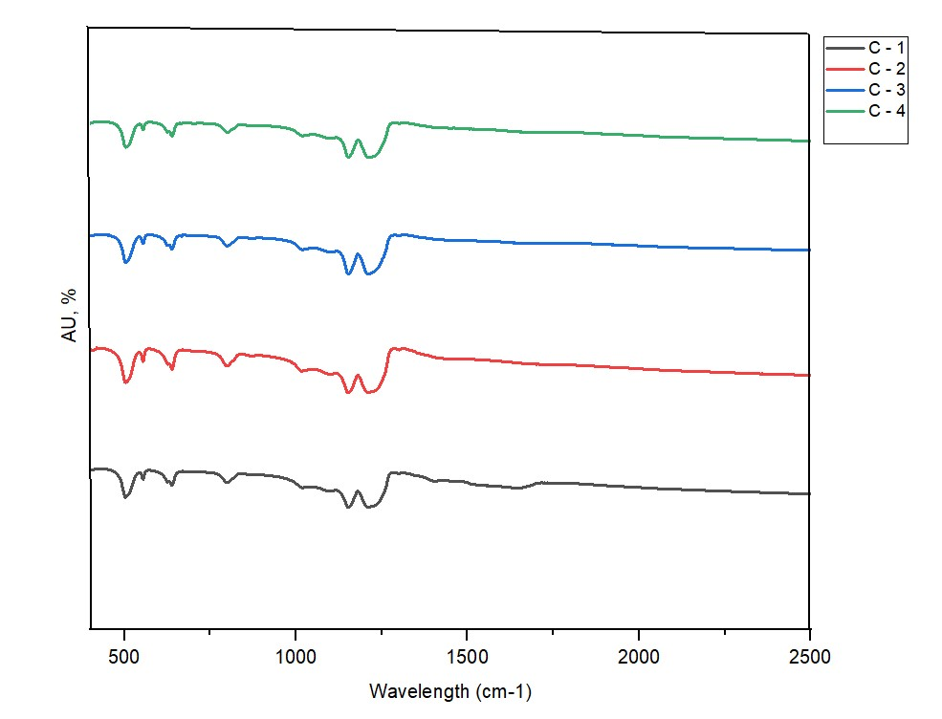
Figure 5: FTIR spectra of the consortium C-1. after a growth period of 24 h, C-2. after oven drying at 74C for 24 h, C-3. after exposure to 100 ppm of ${Pb\left({NO}_{3}\right)}_{2}$, and C-4. 14 h after adding 100 ppm of ${Pb\left({NO}_{3}\right)}_{2}$.
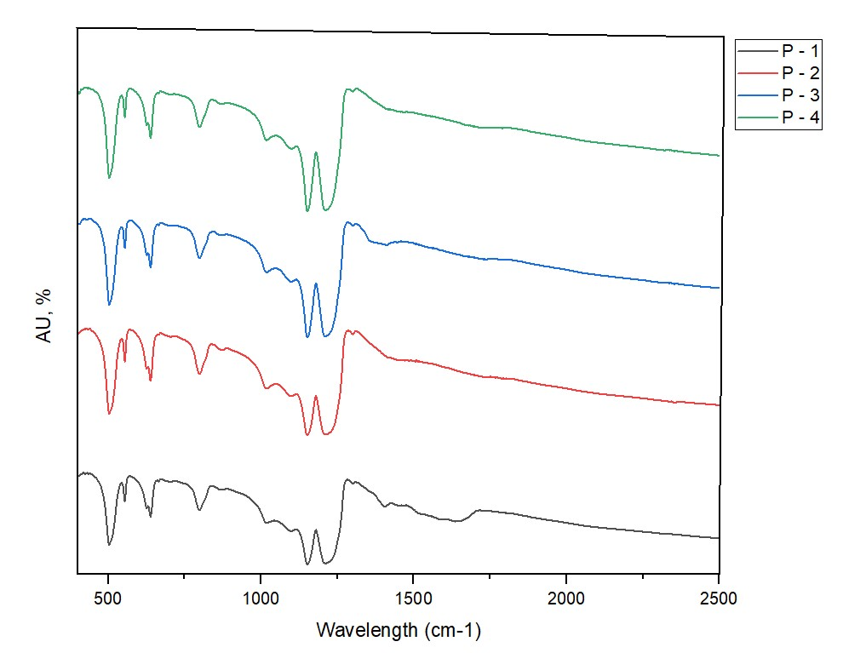
Figure 6: FTIR spectra of P. bifermentans P-1. After a growth period of 24 h, P-2 after oven drying at 74C for 24 h, P-3 after exposure to 100 ppm of ${Pb\left({NO}_{3}\right)}_{2}$, and P-4 14 h after adding 100 ppm of ${Pb\left({NO}_{3}\right)}_{2}$.
  - Conclusions
Metabolically inactive consortium and P. bifermentans were employed as a biosorbent to eliminate Pb(II) from aqueous solution. It was found that, oven drying the consortium and the microbial strain at 74 °C for 24 h successfully inhibited the metabolic activity without rupturing the cell wall. Metabolically inactive consortium and P. bifermentans removed 54.44 mg/g and 27.39 mg/g of Pb(II) in 3 h respectively. FTIR spectroscopy indicated the biosorption of Pb(II) onto functional groups (Alkyl halides, phenols, alkene, and aromatic) as being responsible for this removal. Two-phase pseudo-first-order fits had the highest coefficient of determination which might be due to the fast and slow adsorption rates into different compartments, thereby allowing better representation of a heterogeneous surface. Pseudo-second -order kinetics was found to represent the data slightly better than pseudo-first-order kinetics which suggests an abundance of adsorption sites relative to Pb(II) ions in the solution. It was found that, the consortia and P. bifermentans slightly increased the pH of the solution as a result of the electrostatic attraction between the negatively charged adsorbent surfaces and the positively charged Pb(II) resulting in an increase in adsorption efficiency.
Acknowledgments
This work is based on the research supported in part by the National Research Foundation of South Africa.
References
Ahluwalia, S.S. and Goyal, D., 2007. Microbial and plant derived biomass for removal of heavy metals from wastewater. Bioresource technology, 98(12), pp.2243-2257.
Bilal Shakoor, M, S Ali, M Farid, M Ahsan Farooq, H Muhammad Tauqeer, U Iftikhar, F Hannan, and S Aslam Bharwana (2013). “Heavy metal pollution, a global problem and its remediation by chemically enhanced phytoremediation: A Review”. In: J. Bio. & Env. Sci 2013.3, pp. 12–20.
Hörstmann C., Brink, H.G. and Chirwa, E.M.N., 2020. Pb(II) Bio-Removal, Viability, and Population Distribution of an Industrial Microbial Consortium: The Effect of Pb(II) and Nutrient Concentrations. Sustainability, p.2511.
Leung, W.C., Wong, M.F., Chua, H., Lo, W. and Leung, C.K., 2000. Removal and recovery of heavy metals by
bacteria isolated from activated sludge treating industrial effluents and municipal wastewater. Water Sci.
Technol., 41 (12), 233-240.
Meenambal, M., Phugalendy, K., Vasantharaja, C., Prapakaran, S. and Vijayan, P., 2012. Phytochemical investigation from FTIR and GC-MS studies of methanol extract of Denolix eltaleaves. International Journal of Chemical and Analytical Science, 3(6), 1446–1448.
Moncrieff, A. A., 0. P, Koumides, B. E. Clayton, A. D. Patrick, A. G. C. Renwick, and G. E. Roberts. 1964. Lead poisoning in children. Archives of Disease in Childhood 39:1-13.
Peens J., Wu W.Y., Brink H.G., 2018. Chem. Eng. Trans. 64, 439–444.
Rushikesh, N., Rajdeep, P., Manish, N. and Bhaskar, C., 2018. Priority based functional group identification of
organic molecules using machine learning. The ACM India Joint International Conference, 201 – 209.
Tan, K.L. and Hameed, B.H. 2017 Insight into the adsorption kinetics models for the removal of contaminants from aqueous solutions. J. Taiwan Inst. Chem. Eng. 74, 25–48.
Tiwari, Seema & Tripathi, Indra & Tiwari, Hl. (2013). Effects of Lead on Environment. 2278-9359.
Van Hille, RP, A Antunes, D Sanyahumbi, L Nightingale, and JR Duncan (2003). Development of integrated biosorption systems for the removal and/or recovery of heavy metals from mining and other industrial wastewaters, and determination of the toxicity of metals to bioremediation processes: WRC Report No. 1243/1/03. Tech. rep. Water Research Comission.
Van-Veenhuyzen, B., Brink, H.G. and Chirwa, E.M.N., 2021a. Microbial Pb(ii) Precipitation: the Role of Biosorption as a Pb(ii) Removal Mechanism. Chemical Engineering Transactions. 86. 181-185.
Van-Veenhuyzen, B., Tichapondwa, S., Cilliers, C., Chirwa, E.M.N. and Brink, H.G., 2021b. High Capacity Pb(II) Adsorption Characteristics onto Raw- and Chemically Activated Waste Activated Sludge. Journal of Hazardous Materials, 416. 125943.
Wang, J., and Guo, X., 2020. Adsorption isotherm models: classification, physical meaning, application and solving method. Chemosphere 258, 12727.

