Dear Editors,

Thank you for giving me the opportunity to submit a revised draft of my manuscript titled “Hydrothermal Gasification of Biogas Digestate: A Thermodynamic Study on Effects of Process Parameters Using Aspen Plus” to Chemical Engineering Journal. We appreciate the time and effort that you and the reviewers have dedicated to providing your valuable feedback on my manuscript. We are grateful to the reviewers for their insightful comments on the paper.
Here is a point-by-point response to the reviewers’ comments.

Comments from Reviewer 1:
- Comment 1: You modelled the chemical reaction through a gibbs reactor, that is, at the equilibrium. Is it really going to the equilibrium? did you consider the carbon remaining unreacted? In fact you did all your considerations taking into account the chemical reaction scheme, which might lead to kinetic restrictions.
Response: Thank you for pointing this out. The modelling of hydrothermal gasification using Gibbs free energy minimization has been widely used in the previous research, and numerous studies have shown that this method has a good agreement with experimental works. This approach is considered preferable compared to taking into account the individual chemical reaction schemes, which can be very complex in an HTG system. Although there is a possibility that there is remaining carbon unreacted, the amount is not significant, hence, the gas product yield and composition is very similar to those at equilibrium condition [1].
- Comment 2: What are the input data of the model?
Response: The input data of the model includes proximate analysis of feedstock materials (Table 1), ultimate analysis of feedstock materials (Table 2), and process conditions (Table 3).
- Comment 3: The ultimate analysis sums 99.9%, please check.
Response: Thank you for pointing this out. The ultimate analysis used for this study is taken from a literature [2], and we have re-checked that the values written on this manuscript are consistent with the reference. Since there is no further information on the reference, we assume that this 0.1% difference might be caused by rounding.
- Comment 4: What is the moisture of the initial biomass? what are the water quantities in the ratio feedstock/water?
Response: The proximate and ultimate analysis given in the reference [2] is on a dry-basis and therefore no information on the moisture of the initial biomass was given.
- Comment 5: How was the ash content varied? is it related also to the added water? obviously, more ashes means less volatiles so decreased yields.
Response: The ash content was varied by keeping the total feedstock mass constant. The amount of added water was also kept constant. It is true that as the ash content increased, the organic content of the feedstock decreased accordingly.
Comments from Reviewer 2
- Comment 1: The present work (51) presented by the authors is completely analogous to the work (52) of the same authors. The difference is that in this case the simulation was performed with Aspen plus and the sensitivity analysis also included the ash content, while in work 52 the simulation was performed with Matlab-based code and the presence of inorganic components in the feedstock has been considered.
The close similarity between the two works also extends to the structure of the paper, the data presented in the tables and the results of the sensitivity analysis. However, in both works there is no experimental validation of the models. Some comments made for the paper 52 are also valid for the paper 51. Since the two works are presented at the same conference and in the same topic, the suggestion is to bring them together in a single work that compares the two different simulation tools (Aspen and matlab).
Response: Thank you for your suggestion. We agree with Reviewer 2 on this comment. However, the main reason we are writing two separate manuscripts is because we want to highlight how the ash/inorganic contents of the biomass can play a significant role to influence gas yield and composition, and that Matlab-based code is capable of evaluating the inorganic effect. Furthermore, it is necessary to separate these findings into two different manuscripts due to the page limitation for E2DT publication.

We look forward to hearing from you in due time regarding our submission and to respond to any further questions and comments you may have.

Sincerely,
Fadilla Noor Rahma
Corresponding Author

REFERENCES
[1] Hantoko, D., et al., Thermodynamic study on the integrated supercritical water gasification with reforming process for hydrogen production: Effects of operating parameters. International Journal of Hydrogen Energy, 2018. 43(37): p. 17620-17632.
[2] Parmar, K.R. and A.B. Ross, Integration of hydrothermal carbonisation with anaerobic digestion; Opportunities for valorisation of digestate. Energies, 2019. 12(9): p. 1586.

CHEMICAL ENGINEERING TRANSACTIONS  VOL. , 2023 | A publication of
The Italian Association
of Chemical Engineering
Online at www.cetjournal.it

Guest Editors: David Bogle, Flavio Manenti, Piero Salatino
Copyright © 2023, AIDIC Servizi S.r.l.
ISBN 979-12-81206-04-5; ISSN 2283-9216

Hydrothermal Gasification of Biogas Digestate: A Thermodynamic Study on Effects of Process Parameters Using Aspen Plus
Fadilla N. Rahma^{a,*}, Tian Liª, Roger Khalil^{b}, Khanh-Quang Tranª
ªDepartment of Energy and Process Engineering, Norwegian University of Science and Technology (NTNU), Norway
^{b}SINTEF Energy Research, Norway
fadilla.n.rahma@ntnu.no
In this work, effects of process parameters on hydrothermal gasification (HTG) of biogas digestate are investigated using Aspen Plus software with an assumption that the inorganic contents of feedstock are lumped together as a single input parameter. The investigated parameters are temperature (400-600 ºC), pressure (250-300 bar), feedstock concentration (10-50 wt%), and feedstock ash content (0-40%), while the performance indicators are producer gas yield and composition. According to the modelling results, significant effects on the producer gas yield and composition were observed for temperature and feed concentration changes. On the other hand, pressure only had slight effects on the gas production. Hydrogen composition can be enhanced by keeping the pressure and feedstock composition low while increasing the reaction temperature. Furthermore, a higher ash content leads to a higher H₂ composition, lower CO₂ and CH₄ composition, and higher gas yield. However, the influence of ash content captured in this study does not represent any chemical activities of the ash components.
  - Introduction
Among the rapidly growing interests towards renewable and sustainable energy alternatives, biogas production technology has received significant attention as one of the most promising biofuels (Zabed, Akter et al. 2020). Biogas, primarily consisting of CH₄ and CO₂, is a versatile energy source which can be utilized for transport fuel as well as heat and electricity generation. It has a significant potential as a renewable energy source for both domestic and industrial applications (Kabeyi and Olanrewaju 2022). Biogas energy has accounted for 16,915 MW of global energy production in 2017, 71% of which is contributed by European countries (Herbes, Roth et al. 2020).
Despite its potentials, the implementation of biogas technology is still hindered by significant key challenges. Biogas is mainly produced through anaerobic digestion, a biological process that decomposes organic materials in the absence of oxygen (Surendra, Takara et al. 2014). During the biogas production, the anaerobic digestion simultaneously generates a solid-liquid digestate stream, typically consists of 30-60% fraction of the feed (Romio, Kofoed et al. 2021). Due to its rich nutrient content, biogas digestate is commonly used as bio-fertilizer and soil improver (Lu and Xu 2021). However, this practice recently raises some environmental concerns due to the risk of ammonia emission and the presence of pathogens, organic micropollutants, and heavy metal contents (Nkoa 2014). This leads to more stringent control on digestate-based fertilizer which creates disposal problems for biogas production plants (Dahlin, Herbes et al. 2015). In addition, there is another major issue related to the inadequate availability of suitable feedstock to meet the biogas production target (Divya, Gopinath et al. 2015).
Process integration of anaerobic digestion (AD) and hydrothermal gasification (HTG) is a potential answer to both challenges. The idea of the integration is to process the digestate through HTG to generate producer gas, with a possibility of recycling the producer gas back into the AD. Previous experimental studies have confirmed that biomethane production can be improved through producer gas recycle into the AD (Li, Chen et al. 2019, Yang, Liu et al. 2020). Therefore, the integration provides simultaneous benefits: 1) reducing the amount of material disposal; 2) enabling the AD to utilize a wider selection of feedstock, including materials containing non-digestible fractions; and 3) enhancing biogas production through the producer gas recycling (Li, Chen et al. 2019).
The implementation of AD-HTG integration with producer gas recycling requires a comprehensive understanding about the impact of important operating parameters on the behavior of producer gas from the HTG. Studies about the effects of process parameters on HTG has been carried out previously (Yakaboylu, Harinck et al. 2013, Louw, Schwarz et al. 2016, Okolie, Nanda et al. 2020), however, the use of biogas digestate as a feedstock has not been investigated. In addition, the effect of feedstock ash content has not been reported.
In this paper, an HTG Aspen Plus model is developed with Gibbs free energy minimization principle to study the effect of process parameters in the HTG of biogas digestate. The model is implemented to thermodynamically evaluate the effect of temperature, pressure, feed concentration, and feedstock ash content on the producer gas yield and composition. The result of this present research provides an important insight for the future development of AD-HTG integration.
  - Methods
    - Model Description
An HTG process model is developed in Aspen Plus to represent the typical experimental setup used in previous HTG studies (Byrd, Pant et al. 2007, Byrd, Pant et al. 2008). The same setup, as presented in Figure 1, has also been repeatedly adopted in numerous HTG modelling works utilizing Aspen Plus (Hantoko, Su et al. 2018, Okolie, Nanda et al. 2020). In the Aspen Plus model, the biogas digestate feedstock is regarded as an non-conventional component specified by its proximate and ultimate composition. The composition is obtained from biogas digestate data available in literature (Parmar and Ross 2019) and summarized in Table 1 and Table 2. The inorganic contents of the feedstock are lumped together as a single ash input. The PUMP and HEATER blocks are used to adjust the pressure and temperature of the feedstock to the reaction condition. The HTG reactor is represented by integrating two blocks of reactors (RYIELD and RGIBBS). The RYIELD is employed to break down the non-conventional feedstock component into its elements (C, H, O, N, S, and ash) based on the specified ultimate composition. For this purpose, a Fortran statement is written on a calculator block embedded in the RYIELD reactor. The output from the RYIELD flows into RGIBBS, where the Gibbs free energy minimization occurs. Following HTG, the reaction products are cooled in COOLER and brought to SEP block for separation of producer gas from the liquid product. The Peng-Robinson EoS (equation of state) is chosen for the Aspen Plus model. The process conditions range used for parametric investigation is summarized in Table 3.
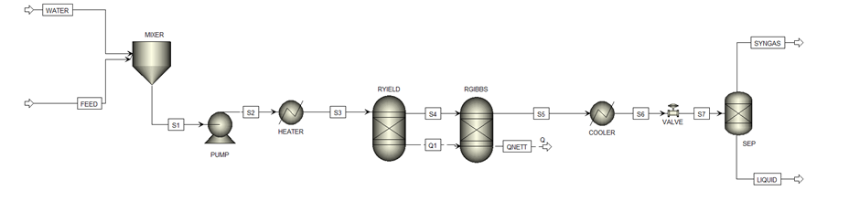
Figure 1: Flowsheet of Aspen Plus Model
Table 1: Proximate Analysis of Feedstock Materials (Parmar and Ross 2019)
Proximate Analysis (wt%) | Value (db)
Fixed Carbon | 8.3
Volatile Matters | 36.2
Ash | 55.5
Table 2. Ultimate Analysis of Feedstock Materials (Parmar and Ross 2019)
Ultimate Analysis (wt%) | Value (db)
C | 24.1
H | 1.7
O | 16.9
N | 1.5
S | 0.2
Table 3. Process Conditions for Parametric Investigation
Parameters | Value
Temperature | 400-600 ºC
Pressure | 250-300 bar
Feedstock concentration wt% | 10-50%

    - Chemical Reactions in Hydrothermal Gasification
HTG of biomass involves a complex combination of chemical reactions. Equation (1) to (3) are commonly recognized as the main chemical reactions in HTG, generating H₂, CO, CO₂, and CH₄ as the major components in the gaseous phase (Yang, Wang et al. 2021). The steam reforming reaction (Equation 1) is an irreversible and highly endothermic reaction responsible for producing CO and H₂ (Yang, Wang et al. 2021). Following the production of CO, two subsequent reactions take place. The water-gas shift reaction (WGSR) converts CO and water from the hydrothermal environment into CO₂ and more H₂ (Equation 2), whereas the methanation reaction (Equation 3) produces CH₄ from H₂ and CO. Both WGSR and methanation reaction are reversible reactions with exothermic nature (Xu, Peng et al. 2021). Additionally, the methanation reaction (Equation 3) is pressure-dependent based on Le Chatelier’s principle. According to the principle, increasing pressure will push the equilibrium reaction towards the side with smaller total reaction coefficients (Susanti, Kim et al. 2014).
$$CH_{x}O_{y}+\left(1-y\right)H_{2}O→CO+\left(1+\frac{x}{2}-y\right)H_{2}$$ | (1)
$$CO+H_{2}O↔CO_{2}+H_{2} ∆H\left(25 ℃\right)=-41.14 kJ/mol$$ | (2)
$$CO+{3H}_{2}↔CH_{4}+H_{2}O ∆H\left(25 ℃\right)=-205.89 kJ/mol$$ | (3)
  - Results and Discussion
    - Model Validation
Figure 2 displays the comparison of modelling result against experimental data from the HTG of cornstarch (Antal Jr, Allen et al. 2000). It shows that the model predicts H₂, CO, CO₂, and CH₄ composition in the producer gas with a high accuracy. This result suggests that the Aspen Plus model can be used to perform the parametric investigation with a good reliability.
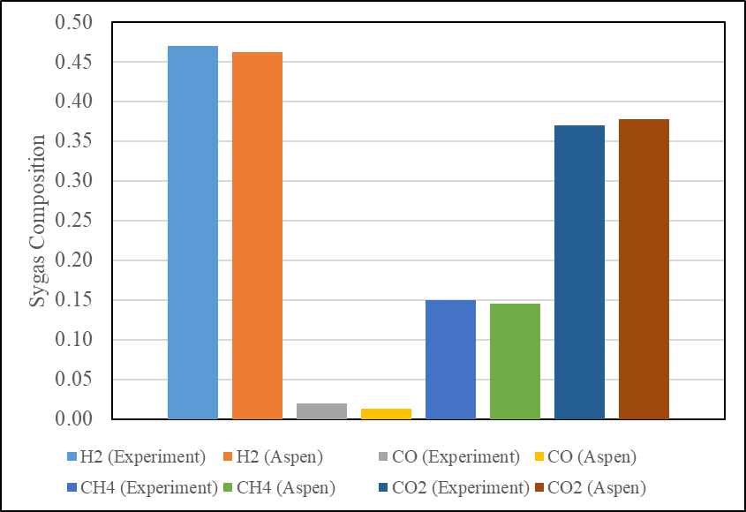
Figure 2. Validation Result of Aspen Plus Model
    - Effect of Temperature of Gas Composition and Yield
The effect of temperature on the gas product composition is presented in Figure 3 (a). This result was obtained at the pressure of 280 bar and feedstock concentration of 10 wt%, with temperature ranging within 400-600 ºC. An increase in temperature enhances the endothermic steam reforming reaction (Equation 1). Accordingly, H₂ production is promoted at higher temperature. Additionally, as the temperature increases, the highly exothermic methanation reaction (Equation 3) is pushed towards the backward direction, therefore converting CH₄ into H₂. This consequently leads to lower CH₄ concentrations at higher temperatures. For the entire temperature range of the investigation, only negligibly small amounts of CO are present in the product gas mixture. This indicates that CO is almost completely consumed during the HTG process via the WGSR and methanation reactions. The result also suggests that the temperature influence on CO₂ concentration is not prominent. A possible contributing factor for this is the slightly exothermic nature of the WGSR reaction (Equation 2) which can be translated to a relatively weak temperature dependence of CO₂ production. Similar results were reported in previous studies involving hydrothermal gasification of other biomass feedstocks (Tang and Kitagawa 2005, Voll, Rossi et al. 2009). Figure 3 (b) displays the effect of temperature on the overall gas yield. It is evident from the figure that temperature has a positive effect on the total gas production. This result agrees well with an earlier study which also found that temperature positively influences the overall gas yield in the HTG of almond shells, algae, and sludge (Macrì, Catizzone et al. 2020).
(a) | 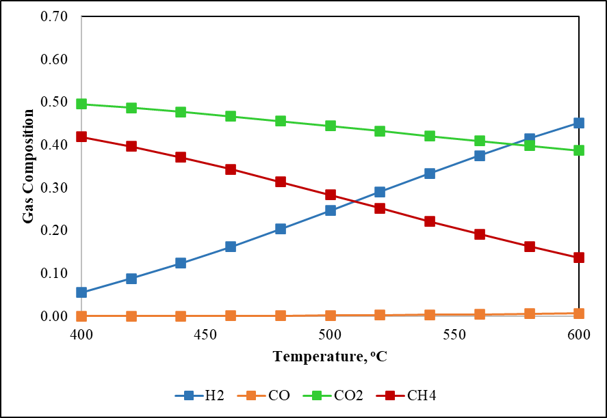 | (b) | 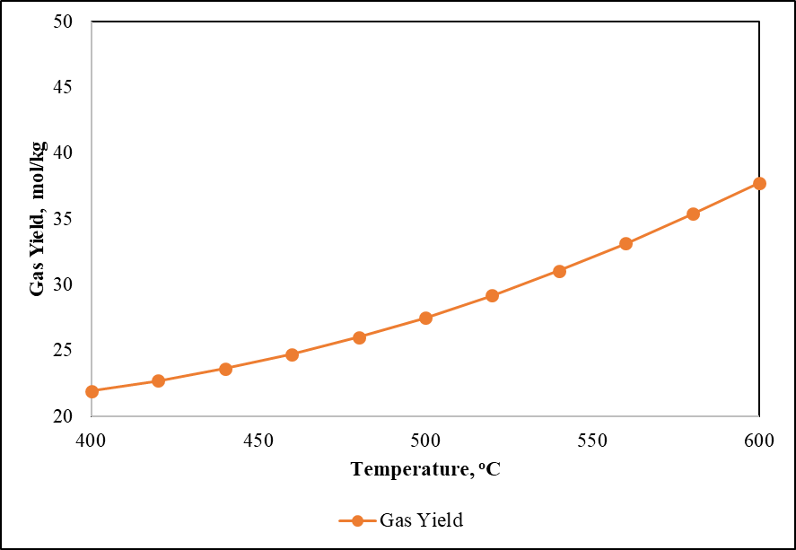
Figure 3. Effect of Temperature on (a) Gas Composition and (b) Gas Yield
    - Effect of Pressure on Gas Composition and Yield
The effect of pressure towards gas composition is displayed in Figure 4 (a). This figure was obtained at the reaction temperature of 600 ºC, feedstock concentration of 10 wt%, and pressure range of 250-300 bar. The figure clearly indicates that pressure gives minor influence towards the gas composition in biogas digestate HTG. It can be observed, however, that a rise in pressure slightly decreases H₂ and increases CH₄ content. This trend is consistent with the Le Chatelier principle, which suggests that HTG pressure only affects the methanation reaction, where higher pressure promotes the production of CH₄ from H₂. Similar findings were reported in the HTG studies of other feedstocks (Castello and Fiori 2011, Hantoko, Su et al. 2018). However, the absolute value of total gas yield is negatively affected by the change of pressure, as indicated by Figure 4 (b).
(a) |  | (b)

Figure 4. Effect of Pressure on (a) Gas Composition and (a) Gas Yield
    - Effect of Feed Concentration on Gas Composition and Yield
The influence of feedstock concentration towards gas composition is presented in Figure 5 (a). The feedstock concentration is defined as mass percentage of feedstock over the total mass of feedstock and water. The parametric investigation was performed by keeping the total mass constant; therefore, a higher feed ratio or percentage represents more feedstock and less water in the reaction system. The feedstock concentration was varied from 10 to 50 wt%, whereas the temperature and pressure were set at 600 ºC and 280 bar, respectively. The presence of water strongly affects the yield and composition of HTG products since the water acts as reactant in the HTG reactions as presented earlier.
As the feedstock concentration increases, H₂ composition drops notably. There are two possible factors responsible for this. First, the decreasing amount of water shifts the WGSR (Equation 2) backward. Second, the methanation reaction (Equation 3) is pushed forward. These actions result in less H₂ present in the product gas mixture. However, CO₂, which is consumed in the backward direction of the WGSR, is only slightly affected by the change in feedstock concentration. This implies that the influence of feedstock concentration towards the WGSR is not prominent, and the decrease in H₂ concentration is mainly contributed by the methanation reaction. This is consistent with the observation that CH₄ production is promoted with the increase in feedstock concentration. Similar observation was reported for a HTG simulation study of dewatered sewage sludge (Hantoko, Su et al. 2018), where the concentration of H₂ was found decreased and the concentration of CH₄ was increased with higher feedstock concentrations. On the other hand, the effect of feedstock concentration on the producer gas yield is displayed on Figure 5 (b). The result shows that a higher feedstock concentration results in lower overall gas yield, as also reported in an earlier study (Onwudili and Williams 2014).
(a) | 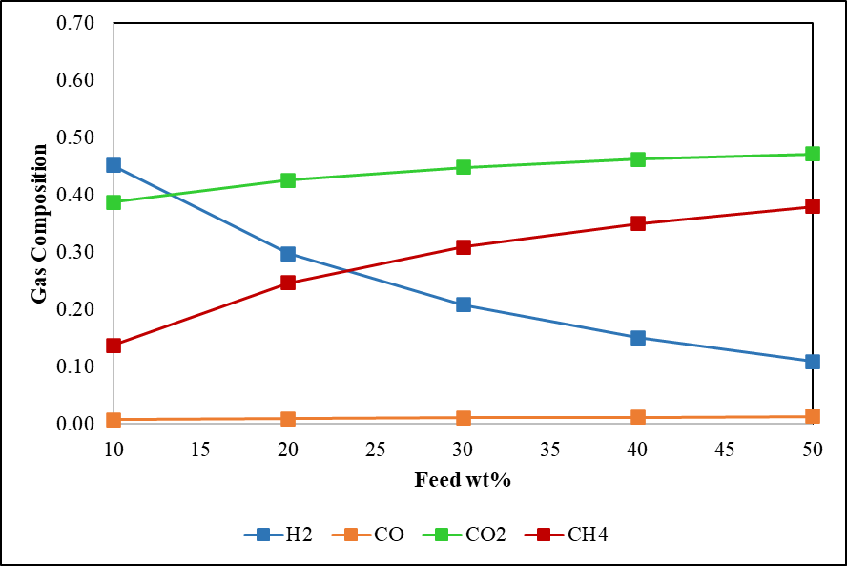 | (b) | 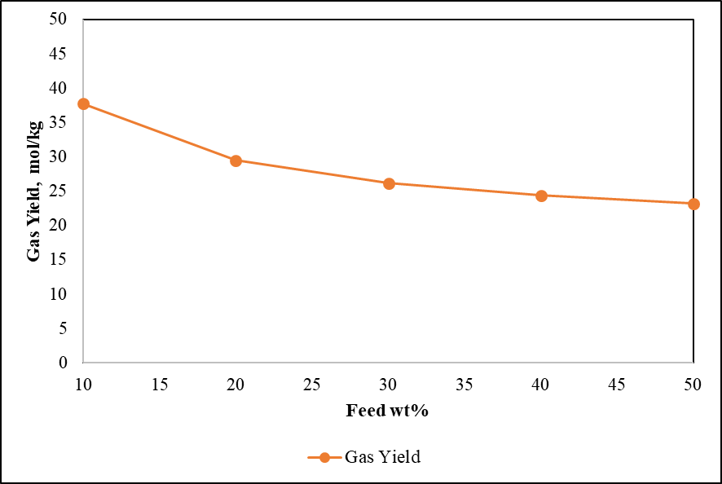
Figure 5. Effect of Feedstock Concentration on (a) Composition and (a) Yield of Product Gas
    - Effect of Ash Content on Gas Composition and Yield
The influence of ash content on the composition and yield of product gas is presented in Figure 6. It is important to note that the ash content of biomass feedstock was defined as a non-conventional lumped component. This is due to the limitation in the Aspen Plus database. Non-conventional components in Aspen Plus are not characterized by molecular formula and not considered as chemical components. The only properties calculated for non-conventional components are enthalpy and density, using empirical correlations. Consequently, no thermodynamic or transport properties are available for the non-conventional components, and they are excluded from any phase or chemical equilibrium calculations (Onarheim, Solantausta et al. 2015). The trend demonstrated in Figure 6, therefore, does not account for any chemical activities of ash components in the feedstock. Indeed, Figures 6a and 6b indicate that ash content affects both the gas composition and the gas yield. However, this effect is attributed to the change in organic components content, i.e., C, H, O, N, and S, with respect to the ash content. As the ash content increases, the organic content decreases accordingly, while the amount of water was kept constant. Hence, a higher ash content can be translated to a lower concentration of organic components in the water. This trend is therefore related to the effect of feedstock concentration, as previously discussed in section 3.4. Higher ash contents or lower combustibles lead to higher H₂ contents, lower CO₂ and CH₄ contents in the product gas, and higher overall gas yields.
(a) | 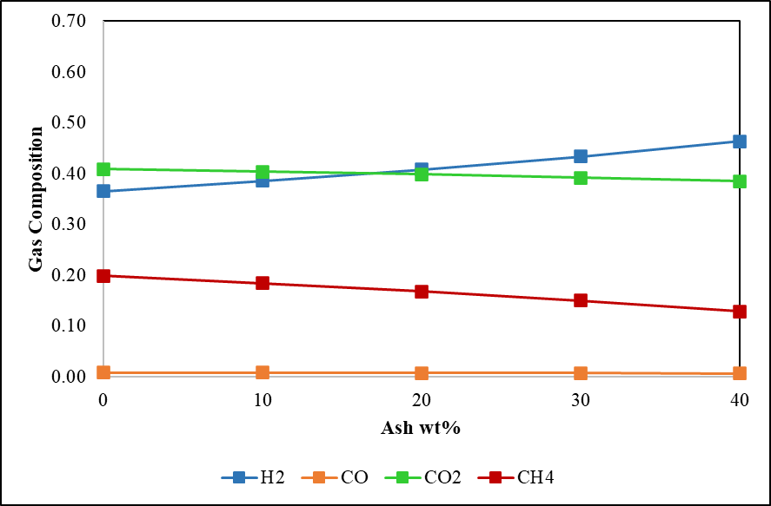 | (b) | 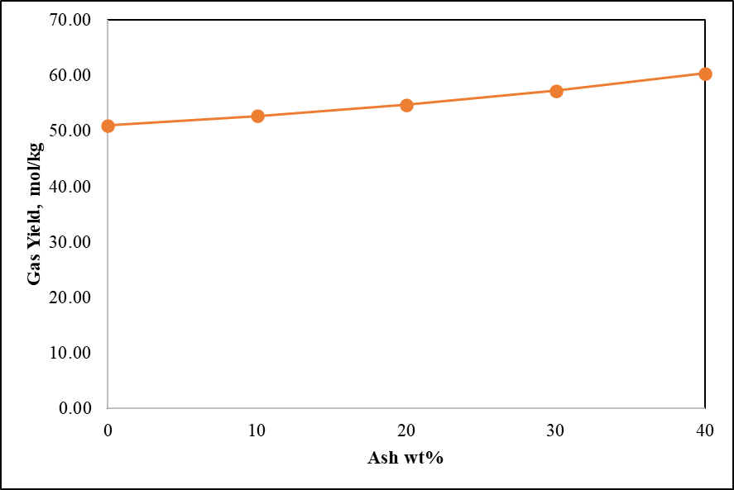
Figure 6. Effect of Ash Content on (a) Gas Composition and (a) Gas Yield
  - Conclusions
The influences of the important process parameters including temperature, pressure, feed concentration, and feedstock’s ash content on HTG of biogas digestate were thermodynamically evaluated using Aspen Plus software. It was observed that temperature effect was positive on the H₂ yield, but negative on the CH₄ yield, and only slightly affected the CO₂ yield. Temperature also had a positive effect on the total producer gas yield. The influence of pressure was less significant, although a rise in pressure slightly decreased the H₂ yield, increased the CH₄ yield, and lowered the total yield of the gaseous product. On the other hand, higher feedstock concentration had a significant effect on increasing the CH₄ and decreasing the H₂ yield and the overall product gas yield. It was also found that higher ash contents led to increased H₂ yield, lower CO₂ and CH₄ contents, and higher total product gas yield. However, the influence of ash content captured in this study does not represent any chemical activities of the ash components.
Acknowledgement
This work was supported by the BioSynGas project partly funded by the Research Council of Norway (Project Number: 319723).
References
Antal Jr, M. J., S. G. Allen, D. Schulman, X. Xu and R. J. Divilio (2000). "Biomass gasification in supercritical water." Industrial & Engineering Chemistry Research 39(11): 4040-4053.
Byrd, A. J., K. Pant and R. B. Gupta (2007). "Hydrogen production from ethanol by reforming in supercritical water using Ru/Al2O3 catalyst." Energy & Fuels 21(6): 3541-3547.
Byrd, A. J., K. Pant and R. B. Gupta (2008). "Hydrogen production from glycerol by reforming in supercritical water over Ru/Al2O3 catalyst." Fuel 87(13-14): 2956-2960.
Castello, D. and L. Fiori (2011). "Supercritical water gasification of biomass: Thermodynamic constraints." Bioresource technology 102(16): 7574-7582.
Dahlin, J., C. Herbes and M. Nelles (2015). "Biogas digestate marketing: qualitative insights into the supply side." Resources, Conservation and Recycling 104: 152-161.
Divya, D., L. Gopinath and P. M. Christy (2015). "A review on current aspects and diverse prospects for enhancing biogas production in sustainable means." Renewable and sustainable energy reviews 42: 690-699.
Hantoko, D., H. Su, M. Yan, E. Kanchanatip, H. Susanto, G. Wang, S. Zhang and Z. Xu (2018). "Thermodynamic study on the integrated supercritical water gasification with reforming process for hydrogen production: Effects of operating parameters." International Journal of Hydrogen Energy 43(37): 17620-17632.
Herbes, C., U. Roth, S. Wulf and J. Dahlin (2020). "Economic assessment of different biogas digestate processing technologies: A scenario-based analysis." Journal of Cleaner Production 255: 120282.
Kabeyi, M. J. B. and O. A. Olanrewaju (2022). "Biogas production and applications in the sustainable energy transition." Journal of Energy 2022.
Li, Y., Y. Chen and J. Wu (2019). "Enhancement of methane production in anaerobic digestion process: A review." Applied energy 240: 120-137.
Louw, J., C. E. Schwarz and A. J. Burger (2016). "Catalytic supercritical water gasification of primary paper sludge using a homogeneous and heterogeneous catalyst: experimental vs thermodynamic equilibrium results." Bioresource technology 201: 111-120.
Lu, J. and S. Xu (2021). "Post-treatment of food waste digestate towards land application: a review." Journal of Cleaner Production 303: 127033.
Macrì, D., E. Catizzone, A. Molino and M. Migliori (2020). "Supercritical water gasification of biomass and agro-food residues: Energy assessment from modelling approach." Renewable Energy 150: 624-636.
Nkoa, R. (2014). "Agricultural benefits and environmental risks of soil fertilization with anaerobic digestates: a review." Agronomy for Sustainable Development 34(2): 473-492.
Okolie, J. A., S. Nanda, A. K. Dalai and J. A. Kozinski (2020). "Hydrothermal gasification of soybean straw and flax straw for hydrogen-rich syngas production: Experimental and thermodynamic modeling." Energy Conversion and Management 208: 112545.
Onarheim, K., Y. Solantausta and J. Lehto (2015). "Process simulation development of fast pyrolysis of wood using aspen plus." Energy & Fuels 29(1): 205-217.
Onwudili, J. A. and P. T. Williams (2014). Production of hydrogen from biomass via supercritical water gasification. Near-critical and supercritical water and their applications for biorefineries, Springer: 299-322.
Parmar, K. R. and A. B. Ross (2019). "Integration of hydrothermal carbonisation with anaerobic digestion; Opportunities for valorisation of digestate." Energies 12(9): 1586.
Romio, C., M. V. W. Kofoed and H. B. Møller (2021). "Digestate post-treatment strategies for additional biogas recovery: A review." Sustainability 13(16): 9295.
Surendra, K., D. Takara, A. G. Hashimoto and S. K. Khanal (2014). "Biogas as a sustainable energy source for developing countries: Opportunities and challenges." Renewable and Sustainable Energy Reviews 31: 846-859.
Susanti, R. F., J. Kim and K.-p. Yoo (2014). "Supercritical water gasification for hydrogen production: current status and prospective of high-temperature operation." Supercritical fluid technology for energy and environmental applications: 111-137.
Tang, H. and K. Kitagawa (2005). "Supercritical water gasification of biomass: thermodynamic analysis with direct Gibbs free energy minimization." Chemical Engineering Journal 106(3): 261-267.
Voll, F., C. Rossi, C. Silva, R. Guirardello, R. Souza, V. Cabral and L. Cardozo-Filho (2009). "Thermodynamic analysis of supercritical water gasification of methanol, ethanol, glycerol, glucose and cellulose." International Journal of Hydrogen Energy 34(24): 9737-9744.
Xu, J., Z. Peng, S. Rong, H. Jin, L. Guo, X. Zhang and T. Zhou (2021). "Model-based thermodynamic analysis of supercritical water gasification of oil-containing wastewater." Fuel 306: 121767.
Yakaboylu, O., J. Harinck, K. G. Smit and W. de Jong (2013). "Supercritical water gasification of manure: A thermodynamic equilibrium modeling approach." Biomass and Bioenergy 59: 253-263.
Yang, C., S. Wang, Y. Li, Y. Zhang and C. Cui (2021). "Thermodynamic analysis of hydrogen production via supercritical water gasification of coal, sewage sludge, microalga, and sawdust." International Journal of Hydrogen Energy 46(34): 18042-18050.
Yang, Z., Y. Liu, J. Zhang, K. Mao, M. Kurbonova, G. Liu, R. Zhang and W. Wang (2020). "Improvement of biofuel recovery from food waste by integration of anaerobic digestion, digestate pyrolysis and syngas biomethanation under mesophilic and thermophilic conditions." Journal of Cleaner Production 256: 120594.
Zabed, H. M., S. Akter, J. Yun, G. Zhang, Y. Zhang and X. Qi (2020). "Biogas from microalgae: Technologies, challenges and opportunities." Renewable and Sustainable Energy Reviews 117: 109503.

