CHEMICAL ENGINEERING TRANSACTIONS  VOL. , 2023 | A publication of
The Italian Association
of Chemical Engineering
Online at www.cetjournal.it

Guest Editors: David Bogle, Flavio Manenti, Piero Salatino
Copyright © 2023, AIDIC Servizi S.r.l.
ISBN 979-12-81206-04-5; ISSN 2283-9216

Hydrothermal Gasification of Biogas Digestate: A Parametric Study Using A Matlab-based Code
Fadilla N. Rahma^{a,*}, Onursal Yakaboylu^{b}, Tian Liª, Roger Khalil^{c}, Khanh-Quang Tranª
ªDepartment of Energy and Process Engineering, Norwegian University of Science and Technology (NTNU), Norway
^{b}SHV Energy, The Netherlands
^{c}SINTEF Energy Research, Norway
fadilla.n.rahma@ntnu.no
In this work, effect of process parameters on hydrothermal gasification (HTG) of biogas digestate are thermodynamically investigated using a Matlab-based code, which is capable of modelling the effects of the feedstock’s inorganic contents and elements. The effects of temperature (400-600 ºC), pressure (250-300 bar), and feed concentration (10-40 wt%) towards the producer gas yield and composition are evaluated while considering the influence of inorganic components in the feedstock. The result shows that temperature and feed concentration play significant roles in determining producer gas composition and yield, whereas pressure only has little influence. Hydrogen production is favored by higher temperature, lower pressure, and lower feed concentration. It was also observed that the presence of inorganic components in the feedstock reduces the production of CO₂, while H₂ and CH₄ is increased. The result of this study is essential in the future development of biogas digestate HTG.
  - Introduction
In the recent years, the increasing urgency of combatting with climate change has been accelerating the energy transition towards renewable and sustainable resources. Biogas produced from low-grade biomass materials via anaerobic digestion is an important alternative in this transition, mainly due to its flexibility to be used as transport fuel, heat, and electricity sources (Scarlat, Dallemand et al. 2018). However, the biogas technology still faces significant issues associated with complicated treatment and management of digestate (Nkoa 2014, Guilayn, Rouez et al. 2020), as well as insufficient supply of sustainable feedstock (Divya, Gopinath et al. 2015).
A potential solution to overcome both problems is by integrating anaerobic digestion (AD) with hydrothermal gasification (HTG). In such an integrated system, wet digestate produced from the AD unit can be gasified, with no need of drying, in the HTG unit to reduce the load of digestate management and to recover the energy content remaining in the digestate. This integration can also widen the AD feedstock choices to include lignocellulosic biomass, which normally is not very suitable as AD feedstock due to their composition and structure complexity (Sudibyo, Pecchi et al. 2022). On the other hand, the producer gas generated from the HTG unit can be recycled back to the AD for enhancing the biogas production (Yang, Liu et al. 2020).
The implementation of AD-HTG integration with producer gas recycling requires a comprehensive understanding about the impact of process parameters on HTG performance including the yield and composition of the producer gas. Past parametric studies on HTG and producer gas using thermodynamic modelling approach have been quite active, of which several focused on investigating the effect of different types of biomass feedstock (Freitas and Guirardello 2013, Macrì, Catizzone et al. 2020, Okolie, Epelle et al. 2021). However, to the best of the authors’ knowledge, the use of biogas digestate as HTG feedstock has not been studied. More importantly, attempt to investigate the effect of inorganic components of the feedstock on HTG performance was very limited, while it has been reported that the inorganic components of the feedstock could cause significant differences between modelling and experimental data (Mutlu and Zeng 2020). This suggests the importance of considering the feedstock’s inorganic components and their chemistry in HTG modelling.
The present research aims to investigate into parametric effects on HTG performance and the behavior of producer gas from the HTG of biogas digestate while taking into account the effect of feedstock’s inorganic components. For this purpose, a multiphase thermodynamic model developed in Matlab by Yakaboylu et al. (Yakaboylu, Harinck et al. 2014), which is capable of predicting compound formation over a wider range of feedstock types as well as using more updated thermodynamic data for the solute species, will be employed. The effect of key process parameters such as temperature, pressure, and feedstock dry matter content on the producer gas composition and yield is evaluated. This work would serve as a foundation for future development of an integrated AD-HTG system, considering the effect of inorganic components of the feedstock.
  - Methods
    - Model Description
As aforementioned, the present study is carried out, employing the multiphase thermodynamic model developed by Yakaboylu et al. The model has been validated with experimental data. Full description of the model can be found in the literature (Yakaboylu, Harinck et al. 2014). A non-stoichiometric approach based on Gibbs free energy minimization is adopted in the model. For a given temperature and pressure, the model predicts product composition at the system’s equilibrium state, which is reached when the Gibbs free energy is at minimum with respect to all possible changes. The equilibrium state is mathematically defined in Equation (1).
$${\left(dG^{t}\right)}_{T,P}=0$$ | (1)
The model is capable of predicting phase distribution of product components by performing multiphase thermodynamic calculations, considering both organic and inorganic components in the feedstock. In a multiphase system, the total Gibbs free energy is calculated as the sum of Gibbs free energy from each phase. Hence, in this thermodynamic model, the Gibbs free energy calculation is carried out for three phases included in the system, namely 1) gas phase, 2) pure condensed phases, and 3) aqueous solution phases. The total Gibbs free energy is presented in Equation (2), where the subscripts i and w refers to component i and water, respectively. The terms $n$, $μ$, $g^{o}$, $x$, and $γ$ respectively represent the component mole amount, the gas chemical potential, the component’s standard molar Gibbs free energy, the component mole fraction, and the activity coefficient based on the component mole fraction.
$$G=\sum_{\begin{aligned}gas \\ phase\end{aligned}}{n_{i}μ_{i}}+\sum_{\begin{aligned}pure \\ condensed \\ phases\end{aligned}}{n_{i}}{g_{i}}^{o}+n_{w}\left({g_{w}}^{o}+RT\ln{x_{w}}+RT\ln{γ_{w}}\right)+\sum_{\begin{aligned}aqueous \\ solution\end{aligned}}{n_{i}}\left({g_{i}}^{o}+RT\ln{x_{i}}+RT\ln{γ_{i}}\right)$$ | (2)
- Calculations for the gas phase
The Gibbs free energy for gas phase is defined as the first term in Equation (2). As the supercritical condition of the HTG system leads to a non-ideal behavior of the gas, the Gibbs free energy calculation is based on the chemical potential of the gases. The gas phase calculation employs Peng-Robinson equation of state (EoS) with thermodynamic data acquired from the FACT53 database of the FactSage software.
- Calculations for the pure condensed phase
The second term in Equation (2) represents the Gibbs free energy of the pure condensed phases. The required thermodynamic data for the pure condensed phases was also obtained from the FACT53 database of the FactSage software.
- Calculations for the aqueous solution
In Equation (2), the Gibbs free energy of the aqueous solution is represented by the third term for the calculation of water in the aqueous phase, and the last term for the solute species. The thermodynamic data for the solute species were taken from the SUPCRT92 software. For the supercritical region, where the water in the aqueous phase is completely vaporized, the calculation is based on an assumption that the solute molecules interact with gases to form aqueous hydrate complexes (Chrastil 1982).
The thermodynamic model is implemented in Matlab using fmincon routine to minimize Equation (2) and obtain the amounts of species at the equilibrium state. A mole and charge balance constraint and non-negativity species amount constraint are applied during the minimization. The required inputs are process conditions, i.e., temperature and pressure, and the molar composition of feedstock and water. The feedstock composition is taken from biogas digestate data available on literature (Parmar and Ross 2019).
Table 1: Proximate Analysis of Feedstock Materials (Parmar and Ross 2019)
Proximate Analysis (wt%) | Value (db)
Fixed Carbon | 8.3
Volatile Matters | 36.2
Ash | 55.5
Table 2. Ultimate Analysis of Feedstock Materials (Parmar and Ross 2019)
Ultimate Analysis (wt%) | Value (db)
C | 24.1
H | 1.7
O | 16.9
N | 1.5
S | 0.2
Ca | 10.4
Cl | 0.0
K | 1.6
Mg | 1.4
Na | 0.9
P | 0.7
Si | 10.2
    - Chemical Reactions in Hydrothermal Gasification
Hydrothermal gasification of biomass includes a series of chemical reactions which produces H₂, CO, CO₂, and CH₄ as the main components in the gaseous phase. The steam reforming reaction (Equation 3), water gas shift reaction (WGSR) (Equation 4), and methanation reaction (Equation 5) are commonly considered as the main chemical reactions in HTG (Xu, Peng et al. 2021, Yang, Wang et al. 2021). The steam reforming reaction produces CO and H₂ from endothermic decomposition of biomass. The reversible WGSR produces more H₂ and CO₂ through exothermic reaction of CO and H₂O. On the other hand, the reversible methanation reaction consumes H₂ to react with CO, producing CH₄ and H₂O (Yang, Wang et al. 2021).
$$CH_{x}O_{y}+\left(1-y\right)H_{2}O→CO+\left(1+\frac{x}{2}-y\right)H_{2}$$ | (3)
$$CO+H_{2}O↔CO_{2}+H_{2} ∆H\left(25 ℃\right)=-41.14 kJ/mol$$ | (4)
$$CO+{3H}_{2}↔CH_{4}+H_{2}O ∆H\left(25 ℃\right)=-205.89 kJ/mol$$ | (5)
  - Results and Discussion
    - Effect of Temperature
Figure 1 (a) shows the effect of temperature towards the producer gas composition at different weight percentages of inorganic components. The temperature influence observed in this figure agrees well with previous studies (Tang and Kitagawa 2005, Voll, Rossi et al. 2009). Higher temperature enhances hydrogen production by promoting the endothermic steam reforming reaction (Equation 3). As the temperature increases, the methanation reaction (Equation 5) is also reversed, therefore CH₄ is consumed to produce more H₂. This also explains the decrease in methane production at higher temperature. The production of CO₂ is favored at lower temperatures, although the temperature dependence is less significant since WGSR is only slightly exothermic. The amount of CO is negligible at the investigated temperature range, indicating that CO is almost completely consumed in the WGSR and methanation reaction. On the other hand, Figure 1 (b) shows that the total gas yield is positively influenced by temperature. This result is in agreement with the literature, concerning with HTG of other biomass feedstocks (Voll, Rossi et al. 2009, Freitas and Guirardello 2014).
In addition, both figures also demonstrate the effect of inorganic contents on the producer gas yield and composition. For any temperature within the observed range, a higher inorganic content always leads to a lower production of CO₂. This might be due to the formation of inorganic salts such as CaCO₃, Na₂CO₃, and K₂CO₃ from the reactions between inorganic components and CO₂. As a consequence of the lower CO₂ composition, the WGSR is driven towards the forward direction to produce more H₂. This explains the higher H₂ composition at higher inorganic content. The result is consistent with the experimental observation reported by Guo et al. (Guo, Guo et al. 2012) and Xu et al (Xu, Wang et al. 2009). Furthermore, Onwudili et al. (Onwudili and Williams 2014) argued that the presence of alkali metals promotes hydrogen production by accelerating the WGSR through the removal of CO₂ as carbonate. Su et al. (Su, Yan et al. 2022) also reported that the production of potassium salts improves the WGSR, resulting in higher H₂ production. The increased H₂ amount due to higher inorganic contents also enhances the production of CH₄ through the methanation reaction. Furthermore, Figure 1 (a) shows that the effect of inorganic contents on gas composition is more prominent at lower temperatures. This might be due to the decreasing carbonate salts forming reaction at higher temperature, which is consistent with the simulation result, although not presented in this paper.

(a) | 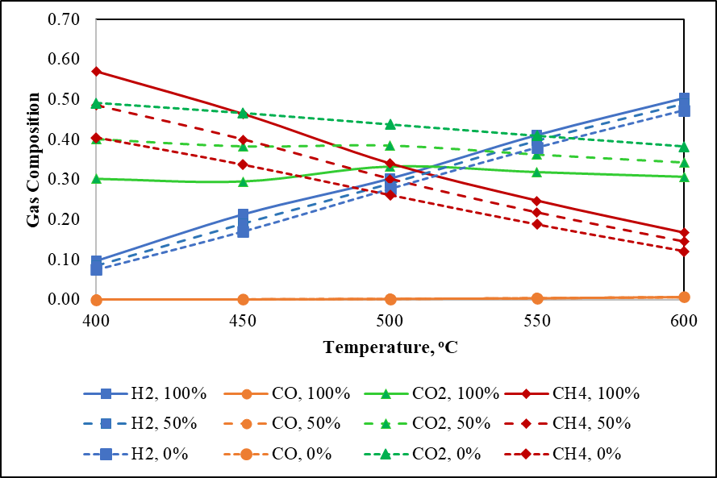 | (b) | 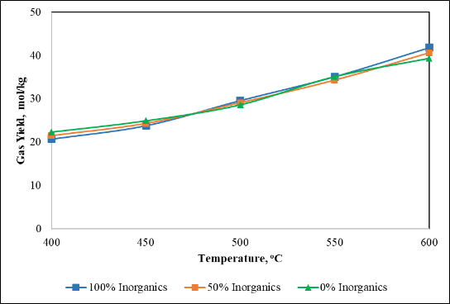
Figure 1. The effect of temperature on producer gas (a) composition and (b) yield at different inorganic contents (P = 280 bar, feedstock concentration = 10%, inorganic contents = 100%, 50%, and 0% wt.)

The effect of inorganic contents on the total gas yield is presented in Figure 1 (b). The figure indicates that at lower temperature, higher inorganic contents are associated with lower gas yields. The trend is reversed at higher temperatures, where a higher gas yields are obtained for the feedstock with higher inorganic contents.
    - Effect of Pressure
Figure 2 (a) and (b) demonstrate how pressure influences the producer gas composition and yield. It is observed that pressure gives minor effect on both gas composition and yield. However, a slight decrease in H₂ production and increase in CH₄ formation is observed at higher pressures. According to the Le Chatelier principle, higher HTG pressure promotes the methanation reaction (Equation 5), hence more CH₄ is produced from H₂. This result agrees well with findings from previous studies (Castello and Fiori 2011, Hantoko, Su et al. 2018).
The effect of different inorganic contents of the feedstock is also displayed in both figures. Consistent trends similar to what presented in the previous section are also observed. Higher inorganic contents negatively affect CO₂ formation, however, the production of both H₂ and CH₄ is increased. The increase in H₂ and CH₄ production is more significant than the decrease in CO₂. Overall, the total gas yield increases for higher inorganic contents, as indicated by Figure 2 (b).
(a) | 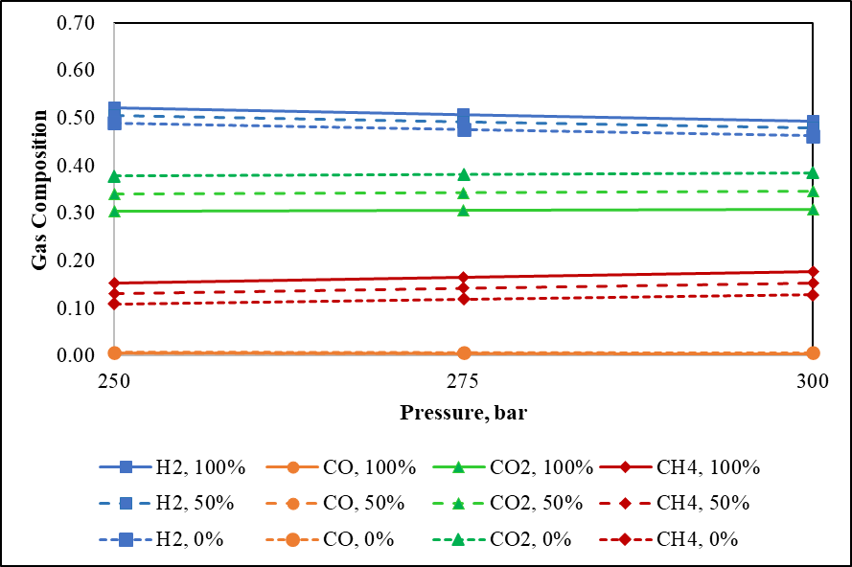 | (b) | 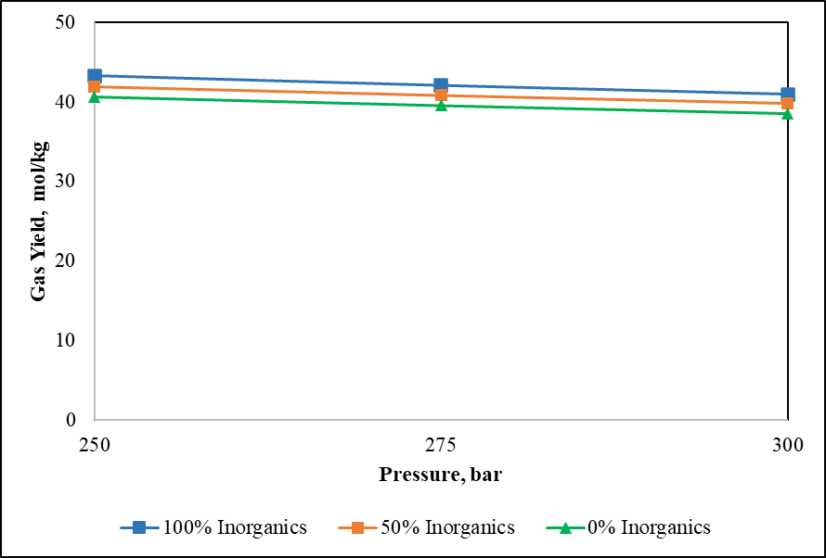
Figure 2. The effect of pressure on producer gas (a) composition and (b) yield at different inorganic contents (T = 600 ºC, feedstock concentration = 10%, inorganic contents = 100%, 50%, and 0% wt.)
    - Effect of Feed Concentration
The effect of feed concentration on gas composition and yield is presented on Figure 3 (a) and (b), respectively. Note that, for this investigation, the total mass of feed and water was kept constant during the simulation. Therefore, a higher feed concentration represents a higher amount of feed and lower amount of water. In an HTG system, water acts as a reactant which can significantly influence the chemical reactions. Figure 3 (a) indicates that H₂ composition is significantly reduced at higher feed concentration. This is because the decreasing water amount affects the methanation reaction, pushing it towards the direction of CH₄ production from H₂. This is also consistent with the significant increase in CH₄ composition at higher feed concentration. On the other hand, Figure 3 (b) indicates that the overall gas yield decreases notably at higher feed concentration. Similar findings were previously published in an earlier study (Hantoko, Su et al. 2018).
Both Figure 3 (a) and (b) also demonstrate the effect of inorganic contents on the producer gas yield and composition. Similar with the result presented in the previous sections, a higher inorganic content always leads to a decrease in CO₂ composition and increase in H₂ and CH₄ composition. According to the simulation result, the formation of carbonate salts is promoted at higher feed composition. Consequently, the effect of inorganic contents on gas composition is more prominent when the feed composition is higher.
(a) | 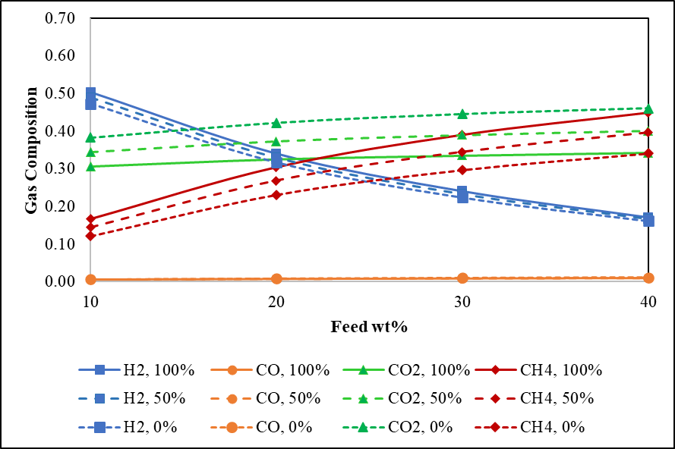 | (b) | 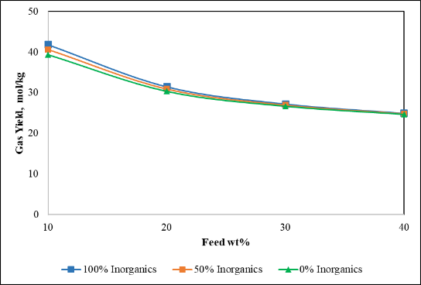
Figure 3. The effect of feedstock concentration on producer gas (a) composition and (b) yield at different inorganic contents (T = 600 ºC, P = 280 bar, inorganic contents = 100%, 50%, and 0% wt.)
  - Conclusions
The present work investigated the influence of important process parameters in the HTG of biogas digestate such as temperature, pressure, and feed concentration, while taking into account the effect of inorganic contents in the feedstock. The study found that temperature rise increases H₂ composition and decreases CH₄ composition, while CO₂ composition is only slightly affected. Temperature also positively influences the total gas yield. Pressure has less significant effect, however, a slight increase in total gas yield and CH₄ composition and a slight decrease in H₂ composition is observed at higher pressure. A higher feed concentration significantly increases the production of CH₄, while H₂ composition, and overall gas yield decrease. Furthermore, it was observed that higher inorganic contents lead to a lower CO₂ composition, while H₂ and CH₄ composition are increased. These results provide a novel insight on a thermodynamic model’s behavior when the feedstock inorganic content is considered.
Acknowledgement
This work was supported by the BioSynGas project partly funded by the Research Council of Norway (Project Number: 319723).
References
Castello, D. and L. Fiori (2011). "Supercritical water gasification of biomass: Thermodynamic constraints." Bioresource technology 102(16): 7574-7582.
Chrastil, J. (1982). "Solubility of solids and liquids in supercritical gases." The Journal of Physical Chemistry 86(15): 3016-3021.
Divya, D., L. Gopinath and P. M. Christy (2015). "A review on current aspects and diverse prospects for enhancing biogas production in sustainable means." Renewable and sustainable energy reviews 42: 690-699.
Freitas, A. and R. Guirardello (2013). "Thermodynamic analysis of supercritical water gasification of microalgae biomass for hydrogen and syngas production." Chemical Engineering Transactions 32: 553-558.
Freitas, A. C. and R. Guirardello (2014). "Comparison of several glycerol reforming methods for hydrogen and syngas production using Gibbs energy minimization." International journal of hydrogen energy 39(31): 17969-17984.
Guilayn, F., M. Rouez, M. Crest, D. Patureau and J. Jimenez (2020). "Valorization of digestates from urban or centralized biogas plants: a critical review." Reviews in Environmental Science and Bio/Technology 19(2): 419-462.
Guo, S., L. Guo, C. Cao, J. Yin, Y. Lu and X. Zhang (2012). "Hydrogen production from glycerol by supercritical water gasification in a continuous flow tubular reactor." International Journal of Hydrogen Energy 37(7): 5559-5568.
Hantoko, D., H. Su, M. Yan, E. Kanchanatip, H. Susanto, G. Wang, S. Zhang and Z. Xu (2018). "Thermodynamic study on the integrated supercritical water gasification with reforming process for hydrogen production: Effects of operating parameters." International Journal of Hydrogen Energy 43(37): 17620-17632.
Macrì, D., E. Catizzone, A. Molino and M. Migliori (2020). "Supercritical water gasification of biomass and agro-food residues: Energy assessment from modelling approach." Renewable Energy 150: 624-636.
Mutlu, Ö. Ç. and T. Zeng (2020). "Challenges and opportunities of modeling biomass gasification in Aspen Plus: A review." Chemical Engineering & Technology 43(9): 1674-1689.
Nkoa, R. (2014). "Agricultural benefits and environmental risks of soil fertilization with anaerobic digestates: a review." Agronomy for Sustainable Development 34(2): 473-492.
Okolie, J. A., E. I. Epelle, S. Nanda, D. Castello, A. K. Dalai and J. A. Kozinski (2021). "Modeling and process optimization of hydrothermal gasification for hydrogen production: A comprehensive review." The Journal of Supercritical Fluids 173: 105199.
Onwudili, J. A. and P. T. Williams (2014). Production of hydrogen from biomass via supercritical water gasification. Near-critical and supercritical water and their applications for biorefineries, Springer: 299-322.
Parmar, K. R. and A. B. Ross (2019). "Integration of hydrothermal carbonisation with anaerobic digestion; Opportunities for valorisation of digestate." Energies 12(9): 1586.
Scarlat, N., J.-F. Dallemand and F. Fahl (2018). "Biogas: Developments and perspectives in Europe." Renewable energy 129: 457-472.
Su, H., M. Yan and S. Wang (2022). "Recent advances in supercritical water gasification of biowaste catalyzed by transition metal-based catalysts for hydrogen production." Renewable and Sustainable Energy Reviews 154: 111831.
Sudibyo, H., M. Pecchi and J. W. Tester (2022). "Experimental-based mechanistic study and optimization of hydrothermal liquefaction of anaerobic digestates." Sustainable Energy & Fuels 6(9): 2314-2329.
Tang, H. and K. Kitagawa (2005). "Supercritical water gasification of biomass: thermodynamic analysis with direct Gibbs free energy minimization." Chemical Engineering Journal 106(3): 261-267.
Voll, F., C. Rossi, C. Silva, R. Guirardello, R. Souza, V. Cabral and L. Cardozo-Filho (2009). "Thermodynamic analysis of supercritical water gasification of methanol, ethanol, glycerol, glucose and cellulose." International Journal of Hydrogen Energy 34(24): 9737-9744.
Xu, D., S. Wang, X. Hu, C. Chen, Q. Zhang and Y. Gong (2009). "Catalytic gasification of glycine and glycerol in supercritical water." International journal of hydrogen energy 34(13): 5357-5364.
Xu, J., Z. Peng, S. Rong, H. Jin, L. Guo, X. Zhang and T. Zhou (2021). "Model-based thermodynamic analysis of supercritical water gasification of oil-containing wastewater." Fuel 306: 121767.
Yakaboylu, O., J. Harinck, K. Smit and W. de Jong (2014). "Supercritical water gasification of biomass: A thermodynamic model for the prediction of product compounds at equilibrium state." Energy & fuels 28(4): 2506-2522.
Yang, C., S. Wang, Y. Li, Y. Zhang and C. Cui (2021). "Thermodynamic analysis of hydrogen production via supercritical water gasification of coal, sewage sludge, microalga, and sawdust." International Journal of Hydrogen Energy 46(34): 18042-18050.
Yang, Z., Y. Liu, J. Zhang, K. Mao, M. Kurbonova, G. Liu, R. Zhang and W. Wang (2020). "Improvement of biofuel recovery from food waste by integration of anaerobic digestion, digestate pyrolysis and syngas biomethanation under mesophilic and thermophilic conditions." Journal of Cleaner Production 256: 120594.

