|  |  |
| --- | --- |
| cetlogo ***CHEMICAL ENGINEERING TRANSACTIONS***  ***VOL. , 2023*** | A publication of  aidiclogo_grande |
| The Italian Association  of Chemical Engineering  Online at www.cetjournal.it |
| Guest Editors: David Bogle, Flavio Manenti, Piero Salatino  Copyright © 2023, AIDIC Servizi S.r.l. **ISBN** 979-12-81206-04-5; **ISSN** 2283-9216 | |

Hydrogen purification and odorization to evaluate the distribution of this energy carrier through the gas pipelines.

Elisa Zanellaa,\*, Giulia Tonsia, Arian Graincaa, Franco Jamolettib, Mariangela Longhia, Carlo Pirolaa

a Università degli Studi di Milano, Dipartimento di Chimica – via Golgi, 19, 20133 Milano (MI), Italy

b Regas spa - Via Redipuglia, 70, 24047 Treviglio (BG), Italy

\* [elisa.zanella@unimi.it](mailto:elisa.zanella@unimi.it)

Due to hydrogen storage and transport problem, a concrete and immediate solution is the exploitation of the gas pipelines now used for natural gas. In this regard, this work aims to evaluate two main aspects that must be taken into account to make this approach possible: the separation of hydrogen from natural gas-hydrogen mixture and the odorization of the latter, in order to provide the safety of the pipelines. Therefore, the first part of this study is the evaluation of the efficiency of a purification system in presence of a variable quantity of methane in the inner stream. For these purposes, electrochemical hydrogen compression (EHC) system was selected, due to the great advantage of allowing both purification and compression in a single device. Different methane-hydrogen mixtures were taken into consideration, going to evaluate how an increasing amount of methane affects the efficiency of the system. The second part of this work is focused on a further development of a previous simulation study related to a possible process for natural gas-hydrogen mixtures odorization systems using AVEVA's PRO II software. As odorant, GASODOR S-FREE was taken into consideration, thanks to the fact that this is a common odorant used for methane with the great advantage of not containing sulfur, unlike THT and mercaptans.

* 1. Introduction

Nowadays energy plays a fundamental role in our society. Indeed, because of the rapid socio-economic development, a constant energy supply is essential to maintain our standard of living, currently satisfied by non-renewable sources. In a scenario dominated by depletion of fossil fuels, global warming (Rajeshwar et al. 2008), and rising energy demand (U.S. EIA, 2019), hydrogen appears very promising due to its green combustion and its extremely high gravimetric energy density (Pareek et al. 2020). However, hydrogen has a very low volumetric energy density and a high flammability, making it extremely difficult to store and transport, hindering its industrial application (Ahluwalia and Peng 2009). Exploiting the gas pipelines currently used for natural gas, beginning with natural gas/hydrogen mixtures with a ratio of 90/10 or 80/20, is a concrete and immediate solution to its storage and transport problems. In this work, two main aspects that must be considered to make this approach feasible were evaluated: the separation of hydrogen from natural gas-hydrogen mixture and the odorization of the latter, to provide the safety of the pipelines.

There are different methods for hydrogen purification, *e.g.* cryogenic (Liemberger et al. 2017), Pressure Swing Adsorption (PSA)(Dehdari et al. 2022), and membranes (Al-Mufachi et al., 2015), but, the most promising technology is based on the Electrochemical Hydrogen Compressor (EHC) because it combines purification with hydrogen compression due to the electrochemical principle on which it is based, namely, the oxidation of impure hydrogen at the anode and the evolution of pure, high-pressure hydrogen at the cathode. Rhandi et al. (2020) demonstrate that the EHC has many advantages: high gas recovery, low operating temperature -if the working temperature is comprised between room temperature and 200 °C, the material durability and sealing system are very convenient- compatibility of the process with continuous operation, low energetic cost of the process, thanks to the minimal work for the purification, and the high purity of the gas that can be reached with this process, higher than 99.9% (Durmus et al., 2021). In addition, this system is compatible with small units of purification, which render them well-suited for fuel cell vehicles refilling systems. The theoretical work to obtain pure hydrogen at the outlet requires a minimum electrical work given by the Nernst equation; however, kinetics limitations depending on charge-transfer limitations, on Ohmic resistances of the cell, and mass-transport limitations should be overcome (Rhandi et al. 2020). Depending on the current density one of these limitations dominates, at f low current density, charge-transfer limitations, specifically overactivation potential, predominate. In the intermediate region, the cell internal resistance, which is primarily attributable to membrane, becomes the dominant factor. In the region of high current density, depletion of reactants limits the overall cell reaction rate (Nordio et al. 2019). The core of this device is the membrane electrode assembly (MEA) and is based on an assembly including two gas diffusion electrodes (GDEs) and a proton exchange membrane. The most important component affecting the performance in EHC systems is the membrane, due to its electrical resistance and proton conductivity that are the main factors affecting its performance. Therefore, a membrane with high ionic conductivity is required to reduce ohmic losses. In addition, the membrane must have high mechanical, thermal and chemical stability to withstand working conditions. The catalyst layer is also essential for decreasing the activation energy of reactions occurring on the electrodes. Pt catalyst exhibits high catalytic activity in the EHC reaction and is a commonly used catalyst in literature (Trégaro et al., 2020; Durmus et al., 2021). In this work, low-temperature EHCs with Nafion membrane and Pt catalysts was investigated and tested in hydrogen separation from different methane-hydrogen mixtures, evaluated the influence of different concentration of methane on the efficiency of the EHC system.

Concerning hydrogen odorization system, previous work on the hydrogen odorization system in pure hydrogen and natural gas-hydrogen mixture systems was continued (Zanella et al. 2022). Contrary to our previous work, the mixture GASODOR S-FREE was taken into consideration as odorant, thanks to the fact that this is the most common odorant used for methane not containing sulfur, unlike THT and mercaptans. Indeed, sulfur is harmful to the environment, climate damaging and detrimental to health; therefore, it would be better to avoid its use. Switching to GASODOR S-FREE sulfur emission can be reduced by 80% (circa 323 t/a) in comparison to THT (GASODOR S-FREE web page). GASODOR S-FREE is composed by 37.4% ethyl acrylate, 60.1% methyl acrylate and 2.5% 2-ethyl-3methylpyrazine (MARCOGAZ AISBL 2021). In addition to being devoid of sulfur, this odorant reduces the risk of corrosion and is ideal for odorizing sulfur-free biogas and hydrogen. Starting from the specifications of INGRID, an automatic odorant injection system developed by Regas spa (Regas spa internal information), and the simulation model previously developed using AVEVA's PRO II process simulation software, it was possible to calculate the gas flow necessary to odorize the pure gas or the gas mixture at different temperatures. Pure methane, pure hydrogen, and methane-hydrogen mixture, namely 90/10 and 80/20 to simulate a possible real future application, were considered as possible gas to be odorized.

* 1. Experimental part and process simulation
     1. Hydrogen purification

The EHC used in this study contains a single cell with an active area of 10 cm2. The core of the cell is the membrane electrode assembly (MEA). It was chosen to work with a 5-layer commercial MEA, supplied by Fuel Cell Store, namely Build Your Own Fuel Cell MEA. Specifically, this MEA was composed by a Nafion 212 membrane, two gas diffusion electrodes (GDEs) made by Pt/C and two Carbon Cloth Gas Diffusion Layer (GDL) (Table 1).

Table 1: 5-layer Membrane Electrode Assembly (MAE) characteristics.

|  |  |
| --- | --- |
| MEA Characteristics | |
| Anode Catalyst | 0.2 mg/cm² PtC (20%) |
| Cathode Catalyst | 0.5 mg/cm² PtC (60%) |
| Membrane | Nafion 212 |
| Gas diffusion Layer | Carbon Cloth |
| Active Area | 10 cm2 |

The closed bipolar graphite plates have a serpentine flow field design with eight channels in parallel, with a depth of 0.75 mm and a length per flow field of 30 mm. The cell was inserted in a jacketed reactor to ensure a constant temperature for all the trials. A description of the bench scale plant is shown in Figure 1. The supplied inlet gases are methane and hydrogen. The flow is governed by two mass flow controllers from Brooks which have a maximum volume flow rate of 100 NmL/min for methane and of 20 NmL/min for hydrogen. For each of the three streams pressure, temperature and dew point are monitored by WIKA, TC Direct, and MICHELL indicators, respectively. The purge and the output flow are monitored with a bubble flowmeter. To maintain the membrane perfectly humidified the gases fed to the anode have to be fully saturated with water with a humidifier system consisting of a flask filled with milli-Q water through which the gases are bubbled. The power supply used is a Elind DC regulated power supply series HL which can range from 0 to 150 V and from 0 to 20 A in potentiostatic mode. At the end of the plant an Agilent 3000 MicroGC from Agilent Technologies equipped with PLOT Q and MoleSieve 5A as first and second column.

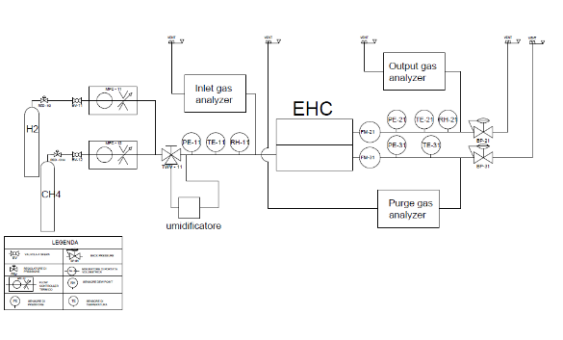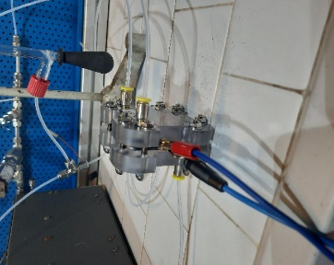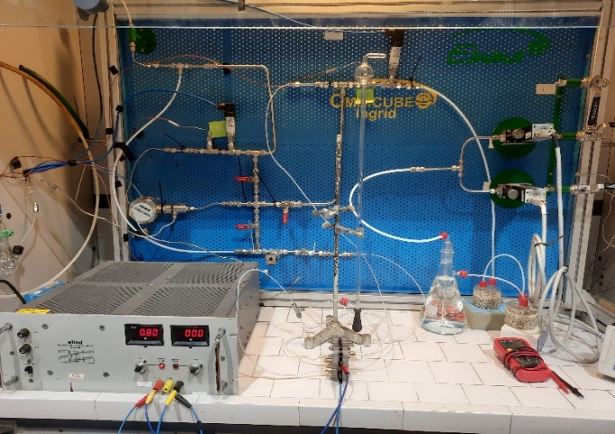

Figure 1: Pilot plant and electrochemical cell use for the tests.

Tests have been performed using the following procedure. At room temperature and atmospheric pressure, the gas mixture has been humidified and circulated in the cell maintaining a constant total flow of 22 mL/min. To determine the resistance and the associated overvoltage of the system, the potential has been monitored as a function of a set current value. Each test last about 12 hours and the current has been varied between 0 A and 1 A. The purity of the output gas has been checked using the microGC. The efficiency of the process has been calculated using the following equations:

|  |  |
| --- | --- |
| $η=η_{Voltage}∙η_{Faradic}$ | (1) |
| $η_{Voltage}=\frac{E_{Nernst}}{E_{cell}}$ | (2) |
| $η_{Faradic}=\frac{{\dot{n}}_{H_{2}}product}{{\dot{n}}_{H_{2}}theoretical}$ | (3) |

where $E_{Nernst}=E°+\frac{RT}{nF}ln⁡(\frac{p_{Cathode}^{H_{2}}}{p_{Anode}^{H_{2}}})$ and ${\dot{n}}_{H_{2}}theoretical \left(\frac{mol}{min}\right)=\frac{I\left(\frac{C}{s}\right) ∙60(\frac{s}{min})}{n_{e^{-}}∙ F\left(\frac{C}{mol}\right)}$ and it is a function of the current gives at the system.

* + 1. Odorization process

The first step of the odorization process is to check the vapor pressures of the main components of GASODOR S-FREE odorant, comparing the calculated values obtained by our simulation with the corresponding ones detected experimentally (Yaws 2015). GASODOR S-FREE is composed by 37.4% ethyl acrylate, 60.1% methyl acrylate and 2.5% 2-ethyl-3methylpyrazine. Because 2-ethyl-3methylpyrazine is not present in the PRO II database, simulations were conducted using a simplified version of the mixture. Since this component made up only 2.5% of the mixture by volume, it was decided to replace it with two equal parts of ethyl acrylate and methyl acrylate. The mixture that was ultimately simulated on PRO II contains 38.75% MA and 61.25% EA by volume.

After checking the consistency of the data calculated on the PRO II software, the industrial process of odorization by lapping has been simulated and studied, going to investigate the minimum flow of gas necessary to obtain the desired concentration of odorant in the final stream. The simulated plant is the same presented in our previous work (Zanella et al. 2022) (Figure 2), consisting of a main stream where the major flow of gas can be throttled generating a pressure gap, which allows a partial flow of gas to enter a tank, where the liquid odorant is held. Here, the gas is odorized, thanks to the vapour-liquid equilibria; then it returns to the main stream.

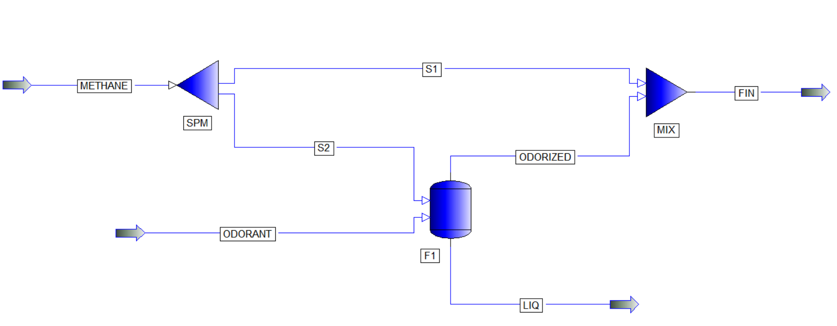

Figure 2: Simulated plant use in PRO II to study the odorization process.

The identified working methodology is the same for the various simulations. As a first step, the change in the concentration of odorants as a function of the gas flow in the secondary stream has been monitored. Specifically, the flow of the stream S2 has been changed starting from 0 NL/h with an increase of 1 NL/h for 50 cycles. Then, the vapor molar fractions (y) of methyl acrylate and ethyl acrylate have been monitored in the final stream FIN. In this way, it was possible to calculate the flow rate necessary to have a quantity of odorant that complies with the legal limits (4.6 mg/L for ethyl acrylate and 2.46 mg/L for methyl acrylate). The same operation was carried out keeping constant the pressure at 4 bar, the most common pressure for INGRID and varying the temperature from 273.15 to 313.15 K, simulating the ambient temperature. Indeed, INGRID does not work with a temperature control system. The initial stream rate is 10,000 NL/h. In this way, pure methane, pure hydrogen, and methane-hydrogen mixtures, namely 90/10 and 80/20, odorization processes were investigated.

* 1. Results and discussion
     1. Hydrogen purification

Primary purification tests have been performed using the MEA presented in Table 1. In these tests, different H2-CH4 molar ratios were examined while the total inlet flow was held constant at 22 mL/min.

To determine the system's resistance and associated overvoltage, the potential has been monitored as a function of a predefined current value. Figure 3 depicts the variation of the system's potential in relation to the set current and methane concentration in the inlet stream. From the polarization curve, the system's relative total resistance could be determined. The results indicate that the total electrochemical resistance of the system increases as the methane concentration rises. In regions of high current density, in the case of 30-70 and 20-80 H2-CH4 molar ratios, it is possible to observe the dominance of the overpotential due to mass-transport limitations; in fact, the cell reaction rate is constrained by hydrogen depletion.



Figure 3: Polarization curve performed with different H2-CH4 molar ratios with a constant total inlet flow rate of 22 mL/min.

Considering the same H2-CH4 inlet molar ratio, the voltage efficiency decreases as the set current increases, due to a higher value of the Ecell compared to the ENernst. On the contrary, the faradic efficiency of the system increases with the current, with values greater than 90% for currents greater than 0.9 A (Table 2). The microGC analysis revealed a methane concentration of less than 1% under all conditions.

Table 2: Some efficiency values calculated for different inlet H2-CH4 molar ratios and current density.

|  |  |  |  |  |
| --- | --- | --- | --- | --- |
| H2-CH4 Ratio | Current density (mA/cm2) | η Voltage (%) | η Faradic (%) | η Tot (%) |
| 70-30 | 30 | 15 | 88 | 13 |
| 60 | 8 | 90 | 7 |
| 90 | 5 | 92 | 5 |
| 50-50 | 30 | 25 | 84 | 21 |
| 60 | 14 | 86 | 12 |
| 90 | 10 | 91 | 9 |
| 30-70 | 30 | 35 | 88 | 31 |
| 60 | 20 | 90 | 18 |
| 90 | 12 | 92 | 11 |

* + 1. Odorization process

As regarding the study of the vapour pressures methyl acrylate and ethyl acrylate, the data obtained from two different equations were compared. The first equation is a Van’t Hoff, used by the PRO II software with database parameters reported in Table 3. The second one is an Antoine equation, with the parameters reported in Table 4.

|  |  |
| --- | --- |
| $log P=C_{1}+\frac{C_{2}}{T}+C_{3}\ln\left(T\right)+C_{4}T^{C_{5}}+C_{6}T^{3}+C_{7}T^{6}+\frac{C_{8}}{T^{2}}+\frac{C_{9}}{T^{4}}+C_{10}T^{2}$ | (4) |

Table 3: Van’t hoff coefficients for the two different compounds.

|  |  |  |  |  |  |  |  |
| --- | --- | --- | --- | --- | --- | --- | --- |
| Compound | C1 | C2 | C3 | C4 | C5 | C6-10 | References |
| Methyl acrylate | 107.69 | -7027.2 | -13.916 | 0.015185 | 1 | 0 | PRO II\_2021: SIMSCI database |
| Ethyl acrylate | 54.005 | -5963.9 | -4.4734 | 5.0315e-18 | 6 | 0 | PRO II\_2021: SIMSCI database |

|  |  |
| --- | --- |
|  | (5) |

Table 4: Antoine coefficients for the two different compounds.

|  |  |  |  |  |
| --- | --- | --- | --- | --- |
| Compound | A | B | C | References |
| Methyl acrylate | 7.27967 | 1384.262 | 234 | (Yaws 2015) |
| Ethyl acrylate | 7.24659 | 1425.36 | 227 | (Yaws 2015) |

As shown in Figure 4, a good overlap has been obtained between the simulated by PRO II and the data calculated with Eq(5).



Figure 4: Comparison between the simulated (Eq(4)) and the calculated data (Eq(5)) related to vapour pressure of methyl acrylate (a) and ethyl acrylate (b).

After checking the consistency of the data calculated on the PRO II software, the liquid-vapor equilibria were evaluated and, finally, the industrial process of odorization has been simulated, starting from the procedure described in the previous section. Considering the previous study made on odorization process simulation, for all these simulations, Soave-Redlich-Kwong model (SRK) has been employed.



Figure 5: a) Comparison between the gas flow vs temperature profiles of odorization process of the different gas mixtures with GASODOR S-FREE odorant. b) Comparison between the vapour pressure of GASODOR S-FREE odorant (green) and tetrahydrothiophene (THT) odorant (red).

In Figure 5 the final results of this simulation are presented. From this graph it was possible to infer the minimum flow of gas necessary to obtain the desired concentration of GASODOR S-FREE odorant (4.6 mg/L for ethyl acrylate and 2.46 mg/L for methyl acrylate, complying legal limits, as reported in Par. 2) in the final stream. The mixtures of gas taken into consideration are the following: pure methane, pure hydrogen, and the binary mixture of methane-hydrogen in ratio 90/10 and 80/20. As shown in Figure 5a, as the temperature increases, a lower gas flow is required because a greater amount of odorants are present in vapour phase (see Figure 4). With the GASODOR S-FREE mixture, gas flows are less than 14 NL/min, as opposed to 65-95 NL/h with the tetrahydrothiophene (THT) odorant (Zanella et al. 2022). This behavior is explained by the significantly higher vapor pressure of the latter odorant compared to tetrahydrothiophene (THT) (Figure 5b), as well as the smaller quantity of odorant mandated by law. This variation in vapor pressure value reduces the amount of gas required to enter the odorizing tank.

* 1. Conclusions

Two main aspects related to hydrogen transport and distribution through natural gas pipeline have been taken into consideration. Considering the separation of hydrogen from natural gas-hydrogen mixture, it is possible to state that electrochemical hydrogen compressor (EHC) can be considered a good system for hydrogen separation from methane, especially in the case of small units of purification. Further studies will focus on the scale up of the system to analyze the efficiency with higher inlet flow. This will also allow to increase the value of the current. The simulation of the lapping odorization system revealed a difference in the secondary flow depending on the inlet gas considered to achieve the desired concentration of odorant in the final gas stream. Comparing the results obtained with GASODOR S-FREE as odorant with the ones obtained in a previous work using tetrahydrothiophene (THT), it was possible to state that with the former lower flows are needed to odorize the inlet gas mixture. This behavior is explained by the significantly higher vapor pressure of the sulfur-free odorant compared to THT.

References

Ahluwalia R. K., Peng J. K., 2009, Automotive hydrogen storage system using cryo-adsorption on activated carbon, International Journal of Hydrogen Energy, 34(13), pp. 5476–5487.

Al-Mufachi N. A., Rees N. V, Steinberger-Wilkens R., 2015, Hydrogen selective membranes: A review of palladium-based dense metal membranes, Renewable and Sustainable Energy Reviews, 47, pp. 540–551.

Dehdari L., Burgers I., Xiao P., et al., 2022, Purification of hydrogen from natural gas/hydrogen pipeline mixtures, Separation and Purification Technology, 282, p. 120094.

Durmus G. N. B., Colpan C. O., Devrim, Y., 2021, A review on the development of the electrochemical hydrogen compressors, Journal of Power Sources, 494, p. 229743.

GASODOR S-FREE web page. Available at: <https://www.gasodor-s-free.com/> accessed 10.03.2023.

Liemberger, W. et al., 2017, Experimental analysis of membrane and pressure swing adsorption (PSA) for the hydrogen separation from natural gas, Journal of Cleaner Production, 167, pp. 896–907.

MARCOGAZ AISBL, 2021, Odorisation of Natural Gas and Hydrogen Mixtures. Available at: <https://www.marcogaz.org/odorisation-of-natural-gas-and-hydrogen-mixtures> accessed 10.03.2023.

Nordio M., Manzolini G., Mulder M., Raymakers L., Van Sint Annaland M., Gallucci F., 2019, Experimental and modelling study of an electrochemical hydrogen compressor, Chem. Eng. Journal, 369, pp. 432–442.

Pareek, A. et al., 2020, Insights into renewable hydrogen energy: Recent advances and prospects, Materials Science for Energy Technologies, 3, pp. 319–327.

Rajeshwar, K. et al., 2008, Renewable energy and the hydrogen economy, in Solar hydrogen generation. Springer, pp. 1–18.

Rhandi M., Trégaro M., Druart F., Deseure J., Chatenet M., 2020, Electrochemical hydrogen compression and purification versus competing technologies: Part I. Pros and cons, Chinese Journal of Catalysis, 41(5), pp. 756–769.

Trégaro M., Rhandi M., Druart F., Deseure J., Chatenet M., 2020, Electrochemical hydrogen compression and purification versus competing technologies: Part II. Challenges in electrocatalysis, Chinese Journal of Catalysis, 41(5), pp. 770–782.

U.S. Energy Information Administration (2019) U.S. Energy Information Administration’s (EIA), International Energy Outlook 2019. Available at: <https://www.eia.gov/todayinenergy>.

Yaws C., 2015, The Yaws handbook of vapor pressure: Antoine coefficients. Gulf Professional Publishing.

Zanella E., Longhi M., Marcolin P., Camarda G., Pirola C., 2022, Investigation of a Possible Process for Hydrogen Odorization in Pure Hydrogen and in Natural Gas-Hydrogen Mixture Systems’, Chemical Engineering Transactions, 96, pp. 139-144 SE-Research Articles.