|  |  |
| --- | --- |
| cetlogo ***CHEMICAL ENGINEERING TRANSACTIONS***  ***VOL. , 2023*** | A publication of  aidiclogo_grande |
| The Italian Association  of Chemical Engineering  Online at www.cetjournal.it |
| Guest Editors: David Bogle, Flavio Manenti, Piero Salatino  Copyright © 2023, AIDIC Servizi S.r.l. **ISBN** 979-12-81206-04-5; **ISSN** 2283-9216 | |

Emission levels and emission factors for modern wood stoves

Øyvind Skreiberg\*, Morten Seljeskog, Franziska Kausch, Roger Khalil

Thermal Energy Department, SINTEF Energy Research, Trondheim, Norway

oyvind.skreiberg@sintef.no

The aim of this work is to recommend more correct emission factors for the modern wood stove category, based on extensive measurements carried out at SINTEF Energy Research in Norway for representative modern wood stoves. Today the best wood stoves outperform the staged air combustion wood stoves introduced in the 1990s, as further continuous improvements have been carried out and new and improved designs have been introduced. Hence, in national emission inventories this should be considered, so the mean emission factors used for the overall modern wood stove category reflect the continuous improvements over the last decades. The measurements carried out in this work made it possible to provide such emission factors for the modern wood stove category, for a wide range of emission compounds. The results show that most emissions of unburnt have been much reduced the last decades. However, for black carbon and for emissions due to minor and trace elements in the wood, this is not the case. Further targeted development and/or new combustion concepts are needed to significantly reduce both black carbon and NOx emissions.

* 1. Introduction

Emissions from wood stoves remain a significant concern, even though modern wood stoves are continuously improved regarding emissions due to incomplete combustion, e.g. particulates of organic origin (Skreiberg and Seljeskog, 2018). Today, modern wood stoves apply staged air combustion. This air-staging is the main reason that new wood stoves have much lower levels of e.g. particulate emissions than older ones. However, there is still a large variation in the actual emission factors used for different emission compounds and for different wood stove categories when reported in official national emission inventories. These national emission inventories are taken further at the international level, e.g. EU, for further elaborations and estimations of e.g. health impacts due to emissions from wood stoves versus other emission sources. This is based on measurement of atmospheric emission concentrations and a relative source contribution to these based on the source dependent emission factors for the individual emission compounds.

Emission factors are used when assessing the sustainability of technologies and processes where emissions are created in different steps through value chains. Even though there are many factors influencing the emission factors, there is a tendency to lump technologies and processes together for simplicity reasons, making what is believed to be on average representative emission factors for a broader range of technologies or technology matureness levels. This makes it hard to distinguish and highlight improvements that occur due to continuous development and improvement of technologies, even if a specific emission level may have been reduced with e.g. 80% since the introduction of the technology.

For wood stove technology, the emission factors in the Norwegian national emission inventory are a weighted average for open fireplaces, old wood stoves (pre 1998) and new wood stoves (from 1998) and are calculated based on their individual emission factors and the wood amount used in the respective technology. The importance of the year 1998 is that from that year, all wood stoves sold in Norway had to be approved by the Norwegian standard NS 3058/3059:1994 (NS94) and satisfy a real life use representative load weighted particle emission level of 10 g/kg. Since 1998, continuous development has led to particle emission levels below 2 g/kg. Clearly, an "average" emission level for new stoves of e.g. 6 g/kg does not highlight the technological development level of the new stoves of today, and if keeping this emission factor for several years it becomes increasingly wrong. Hence, it would make sense to create time-dependent emission factors, i.e. splitting the emission factors for the new wood stoves category into year dependent emission factors.

As for all technologies, the replacement of old and often inefficient and polluting energy technologies is needed to advance society and reduce climate, environmental and health impacts. Wood stoves are still mainly manually operated appliances made of materials with long lifetime, making people more reluctant to exchange them unless real incentives are seen. Anyone can get the fire going in a wood stove, and it is often not easy for the user to relate this fire to high or low emission levels. Incentives can be connected to personal economy (more energy-efficient stoves, or financial support to exchange old stoves), climate, environment and/or health awareness (stove technology with reduced emissions, and improved energy efficiency), user-friendliness or aesthetic aspects.

In this work, emission factors for today's new wood stoves have been derived based on experiments carried out at SINTEF Energy Research with selected representative stoves. The goal is to provide the authorities and the Norwegian national emission inventory with emission factors to be used in a revised approach where technology development is also accounted for. This will give a more realistic estimate of emissions from new wood stoves in Norway and will be an incentive for authorities and users to accelerate the exchange of old stove technology with new and much more performant technology. This will have direct positive climate, environmental and health implications, benefiting society.

A critical review and discussion on emissions factors have recently been carried out (Skreiberg et al., 2022). The review clearly showed that more work is needed to establish reliable enough emission factors for several emission compounds, and that for some emission compounds large differences in emission factors between Norway and e.g. the other Nordic countries exist. Often, there are no logical reasons for such major differences, other than that the emission factors are based on very different sets of data and/or assumptions.

# Methods

Historical and current emission factors for wood stoves have been reviewed (Skreiberg et al., 2022) and this combined with experimental campaigns where representative new stoves have been tested and equipped with extensive emission measurement equipment, gives a solid foundation for recommending new emission factors that are more representative than the current ones for this wood stove category.

* + 1. Measurement campaigns

Measurements campaigns were carried out for three representative new stoves (cast iron, plate steel, lightweight soapstone), according to the Norwegian standard NS94 (using spruce stemwood), but with selected additional emission measurements as well as chimney inlet temperature measurement according to also NS-EN16510-1:2022 (EN22), see Figure 1. This allows a detailed assessment of both environmental and energetic performance of the three stoves, and comparison with EN22 also regarding energetic performance. The energetic performance was assessed in an earlier work (Skreiberg et al., 2023).

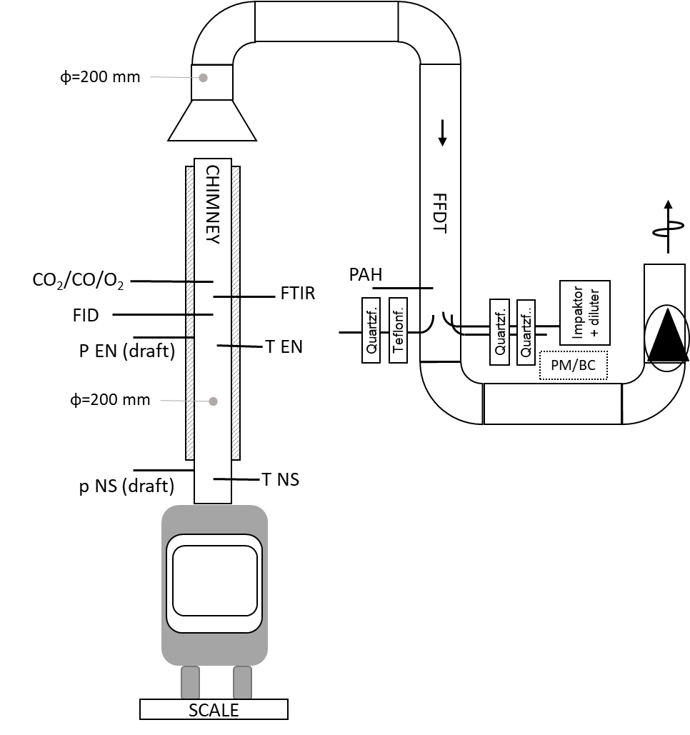

*Figure 1: Experimental setup 1 (left) and 2 (right, with change of filter type for Particle Matter (PM)/Black Carbon (BC, as EC)/Organic Carbon (OC) measurements and impactor measurements without flue gas dilution)*

The experimental setup is in the base case designed to carry out experiments and measurements according to NS94. However, the setup was supplemented with additional equipment/analysers for measurement of a wider range of emission compounds. The species measured were: O2 (paramagnetic); H2O (FTIR); TSP (dilution tunnel method); PM10, PM2.5 and PM1 (gravimetric impactor); EC and OC (dilution tunnel method, separate filter), Organic Gaseous Compounds (OGC), measured with a Flame ionization detector (FID), Polycyclic Aromatic Hydrocarbons (PAH) using a “Molab” sampling system); Non-methane volatile organic compounds (NMVOC) and CH4 measured with a Fourier Transform Infrared Spectroscope (FTIR); CO and CO2 (ABB EL3020 and FTIR); NOx, N2O, NH3, HCN, HNCO, SOx, HCl, HF (FTIR). Additionally, the total Volatile Organic Compounds (VOC) according to the FTIR was compared to the FID OGC. The NMVOCs measured by the FTIR were: HCHO, C2H2, C2H4, CH3CHO, C2H6, C3H6, C3H8, C3H4O, C3H6O, HC2CH2CH3, C4H8 (1 and iso), n-C4H10, i-C4H1O, C5H10, n-C5H12, C6H6, n-C6H14, C7H8, C7H14, C7H6O and C7+, and individually C8H10 (ethyl benzene + O-xylene) and C10H8. The EC/OC measurement procedure is described in Seljeskog et al. (2013).

* + 1. Evaluation methods

The FTIR is calibrated to measure within a specific range for each emission compound. Levels exceeding the maximum level in the range are predicted but will have a significant uncertainty connected to them. So, a flue gas dilution system was used to avoid exceeding the calibration ranges, but an uncertainty is also connected to the dilution ratio. When analysing the FTIR results the derived dilution ratio was in general overpredicted, giving too high emission levels when correcting the measured FTIR level to arrive at the real emission level in the undiluted flue gas. Therefore, an alternative approach was used to find a more correct dilution ratio, where the CO2 level measured by a conventional (IR) analyser was used as reference, and the dilution ratio was adjusted so the CO2 level predicted by the FTIR matched the CO2 level measured by the conventional analyser. The revised approach resulted in significantly improved consistency between the FTIR measurements and those predicted by conventional analysers and the FID.

For some emission compounds, in some phases of the combustion cycle and at poor combustion conditions yielding emission levels still exceeding the calibration ranges, the emission level predicted by the FTIR was set to the maximum level in the calibration range. In such cases also correlation factors were checked, to reveal obvious interference between some emission compounds. FTIR analysers measure many emission compounds, where some have overlapping absorbance spectra. Hence, the FTIR calibration also includes interference correction. Obvious interference was sometimes found and then predicted interfered values were manually adjusted. In one experiment, at low load, for SO2 and N2O, reliable average values could not be derived due to too extensive interference throughout a major part of the experiment.

Fuelsim-Transient (Skreiberg, 2002) was used to evaluate the individual experiments. This software allows to account for the transient behaviour during an experiment and calculation of weighted average values. Based on a statistical load firing frequency, a weighted average emission factor was calculated for each species for each stove. Finally, a mean emission factor was calculated for each species for all three stoves. Also, the individual experiments were divided into low load and nominal load, and resulting mean values were used to compare emission levels at nominal and low load.

* 1. Results and discussions

Wood log combustion in wood stoves is an inherently transient combustion process. This transient behaviour has been highlighted in earlier works, e.g. Skreiberg and Seljeskog (2018) and Skreiberg et al. (2023). Based on the transient results weighted average values can be derived for each experiment. In EN22 only arithmetic average values are used, i.e. not accounting for the typical transient behaviour of wood stoves. A more correct approach is to account for the transient behaviour through deriving weighted average values, i.e. determining the average value as the mean of an integrated transient value. The fuel consumption rate changes continuously throughout one experiment in addition to the flue gas flow and the excess air ratio, and hence the contribution of an instantaneous emission level to the total emission level must consider the transient behaviour to account for such differences. This can be done in the inhouse calculation tool, Fuelsim-Transient (Skreiberg, 2002). In Table 1 weighted average values are given for the ten experiments carried out with the three different modern stoves, where FTIR measurements were also carried out in addition to FID measurements and particle emission measurements, where also the fraction of elemental/black carbon was determined as well as the particle size distribution. This allows for a comprehensive comparison and assessment of the emission levels from the three modern wood stoves at different operating conditions.

Table 1 Weighted average values for assessing combustion process and energetic performance

Table 2 shows the weighted average emission levels for the same experiments, and two additional experiments with a reduced set of measurements. Particle emissions increase with decreasing load, and PM2.5 is the dominating part of the particle emission level. EC and OC accounts for on average 70% of the particle emissions. The rest of the particle composition is H, O, trace elements and fly ash. As for correlations between the different emission levels, typically OC correlates well with TSP, PM10 and PM2.5, but not with EC. As for OC, a low load increases the EC emissions somewhat, but the trend is less clear than for OC. EC is mainly soot emissions, depends very much on local combustion conditions and are less load dependent, and EC emissions are harder to reduce compared to OC emissions. However, when looking at the EC emissions as a function of load, the highest EC emission is found at the highest load, indicating insufficient residence time for burnout of the soot particles and/or local flame extinction due to large flames hitting cold surfaces. The EC emission correlates significantly better with the O2 concentration, and a relatively clear trend of decreasing EC emission with increasing O2 concentration can be found, maybe due to a reduction in sub-stoichiometric combustion conditions, allowing for a higher O2 concentration and longer residence time in oxidative conditions.

The attempt to measure PAH emissions resulted in much higher emission levels for Stove 2 compared to Stove 1. As no reasonable explanation for the large difference was found, PAH emissions were not measured for Stove 3. However, also the PAH emissions for Stove 1 were much higher than the current emission factors used in the Norwegian national emission inventory. More work is needed to assess this further. As for gaseous emissions, there is a relatively clear correlation between CO and CxHy emissions, even though such a correlation does not exist throughout a batch combustion cycle due to increasing CO and decreasing CxHy in the char combustion phase. Except for these mentioned correlations, no clear correlations can be found between the other emission compounds for average values, except for some hydrocarbons included in OGC/VOC. However, when looking at the emissions in the different phases of the batch combustion cycle, clearer correlations can be found. Separating the char combustion period from the rest of the combustion cycle will yield clearer correlations for the part of the combustion cycle where the combustion conditions are relatively stable.

Table 2 Weighted average emission levels, in g/kg dry fuel



Explanation: IF: too high interference in the FTIR to be determined; nm: not measured. Red numbers for TSP for Stove 1 are considered to have higher uncertainty due to a different filter type used. Red numbers for PM10 and PM2.5 for Stove 3 are considered to have higher uncertainty due to a detected leakage. These numbers have been discarded when calculating the recommended new emission factors for modern wood stoves.

* 1. Recommended emission factors for modern wood stoves
     1. Recommended emission factors

In Table 3 the current and the recommended new emission factors for modern wood stoves are presented. PM2.5 accounts on average for 98.4% of PM10, while PM1 accounts for 96.3% of PM10. For PM10, PM2.5, CO, NMVOC, CH4 and OC the modern wood stoves shows much reduced emission factors compared to the current ones in use as an average for modern wood stoves. If dividing the experiments into nominal load and part load operation, the emission factors are about three times higher at part load compared to nominal load, highlighting the importance of also operating the modern wood stoves as often as possible at nominal load. PM2.5 emissions are reduced slightly less than PM10, which could be expected as the smaller the particles, the harder to reduce their emissions. For EC emissions, the emission factor is higher for the modern wood stoves compared to the current one in use, highlighting that it is much harder to decrease this emission, and the EC emission at nominal load is only slightly lower than at part load. For NOx emissions, the emission factor is on par with the current one for spruce, i.e. modern wood stove design is not helping to reduce NOx emissions. Typically, NOx emissions can be reduced in a reduction zone in a well-controlled staged air combustion process. The current staged air combustion principle in modern wood stoves does not facilitate for such a reduction zone, with a sufficiently long enough residence time and a more ideal stoichiometry. Nitrous oxide emissions are significantly lower in the modern wood stoves compared to the current emission factor, while NH3 is on par with the current emission factor. NH3 emissions are higher at part load than at nominal load, which could be expected, as NH3 is an intermediate N-species released from the wood during its devolatilisation, and its survival result from incomplete combustion. N2O emissions are temperature dependent and are increasing somewhat at part load operation, i.e. at lower temperatures. HCN emissions are low, and slightly higher at nominal load. Typically, increased temperatures favour HCN release from the wood, which could explain higher HCN emissions with increasing load. HCN is also a precursor for N2O emissions, but N2O emissions are higher at part load, probably temperature controlled. Emissions of HNCO were not found in any of the experiments, and this is as expected since this is a N-intermediate formed in much lower levels than NH3 and HCN, and which is readily converted. Emissions of SO2 are also lower, indicating that the S content in the spruce wood is lower than earlier believed, as this emission factor was based on analysis of the S-content in the wood, with significant connected analysis uncertainty at low S levels, and not measured SO2 emissions. The SO2 emissions at part load are somewhat lower than at nominal load, which could be expected as other S-species might be emitted at part load, and more inorganic bound S might stay in the ashes. HCl emissions are extremely low, indicating that the Cl content in the wood is low, but also that some of the Cl can be found in the smallest particles, which typically is the case for also some of the S. As some emissions are rather low, also compared to their calibrated measurement range in the FTIR, a significant uncertainty is also connected to some of the values. In addition, interference correction between different species in the FTIR is more challenging when the emission levels are higher, i.e. at part load operation. Regarding speciation of the NMVOCs, n-C5H12, C6H6 and C7H14 are the top three measured by the FTIR when ranged after carbon mass, accounting for above 40% on average. Measured C7+ was then excluded, as the composition of the C7+ is unknown, and the analyses show that the correspondence between the FID (OGC) and the FTIR (VOC) becomes much better when leaving out the C7+. A FID has a lower response factor for compounds containing especially O, and therefore cannot account for all the carbon in the VOCs.

Table 3 Current and recommended new emission factors for modern wood stoves, in g/kg dry fuel



Explanation: "Old" new stove is the current emission factor representing all new stoves in the Norwegian national emission inventory. In the case of NOx, N2O, NH3 and SO2 this is for spruce. Part load and nominal load emission factors are arithmetic averages.

* + 1. Recommended method of implementing the emission factors

The three tested stoves, considered representative for the performance of modern wood stoves on the market today, can be a reference in the derivation of a trend curve for the emission factors from the entire fleet of modern wood stoves (from 1998). Many emissions of unburnt can be lumped together, showing similar emission reductions, while others do not show a similar trend and need to be handled individually. Figure 2 illustrates such a trend curve for PM10 and CO.

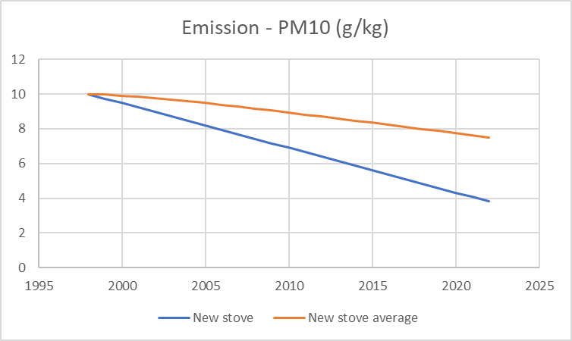   
Figure 2: New stove emission factor in g/kg dry fuel compared to an average emission factor for the whole fleet of new wood stoves (from 1998), illustrated for PM10 and CO

* 1. Conclusions

The new wood stoves of today are performing much better than an average new stove representing all wood stoves produced from 1998. This can clearly be seen for several emission compounds measured in this work, i.e. the emission compounds due to poor combustion conditions. However, for some of the emission compounds the picture looks different, as these emissions are more dependent on the content of minor and trace elements in the wood. In addition, the part of the particle emission level that is soot/black carbon is more difficult to reduce since this emission level also can be significant due to technology design or operational limitations, even if the combustion conditions are much improved. To reduce black carbon the design of modern wood stoves needs to be optimised, e.g. by using advanced modelling tools such as Computational Fluid Dynamics to arrive at improved designs allowing for proper soot burnout throughout the combustion cycle and at varying loads. Automating the air supply and division combined with otherwise proper stove operation will ultimately be needed to further decrease all emissions of unburnt. For NOx emission reduction, more radical design changes are needed, towards a physically separated two-stage combustion process. Based on the findings in this work, several emission compounds in the Norwegian national emission inventory could be updated, both regarding emission factors, and with respect to handling of their time dependence, i.e. accounting for the continuous development leading to improvement of technologies and reduced emission levels.

Acknowledgments

The authors acknowledge the financial support by the knowledge building project SusWoodStoves, financed by the Research Council of Norway and industry partners.

References

NS EN13240:2001, Roomheaters fired by solid fuel, Requirements and test methods.

NS-EN16510-1:2022, CSN EN 16510-1 - Residential solid fuel burning appliances - Part 1: General requirements and test methods.

NS 3058:1994, Enclosed wood heaters, Smoke emission; NS 3059:1994, Smoke emission - Requirements.

Seljeskog M., Goile F., Sevault A., Lamberg H., 2013, Particle emission factors for wood stove firing in Norway, BlackOut project report, SINTEF TR A7306.

Skreiberg Ø., 2002, Fuelsim-Transient: A Mass, Volume and Energy Balance Spreadsheet for Batch

Combustion Applications, Trondheim: NTNU.

Skreiberg Ø., Seljeskog M., 2018, Performance history and further improvement potential for wood stoves, Chemical Engineering Transactions, 65, 199–204.

Skreiberg Ø., Seljeskog M., Kausch F., 2022, A critical review and discussion on emission factors for wood stoves, Chemical Engineering Transactions, 92, 235–240.

Skreiberg Ø., Seljeskog M., Kausch F., 2023, Energy efficiency increase by improved operation and control in wood stoves, Chemical Engineering Transactions, 99, 55–60.