CHEMICAL ENGINEERING TRANSACTIONS  VOL. , 2023 | A publication of
The Italian Association
of Chemical Engineering
Online at www.cetjournal.it

Guest Editors: David Bogle, Flavio Manenti, Piero Salatino
Copyright © 2023, AIDIC Servizi S.r.l.
ISBN 979-12-81206-04-5; ISSN 2283-9216

A Perspective on the Role of Digitalization Enablers in Sustainable Pharmaceutical Manufacturing
Fatima Imran*, Rüdiger Lück, Christian Jordan, Christoph Herwig, Michael Harasek
Institute of Chemical, Environmental and Bioscience Engineering, TU Wien, Vienna, Austria
fatima.imran@tuwien.ac.at
Due to the steady rise in the implementation of Industry 4.0 concepts in chemical and (bio)pharmaceutical industries, an essential aspect of transitioning pharmaceutical production towards Sustainable Pharmaceutical Manufacturing (SPM) is the utilization of digitalization technologies. SPM involves the collaboration of a multitude of different process engineering and sustainability-oriented systems methodologies like Lifecycle Assessment and green metrics. Keeping this in mind, this paper aims to provide a concise review of critical areas of digitalization aspects to overcoming the hurdles towards sustainability of pharmaceutical processes: process analytical technologies (PATs), soft sensors and Digital Twins (DTs). These tools enable manufacturing under the Quality-by-Design (QbD) paradigm, prioritizing process and product understanding and yield to reduce the number of tests, resources, and costs in the long run. Modernization through DTs and PAT requires significant data exchange and a fully realized data management system. Successful integration of digitalization, I4.0, and lean manufacturing concepts have been found to be of substantial advantage for flexible supply chains and continuous manufacturing, higher efficiencies, and productivity with minimal waste production. The path to utilizing these tools to their full potential in the pharmaceutical industry is closely examined for application in specific processes and products in the future.
  - Introduction
Industry 4.0 (I4.0), and its concepts applied to the pharmaceutical sector, Pharma 4.0, is considered the next stage of the continuing industrial revolution that started with mechanical production in the 19th century. It was coined in 2011 by a German initiative with the express aim of improving the capabilities and competitiveness of production and manufacturing in Germany (BMBF, 2016). Industry 3.0 (I3.0) is driven by the deployment of rapid communication technologies, wireless data exchange, networked computing, and new sensing technologies. While generating large amounts of data and using model-based methods in production to assure product quality, the following steps towards I4.0 go beyond the pure availability of complex data sets in real-time environments. I4.0 is the imagination of smart factories with Digital Twin (DT)-based operational decisions along the horizontal and vertical production chain. I4.0 encompasses concepts such as the Internet of Things (IoT), Cyber-Physical Systems (CPS) (Arden et al., 2021), and cloud computing to improve the economic and environmental sustainability of production processes (Steinwandter et al., 2019). Technology introduced and applied based on such concepts requires the integration of machinery essential for manufacturing into a processing unit. This leads to several favourable qualities such as high adaptability and accessibility, high accuracy and efficiency of the controlled machines and operations (Kamble et al., 2018), higher and more consistent product qualities, and a more efficient method towards scale-up and a larger scale of operations (Destro and Barolo, 2022). Implementing I3.0 concepts such as continuous manufacturing, Quality-by-Design (QbD) strategies, Process Analytical Technologies (PAT) tools, and DTs (Arden et al., 2021), together with data storage technology, will enable the pharmaceutical industry to evolve towards the widespread implementation of I4.0.
It is also, however, necessary to provide context to the application of such concepts and technologies. This paper aims to examine these concepts regarding the sustainability of pharmaceutical production. Over the years, there has been a significant trend toward the investigation of how sustainable a production process is. This trend is the catalyst for a ‘greener’ mindset and a lifecycle analysis approach toward producing active pharmacological ingredients. This review examined the combination of I3.0 and I4.0 concepts in the broader context of sustainability. Additionally, the challenges and hurdles of adopting the concepts listed above by the industries in the pharmaceutical sector are discussed.
  - Review Methods
A keyword search of the following was carried out on the Scopus and Elsevier databases: Sustainable Pharmaceutical Manufacturing (SPM), process intensification, green metrics, continuous biomanufacturing (CBM), digitalization & I4.0, batch-to-continuous process operation, DT lifecycle, model-assisted design of experiments (DoE), advanced process control, process monitoring & control. This research illustrated the most important themes that are outlined below.
  - Green Metrics for Sustainability Evaluation
To quantify the ‘greenness’ or the sustainability of SPM processes (or processes in general), various metrics/assessments are necessary. These metrics must be simple to use and apply, clearly defined, and integral to the decision-making of the project and manufacturing process. Many different metrics have been developed to be able to measure the ‘greenness’ of a process. Different metrics consider other aspects of a process, whether it be the amount of water, solvents, or reagents used or energy consumption, or greenhouse gas emissions. The sustainability of an SPM process is evaluated by analyzing its environmental footprint. To compare different processes, green metrics have been introduced to assess sustainability in numerical terms (Jimenez-Gonzalez and Lund, 2022).
Standard green metrics include the Water Related Impact of Energy (WARIEN) (Cataldo et al., 2020), Environmental factor (E-Factor) (Jimenez-Gonzalez and Lund, 2022) and Process Mass Intensity (PMI) (Jimenez-Gonzalez and Lund, 2022). The E-factor is defined as the mass ratio of waste in relation to a unit mass of product. Another green metric is PMI, which describes the ratio between the total mass of all materials processed and the mass of the product. An extension is the WARIEN metric, which relates CO₂ emissions to the unit mass of the product. In addition to the actual process emissions, WARIEN also takes into account emissions during the production of raw materials (e.g. purified water). The concepts of I4.0 are posed to minimize waste and prioritize resource efficiency and thus lead to a more sustainable production process and chain. Therefore, it is evident that an interdisciplinary connection exists between a lifecycle approach and the I4.0 concepts outlined in this paper. Taking this into account, several tools are examined within the scope of this work that helps pave the way toward sustainability in the pharmaceutical industry.
  - The Digitalization Enablers
    - Process Analytical Technologies (PATs)
Based on the review performed while writing and collecting data for this work, the application of PATs was found to be highly important towards integrating more sustainability into the manufacture of pharmaceutical products. Regardless of whether a batch or a continuous mode of operations is applied, a sophisticated method of providing real-time control and monitoring of Critical quality attributes (CQAs) of a product and raw material (Critical Raw Material Attribute, CMA) and Critical process parameters (CPPs) that directly correspond with a CQA of the desired product (Gerzon et al., 2022) are necessary for the digitalization of the process and for monitoring product control and output. The properties of a product in the pharmaceutical industry are set under strict regulations. Therefore, the application of PAT tools can be an excellent method towards including considerations about the CQAs of a product during the design of the product itself. Implementing such technologies (Figure 1) requires not only a deeper understanding of the process and the CPPs that influence the product’s CQAs but also expedites further process understanding and the necessary CMAs (Sacher et al., 2022). PAT tools and solutions are not novel technologies, and the integration of on-line and in-line PAT tools into bioprocesses has steadily increased over the last couple of decades in many different ways despite the fact that such technologies are invasive and need to be taken into account in the process space and design (Gerzon et al., 2022), as seen in Figure 1. Product integrity must also be considered with in-line measurement techniques since the quality requirements in the pharmaceutical industry are very high. Only within the last few years has the technology really been used for real-time monitoring and control within the (bio)pharmaceutical industry.
Due to the emphasis on I4.0 concepts in this work, it was interesting to note the integration of PAT-based monitoring and control with a cyber-physical network that is able to provide real-time optimization and predictions of the process. This is a relatively new concept, as few papers dealt with the review and concept of such a collaboration (Arden et al., 2021). Long-term data storage from PAT tools (possible through cloud services and a working network of the equipment and machines) facilitates the set-up of DTs and adaptive control and prediction, among other things. If applied and used correctly, such a combination can lead to a valid smart pharmaceutical process (Barenji et al., 2019).

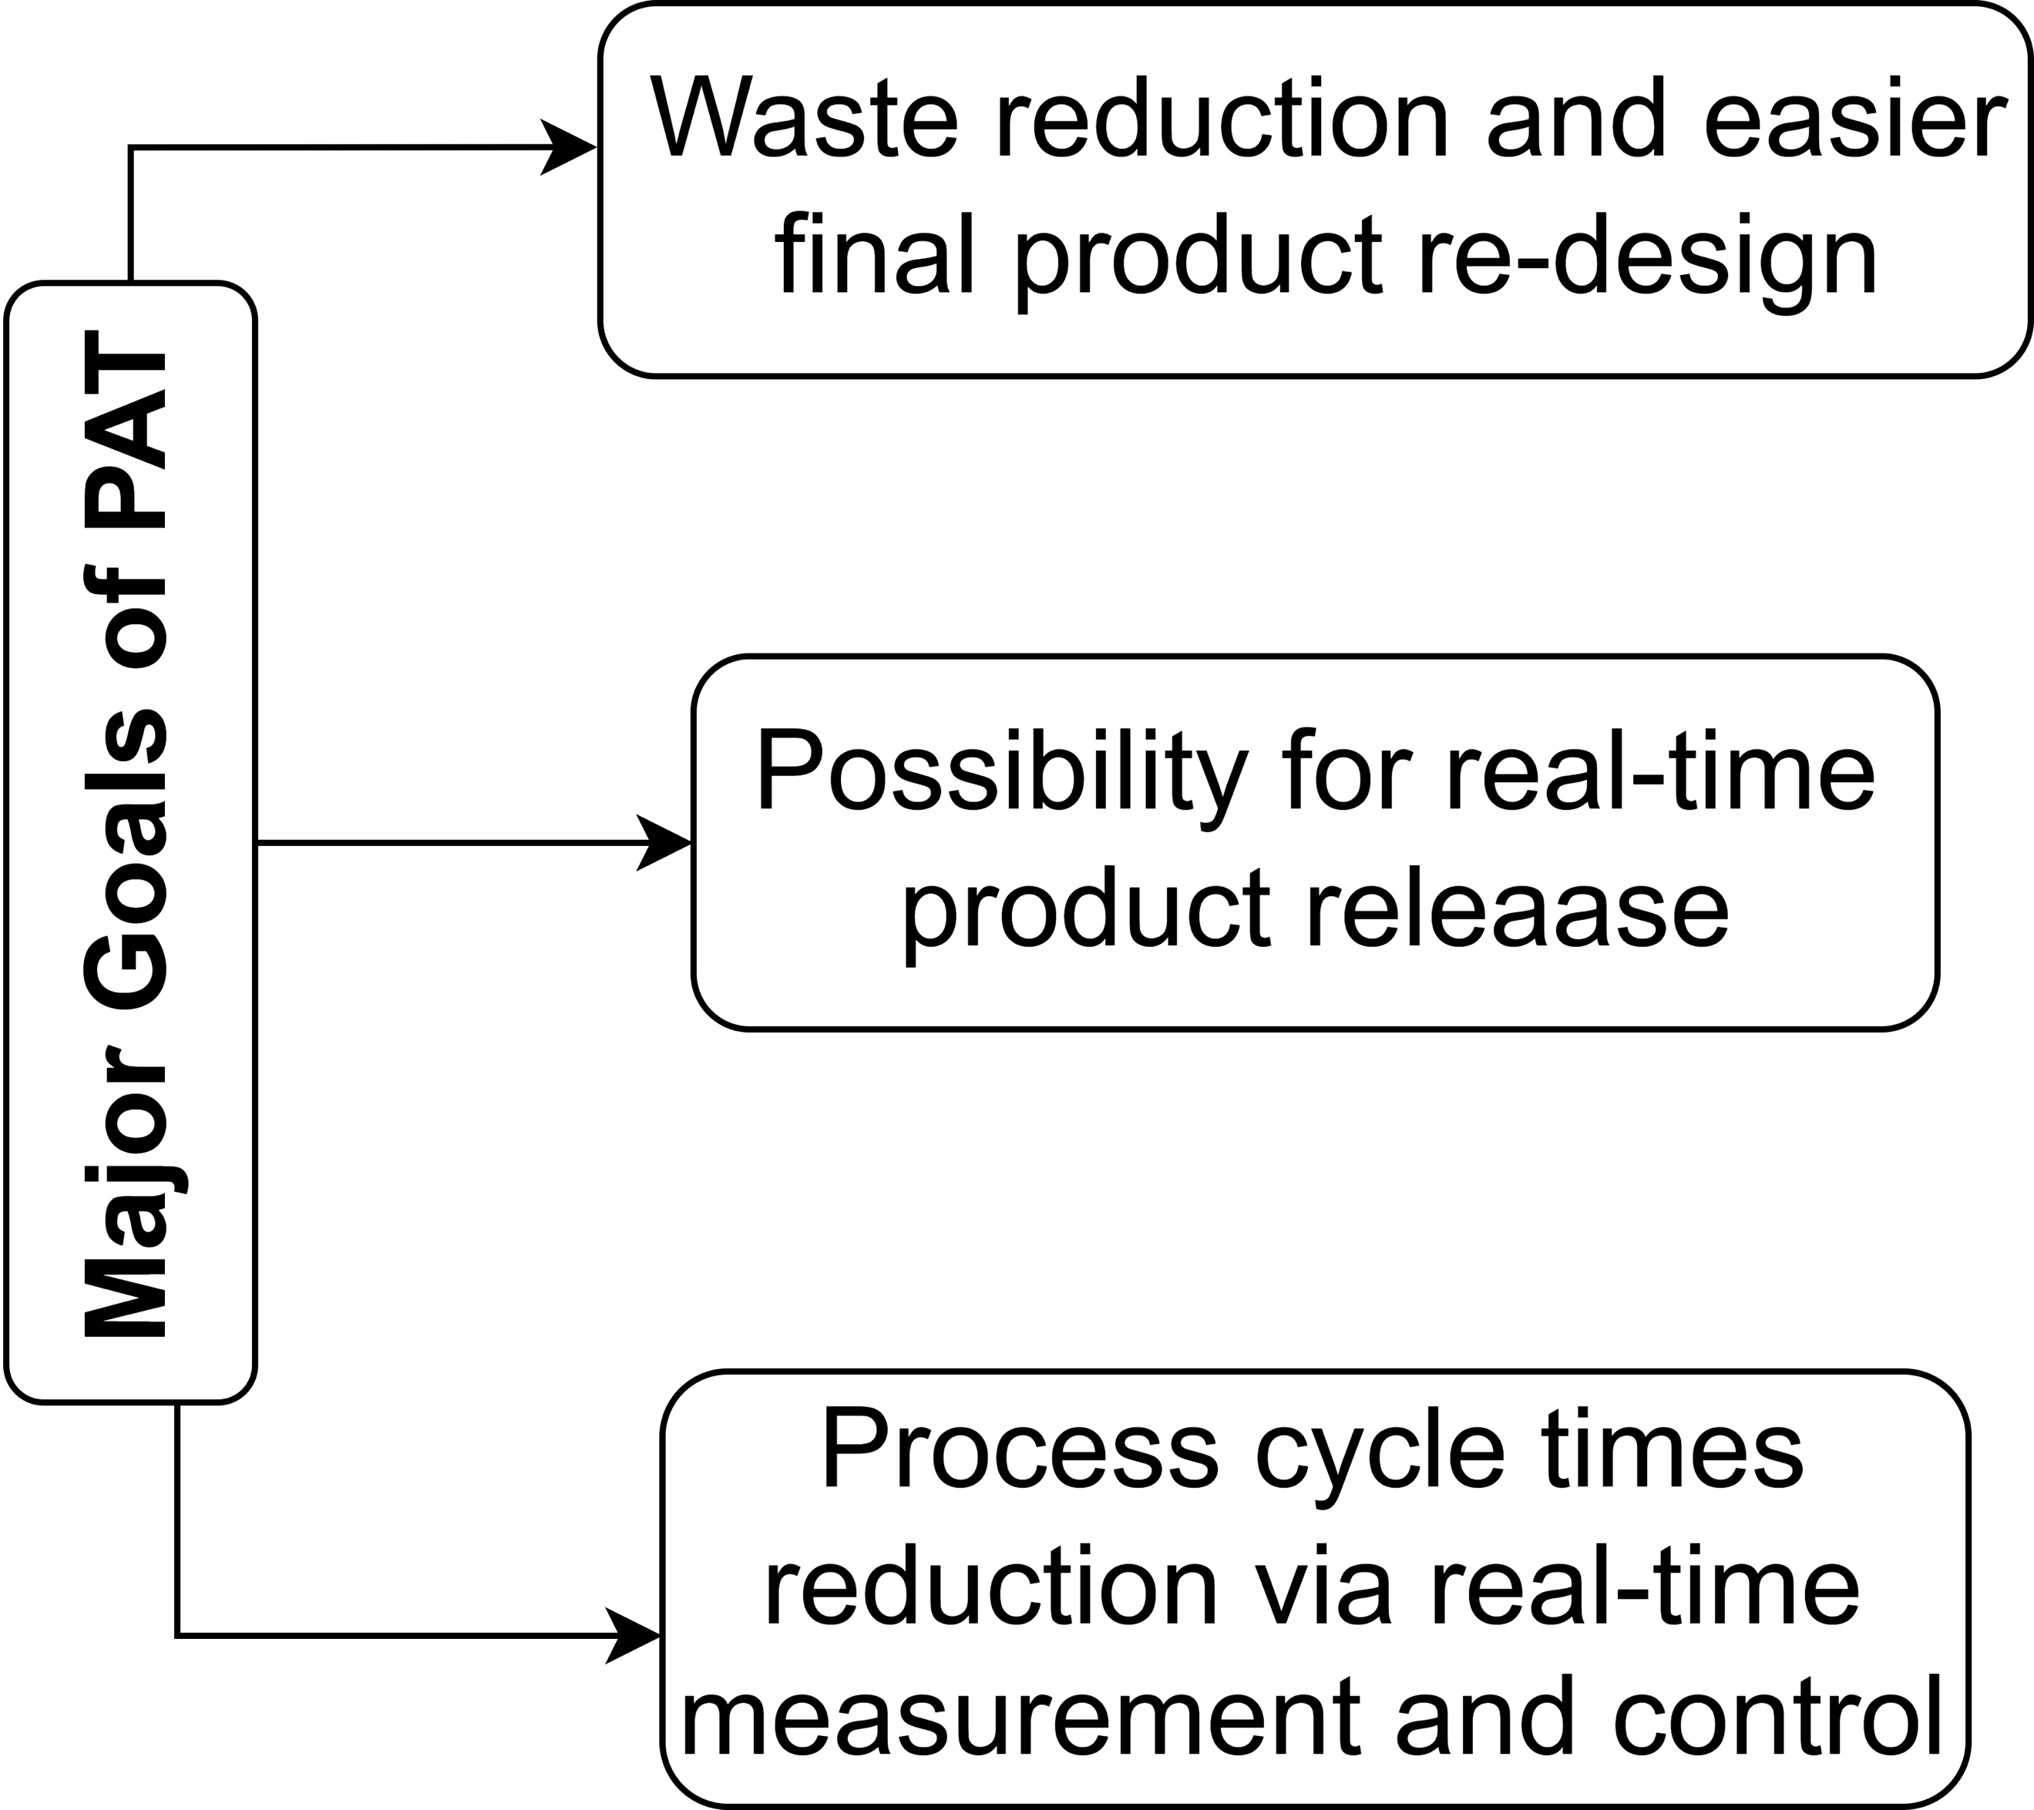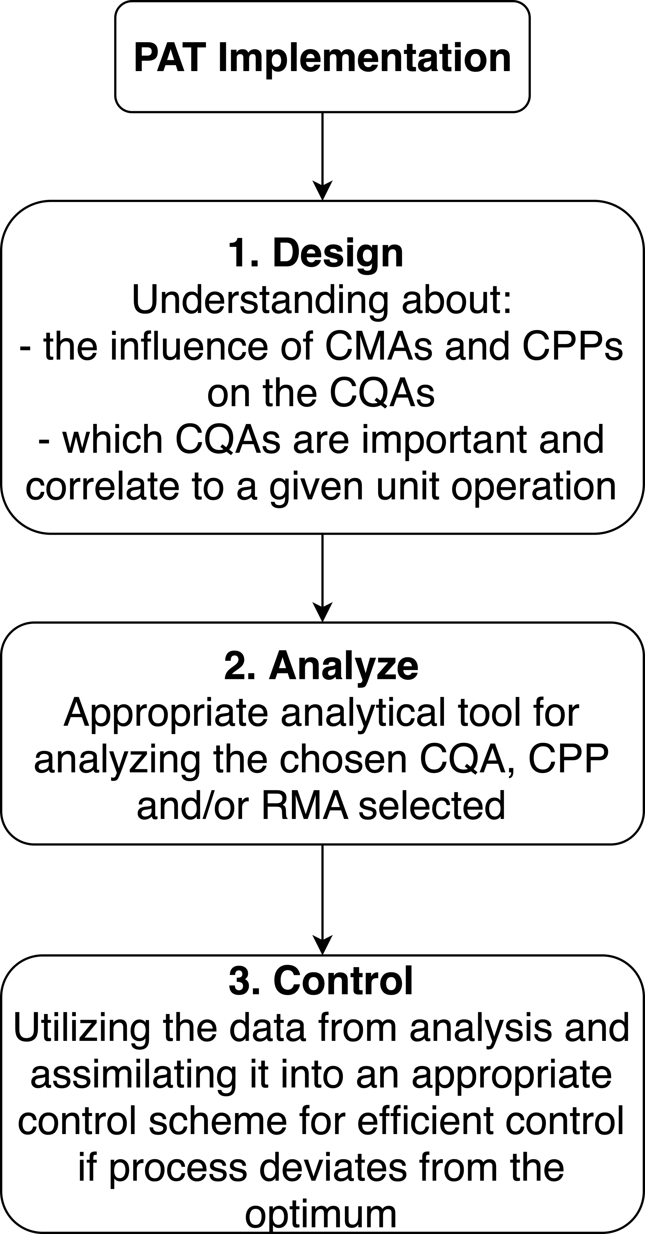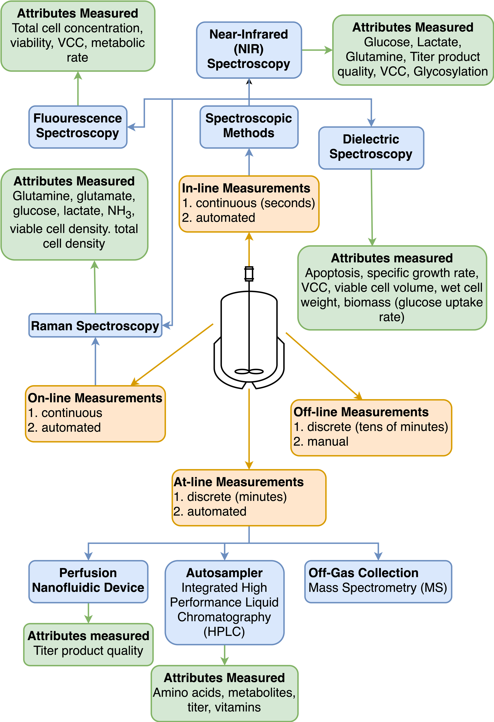
Figure 1: Major goals of PAT utilization in terms of sustainability (top left), adapted from Gerzon et al. (2022); Three broad steps towards PAT implementation (bottom left), adapted from Sacher et al. (2022); Few of many different methods of PAT employment in the pharmaceutical industry; VCC: viable cell count (right); adapted from Kempf (2018), Barenji et al. (2019), Fung Shek and Betenbaugh (2021) and Gerzon et al. (2022)
Lastly, it is crucial to examine the effect of PAT implementation on the green metrics and sustainability of a process. As the application of PAT requires a comprehensive process understanding and, ideally, a real-time and in-/on-line monitoring and control framework to function properly, this can lead to a minimization of experimentation and trials towards the desired product quality and output. Hence, the aforementioned prior knowledge of process and product design can have a waste and resource minimization effect, thus improving green metrics. However, it must be mentioned that the effect of power consumption due to such cloud technologies must also be considered (Kaur et al., 2018).
    - Soft Sensors
Monitoring and observing critical parameters is essential for ensuring product quality and maintaining the process in a desired and robust state. Process monitoring does not only mean measuring certain CPPs and CMAs. Process monitoring refers to measuring, monitoring, modelling and control (M³C) (Luttmann et al., 2012). Selected process variables are tracked over time (measuring), deflections from setpoints are detected (monitoring) and explained or predicted (modelling), and possible actions are evaluated (control). As outlined in the previous section, proper PAT methods are required to measure CMAs and CPPs. However, not all measurements are directly accessible or measurable at a sufficient frequency. If specific off-line or at-line measurements are identified as being critical, the time delay between sampling and the availability of results leads to delayed quality checks (Gerzon et al., 2022). Time delay is even more critical in continuous manufacturing since missed quality targets are propagated in downstream units.
Furthermore, in-line measurements with hard sensors are a potential risk of contamination due to their invasive nature (Luttmann et al., 2012). A model-based tool established particularly in bioprocess technology is soft sensors (software sensors). Soft sensors combine a mathematical model with indirect or secondary measurements (Kroll et al., 2017). In the context of control theory, a soft sensor is a state observer predicting input-output relations in a finite time horizon (Golabgir et al., 2015). Inputs are the online measured, non-invasive process variables, while the outputs are the predicted process states. To ensure reliability and trust in the soft sensor, an analysis of the significance and identifiability of the model parameters is recommended. An observability analysis aids in proving the appropriateness of the model structure with respect to the information content of measurements (Kroll et al., 2017). Soft sensors are used in different scenarios. Müller et al. (2023) demonstrated the applicability of a soft sensor for estimating the maximum substrate uptake capacity and the yield coefficient in a fed-batch E. coli cultivation. A soft sensor based on off-gas measurements was utilized to prevent overfeeding of induced cultures due to changes in cell hunger. Sagmeister et al. (2013) applied a soft sensor for static and dynamic control of specific substrate update rates of induced P. pastoris and E. coli expression systems.
Soft sensors are considered to be highly valuable tools for continuous and greener bioprocesses. Integrating machine learning models (artificial neural networks, partial least squares) into soft sensor models seems to be of very high interest. Data-driven models would ease handling large data sets while difficult-to-quantify parameters (e.g., pH) could be incorporated. Apart from enabling rapid quality checks, soft sensors are cheaper in comparison to hard sensors. They have proven to keep highly nonlinear bioprocesses in optimal conditions with adaptive control strategies (e.g., feeding profiles). Regarding SPM, soft sensors can prevent defects due to contamination, detect changes in product quality in real-time, and save resources through optimized process control (Figure 2).

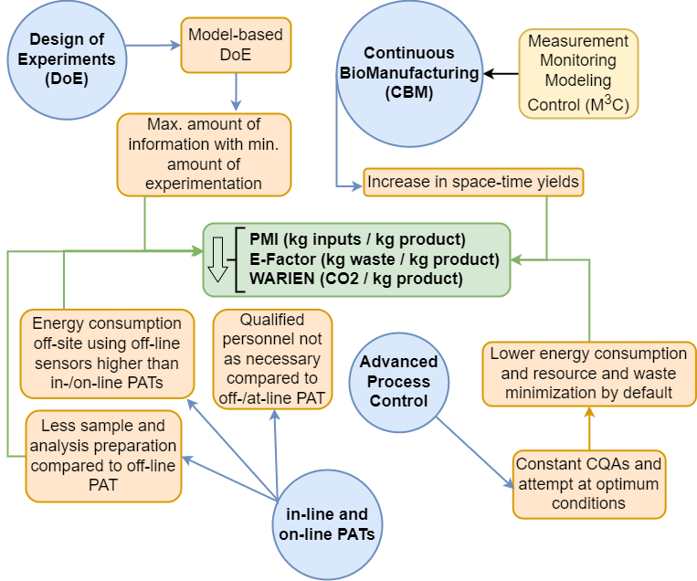
Figure 2: Digitalization key enablers and their effect on green metrics
    - Predictive Potential and Process Monitoring of Digital Twins (DTs)
Continuous manufacturing is a key enabler of intensified processing. Intensification comprises concepts of flow processing (continuous), process integration (cycles and heat integration) and novel equipment designs (membrane reactors) to achieve higher space-time yields and increase overall efficiencies (Boodhoo and Harvey, 2013). While CBM is an established mode in the chemical industry, many pharmaceutical processes still run in batch mode despite the benefits of intensified continuous operation. Regulatory authorities (FDA, EMA) set high standards in the pharmaceutical industry to guarantee the safety and efficacy of drugs but explicitly encourage enabling continuous manufacturing lines (Sommeregger et al., 2017). However, quality assurance cannot be done in the traditional approach by testing the batch quality of products or intermediates. Instead, continuous monitoring of quality gates is required.
Since varying inlet streams (CMAs) might cause changes in the CQAs, advanced control strategies must be applied. To combine complex data sets, variable process input parameters, dynamic models, advanced process control and green metrics, DTs seem to have the highest potential as a digital shadow of the entire manufacturing (Chen et al., 2020). DTs show great promise in translating complex data sets into robust process knowledge, enabling consistent product quality with variable process input parameters, transferring nonlinear bioprocesses into dynamic models, and combining advanced process control and green metrics. DTs are data management, monitoring and control, and active decision-making in case of failures (early failure detection). The digital maturity of a DT determines the level of integration and actionable decisions in a facility. The DT is expected to interact horizontally along all unit operations and vertically from operator instructions to global supply chains (Arden et al., 2021). Hereby, an ongoing challenge is the full integration of upstream and downstream unit operations (Hong et al., 2018). The predictive potential of a DT will enhance the integration of unit operations by enabling real-time tracking of CPPs, observing quality-related attributes throughout the whole process, propagating deviations, and evaluating risks. By merging the entire data set and smart data management in the DT, significant efficiency gains are also anticipated through adaptive process control and the incorporation of green metrics.
  - Conclusions
The tools PAT, soft sensors and DTs are the primary enablers of digitalization in the (bio-) pharmaceutical industry. In this contribution, the usage of those enablers for greener pharmaceutical manufacturing was analyzed. Green metrics are required to design new processes and benchmark with traditional manufacturing. The green metrics PMI, E-factor and WARIEN are process-independent and are applicable for characterizing, evaluating, or benchmarking pharmaceutical production.
However, green metrics is an evolving field. New metrics should be introduced for a more holistic process perspective on sustainability. The consistent characterization of process development and industrial manufacturing regarding environmental impact reduction is unavailable. The increasing sensitivity of society to greener products combined with economic pressure due to higher CO₂ certificate prices will lead to a shifted focus towards sustainable manufacturing.
Nomenclature
CBM – Continuous BioManufacturing
CMA – Critical Raw Material Attribute
CPP – Critical Process Parameter
CPS – Cyber-Physical System
CQA – Critical Quality Attribute
DT – Digital Twin
E-Factor – Environmental Factor
EMA – European Medicines Agency
FDA – Food and Drug Administration
HPLC – High-Performance Liquid Chromatography
I3.0 – Industry 3.0
I4.0 – Industry 4.0
IoT – Internet of Things
LCA – Lifecycle Assessment
M³C – Measurement, Monitoring, Modeling and Control
MS – Mass Spectroscopy
NIR – Near-Infrared Spectroscopy
PAT – Process Analytical Technology
PMI – Process Mass Intensity
QbD – Quality-by-Design
SPM – Sustainable Pharmaceutical Manufacturing
VCC – Viable Cell Count
WARIEN – Water-Related Impact of Energy

Acknowledgements
The authors would like to acknowledge the financial support the EU Horizon project ENVIROMED provided under Grant agreement ID: 101057844.
References
Arden N.S., Fisher A.C., Tyner K., Yu L.X., Lee S.L. and Kopcha M., 2021, Industry 4.0 for pharmaceutical manufacturing: Preparing for the smart factories of the future, International Journal of Pharmaceutics, 602, p.120554.
Barenji R.V., Akdag Y., Yet B. and Oner L., 2019, Cyber-physical-based PAT (CPbPAT) framework for Pharma 4.0, International Journal of Pharmaceutics, 567, p.118445.
BMBF, 2016, Industry 4.0, Bundesministerium für Bildung und Forschung - BMBF. <https://www.bmbf.de/bmbf/de/forschung/digitale-wirtschaft-und-gesellschaft/industrie-4-0/industrie-4-0.html> accessed 14.02.2023. (in German)
Boodhoo K. and Harvey A., 2013, Process Intensification: An Overview of Principles and Practice, In: K. Boodhoo and A. Harvey, (Eds.), Process Intensification for Green Chemistry, Chichester, UK: John Wiley & Sons, Ltd. pp.1–31.
Cataldo A.L., Sissolak B., Metzger K., Budzinski K., Shirokizawa O., Luchner M., Jungbauer A. and Satzer P., 2020, Water related impact of energy: Cost and carbon footprint analysis of water for biopharmaceuticals from tap to waste, Chemical Engineering Science: X, 8, p.100083.
Chen Y., Yang O., Sampat C., Bhalode P., Ramachandran R. and Ierapetritou M., 2020, Digital Twins in Pharmaceutical and Biopharmaceutical Manufacturing: A Literature Review, Processes, 8(9), p.1088.
Destro F. and Barolo M., 2022, A review on the modernization of pharmaceutical development and manufacturing – Trends, perspectives, and the role of mathematical modeling, International Journal of Pharmaceutics, 620, p.121715.
Fung Shek C. and Betenbaugh M., 2021, Taking the pulse of bioprocesses: at-line and in-line monitoring of mammalian cell cultures, Current Opinion in Biotechnology, 71, pp.191–197.
Gerzon, G., Sheng, Y. and Kirkitadze, M., 2022, Process Analytical Technologies – Advances in bioprocess integration and future perspectives, Journal of Pharmaceutical and Biomedical Analysis, 207, p.114379.
Golabgir A., Hoch T., Zhariy M. and Herwig C., 2015, Observability analysis of biochemical process models as a valuable tool for the development of mechanistic soft sensors, Biotechnology Progress, 31(6), pp.1703–1715.
Hong M.S., Severson K.A., Jiang M., Lu A.E., Love J.C. and Braatz R.D., 2018, Challenges and opportunities in biopharmaceutical manufacturing control, Computers & Chemical Engineering, 110, pp.106–114.
Jimenez-Gonzalez C. “Conchita” and Lund C., 2022, Green metrics in pharmaceutical development, Current Opinion in Green and Sustainable Chemistry, 33, p.100564.
Kamble S.S., Gunasekaran A. and Gawankar S.A., 2018, Sustainable Industry 4.0 framework: A systematic literature review identifying the current trends and future perspectives, Process Safety and Environmental Protection, 117, pp.408–425.
Kaur A., Singh V.P. and Singh Gill S., 2018, The Future of Cloud Computing: Opportunities, Challenges and Research Trends, In: 2018 2nd International Conference on 2018 2nd International Conference on I-SMAC (IoT in Social, Mobile, Analytics and Cloud) (I-SMAC)I-SMAC (IoT in Social, Mobile, Analytics and Cloud) (I-SMAC), 2018 2nd International Conference on 2018 2nd International Conference on I-SMAC (IoT in Social, Mobile, Analytics and Cloud) (I-SMAC)I-SMAC (IoT in Social, Mobile, Analytics and Cloud) (I-SMAC), pp.213–219.
Kempf J., 2018, Continuous Online Measurement of Viable Cell Density for Improved Process Insight. <https://www.process-worldwide.com/continuous-online-measurement-of-viable-cell-density-for-improved-process-insight-a-722766/> accessed 10.03.2023.
Kroll P., Hofer A., Ulonska S., Kager J. and Herwig C., 2017, Model-Based Methods in the Biopharmaceutical Process Lifecycle, Pharmaceutical research, 34(12), pp.2596–2613.
Luttmann R., Bracewell D.G., Cornelissen G., Gernaey K.V., Glassey J., Hass V.C., Kaiser C., Preusse C., Striedner G. and Mandenius C.-F., 2012, Soft sensors in bioprocessing: A status report and recommendations, Biotechnology Journal, 7(8), pp.1040–1048.
Müller D.F., Wibbing D., Herwig C. and Kager J., 2023, Simultaneous real-time estimation of maximum substrate uptake capacity and yield coefficient in induced microbial cultures, Computers & Chemical Engineering, 173, p.108203.
Sacher S., Poms J., Rehrl J. and Khinast J.G., 2022, PAT implementation for advanced process control in solid dosage manufacturing – A practical guide, International Journal of Pharmaceutics, 613, p.121408.
Sagmeister P., Wechselberger P., Jazini M., Meitz A., Langemann T. and Herwig C., 2013, Soft sensor assisted dynamic bioprocess control: Efficient tools for bioprocess development, Chemical Engineering Science, 96, pp.190–198.
Sommeregger W., Sissolak B., Kandra K., von Stosch M., Mayer M. and Striedner G., 2017, Quality by control: Towards model predictive control of mammalian cell culture bioprocesses, Biotechnology Journal, 12(7), p.1600546.
Steinwandter V., Borchert D. and Herwig C., 2019, Data science tools and applications on the way to Pharma 4.0, Drug Discovery Today, 24(9), pp.1795–1805.

