|  |  |
| --- | --- |
| cetlogo ***CHEMICAL ENGINEERING TRANSACTIONS***  ***VOL. , 2023*** | A publication of  aidiclogo_grande |
| The Italian Association  of Chemical Engineering  Online at www.cetjournal.it |
| Guest Editors: David Bogle, Flavio Manenti, Piero Salatino  Copyright © 2023, AIDIC Servizi S.r.l. **ISBN** 979-12-81206-04-5; **ISSN** 2283-9216 | |

On the gasification of torrefied Japanese Cedar to maximise the production of hydrogen

Cristina Molinera,\*, Sara Montaldoa,b, Hideyuki Matsumotob, Elisabetta Aratoa

a Dipartimento di Ingegneria Civile, Chimica e Ambientale (DICCA), Università degli Studi di Genova, Genova (Italy)

b Department of Chemical Science and Engineering, Tokyo Institute of Technology. Tokyo (Japan)

cristina.moliner@unige.it

Hydrogen, H2, is likely to become the key renewable energy carrier for the future. Thermochemical conversion of biomass can be applied to produce H2 involving a variety of conversion technologies, including gasification, that produce a mix of synthesis gas, H2 and CO. It is of paramount importance thus having a consolidated, efficient, versatile and clean technology to produce H2 in a sustainable and continuous manner contributing to current energy policies.

For this work, a bench-scale batch gasifier located at the Tokyo Institute of Technology, Tokyo Tech, was used for the production of syngas from the torrefied woody biomass. These data were inputs for the development of an hybrid model for the prediction of the composition of the producer gas. The time-depending data obtained in the semi-batch gasifier process was composed of three regions (pyrolysis, oxidation and reduction zones) in which recurrent neural networks were combined with physical-based models, whose parameters were conveniently tuned to fit the experimental data.

* 1. Introduction

Modelling activities can help in optimising thermo-chemical reactions to achieve a specific producer gas composition maximising hydrogen yield. The most influencing parameters elements can be related to the feedstock characteristics (content of moisture and ash, particle size, biomass density), to the type of reactor and to the applied operational conditions (Suzuki et al. 2020). Experiments at lab scale are the starting point for the design and optimisation of a technology, even though expensive and time-consuming. Modelling tasks permit to evaluate the influence of the variation of the involved parameters on the producer gas in a more immediate and less expensive way.

Specifically, models for the simulation of the gasification of biomass can be categorized into thermodynamic equilibrium models and kinetic models. The former assume that all the reactants are in fully mixed conditions for an infinite period (Baruah D, 2014). This highly simplified approach does not consider the gasifier design nor the kinetic limitations of the process and remarkable deviations from the experimental data have been obtained, especially in those cases when the internal temperature is low and the equilibrium cannot be achieved (Bridgwater, 1995). Despite these limits, the equilibrium models remain a widely used approach due to its simplicity. These models can be subdivided into stoichiometric and non-stoichiometric equilibrium models. The former approach consists in defining a set of reactions, calculating the equilibrium constants at a defined temperature, and computing the equilibrium (Li et al. 2001). The latter calculates the equilibrium of a set of reactions by minimizing the Gibbs free energy (Safarian S, 2019). Kinetic models evaluate the system in non-equilibrium conditions, and they can determine the variation of the gas composition and gasifier temperature along the reactor’s height and over time. These models include both kinetic and fluid dynamics studies and knowing parameters as the particle size distribution of the reactants become essential. This approach needs an extensive effort in terms of formulation of the kinetic and transport equations and computer time (Safarian S, 2019). As a result, they provide more accurate results with respect with equilibrium models (Bove et al. 2016, Marchelli et al. 2019), highly specific for a determined reactor and type of biomass.

A more recent approach considers the employment of machine learning to develop a predictive model. Specifically, the model can be obtained by developing an Artificial Neural Network (ANN), which has the feature of learning by itself from experimental data. Obviously, the higher the number of experimental data, the higher the level of accuracy can be achieved. The advantage of using an ANN is that it does not require a mathematical description of the physical phenomenon, permits to obtain a higher level of accuracy with the same number of inputs as in equilibrium models, and presents good performances especially in case of non-linearities in the output (Elman, 2020).

In this framework, the purpose of this study is to develop a model that accurately describes the behaviour of a semi-batch gasifier located at the Tokyo Institute of Technology, Tokyo Tech (Japan) through the combination of physical models based on equilibrium and ANNs. In this way, the number of experimental data necessary to train the neural network was reduced, and, at the same time, the level of accuracy of the stoichiometric equilibrium model increased considerably.

* 1. Materials and methods

2.1. Description of the reactor and measuring systems

A bench-scale batch gasifier located at the Tokyo Institute of Technology, Tokyo Tech, was used to produce syngas from the torrefied woody biomass. Differently from the continuous gasification processes, in batch gasification the biomass is fed at the beginning of the process at the bottom of the reactor and a certain fluidization is provided only by the airflow. The composition of the produced gas was analysed both online during the experiments and offline, where gas samples at specific gasifier temperatures were collected in sample bags and then analyzed to determine their compositions. Temperature was monitored with nine thermocouples located along the height of the reactor (see Figure 1a). The four reaction zones are drying and pyrolysis, oxidation and reduction, distributed inside the gasifier (Figure 1b). Drying and pyrolysis take place at the bottom of the reactor (thermocouples TR1, TR2 and TR3 located in the lower part of the reactor jacket). Above, the oxidation zone corresponds to the area where the main airflow is fed into the reactor (thermocouples TR4 and TR5). The reduction zone covers the top solid biomass layer (thermocouple TR6) up to the top of the reactor (thermocouple TR9). Further details on the experimental settings and the obtained results can be found at Suzuki et al. 2020.

|  |  |
| --- | --- |
|  |  |
| (a) | (b) |

*Figure* 1*. Detailed reactor design (a) and semi-batch gasifier scheme (b)*

2.2. Modelling strategy

The model was developed considering three reactions zones separately. All the reactor zones are connected in the way that the reaction products of the first zone are the reactants of the second and so on. The first zone corresponds to the pyrolysis zone (TR1 to TR4) and it operates at the lowest temperature. The products, mainly char and volatiles, are fed to the oxidation zone (TR5 and TR6) where temperature increases, and oxidation reactions become predominant. The products enter the reduction zone which includes the char top layer above TR6. A drying section was not considered as biomass underwent a torrefaction process that reduced the moisture content to 4% before being fed into the reactor. The obtained results were the combination of the application of heat and material balances to each region as described in Section 2.2.1 and Section 2.2.2.

**2.2.1. Heat balance: ANNs models**

Heat balances in each region are calculated through a Recurrent Neural Network (RNN) in which the time series data collected by each thermocouple during the experimental sessions were employed to develop a time series artificial neural network. A RNN is an artificial neural network that remembers things learnt from prior outputs while it generates a new output (Kumaraswamy, 2021). During the training, the RNN receives as inputs the time and temperature series, and after being tested and validated, it can return the temperature at any time step.

The data set from a single experimental session as described in Suzuki et al. 2020 is a sequence of 3025 values divided into three groups. The first one contains the 75% of the values and it corresponds to the data used to train the RNN. The second and the third group contain the 15% and 10% of the values respectively and they are used to validate and test the neural network. The model employs 10 hidden neurons and 2 delays, and the algorithm chosen to train the network is Levenberg-Marquardt. A single RNN is developed for each of the thermocouples located in the pyrolysis, oxidation, and reduction zone. The obtained neural network is used in a Simulink model which provides the temperature profile as an output. Figure 2 shows the neural network plot response (a) and error histogram (b) of the developed model.

|  |  |
| --- | --- |
|  |  |
| (a) | (b) |

*Figure* 2*. Neural Network Plot response (a) and Neural Network Plot Error Histogram (b) of the developed model*

**2.2.2. Material balance: equilibrium models**

Modelling based on material balances and kinetic data were applied to each region. For the *pyrolysis* zone, material balances describing the decomposition of the torrefied biomass were implemented and solved on Simulink to determine the number of moles generated in the reaction. The initial feed was 700 g of biomass per zone (total of 2800 g). The dry biomass molecular formula ($CH_{1.4}O_{0.68})$ was determined from the ultimate analysis carried on the torrefied Japanese Cedar (Suzuki et al. 2020). The system was solved through three atomic balances (C, H and O) and three empirical correlations (Eq 1-3) between the mass ratios of the single components (Sharma AK, 2011):

|  |  |
| --- | --- |
| $$Y_{CO/{CO}_{2}}= e^{-1.845+\frac{7730.3}{T}-\frac{5019898}{T^{2}}}$$ | (1) |
| $$Y_{\frac{H_{2}O}{{CO}_{2}}}=1$$ | (2) |
| $$Y_{ME/{CO}_{2}}=5×{10}^{-16}T^{5.06}$$ | (3) |

Being ME a mix of methane and ethylene with molecular formula 𝐶1.16𝐻4 (Sharma A., 2011). The char yields from the wood constituents was considered as pure carbon. Tar molecular formula was approximated to 𝐶6𝐻6.2𝑂0.2 in accordance with Thunman (Thunman H, 2011). The proportion of wood constituents, cellulose, hemicellulose and lignin in Table 1 (Tillman DA, 1981) was used to determine the char and volatiles yield (Eq. 4 and Eq. 5).

|  |  |  |
| --- | --- | --- |
| $$Y_{char,ash-free}=Y_{cellulose}Y_{char}+Y_{hemicellulose}γ_{char}+Y_{lignin}f_{char }$$ | | Eq. 4 |
| $$Y_{vol}=1-Y_{char,ash-free}$$ | Eq. 5 | |

Table 1: Proportion of the constituents and fractional char yield (Tillman, 2011)

|  |  |  |  |  |
| --- | --- | --- | --- | --- |
| Biomass Constituents | Cellulose | Hemicellulose |  | Lignin |
| Fractional Char yield | 0.05 | 0.10 |  | 0.55 |
| Proportion | 0.43 | 0.35 |  | 0.22 |

The *oxidation* model is the result of the combination of the heat and material balance. The heat balance was calculated using an ANN that received TR5 time series as an input and provided the oxidation zone temperature profile as an output. The char reaction rate was calculated considering the system as a semi-batch reactor, since the char is already loaded into the control volume and the airflow is fed continuously at constant flow. The reaction rate for the H2 was calculated considering the reaction occurring in a continuous flow system. The H2 and char reaction rates were used to calculate the output moles of non-reacted hydrogen and char and the produced carbon monoxide, carbon dioxide and water. The final composition of the gas was calculated in Matlab as the sum of the gases produced in the pyrolysis zone, those not reacted in the oxidation zone, and those produced by the oxidation reactions.

Finally, the *reduction* zone was modelled considering the material and the heat balance from the top char layer (TR6) and the top of the reactor. The products exiting the oxidation zone, the gases generated in the pyrolysis zone and not combusted, and the top char layer were considered as the inputs of the model. The composition of the producer gas was determined by the stoichiometric equilibrium model proposed by Sharma (Sharma A. K., 2008). The use of biomass previously torrefied permits to operate at lower temperatures, hence the maximum temperature inside the reactor is lower compared to other gasification processes. For this reason, the production of methane is not favored and the reactions involving this compound were neglected. R1-R2 were considered as representative reactions of the reduction zone.

|  |  |  |
| --- | --- | --- |
| C + CO2 ↔ 2CO | | R1 |
| C + H2O ↔ CO + H2 | R2 | |

The producer gas composition was obtained from the solution of the material balances and the equilibrium constants in terms of Gibbs function for each constituent (Burcat, 1984). The system of non-linear equations was solved in Matlab.

* 1. Results and discussion

Figure 3 shows the outputs of the reduction zone which are the sum of all the compounds produced during the entire process. The plot does not include the start-up process and it illustrates the gas composition during the core part of the gasification. All the products exiting from an initial previous zone enter the following and react in those local conditions. A sharp step at the time equal to 7300 s is shown. It corresponds to the stop of the airflow and the consequent end of the oxidation reactions. Not being consumed anymore in the oxidation zone, the hydrogen produced in the pyrolysis zone is expected to diffuse through the char layer and reach the reduction zone, as shown in the last part of Figure 3.

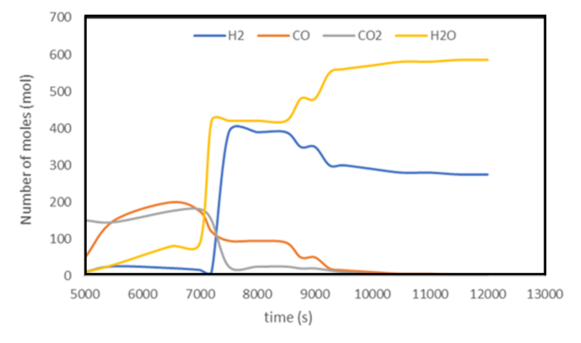

*Figure 3. Distribution of the molar composition of the simulated producer gas over time (s)*

The data obtained by solving the gasification model have been compared to the experimental data obtained during the experimental campaign (Suzuki et al. 2020). The differences in the results can be attributed to the assumption of being able to reach the thermodynamic equilibrium that is considered valid in each part of the reactor. This assumption can be considered a good approximation both in the oxidation and reduction zone. In fact, the partial combustion is a very fast reaction, and it is reasonable that it achieves the equilibrium. The reduction reactions are less favoured, however, the temperature at the top of the reactor is sufficiently high to assume that the species manage to achieve the equilibrium as well. On the contrary, the pyrolysis reactions occur at lower temperature and the thermodynamic equilibrium cannot be considered. For this reason, an equilibrium deviation factor, ϵ, was considered for adjusting the quantity of H2 produced in the pyrolysis zone, with values between 0 and 1 which indicates how close to the equilibrium is the H2 production. Figure 4 shows the evolution of the equilibrium factor, whose value increases with the increasing time. The equilibrium deviation factor trend is comparable to a second order polynomial expression. This is reasonable, since it is expected a growth of the value in the first part of the process, and a following decrease due to the decrease of the temperature at the end of the process.



*Figure 4. Variation of the equilibrium deviation factor over time (s)*

After tuning the pyrolysis reactions, the producer gas composition (shown in Figure 5) presented a trend comparable to that obtained during the experiments (Suzuki et al. 2020). The obtained data will be added to the experimental data in a successive step to achieve an adequate number of inputs for a machine learning curve fitting to obtain the overall producer gas composition model as an output.

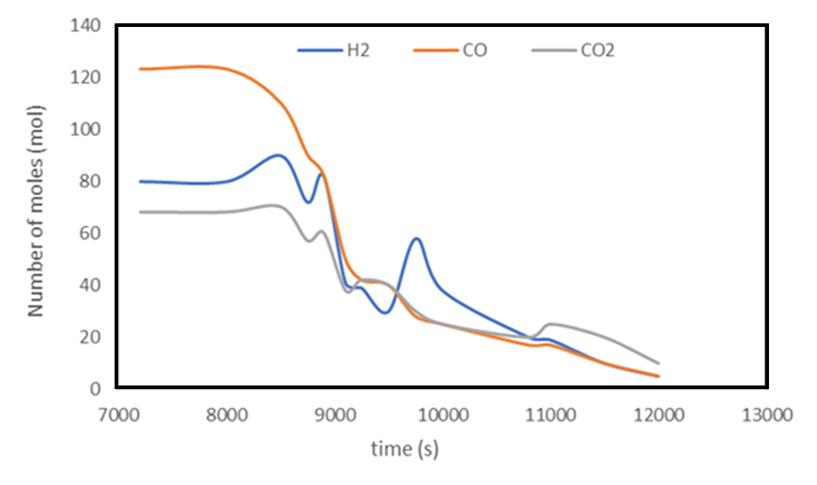

*Figure 5. Amount of CO, CO2 and H2 in the producer gas*

* 1. Conclusions

A bench-scale batch gasifier located at the Tokyo Institute of Technology, Tokyo Tech, was used to produce syngas from the torrefied woody biomass. Modelling activities combined a machine learning-based approach with the application of physical models to the three main regions of the reactor: pyrolysis, oxidation, and reduction. Artificial neural networks were used to perform the heat balances along the height of the reactor. Material balances considered all regions at the thermodynamic equilibrium. Experimental and modeling results presented differences due to the hypothesis of thermodynamic equilibrium established at the modeling stage. The experimental data permitted to tune the model results to shift the equilibrium up to the experimental evidence. The obtained reliable data will be added in a further step to the experimental data to achieve an adequate number of inputs for a machine learning curve fitting to obtain the overall producer gas composition model as an output.

Acknowledgments

The present work was performed in the framework of the bilateral Agreement between the Polytechnic School of the University of Genoa (Italy) and the Tokyo Institute of Technology (Japan).

References

Baruah D, B. D. (2014). Modeling of biomass gasification: A review. Renewable and Sustainable Energy Reviews, 39, 806-815.

Bove, D., Moliner, C., Baratieri, M., Bosio, B., Arato, E. (2016). Kinetic characterization of the residues from the pruning of apple trees for their use as energy vectors. Chemical Engineering Transactions, 50, pp. 1-6.

Bridgwater, A. (1995). The technical and economic feasibility of biomass gasification for power generation. Fuel, 74(5), 631-653.

Burcat, A. (1984). Thermochemical Data for Combustion Calculations. New York: Springer-Verlag.

Elman F, Y. O. (2020). Predictive modeling of biomass gasification with machine learning-based regression methods. Energy, 191.

Kumaraswamy, B. (2021). Neural networks for data classification. Artificial Intelligence in Data Mining Theories and Applications. Chapter 6. pp. 109-131

Li, X., Grace, J.R., Watkinson, A.P., Lim, C.J., Ergüdenler, A (2001). Equilibrium modeling of gasification: A free energy minimization approach and its application to a circulating fluidized bed coal gasifier. Fuel, 80 (2), pp. 195-207.

Marchelli, F., Moliner, C., Baratieri, M., Bosio, B., Arato, E. (2019). From equilibrium to kinetic modelling: The gasification of apple pruning residues in a spouted bed reactor. 27th European Biomass Conference and Exhibition, EUBCE 2019. Pages 813 – 820.

Safarian S, U. R. (2019, August). A review of biomass gasification modelling. Renewable and Sustainable Energy Reviews, 110, 378-391.

Sharma, A. (2008). Equilibrium and kinetic modeling of char reduction reactions in a downdraft biomass gasifier: a comparison. Solar Energy, 82, 918-928.

Sharma, A. (2011). Modeling and Simulation of a downdraft biomass gasifier 1. Model development and validation. Energy Conversion and Management, 52, 1386-1396.

Suzuki S., Matsumoto H., Izuka T. (2020). Effect of the supply method on the semi-carbonized utilization of woody biomass on the pyrolysis gasification behavior. The Japan Carbonization Research Society (JCRS)

Thunman H, N. F. (2011). Composition of volatile gases and thermochemical properties of wood for modeling of fixed and fluidized beds. Energy Fuel, 15, 1488-1497.

Tillman DA, R. A. (1981). Wood Combustion. Academic Press Inc.