CHEMICAL ENGINEERING TRANSACTIONS  VOL. , 2023 | A publication of
The Italian Association
of Chemical Engineering
Online at www.cetjournal.it

Guest Editors: David Bogle, Flavio Manenti, Piero Salatino
Copyright © 2023, AIDIC Servizi S.r.l.
ISBN 979-12-81206-04-5; ISSN 2283-9216

High throughput screening for CO₂ capture by MOF pressure swing adsorption based on maximum economic benefit
Hong Xu^{a,b,c}, Yali Yaoª, Xinying Liuª*
ª Institute for Catalysis and Energy Solutions, University of South Africa (UNISA), South Africa.
^{b} College of Chemistry and Pharmaceutical Engineering, Hebei University of Science and Technology, Shijiazhuang 050018, China.
^{c} International Joint Laboratory of New Energy, Hebei University of Science and Technology, Shijiazhuang 050091, China.

The seriousness of the greenhouse effect has forced more and more national and international institutions to actively develop carbon dioxide separation technologies, capture and storage technologies to control CO₂ emissions. Among the many CO₂ separation technologies, adsorption separation is a common method used in mixed gas separation technology at present. Pressure swing adsorption (PSA) has less regeneration time and less energy consumption, so is used more widely than temperature swing adsorption (TSA) and vacuum swing adsorption (VSA), which are the other two types of adsorption separation technologies. However, the adsorption capacity and adsorption selectivity of the existing adsorbents are poor, resulting in high energy consumption. This study is based on the results of industrial process simulation of flue gas from power plants [Sai et al. 2022], when the economic benefits of CO₂ / N₂ mixed gas PSA separation process are optimal, the adsorption capacity of MOF material is within a certain range. More than 4000 computation-ready, experimental metal-organic frameworks (CoRE MOFs) were calculated using Grand Canonical Monte Carlo (GCMC) high-throughput simulation, the PSA process of 1bar and a temperature of 298K, obtained 142 MOFs with potential performance. By comparing the optimal conditions required for CO₂ capture in industrial simulation, we successively screened 14 and 11 kinds of MOF materials with good commercial application value and potential in industrial separation of CO₂ suitable for four-stage and six-stage industrial separation respectively. It was found that materials containing Cu, Co, Ga, Mn, V, F, Br and Zn or nitrogen functional groups are more likely to adsorb and separate CO₂. By calculated the adsorption properties of the MOFs at other industrial concentration of CO₂ (1.25%, 2.1%, 2.55%, 3.5%, 7.5%, 20%, 30%) using the 142 kinds of good materials screened at 13% CO₂ of flue gas from power plants, obtained the materials suitable for adsorption and separation at these ratios through the same screening conditions. When increasing the proportion of CO₂, the number of selected materials meeting the requirements increased. The adsorption and separation performance of these materials with different proportions of CO₂ were found to be outstanding and the amount of suitable material screened at these ratios was directly proportional to the CO₂ content. These materials are likely to improve the economic efficiency of industrial CO₂ adsorption and separation.
1. Introduction
In recent years, global climate change caused by greenhouse gases, closely related to the increasing atmospheric CO₂ concentration. There is an urgent need to revise the energy structure, develop low-carbon and carbon-free energy, improve energy efficiency, and to actively develop carbon dioxide separation, capture and storage technology, in order to control carbon dioxide emissions. The immediate driver of CO₂ is the burning of fossil fuels, including coal and oil, which accounts for 89% of global CO₂ emissions. A reduction in energy-related CO₂ emissions could be achieved by switching to renewable energy sources and improving energy efficiency [Zhao et al., 2019].
Among the many gas separation technologies, adsorption separation is commonly used at present. In particular, pressure swing adsorption (PSA), which has a short regeneration time and low energy consumption, is more widely used than temperature swing adsorption (TSA) and vacuum adsorption (VSA). However, it is not often understood that the better the adsorption performance of the material does not mean the better the economic benefit.
Metal-organic frameworks (MOFs) are an attractive class of porous nanomaterials that were discovered in the mid-1990s [Liang et.al., 2020, Furukawa et al., 2013, Ploetz et al., 2020]. Transition metal ions and organic ligands connect by self-assembly and form porous crystalline materials with a periodic network structure [Yang et al., 2012, Hungerford et al., 2018]. It is characterised by: a high specific surface area; adjustable pore size; structural diversity; good chemical stability. It is a popular field in chemical and materials research [Liu et al., 2021,Camille et al., 2018]. Based on combinatorial chemistry, it is easy to design and accurately control the pore chemical characteristics and pore size of MOFs at the molecular level, so as to control their gas adsorption and separation properties.
Based on the industrial process simulation conclusion of the adsorption capacity range of CO₂ / N₂ PSA separation process at the best economic benefit [Sai et al. 2022], a total of 4188 computation-ready, experimental metal-organic frameworks (CoRE MOFs) were screened by Grand Canonical Monte Carlo (GCMC) high-throughput simulation. The adsorption capacity, selectivity and adsorption properties of CO₂ and N₂ were obtained. Then, by comparing the optimal conditions required for CO₂ capture in industrial simulation and combining with the relevant screening experience in molecular simulation, 11 MOF materials suitable for industrial level 4 separation and 14 MOF materials suitable for level 6 separation were obtained in accordance with the conditions of CO₂ adsorption capacity, selectivity and N₂ adsorption capacity. By comparison and screening, the MOF materials with good performance and the best economic benefits were determined, which suggests that these materials would have better commercial application value and potential.
2. Grand Canonical Monte Carlo (GCMC) simulation method
GCMC simulation is a standard method used to investigate the adsorption behavior of guest molecules in porous materials [Li et al., 2021,Wu et al., 2021]. High-throughput-based complex adsorption and diffusion simulation suite (HT-CADSS) based on GCMC method developed by Professor Zhong's group of Tianjin Polytechnic University was used to conducted to evaluate the absorption performance of MOFs [Yan Tongan, 2019]. This software package has been widely used to study the adsorption and separation performance of porous materials used with various gases, such as MOF and zeolite. Materials Studio was used to determine the crystal structure of the materials. MOF skeleton atoms were described using the standard Universal force field (UFF) and Dreiding force field, guest molecules were described using the transferable potentials for phase equilibria (TraPPE) model. The Van der Waals interaction between framework atoms and guest molecules was modeled using the Lennard-Jones (LJ) potential model. The skeleton atomic charge of MOF material was calculated using the Charge Equilibration (Qeq) method. During the simulation, the structure of the MOF material was considered to be a rigid model.
Materials with a pore limiting diameter (PLD) below 3.3 Å were eliminated to ensure that CO₂ (molecular dynamic diameter=3.3 Å) were adsorbed by the materials selected, 4188 MOFs met the requirements were obtained. All the GCMC simulations were performed at a constant temperature of 298K. A pressure of 1bar was used for preliminary screening in the first step and a total of 8 pressure points were used for screening in the second screening step, i.e. 0.05, 0.1, 0.15, 0.2, 0.4, 0.6, 0.8 and 1bar. Due to the large amount of MOFs, by using the better material obtained by coarse screening in the first step and then fine calculation in the second step can greatly save the screening time.13% CO₂ ratio of industrial coal-fired power plant is adopted for the above two steps.
The formula used was:
S_{i/j}^{ads}= ( x_{i} / x_{j} ) · ( y_{j} / y_{i} ) | Eq(1)
ΔN_{i} = N_{i}^{ads} - N_{i}^{des} | Eq(2)
ΔN_{j} = N_{j}^{ads} - N_{j}^{des}

Where: x and y are the molar fraction of gas molecules in the adsorbed phase and bulk phase; S_{i/j}^{ads} represents selectivity under adsorption pressure; N_{i}^{ads} and N_{i}^{des} represent the adsorption capacity of component i (“ i ” is the target adsorbed gas, CO₂) under adsorption pressure and desorption pressure; N_{j}^{ads} and N_{j}^{des} represent adsorption capacity of component i (“ j ” is the foreign gas, N₂) under adsorption pressure and desorption pressure; ΔN_{i} represents the working capacity of component i; ΔNj represents the working capacity of component j.
3. Result
3.1 GCMC large-scale screening of the first step
After the first step GCMC calculation of 4188 MOFs, the adsorption properties were obtained and the three most important adsorption properties were focused on, i.e.: CO₂ / N₂ selectivity (S_{i/j}^{ads}); CO₂ adsorption capacity (N_{i}^{ads});N₂ adsorption capacity (N_{j}^{ads}). To determine the specific values of these three screening conditions, we refered the conclusions given in the techno-economic investigation study of how novel solid sorbents reduce the cost of post-combustion CO₂ capture [Sai et al. 2022]. The study gives two range of industrial conditions: four step and six step single-stage pressure - vacuum swing adsorption. To maximize the economic benefit of the two industrial conditions, the most suitable CO₂ capacity of the material is different. As shown in Table 1, the N_{i}^{ads} of MOFs was divided into two ranges, it should be controlled between 1.9-3.5 mol/kg and 5.5-8.5 mol/kg under the condition of range 1 and range 2 respectively, which can maximize the economic benefit of the corresponding adsorption process. S_{i/j}^{ads} was set to a value more than 300 represent the material has desirable selection properties. N_{j}^{ads} is set to a value less than 0.07 mol/kg according to a conclusion in the literature that the lower the adsorption amount of N₂, the better the material performance. Under the up three screening conditions, MOFs with potential CO₂ adsorptive property were screened respectively. Figure 1 shows the CO₂ capacity, N₂ capacity and selectivity of the 69 and 73 potential MOFs, a total of 142 materials. The greater amount of CO₂ capacity and the smaller amount of N₂ capacity, the greater amount of the CO₂ / N₂ selectivity. The selectivity of most range 1 materials is in the 300-1500 range and range 2 MOFs is in the 500-3000 range, only a few materials appears in the tens of thousands of extremely high values.

Table 1. Three screening conditions used in the first step.

Screening conditions used in the first step | N_{i}^{ads} of range 1 (mol/kg) | N_{i}^{ads} of range 1 (mol/kg) | N_{j}^{ads} (mol/kg) | S_{i/j}
Value | 1.9-3.5 | 5.5-8.5 | <0.07 mol/kg | >300

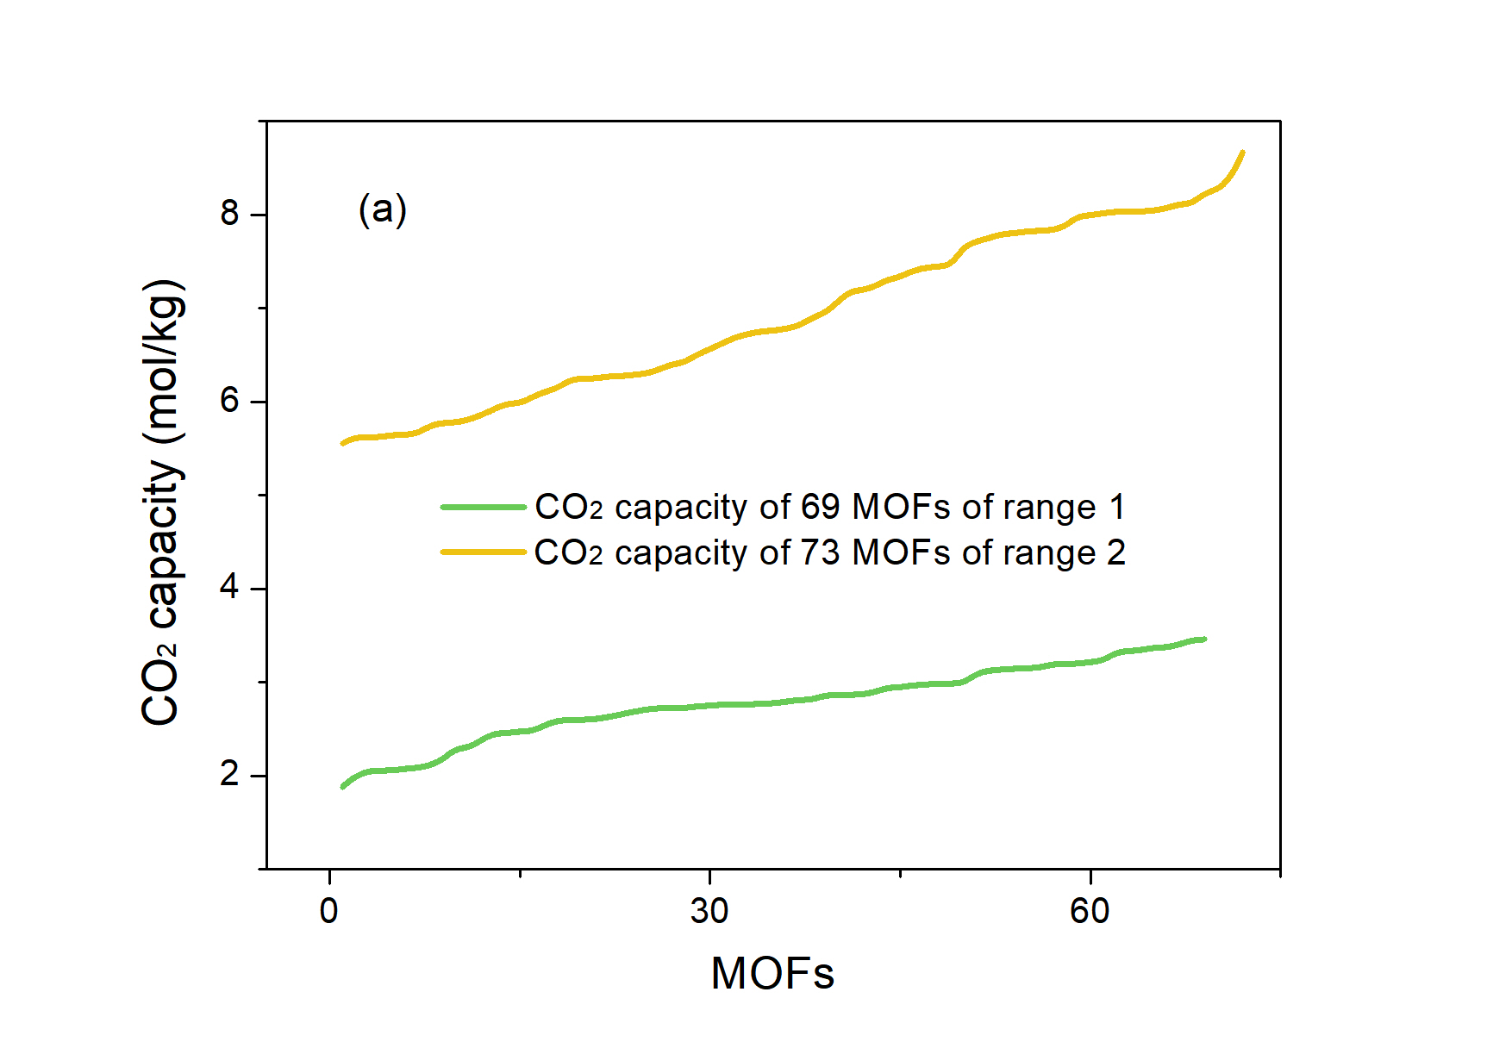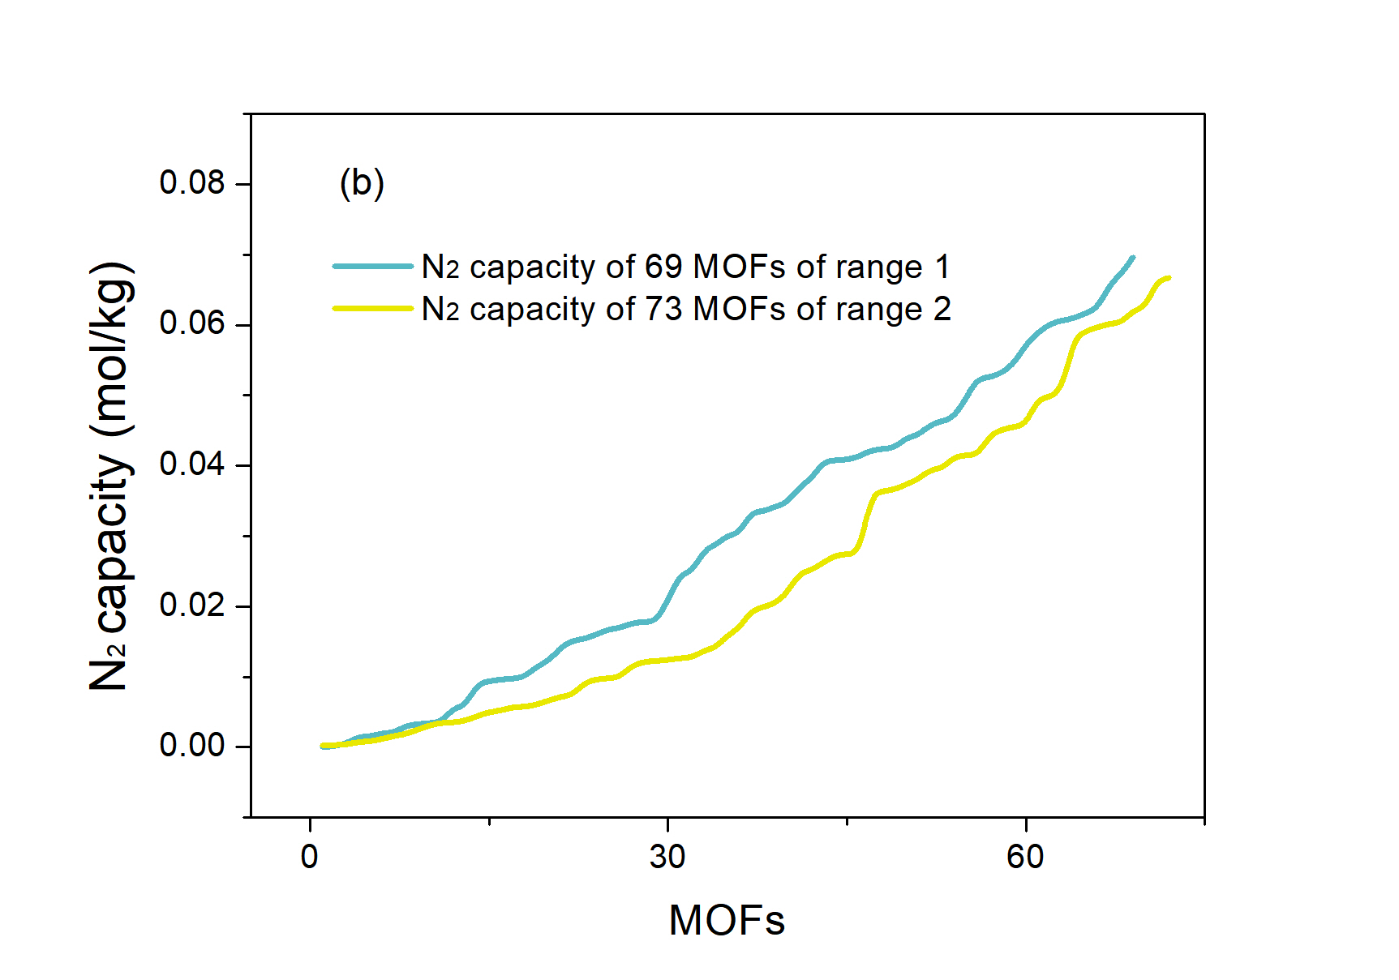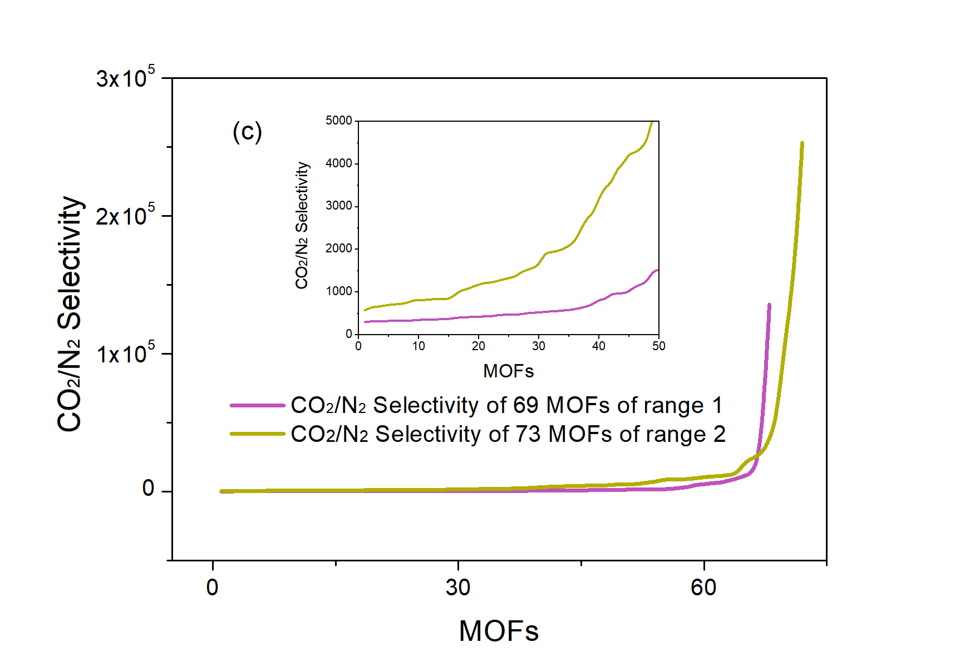
Figure 1. CO₂ capacity, N₂ capacity and CO₂ / N₂ selectivity of the 142 potential MOFs (69 MOFs from range 1 and 73 MOFs from range 2).
3.2 GCMC large-scale screening of the second step
The 142 materials selected in the first step were calculated again using 8 pressure points (0.5-1.0bar) at 298K. Multiple pressure points can be calculated to obtain an important reference index of the adsorption performance of the material: working capacity, and obtain the adsorption isotherm of the MOF's selective adsorption of the guest molecule. See the screening conditions in tab. 2, under the condition of 1bar adsorption and 0.1 bar desorption, CO₂ working capacity (ΔN_{i}) is chosen the value greater than 1.5 mol/kg and greater than 3mol/kg of range 1’ and range 2’. Pass this filter, 14 kinds of range1’ and 11 kinds of range 2’ MOFs with the best performance were obtained, respectively. Fig. 2 indicate the CO₂ working capacity of the top MOFs. The capacity increase trend of the materials we screened was basically consistent with the trend in the industrial simulation results, which was suitable for the adsorption and separation of CO₂ / N₂ mixed gas at 13% CO₂ content.

Table 2. Screening conditions used in the second step.

Screening conditions used in the second step | ΔN_{i} of range 1’ (mol/kg) | ΔN_{i} of range 2’ (mol/kg)
Value | >1.5mol/kg | >3mol/kg

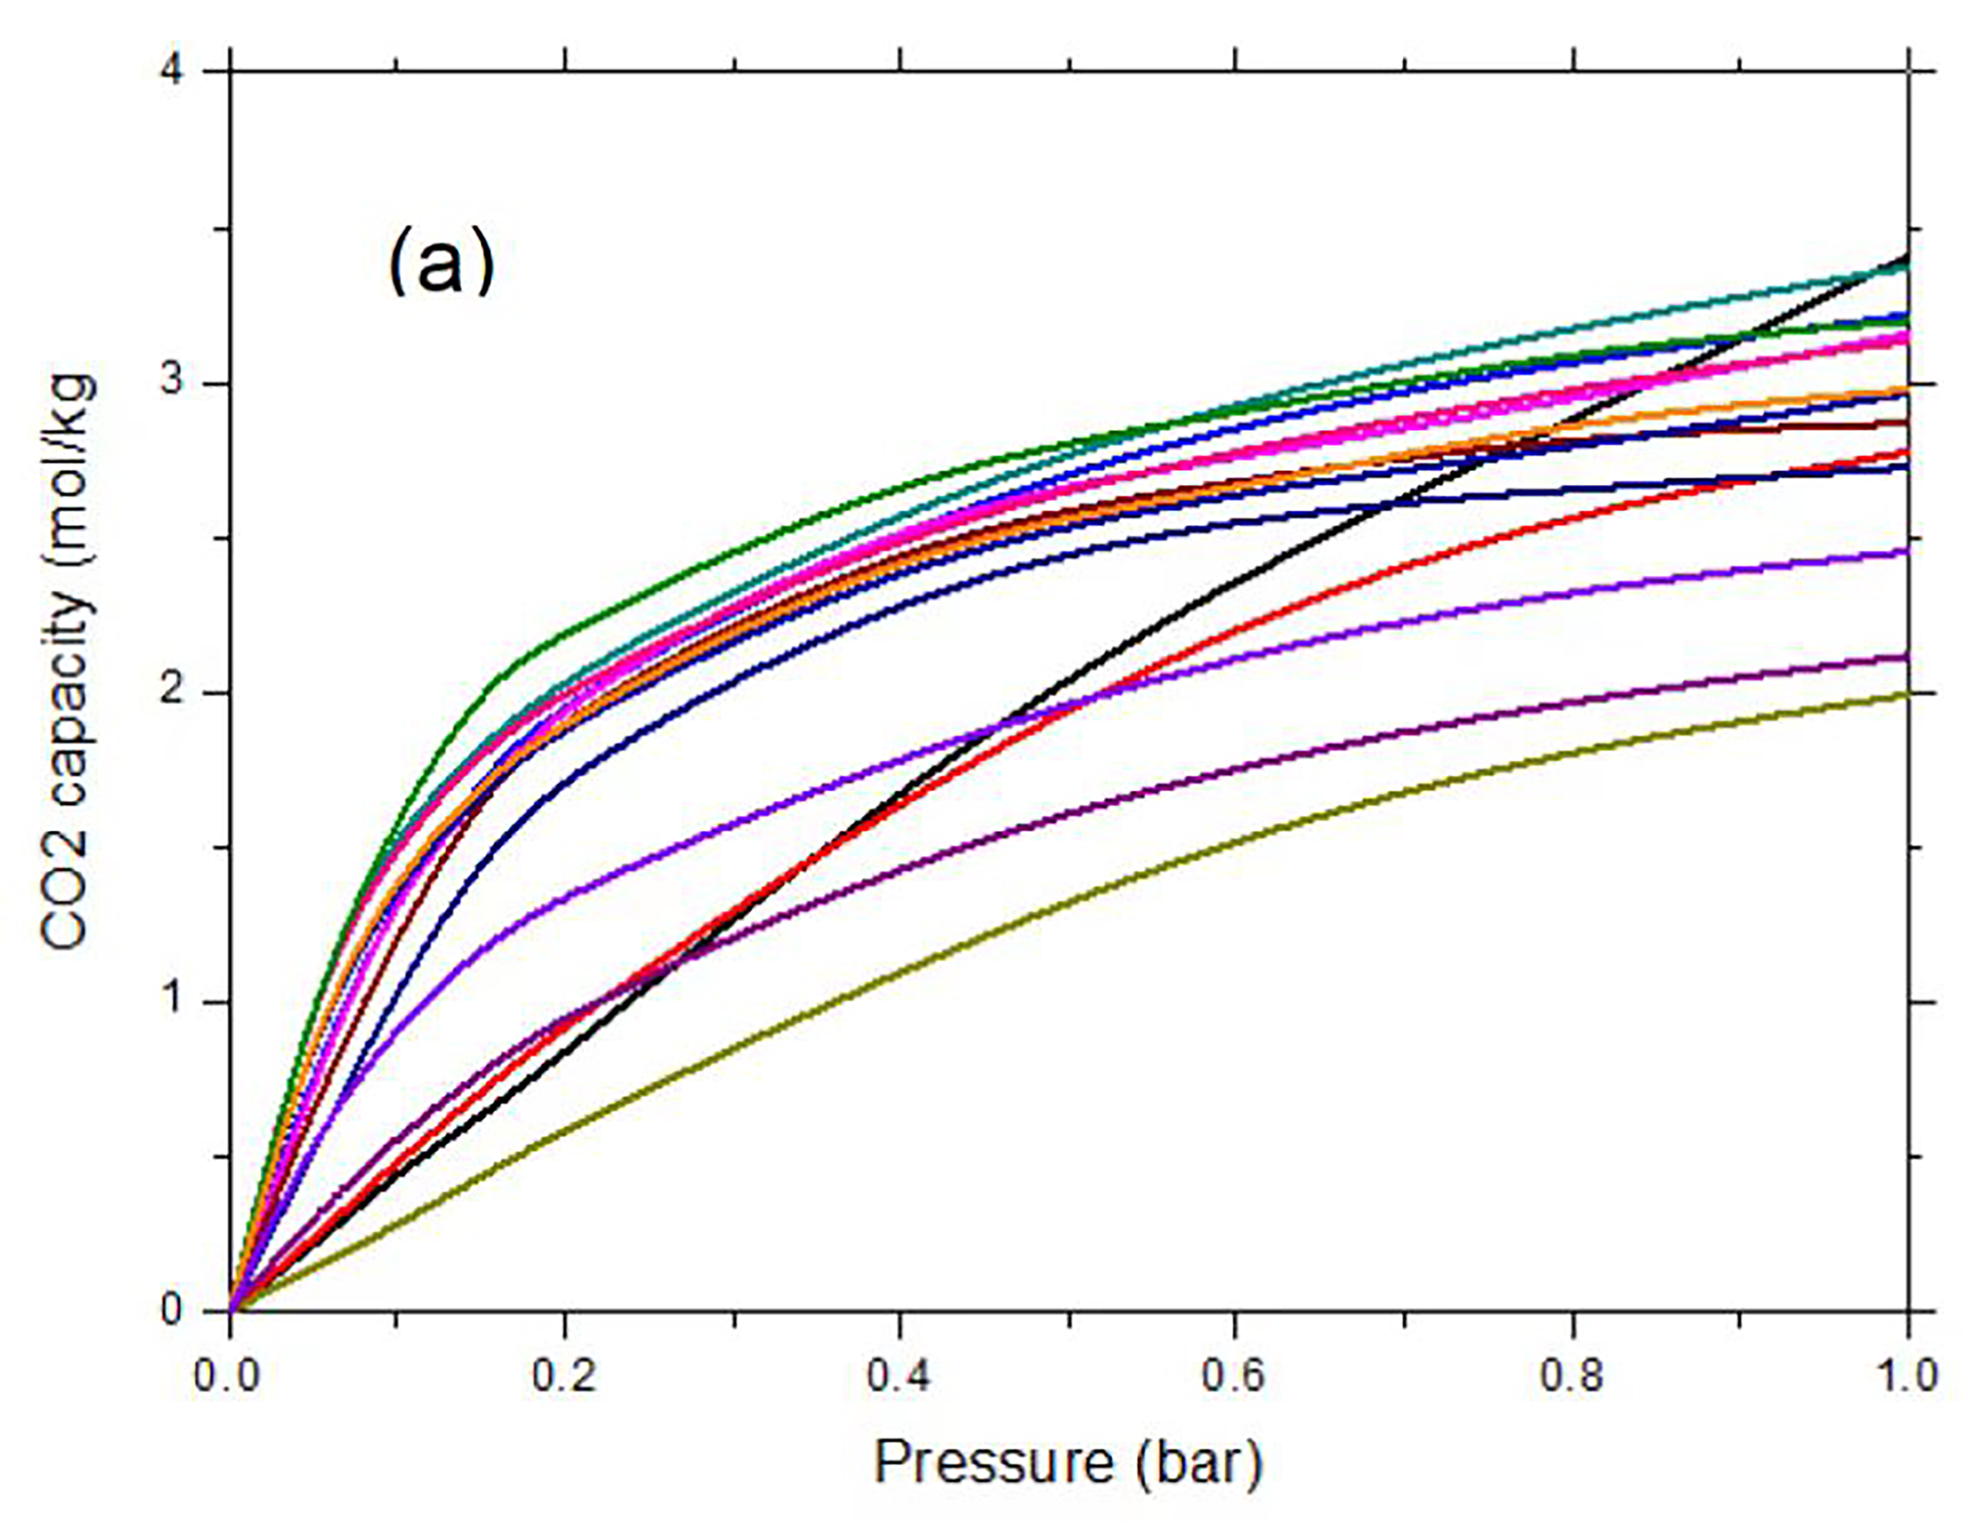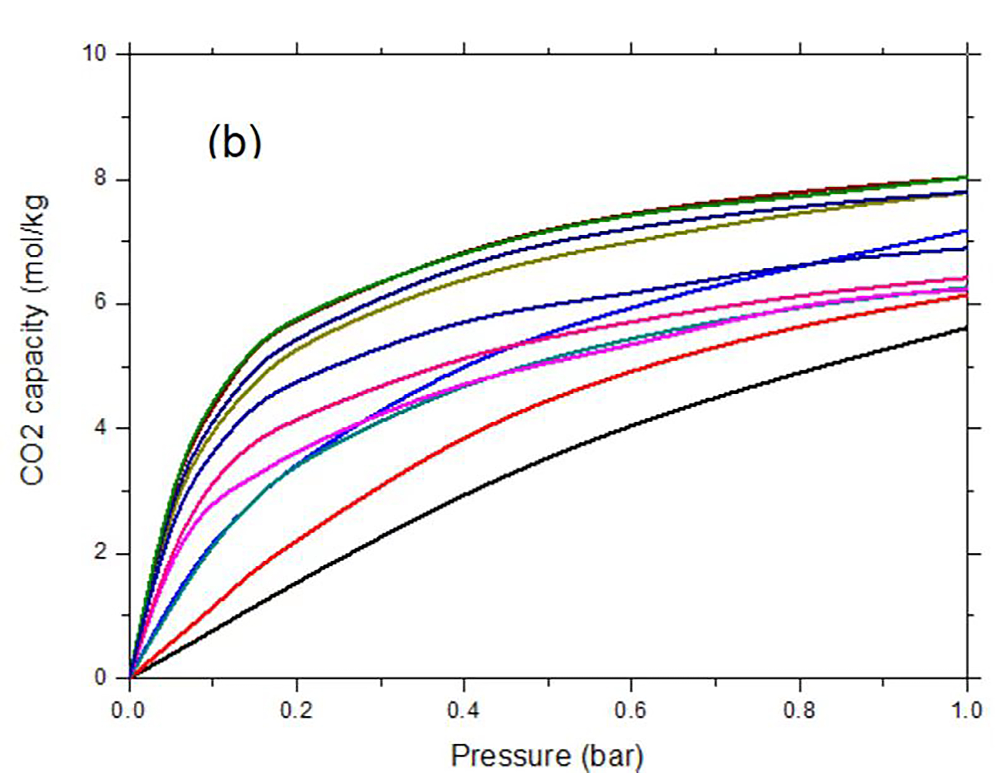

Figure 2. CO₂ working capacity of the top 25 MOFs.
(a) CO₂ working capacity of 14 MOFs of range 1’. (b) CO₂ working capacity of 11 MOFs of range 2’.

By analyzing the atom and functional group of the top MOFs, 14 MOFs screened by range 1’ were analyzed. As shown in Table 3, it was found that there are 4, 4, 4, 2, 2, 2, 1 and 1 MOFs containing Cu, Co, Ga, Mn, V, F, Br and Zn, respectively. Cu has been proved that copper metal–organic frameworks have high CO₂ adsorption capacity[Lssig et al., 2011, Sanz et al., 2013]. The nitrogen functional groups exert a beneficial influence on CO₂ capture at 298K, -P-O- bond has no positive effect on the adsorption and separation of CO₂ [Sanchez et al., 2014]. MOFs with Co, Ga, Mn, V, F, Br and Zn also have a good adsorption performance. The action mechanism of these elements needs further study.

Table 3. CO2 capacity at 1 bar and structural analysis of 14 MOFs screened by range 1’

ID | MOF ID | 1.0bar CO2 capacity (mol/kg) | Cell Atom | Functionalization
1 | AHOKOX | 3.41 | Cu, P, C, H, O | -O-Cu-O-,-CH2-CH2-CH2-CH2-CH2-,O-P-O
2 | VUFBEE | 3.37 | V, Mn, P, H, O | -Mn-O4-,-V-O4-, -P-O4-
3 | VOHQEO | 3.22 | F, Ga, P, H, O | -Ga-O4-, F-Ga-O3-, -P-O4-
4 | EVEGIV | 3.19 | Cu, C, H, O, N | -Cu-N4-, -N-Cu-
5 | VEYVEC | 3.16 | Co, C, H, O, N | -N2-Co-O2-, -OH, -O-Co, O-C=O, H-O-H
6 | OPAMOI | 3.13 | V, Co, P, H, O | -V-O4-, O-Co-O, -P-O4-
7 | DEPSEW | 2.98 | Ga, P, H, O | O-Zn-O, -Ga-O4-, Ga-O, -P-O4-
8 | DEPTOH | 2.96 | Ga, P, H, O | O-Co-O, -Ga-O4-, Ga-O, -P-O4-
9 | XUWSUD | 2.86 | Mn, Ga, P, H, O | -Ga-O4-, -Mn-O4- -P-O4-
10 | AHOKIR | 2.77 | Cu, P, C, H, O | -O-Cu-O-,-CH2-CH2-CH2-,O-P-O
11 | XOJWEZ | 2.72 | Cu, Br, C, H, N | -N-Cu-N-, -N-Cu-Br-,-CH3
12 | RACZEC | 2.45 | F, Co, C, H, O, N | Co-O-Co,-N-Co-O4-,-N-Co
13 | TANMIH | 2.12 | Co, C, H, O, N | -Co-O6-, -N2-Co-O4-
14 | DAFSOV | 1.99 | Zn, C, H, O, N | -O2-Zn-N-

3.3 The adsorption properties of 142 potential MOFs at other CO₂ ratios
In order to meet the requirements of different industrial conditions and explore the adsorption capacity of this screening method when using other concentrations of CO₂, we calculated the adsorption performance of 142 MOFs at CO₂ concentrations of 1.25%, 2.1%, 2.55%, 3.5%, 7.5%, 20% and 30%. [Sai et al., 2022, David et al., 2020].The pressure points selected were 1bar and 0.1bar. As shown in Table 4, these materials still have good adsorption capacity under the 7 CO₂ ratios. This indicates that the material with good performance screened at 13% CO₂ content is also suitable for the separation of CO₂ / N₂ mixed gas with other proportions. The MOFs screened can be used at different CO₂ levels and are suitable for most industrial situations where CO₂ adsorption and separation is required. In terms of the amount of material that was screened, it was found that the overall trend is that the higher the proportion of CO₂, the more qualified materials. This is consistent with the finding that the higher the concentration of CO₂, the better the selectivity of the material for CO_{2.}

Table 4. The number of top MOFs screened under the CO₂ ratio for other 7 industrial conditions ( 1.25%, 2.1%, 2.55%, 3.5%, 7.5%, 20%, 30% ) Na and Nb is the number of MOFs screened by the 3 screening conditions in table 1, Nb is the number of MOFs screened by the 4 screening conditions in table 1 and table 2.

CO₂ concentration | Na | Nb
1.25% | 36 | 5
2.10% | 47 | 7
2.55% | 53 | 10
3.50% | 63 | 9
7.50% | 92 | 17
20% | 137 | 36
30% | 139 | 33
- Conclusion
Based on the maximum economic benefits in industrial studies, we screened 4188 CoRE MOFs (PLD > 3.3 Å) by using a two-step GCMC high-throughput calculation. Setting 4 screening conditions include: CO₂ adsorption capacity, N₂ adsorption capacity, CO₂ selectivity and CO₂ working capacity. The most suitable 14 and 11 MOFs for six-step and four-step industrial separation of CO₂ gas were obtained. By analyzing the 14 materials in range 1, the elements ( Cu, Co, Ga, Mn, V, F, Br, Zn) and the nitrogen functional groups that are most conducive to CO₂ adsorption and separation were identified. Through the calculation and screening of the materials obtained in the first step, the adsorption separation calculation was carried out under other CO₂ ratios, and it was verified that these materials are not only suitable for the carbon dioxide content of 13ppm, but also suitable for the adsorption and separation of CO₂ gas in other industries. This study on the benefits of industrial separation should provide some reference value for use in industrial separation of CO₂.
Acknowledgments
The authors gratefully acknowledge the financial support of South Africa National Research Foundation (no. 137947). This work also supported by College of Chemistry and Pharmaceutical Engineering of Hebei University of Science and Technology.
References
Camille P., 2018, Present and future of MOF research in the field of adsorption and molecular separation. Current Opinion in Chemical Engineering, 20, 132-142.
David Danaci et al., 2020, Exploring the limits of adsorption-based CO₂ capture using MOFs with PVSA – from molecular design to process economics. Mol. Syst. Des. Eng., 5, 212-231.
Furukawa H., Cordova K.E., O’Keeffe M., Yaghi O.M., 2013, The chemistry and applications of metal-organic frameworks. Science, 341, 1230444-1230455.
Hungerford J., Bhattacharyya S., Tumuluri U., Nair S., Wu Z., Walton K.S., 2018, DMOF-1 as a representative MOF for SO2 adsorption in both humid and dry conditions., J. Phy. Chem. C, 122, 23493-23500.
Li Y. Z. et al., 2021, Multiple functions of gas separation and vapor adsorption in a new MOF with open tubular channels. ACS Appl. Mater. Interfaces, 13, 4102−4109.
Liang J. et al., 2020, A chemically stable cucurbituril-based hydrogen-bonded organic framework for potential SO2/CO2 separation., J. Mater. Chem. A, 8, 19799-19805.
Liu J. X., Li J., Tao W. Q., Li, Z., 2021, 3.Al-based metal-organic framework MFM-300 and MIL-160 for SO₂ capture: A molecular simulation study. Fluid Phase Equilibr., 536, 112963-112970.
Lssig D. et al., 2011, A Microporous Copper Metal–Organic Framework with High H₂ and CO₂ Adsorption Capacity at Ambient Pressure. Angew. Chem, 123, 10528-10532.
Mansi S. S., Michael T., Siepmann J. L. 2017, Hydrogen sulfide capture: From absorption in polar liquids to oxide, zeolite, and metal–organic framework adsorbents and membranes. Chem. Rev., 117, 9755−9803.
Ploetz E., Engelke H., Lächelt U., Wuttke S., 2020, The chemistry of reticular framework nanoparticles: MOF, ZIF, and COF Materials. Adv. Funct. Mater., 1909062-1909138.
Sai G. S. et al., 2022, How much can novel solid sorbents reduce the cost of post-combustion CO₂ capture? A techno-economic investigation on the cost limits of pressure–vacuum swing adsorption. Applied Energy, 306, 117955–117968.
Sanz R. et al., 2013, Synthesis of a honeycomb-like Cu-based metal–organic framework and its carbon dioxide adsorption behaviour. Dalton Trans., 42, 2392-2398.
Sanchez A. S. et al., 2014, Influence of Porous Texture and Surface Chemistry on the CO₂ Adsorption Capacity of Porous Carbons: Acidic and Basic Site Interactions. ACS Appl. Mater. Interfaces, 6, 23, 21237-21247.
Yang S. et al., 2012, Selectivity and direct visualization of carbon dioxide and sulfur dioxide in a decorated porous host., Nat. Chem., 4, 887-894.
Yan T., 2019, Large‐scale screening and design of metal–organic frameworks for CH44/N22 separation. Chemistry, an Asian Journal, 14, 3688-3693.
Zhao R. K. et al., 2019, A comprehensive performance evaluation of temperature swing adsorption for post-combustion carbon dioxide capture. Renewable and Sustainable Energy Reviews,114, 109285-109297.

