|  |  |
| --- | --- |
| cetlogo ***CHEMICAL ENGINEERING TRANSACTIONS***  ***VOL. , 2023*** | A publication of  aidiclogo_grande |
| The Italian Association  of Chemical Engineering  Online at www.cetjournal.it |
| Guest Editors:  Copyright © 2023, AIDIC Servizi S.r.l. **ISBN** 979-12-81206-XX-X; **ISSN** 2283-9216 | |

Safe Management of Pressure Equipment contained in Wind Turbines

Vincenzo Nastasia, Antonino Muratoreb,Giovanni Grillonea,\*,Giuseppe Giannellib

aInail, UOT Palermo, Via dei cantieri 120 - 90142 Palermo, Italy

bInail, UOT Como, Via Petrarca 4 - 22100 Como, Italy

\*corresponding author: g.grillone@inail.it

Renewable energies are the backbone of the energy transition. Among these energies, in recent years wind energy (together with solar) has largely established itself thanks to technological innovation and the production of increasingly performing wind turbines (for example the modern Enercon E-126 turbine can produce up to 7 MW). The wind turbines contain pressure equipment (hydraulic accumulators), the use of which can pose risks to the safety and health of the personnel assigned to supervise and maintain the wind turbines themselves, if they are not adequately managed. The hydraulic accumulators, installed in the nacelle of the wind turbine, are part of the hydraulic system (equipped with an oil tank) which regulates the pitch of the wind blades (i.e. the speed of the blades) and for the functioning of the braking system. The aforementioned accumulators can withstand a maximum operating pressure exceeding 300 bar. For such equipment, in Italy, the manager of the wind turbine, after correct installation and the relative risk analysis, must request commissioning and the first periodic check at INAIL (National Institute for Insurance against Accidents at Work). Following the authors' experience in this field, the purpose of this article is to give wind turbine managers an organic approach for the correct management of pressure equipment, in order to prevent the risk of accidents, starting from the construction phase of the devices up to phase of their use.

* 1. Introduction

The hydraulic accumulators, installed in the nacelle of the wind turbine, are part of the hydraulic system (equipped with an oil tank) of the wind turbine, which has the function of regulating the pitch of the wind blades and the functioning of the braking system.

Hydraulic accumulators, built in the European Union following the European directive PED (Pressure Equipment Directive) 2014/68/EU, are pressure equipment that can withstand a maximum operating pressure, Ps, higher than 300 bar. Considering the high values of Ps, the personnel operating in wind turbines must be considered at risk for their safety and health, especially in small and medium-sized companies (Muratore et al. 2021).

The purpose of this article is to provide the Employer/Manager of the Wind Turbine (hereinafter called E/MoWT) with a concise and complete picture of the safe use of hydraulic accumulators in the wind turbine. Authors specify the main steps to control and assess the "pressure" risk during the use of the abovementioned work equipment (use of work equipment means any work operation connected with the equipment itself, such as commissioning or decommissioning, use, transport, repair, transformation, maintenance, cleaning, of the abovementioned equipment) and the Italian regulatory requirements relating to the abovementioned hydraulic accumulators.

* 1. The hydraulic system of wind turbine

The hydraulic system of the wind turbine generally consists of a hydraulic unit with pumps and filters, located in the nacelle and of other components including the hydraulic accumulators. The hydraulic unit supplies oil (under pressure) to the various hydraulic systems of the turbine and consists mainly of: a) oil filter, b) pumping system, c) relief valves, d) maximum pressure relief valve (also called overpressure valve or safety valve), d) brake circuit.

The pumping system normally has two redundant pumps and pressurizes the hydraulic oil taken from the tank. The pumps are driven by generally three-phase motors that keep the oil pressure within a certain range (example: pressure between 235 and 260 bar; temperatures below 40°C; flow rate of each pump equal to 25÷30 liters/minute).

Depending on the circuit pressure and the activity of the blade pitch system, the pump can operate in "pump mode" or in "relief mode". The 'Pump mode' is activated by low blade pitch activity: the pump operates in a discontinuous manner; it starts to operate at a fixed minimum pressure value and stops when the pressure value equal to the operating value is reached.

The 'Relief mode' is activated if the ignition is very frequent: in this case the pump is activated continuously and the pressure is regulated by the opening and closing of the relief valve. The safety devices provided in the hydraulic system are sensors of:

1. oil pressure;
2. oil temperature;
3. oil level.

The oil pressure sensors allow to measure constantly both the pressure on the pitch circuit and the pressure on the braking circuit and allow the turbine control system to activate and deactivate the pumping system.

The pressure of the pumps supplying the hydraulic system of the wind turbine is generally in the range 235÷260 bar, lower than the calibration pressure of overpressure valve (generally 275 bar), while the maximum working pressure for which hydraulic accumulators are designed and manufactured is approximately 300÷330 bar.

During normal functioning, the pressure is regulated by a pressure switch thanks to which, if the hydraulic circuit exceeds a fixed threshold (for example 260 bar), the power supply to the pump motors is interrupted. In the unfortunate case of failure of the stopping of the pumps (for example due to a malfunction of the pressure switch or other), the overpressure valve intervenes (for example set at 275 bar on the hydraulic control unit).

The safety system described ensures that the pressure in the hydraulic circuit is always below the maximum permitted operating pressure of the pressure equipment (300÷330 bar).

The temperature sensor allows the turbine to be put into "pause" in case of high hydraulic oil temperature (lower than the flash point of the oil, about 65 °C) or low (this value must be such that, depending on the type of oil, the oil must always remain fluid).

In this regard, manufacturers, in the instructions for use of hydraulic accumulators, recall that: a) accumulators must be pre-loaded with nitrogen and never with air or oxygen, as in this case there is an added risk of explosion; b) mechanical work or welding and brazing work must be avoided as there is a risk of bursting of the pressure vessel.

In addition, maintenance personnel should be informed that the body of the accumulator can reach temperatures above 50 °C due to malfunctions, which can cause serious burns to themselves.

It should be noted that the permitted operating temperature is indicated in the declaration of conformity issued by the manufacturer, according to PED European Directive 2014/68/EU and depends on the body of the accumulator and bladder.

The oil level sensor allows the turbine to be stopped in the event of low values, which could cause a malfunction or failure of the hydraulic system.

* 1. Hydraulic accumulators installed in wind turbine

The hydraulic accumulators installed inside the nacelle of the wind turbine are generally of the "bladder" type. The bladder is internally charged with nitrogen (pressure equal to approximately 110 bar) and serves to absorb and release the oil (under pressure) in the hydraulic circuit, in order to keep the circuit pressurized continuously even if the hydraulic pumps are not functioning, because they are stopped for emergency and/or fault or not working for other reasons.

Furthermore, the hydraulic accumulators regulate the pitch of the blades (i.e. the speed of the blades) and the braking system of the wind turbine. The main task of the pitch regulation system is to move the blades with a control aimed at optimizing the energy production and, in certain cases, at operating the aerodynamic brake.

The pitch system allows the control of rotor, rotation speed, loads and rotor stop.

Therefore, hydraulic accumulators are important components for the safe operation of the entire wind turbine.

Generally, in the nacelle of recent wind turbines there are several bladder hydraulic accumulators (according to authors’ experience up to a maximum of 4, with a capacity greater than 25 liters), constructed to withstand a maximum operating pressure (Ps) higher than 300 bar, and a maximum operating temperature Ts between –20 °C and 80 °C. This type of hydraulic accumulator falls into the IV category of risk for pressure equipment according to the European directive PED n. 2014/68/EU (highest risk category for pressure equipment).

Figure 1 shows table 2 (non-hazardous fluid) of the PED Directive n. 2014/68/EU according to which, for a volume of 30 liters of a hydraulic accumulator (in abscissa) and a maximum operating pressure (Ps) of 300 bar (in ordinate), the PED risk category, determined for the equipment considered, is equal to IV.

Figure 2 shows a diagram of a bladder hydraulic accumulator, while Figure 3 shows a representative picture of two hydraulic accumulators installed in the nacelle of a wind turbine of the Mazara del Vallo wind farm (province of Trapani), verified by technicians of INAIL (National Institute for Insurance against Accidents at Work), section of Palermo, in 2022.



*Figure 1. Table 2 extracted from the PED Directive n. 2014/68/EU, which allows to identify the risk category (risk categories = I÷IV, where I is the lowest risk and IV the highest risk) in the case of non-hazardous fluids.*

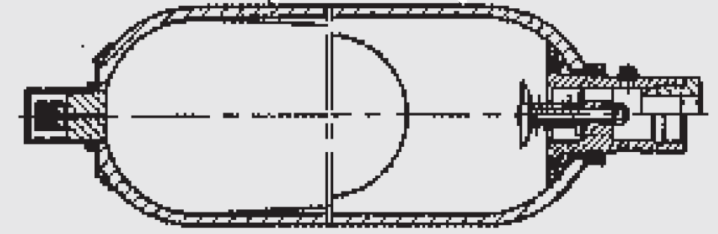

*Figure 2. Diagram of a bladder hydraulic accumulator extracted from the Hydac International user manual (manual code: INT 3.201.BA11/02.19; year=2019) and installed in a wind turbine of the Mazara del Vallo wind farm.*

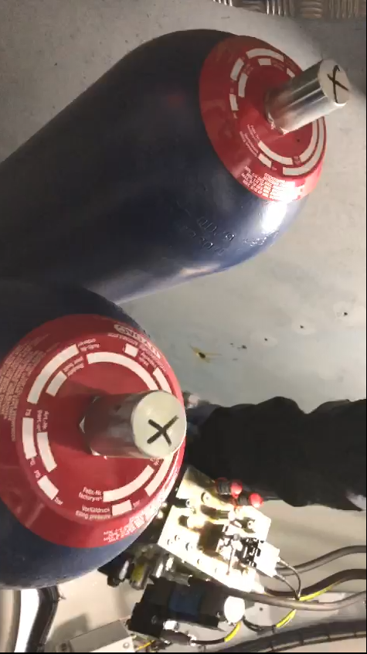

*Figure 3. Picture of two bladder hydraulic accumulators installed inside the nacelle of a wind turbine of the Mazara del Vallo wind farm (province of Trapani), made by the authors.*

* 1. Hydraulic accumulators installed in wind turbine: prevention and pressure risk assessment, operating checks and ten-year integrity checks

The main phases that allow to prevent and evaluate the "pressure" risk during the use of the hydraulic accumulators installed in the wind turbines can be summarized in two main steps:

1. Step 1: Verification of the documentary conformity. Within the European Union (EU), the Employer/Manager of the Wind Turbine (E/MoWT) must verify the documentary conformity of the pressure equipment located inside the wind turbine, designed and built according to the EU directive PED (Pressure Equipment Directive) 2014/68/EU, acquiring from the manufacturer of the aforementioned equipment: a) the EC declaration of conformity to the PED 2014/68/EU directive; b) the manual/s for use and maintenance of the equipment. In addition, the E/MoWT must check the presence of "obvious deficiencies" of the hydraulic accumulators, i.e. verify that accumulators follow the laws and the regulations transposing the EU directives, which the manufacturer has not followed correctly in the design and construction phase, also checking whether the hydraulic accumulators have suffered damage during transportation or assembling.
2. Step 2: Equipment maintenance. The E/MoWT must have maintenance and accumulator checks carried out over time (carried out with its own personnel, already competent or adequately trained, or with suitable external specialized personnel) following the instructions in the user and maintenance manual provided by the manufacturer. Maintenance operations, ordinary or extraordinary, must always be recorded by the employer in a specific control register. Furthermore, in several EU countries, in addition to the checks required by the manufacturer, it is necessary to carry out appropriate periodic checks established by national laws.

In Italy, the E/MoWT must communicate the commissioning of the aforementioned equipment to INAIL (National Institute for Insurance against Accidents at Work), exclusively on-line via "CIVA" application (available on the INAIL website), receiving an identification number from INAIL for each equipment (Grillone et al, 2020). After receiving the identification numbers of all work equipment, the E/MoWT has the above-mentioned pressure equipment subjected to commissioning check by technicians of INAIL, as required by the Decree of the Ministry of Productive Activities n. 329, issued on December 1, 2004 (DMPA 329/04), that exempts the check of hydraulic accumulators with a capacity of less than 25 liters.

After the commissioning phase of the pressure equipment, the E/MoWT has the aforementioned pressure equipment subjected to appropriate periodic checks (L.D. 81/08, DMLSP 11/04/2011) and in particular to:

1. First periodic check of the pressure equipment**.** Italian laws provides that the first periodic check of the pressure equipment is carried out by INAIL, which must provide (directly or through the assignment conferred to a Private Qualified Entity, authorized by the Ministry of Labor and chosen by the E/MoWT, hereinafter referred to "SA") within 45 days of its request. After this period, the E/MoWT entrusts the first periodic check of the pressure equipment to a SA of its choice.
2. Periodic checks of the pressure equipment following the first one. The E/MoWT must have the periodic checks of the pressure equipment carried out, after the first one, by the competent regional structures (Local Health Authorities, LHA, Regional Environmental Protection Agencies, REPA), or by a SA authorized to operate in the regional area concerned.

According to the authors’ checks carried out for INAIL, the commissioning check and the first periodic check of the hydraulic accumulators installed in the wind turbines, consisting in checking the correct functioning of the accumulators themselves and the adequacy of the safety devices installed, almost always had a positive result.

The periodic checks following the first one, provided by Italian laws, which, as mentioned, are carried out by the LHA, REPA or by the SA (DMPA 329/04, L.D. 81/08 and DMLSP 11/04/2011), can be divided into two types: functioning checks and ten-year integrity checks.

Operational check of the hydraulic accumulators installed in the wind turbine (in Italy to be carried out at least every 3 years as the fluid is "non-dangerous", see: DMPA 329/04, L.D. 81/08 and DMLSP 11/04/2011), consists of:

1. check that the actual conditions of use are in accordance with the manufacturer’s instructions contained in the user manual and maintenance of the hydraulic accumulator;
2. verify the functionality of the accessories/safety devices, carrying out "bench" tests for the overpressure valves, with simulations, or, where it is not prejudicial to the operating conditions, determining the intervention on site. It should be emphasized that the overpressure valves included in the hydraulic system of the wind turbine (including the hydraulic accumulators) must be periodically calibrated "on the bench" or possibly replaced with others of equal characteristics (acquiring suitable construction and calibration certification from the manufacturer).

It should also be noted that the overpressure valves present in the hydraulic system of the wind turbine must be dimensioned to allow the release of the highest estimated oil flow, according to an assessment by a technician delegated by the E/MoWT, depending on the following causes which can determine the intervention of the valves themselves:

1. operating faults, such as maneuvering errors, failures of automatic controls and automatic adjustment mechanisms including pressure reduction devices, heat supply from external sources not due to fire, etc. etc.;
2. external fire, not to be taken into account when, according to the user’s declaration, the presence of flammable substances, solid or liquid, in sufficient quantities to ignite a fire, is excluded in the area where accumulator is installed.

The operation checks of the hydraulic accumulators installed in the wind turbines, as ascertained by authors’ checks carried out for INAIL (i.e. commissioning or first periodic verification of the hydraulic accumulators installed in the wind turbines) gave positive results in 95% of cases (checks on wind turbines in Western Sicily).

The ten-year integrity check of the pressure equipment, and therefore also of the hydraulic accumulators installed in the wind turbine, mandatory in Italy according to DMPA 329/04, L.D. 81/08 and DMLSP 11/04/2011, has been effective in showing an early degradation of pressure equipment (initial thickness decrease of the casing, generalized or localized, etc.), which if it is not properly managed on time can lead to serious accidents. This problem is accentuated in hydraulic accumulators because they can operate at a maximum operating pressure higher than 300 bar.

The abovementioned ten-year integrity check consists in inspecting the various components of the pressure equipment by internal (if it is possible) and external visual inspection of the equipment and checks on the thickness of the accumulator.

If the visual and/or instrumental examination reveals defects which may affect the normal operation of the equipment, appropriate additional investigations must be undertaken to determine the extent of the defect and, where it is possible, its possible origin, in order to take the most appropriate action to restore the structural integrity of the component, or to assess the level of safety commensurate with the time of further operating of the equipment with the permanence of the defects found.

To date, the ten-year integrity checks of the hydraulic accumulators installed in wind turbine located in Italy, according to what is known to the authors, have not yet been carried out because only a few years ago they are registered and subjected to the procedures of commissioning and subsequent first periodic check by INAIL.

However, the authors suggest to E/MoWT to carry out a continuous monitoring of hydraulic accumulators with expert personnel, in order to highlight any decrease in the thickness of such equipment; the frequency of these checks must take into account the type of environment and, in particular, whether the environment itself is corrosive. It is also advisable to extend these checks to pipes and pressure tanks of less than 25 liters in capacity.

As noted by the authors in their work at Inail for similar pressure equipment (i.e. with operating conditions of pressure and temperature comparable), the ten-year integrity checks recommend replacing the pressure equipment if initial corrosion steps are found.

In this case, if the replacement of pressure equipment is envisaged for this reason and it is necessary to use the aforementioned equipment for a short period, it is necessary, in advance, to acquire a technical study regarding the residual life assessment of the equipment carried out by a technician expert in this sector.

* 1. Conclusions

The focus of this article is to provide the Employer/manager of the wind turbines with useful suggestions to prevent and assess the "pressure" risk for the hydraulic accumulators installed in the nacelle of wind turbine itself, specifying what are the main phases which allow the assessing of the risk, during use phase, of the aforementioned work equipment and to furnish a general overview of the checks required by Italian legislation for the hydraulic accumulators installed in the nacelle of the wind turbine.

The commissioning check and the first periodic check of the hydraulic accumulators installed in the wind turbines, foreseen by Italian laws and executed by the authors, consisting in checking the correct functioning of the accumulators themselves and the adequacy of the safety devices installed, gave positive results in 95% of cases (checks on wind turbines in Western Sicily).

To date, the ten-year integrity checks of the hydraulic accumulators installed in wind turbine located in Italy have not yet been carried out because only a few years ago they are registered and subjected to the procedures of commissioning and subsequent first periodic check by INAIL. Therefore, further studies and checks on these pressure equipment are desirable in the next years.

References

DMLSP 11/04/2011: Decree of the Ministry of Labor and Social Policies issued on April 11, 2011. Regulation of the methods for carrying out the periodic checks referred to in Annex VII of the legislative decree of 9 April 2008, n. 81, as well as the criteria for the qualification of the subjects referred to in article 71, paragraph 13, of the same legislative decree. Official Journal of the Italian Republic, General Series n.98 (29 April 2011), Ordinary Supplement n. 111.

DMPA 329/04: Decree of the Ministry of Productive Activities n. 329 issued on December 1, 2004. Regulation laying down rules for the commissioning and use of pressure equipment and assemblies referred to in article 19 of the legislative decree of 25 February 2000, n. 93. Official Journal of the Italian Republic, General Series n.22 (01/28/2005), Ordinary Supplement n. 10.

European Union, 2014, Directive 2014/68/EU of the European Parliament and of the Council of 15 May 2014 on the harmonization of the laws of the Member States relating to the making available on the market of pressure equipment (recast), Official Journal of the European Union, N. 189, 27.6.2014, p. 164–259.

Grillone G., Muratore A., Nastasi V., 2020, Gestione in sicurezza degli Idroestrattori a forza centrifuga nell’industria alimentare: obblighi del datore di lavoro (Safe management of centrifugal hydro-extractors in food industry: obligations of employer), Industrie Alimentari, Vol. 59, n. 612, May 2020, 5-11.

Hydac International, Operating Instructions for Bladder Accumulators, Manual code: INT 3.201.BA11/02.19, 2019.

L.D. 81/08: Legislative Decree 9 April 2008, n. 81, as modified by Legislative Decree 3 August 2009, n. 109. “Implementation of Article 1 of Law 3 August 2007, no. 123, concerning the protection of health and safety in the workplace”, Official Journal of the Italian Republic, General Series n. 101, 30 April 2008 - Ordinary Supplement n. 108; Supplementary Decree: Official Journal of the Italian Republic, General Series n. 180, 5 August 2009 - Ordinary Supplement n. 142/L.

Muratore A., Giannelli G., Nastasi V., Sferruzza G., Grillone G., 2021, Risk assessment of pressure equipment during use phase, Proceedings of the 31th European Safety and Reliability Conference, Angers, France, 19-23 September 2021, ESREL2021 Organizers, Publisher: Research Publishing, Singapore. ISBN: 978-981-18-2016-8, pp.2420-2425, doi: 10.3850/978-981-18-2016-8\_305-cd.