CHEMICAL ENGINEERING TRANSACTIONS  VOL. , 2023 | A publication of
The Italian Association
of Chemical Engineering
Online at www.cetjournal.it

Guest Editors: David Bogle, Flavio Manenti, Piero Salatino
Copyright © 2023, AIDIC Servizi S.r.l.
ISBN 979-12-81206-04-5; ISSN 2283-9216

Development of a Methodology for the Identification of High Emitting Mobile Sources in Narrow and Deep Street Canyons
Domenico Toscano*, Benedetto Mele, Fabio Murena
Department of Chemical, Materials and Production Engineering University of Naples, Piazzale V. Tecchio 80, 80125
domenico.toscano@unina.it
In urban areas transport represents a significant source of atmospheric pollutants and greenhouse gases (GHG). In the case of vehicular transport, a significant contribution to total emissions is given by a category of vehicles with excessively high emissions of one or more pollutants defined as high emitting vehicles (high-emitters). High emitters can contribute a disproportionally way to total emissions of many airborne pollutants (NOx, COV, PM and GHGs). Remote sensing (RS) techniques have been developed with the aim to identify high emitterss but until now they have found only few practical applications. Among RS technologies, point sampling (PS) is the most promising for implementation in narrow and deep street canyons due to the limited impact on both pedestrians and architecture and the small space occupancy. In this paper we present results of preliminary monitoring campaigns carried out in a narrow and deep street canyon in Naples (Italy) in low-traffic conditions. Fine particles (FPs) concentration (20-1000 nm) were monitored using a condensation particle counter (CPC). Time patterns of FPs concentration have been analyzed by a code developed in MATLAB to identify FP concentration peaks and successively to attribute each identified peak to a specific vehicle. To study the effect of operating conditions (wind speed and direction) on the plume formed by vehicle exhausts, CFD simulations have been also carried out. Results show good performances of the code in the identification of FPs peaks and a limited effect of ambient parameters on the dispersion of the plumes inside the street canyon studied.
  - Introduction
Despite the recent implementation of more stringent standards for anthropogenic emissions, the goal of urban air quality remains a difficult task globally. Motor vehicles are a major source of air pollutant emissions in urban areas. Exposure to motor vehicle emissions has several effects on human health, particularly asthma and other respiratory symptoms, as well as cardiovascular effects, which have a certain impact on premature mortality (Hoek et al. 2013). It has previously been proposed that a small fraction of vehicles (i.e. "high emitters") contribute disproportionally to a large fraction of total fleet emissions (Ahn et al., 2004). Several reasons exist as to why a vehicle can belong to the high emitters category: lack of maintenance, tampering interventions of the engine or the exhaust treatment units, use of defeat device, use of illegal fuels and others. Vehicle exhaust emissions tend to increase with the vehicle’s age due to deterioration of the engine controls, the catalyst and potentially the particle filter (Chen and Borken-Kleefeld, 2016). Identifying and then repairing or removing these vehicles identified as high-emitters is a cost-effective strategy for reducing on-road vehicle emissions. Remote sensing (RS) has enormous potential for identifying high-emitters because RS devices can remotely measure the emission rates of a large number of vehicles during pass-by without disrupting traffic (Bishop et al., 2000). One significant issue is that RS devices only take snapshot measurements as vehicles pass by the sensor (equivalent to emissions in less than a second), making it impossible to characterize the average emission level of individual vehicles over a representative driving period (Huang et al., 2018; 2020). The development of RS technology in narrow and deep street canyons must contend with the complication of building facades, which can alter the formation of the plume and the pollutant concentration field. Furthermore, due to the passage of pedestrians and the historical value of the streets, the use of most common horizontal or vertical monitoring systems is inappropriate. As a result, there is a specific need to develop RS systems for use in narrow and deep street canyons in order to prohibit the circulation of dirty vehicles in all historic centres present in the majority of European cities. In comparison to cross-road and top-down technologies, a point sampling (PS) technique appears to be more appropriate for this type of application. Street canyons in urban areas can be a source of pollution due to the aspect ratio H/W (building height/street width) (Vardoulakis et al. 2003). When H/W > 1.5, the street canyon is considered deep, and pollutants emitted at street level can accumulate due to limited air exchange with the surrounding atmosphere. Deep street canyons are common in Naples, raising concerns about air pollution (Murena, 2020). Naples' vehicle fleet is quite old. As a result, vehicle maintenance and configuration may play a significant role in determining real-world emissions. Murena and Prati (2020) found that high emitters gave a significant contribution to local air quality. In this paper, we examine data from some preliminary monitoring campaigns conducted in a deep street canyon typical of many historical urban centers in the Mediterranean region. The goal is to investigate some issues in the development of a procedure for identifying high emitters in narrow and deep street canyons using a PS technique measuring fine particle (FP) concentration. CFD was used to investigate the effect of operating conditions (wind speed and direction) on the plume released by vehicle exhausts. The results show that the code performs well in identifying FPs peaks.
  - Material and Methods
    - The monitoring area
The monitoring campaign was performed in the historic centre of Naples in via S. Anna di palazzo (SAP) (Figure 1a). The street is ≈ 5.5 m width and has an average building height of about 20 m with an aspect ratio (H/W) ≈ 4. The average traffic was 57 vehicles/hour. Therefore, it is defined as a low-traffic street.
a)  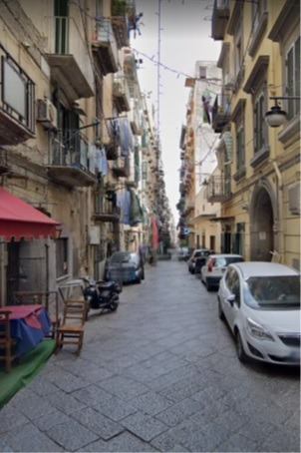 | b)  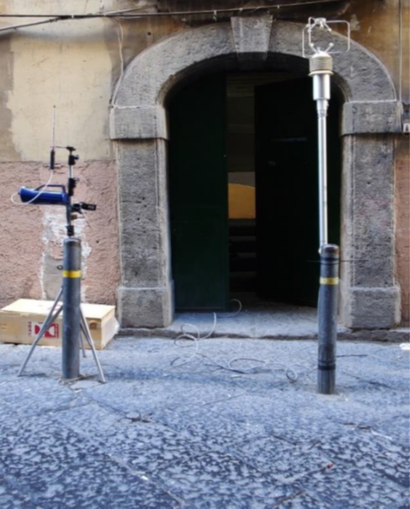
Figure 1. a) via Sant’Anna di Palazzo (SAP), b) the sampling point setting
    - Instruments
The remote sensing system included: a condensation particle counter (CPC), a sonic anemometer and a video camera (Figure 1b). The measurements were taken in different periods from November 2020 to February 2022. The sampling point was at about 0.75 m from the building façade and H= 2 m from soil. A P-Track 8525 condensation particle counter (CPC) was used to measure particle number concentration from 20 to 1000 nm. This range of measure includes the fraction of atmospheric aerosol named fine particles (FPs) and a part of ultrafine particles (UFPs < 100 nm) (Kumar et al., 2010). Full scale of the instrument is 5∙10⁵ particles/cm³ and the frequency of measurements is 1 Hz. The vehicular flow was recorded with a CX200 Sony Handy camera. The stored videos were analyzed to register the passage of vehicles lumped into three categories: i) four-wheels vehicles (4WV); ii) two-wheels vehicles (2WV); iii) light duty vehicles (LDV). Since the street is very narrow, high duty vehicles were not present.
The three components of air velocity (u,v,w) and temperature were measured inside the street canyon with a 50 Hz frequency using a sonic anemometer (OHM HD2003).
    - Data processing
A data processing elaboration has been developed by a MATLAB code to compute background concentration, identify FP peaks, and finally select those that could be attributed to high emitters. A sensitive analysis was carried out to investigate the effect of data processing parameters on the results, with the goal of optimizing high emitter identification. Background concentration was evaluated in two different ways:

- taking a rolling 1-2-minute block 5th percentile or minimum centred on the 10-s period of interest for each measurement.
- assuming a constant background equal to the 5th percentile or minimum concentration during each measurement.

To identify FP peaks, a cut-off concentration was determined by multiplying background concentration by a factor in the range of 2-3. A peak start time was set when concentration is greater than cut-off, and a peak end time was set when concentration became cut-off. The peaks are assumed to be high emitter plume exhausts. This method is similar to that described by Kelp et al (2020).
    - The CFD model
The effect of operating conditions (wind speed and direction) on the plume formed by vehicle exhausts has been studied carrying out CFD simulations. An idealized street canyon with the same geometric of SAP has been modelled in FLUENT. A mesh of about 7∙10⁵ hexahedral cells with refinements at the walls was generated. The unsteady incompressible formulation of Navier-Stokes equations were solved with the steady Reynolds-averaged Navier Stokes (RANS) equations, with a k-ω shear-stress transport (SST) turbulence model. In order to describe the moving vehicles a “dynamic mesh update" technique has been applied. The source was represented as a circle with a diameter of 6 cm located at 25 cm height from the ground, moving at fixed velocity of 5 m/s (18 km/h) along a line at distance of 1.65 m from the receptor.
  - Results
An example of FP time series diagrams measured by the CPC is reported in Fig. 1. The solid line corresponds to FPs concentration while the vertical and dotted lines indicate the time a vehicle is passing at the monitoring site. Depending on the vehicle’s category, dotted lines have different colours: green for cars (4W); red for motorcycles (2W) and yellow for light-duty (LD) vehicles.
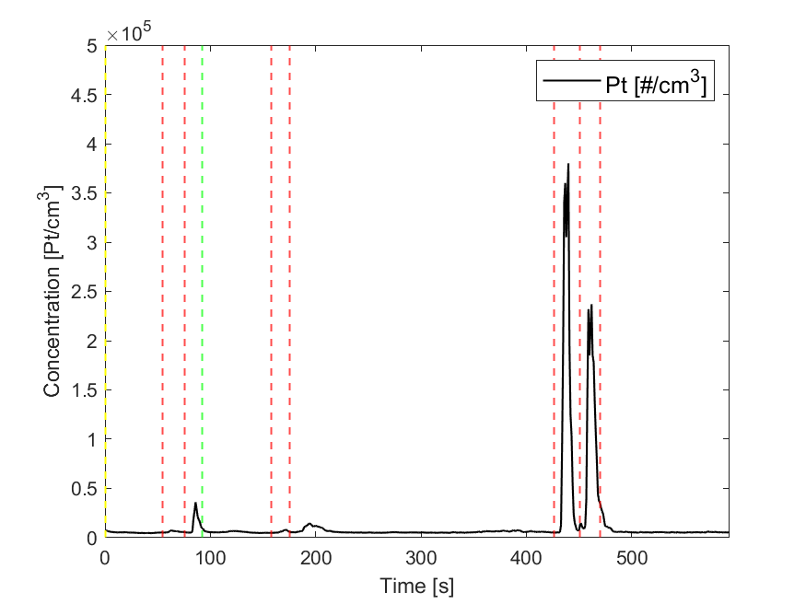
Figure 2 Time series of FPs concentration diagram. Vertical lines indicate the passage of a vehicle: green (4W), red (2W), yellow (LDV)
The time patterns of FPs concentration (Figure 2) are chromatogram-like diagrams composed of a baseline—quite constant during each measurement—and some concentration peaks. In this case it is possible to observe the presence of three peaks. The first peak is at 87 seconds, the second at 440 s and the last at 462 s. Identification of vehicles generating the peaks is easy and it is also possible to calculate the time interval between the passage of the vehicle and the time the peak reaches the maximum value. This is defined as the delay time of the peak maximum and in this case they are 11, 14 and 11 s respectively. Several parameters can affect delay times, including the distance between the source and the sampling point, vehicle speed and shape, and wind speed and direction (Li et al., 2019). Wind speed and direction can also have an impact on RS measurements (Huang et al., 2022). However, in narrow and deep street canyons, the ranges of variation in vehicle and wind speed are limited. The wind direction at the canyon's bottom is primarily parallel to the street axis and can only change if it is co-current or counter-current with vehicle movement. The delay time in a deep street canyon is strongly site dependent, so a sensitivity study using computational fluid dynamic (CFD) simulations of exhaust plumes tailored to the case study is required.

The following environmental conditions have been investigated with CFD:
- wind speed from 0 to 0.5 m/s.
- wind direction parallel to the street axis toward or opposite with that of the moving vehicle.

Figure 2 shows the concentration time pattern in function of wind speed assuming the direction of the wind is opposite to that of the vehicle's advancement. It can be observed that as the wind speed increases there is an increase in the peak delay time and a reduction in the maximum concentration. In fact, a higher wind speed dilutes the pollutant emitted by the source and therefore reduces the concentration.

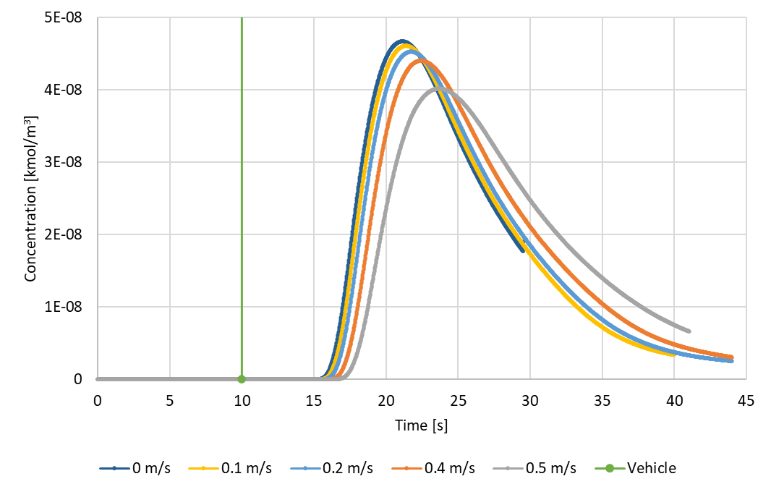
Figure 3. Results of CFD simulation. Effect of the wind velocity. Green line indicates the passage of the vehicle.
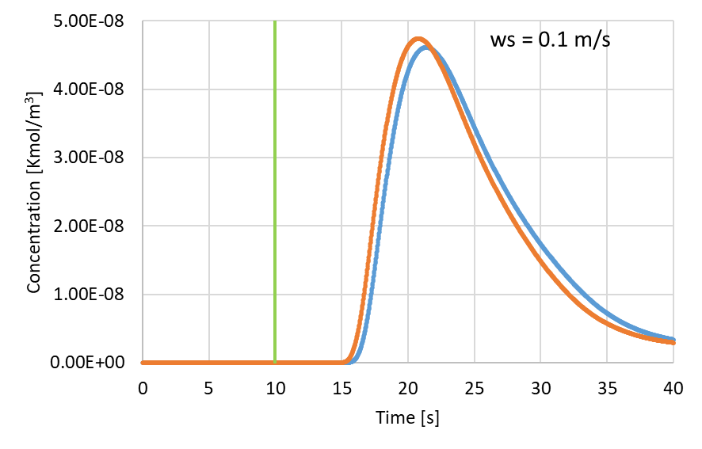
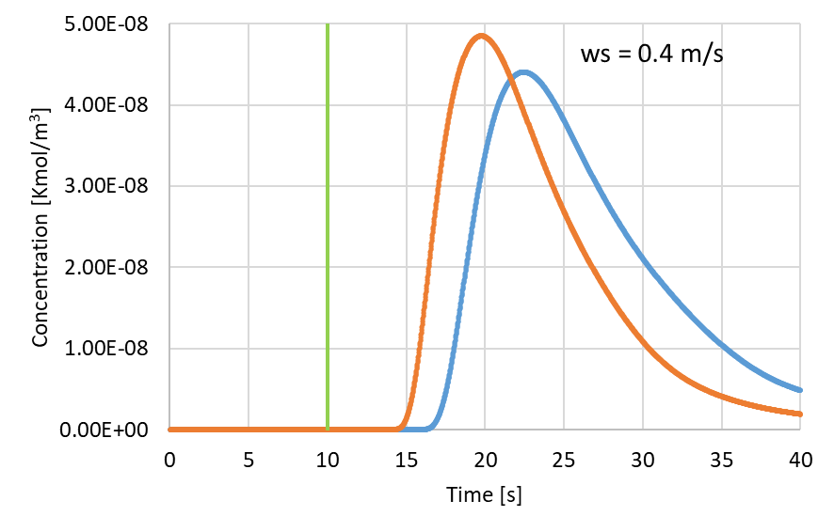
Figure 4. Results of CFD simulations. Effect of wind direction. Opposite (blue line) or concordant (orange line) with vehicle’s direction. Up wind speed = 0.1 m/s; down wind speed 0.4 m/s.
The effect of the wind direction depends on the wind speed. There is no difference between opposite and concordant wind direction in case of low wind speed (Fig. 4 up) and about two seconds in the delay time when wind speed = 0.4 m/s (Figure 4 down).
.
The effect of the wind direction depends on the wind speed. There is no difference between opposite and concordant wind direction in case of low wind speed (Fig. 43 up) and about two seconds in the delay time when wind speed = 0.4 m/s (Figure 43 down).
The results of the CFD simulations were analyzed to evaluate the characteristic peak delay times relative to the passage of the vehicle. Firstly, the maximum pollutant concentration value was calculated for each simulated scenario, along with the corresponding time at which it occurs. The time at which the concentration reaches 1% of the maximum value was hypothesized as the start time of the peak. Subsequently, the end time of the peak was calculated as the time when the concentration, after reaching the maximum, drops to 10% of the maximum concentration. The peak duration was determined as the difference between the start and end times. Finally, the delay times were calculated as the difference between the start time and the time of the maximum relative to the vehicle passage time and these. These calculated values represent the characteristic peak times and ranging from 6 to 12 s, and the peak duration varies between 19 and 32 seconds. However, experimentally, analysing all the FP concentration time patterns measured, it was possible to observe that the delay time of peak maximum was in the range from 11 to 24 s. Furthermore, there is a significant difference in the amplitude of the peak as well. In real-world situations, the amplitude of the peak is much greater than that simulated by the CFD model. The discrepancy in these temporal intervals could be attributed to the fact that the effect of turbulence induced by the vehicle shape was not simulated.
The delay time of the peak maximum is an important parameter for the development of the PS technology. In fact, only if the value of this parameter is known it is possible to identify the vehicle whose emissions have generated the peak.
  - Conclusions
Preliminary tests carried out in a low traffic narrow and deep street canyon showed the potentiality of RS technique for the identification of high emitter vehicles measuring FP concentrations with a CPC. The results show that in case of low-traffic FP concentration peaks can be accurately identified in narrow and deep street canyons.
An accurate identification of high emitters requires the assessment of the delay time of peaks which can be influenced by some operating conditions.
A sensitive study on the effect of operating conditions on the value of the delay time was performed developing a CFD model for a street canyon with the same geometry of the case study. The simulations show that both wind speed and direction have a limited effect on the delay time of peak maximum. As a matter of fact, in narrow and deep street canyon the ranges of variation of both wind speed and direction are limited. More research is necessary to verify the possibility of application of the methodology in case of high traffic. It is mandatory to carry out monitoring campaigns in narrow and deep street canyons with high traffic. It is also necessary to develop a more accurate CFD model, taking in count the shape of the vehicles and the effect of induced turbulence.
In case of high traffic identification of high emitters could more uncertain due to the passage of more than one vehicle in the time interval corresponding to the delay time of maximum.
References
Ahn, K., Rakha, H., & Trani, A. (2004). Microframework for modeling of high-emitting vehicles. Transportation Research Record, 1880(1), 39-49.
Bishop, G. A., Stedman, D. H., Hutton, R. B., Bohren, L., & Lacey, N. (2000). Drive-by motor vehicle emissions: immediate feedback in reducing air pollution. Environmental science & technology, 34(6), 1110-1116.
Chen, Y., & Borken-Kleefeld, J. (2016). NO x emissions from diesel passenger cars worsen with age. Environmental science & technology, 50(7), 3327-3332.
Hoek, G.; Krishnan, R.M.; Beelen, R.; Peters, A.; Ostro, B.; Brunekreef, B.; Kaufman, J.D., 2013. Long-term air pollution exposure and cardio- respiratory mortality: A review. Environmental Health, 12, 43.
Huang, Y., Lee, C. K., Yam, Y. S., Mok, W. C., Zhou, J. L., Zhuang, Y., ... & Chan, E. F. (2022). Rapid detection of high-emitting vehicles by on-road remote sensing technology improves urban air quality. Science Advances, 8(5), eabl7575.
Huang, Y., Organ, B., Zhou, J. L., Surawski, N. C., Hong, G., Chan, E. F., & Yam, Y. S. (2018). Remote sensing of on-road vehicle emissions: Mechanism, applications and a case study from Hong Kong. Atmospheric Environment, 182, 58-74.
Huang, Y., Surawski, N. C., Yam, Y. S., Lee, C. K., Zhou, J. L., Organ, B., & Chan, E. F. (2020). Re-evaluating effectiveness of vehicle emission control programmes targeting high-emitters. Nature Sustainability, 3(11), 904-907.
Kelp M., Gould T., Austin E., Marshall J.D., Yost M., Simpson C., LarsonT. Sensitivity analysis of area-wide, mobile source emission factors to high-emitter vehicles in Los Angeles. Atmospheric Environment 223 (2020) 117212.
Li, B., Li, X. B., Li, C., Zhu, Y., Peng, Z. R., Wang, Z., & Lu, S. J. (2019). Impacts of wind fields on the distribution patterns of traffic emitted particles in urban residential areas. Transportation Research Part D: Transport and Environment, 68, 122-136
Murena and M.V. Prati “The contribution of high emitters vehicles to FPs number concentration in the historical center of Naples” 12th International Conference on Air Quality – Science and Application Thessaloniki, 9-13 March 2020
Murena F. Sustainable Development of the Historic Centre of Naples: The Impact of Vehicular Traffic and Food Service Business on Air Quality. Atmosphere 2020, 11, 938; doi:10.3390/atmos11090938.
Vardoulakis, S., Fisher, B. E., Pericleous, K., & Gonzalez-Flesca, N. (2003). Modelling air quality in street canyons: a review. Atmospheric environment, 37(2), 155-182.

