CHEMICAL ENGINEERING TRANSACTIONS  VOL. , 2023 | A publication of
The Italian Association
of Chemical Engineering
Online at www.cetjournal.it

Guest Editors: David Bogle, Flavio Manenti, Piero Salatino
Copyright © 2023, AIDIC Servizi S.r.l.
ISBN 979-12-81206-04-5; ISSN 2283-9216

Production of Urea-based De-NO_{x} Reduction Agents with Minimum Additional Contributions to the GHG Emissions
Damiano Visciottiª
ªTecnimont SpA (MAIRE Group), via Gaetano de Castillia 6A, 20124 Milano - Italy
d.visciotti@tecnimont.it

The present paper is a review of the most viable, sustainable, and carbon-neutral industrial routes available for producing urea based de-NO_{x} reduction agents (e.g., AdBlue 32%), with a negligeable contribution to the GHG emissions, in comparison with the conventional current applications.
Starting from the analysis of the trend in the demand of urea-based de-NO_{x} agents and the forecast growth of such market, the study provides a quantitative assessment of the contribution to the GHG emissions due to the common production routes of these chemicals, showing an alternative industrial process which balances and neutralizes this adverse environmental effect.
Indeed, some carbon-intensive industrial processes such as cement or steel productions have, as of now, no feasible way to avoid or significantly limit CO₂ emissions from their flue gas waste streams.
The integration schemes with such existing large CO₂ point emitters are investigated with the objective to produce a carbon-neutral urea-based de-NO_{x} agent with minimum additional contributions to the GHG emissions.
- Introduction
Nitrogen oxides are well known to be troublesome gaseous components polluting atmospheric air. Among the nitrogen oxides forms (N₂O, NO, N₂O₃, NO₂, N₂O₄, N₂O₅), the most common in atmospheric air are nitrogen oxide (NO) and nitrogen dioxide (NO₂), which total content is marked with a common symbol NO_{x}.
Though nitrogen oxides have also non-anthropic origin, as instance the denitrification natural process of soils (Abbasi and Adams, 2000), the predominant source is represented by all combustion processes of solid, liquid and gas fuels. Several industrial activities heavily contribute to produce NO_{x} polluted flue gas: transport and automotive, power plants, industrial processes (mostly nitric acid and derivatives) and municipal solid waste incineration.
NO_{x} emissions can cause a series of health problems, such as eye and throat inflammation, chest tightness, nausea, and headaches, as well as environmental problems, such as ozone depletion, acid rain, haze, photochemical smog, and indirect greenhouse gas effects (Fuglestvedt et al., 1996). Therefore, NO_{x} emissions must be reduced and controlled.
Most common NO_{x} control methods can be categorized into following ones (Zhu and Xu, 2022):
- pre-combustion (e.g. by selecting fuel sources with less nitrogen content),
- in-combustion (e.g. low NO_{x} burners), and
- post-combustion (via reaction with absorbents, oxidants, or reductants).
By using the first two control methods, most of the exhaust gases from industrial combustion processes cannot meet emission standards. Therefore, a post-combustion approach is usually used to achieve a higher NO_{x} reduction. The most widely used post-combustion technique is the Selective Catalytic Reduction (SCR), which reduces NO_{x} into molecular nitrogen (N₂) by heterogeneous catalytic reaction with gaseous ammonia under moderate temperature (preferably in the range 250÷350 °C). Gaseous ammonia can be introduced into the flue gas chamber either as straight ammonia, or as other ammonia precursor, that releases gaseous ammonia after thermal decomposition in contact with hot flue gas.
The current orientation of the market, between the different precursors of gaseous ammonia, is in favor of the usage of urea [CO(NH₂)₂] diluted in a water solution, as it is not toxic in comparison with water-ammonia solutions, and it is produced worldwide on a large scale, which makes it widely available (Halonen et al., 2017).
It is well known that the production process of urea, as well as the further thermal decomposition of the same into CO₂ and NH₃ occurring in the SCR flue gas system, have a significant contribution to GHG emissions.
The demand of de-NO_{x} reduction agents is expected growing quickly in the next years, due to more stringent legislation on emissions of NO_{x} gases (such as the Directive 2010/75/EU).
Based on the data currently available of CO₂ emissions from Energy Combustion and Industrial Process (IEA, 2021), a forecast of 80 Mt/y has been estimated for the world-scale demand of urea based de-NO_{x} reduction agents within the year 2040, for matching the most stringent NO_{x} emission scenarios (see table 1). The estimate is coherent with the available forecast in cutting the worldwide NO_{x} emissions from current 108 Mt/y to 45 Mt/y in 2040 (IEA, 2022). Such expected demand of urea based de-NO_{x} reduction agents, assuming a conventional production route based on natural gas, would generate in the year 2040 an amount of GHG emissions more than 90 Mt CO_{2 eq.}/y.
It is not sustainable that the control of NO_{x} emissions generates a drawback effect with detrimental effects over the environment. It is then of interest to study and develop alternative routes, aimed to produce urea based de-NO_{x} reduction agents, that have the advantage of negligeable GHG effects.
- Mechanism of NO_{x} Reduction Reactions
As discussed by Halonen et al. (2017), one of the most widespread de-NO_{x} reduction agents for SCR systems is urea diluted in a water solution. The trade name for the urea-water solution is AdBlue in Europe and DEF (Diesel Exhaust Fluid) in the US. In the automotive industry, urea with a concentration of 32.5 wt% is typically used. This concentration was chosen because it is the concentration with the lowest crystallization point of – 11 °C even though higher concentrations of up to 50 wt% can be used (marine grade).
A simplified scheme of the thermal decomposition of urea in flue gas and NO_{x} reduction reactions with ammonia in SCR systems is given below (Maizak et al., 2020):
CO(NH₂)₂ → NH₃ + HCNO (1)
H₂O + HCNO → NH₃ + CO₂ (2)
NO + NH₃ + ¼ O₂ → N₂ + ³/₂ H₂O (3)
NO + NO₂ + 2 NH₃ → 2 N₂ + 3 H₂O (4)
4 NH₃ + 3 O₂ → 2 N₂ + 6 H₂O (5)
2 NH₃ + 2 O₂ → N₂O + 3 H₂O (6)
2 NH3 + 2 NO₂ + 2 H₂O → NH₄NO₃ + NH₄NO₂ (7)
In the preferred temperature range of SCR systems (i.e. 250÷350 °C), reactions (1) to (4) are sufficient to represent adequately the thermodynamic of the system.
As per stoichiometry, every 1 mol of NO_{x} being reduced into N₂ is balanced by 1 mol of NH₃ being depleted.
Assuming the ammonia slip is negligeable for our considerations, based on reactions (1) and (2), 1 mol of urea is then sufficient for reducing 2 mols of NO_{x} into N₂.
- Forecast of the Demand of De-NO_{x} Reduction Agents and Relevant GHG Impact
Though the current market of urea based de-NO_{x} reduction agents is only 6 Mt/y in comparison with the world urea production of 170 Mt/y (Argus and Fertecon, 2021), the demand is expected to increase quickly, motivated by the growing stringency of legislation on emissions of NO_{x} gases (Directive 2010/75/EU and following 2017 LCP BREF). The forecast is that the industrial sector with dominating demand of de-NO_{x} systems will be the massive coal and natural gas fired power generation sector, which alone represents half of the current world Total Energy Supply (IEA, 2021).
An estimate for the potential demand of urea de-NO_{x} reduction agents has been carried out considering the mechanism of reaction explained in paragraph 2, together with the flue gas emission database available for combustion sources in the energy and industrial process, and the NO_{x} emission scenarios outlined by the IEA study (2022) for the next two decades.

Data available from the European IPPC Bureau (2007) have been used to appraise the GHG emissions correlated to the increased demand of urea; the figure 1 provides a summary of main GHG contributors of the conventional urea process.
The biggest CO₂ contributor is the production of the ammonia via Steam Methane Reformer (SMR), which is equivalent to 0.97 t CO_{2 eq.}/t of urea and represents almost the 85% of GHG generation. The contribution factors due to process heat (steam) and electric energy (required by the transformation and finishing process) represent roughly the 10% and 5% respectively.
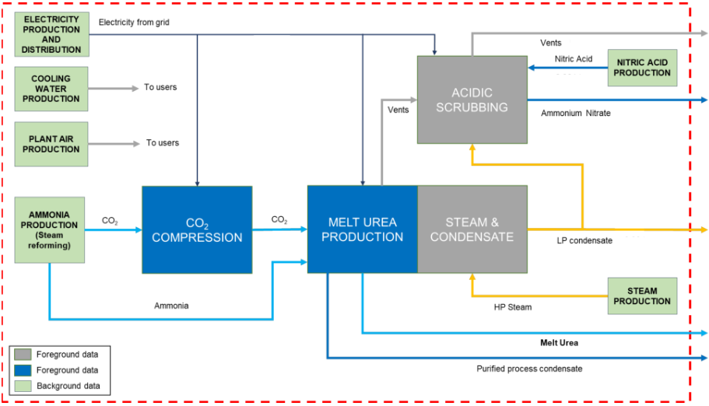
Figure 1: block diagram and main GHG sources of the conventional urea process.
To sum up, the overall carbon footprint of conventional urea production process is 1.17 t CO_{2 eq.}/t (in liquid solution form), or 1.22 kg CO_{2 eq.}/t (in solid granulated form).
The GHG generation due to the expected demand of urea de-NO_{x} agents is outlined in Table 1.
Pollutant or  Product | Coal  (Mt/y) | Natural Gas  (Mt/y) | Oil  (Mt/y)
Current CO₂ emissions | 15,300 | 7,500 | 10,700
Forecast NO_{x} emissions (2040) | 9.8 | 13.7 | 21.5
Forecast Urea de-NO_{x} demand | 23.7 | 33.1 | 23.3
CO₂ eq. GHG | 27.8 | 38.8 | 27.3
Table 1: urea de-NOx worldwide carbon footprint, for future scenarios of reduced NOx emissions, using the urea conventional production process.

It can be concluded that the increased demand of urea de-NO_{x} reduction agents awaited in the next decades, assuming a conventional urea production route based on natural gas, would generate within the year 2040 an amount of GHG emissions more than 90 Mt CO_{2 eq.}/y.
- Carbon Capture Technologies Integrated with Existing Industrial Processes
Power plants and other important industrial activities, such as cement and steel productions, release relatively high amounts of anthropogenic carbon dioxide. Integrating the recovery process of these large point source emitters with new urea plants, expected to be in operation for balancing the increasing demand of de-NO_{x} reduction agents, is seen as a key task to achieve the target of minimizing the GHG effects that otherwise would arise.
To date, most research and development has centered on capturing CO₂ emitted from coal power plants, as these are the largest emitters; however also the CO₂ concentration plays a crucial role in selecting the most suitable and attractive source. In fact, the separation efficiency of every technology is strongly dependent on CO₂ partial pressure, hence the the cost of capture is more beneficial at higher concentrations.
As can be evaluated from table 2, comparing CO₂ emissions from power and large industrial point sources, cement and iron productions look the most attractive industrial processes for the integration with urea production process, for the higher concentration and larger emitter size.
Table 2: Large CO₂ emissions from power and industrial point sources worldwide [Baker et al., 2018].
Source | No of  sources | Total CO₂ emissions  Mt/y | Average source size Mt/y | CO₂ concentration  (% vol.)
Electric power plant | 5,840 | 14,600 | 2.5 | 5÷15
Cement production | 1,180 | 930 | 0.8 | 20÷30
Refineries | 640 | 800 | 1.3 | 30÷40
Iron and steel | 270 | 650 | 2.4 | 20÷30
Petrochemical | 470 | 380 | 0.8 | 5÷10

Several studies have been presented in describing the recent development of cost-effective technologies to capture the CO₂ produced in power plants and industrial processes and utilize or sequester it underground (Figueroa et al., 2008).
The main capture technology currently demonstrated at large scale is the chemical absorption, which makes use of amine based aqueous solvents, such as solutions of methyl-diethanolamine (MDEA) and mono-ethanolamine (MEA), or blend of MDEA and tri-ethylene tetramine (TETA), as discussed by Amann and Bouallou (2009).
The amine solution, once enriched of CO₂ in the Absorber, is then regenerated by stripping at lower pressure and by means of steam. Capacity up to 2.0 Mt/y of captured CO₂ can be commonly achieved.
The use of membranes has emerged as a promising second-generation capture technology for flue gas of power plants (Merkel et al., 2013). Membrane technology is at the development stage with several small pilot plants having been built and operated up to 100 kt/y of CO₂. Membranes are expected to have competitive capture costs, as well as operational advantages such as simple flow scheme and no other power source other than electricity, so that no changes to the power plant steam cycle are needed. (Font-Palma et al., 2021).
Ramírez-Santos et al. (2017) have estimated operation costs of less than € 33/t CO₂ for capture from steel plants. Membranes for CO₂ recovery from flue gas of both steel (Lie et al., 2007) and cement plants (Hägg et al., 2017) have been proven with pilot demonstration.
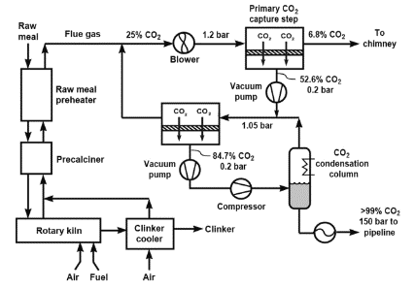
As example of practical applications of membrane separation process, the figure 2 provides a schematic diagram of a cement plant fitted with a membrane CO₂ capture system. Flue gas is available at 25% of CO₂ from kiln furnace. The system captures 80% of the CO₂ emitted (800 t/d) at an energy cost of 286 kW_{e}/t of CO₂ (Baker et al., 2018).

Figure 2: CO₂ membrane capture process applied to a cement plant.

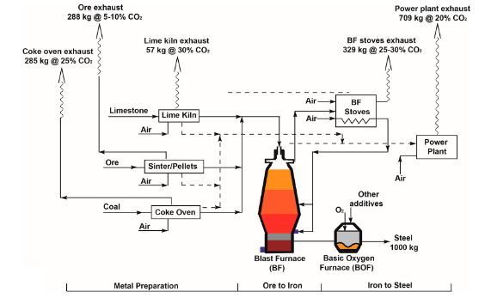
Another promising application for integrated process is shown in figure 3, which provides a simplified block diagram of a steel production process. Total CO₂ emissions are about 1.8 t CO₂/t of steel produced. Exhaust gas from blast furnace (BF) stoves are 28.5% rich in CO₂. Emissions are shown with the CO₂ concentration in the gas and the mass of CO₂ in kg/t of steel produced.

Figure 3: CO₂ emission sources for a blast furnace and BOF steel production process (Global CCS Institute, 2015).
- Production of Urea-based De-NO_{x} Reduction Agents with Minimum GHG Emissions
Here it is presented a case study showing how the GHG contribution of AdBlue urea solution can be minimized with an improved configuration.
5.1 Case Study for the Improved Process
Main assumptions of the case study for the carbon neutral AdBlue plant are:
- Urea is produced in liquid form (AdBlue solution 32%) with a capacity of 500 kt/y via a Total Recycle CO₂ Stripping process;
- Ammonia consumption is assumed 567 kg/t of urea and is supplied from a mix (50%/50%) of blue and green ammonia sources, assuming the relevant carbon contribution is equal to 0.17 and zero t CO_{2 eq.}/t of NH₃ respectively (Mielke and Noelker, 2023);
- The carbon contribution due to transportation of liquid ammonia to the urea plant is assumed 0.3 t CO_{2 eq.}/t of NH₃ (Al-Breiki and Bicer, 2020), assuming ocean tankers fuelled by Heavy Fuel Oil;
- CO₂ feedstock is assumed 740 kg/ton of urea and is sourced from a nearby existing cement plant, captured by means of double stage membrane system;
- Net consumption of process steam is zero by ensuring the recovery of the waste steam generated in the urea reactor to the pressure level required by the Stripping process (see figure 4);
- Both CO₂ and low-pressure steam compressors are driven by electromotor;
- Electricity (for both process and utilities) is produced by a NG fired generator with 40% efficiency.
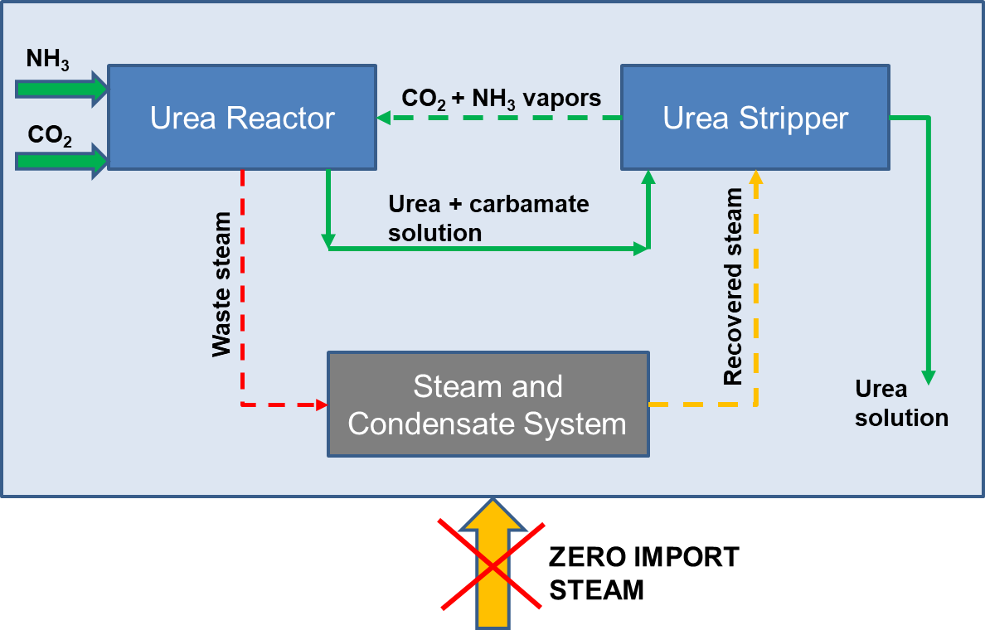

Figure 4: conceptual scheme of the urea melt section with zero import of process steam; the waste steam generated in the urea Reactor is recovered to the pressure level required by the Stripper.

A comparative quantitative analysis of the improved process has been performed against a conventional urea scheme, where the ammonia is produced via SMR, and the excess CO₂ is vented to the atmosphere after separation in the amine recovery section. The assumptions of GHG generation due to the production of the ammonia feedstock are the same ones used for the analysis previously summarized in table 1. In the conventional urea CO₂ Stripping process, the heat for Stripping is provided by medium pressure steam at 2.2 MPa, supplied from a NG fired boiler.
The results of the comparative quantitative analysis in terms of GHG emissions are summarized in table 3.
Table 3: Comparative analysis of GHG emissions between a conventional and improved AdBlue urea plant.
Urea plant | GHG for  NH₃ product.  t CO_{2 eq.}/t urea | GHG for  NH₃ transport  t CO_{2 eq.}/t urea | GHG for  Process steam  t CO_{2 eq.}/t urea | GHG for  Electric power  t CO_{2 eq.}/t urea | Overall GHG emissions  t CO_{2 eq.}/t urea | Absolute GHG emissions Mt CO_{2 eq.}/y
Conventional | 0.97 | 0 | 0.13 | 0.07 | 1.17 | 93.9
Improved | 0.05 | 0.17 | 0 | 0.17 | 0.39 | 31.3
Δ | -0.92 | +0.17 | -0.13 | +0.10 | -0.78 | -62.6

To sum up, the improved AdBlue process can lower the overall GHG emissions (including the contribution of liquid ammonia transportation) of 0.78 t CO_{2 eq.}/t urea, compared with the conventional route. Which means, in terms of absolute emissions, a saving of more than 60 Mt CO_{2 eq.}/y.
- Conclusions
In the next two decades, the demand of urea based de-NO_{x} reduction agents is expected to increase very fast, motivated by the growing stringency of legislation on emissions of NO_{x} gases. The forecast for the worldwide urea consumption as de-NO_{x} reduction agents is 80 Mt/y within the year 2040. The adverse effect of GHG emissions, caused by the conventional industrial production of urea, can be significantly limited by the integration with existing large point emitters, such as cement and steel plants. This work is presenting an improved AdBlue urea process, where the CO₂ is recovered from the flue gas of a typical cement plant, the ammonia is supplied by a mix (50%/50%) of blue and green sources, and the import of process steam is avoided by recovering the waste steam generated in the urea Reactor; within the year 2040, the improved process, despite the incremental demand of urea based de-NO_{x} reduction agents, can lower the expected GHG emissions from 94 down to about 31 Mt CO_{2 eq.}/y, even including the carbon footprint due to ammonia transportation and assuming the required electric energy is fully generated by fossil fuels.

References
Abbasi M. K., Adams W. A., 2000, Gaseous N emission during simultaneous nitrification denitrification associated with mineral N fertilization to a grassland soil under field conditions, Soil Biology and Biochemistry, 32, 1251-1259.
Al-Breiki M., Bicer J., 2020, Comparative cost assessment of sustainable energy carriers produced from natural gas accounting for boil-off gas and social cost of carbon, Energy Report, 6, 1897-1909.
Amann J.M., Bouallou C., 2009, CO₂ Capture from Power Stations Running with Natural Gas (NGCC) and Pulverized Coal (PC): Assessment of a New Chemical Solvent Based on Aqueous Solutions of N-Methyl-Di-Ethanol-Amine plus Tri-Ethylene Tetramine, Energy Procedia, 1. 10.1016
Baker R. W., Freeman B., Kniep J., Huang Y., Merkel T. C., 2018, CO₂ Capture from Cement Plants and Steel Mills Using Membranes, Ind. Eng. Chem. Res., 57, 15963−15970.
European IPPC Bureau, 2007, Reference Document on Best Available Techniques for the Manufacture of Large Volume Inorganic Chemicals - Ammonia, Acids and Fertilisers, 8.3, 327-331.
Figueroa J. D., Fout T., Plasynski S., McIlvried H., Srivastava R. D., 2008, Advances in CO₂ capture technology - The U.S. Department of Energy’s Carbon Sequestration Program, Int. J. Greenhouse Gas Control, 2, 9−20.
Font-Palma C., Cann D., Udemu C., 2021, Review of Cryogenic Carbon Capture Innovations and Their Potential Applications, 7, 58.
Fuglestvedt, J.S., Isaksen, I.S.A., Wang, 1996, Estimates of indirect global warming potentials for CH₄, CO and NO_{x}, Clim. Chang, 34, 405–437.
Global CCS Institute, 2015, Applying carbon capture and storage to a Chinese steel plant.
Hägg M. B., Lindbråthen A., He X., Nodeland S. G., Cantero T., 2017, Pilot Demonstration-reporting on CO₂ Capture from a Cement Plant Using Hollow Fiber Process, Energy Procedia, 114, 6150−6165.
Halonen S., Kangas T., Haataja M., Lassi U., 2017, Urea-water-solution properties: density, viscosity, and surface tension in an under-saturated solution, Emission Control Science and Technology, 3, 161–170.
IEA, Emissions of Nitrogen oxyde (NO_{x}) by sector and scenario 2015-2040, 2022, < iea.org/data-and-statistics/charts/emissions-of-nitrogen-oxyde-nox-by-sector-and-scenario-2015-and-2040>.
IEA, Global Energy Review: CO2 Emissions in 2021, 2021, <iea.org/reports/global-energy-review-co2-emissions-in-2021-2>.
Lie J. A., Vassbotn T., Hägg M. B., Grainger D., Kim T.J., Mejdell T., 2007, Optimization of a membrane process for CO₂ capture in the steelmaking industry, Int. J. Greenhouse Gas Control, 1 (3), 309−317.
Maizak D., Wilberforce T., Olabi A.G., 2020, DeNO_{x} removal techniques for automotive applications: A review, Environmental Advances, 2.
Merkel T. C., Wei X., He Z., White L. S., Wijmans J. G., Baker R. W., 2013, Selective Exhaust Gas Recycle with Membranes for CO₂ Capture from Natural Gas Combined Cycle Power Plants, Ind. Eng. Chem. Res., 52 (3), 1150−1159.
Mielke B., Noelker K., 2023, Blue Ammonia for lower CO₂ emissions, 36th Nitrogen & Syngas Conference, Barcelona.
Ramírez-Santos Á. A., Castel C., Favre E., 2017, Utilization of blast furnace flue gas: Opportunities and challenges for polymeric membrane gas separation processes, J. Membr. Sci., 526, 191−204.
Zhu Z., Xu B., 2022, Purification Technologies for NO_{x} Removal from Flue Gas: A Review, Separations, 9, 307.

