S CHEMICAL ENGINEERING TRANSACTIONS  VOL. , 2023 | A publication of
The Italian Association
of Chemical Engineering
Online at www.cetjournal.it

Guest Editors: David Bogle, Flavio Manenti, Piero Salatino
Copyright © 2023, AIDIC Servizi S.r.l.
ISBN 979-12-81206-04-5; ISSN 2283-9216

The importance of tailoring Carbon Capture design to optimize plant Capex and improve system efficiency
Fabio E.G. Ferrariª. Lucrezia Del Gesso, Paolo Felici, Andrea Orsetti
ªNextChem Spa, via Gaetano de Castillia 6a Milano
f.ferrari@nextchem.it

The necessity to reduce the environmental impact of industrial production sites in the recent years has accelerated the decarbonization strategies of many companies and the possibility to install Post-Combustion Carbon Capture units in new or existing assets has become one of the key elements to achieve the target to minimize plants carbon footprint.
In the installation of such units, it is possible to identify multiple technical solutions that would tailor the implementation of the Carbon Capture unit by optimizing the number of equipment and increase the system efficiency, minimizing the relevant OpEx.
The capability to manage the peculiarities of the specific industry and the criticalities of existing plants would lead to better designed solutions. Two case studies are presented relevant to different technical installations, specifically the Amine Post Combustion Carbon Capture for a Steam Reformer and a Power Generation plant.
The necessity to reduce the flue gas inlet temperature to Carbon Capture unit offers the possibility to improve the heat recovery within the system, therefore increasing the overall efficiency; at the same time a clear identification of the key emission points can provide room to integrate different units, using the same absorption equipment or a single regeneration loop.
The wide range of Carbon Dioxide concentrations that characterizes the different post-Combustion services (i.e. from Reforming to Gasification) shall be combined with the possible presence of critical contaminants, therefore requiring dedicated optimizations that will be described and analyzed in the present paper.
Introduction
The goals agreed during Paris climate accord have committed the world industry in keeping the global warming below 2°C above preindustrial levels, therefore implying a strong reduction in CO₂ emissions of about 40% to be achieved by 2030.
Among the different technical solutions, Carbon Capture and Storage (CCS) is the simplest implementation and it foresees a process where a CO₂ rich stream is separated from a gas mixture and compressed, treated and stored in a safe long-term location.
CCS is a proven and well understood technology, because since the 1930s, carbon capture equipment has been used commercially to purify natural gas, hydrogen, and other gas streams in industrial settings. CO₂ was first injected underground in commercial-scale operations in 1972. Over 260 million of tons of CO₂ emissions from human activity (anthropogenic sources) has already been captured and stored. The current global capture and storage stands over 40 million of tons per year, while only in Europe are estimated about 80 millions of tons per year by 2030 on existing and planned CCUS facilities (IAOGP, 2020). In point-source CO₂ capture or Post-Combustion CO₂ Capture (PCC), Carbon Dioxide is separated from the flue gas of a conventional plant, after fuels have completely burnt. Thus, the CO₂ needs to be separated from a mixture of mainly N₂, H₂O, O₂, and other minor constituents like NOx and SOx.

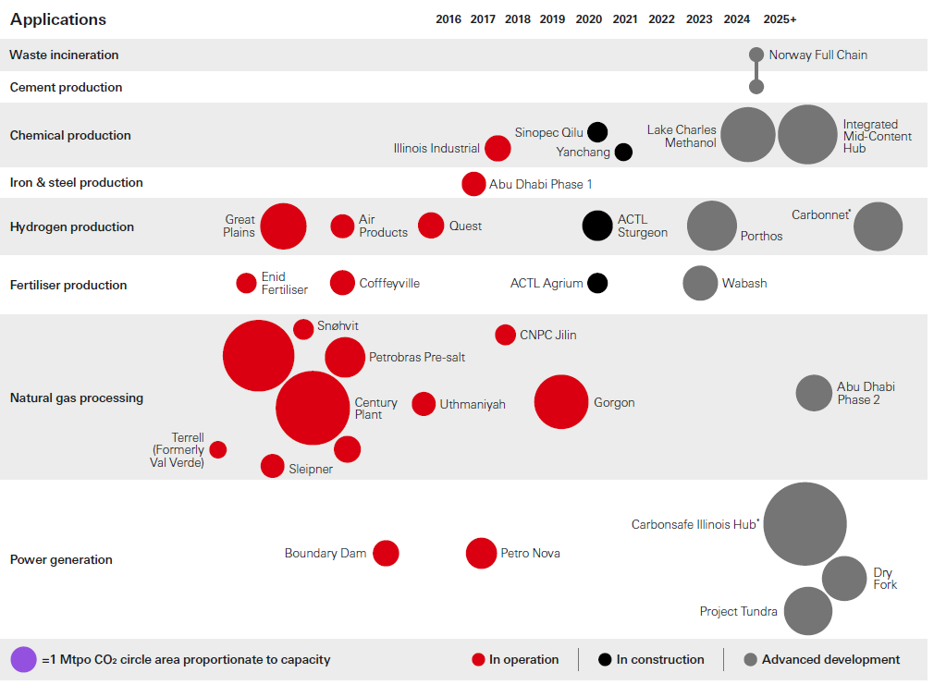
Figure 1: Large-Scale CCUS Facilities in Operation, Construction, and Advanced Development (HSBC, 2020).
Reactive amine absorption processes have been widely deployed in natural and industrial gas streams purification applications, especially for acid gas (CO₂, H₂S) removal. The consolidated operating experience boosted the application of these technologies to the treatment of flue gas (Mokhatab et al., 2012).
Alternatively, traditional carbonate–based absorbent solutions have been reconsidered as substitute to amine. Carbonate based solution have a higher degradation resistance to oxygen than amines but their lower efficiency at atmospheric pressure requires the flue gas to be compressed to reach the optimal operating conditions. It is industrial experience that this solution may not be economical or feasible for some processes, especially for low CO₂ concentrations (Smith et al., 2016).
CCS can also be obtained by separation with membranes. Membranes are specific equipment designed to allow for selective permeation of one gas through them. The typical driver for separation is pressure, meaning that the overall flue gas must be fed at high pressure to overcome the pressure drop of the membrane. This limits the application of this technology to flue gases at high pressure or with a high concentration of CO₂. Furthermore, membranes have not yet been applied for large scale applications and their reliability and costs still have to be improved.
An additional methodology to implement a Carbon Capture system is by distillation of a liquefied gas stream and refrigeration separation. Liquefying a gas allows the separation of its component in a distillation column thanks to the different volatility of the gases and refrigerated separation can be applied also for CCS. Even though the TRL of this technology still must be improved, the separation by refrigeration is interesting when CO₂ needs to be liquefied for storage and shipping purposes (Baxter et al., 2019).
PCC systems are generally simple add-on facilities, whose installation does not require major retrofitting works in the existing plant. Tie-ins to the existing plant and integration with existing facilities are usually impacting the following main intervention areas:
- integration with the flue gas path;
- interfacing with the plant combustion control system;
- provision of utilities (Steam, Cooling Water, Demi Water, Instrument Air, Nitrogen, Electricity).
Among the technological alternatives, chemical absorption-based process for CO₂ capture from post-combustion streams is the most adopted solution. Amine-based PCC has been evaluated as the benchmark in this paper due to the following considerations:
- It is the most reliable and flexible option, specifically due to its resistance to degradation in presence of Oxygen, NO_{x} and SO_{x};
- Amine-based systems are effective in a wide range of flue gas CO₂ concentrations;
- It is a well-known technology that is already been used extensively and it is similar to other end-of-pipe environmental control systems used for the treatment of flue gases;
- Major efforts are ongoing to improve this process for it is regarded as the system that will lead the CO₂ abatement efforts for example using different columns configurations or solvent concentrations (Kayahan et al 2023).

The process scheme of chemical absorption processes for PCC is essentially the same as the one for conventional oil & gas applications. A simplified diagram of a typical chemical absorption-based PCC plant is shown in Figure 2:
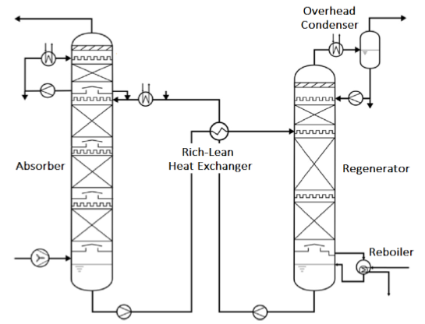
Figure 2: Simplified diagram of a chemical absorption process for CO₂ capture.
The typical PCC plant foresees a flue gas stream that is firstly cooled in a Quenching Column that reduces its temperature to the optimum value (i.e., between 35 to 43°C) and it is delivered to an Absorption Column where it enters in contact in counter-current on packed beds with the amine solution.
The cleaned flue gas leaves the top of the column, while the rich solution is sent to the Regeneration Column after having recovered part of the lean solution heat with a feed/effluent exchanger.
The stripping vapor from column reboiler flows upward while the rich solution proceeds downward in the Regenerator therefore achieving the regeneration of amine solution at the column bottom, while from the top an almost clean CO₂ is delivered to battery limits downstream the overhead condensation.
The present paper will evaluate the main elements that condition the system design, the general evaluation on the criteria that shall be followed to calculate main equipment sizing and two case studies that highlight the importance of tailoring the system topology when addressing the project specific conditions.
Modelling Strategy for CCS system
In the industrial application most of the available processes are licensed technologies, therefore the relevant solution model is considered confidential, and it is often not available to the engineering companies.
However, to perform system optimizations well before Licensor’s involvement, it is a technical advantage to create internal models that leverage on the market experience to simulate plants performances and anticipate system design.
Those company internal tools are not considered substitutive to the essential know-how from Licensors, but they are a strategic instrument to perform in advance multiple sensitivities as well as optimizations on the overall plant operation, especially when the Carbon Capture system must be integrated among other units.
Two main software are used to model the Carbon Capture plant and they are used in combination to countercheck the calculations and ensure the highest reliability during early project phases:
- AspenPlus® and Hysys ® from Aspentech;
- ProMax® from Bryan Research & Engineering.

The key aspects that have been considered when modelling the Carbon Capture plants are the following:
- Identification of the Thermodynamic model;
- Definition of the Amine solution composition.
One of the most comprehensive models, with a good fit with Carbon Capture plant operation, is the one described in the paper by Zhang (Zhang et al., 2011) and uses electrolyte-NRTL activity coefficients for liquid phases properties definition, while PC-SAFT equation of state is deployed for vapor phase.

The original study describes the CO₂ absorption with MEA only using the following equilibrium reactions:
2 H₂O ↔ H₃O⁺ + OH⁻ (1)
CO₂ + 2 H₂O + HCO₃⁻ ↔ H₃O⁺ (2)
HCO₃⁻ + 2 H₂O ↔ CO₃²⁻ + H₃O⁺ (3)
MEACOO- + H₂O ↔ MEA + HCO₃⁻ (4)
MEAH⁺ H₂O ↔ MEA + HCO₃⁻ (5)
The model has been upgraded in a subsequent study (Zhang et al, 2013) to include the formation of carbamate and bicarbonate and better describe system kinetic limitations.
NextChem has furtherly improved its internal models with the introduction of the additional components that constitute the Amine solution formulations using available literature data (Singh et al., 2013) and tuning the simulator parameters with the operating information from existing plants.
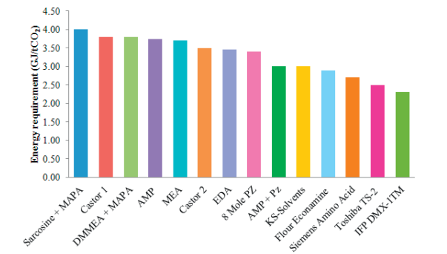
Figure 3: Tabulation of the energy consumption in the stripper from different sources (Singh et al., 2013).
The implementation of these models provides simulation results that are sufficiently close to the plant expected performance and allow for a preliminary evaluation on the equipment sizing, especially for the critical columns, therefore enabling a better optimization of the design.
The models have been furtherly tuned taking advantage from the company database that includes the data of the already built plants as well as all the literature available information.
Recognized issues when designing the CCS
The current state of the art on the use of commercially available software and the implementation of conventional models do not provide a fully comprehensive description for all the phenomena connected with Carbon Capture unit.

The interaction between CO₂ Capture aminic solution and other air pollutants, i.e., SO₂ and NOx, usually cannot be fully described. Specifically acid gases react with MEA to form heat-stable salts that reduce solvent CO₂ absorption capacity and cannot be removed from the solution (Supap et al., 2011).
Very low concentrations of those components are necessary to minimize the loss of solvent, which is mainly caused by SO₂ and NO₂ (typically about 5% of total NOx is NO₂) (Rao et al., 2002).
To manage solvent degradation, the same is estimated from experimental data and parametrically included in the overall plant sizing criteria.

Another critical element that shall be considered when addressing the design of Carbon Capture units is connected with an adequate description of the system pressure drop, in order to be in the position to assess the Carbon Dioxide partial pressure inside the absorption column and identify the optimum CO₂ loading, therefore consequentially impacting on the solvent circulation rate. The adopted solution has been to tune the simulated results with the direct feedback provided by the Vendors of column internals (i.e., trays or structured packings), therefore identifying reasonable margins of conservativeness that will ensure the system performance within the guaranteed operation.
The last issue that must be highlighted is the calculation of the heat of regeneration at different operating conditions as well as at various CO₂ loading. This element is fundamental because it affects the Stripping Column performance (Michailos et al., 2022) and might deeply condition the integration of the CCS in the overall system. In order to mitigate the uncertainties connected with the identification of system operating conditions, it might be essential to start the optimization analysis from Licensor initial input, which is important to have a first critical guess on the most plausible parameters for the specific service.
Criteria for the system design
Carbon Dioxide removal from flue gas is mainly a gas-liquid mass transfer process and the chemical reaction that permits CO₂ diffusion into the liquid film inside the Absorption Column is affected by all feedstock main operating variables, such as:
- Flue Gas inlet temperature and pressure;
- Flue Gas composition and CO₂ Concentration.
Even if this consideration seems prosaic, it is critical to adequately manage the inlet conditions to Carbon Capture plant, in case providing essential pre-treatment system to ensure the optimum operating variables.
Reference is given to the work of Rao for the U.S: Department of Energy (Rao et al, 2002), because, even if their presented numbers are not applicable to all services, the study is an exhaustive collection of all the main critical operating parameters to be considered when designing a Carbon Capture plant.

Moreover, it is important to have a clear picture on the Carbon Dioxide concentration for the specific industrial service, as listed in Table 1 below, because this element may deeply impact on the identification of the solution to be implemented for the Carbon Capture, as qualified in the following Case Studies.

Table 1: Emission sources for different Industrial systems.
 | Emission Source | CO₂ Content (vol%)
Power Generation | Coal to power | 12-15
 | NG to power | 3-10
 | Oil to power | 3-8
 | Bioenergy | 3-8
Large Emitters | Cement production | 14-33
 | Iron and Steel | 15
 | Refineries (excluding H₂ e NH₃) | 3-13
 | Ethylene production | 12
 | Waste Combustion | 20
High Purity Sources | NH3 production | 100
 | H2 production | 70-90
 | NG production | 5-70%
 | Biomass fermentation | 100
Case Study 1 – Steam Reformer
The currently most widespread application of post combustion Carbon Capture systems to Steam Reformers is within Ammonia plants, especially when they are integrated with a downstream Urea production plant. The reason is that the captured CO₂ can be utilized to increase the Urea production capacity together with the flowrate from the process carbon capture on syngas.

The real challenge however is the possibility to retrofit the existing stream reformers, whether if they are foreseen for an Ammonia plant or dedicated to Hydrogen production.
The CO₂ avoidance cost to retrofit existing systems has been found generally higher than that of new plants, mainly because of the higher energy penalty resulting from a less efficient heat integration (Rao et al., 2002), however the issue can be mitigated by clearly identifying system inefficiencies.

Most of older Ammonia Plants are characterized by high temperatures at the Reformer Stack (e.g., 160-180°C), because the energy integration has been previously focused only on the existing Carbon Capture plant on syngas. It is therefore essential to consider the complete retrofit of the emission point as well as the analysis of the reformer convective section. This analysis might be critical and shall leverage on contractor experience, especially in case of limited plot area and if multiple emission points shall be managed.

The possibility to fully recover the heat from Flue Gas might ensure the reuse of this energy in the Carbon Capture regeneration system, while the possibility to install a single PCC system for multiple emission points can provide a reduction up to 10-20% of the overall retrofit CapEx.
The CapEx optimization can be achieved by foreseeing dedicated Quenchers close to the emission points, with common Absorption and Regeneration columns for all Flue Gases cleanings. Doing this will reduce the dimension of the ducts from the quencher to the absorber while having a single line of absorption and regeneration.
Case Study 2 – Power Generation Plant
The possibility to reduce the carbon footprint of Power Generation Plants is one of the key topics that is now driving the industry, especially due to the sensible increase in the emissions that has been caused by the electricity demand growth.
Power Plants have been up to now characterized by large Carbon Capture units associated to Coal-Fired systems, however NextChem experience has shown the importance to provide solutions that can be applied also to smaller producers.
The rationale when addressing the design of those plants shall consider the following elements:
- Power Generation Plants are characterized by very low concentrations of Carbon Dioxide in the Flue Gas. This element is critical because leads to larger equipment in the absorption section and higher OpEx due to the higher amminic solvent to be circulated in the unit.
- CapEx optimization shall not be the only criteria to size the unit, but operational flexibility might be the most important element. In Combined Cycle units where multiple Gas Turbines are present, the system is often characterized by fluctuations in the energy requirements, therefore imposing frequent turndowns and ramp-ups.
In those cases, it is usually effective to consider the installation of multiple Carbon Capture units, going against the economy of scale, because it is more advantageous to ensure a higher flexibility that overcomes CCS technical limitations (e.g., turndown not lower than 50%), at the expenses of a lower per-unit cost.
- In case of multiple combined cycle plants, it is still possible to evaluate additional CapEx optimizations by studying the frequency of simultaneous operation of the different emission points.
Those cases often provide the opportunity to foresee common regeneration columns, designed to have a single stripping item dedicated to multiple absorption sections.
- The system layout is a critical element to be addressed since design early phases, especially when the clean Flue Gas shall be collected back to the power generation stack. In those cases, the Flue Gas duct design as well as the pressure drop downstream Absorption Column might deeply affect unit design.

Conclusions
The possibility and necessity to install Post-Combustion Carbon Capture Units for new or existing facilities has been often addressed as a problem of sub-optimization through the provision of oversized systems regardless of the relevant consumptions or a matter of optimization on the overall CapEx.
NextChem experience on the market has shown the importance to have a robust simulation to fully outline the system with dedicated sensitivities, coupled with an effective collaboration with CCS Licensors.
Those elements shall be the foundation to evaluate the industrial application peculiarities and tailor the design for the specific service, by identifying the system criticalities and in some cases disregard the optimum solution in view of the operational constraints.
It is therefore effective to foresee dedicated Feasibility Analysis to study the preferable solution that might be applied in the specific context and then optimize the identified system configuration to minimize the relevant CapEx and OpEx.
This approach combined with the experience on similar cases, such as the ones outlined in the present paper, shall offer the opportunity to facilitate the implementation of those essential instrument to decarbonize the industrial panorama.

References
Baxter L. L., Baxter A., Bever E., Burt S., Chamberlain S., Frankman D., Hoeger C., Mansfield E., Parkinson D., Sayre A., and Stitt K.. Cryogenic Carbon Capture Development Final/Technical Report, 2019. Web. doi:10.2172/1572908.

HSBC, Centre of Sustainable Finance, CCUS for Paris Alignment, September 2020 Report.

IAOGP, International Association of Oil & Gas Producers, Global CCS Institute, October 2022 Report.

Kayahan E., Di Caprio U., Van den Bogaert A., Khan M., Bulut M., Braeken L., Van Gerven T., Leblebici M.E., A new look to the old solvent: Mass transfer performance and mechanism of CO2 absorption into pure monoethanolamine in a spray column. Chemical Engineering and Processing - Process Intensification, Volume 184, February 2023, 109285.

Michailos S., Gibbins J., A Modelling Study of Post-Combustion Capture Plant Process Conditions to Facilitate 95–99% CO2 Capture Levels From Gas Turbine Flue Gases, Frontiers in Energy Research, 2022, Vol. 10.

Mokhatab S., Poe W. A., Chapter 7 - Natural Gas Sweetening, Handbook of Natural Gas Transmission and Processing (Second Edition), 2012, 253-290.

Rao A.B., Rubin E.S., A Technical, Economic, and Environmental Assessment of Amine-Based CO2 Capture Technology for Power Plant Greenhouse Gas Control, Environmental Science & Technology 36 (20), 2002, 4467-4475

Singh P., Van Swaaij W., Brilman W., Energy Efficient Solvents for CO2 Absorption from Flue Gas: Vapor Liquid Equilibrium and Pilot Plant Study. Energy Procedia. 37, 2013, 2021-2046.

Smith K.H., Nicholas N.J., Stevens G.W., in Absorption-Based Post-combustion Capture of Carbon Dioxide, 2016, 145-166.

Supap T., Idem R., Tontiwachwuthikul P., Mechanism of formation of heat stable salts (HSSs) and their roles in further degradation of monoethanolamine during CO2 capture from flue gas streams, Energy Procedia, Volume 4, 2011, 591-598.

Zhang, Y.; Que, H.; Chen, C.-C. Thermodynamic modeling for CO2 absorption in aqueous MEA solution with electrolyte NRTL model. Fluid Phase Equilib. 2011, 311, 67-75.

Zhang, Y.; Chen, C.-C. Modeling CO2 Absorption and Desorption by Aqueous Monoethanolamine Solution with Aspen Rate-based Model. Energy Procedia 2013, 37, 1584-1596.

