CHEMICAL ENGINEERING TRANSACTIONS  VOL. , 2023 | A publication of
The Italian Association
of Chemical Engineering
Online at www.cetjournal.it

Guest Editors: David Bogle, Flavio Manenti, Piero Salatino
Copyright © 2023, AIDIC Servizi S.r.l.
ISBN 979-12-81206-04-5; ISSN 2283-9216

Screening study of potassium carbonate solvents for bio-energy carbon capture and storage (BECCS)
Nima Mirzaei, Aishwarya Babu, Efthymios Kantarelis, Matthäus U. Bäbler*
KTH Royal Institute of Technology, Department of Chemical Engineering, Division of Process Technology, Teknikringen 42
* babler@kth.se
The present work aims at investigating absorption of CO₂ into promoted and unpromoted aqueous K₂CO₃. For this we performed a series of lab experiments in a thermostated batch stirred tank gas-liquid reactor containing the solvent. The absorption of CO₂ was monitored by the decrease in the reactor pressure. To compare the different solvent blends, the experimental conditions, i.e., injection pressure, reactor temperature, stirring speed, and solvent volume were kept constant. For the interpretation of the experiments a simple absorption model is formulated based on which an apparent absorption rate is derived. Among the different rate promoters studied, we found that V₂O₅ results in a substantial increase of the absorption rate, while the use of B(OH)₃ in conjunction with V₂O₅ does not provide any tangible benefits. A semi-qualitative comparison with rate constants reported in the literature suggests that this hindering effect of B(OH)₃ is due to the lower pH of the solvent containing B(OH)₃. The solvent blends containing amine-promoters MEA and piperazine demonstrated rapid absorption. Comparison with the literature indicates that absorption in the presence of these promoters is mass transfer limited under the experimental conditions.
  - Introduction
Bio-energy carbon capture and storage (BECCS) is an accepted method for achieving negative green-house gas emissions. BECCS is based on the principle to capture and store CO₂ that originates from the conversion of biomass. Biomass is a renewable feedstock that forms by binding CO₂ from the atmosphere. Hence, by capturing and storing the CO₂ that originates from the conversion of biomass a net removal of carbon from the atmosphere is achieved. In its simplest setup BECCS is built around power plants, pulp-and-paper mills or waste incinerators that use biomass as feedstock (Rosa et al. 2021). The biogenic CO₂ that leaves these plants with the flue gas is sent to an absorption unit for CO₂ removal.
In an absorption unit, a liquid solvent is used to wash out the CO₂ from the flue gas. This is done in an absorption column where the solvent flows counter-currently to the gas from top to bottom, leaving the column rich in CO₂. The use of aqueous K₂CO₃ as solvent has been favoured by many recent BECCS projects. The reason for this is its low regeneration energy and the flexibility in operating conditions which enables integration of the capture unit into e.g. district heating networks (Gustafsson et al. 2021). Moreover, compared to amine-based technologies, K₂CO₃ is more stable, non-toxic, and non-volatile. However, absorption of CO₂ into aqueous K₂CO₃ is slow. Hence, promoters are used to enhance the absorption.
Amines, chief among them monoethanolamine (MEA) and piperazine (Pz), are known to be efficient promoters for K₂CO₃ solvents. Cullinane and Rochelle (2004) showed that the addition of 5 wt% Pz to 20 wt% K₂CO₃ enhances the absorption rate of CO₂ by almost a factor 15. Likewise, Thee et al. (2012b) demonstrated that the reaction of CO₂ with 30 wt% aqueous K₂CO₃ promoted with 5 wt% MEA increases by factor of 16. The enhancement of the reaction rate when adding amines to aqueous K₂CO₃ can be explained by a zwitterion mechanism (Danckwerts, 1979):
$$\text{C}{\text{O}}_{\text{2}}\text{+}{\text{R}}_{\text{2}}\text{NH⇌}{\text{R}}_{\text{2}}{\text{N}}^{\text{-}}\text{HC}{\text{O}}_{2}^{+}$$ | (1)
$${\text{R}}_{\text{2}}{\text{N}}^{\text{-}}\text{HC}{\text{O}}_{\text{2}}^{\text{+}}\text{+B→}{\text{R}}_{\text{2}}\text{NC}{\text{O}}_{\text{2}}^{\text{-}}\text{+B}{\text{H}}^{\text{+}}$$ | (2)
In this mechanism, CO₂ and the amine R₂NH react to produce the zwitterion, which then undergoes an irreversible reaction with the base B (CO₃²⁻, OH⁻, or the amine itself) to produce carbamates. Danckwerts (1979) showed that if the acid-base reaction (2) is fast (a condition typically satisfied due to abundance of CO₃²⁻ in K₂CO₃ solvents, that is B = CO₃²⁻ (Laddha and Danckwerts, 1982)), the overall reaction rate is of first-order with respect to both amine and CO₂ concentrations. The carbamate is regenerated back to the active amine form in reaction with water:
$${\text{R}}_{\text{2}}\text{NC}{\text{O}}_{\text{2}}^{\text{-}}\text{+}{\text{H}}_{\text{2}}\text{O⇌}{\text{R}}_{\text{2}}\text{NH+HC}{\text{O}}_{\text{3}}^{\text{-}}$$ | (3)
Despite their excellent promoting behavior, the high regeneration energy of the amines as well as their volatility, thermal degradation, and tendency to form harmful oxidation products are of concern when using amines as promoters (Du, 2016).
Inorganic promoters are regarded as alternatives to amines, as they are relatively stable and less volatile. Boric acid B(OH)₃ (BA) and vanadium pentoxide V₂O₅ (VO) and mixtures thereof are the most prominent members of this category (Eickmeyer, 1984). VO is commonly used as a corrosion inhibitor, but was found to also enhance the hydrolysis of CO₂ through its vanadate species HVO₄²⁻ and HV₂O₇³⁻ (Nicholas et al., 2014). The formation of vanadium oligomers was stated as an issue concerning the use of VO as rate promoter, as the oligomers may not be active towards CO₂ (Nicholas et al., 2014). However, McCann et al. (2015) showed that over the relevant pH (8.5-10.5) and temperature (up to 84 ˚C) ranges for CO₂ absorption, instead of forming vanadium oligomers, VO tends to form carbonato-vanadate complexes:
$${\text{H}}_{\text{2}}\text{V}{\text{O}}_{\text{4}}^{\text{2-}}\text{+}{\text{CO}}_{\text{3}}^{\text{2-}}\text{+}{\text{H}}^{\text{+}}\text{⇌HV}{\text{O}}_{\text{4}}\text{C}{\text{O}}_{\text{2}}^{\text{2-}}\text{+}{\text{H}}_{\text{2}}\text{O}$$ | (4)
$${\text{H}}_{\text{2}}\text{V}{\text{O}}_{\text{4}}^{\text{2-}}\text{+2}{\text{CO}}_{\text{3}}^{\text{2-}}\text{+2}{\text{H}}^{\text{+}}\text{⇌V}{\text{O}}_{\text{4}}{\left(\text{C}{\text{O}}_{\text{2}}\right)}_{\text{2}}^{\text{3-}}\text{+2}{\text{H}}_{\text{2}}\text{O}$$ | (5)
The equilibrium constants for reactions (4-5) are high ($pK_{a}$ around -11 and -20, respectively, at room temperature), indicating that in aqueous K₂CO₃, the mono-vanadates, as well as the reaction complexes, remain the major constituents of vanadate species (McCann et al., 2015). In alkaline environments, VO behaves as an acid, resulting in lower contribution from OH⁻ to the reaction rate. To form the active species HVO₄²⁻, VO first has to dissociate completely into H₂VO₄⁻, additionally resulting in lower chemical capacity. As such, the concentration of VO as promoter needs to be kept small to balance the rate enhancing effect with the decrease in chemical capacity.
Similar to VO, BA also demonstrates acidic behaviour. However, it solely behaves as a weak acid, partially deprotonating to its active species, B(OH)₄⁻. Hence, the loss in chemical capacity of aqueous K₂CO₃ in presence of BA is relatively low, although the concentration of OH⁻ decreases. In their pilot campaign, Smith et al. (2012) did not observe substantial improvements in the absorption rate of CO₂ in BA-promoted aqeuous K₂CO₃. In another work by the same group, it was reported that BA exhibits promotive behaviour comparable to that of tertiary and hindered amines. However, the promotive effect was relatively mild and does not indicate improvements in absorption rate compared to unpromoted K₂CO₃ (Thee et al. 2012a).
The overall reaction rate of CO₂ in promoted solvents can be described as sum of its reaction rate with the individual species in the solvent:
$$r_{CO_{2}}/\left[CO_{2}\right]=\sum_{A}{k_{A}\left[A\right]}$$ | (6)
where $r_{CO_{2}}$ is the rate of CO₂ consumption, $\left[\text{C}{\text{O}}_{\text{2}}\right]$ is the concentration of free CO₂ in the solvent, $\left[A\right]$ is the concentration of reactive species (OH⁻ as well as the active promoter species), and $k_{A}$ is the reaction rate constant of species A. Quantitative research into the role of promoters aims at determining $k_{A}$ for different promoters.
In this work, the absorption of CO₂ into blends of aqueous K₂CO₃ with the above-mentioned promoters (MEA, Pz, VO, and BA) was investigated in a bench-scale stirred tank reactor operated in batch mode. The measured data was qualitatively assessed by the time of the absorption process and by the means of a simple absorption model. The results of this experimental campaign are compared with literature data and the discrepancies are addressed.
  - Experimental procedure
    - Materials
Potassium carbonate (ACS Reagent ≥ 99.0%, Merck), vanadium pentoxide (≥ 99.6%, Merck), boric acid (ACS Reagent ≥ 99.5%, Merck), monoethanolamine (≥ 99%, Merck), and piperazine (Reagent Plus, ≥ 99%, Merck) were used without further purification. Solvents blends were prepared based on the desired mass fractions of K₂CO₃ and the promoter(s) with deionized water. Promoter concentrations were chosen based on the higher limits of those reported in the literature. All solvent blends were used as fresh, i.e. no CO₂ was absorbed prior to the experiment.
    - Experimental setup and procedure
Figure 1.a shows a schematic of the experimental setup used in the experiments. The setup comprised of a batch stirred tank gas-liquid reactor (Miniclave, 300 ml, Büchiglas) and a gas storage unit (double-ended gas sampling bomb cylinder, 500 ml, Swagelok). The stirring in the liquid phase was achieved using a stir bar (25 mm) and a magnetic stirrer. To achieve a flat gas-liquid interface, the reactor was equipped with a baffle. The temperature in the reactor was controlled by recirculating water using a thermal bath (Haake F3). Gas pressure in the gas storage unit and the reactor were monitored by the two pressure sensors (DMP331i, BD Sensors, 0-100 kPa and 0-1000 kPa). Temperature and pressure were recorded using NI USB-6431 via LabView interface.
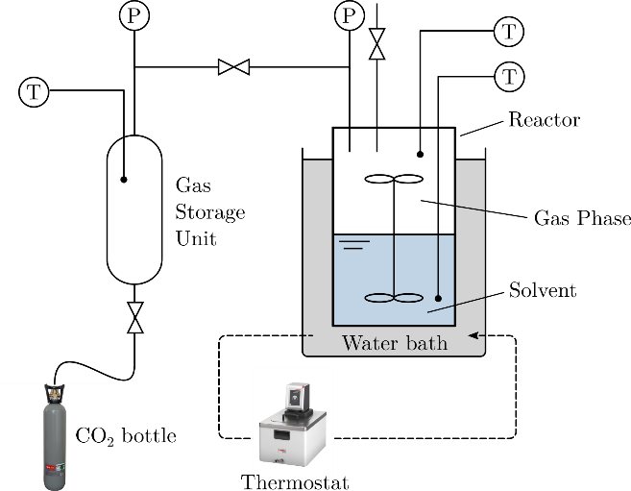  (a) | 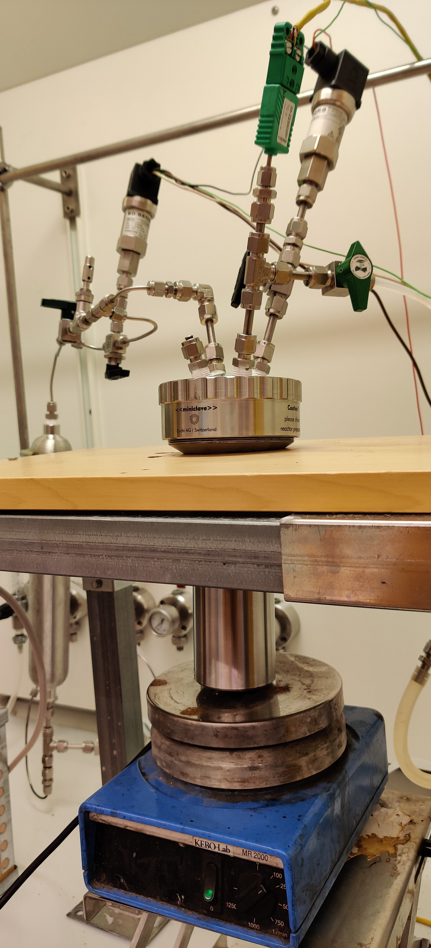  (b)
Figure 1: (a) Schematic of the gas injection setup used in the experiments. (b) View of the stirred batch reactor.
Prior to each experiment, the pH of the solvent was measured. The reactor was loaded with approximately 150 ml of the solvent blend and then closed. The whole apparatus was evacuated for approximately five minutes to 1 kPa, to remove the residual atmospheric air. After evacuation, the gas storage unit was filled with more than 550 kPa of CO₂. At the same time, the heating bath was turned on and the pressure and the temperature in the reactor were allowed to equilibrate for 1-2 hours. The reactor temperature was controlled at approximately 50 ˚C. The absorption experiment was started by opening the valve between the storage unit and the reactor, prompting the transfer of CO₂ to the reactor. The valve was left open for almost one minute to allow the pressure in the reactor and the storage to equilibrate, at approximately 400 kPa. Then the valve was closed again and the CO₂ in the reactor was allowed to be absorbed by the solvent. The absorption of CO₂ was observed and monitored by the drop in the reactor pressure over time.
    - Data analysis
The data collected in each experiment consists of a time series of the pressure in the gas-liquid reactor $p_{{CO}_{2}}\left(t\right)$. The latter decreases in time due to the absorption of CO₂. For the interpretation of the experimental data, we propose the following simple model:
$$\frac{dp_{CO_{2}}}{dt}=K\left(p_{CO_{2}}-p_{CO_{2}}^{*}\right)$$ | (7)
where $p_{CO_{2}}$ is the pressure in the reactor, $p_{CO_{2}}^{*}$ is the equilibrium pressure that establishes at the end of each experiment, and $K$ is the apparent absorption rate factor. For a starting pressure of $p_{CO_{2}}^{\left(0\right)}$, assuming that the change in solvent properties is negligible such that $p_{CO_{2}}^{*}$ can be considered constant, equation (7) can be integrated to yield:
$$p_{CO_{2}}-p_{CO_{2}}^{*}=\left(p_{CO_{2}}^{\left(0\right)}-p_{CO_{2}}^{*}\right)exp\left(-Kt\right)$$ | (8)
Equation (8) describes the exponential time dependence of the CO₂ absorption in a batch gas-liquid reactor. At the beginning of the experiment, due to the high driving force ($p_{CO_{2}}^{\left(0\right)}-p_{CO_{2}}^{*}$) the absorption rate is high. As the experiment approaches equilibrium, the driving force diminishes and eventually equals to zero, hence the pressure decay flattens out. Linearization of equation (8) results in:
$$\ln\left(p_{CO_{2}}-p_{CO_{2}}^{*}\right)=-Kt+\ln\left(p_{CO_{2}}^{\left(0\right)}-p_{CO_{2}}^{*}\right)$$ | (9)
Equation (9) indicates that the logarithm of pressure decay as a function of time is a straight line, the slope of which is $K$. The apparent absorption rate $K$ is a function of the interface area between the gas and the liquid, the liquid-side mass transfer resistance (stirring), and the kinetics of CO₂ reaction with the solvent. Provided that the experimental conditions, i.e., stirring speed, solvent temperature, and starting pressure are fixed, the difference in apparent absorption rates between two solvents can be attributed to the effect of promoters.
  - Results and discussion
Figure 2 shows the decay of the pressure inside the reactor for blends of aqueous 25 wt% K₂CO₃, without promoter (blue) and with 3 wt% V₂O₅ (yellow), 7 wt% B(OH)₃ (red), 7 wt% piperazine (purple), and 7 wt% MEA (green). The experiments were performed under the same conditions, namely a temperature of 50 ˚C, a starting CO₂ pressure of approximately 400 kPa, and a stirring speed of 500 rpm. The apparent rates of absorption for the different solvent blends, calculated by equation (9) are shown in the inset of Figure 2, where blends containing multiple promoters, 3 wt% V₂O₅ and 3 wt% B(OH)₃ (orange) as well as 3 wt% V₂O₅ and 6 wt% B(OH)₃ (brown) are also included.
Among the blends tested, the one promoted with MEA (green) demonstrated the highest absorption rate (expressed by the rapid pressure decrease), followed by Pz (purple). The solvent blend with VO (yellow) also showed significant enhancement in the absorption rate, albeit not as fast as amine-promoters. However, the blend promoted with BA (red) indicated similar absorption rate to that of the unpromoted solvent (blue) (repetition of experiments with unpromoted K₂CO₃ indicated no significant difference with the BA-promoted solvent). Furthermore, addition of BA to VO demonstrates an inhibiting effect on the absorption rate (column 2 to 5 in the inset in Fig. 2); 6 wt% BA nearly completely inhibited the enhancing effect of VO.
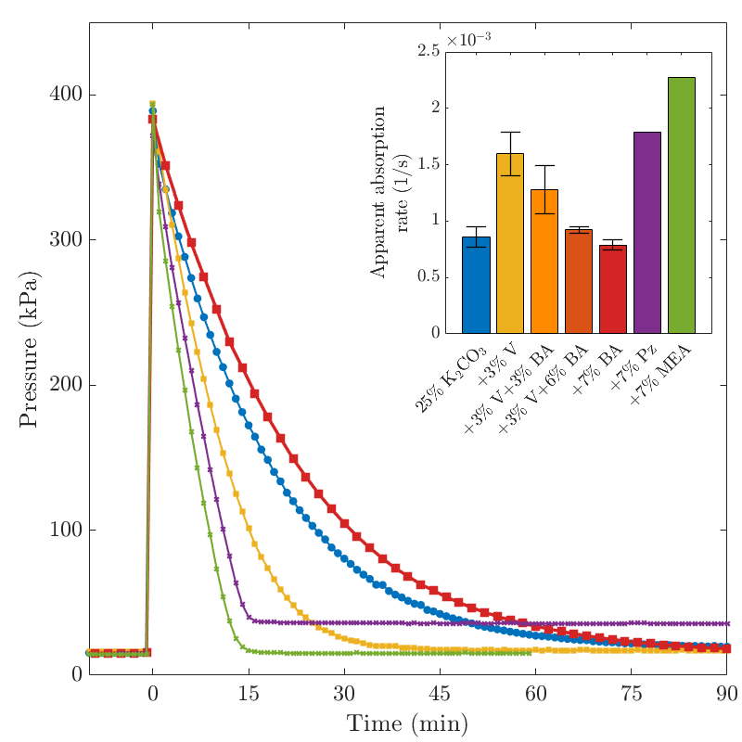
Figure 2: Pressure decay curves for blends of fresh 25 wt% aqueous K₂CO₃ with and without promoters. Inset: Apparent absorption rate for these blends calculated using slope of the pressure curves. Error bars are calculated from the standard deviation in the case multiple experiments were performed.
To compare the experimental results with the literature, extra information about the blends (solvent pH before the experiment and approximate concentration of promoter(s) in molarity) are provided in Table 1. Additionally, the reaction rate constants for the promoters, compiled from the indicated literature, are included.

Table 1: Promoter concentration and pH of the solvent blends used in the experiments together with the rate constants at 50 ˚C as reported in the literature.
 | Blend  25 wt% K₂CO₃ | Promoter(s) conc. (M) | pH (Exp.) | Promoter rate constant (M⁻¹.s⁻¹) | Reference for rate  constant expression
1 | + 7 wt% MEA | 1.3 | 11.5 | 3.05$×$10⁴ | (Thee et al. 2012b)
2 | + 7 wt% Pz | 1 | 12.8 | 1.52$×$10⁵ | (Bishnoi and Rochelle, 2000)
3 | + 3 wt% VO | 0.3 | 10.2 | 3.88$×$10⁴ | (Nicholas et al. 2014)
4 | + 3 wt% VO + 3 wt% BA | 0.3, 0.6 | 9.9 | -
5 | + 3 wt% VO + 6 wt% BA | 0.3, 1.2 | 9.6 | -
6 | + 7 wt% BA | 1.4 | 9.2 | 2.67$×$10² | (Thee et al. 2012a)
    - Blends with MEA and Pz
Experiments with 7 wt% MEA and 7 wt% Pz are shown by the green and purple curves in Figure 2. The molarity of MEA and Pz in the two experiments is roughly the same (Table 1, 1.3 M MEA to 1 M Pz). Assuming negligible contribution from OH⁻ to the absorption, and uniform concentrations throughout the solvent, the data in Figure 2 would suggest that $k_{MEA}$ and $k_{Pz}$ are rather close. However, as indicated in Table 1 (rows 1 and 2), the rate constant of Pz is 5 times that of MEA, suggesting that the uniform concentration assumption is invalid. Due to high starting pressure in experiments ($p_{CO_{2}}^{\left(0\right)}≈400$ kPa), the solvent close to the gas-liquid interface is depleted of amines, which renders the experiments mass transfer-limited and unresponsive to the higher reaction rate of Pz. Hence, the similar absorption rates of the MEA-blend and the Pz-blend observed in Figure 2 is caused by mass transfer limitations. To overcome the mass transfer limited regime, these two blends need to be tested with lower CO₂ pressure and higher stirring speed.
    - Blends with VO and BA
Experiments with 3 wt% VO and 7 wt% BA are shown by the yellow and red curves in Figure 2. With $p_{K_{a}}$ of 9.15, approximately half of the BA concentration is in its active form, B(OH)₄⁻. It can be noted from Table 1 that $k_{BA}$ is two orders of magnitude lower than that of other promoters, while at pH of 9.2, the contribution of OH⁻ to the reaction rate is 100 folds less compared to the unpromoted solvent (that has pH = 11.5). Taking $k_{OH}=4.7×{10}^{4}$ M⁻¹.s⁻¹ (Danckwerts and Sharma, 1966), the product $k_{OH}\left[OH^{-}\right]$ in the unpromoted solvent is similar in magnitude to that of $k_{BA}\left[B{\left(OH\right)}_{4}^{-}\right]$ in the solvent promoted with BA, resulting in practically the same absorption rate as that of the unpromoted solvent.
A similar argument can be used to explain the VO-blend. The monomeric vanadium species (H₂VO₄⁻ to HVO₄²⁻) have a $p_{K_{a}}$ of 7.8. It could thus be determined that most of the vanadium in the VO-promoted solvent at pH = 10.2 is in form of the active species, HVO₄²⁻. Given the high value of $k_{VO}$ (Table 1), despite the drop in pH by one unit, the product $k_{VO}\left[HVO_{4}^{2-}\right]$ is over 100 times larger than that of the rate product for unpromoted solvent.
With the lower pH caused by the addition of BA (Table 1, rows 4-5), the concentration of HVO₄²⁻ decreases, hindering the contribution of VO to the absorption. The partial replacement of HVO₄²⁻ with active boron species lowers the overall reaction rate product (see equation 6) due to the relatively low activity of B(OH)₄⁻ towards CO₂. Consequently, increasing concentration of BA in presence of VO in aqueous K₂CO₃ results in lower CO₂ absorption rate.
  - Conclusions
In this work, the absorption of CO₂ into fresh aqueous K₂CO₃ in the presence of different rate promoters was experimentally investigated. To compare the results, the experiments were conducted under the same operating conditions, i.e. temperature of 50 ˚C, starting pressure of approximately 400 kPa, and stirring speed of 500 rpm. The results indicated that while the apparent absorption rate increased significantly in the presence of amines, mass transfer limitations arising from the experimental conditions prevent a fair comparison of piperazine and monoethanolamine with each other. Under mass transfer limited conditions, the gas-liquid interface is depleted of amines. As such, the absorption rate is controlled by the stirring rate and is insensitive towards the reaction rate of CO₂ with the constituents in the solvent. It was also determined that the addition of vanadium pentoxide improves the apparent absorption rate, albeit not as effectively as the amines. The presence of boric acid in conjunction with the vanadium pentoxide inhibited the rate-enhancement effect of the latter. Theoretical analysis of the data reveals that this inhibiting effect is solely due to the lower pH of the VO-BA-blend compared to the VO-blend. At low pH, the concentration of active vanadium species and hence the VO contribution to the reaction rate decreases. The results concerning solvents with inorganic rate promoters were in agreement with literature.

Nomenclature
$\left[\text{A}\right]$ – concentration of active species in solvent, M
$\left[\text{C}{\text{O}}_{\text{2}}\right]$ – concentration of free CO₂ in the solvent, M
$k_{A}$ – reaction rate constant of CO₂ with species A, M⁻¹.s⁻¹
$K$ – apparent absorption rate of CO₂, s⁻¹
$p_{\text{C}{\text{O}}_{\text{2}}}^{\left(0\right)}$ – starting pressure of CO₂, Pa

$p_{\text{C}{\text{O}}_{\text{2}}}^{*}$ - equilibrium (final) pressure of CO₂, Pa
$r_{\text{C}{\text{O}}_{\text{2}}}$ – rate of CO₂ reaction, M.s⁻¹
Abbreviations
BA – boric acid
BECCS – bio-energy carbon capture and storage
MEA – monoethanolamine
Pz – piperazine
VO – vanadium pentoxide
References
Bishnoi S., Rochelle G. T., 2000, Absorption of carbon dioxide into aqueous piperazine: reaction kinetics, mass transfer and solubility, Chemical Engineering Science, 55(22), 5531-5543.
Cullinane J. T., Rochelle G. T., 2004, Carbon doixide absorption with aqueous potassium carbonate promoted by piperazine, Chemical Engineering Sciences, 59, 3619-3630.
Danckwerts P. V., 1979, The reaction of CO₂ with ethanolamines, Chemical Engineering Science, 34(4), 443-446.
Danckwerts P. V., Sharma M. M., 1966, The absorption of carbon doixide into solutions of alkalis and amines (With some notes on hydrogen sulphide and carbonyl sulphide), The Chemical Engineer, 244-280.
Du Y., 2016, Amine Solvent Development for Carbon Dioxide Capture, PhD Thesis, The University of Texas at Austin, Austin, USA.
Eickmeyer A. G., 1984, Removal of CO₂ From Gas Mixtures, United States of America Patent No. 4430312.
Gustafsson K, Sadegh-Vaziri R., Grönkvist S., Levihn F., Sundberg C., 2021, BECCS with combined heat and power: assessing the energy penalty, International Journal of Greenhouse Gas Control, 100, 103434.
Laddha S. S., Danckwerts, P. V., 1982, The absorption of CO₂ by amine-potash solutions, Chemical Engineering Sciences, 37(5), 665-667.
McCann N., Imle M., Hasse H., 2015, Carbonate complexes of vanadate, Polyhedron, 95, 81-85.
Nicholas N. J., da Silva G., Kentish S., Stevens G. W., 2014, Use of vanadium (V) oxide as a catalyst for CO₂ hydration in potassium carbonate systems, Industrial & Engineering Chemistry Research, 53(8), 3029-3039.
Rosa L., Sanchez D. L., Mazzotti M, 2021, Assessment of carbon dioxide removal potential via BECCS in a carbon-neutral Europe, Energy & Environmental Science, 14(5), 3086-3097.
Smith K. H., Anderson C. J., Tao W., Endo K., Mumford K. A., Kentish S. E., Qader A., Hooper B, Stevens G. W., 2012, Pre-combustion capture of CO₂ - Results from solvent absorption pilot plant trials using 30 wt% potassium carbonate and boric acid promoted potassium carbonate solvent, International Journal of Greenhouse Gas Control, 10, 64-73.
Thee H., Smith K. H., da Silva G., Kentish S. E., Stevens G. W., 2012, Carbon dioxide absorption into unpromoted and borate-catalyzed potassium carbonate solutions. Chemical Engineering Journal, 181-182, 694-701.
Thee H., Suryaputradinata Y. A., Mumford K. A., Smith K. H., da Silva G., Kentish S. E., Stevens G. W., 2012, A kinetic and process modelling study of CO₂ capture with MEA-promoted potassium carbonate solutions, Chemical Engineering Journal, 210, 271-279.

