CHEMICAL ENGINEERING TRANSACTIONS  VOL. , 2023 | A publication of
The Italian Association
of Chemical Engineering
Online at www.cetjournal.it

Guest Editors: David Bogle, Flavio Manenti, Piero Salatino
Copyright © 2023, AIDIC Servizi S.r.l.
ISBN 979-12-81206-04-5; ISSN 2283-9216

Controlling Process Variables in 3D Printing to Limit the Energy Consumption
Antonella Patti^{a,}*, Stefano Acierno^{b}, Gianluca Cicalaª, Domenico Acierno^{c}
ªDepartment of Civil Engineering and Architecture (DICAr), University of Catania, Viale Andrea Doria 6,95125 Catania, Italy
^{b}Department of Engineering, University of Sannio, Piazza Roma 21, 82100 Benevento, Italy.
^{c}CRdC Nuove Tecnologie per le Attività Produttive Scarl,Via Nuova Agnano 11, 80125, Naples, Italy
antonella.patti@unict.it
This study looked at effective energy usage and renewable resources to make 3D printing more environmentally friendly. The use of bio-based materials and the investigation of technological aspects that maximized the mechanical properties of 3D-printed products and assured energy cost savings were the adopted strategies. Two bio-based thermoplastics made from pure and filled polylactide acid (PLA) with wood were examined. These filaments were printed by changing the extruder temperature (from 190 to 220°C, respectively) and the printing speed (from -30% to +30% of default value) to verify the actual process conditions that allow the material to be extruded for a given printer apparatus. A dynamic mechanical analysis was performed on developed specimens. The energy consumption, to heat and melt the thermoplastics, for every combination of processing variables, was calculated. Results allowed to attest that storage modulus of printed parts and the amount of energy spent during printing were more affected by printing speed than by extruder temperatures. Particularly in the case of PLA+WOOD, by doubling the printing speed, the productivity increased by 37% despite a 30% rise in energy usage. The mechanical properties and printing accuracy did not appear to be severely impacted by an increase in printing speed from 70 to 130 mm/s at least for simple geometries and small sample sizes.
  - Introduction
Reducing energy production from fossil fuels, increasing energy production from renewable sources, reducing polluting gas emissions causing climate change, reducing energy consumption, and increasing energy efficiency are ones among the most important goals of sustainable energy transitions (Diji, 2019).
Energy efficiency is a critical factor in the manufacturing industry, and energy consumption is directly related to product cost (Nguyen et al., 2021). Manufacturing processes comprise the physical methods used to change the form or shape of a material. The energy required for such transformations, along with material shape and information, are considered as a process input, while wastes, as well as waste/lost heat represented the output. When compared to transportation, residential, and commercial end-use sectors, the manufacturing industry has historically been one of the world's largest energy consumers and carbon dioxide (CO₂) emitters. The manufacturing sector consumes around 33% of primary energy and emits 38% of global CO₂ emissions. The rising cost of energy, combined with current efforts toward sustainability, has prompted to reduce energy consumption for the point of view of economy and ecological responsibility (Apostolos et al., 2013).
In the last 30 years, additive manufacturing (AM) technology emerged as a new digital manufacturing technology that integrates machinery, computer, numerical control, and materials. By means of computer aided design (CAD), this process permits the realization of 3D objects with detailed and accurate geometry. Fused Deposition Modeling (FDM) is a popular 3D printing technology that involves melting a thermoplastic filament and depositing it layer-by-layer on a heated support to create 3D parts. The FDM method is quickly becoming a popular technology on a global scale due to its ability to efficiently fabricate complex and on-demand products. The total energy consumption of the 3D printing process has been classified as primary and secondary energy (Peng, 2016). The primary energy in FDM was associated with the heat required by thermoplastic materials to melt over their glass transition temperature. Secondary energy was referred to the energy required by supplementary components, such as drive motors, table warm-up and ventilation system, in order to realize and support the printing process. Along with ensuring the quality and cost of the printed product, energy efficiency is a critical point to be optimized. Power consumption is a significant challenge for the manufacturing cost-cutting purpose (Nguyen et al., 2021). Insulating the heated bed and nozzle, printing with low-melting temperature materials, and printing with large layer heights were attempted as methods to reduce the energy use in FDM printers (Hopkins et al., 2021). Printing at an increased nozzle temperature raised the tensile strength and modulus (Akhoundi et al., 2020). Greater layer thickness lowered mechanical characteristics and printing quality, reduced the precision in fine details, and made more visible the layers separation (Patti, et al., 2022c). Finally, lowering the print speed and layer thickness resulted in greater mechanical strength and improved surface polish of printed components (Nyiranzeyimana et al., 2021).
One of the most attractive alternatives to fulfil product sustainability and lessen the demand on synthetic fibers as reinforcement in composites is the incorporation of wood in plastics (Patti et al., 2021). Firstly, the replacement of wood-based components for fossil-based products has a direct influence on cutting greenhouse gas (GHG) emissions. Then, since the carbon in wood is retained in related products for months or decades, a sink effect may occur when the volume of wood entering the market exceeds the annual amount of wood disposed of (Hurmekoski et al., 2022). For these two primary reasons, wood can be seen as a multifunctional material capable of serving as both a carbon sink and a renewable energy source. Wood-based goods can give an useful contribution to reduce climate change and GHG emissions(Gustavsson et al., 2006).
In this work, commercially available filaments made from neat and wood filled polylactide were extruded in a 3D printer in different operating conditions (i.e., by changing printing speed and nozzle temperature). The amount of material extruded over time (productivity) was measured, as well the energy required to heat and melt the material during the operation was estimated. The prepared samples were characterized through dynamic mechanical analysis. Results have been presented in terms of energy consumption during 3D printing process and mechanical resistance of 3D printed parts as a function of printing temperature and speed. An ideal combination of both processing variables (nozzle temperature and printing speed) to allow energy savings during the 3D printing process while ensuring elevated mechanical performance of the final products, was presented.
  - Materials and Methods
    - Materials
As raw materials for this study, two commercially available filaments (nominal diameter of 1.75 mm) were used: a basic biopolymer composed of pure polylactide acid (PLA) and a filled biopolymer composed of wood and PLA polymer (PLA+WOOD) supplied by Eumakers (Barletta, Italy).
    - Printing technology
All systems were dried in an oven at 70 °C for 7 hours prior to be extruded in a 3D printing machine (M200, by Zortax, Olsztyn, Poland). Depending on the used filament, different working conditions have been established to allow a consistent melt flow outside the nozzle and regular layer deposition on the heated platform. To favor the adhesion of the initial layer to the building base (heated platform), the bed temperature was set slightly higher than the glass transition temperature of the basic material, but not too much above the glass transition to avoid printing object distortion after removal from the bed.
PLA was processed using: 0.09 mm layer thickness, retraction speed of 27 mm/s, and retraction distance of 2.7 mm. The wood-based filament was printed with a greater layer thickness of 0.19 mm, a lowered retraction speed of 20 mm/s, and a retraction distance of 1 mm. The printing speed and extrusion temperature were then varied. In specifically, extrusion temperatures were set up to 220°C, whereas the printing rate was changed from -30% to +30% with respect to a default value.
Rectangular specimens with dimensions of 2 mm in thickness, 5 mm in width, and 25 mm in length were printed using PLA and PLA+WOOD filaments to evaluate the thermo-mechanical performance of the respective 3D parts.
2.3 Procedures
The dynamic mechanical analysis (DMA) was performed on a Tritec 2000 machine (Triton Technology Ltd., Leicestershire, UK) in the temperature range of room to 80°C. The sample was subjected to a single frequency of 1 Hz and controlled strain in a single cantilever fixture. The support distance was equal to 10 mm. Three samples were produced and characterized for each different operating condition (i.e. variables printing speed and extruder temperature).
An energy model, which neglected energy losses, based on the split of required energy into two contributions was used to predict the FDM energy consumption. The first contribution (Q₁ in KJ/day) considered the heating and melting of thermoplastics while the second contribution included the energy needed by accessory components (Annibaldi et al., 2019). Equation 1 describes the first energy contribution in the case of crystalline material:
$Q_{1}=\dot{m} \left(c∆T+∆H_{f}\right)$ (1)
where $\dot{m}$ is the extruded mass per unit of time in Kg/day, c is the specific heat capacity (for PLA=1.8 KJ/(Kg °C), for WOOD=2 KJ/(kg °C)(Brooks et al., 2018)), $∆T$ is the difference in temperature, $∆H_{f}$is the enthalpy of fusion (for PLA= 33.4 KJ/Kg, for PLA+WOOD=43.9 KJ/Kg, according to preliminary thermal analysis).

  - Experimental results
    - Feasibility of 3D printing for PLA
The FDM process is based on a dynamic equilibrium between the force of extrusion and melt pressure. The extrusion force is referred as the force required by roller to push the filament in the conduit. Typically, by increasing the extrusion speed, the maximum extrusion force decreases while the melt pressure increases (Geng et al., 2019). At a fixed temperature, the increment of the printing speed could result in an exceedance of the maximum pressure drop allowable by printer apparatus, causing the discontinuous flow of material from the nozzle and a poor printing quality (Patti, et al. 2022a).
PLA printability was investigated as extrusion temperature and printing speed changed. Table 1 outlines the attempts done as well as the overall considerations on the obtained specimens.
Table 1: Suitable extruder temperature and printing speed to process PLA (X: No print; : feasible print)
Extruder temperature (°C) | Printing speed
 | -30% | -15% | 0% (default) | +15% | +30%
220°C | Poor edge  precision | / | Poor edge  precision | / | Poor edge  precision
210°C
200°C |  |  |  | Poor filling | X
190°C | build-up and detachment | build-up and detachment | Poor  filling | Poor  filling | Very poor  filling

The printing process was always feasible by setting an extrusion temperature of 210 ºC and 220 °C (for each of the chosen printing speeds). The maximum allowable printing speed at 200 °C was +15% of default value however the obtained samples showed an evident little filling. A good print quality was never achieved at 190°C: at high printing speeds (> default), the obtained samples were filled worse, while at low printing speeds (< default) the deposited base on the heated platform tended to detach and the polymer melt remained accumulated on the nozzle (problem with first-layer adhesion). Low precision in edge refinement was also noted at 220 °C.

    - Storage modulus changes with nozzle temperature and printing speed
The thermo-mechanical properties of 3D printed parts made from PLA (Fig. 1(a)) and PLA+WOOD (Fig. 1(b)) were reported in terms of storage modulus at 30°C as function of extruder temperature and printing speed changes. In general, the extruder temperature had a significant impact on polymer fluidity and melt viscosity. By raising the printing temperature, the viscosity of the molten polymer was reduced. This was found to be beneficial in terms of enhancing layer adhesion. As a result, increasing the extruder temperature improved the mechanical strength of 3D printed objects. However, literature confirmed that this effect was strongly influenced by material properties, i.e. the material should possess good thermal stability over time; otherwise, the higher the extruder temperature, the lower the mechanical resistance of the developed products.(Patti et al., 2022b)
In this case, DMA results showed higher values in storage modulus (measured at 30°C) when the two filaments were worked at higher extruder temperatures.
The printing speed is defined as the velocity of nozzle movement along the XY plane in the build platform during the material extruding. As concerning the impact of this parameter on the mechanical properties of final products, opposite results can be highlighted in the literature of interest. In details, Maguluri et al. (2021) reported that an increment of printing rate from 20 to 40 mm/s led to a marginal increase of the tensile strength, light increment in elastic modulus and the fracture strain in PLA-based printed objects. Yu et al. (2019) verified a reduction of tensile and compressive in polylactic acid samples by changing the printing velocity from 30 to 60 mm/s. Because of the high-speed movement, the homogeneity of the sample may be reduced as the printing speed was increased. The materials fluidity was reduced, and the deposition of material was course. The filament could be damaged suddenly, leading to defects in the sample. An optimization of printing parameters for five commercially available printing materials (polylactic acid, acrylonitrile butadiene styrene, carbon fiber reinforced PLA, carbon fiber reinforced ABS and carbon nanotube reinforced ABS) was proposed by Abeykoon et al. (2020). For PLA, the support platform was kept at room temperature and nozzle temperature of 215°C. Changes in Young modulus for PLA printed parts were reported by varying the printing speed from 70 to 110 mm/s, with 90 mm/s being identified as an ideal value for achieving the greatest modulus (~1.5 GPa). The authors attributed the decrease in such parameters over 90 mm/s to probable melting instabilities reached once the nozzle temperature and speed were stabilized. However, they urged additional research to corroborate the conclusion.

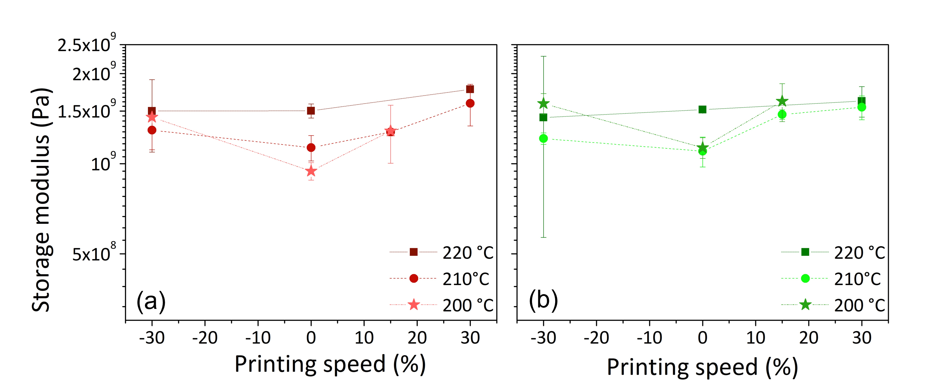
Figure 1. Storage modulus (in Pa) at 30°C for 3D parts of (a) PLA and (b) PLA+WOOD
In this investigation, the trend of the storage modulus versus print rate was not well defined. However similar consideration could be draw both for PLA and PLA+WOOD. The measured parameter appeared to be reduced while the printing speed was between -30% and 0%, but rose when the printing speed was between 0% and 30%. Printing speed was thought to have two effects on the mechanical properties of 3D specimens. On the one hand, it resulted in a lower deposited mass and a rougher melted filament, both of which caused defects and sample deformation. However, by speeding up the process, the previously deposited layers made faster contact with the next layers, the materials were less cooled, and the pieces could better stick together. While the first factor contributed to a decrease in mechanical strength, the second factor favoured the improvement of the resistance.

    - Processing time, productivity, and predicted energy consumption during printing
The amount of energy utilized by printers was directly dependent on the different printing requirements for distinct materials, as well as on the duration of process. The two chosen materials (PLA and PLA+WOOD) were manufactured using the same bed and nozzle temperatures, the same printing rates but varying layer thicknesses, and retraction speeds and distances. These changes in printing settings led to variations in printing times. The productivity, or the amount of material processed in a given amount of time, is affected by the printing speed. This parameter significantly contributes to the overall printing process optimization. In instance, for a given amount of processed material, productivity increases as printing speed increases since processing time decreases.
Table 2 shows the printing time and productivity depending on selected printing speeds and materials.
The energy consumption was assessed at different extruder temperatures in accordance with Eq. (1) ("2.3 Procedures" paragraph) and was displayed in Fig. 2 as a function of extruder temperature and printing speed.

Table 2. Printing time (in min), productivity (in Kg/day) and print energy (in KJ) for PLA and PLA+WOOD
 |  | PLA |  | PLA+WOOD
Print speed (%) | Print speed (mm/s) | Time  (min) | Productivity (Kg/day) | Time  (min) | Productivity (Kg/day)
-30% | 70 | 67 | 0.12 | 46 | 0.17
-15% | 85 | 58 | 0.14 | 41 | 0.18
0% | 100 | 52 | 0.15 | 36 | 0.23
15% | 115 | 48 | 0.17 | 34 | 0.23
30% | 130 | 44 | 0.18 | 31 | 0.27

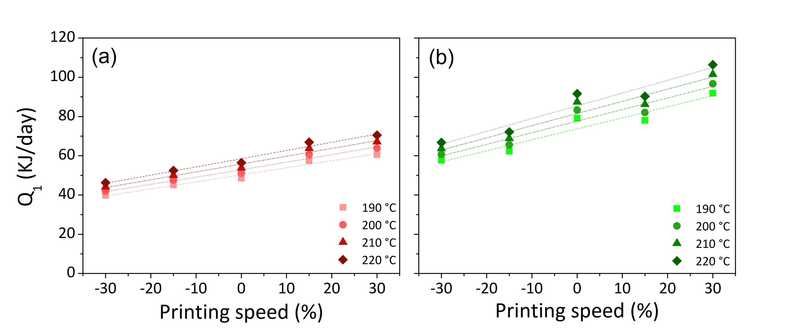
Figure 2. Energy requirement at different printing speed and nozzle temperature for (a) PLA and (b) PLA+WOOD
The amount of extruded material, in terms of mass (g), was quite similar regardless of printing speed or nozzle temperature. Small differences in the mass of extruded specimens resulted in a 10% experimental error. Changes in productivity and associated energy consumption, on the other hand, were primarily attributed to decreased printing time as printing speed increased. For this reason, the energy needed to print PLA and PLA+WOOD was estimated to increase significantly by around 34% and 37%, respectively, when the speed was increased from 70 mm/s to 130 mm/s. However, even if the spent energy was increased, it was balanced by increased productivity (due to the same extruded mass in less time). Working at 190°C instead of 220°C did not result in a strong energy efficiency for the 3D printing process, meaning an energy saving of about 14%. At the same productivity, when the extrusion temperature changed, so did the ∆T of the sensible heating. However, the ∆T_{190°C} was very comparable to ∆T _{220°C} (~ 85%) The energy needed to print PLA+WOOD filament was around 30% greater than the energy needed for PLA. This was attributable to two causes: i) specific technological variables, such as lower layer thickness, were selected to print the composite material, resulting in a shorter printing time. This led to an increased productivity, i.e., more extruded mass at the same printing time; ii) the melting enthalpy of PLA/WOOD was higher compared to basic PLA (~30%)
  - Conclusions
3D parts made from PLA and PLA+WOOD were printed using FDM technology by varying printing rates and nozzle temperatures. The thermo-mechanical properties of manufactured samples, as well as the energy used to heat and melt the filaments, were shown under various processing settings. The printing of PLA filament was not always achievable depending on the combinations of extruder temperature and printer velocity. Only at temperature of 210°C the printing was permitted with good quality for each tested printing speed. The storage modulus measured at 30°C for the studied materials exhibited a non-monotonous trend with the printing speed, demonstrating increase beginning from the default value (0%) both raising and lowering the printing speed. As concerning the impact of processing temperature on mechanical properties, for both systems, the higher the value the greater the storage modulus. The heating and melting phase to print the PLA filament was less wasteful compared the PLA+WOOD filament; however, the productivity (mass extruded on time) was higher for the filled polymer.
In conclusion, working at higher speed (+30%) and temperature (210°C) appeared to be a good solution, at least for small sample size and simple geometry, since it did not hinder material processability, did not affect mechanical resistance, and, despite a higher energy consumption (30%), it led to an increase in productivity (37%).
Acknowledgments
A. Patti wishes to thank the Italian Ministry of Education, Universities and Research (MIUR) in the framework of Action 1.2 “Researcher Mobility” of The Axis I of PON R&I2014-142 2020 under the call “AIM—Attrazione e Mobilità Internazionale”. S. Acierno and G. Cicala acknowledge the support of the Italian Ministry of University, project PRIN 2017, 20179SWLKA“Multiple Advanced Materials Manufactured by Additive technologies (MAMMA)
References
Abeykoon C., Sri-Amphorn P., Fernando A. (2020), Optimization of Fused Deposition Modeling Parameters for Improved PLA and ABS 3D Printed Structures. International Journal of Lightweight Materials and Manufacture, 3(3): 284–297.
Akhoundi B., Nabipour M., Hajami F., Shakoori D. (2020), An Experimental Study of Nozzle Temperature and Heat Treatment (Annealing) Effects on Mechanical Properties of High-Temperature Polylactic Acid in Fused Deposition Modeling. Polymer Engineering & Science, 60(5): 979–987.
Annibaldi V., Rotilio M. (2019), Energy Consumption Consideration of 3D Printing. 2019 IEEE International Workshop on Metrology for Industry 4.0 and IoT, MetroInd 4.0 and IoT 2019 - Proceedings: 243–248.
Apostolos F., Papacharalampopoulos A., Pastras G., Stavropoulos P., Chryssolouris G. (2013), Energy Efficiency of Manufacturing Processes: A Critical Review. Procedia CIRP: 628–633.
Brooks H., Wright, C., Harris, S., Fsadni A. (2018), Fire Resistance of Additively Manufactured Water Filled Polymer Parts. Additive Manufacturing, 22: 138–145.
Diji, Chukwuemeka Jude (2019), Energy Transition Process and Sustainable Development. Encyclopedia of Sustainability in Higher Education: 516–523.
Geng, Peng, Zhao, Ji, Wu, Wenzheng, Ye, Wenli, Wang, Yulei, Wang, Shuobang and Zhang, Shuo (2019), Effects of Extrusion Speed and Printing Speed on the 3D Printing Stability of Extruded PEEK Filament. Journal of Manufacturing Processes, 37: 266–273.
Gustavsson, L., Madlener, R., Hoen, H. F., Jungmeier, G., Karjalainen, T., Klöhn, S., Mahapatra, K., Pohjola, J., Solberg, B. and Spelter, H. (2006), The Role of Wood Material for Greenhouse Gas Mitigation. Mitigation and Adaptation Strategies for Global Change, 11(5–6): 1097–1127.
Hopkins N., Jiang L., Brooks H. (2021), Energy Consumption of Common Desktop Additive Manufacturing Technologies. Cleaner Engineering and Technology, 2: 100068.
Hurmekoski E., Seppälä J., Kilpeläinen A., Kunttu J. (2022), Contribution of Wood-Based Products to Climate Change Mitigation, 129–149, in: Hetemäki, L., Kangas, J., and Peltola, H. (Eds.), Forest Bioeconomy and Climate Change. Cham: Springer.
Maguluri N., Suresh G., Rao K. V. (2021), Assessing the Effect of FDM Processing Parameters on Mechanical Properties of PLA Parts Using Taguchi Method. Journal of Thermoplastic Composite Materials.
Nguyen N. D., Ashraf I., Kim W. (2021), Compact Model for 3D Printer Energy Estimation and Practical Energy-Saving Strategy. Electronics 10(4): 483.
Nyiranzeyimana, G., Mutua, J. M., Mose, B. R. and Mbuya, T. O. (2021), Optimization of Process Parameters in Fused Deposition Modelling of Thermoplastics: A Review. Materialwissenschaft und Werkstofftechnik, 52(6): 682–694.
Patti A., Acierno S., Cicala G., Acierno D. (2022a), Predicting the Printability of Poly(Lactide) Acid Filaments in Fused Deposition Modeling (FDM) Technology: Rheological Measurements and Experimental Evidence. ChemEngineering, 7(1): 1.
Patti A., Acierno S., Cicala G., Acierno D. (2022b), Recycling Waste from Film Packaging to 3D Printing Applications : A Prospective Study to Identify the Processing Temperature. Chemical Engineering Transactions, 96: 55–60.
Patti A., Acierno S., Cicala G., Tuccitto N., Acierno D. (2022c), Refining the 3D Printer Set-up to Reduce the Environmental Impact of the Fused Deposition Modelling (Fdm) Technology. Chemical Engineering Transactions, 91: 415–420.
Patti, A., Cicala, G. and Acierno, S. (2021), Rotational Rheology of Wood Flour Composites Based on Recycled Polyethylene. Polymers, 13(14): 2226.
Peng T. (2016), Analysis of Energy Utilization in 3D Printing Processes. Procedia CIRP, 40: 62–67.
Yu Z., Gao Y., Jiang J., Gu H., Lv S., Ni H., Wang X., Jia C. (2019), Study on Effects of FDM 3D Printing Parameters on Mechanical Properties of Polylactic Acid. IOP Conference Series: Materials Science and Engineering, 688(3).

