|  |  |
| --- | --- |
| cetlogo ***CHEMICAL ENGINEERING TRANSACTIONS***  ***VOL. xxx, 2025*** | A publication of  aidiclogo_grande |
| The Italian Association  of Chemical Engineering  Online at www.cetjournal.it |
| Guest Editors: David Bogle, Flavio Manenti, Piero Salatino  Copyright © 2025, AIDIC Servizi S.r.l. **ISBN** 979-12-81206-21-2; **ISSN** 2283-9216 | |

Biorefinery assessment and Techno-economic-environmental Supply Chain optimization for the Southern Italy Wine agroindustry

Vittoria Fattaa,\*, Maria Teresa Petroneb, Aristide Giulianob, Isabella De Barib, Nicola Pierrob

aItalian National Agency for New Technologies, Energy and Sustainable Economic Development (ENEA), Energy Technologies and Renewable Sources Department (TERIN), Bioenergy, Biorefinery and Green Chemistry Division (BBC), Palermo office, Via Principe di Granatelli, 24 90139 Palermo Italy

bItalian National Agency for New Technologies, Energy and Sustainable Economic Development (ENEA), Energy Technologies and Renewable Sources Department (TERIN), Bioenergy, Biorefinery and Green Chemistry Division (BBC), Trisaia research centre, S.S. 106 Ionica, km 419+500 75026 Rotondella (MT) Italy

vittoria.fatta@enea.it

The Percival Project seeks to valorize agro-industrial by-products and waste streams by converting them into high-value-added products. The initiative focuses on identifying innovative, efficient, and environmentally sustainable processes that can stimulate new business opportunities, particularly in Southern Italy, a region characterized by rich and diverse viticultural activity. Specifically, the area generates approximately 161 ktSS/year of grape marc, 30 ktSS/year of wine lees, and 290 ktSS/year of pruning residues. A critical challenge lies in determining the optimal location and capacity of facilities dedicated to converting these residues into energy carriers and bio-based products. Inefficiencies in this aspect often result in the underutilization of available resources. This study addresses the issue through the development of a mathematical optimization approach that simultaneously considers economic and environmental objectives. A Mixed-Integer Linear Programming (MILP) model was constructed using AIMMS software and applied to a case study in Southern Italy. By adopting a cascade biorefinery framework, the model targets the transformation of grape marc, wine lees, and prunings into antioxidants, biochar, and biomethane. Updated data on residue availability were collected and spatially mapped using methodologies based on the “Atlante delle Biomasse” database. Model results indicate a potential annual output of approximately 200 ton of antioxidant compounds, 9’000 ton of biochar, and 80’000 GJ of biomethane. The optimal configuration includes the installation of twelve biorefinery facilities: two in Basilicata, three in Campania, and seven in the Puglia region. These findings provide strategic insights for regional planning and sustainable bioeconomy development.

* 1. Introduction

Integrated cascade processes, including pretreatment, extraction, and fractionation techniques based on chemical and biotechnological transformations, can significantly enhance the economic and environmental sustainability of biorefinery systems. Residual biomass, in particular, offers substantial potential for the generation of both energy-based and value-added chemical products (Caporusso et al., 2022). However, the widespread deployment of biorefineries is often hindered by limitations in biomass availability and the long distances separating production sites from processing facilities. In this context, supply chain modeling and optimization emerge as crucial tools for identifying the most effective strategies for valorizing specific fractions of agro-industrial residues. Some authors (Alherbawi et al., 2022) studied a GIS-based proposed optimization to identify the ideal location for a multi-feedstock biorefinery, in Qatar. By analyzing availability and logistic criteria, the model selected an optimal site minimizing the transportation costs to an average of 7 $/t and maximizing the biomass energy recovery.

*Figure 1: Schematized methodology for optimizing the supply chain for the valorization of agro-industrial waste from wine production in Southern Italy.*

A MILP-based optimization framework to design cost-effective supply chains for sugarcane-based biorefineries was also studied (Machin Ferrero and Mele, 2022), highlighting the potentiality of this approach to support strategic decisions in bioenergy and agribusiness planning. Within the framework of the Percival Project (Fatta et al., 2024), which aims to valorize by-products originating from agro-industrial supply chains typical of Southern Italy (e.g. Basilicata, Campania and Puglia region) through the development of biochemicals, biomaterials, and biofuels, this study focuses on supply chain optimization. The objective is to identify optimal biorefinery configurations in terms of geographic localization and processing capacity, specifically for the conversion of wine industry residues into high-value-added products.

* 1. Methodology

The methodology adopted in this study is illustrated in the flow diagram presented in Figure 1. Initially, regions in Southern Italy characterized by a strong presence of the wine agroindustry were identified. The corresponding biowaste was quantified and geolocated at the municipal level. Subsequently, conversion technologies were evaluated based on their technical performance as well as their operating and capital costs. Target products were then selected, and the relevant process yields were incorporated. The algorithm performs an initial supply chain network optimization for a territory subdivided into municipalities, using data sourced from the national “Atlante delle Biomasse” database (Pierro et al., 2021).

* + 1. Process Flow Diagram for Wine Waste Valorization

Figure 2 presents a valorization process for vineyard residues, specifically grape marc, wine lees and pruning. This last one, pruning to the pyrolysis process producing biochar. In parallel, grape marc, wine lees are milled and subjected to a solid-liquid extraction. This extraction produces two outputs: a liquid extract containing valuable bioactive compounds, and a solid residue. The liquid extract, rich in resveratrol and other antioxidants, can be used for further applications in nutraceutical, pharmaceutical, or food sectors, while the solid by-product may have additional uses or be treated further. The solid residues can be used into an anaerobic digestion process producing biomethane. This integrated approach maximizes the use of vineyard waste in a sustainable and circular way.

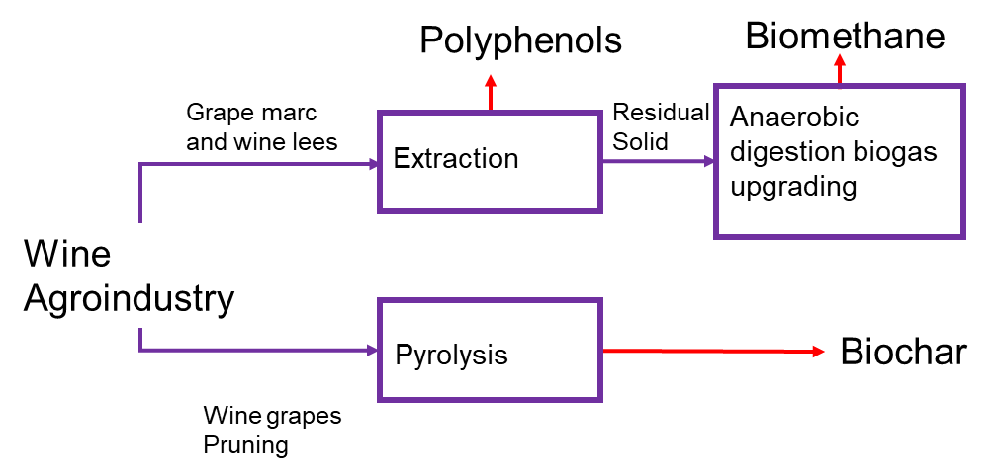

*Figure 2: Block Flow Diagram* for Wine Waste Valorization

* + 1. Supply chain model hypothesis and database

Wine is one of the oldest and most widely consumed beverages Worldwide, and its consumption continues to increase, leading to significant waste, particularly from vine prunings, grape marcs, and wine lees (Ayala et al., 2025). During grape production and processing, byproducts known as vine prunings are generated. Vineyard pruning is mainly carried out during the winter period (from November to March), preferably between December and February, during the vine’s dormancy when the plant has lost its leaves (Fernández-Puratich et al., 2015). After the grapes are processed, a paste composed of stems, grape skins, and seeds, referred to as grape marcs, remains and represents the most significant byproduct of winemaking (Haas et al., 2018). Another important byproduct is wine lees, which form from the settling of leftover fermentation products and dead yeast cells at the bottom of the vessel (Tournour et al., 2015). Approximately 0.01 kg of resveratrol-rich extract can be derived from 1 kg of dried grape marc and wine lees (Maroun et al., 2017). In the case of biomethane, 1 kg of residual organic matter yields about 0.07 kg of gas (Iragavarapu et al., 2023). Through pyrolysis, vine pruning residues can generate approximately 0.3 kg of biochar per kilogram of dry biomass (Jesus et al., 2022). The market price of resveratrol was set at 50 €/kg, biomethane at 0.50 €/kg, and biochar at 1,500 €/t. Capital cost data for biorefineries were categorized by technology type extraction, anaerobic digestion, and pyrolysis. Maintenance and operational expenses were estimated at 10% of the capital investment. Biomass supply costs were fixed at 100 €/t for harvesting. To estimate transportation costs from harvesting sites to biorefineries, the inter-municipality distances were calculated. Although this method may slightly overestimate distances, it remains essential for a comprehensive cost assessment. Wet waste transportation was assumed to be carried out using drawbar trailer trucks. Transportation costs using this system amount to €2.64/t + €0.15/t·km (Rotter and Rohrhofer, 2014). These values account for the handling and waiting times during loading and unloading performed via telescopic handler for feedstock and pumping systems for bioproducts. Return trips with empty trucks were assumed to incur costs of 0.15 €/t km. Additional biomass management costs included baling, collection, stacking, and storage. For the latter, a storage cost of 16.9 €/t was applied (Ortiz et al., 2011).

* + 1. Supply chain modelling

Residual biomass is considered transported from the original municipality to a biorefinery where it is converted into target products (resveratrol, biomethane, biochar). The problem is formulated as follows: given are a one year horizon divided into 12 months, the wastes and location each month, the type of bioproducts and the distance between all possible pairs of location. Each municipality is restricted to be able to facilitate only one biorefinery. The biorefineries locations and processing capacities, the storage capacities, the biomass flows from harvesting sites to biorefineries each month are decided in such way that the total annual profit is maximized. Mathematical model consists in a MILP (Mixed Integer Linear Programming), by following formulation (Galanopoulos et al., 2018):

|  |  |
| --- | --- |
| $$Max Z=f(x,y)$$ | (1) |
| $$h(x)=0$$ | (2) |
| $$g(x,y)≤0$$ | (3) |
| $$x∈X, y∈\{0,1\}$$ | (4) |

Where *Z* is the objective function (i.e. the annual profit), *h(x)* are the linear equality constraints containing only real variables, *g(x,y)* are the linear inequality constraints containing the binary variables, *X* is the set of real numbers, *y* are the binary variables (Giuliano et al., 2014).

* 1. Results and discussion
     1. Regional feedstock availability

The initial results focus on quantifying the residual biomass available in the selected regions. Figure 3 presents data from the “Atlante delle Biomasse” database (Pierro et al., 2021), which highlights particularly high levels of residues in Puglia—specifically, 120, 26, and 264 ktdry/y of grape marc, wine lees, and prunings, respectively. The second most abundant region is Campania, with corresponding totals of 39, 3, and 21 ktdry/y. Basilicata shows the lowest figures, with approximately 2, 0.5, and 5 ktdry/y. An essential factor in supply chain analysis is the spatial distribution of feedstock. The northern areas of Puglia and Campania emerge as the most resource-rich zones. Notably, the Taranto metropolitan area also exhibits significant quantities of prunings. This is due to the differing cultivation patterns of wine grapes, which produce grape marc and wine lees, whereas table grape farming generates waste primarily in the form of prunings.

1. (b) (c)

*Figure 3: Grape marc (a), wine lees (b) and pruning (c) availability in the Southern Italy (tdry/y), from the “Atlante delle Biomasse” database (Pierro et al., 2021)*

* + 1. Regional production potential

Through the analysis of residual availability, it was possible to implement the optimal supply chain model for each of the selected regions. Basilicata emerged as the region with the lowest productive potential, with only two sites identified as optimal. In northern Basilicata, the municipality of Venosa was deemed suitable for an anaerobic digestion plant coupled with polyphenol extraction. In the southern part of the region, the municipality of Bernalda was found optimal for a pyrolysis plant processing vine prunings, with a biochar productivity of 1’400 t/y. The distance between these two optimal sites reflects the uneven distribution of grape cultivation within Basilicata: wine grape production is concentrated in the northern municipalities, while table grape farming is prevalent in the south-east. Campania shows a less pronounced disparity between grape types, which explains a higher concentration of conversion facilities. In particular, the northern part of Campania features a single location, San Lorenzo Maggiore, where all three biorefinery technologies are best implemented together. Supply chain optimization therefore aims to concentrate all processing stages, from feedstock extraction to conversion, within a single site. In the southern part of Campania, within the province of Salerno, two neighboring municipalities, Bellizzi and Eboli, emerge as optimal. Bellizzi is suitable for pyrolysis of prunings (1’702 t/y of biochar), while Eboli offers potential for the valorization of grape marc and wine lees, yielding approximately 85 t/y of resveratrol and 598 t/y of biomethane through anaerobic digestion. Puglia stands out as the region with the most diversified range of optimal solutions and the greatest availability of grape processing residues. Here, seven municipalities represent ideal sites for facility development. In the northern part of the region, where both wine and table grape residues are more abundant, San Severo and Cerignola are particularly suitable for implementing all technologies together, enabling larger-scale operations and fostering economies of scale. Table 1 provides a quantitative overview of the productive potential of key biorefinery outputs, polyphenols, biomethane, and biochar, as well as the corresponding potential CO₂ emissions avoided in each of the selected regions. These values reflect the efficiency and strategic relevance of the optimal supply chain configurations previously identified. Basilicata, with the lowest biomass availability, shows modest output figures: 21 t/y of polyphenols, 149 t/y of biomethane, and 1,431 t/y of biochar, leading to an estimated 5’694 t/y of avoided CO₂ emissions. Campania presents intermediate productivity, with 378 t/y of polyphenols, 2’645 t/y of biomethane, and 5’577 t/y of biochar. This results in a significant environmental benefit, with approximately 28’384 t/y of CO₂ emissions potentially avoided. These outputs are concentrated in fewer conversion sites thanks to the more homogeneous distribution of wine and table grape cultivations. Puglia stands out clearly for both its biomass abundance and resulting product yields. With 1’425 t/y of polyphenols, nearly 10’000 t/y of biomethane, and over 76,000 t/y of biochar, the region offers exceptional capacity for biorefinery development. The estimated potential for avoided CO₂ emissions reaches 311’581 t/y, marking Puglia as a key player in reducing environmental impact through circular bioeconomy strategies. These results further reinforce the need to prioritize integrated technological solutions in the municipalities previously identified, where economies of scale are most achievable.

Table 1: Target product potential productivity in each selected Italian region and potential CO2 avoided emissions

|  |  |  |  |  |
| --- | --- | --- | --- | --- |
| Territory | Polyphenols (t/y) | Biomethane (t/y) | Biochar (t/y) | Potential CO2 avoided emissions (t/y) |
| Basilicata region | 21 | 149 | 1’431 | 5’694 |
| Campania region | 378 | 2’645 | 5’577 | 28’384 |
| Puglia region | 1’425 | 9’978 | 76’813 | 311’581 |

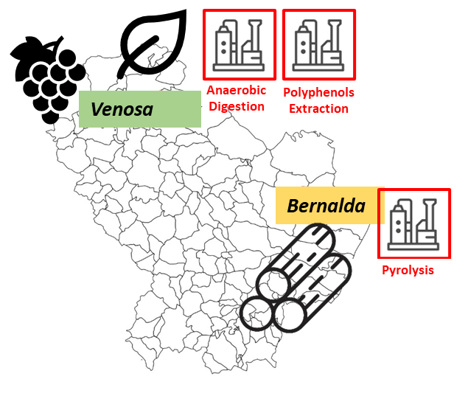*(a)*

*(b)*

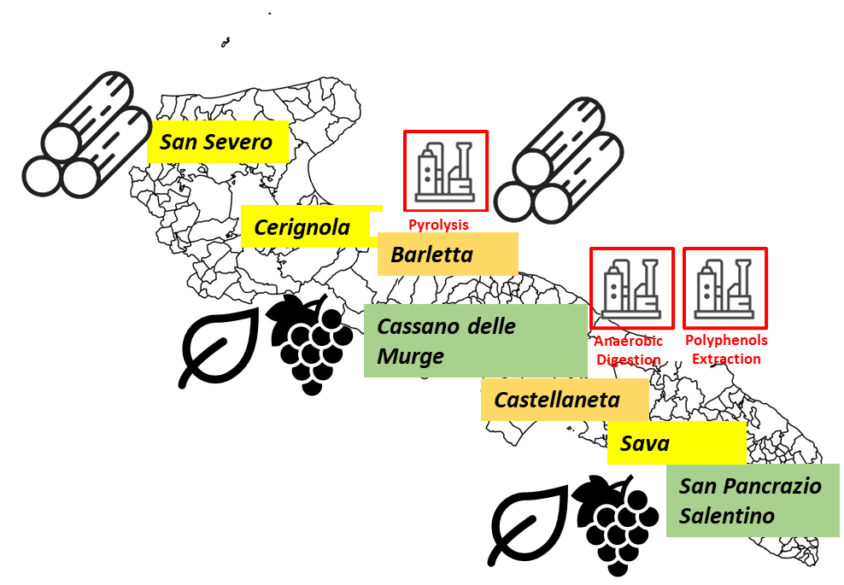*(c)*

*Figure 4: Optimal biorefinery plant distribution in Basilicata (a), Campania (b) and Puglia (c), with anaerobic digestion and solid-liquid extraction processes, in green, only pyrolysis process in orange and all three biorefinery treatments in yellow*

* 1. Conclusions

In this work, a supply chain optimization model was developed and solved to identify the most effective biorefinery configurations, both in terms of geographic location and plant scale, for the valorization of residual biomass from the wine industry. The results revealed region-specific strategies, with considerable variation across the Italian territories considered. Overall, the modelled supply chain enables an annual production of approximately 1’824 tonnes of antioxidant compounds, 12’772 tonnes of biomethane, and 83’821 tonnes of biochar. To achieve these outputs, a total of four integrated plants combining solid-liquid extraction with anaerobic digestion were required. Additionally, four pyrolysis plants focused exclusively on vine prunings, and four multifunctional plants capable of processing all three types of residues, grape marc, wine lees, and prunings, were identified as optimal. Average plant capacities were estimated at around 228 t/y for antioxidant extraction, 1’597 t/y for biomethane production, and 9’313 t/y for biochar. From an environmental standpoint, the latter two products contribute significantly to climate mitigation, with a combined potential to avoid up to 345 kilotonnes of CO₂ emissions annually.

Acknowledgments

The present work is part of the national project PERCIVAL funded through the program PON 2014-2020.

References

Alherbawi M., Mckay G., Mackey H.R., Al-Ansari T., 2022. Multi-biomass Refinery Siting: a Gis Geospatial Optimization Approach. Chemical Engineering Transactions 92, 73–78. https://doi.org/10.3303/CET2292013

Ayala J.R., Rojano B.A., Coronado M.A., Alzate-Arbeláez A.F., Sagaste C.A., Vélez A.D., Montes D.G., 2025. Valorization Pathway for Grape Pruning and Pomace Waste from the Wine Industry: Energy and Non-Energy Applications. Molecules 30, 2332. https://doi.org/10.3390/molecules30112332

Fatta V., Petrone M.T., Giuliano A., De Bari I., Pierro N., Rosso V., Ocleppo E., 2024. Bioproducts Extraction from Agro-industrial By-products and Their Valorisation. Development of Process Layouts. Chemical Engineering Transactions 109, 421–426. https://doi.org/10.3303/CET24109071

Fernández-Puratich H., Hernández D., Tenreiro C., 2015. Analysis of energetic performance of vine biomass residues as an alternative fuel for Chilean wine industry. Renewable Energy 83, 1260–1267.

Galanopoulos C., Barletta D., Zondervan E., 2018. A decision support platform for a bio-based supply chain: Application to the region of Lower Saxony and Bremen (Germany). Computers and Chemical Engineering 115, 233–242. https://doi.org/10.1016/j.compchemeng.2018.03.024

Haas I., Toaldo I., Burin V., Bordignon-Luiz M., 2018. Extraction optimization for polyphenolic profiling and bioactive enrichment of extractives of non-pomace residue from grape processing. Industrial Crops and Products 112, 593–601. https://doi.org/10.1016/j.indcrop.2017.12.058

Iragavarapu G.P., Imam S.S., Sarkar O., Mohan S.V., Chang Y.-C., Reddy M.V., Kim S.-H., Amradi N.K., 2023. Bioprocessing of Waste for Renewable Chemicals and Fuels to Promote Bioeconomy. Energies 16, 3873. https://doi.org/10.3390/en16093873

Machin Ferrero L.M., Mele F.D., 2022. Optimal Design of Sugar-Cane-Based Biorefinery Networks in Argentina. ACS Sustainable Chem. Eng. 10, 7916–7928. https://doi.org/10.1021/acssuschemeng.2c00921

Ortiz D.S., Curtright A.E., Samaras C., Litovitz A., Burger N.E., 2011. Near-Term Opportunities for Integrating Biomass into the U.S. Electricity Supply: Technical Considerations.

Pierro N., Giocoli A., Motola V., Dipinto S., 2021. Valutazione disponibilità biomasse agro-industriali a livello nazionale e loro pubblicazione sul portale Webgis atlante delle biomasse [WWW Document]. URL https://iris.enea.it/handle/20.500.12079/56881 (accessed 10.17.23).

Rotter S., Rohrhofer C., 2014. Logistics Concept.

Tournour H.H., Segundo M.A., Magalhaes L.M., Barreiros L., Queiroz J., Cunha L.M., 2015. Valorization of grape pomace: Extraction of bioactive phenolics with antioxidant properties. https://doi.org/10.1016/j.indcrop.2015.05.055