|  |  |
| --- | --- |
| cetlogo ***INGENIERÍA QUÍMICA ACTAS***  ***Volumen XXX, 2025*** | Una publicación de  aidiclogo_grande |
| La Asociación Italiana  de Ingeniería Química  En línea en www.cetjournal.it |
| Editores invitados: David Bogle, Flavio Manenti, Piero Salatino  Copyright © 2025, AIDIC Servizi Srl  **ISBN** 979-12-81206-21-2; **ISSN** 2283-9216 | |

**Sustainable Electricity Generation Using Dog Excreta and Microbial Fuel Cells with Geobacter sulfurreducens**

Adriana M. Miñano Tapia\* ,Yojana D.C Montalban Cordova\* , Eusterio H. Acosta Suasnabar

Cesar Vallejo University, School of Environmental Engineering, Av. Alfredo Mendiola 6232, Los Olivos, Lima, Peru.

[eacostas@ucv.edu.pe](mailto:eacostas@ucv.edu.pe)

Organic waste from dog excreta in urban areas represents an environmental problem due to its negative impacts on the surroundings. The objective of this research was to generate electricity from dog excreta using microbial fuel cells (MFCs) with Geobacter sulfurreducens. The study was applied research with a quantitative approach and an experimental design. Three double-chamber microbial fuel cells (MFCs) with a volume of 206 cm³ were constructed and operated, interconnected by a proton exchange membrane (PEM) and equipped with graphite electrodes. The highest amount of electricity generated was recorded in the third sample of the second repetition. The microbial fuel cell (MFC) achieved values of 0.57 V, 0.210 A, and 0.1197 W over a 24-hour period. These results demonstrate the feasibility of this technology as a sustainable energy source, as well as offering an innovative solution for urban organic waste management and renewable electricity generation.

* 1. Introduction

Microbial fuel cells are an innovative technology that enables the production of electricity and bioelectricity from biomass through the action of bacteria (Logan et al., 2005). On the other hand, dogs have been essential companions to humans, playing crucial roles such as rescue, assistance for visually impaired individuals, emotional support for people with autism, and companionship for those facing emotional difficulties. However, this close coexistence also has adverse effects on both health and the environment, primarily due to the accumulation of their excreta (Aguillón et al., 2022). The increasing population of pet dogs, along with the presence of unsupervised dogs, can contribute to greater fecal contamination in urban areas, thereby increasing the risk of human exposure to various zoonotic parasites. This issue has led to a rise in the number of stray dogs defecating in public spaces, causing significant environmental contamination with parasite eggs. Previous studies have documented the presence of gastrointestinal parasites in dogs in Nigeria over time (Kamani et al., 2021). The increase in the canine population has become a major environmental concern in Peru. In many regions, most households have at least one dog, and these animals often roam in the mornings, defecating in public spaces such as streets and parks. As a result, people may unknowingly transport contaminants on their shoes when returning home (Delgado and Huaman, 2020). One of the most significant effects on communities is the spread of diseases among dogs, driven by poor living conditions, lack of vaccination, and absence of deworming. This situation not only affects their well-being but also poses a health risk to the population, with children being the most vulnerable group. In the case of stray dogs suffering from dermatological or intestinal diseases, the issue worsens when these illnesses spread through their excreta (Alba et al., 2022).

Dog feces often harbor various parasites, with hookworms, Strongyloides stercoralis, Toxocara canis, and Trichuris vulpis being the most common. For this reason, pet owners are advised to collect their pets' waste to prevent the spread of these parasites, which can disperse through soil contact and foot traffic (Tamponi et al., 2020). On the other hand, microbial fuel cells (MFCs) can utilize organic substrates to generate electricity through bacterial catalysis. Electron transfer to the electrode can occur directly via exoelectrogenic bacteria, such as Geobacter and Shewanella species (Wang et al., 2015). In particular, Geobacter sulfurreducens is capable of completely oxidizing electron donors, using an electrode as the sole acceptor. Additionally, it has the ability to transfer electrons efficiently without the need for electron mediators (Bond & Lovley, 2003).

Microbial fuel cells are bioelectric systems capable of transforming chemical energy into electrical energy through the catalytic action of microorganisms, primarily bacteria. These microorganisms facilitate the oxidation of the substrate, such as organic waste, at the anode, while at the cathode, the reduction of an oxidant, typically oxygen (O₂), takes place (Das D., 2018). This emerging technology has the potential to mitigate various environmental issues, such as water pollution, while also contributing to clean energy generation. Thus, microbial fuel cells represent a promising alternative for the development of renewable energy sources (Ge et al., 2014).

In this context, the production of electricity from dog excreta using microbial fuel cells with Geobacter sulfurreducens constitutes an innovative and sustainable alternative. This technology not only contributes to the development of sustainable energy solutions but also represents an efficient approach to waste management and renewable energy generation in urban environments.

**2. Methodology**  
The research was conducted following the procedures detailed below:

**2.1. Excreta Preparation:**  
Dog excreta were collected, and a 5 g sample was weighed and placed in an oven at 105 °C for two hours to determine its moisture content. The sample was then ground in a mortar, a suspension was prepared with 100 mL of water, and it was subsequently filtered. Finally, to analyze the organic matter content, the sample was placed in a muffle furnace at 500 °C for 30 minutes.

**2.2. Acquisition of Geobacter sulfurreducens**

The American Type Culture Collection (ATCC) strain of Geobacter sulfurreducens was used, obtained from the Leibniz Institute DSMZ - German Collection of Microorganisms and Cell Cultures GmbH (DSMZ). The strain was reactivated and cultured in the laboratory. During the process, 200 mL of DSMZ 286 medium was used, 100 mL of the ATCC strain was inoculated in duplicate, and incubation was carried out for 72 hours. In biomass production, 2 L of Geobacter sulfurreducens was generated, with a cell concentration of 5.2 × 10⁷ CFU/mL. The pH and temperature were measured, and morphological analysis was performed using electron microscopy. Finally, the samples were bottled, sealed, and labeled.

**2.3. Preparation of Microbial Fuel Cells:**

Three microbial fuel cell (MFC) systems were constructed, each consisting of two hermetically sealed chambers with a volume of 206 cm³, as shown in Figure 1. The cells were interconnected using a Nafion 117 proton exchange membrane (PEM), secured with a metal clamp for immobilization. Each cell was equipped with a graphite electrode, which was connected to an external electrical circuit using a 15 cm long copper wire. Additionally, 5 mm thick polyethylene supports were added to stabilize the systems while maintaining interconnection between the cells.

|  |  |
| --- | --- |
| *Figure 1. Microbial Cells* | *Figure 2. Measurement of Parameters in the Cell* |

**2.4. Preparation of Solutions:**

The solution used consisted of 100 g of dog excreta dissolved in 550 mL of deionized water, with a pH of 7.5 and a temperature of 30 °C. Three microbial fuel cell (MFC) systems were set up using a single excreta suspension preparation, which was subsequently distributed among the anodic cells in different proportions, along with the bacterium Geobacter sulfurreducens. The measurements of the cell parameters, shown in Figure 2, were performed by directly connecting the external circuit wires to the multimeter terminals, ensuring the correct polarity of the negative and positive charges.

2. 3. Results

The following results were obtained in the research. The characteristics of Geobacter sulfurreducens in solution are shown in Table 1.

*Table 1*. *Preparation of the Solutions*

|  |  |  |  |  |  |
| --- | --- | --- | --- | --- | --- |
| Sample | Concentration of Geobacter sulfurreducens (UFC /mL) | pH | Temperature  °C | Volume of Geobacter sulfurreducens (mL) | Excreta Solution  (mL) |
| M1 | 5.2 x 107 | 7.5 | 30 | 25 | 175 |
| M2 | 5.2 x 107 | 50 | 150 |
| M3 | 5.2 x 107 | 75 | 125 |

In Table 1, the amount of Geobacter sulfurreducens (mL) maintains a constant concentration of 5.2 × 10⁷ CFU/mL for the preparation of the excreta suspension. In Cell 1, 175 mL of suspension and 25 mL of bacteria were added; in Cell 2, 150 mL of suspension and 50 mL of bacteria; and in Cell 3, 125 mL of suspension and 75 mL of bacteria.

The optimal variable values for electricity generation are presented in Table 2, considering voltage (V), current intensity (A), electrical power (W), operating time of the microbial fuel cells (h), and the energy obtained (kWh).

*Tabla 2.**Variables óptimas para generar electricidad*

|  |  |  |  |  |  |  |
| --- | --- | --- | --- | --- | --- | --- |
| **Repetition Code** | **Sample Code** | **Voltage (V)** | **Intensity (A)** | **Power**  **(W)** | **Working time**  **(h)** | **Energy (kW/h)** |
| **R1** | **M1** | 0.16 | 0.053 | 0.0085 | 24 | 0.204x10-3 |
| **M2** | 0.37 | 0.111 | 0.0411 | 24 | 0.986 x10-3 |
| **M3** | 0.52 | 0.172 | 0.0894 | 24 | 2.146 x10-3 |
| **R2** | **M1** | 0.16 | 0.053 | 0.0085 | 24 | 0.204 x10-3 |
| **M2** | 0.32 | 0.097 | 0.0310 | 24 | 0.744 x10-3 |
| **M3** | 0.57 | 0.210 | 0.1197 | 24 | 2.873 x10-3 |
| **R3** | **M1** | 0.21 | 0.053 | 0.0111 | 24 | 0.267 x10-3 |
| **M2** | 0.34 | 0.100 | 0.0340 | 24 | 0.816 x10-3 |
| **M3** | 0.55 | 0.190 | 0.1045 | 24 | 2.508 x10-3 |

The Table 2 presents data on various electrical parameters obtained from multiple experimental trials. Each row corresponds to a specific measurement of a sample in a given repetition. It is observed that the power and energy generated vary significantly between samples and repetitions, with the highest values recorded in M3 of each repetition. In each repetition, voltage, current, power, and energy values increase from M1 to M3. R2-M3 exhibits the highest values across all categories, indicating that this sample was the most efficient in energy generation. On the other hand, R1-M1 and R2-M1 show the lowest values, reflecting lower electrical performance.

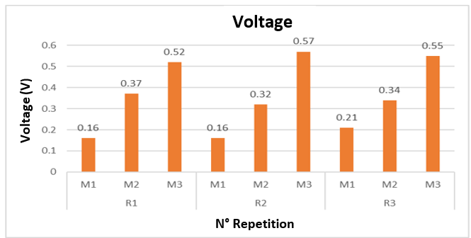

*Figure 3. Voltage in the MFC in three repetitions*

Figure 3 presents the voltage values (mV) obtained from different samples (M1, M2, and M3) for each experimental repetition (R1, R2, and R3). In each repetition, the voltage progressively increases from M1 to M3. In R1, the voltage ranges from 0.16 V (M1) to 520 mV (M3); in R2, a similar pattern is observed, but with slightly higher values, ranging from 0.16 V (M1) to the overall maximum of 0.57 V (M3). In R3, intermediate values are recorded compared to R1 and R2, with a range of 0.21 V (M1) to 0.55 V (M3). Repetition R2 shows the highest overall values, suggesting that the experimental conditions in this repetition favored a higher voltage production.

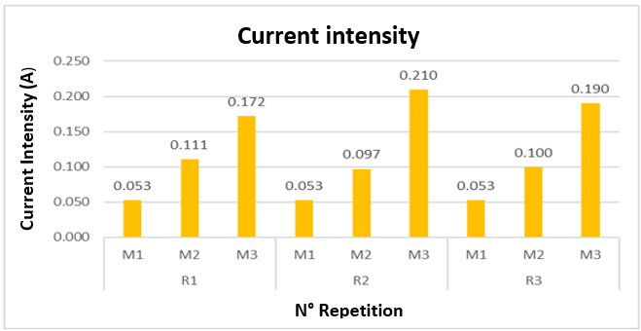

*Figure 4. Current Intensity in the MFC in Three Repetitions*

Figure 4 presents the current intensity (A) values obtained in the samples (M1, M2, and M3) for each experimental repetition (R1, R2, and R3). In R1, the current intensity ranges from 0.053 A (M1) to 0.172 A (M3). In R2, a similar pattern is observed, but with higher values, ranging from 0.053 A (M1) to a maximum of 0.210 A (M3). In R3, intermediate values are recorded compared to R1 and R2, with a range from 0.053 A (M1) to 0.190 A (M3). On the other hand, the values for M1 remain constant across all repetitions (0.053 A), indicating lower performance compared to samples M2 and M3.

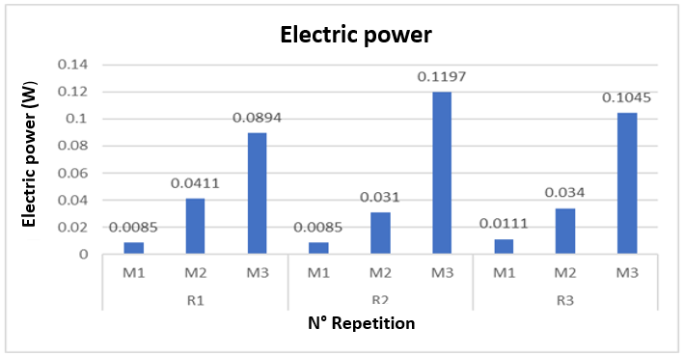

*Figure 5. Electrical Power in the MFC in Three Repetitions*

**Figure 5 presents the electrical power (W) values obtained in different samples (M1, M2, and M3) for each experimental repetition (R1, R2, and R3). In R1, the power ranges from 0.0085 W (M1) to 0.0894 W (M3). In R2, the highest value is recorded, with a range from 0.0085 W (M1) to 0.1197 W (M3). In R3, intermediate values are observed, ranging from 0.0111 W (M1) to 0.1045 W (M3). On the other hand, M1 values remain consistently low across all repetitions, reflecting lower electrical performance compared to M2 and M3.**

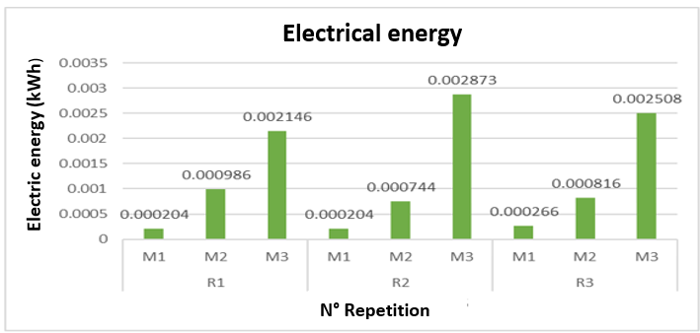

*Figure 6. Electrical Energy in the MFC in Three Repetitions*

Figure 6 presents the electrical energy (kWh) values obtained in different samples (M1, M2, and M3) for each experimental repetition (R1, R2, and R3). In R1, the energy ranges from 0.000204 kWh (M1) to 0.002146 kWh (M3). In R2, the highest value among all repetitions is recorded, reaching 0.002873 kWh in M3, while M1 and M2 show lower values of 0.000204 kWh and 0.000744 kWh, respectively. In R3, intermediate values are observed, with M3 reaching 0.002508 kWh, while M1 and M2 show 0.000266 kWh and 0.000816 kWh, respectively. Overall, electrical energy progressively increases from M1 to M3 in each repetition, with R2 demonstrating the highest energy performance.

**4. Discussion**

The results obtained in this study show that the microbial fuel cell (MFC) achieved values of 0.57 V, 0.210 A, and 0.1197 W within a 24-hour period, indicating a remarkable performance in energy generation. When comparing these values with those reported by (Segundo et al., 2022), who used onion waste and obtained peak values of 4.459 ± 0.0608 mA and 0.991 ± 0.02 V, it is observed that the voltage achieved in this study is lower than that reported by them. However, the current and power recorded in this experiment are significantly higher, suggesting that the MFC used in the present research has greater efficiency in energy conversion.

When compared to the study by (Silva-Palacios et al., 2023), it is observed that the MFC with Geobacter outperformed in voltage (0.57 V vs. 0.53-0.55 V) and current (0.210 A vs. 1.52-1.76 mA) compared to systems using Serratia fonticola and Rhodotorula glutinis. This difference could be attributed to the specialized electrogenic nature of Geobacter, which is capable of directly transferring electrons to the electrodes without chemical mediators (Romero et al., 2012), unlike other microorganisms that require more complex metabolic conditions. The temperature of 30°C used in this study favored the metabolic activity of Geobacter, optimizing the electron transfer kinetics (Verstraete & Rabaey, 2005). This contrasts with the comparative study conducted at 18°C, where efficiency decreases due to the reduction of enzymatic activity (Lopez, 2014).

When comparing these values with those reported by (Plasencia-Verde et al., 2021), it is observed that electrical performance varies depending on the composition and concentration of the substrate used. During the third period of their study, the highest efficiency was achieved with cocoa husk at a concentration of 1.20 g, reaching a voltage of 726 mV and a power density of 11.75 mW/m². On the other hand, mucilage at a 12.50% dilution showed a voltage of 474 mV and a power density of 6.52 mW/m². These values suggest that cocoa husk has greater potential as an energy source in MFCs compared to mucilage, which can be attributed to its chemical composition and the availability of biodegradable organic matter. These results reinforce the importance of continuing to investigate the optimization of operating conditions to maximize MFC efficiency using different types of organic waste, ultimately improving system performance.

* 1. Conclusiones

The results obtained in this study demonstrate the feasibility of generating electricity from dog feces in microbial fuel cells (MFCs) using Geobacter sulfurreducens as an electrogenic microorganism. A maximum voltage of 0.57 V, a current of 0.210 A, and a power output of 0.1197 W were achieved over a 24-hour period. The combination of 75 mL of Geobacter sulfurreducens and 125 mL of feces solution in R2 of M3 showed the best performance in electricity generation, highlighting the potential of this system as a sustainable alternative for bioelectricity production. The use of dog feces as a substrate enabled efficient electricity generation, suggesting that this type of organic waste can be utilized in bioenergy technologies instead of posing an environmental problem.

**Acknowledgments**

The authors thank the Vice Rectorate for Research of Universidad César Vallejo and the Faculty Research Support Fund for the financial support provided for the publication of this research.

References

Aguillón-Gutiérrez D., Meraz-Rodríguez Y., García-De-La-Peña C., Ávila-Rodríguez, V., Rodríguez-Vivas R., Moreno-Chávez, M., 2021, Prevalence of parasites in dog feces of Gomez Palacio, Durango, Mexico. Abanico Veterinario, 11.

Alba-Maldonado J. M., Carvajal-Rodríguez D. C., Hoyos-Patiño J. F. 2022. Canine population in street conditions in the city of Ocaña, Norte de Santander. Formación Estratégica, 2(1), 1–17. Retrieved from https://formacionestrategica.com/index.php/foes/article/view/112 [Accessed: 24.10.2024]. (In Spanish).

Bond, D. R., Lovley, D. R., 2003, Electricity production by Geobacter sulfurreducens attached to electrodes. Applied and Environmental Microbiology, 69(3), 1548-1555.

Das D., (2018). Microbial fuel cell. Springer-Verlag GmbH.

Delgado S. S., Huaman B., 2020, Dog proliferation and environmental pollution case: Tupac Amaru urbanization, San Sebastián district, Cusco Province – Perú, 2019. Universidad Andina del Cusco, Escuela Profesional de Economía, Revista Integración, 03. (In Spanish).

Kamani J., Massetti L., Olubade T., Balami J. A., Kennedy M., Samdi K. M., Traub R. J., Colella V., González-Miguel, J., 2021, Canine gastrointestinal parasites as a potential source of zoonotic infections in Nigeria: A nationwide survey. Preventive Veterinary Medicine, 192.

Logan B. E., Murano C., Scott K., Gray N. D., Head I. M. (2005). Electricity generation from cysteine in a microbial fuel cell. Water Research, 39(5), 942-952.

Lopez, H. J., 2014, Desarrollo de una celda de combustible microbiana (CCM) para aplicación en tratamiento de aguas residuales, Master’s thesis, Centro de Investigación y Desarrollo Tecnológico en Electroquímica, Querétaro, México. (In Spanish).

Plasencia-Verde C. C., Grabiel-Rios K. S., Luque J. A., Best, I. K., 2021, Evaluation of the energy potential of cocoa waste (Theobroma cacao L.) through microbial fuel cells (MFC). Información Tecnológica, 32(4), 89-98. (In Spanish).

Romero A. A., Vásquez J. A., Lugo, G. A., 2012, Bacteria, source of energy for the future. Tecnura, 16(32), 118-143.

Segundo R. F., De La Cruz-Noriega M., Milly Otiniano N., Benites S. M., Esparza M., Nazario-Naveda R., 2022, Use of onion waste as fuel for bioelectricity generation. Molecules, 27(3), 625.

Silva-Palacios F., Salvador-Salinas A., Quezada-Álvarez M. A., Rodríguez-Yupanqui M., Segundo R. F., Nazario-Naveda R., Cabanillas-Chirinos, L. 2023. Bioelectricity generation through microbial fuel cells using Serratia fonticola bacteria and Rhodotorula glutinis yeast. Energy Reports, 9, 295-301.

Tamponi C., Knoll S., Tosciri G., Salis F., Dessí G., Cappai M. G., Varcasia A., Scala, A., 2020, Environmental contamination by dog feces in touristic areas of Italy: Parasitological aspects and zoonotic hazards. The American Journal of Tropical Medicine and Hygiene, 103(3), 1143-1149.

Verstraete W., Rabaey K. 2005, Microbial fuel cells: Novel biotechnology for energy generation. Trends in Biotechnology, 23(6), 291-298.

Wang H., Luo H., Fallgren P. L., Jin S., Ren Z. J. 2015, Bioelectrochemical system platform for sustainable environmental remediation and energy generation. Biotechnology Advances, 33(3–4), 317-334.