 INGENIERÍA QUÍMICA ACTAS  Volumen XXX, 2025 | Una publicación de  
La Asociación Italiana
de Ingeniería Química
En línea en www.cetjournal.it

Editores invitados: David Bogle, Flavio Manenti, Piero Salatino
Copyright © 2025, AIDIC Servizi Srl
ISBN 979-12-81206-21-2; ISSN 2283-9216
Risk in the Marine Ecosystem in the Anchovy Production on
the Northern and Central Coast of Peru Due to the Effect of
Climate Change
Ruth L. Peña Ramírez*, Eusterio H. Acosta Suasnabar

Cesar Vallejo University, School of Environmental Engineering, Av. Alfredo Mendiola 6232, Los Olivos, Lima, Peru.
eacostas@ucv.edu.pe
Climate change alters conditions in the marine ecosystem, impacting the anchoveta population and prompting its migration to bodies of water with lower temperatures. The objective of the research was to examine the threat and implications of climate change on the anchovy population on the northern and central coast of Peru. To achieve this, information on climate variables was reviewed from institutions such as the Institute of the Sea of Peru (IMARPE), the Ministry of Production (PRODUCE), and the Climate Change Knowledge Portal WBG, covering the period from 2002 to 2022 on the northern and central coast of Peru. Information was obtained on temperature, seawater salinity, precipitation, and anchovy quantity, which were subjected to a correlation analysis to determine the association and impact on the anchovy population. The results indicated that by the year 2050, the increase in seawater temperature would be 0.48 °C and there would be a reduction in anchovy production of 985,189 tons. This demonstrates that the temperature increase due to climate change will decrease the quantity of anchovy along the Peruvian coast. Additionally, the possible consequences for the fishing industry and food security in these specific areas of Peru were analyzed.

- Introduction
The oceans are an important source of food for various species globally and also provide the essential oxygen for respiration on the Earth's surface. However, presently, marine water undergoes a process of degradation caused by pollution and ocean acidification, which is having an adverse impact on biodiversity and marine ecosystems. This deterioration also adversely affects artisanal fishing (Silva et al., 2019). Variations in ocean salinity globally result from discrepancies in freshwater input, precipitation, and evaporation, influenced by natural climate processes and climate change. Changes in rainfall patterns directly impact seawater salinity, as increased precipitation leads to lower salinity concentration, and vice versa. In subtropical areas, characterized by low rainfall and high evaporation, salinity is increasing, while in equatorial zones, with higher precipitation and lower evaporation, salinity is decreasing. These changes in salinity influence water density and have repercussions on ocean circulation (UN, 2017).
Oceans undergo harmful variations due to climate change, leading to an increase in temperature, acidity, and sea level. Additionally, they absorb carbon dioxide (CO₂) from the atmosphere, causing acidification and a decrease in oxygen levels in the marine ecosystem (World Bank, 2022). Climate change affects carbonate chemistry and oxygen, reducing carbonate ions in the ocean while pH experiences an increase. It is projected that by 2050, there will be a gradual increase in climate sensitivity, with seas warming by 0.8°C and a 5% decrease in oxygen concentration (Cao et al., 2014).
The Instituto of the Sea of Peru (2019) and the Ministry of Production (2014) reported on the behavior of marine organisms, which are affected by extreme events such as climate change and El Niño events. A variety of predominantly pelagic marine ecosystem resources, such as anchovy, sardine, jack mackerel, and mackerel, exhibit significant variability occurring on interannual timescales associated with El Niño and La Niña. The occurrence of events like El Niño causes increases in sea temperature, rising sea levels, changes in ocean patterns, and torrential rains, primarily in the northern region, altering the distribution and abundance of fishery resources, among other negative impacts. The presence of La Niña leads to the emergence of colder temperatures on the ocean surface in the central Pacific, thus creating a more pronounced temperature gradient from coastal areas to the central Pacific (Cai et al., 2015). It is anticipated that extreme La Niña and El Niño events will occur more frequently in the future, which could have significant implications for vulnerable ecosystems, such as the reduced ability of marine organisms to recover from adverse climate conditions (Ong et al., 2018).
Therefore, the research was important to better understand the dynamics of the marine ecosystem and may have significant implications for the management and conservation of marine resources, especially in the context of global climate change.

- Methodology
The research was conducted following the steps described below:

2.1 Data Collection
The information was obtained from the Institute of the Sea of Peru (IMARPE) and the Ministry of Production (PRODUCE), which included necessary data such as anchovy population, temperature, and seawater salinity at ports corresponding to the northern and central zones of Peru during the period 2002-2022. For climatological variables, access was gained through the Climate Change Knowledge Portal.

  - Data classification
Next, the data on sea water temperature, salinity, precipitation, and anchovet population were filtered and classified in Microsoft Excel. Missing data for the anchovy resource from the period 2002-2012 had to be manually entered on a daily basis. Table 1 shows the quantity of data obtained and processed per institution.

Table 1: Quantity of data obtained and processed
Institution | Variable | Quantity of data (2002 – 2022)
Institute of the Sea of Peru (IMARPE) | Temperature | 1984
 | Salinity | 1644
Climate Change Knowledge Portal | Precipitation | 3359
Ministry of Production (PRODUCE) | Anchovy | 3049
 | Juveniles < 12 cm | 3049

  - Data Tabulation
The information was tabulated and organized using Excel tools, and descriptive statistics were performed. The variables included sea water temperature and salinity, precipitation, and anchovy population.

  - Projection of Variables
Once the analysis of the variables' behavior during the periods 2002-2022 was completed, the future behavior of these variables was projected. Specifically, the impact of high Sea Surface Temperature (SST) and Sea Surface Salinity (SSS) variation on the anchovy population for the year 2050 was evaluated using the multivariable regression statistical method. The mathematical equation obtained Ec. (1) was graphically represented to facilitate understanding of the future projection. The equation derived from the data of the three most significant variables in the periods 2002-2022 helped verify the relationship between these indicators.

Anchovy (t) = -215,634,308 – 1,331,289 x SST + 7,087,240 x SSS Ec. (1)

La TSS y la SSS son atributos fundamentales en las aguas peruanas, mostrando variaciones tanto zonales como meridionales, y una considerable fluctuación en términos de distribución espacial y temporal (IMARPE, 2019).

2.3 Analysis of variable behavior during the period 2002-2022

The analysis of variable behavior during the period 2002-2022 was conducted, and a projection was made for the future behavior of these variables. The impact of high temperatures and variations in salinity on the anchovy population for the year 2050 was evaluated using the statistical method of multivariable regression.

3. Results
3.1.Historical Description of Variables
Below, Table 2 presents the database of annual variables for the period 2002-2022 of Sea Water Temperature (SST) (°C), Sea Surface Salinity (SSS), Precipitation (mm), Juveniles (%) and Anchovy (tons).
Table 2: Annual database.
Year | Temperature (SST)  (°C) | Salinity (SSS)  (UPS) | Precipitation (mm) | Juveniles  (%) | Anchovy  (tons)
2002 | 19.69 | 34.61 | 1695.90 | 34.50 | 4,868,453
2003 | 19.01 | 34.73 | 1767.87 | 7.10 | 4,951,034
2004 | 18.84 | 34.75 | 1752.45 | 11.80 | 6,765,398
2005 | 18.93 | 34.75 | 1535.34 | 19.50 | 7,661,852
2006 | 19.36 | 34.64 | 1788.80 | 3.30 | 4,976,891
2007 | 18.46 | 34.62 | 1690.03 | 3.40 | 5,148,142
2008 | 19.37 | 34.41 | 1687.51 | 3.80 | 1,270,327
2009 | 19.12 | 34.51 | 1690.04 | 3.60 | 5,323,010
2010 | 18.84 | 34.64 | 1407.26 | 6.60 | 2,916,183
2011 | 18.75 | 34.67 | 1629.87 | 8.30 | 6,315,201
2012 | 19.38 | 34.47 | 1460.10 | 0.31 | 3,068,429
2013 | 18.13 | 34.62 | 1606.56 | 1.59 | 4,502,534
2014 | 19.50 | 34.71 | 1572.07 | 3.42 | 1,923,308
2015 | 20.74 | 34.79 | 1570.35 | 9.52 | 3,387,469
2016 | 19.86 | 34.75 | 1557.09 | 11.15 | 2,584,948
2017 | 20.02 | 34.53 | 1624.58 | 8.93 | 3,027,145
2018 | 18.80 | 34.69 | 1597.78 | 6.33 | 5,838,720
2019 | 19.37 | 34.67 | 1645.44 | 8.56 | 3,172,676
2020 | 18.86 | 34.62 | 1584.20 | 3.28 | 4,320,756
2021 | 18.88 | 34.57 | 1498.25 | 8.40 | 4,927,888
2022 | 18.29 | 34.54 | 1234.53 | 23.04 | 3,775,509

In Table 2, the annual database was presented, since in IMARPE and PRODUCE these data were recorded daily. Approximately 13,000 data were processed, allowing us to transform the daily or monthly information into annual. This change enabled us to work properly, conduct statistical tests, and interpret the research results.

3.2 Level of relationship between variables
In Table 3, the pairwise Pearson correlation of anchovy, precipitation, temperature, and seawater salinity indicators for the period 2002-2022 was presented.

Table 3: Pearson pairwise correlation
Variable X | Variable Y | N | Correlation | 95% confidence interval for ρ
SSS (UPS) | SST (°C) | 21 | 0.156 | (-0.296; 0.551)
Anchovy (t) | SST (°C) | 21 | -0.429 | (-0.726; 0.003)
Juveniles (%) | SST (°C) | 21 | 0.104 | (-0.343; 0.513)
Precipitation (mm) | SST (°C) | 21 | 0.184 | (-0.269; 0.571)
Anchovy (t) | SSS (UPS) | 21 | 0.364 | (-0.081; 0.687)
Juveniles (%) | SSS (UPS) | 21 | 0.157 | (-0.294; 0.552)
Precipitation (mm) | SSS (UPS) | 21 | 0.165 | (-0.287; 0.557)
Juveniles (%) | Anchovy (t) | 21 | 0.252 | (-0.201; 0.617)
Precipitation (mm) | Anchovy (t) | 21 | 0.255 | (-0.199; 0.618)
Precipitation (mm) | Juveniles (%) | 21 | -0.192 | (-0.576; 0.262)

3.3 Determination of the incidence between variables
To determine the incidence of climate change indicators (seawater temperature and salinity) on the anchovy resource, the response surface or double entry method was used. This method represented the behaviour of the variables, considering that, according to the results obtained using Pearson's correlation method, the indicators show a greater relationship with anchovy production. Ec. (1) made it possible to determine the quantity of anchoveta as a function of the regression statistics, with a multiple correlation coefficient of 0.61. This implies that the equation obtained provides a robust relationship (Hernández et al., 2018).
In Table 4, the two-way table was shown, illustrating the relationship and incidence among the three variables: temperature, salinity, and anchovy quantity.

Table 4: Double entry table
 |  | Temperature (°C)
 |  | 17.0 | 17.5 | 18.0 | 18.5 | 19.0 | 19.5 | 20.0 | 20.5 | 21.0 | 21.5
Salinity (UPS) | 34.1 | 3.41 x 10⁶ | 2.74 x 10⁶ | 2.08 x 10⁶ | 1.41 x 10⁶ | 7.46 x 10⁵ | 8.04 x 10⁴ | 5.85 x 10⁵ | 1.25 x 10⁶ | 1.92 x 10⁶ | 2.58 x 10⁶
 | 34.2 | 4.12 x 10⁶ | 3.45 x 10⁶ | 2.79 x 10⁶ | 2.12 x 10⁶ | 1.45 x 10⁶ | 7.89 x 10⁵ | 1.24 x 10⁵ | 5.42 x 10⁵ | 1.21 x 10⁶ | 1.87 x 10⁶
 | 34.3 | 4.83 x 10⁶ | 4.16 x 10⁶ | 3.49 x 10⁶ | 2.83 x 10⁶ | 2.16 x 10⁶ | 1.50 x 10⁶ | 8.32 x 10⁵ | 1.67 x 10⁵ | 4.99 x 10⁵ | 1.16 x 10⁶
 | 34.4 | 5.53 x 10⁶ | 4.87 x 10⁶ | 4.20 x 10⁶ | 3.54 x 10⁶ | 2.87 x 10⁶ | 2.21 x 10⁶ | 1.54 x 10⁶ | 8.75 x 10⁵ | 2.10 x 10⁵ | 4.56 x 10⁵
 | 34.5 | 6.24 x 10⁶ | 5.58 x 10⁶ | 4.91 x 10⁶ | 4.25 x 10⁶ | 3.58 x 10⁶ | 2.92 x 10⁶ | 2.25 x 10⁶ | 1.58 x 10⁶ | 9.18 x 10⁵ | 2.53 x 10⁵
 | 34.6 | 6.95 x 10⁶ | 6.29 x 10⁶ | 5.62 x 10⁶ | 4.96 x 10⁶ | 4.29 x 10⁶ | 3.62 x 10⁶ | 2.96 x 10⁶ | 2.29 x 10⁶ | 1.63 x 10⁶ | 9.61 x 10⁵
 | 34.7 | 7.66 x 10⁶ | 6.99 x 10⁶ | 6.33 x 10⁶ | 5.66 x 10⁶ | 5.00 x 10⁶ | 4.33 x 10⁶ | 3.67 x 10⁶ | 3.00 x 10⁶ | 2.34 x 10⁶ | 1.67 x 10⁶
 | 34.8 | 8.37 x 10⁶ | 7.70 x 10⁶ | 7.04 x 10⁶ | 6.37 x 10⁶ | 5.71 x 10⁶ | 5.04 x 10⁶ | 4.38 x 10⁶ | 3.71 x 10⁶ | 3.04 x 10⁶ | 2.38 x 10⁶
 | 34.9 | 9.08 x 10⁶ | 8.41 x 10⁶ | 7.75 x 10⁶ | 7.08 x 10⁶ | 6.42 x 10⁶ | 5.75 x 10⁶ | 5.08 x 10⁶ | 4.42 x 10⁶ | 3.75 x 10⁶ | 3.09 x 10⁶
 | 35.0 | 9.79 x 10⁶ | 9.12 x 10⁶ | 8.46 x 10⁶ | 7.79 x 10⁶ | 7.12 x 10⁶ | 6.46 x 10⁶ | 5.79 x 10⁶ | 5.13 x 10⁶ | 4.46 x 10⁶ | 3.80 x 10⁶
 | 35.1 | 1.05 x 10⁷ | 9.83 x 10⁶ | 9.16 x 10⁶ | 8.50 x 10⁶ | 7.83 x 10⁶ | 7.17 x 10⁶ | 6.50 x 10⁶ | 5.84 x 10⁶ | 5.17 x 10⁶ | 4.51 x 10⁶
 | 35.2 | 1.12 x 10⁷ | 1.05 x 10⁷ | 9.87 x 10⁶ | 9.21 x 10⁶ | 8.54 x 10⁶ | 7.88 x 10⁶ | 7.21 x 10⁶ | 6.55 x 10⁶ | 5.88 x 10⁶ | 5.21 x 10⁶
 | 35.3 | 1.19 x 10⁷ | 1.12 x 10⁷ | 1.06 x 10⁷ | 9.92 x 10⁶ | 9.25 x 10⁶ | 8.59 x 10⁶ | 7.92 x 10⁶ | 7.25 x 10⁶ | 6.59 x 10⁶ | 5.92 x 10⁶
 | 35.4 | 1.26 x 10⁷ | 1.20 x 10⁷ | 1.13 x 10⁷ | 1.06 x 10⁷ | 9.96 x 10⁶ | 9.29 x 10⁶ | 8.63 x 10⁶ | 7.96 x 10⁶ | 7.30 x 10⁶ | 6.63 x 10⁶
 | 35.5 | 1.33 x 10⁷ | 1.27 x 10⁷ | 1.20 x 10⁷ | 1.13 x 10⁷ | 1.07 x 10⁷ | 1.00 x 10⁷ | 9.34 x 10⁶ | 8.67 x 10⁶ | 8.01 x 10⁶ | 7.34 x 10⁶

According to Table 4, there is a level of incidence among the three indicators. Thus, if the temperature is 17 °C and the salinity is 35.5 UPS, then the levels of anchovy resources were 1.33 x 10^7 tons, which is one of the highest in the table. However, if the temperature is 21.5 °C and the salinity is 35.5 UPS, then the anchovy levels were 7.34 x 10^6 tons, which is the lower range.

3.4. Projection for the Year 2050
The projection for the year 2050 has been worked with a confidence level of 95 %. Figure 1 displays the projection of sea water temperature for the year 2050.

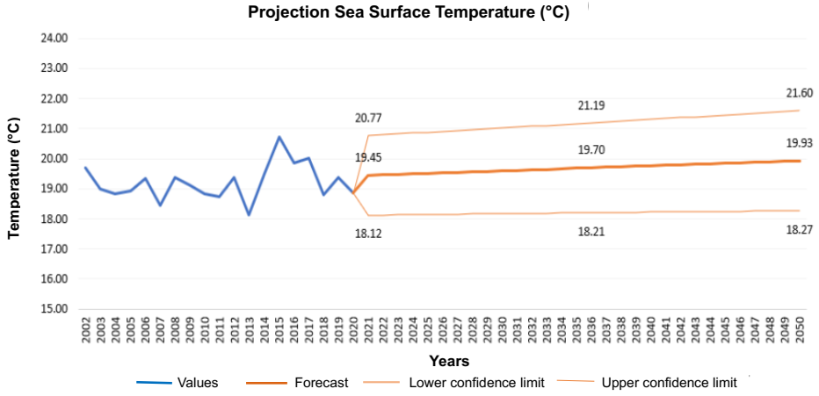
Figure 1. Projection of sea water temperature for the year 2050.

In Figure 1, the future projection of temperature until the year 2050 was observed, with an increase of 0.48 °C. The values obtained are a maximum of 21.60 °C, a mean of 19.93 °C, and a minimum of 18.27 °C.

In Figure 2, the projection of sea water salinity for the year 2050 is shown. In Figure 3, the future projection of salinity until the year 2050 was observed, with an increase of 0.02 UPS. The values obtained are a maximum of 34.85 UPS, a mean of 34.64 UPS, and a minimum of 34.44 UPS.
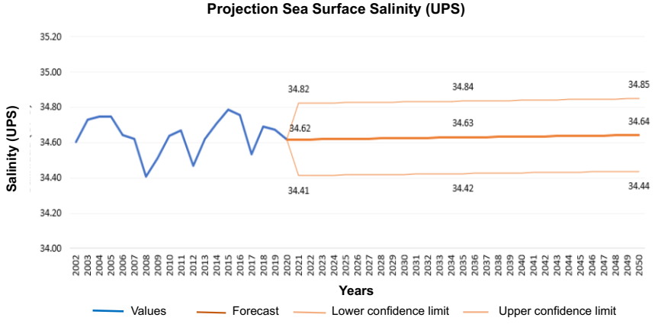
Figure 2. Projection of sea water salinity for the year 2050.

The projection of anchoveta production for the year 2050 was shown in Figure 3.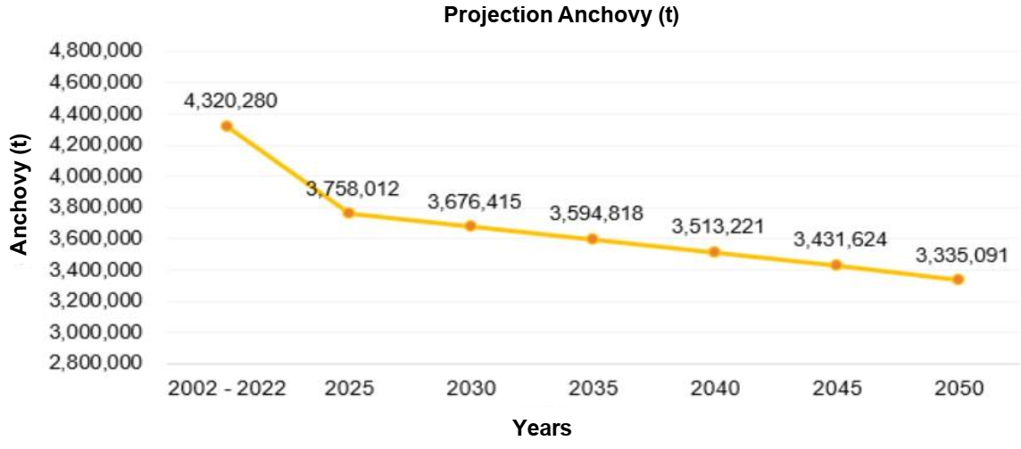
Figure 5. Projection of anchovet for the year 2050.

In Figure 3, the future projection of anchovy until the year 2050 was observed, obtaining a decrease of 985,189 tons, representing a reduction of 22.8 % in the future quantity of anchovy. The value obtained for the year 2050 is 3,335,091 tons, which is lower than the average quantity obtained in the period 2002-2022 (4,320,280 tons).

- Discussion
The results obtained in the present study show that environmental factors associated with climate change have a significant influence on the population dynamics of anchovy (Engraulis ringens). It was observed that the population of this species tends to increase when sea water temperatures are lower, suggesting a preference for colder environments. This trend is consistent with the behavior of pelagic species, which show an affinity for moderately low temperatures and an optimal salinity in the range of 34–35 PSU. These findings are consistent with previous research. (Castillo et al., 2021) noted that the increase in sea surface temperature can induce species migration toward areas with more suitable environmental conditions, both for survival and for egg incubation. Similarly, (Contreras et al., 2017) reported that 96% of anchovy larval mortality is attributed to abrupt and extreme temperature changes, which also generate instability in salinity levels—a key factor in larval development. During the period 2002–2022, sea water salinity records showed maximum values of 34.99 PSU at the end of the years 2008 and 2015. This increase in salinity is mainly related to higher evaporation rates and decreased precipitation, which lead to a greater concentration of salts. (Fournier et al., 2020) support this interpretation by indicating that high temperatures and intensive ocean evaporation increase salinity, while sustained precipitation tends to reduce it. Additionally, (Arias et al., 2021) stated that the incursion of warm waters from the southwest (SSW) contributed to a warming phase and an increase in salinity in the Pacific Ocean, altering its physicochemical composition. In turn, Silvy et al. (2020) reported that high levels of precipitation can reduce sea water salinity due to the dilution effect, which can modify the habitat and behavior of anchovy. Altogether, these results confirm the existence of a complex interaction between temperature, salinity, and precipitation, which directly affects the ecology and population dynamics of anchovy— a key species for the marine ecosystem and regional fishing activity.

- Conclusions
Within the incidence during the period 2002-2022 among the variables of climate change indicators, anchovy levels were determined. If the temperature is 17 °C and the salinity 35.5 UPS, the quantity was 1.33 x 10⁷ tons of anchovy, being this the highest value. On the other hand, if the temperature is 21.5 °C and the salinity 35.5 UPS, the quantity was 7.34 x 10⁶ tons of anchoveta, being this the lowest value. The projection of the temperature increase from 2022 to 2050 was 0.48 °C, negatively impacting the anchovy population, which caused a reduction of 985,189 tons, representing a loss of 22.8 % of the resource for the same period of time. These results have significant implications for the management and conservation of this species and its ecosystem, especially in the current context of climate change.

Acknowledgments
The authors would like to express their gratitude to the Vice-Rectorate for Research of Cesar Vallejo University and the Fund for Support of Teaching Research for the financial support provided for the publication of this research.

References
Arias P., Bellouin N., Coppola E., Jones R., Krinner G., Marotzke J., Zickfeld K., 2021, Sixth Assessment Report of the Intergovernmental Panel on Climate Change; IPCC Resumen technical. <ipcc.ch/report/ar6/wg1/chapter/technical summary/>
Cai W., Wang G., Santoso, A., Mcphaden M.J., Wu, L., Jin F., Timmermann A., (...), Guilyardi E., 2015,
Increased frequency of extreme La Niña events under greenhouse warming. Nature Clim Change 5, 132–137
Cao L., Wang S., Zheng M., Zhang, H., 2014, Sensitivity of ocean acidification and oxygen to the uncertainty in climate change. Environmental research letters, 9, 6.
Castillo P.R., Niquen M., Cruz L.L., Guevara-Carrasco R., Cuadros G., 2021, Migration behavior of anchoveta (Engraulis ringens) in the Northern Humboldt Current System between September 2019 and September 2020. Latin american journal of aquatic research, 49, 5, 702-716.
Contreras J.E., Rodríguez‐Valentino C., Landaeta M.F., Plaza G., Castillo M.I., Alvarado‐Niño M., 2017, Growth and mortality of larval anchovy Engraulis ringens, in northern Chile during winter and their relationship with coastal hydrographic conditions. Fisheries oceanography, 26, 6, 603-614.
Fournier S., Lee T., Wang X., Armitage T.W.K., Wang O., Fukumori, I., Kwok R., 2020, Sea Surface Salinity as a Proxy for Arctic Ocean Freshwater Changes. Journal of geophysical research. Oceans, 125, 7.
Hernández J.D., Espinosa F., Rodríguez, J.E., Chacón J.G., Toloza C.A., Arenas M.K.,2018, On the appropriate use of the Pearson correlation coefficient: definition, properties, and assumptions. 37, 5. Spanish.
Institute of the Sea of Peru (IMARPE), 2019, Report on oceanographic and biological-fishery conditions November 2019, Activity 4 Generation of information and monitoring of the El Niño Phenomenon, Peruvian Sea Institute Report, page 52,
<imarpe.gob.pe/imarpe/archivos/informes/imarpe_gti_mens_noviembre2019.pdf> Spanish
Ministry of Production (PRODUCE), 2014. Diagnosis of current vulnerability of the fishing and aquaculture sector to climate change. Fishing diagnosis publication, 2, 34,
<produce.gob.pe/documentos/pesca/dgsp/publicaciones/diagostico-pesquero/Tomo-2.pdf>. Spanish
Ong J., Rountrey A., Negro B., Nguyen H., Coulson P., Newman E., Wakefield C., Meeuwig J., Meekan Mark G., 2018, A boundary current drives synchronous growth of marine fishes across tropical and temperate latitudes, Global Change Biology, 24, 5, 1894–1903
Silva C., Leiva F., Lastra J., 2019, Predicting the current and future suitable habitat distributions of the anchovy (Engraulis ringens) using the Maxent model in the coastal areas off central‐northern Chile. Fisheries oceanography, 28, 2, 171-182.
Silvy Y., Guilyardi E., Sallée J. B., Durack P.J., 2020, Human-induced changes to the global ocean water masses and their time of emergence. Nature climate change, 10, 11, 1030-1036.
The World Bank, 2022, What You Need to Know About Oceans and Climate Change. World Bank, Feature story February 8, 2022, < n9.cl/qn6vsa> accessed 24.01.2024.
United Nations, 2017, THE EFFECTS OF CLIMATE CHANGE AND CLIMATE CHANGE AND RELATED ATMOSPHERIC RELATED ATMOSPHERIC CHANGES ON OCEANS. Capítulo II D, SBN 978-92-1- 361388-7, <un.org/regularprocess/sites/www.un.org.regularprocess/files/17-05753_s-impacts-of-climate-change.pdf> accessed 20.01.2024.
.

