 CHEMICAL ENGINEERING TRANSACTIONS  VOL. xxx, 2025 | A publication of  
The Italian Association
of Chemical Engineering
Online at www.cetjournal.it

Guest Editors: David Bogle, Flavio Manenti, Piero Salatino
Copyright © 2025, AIDIC Servizi S.r.l.
ISBN 979-12-81206-21-2; ISSN 2283-9216

On the Use of Water-Based Nanofluids in Buildings HVAC Systems: A Simulative Study on Energy Savings and Indoor Comfort Potential
Laura Cirrincioneª, Gianluca Scaccianoceª, Marco Vocciante^{b,}*
ªDipartimento di Ingegneria, Università degli Studi di Palermo, Viale delle Scienze Bld. 9, 90128, Palermo, Italy
^{b}Dipartimento di Chimica e Chimica Industriale, Università degli Studi di Genova, via Dodecaneso 31, 16146, Genova, Italy
marco.vocciante@unige.it
Nanofluids, known for their enhanced thermal conductivity and heat transfer properties, present a promising alternative to traditional fluids. This study explores the potential of water-based nanofluids containing CuO and Al₂O₃ nanoparticles as replacements for conventional heat exchange fluids in HVAC systems. Detailed modeling of HVAC systems were conducted using EnergyPlus to evaluate energy consumption in a reference building, while maintaining optimal indoor comfort conditions, by comparing the performance of configurations incorporating the thermophysical properties of CuO and Al₂O₃ nanoparticles against a conventional fluid configuration. Preliminary results show improvements in heat transfer efficiency and energy savings, with variations based on nanoparticle type and concentration. Nanofluids exhibit higher thermal conductivity, leading to better energy performance depending on the working conditions, such as temperature and concentration. The outcomes of this preliminary study highlight the potential of nanofluids to maintain stable and uniform temperatures. This research contributes to the growing body of knowledge on nanofluids in HVAC applications, suggesting that water-based nanofluids could enhance the energy efficiency and sustainability of building systems.
  - Introduction
Achieving optimal energy management and reducing carbon emissions in urban areas are key objectives of international, European, and national energy and environmental policies. This is evidenced by initiatives such as the United Nations Sustainable Development Goals (SDGs), particularly Goals 11 and 12, which focus on responsible consumption and production to make cities inclusive, safe, resilient, and sustainable (UN, 2024). Additionally, the European Union's long-term environmental strategies (EC, 2018), climate and energy frameworks (EC, 2014), GreenDeal (EC, 2019), and NextGenerationEU (EC, 2020) policies, which have been adopted nationally, including Italy's National Recovery and Resilience Plan – PNRR (MIMIT, 2021), underscore these goals. Accordingly, improving the energy and environmental performance of buildings is crucial, as they constitute a significant portion of the urban landscape and are responsible for a substantial share of energy consumption and pollutant emissions, accounting for approximately 40% globally (IEA, 2019). In particular, space conditioning, including heating and cooling, represents the largest energy consumption category within buildings (UNEP, 2020). Consequently, to enhance buildings' resilience to climate change, it is essential to adopt sustainable technologies from a circular economy perspective, promoting energy equity and accessibility. This approach aims to achieve Nearly Zero Energy Buildings – NZEB (EC, 2010) and Positive Energy Districts – PEDs (Cirrincione et al., 2023), as recommended by various European and national directives (González-Prieto et al., 2023). Energy-efficient, smart and flexible energy storage and exchange systems are vital for sustainable energy management within district energy systems, where buildings are the primary users (Cirrincione et al., 2022).
In light of the above, innovative solutions are needed to address building energy requirements by increasing process efficiency while maintaining optimal occupant comfort, considering site-specific climate conditions (Du et al., 2023). Recent advances include systems that integrate renewable energy sources, such as photovoltaic-thermal – PVT systems (Cirrincione et al., 2020), with low-impact storage solutions (Cao et al., 2023) like hydrogen (Saeedmanesh et al., 2018) or PCM materials (Utpol et al., 2024). In addition, the search for more effective working fluids has led to the exploration of nanofluids – NFs (Choi and Eastman, 1995), which are conductive fluids enhanced with nanoparticles – NPs (Bahiraei et al., 2018). These nanofluids can indeed offer improved thermal conductivity and energy efficiency, making them promising for applications in heat exchangers – HEs, microelectronics, household refrigerators, and fuel cells (Sajid and Ali, 2019), especially when combined with more efficient devices to further increase savings (Vocciante and Kenig, 2021). As a result, the use of nanofluids for buildings applications has recently been explored showing encouraging potential (Sathishkumar et al., 2024). Indeed, this approach not only improves energy efficiency, but also enhances the resilience of buildings to climate change, a topic of growing interest in recent years (Peri et al., 2024).
Based on the scientific literature regarding the use of nanofluids for buildings applications, broadly speaking two main macro categories can be identified. The first one involves building systems applications, into which mainly fall cooling and heating – HVAC systems (Benazzouz et al., 2025), PVT systems (Chaichan et al., 2025) and heath transfer and energy storage (Liu et al., 2025). On the other hand, the second category covers building envelope applications, for which the use of nanofluids has been investigated for what concerns both opaque elements (such as, the employment of nanofluid-based additives in cementitious materials to enhance structural characteristics (Wei et al., 2024), or the use of nanoparticles in PCMs-based envelope components to improve thermal insulation (Alqaed et al., 2022)) and glazed elements (as for example, the use of nanofluids in smart and photovoltaic windows for better lighting (Zhang et al., 2023), thermal (Wang et al., 2024) and energy (Abd El-Samie et al., 2024) performance, or the integration of the of nanofluids in tubular daylighting devices – TDDs (Wu et al., 2024), also for domestic hot water – DHW applications (Liu et al., 2022)).
In light of the above introduced background, and given the novelty of this research topic, the goal of this research is to contribute to the growing body of knowledge on the use of water-based nanofluids in HVAC applications in buildings, providing insights into their practical implementation and benefits in reference to the main energy and environmental implications of interest, that is energy consumption and indoor comfort potential. To this purpose, the study involves a detailed modeling of HVAC systems conducted to compare the performance of HVAC systems using nanofluids, incorporating the thermophysical properties of CuO and Al₂O3 nanoparticles, against those using conventional fluids.
  - Materials and methods
As previously mentioned, this work investigates the potential benefits of replacing a conventional heat exchange fluid, i.e., water, in HVAC systems with water-based nanofluids containing CuO and Al₂O₃ nanoparticles at different concentrations. Specifically, utilizing the EnergyPlus simulation tool (EP, 2025), the energy consumption for heating and cooling suitable to ensure optimal indoor comfort conditions was evaluated for a reference building, i.e., the BESTEST Case 600 (ASHRAE, 2020), according to the energy demand calculation methods given by the Standard for Energy Efficiency in Buildings (ISO, 2017), under different climate scenarios, using the climatic data of two Italian cities: Genoa and Palermo. In fact, these cities are located in different climatic zones according to the Koppen-Geiger climate classification (Kottek et al., 2006), providing a variety of weather conditions for the analysis, as shown in Figure 1.

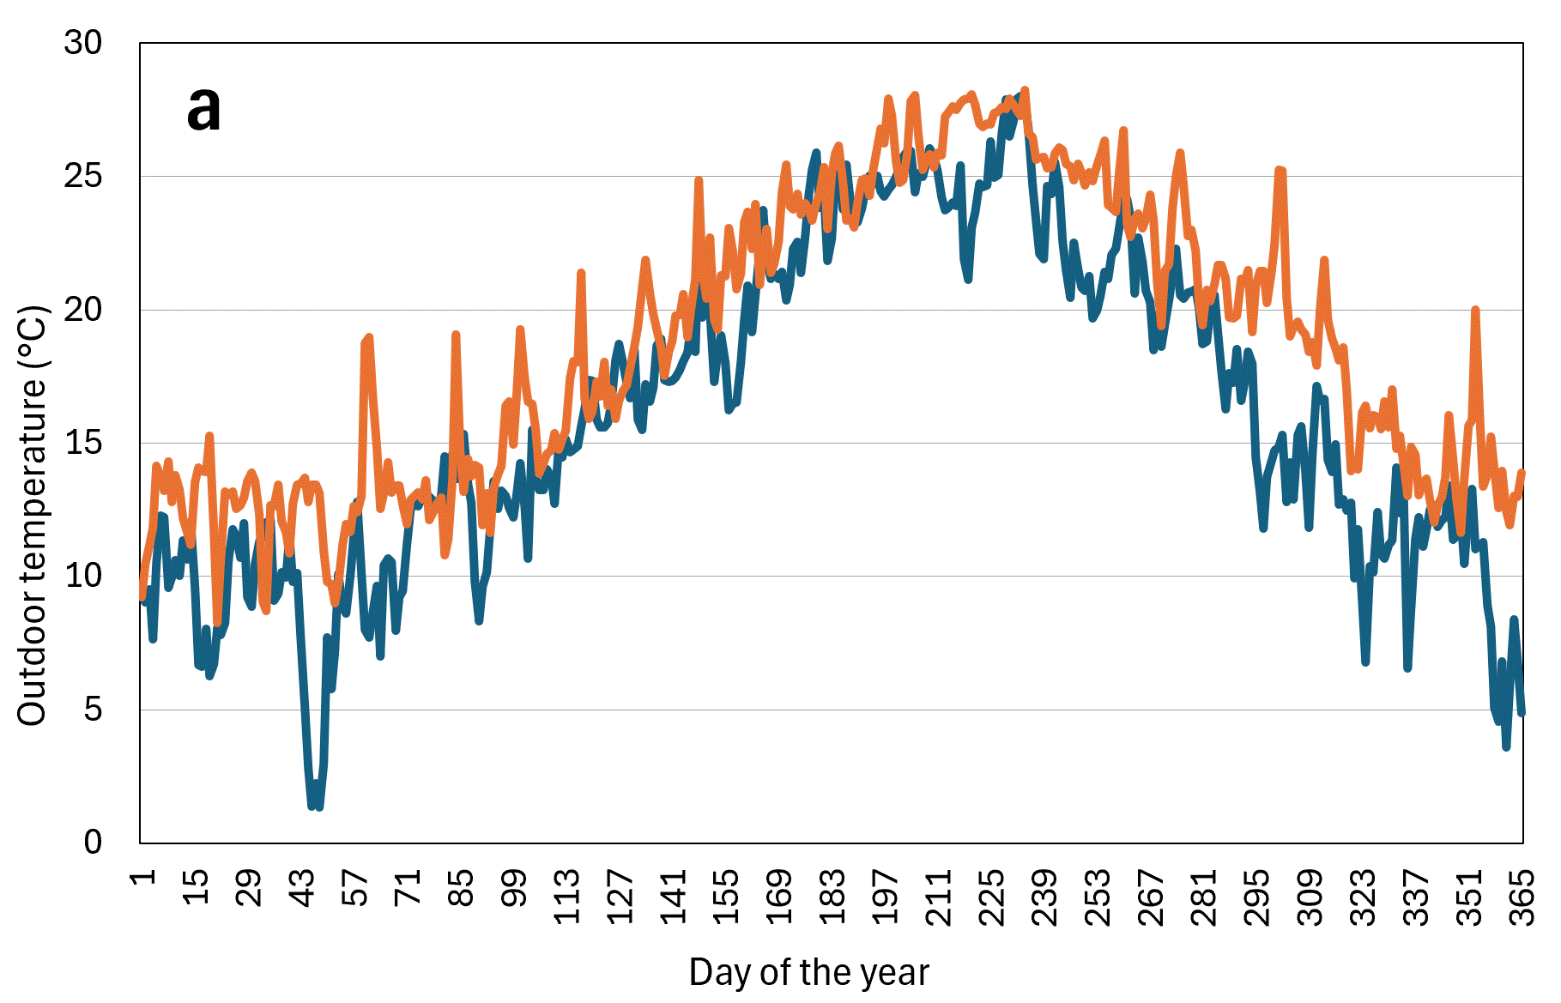 | 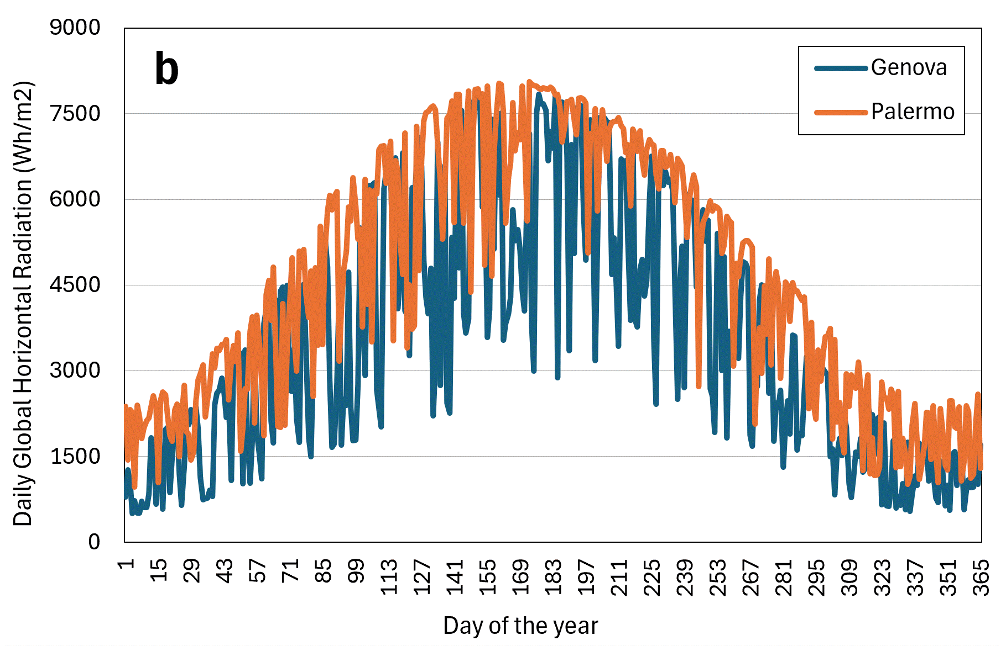
Figure 1: Daily outdoor temperature (a) and daily global horizontal solar radiation (b) for the city of Genova and Palermo
More in detail, the BESTEST Case 600 was used for the simulations, which refers to a rectangular single-zone structure measuring 8 meters wide, 6 meters long, and 2.7 meters high, constructed with lightweight materials, including plasterboard, fiberglass quilt, and wood siding. The building has no interior partitions and features 12 square meters of windows on the south-facing wall with no shading devices to maximize solar gain.
The BESTEST Case 600 is typically used to test simulation programs. However, since its main focus is on testing the building envelope, an air-conditioning equipment has been added to the system consisting of a fan-coil unit with two coils: one for heating and one for cooling. A natural gas boiler served as the heating element for the water distribution circuit during the heating season, while a chiller was used for cooling during the cooling season. In order to maintain optimal indoor comfort conditions (ISO, 2005), the room temperature is controlled with a dual-setpoint system, set to 20°C for heating and 27°C for cooling (ASHRAE, 2023).
The energy consumption will be assessed as energy use intensity (MJ/m²) for cooling – HVAC_El and for heating – HVAC_NaturalGas (ISO, 2017).
Regarding the selected nanofluids, their characterization data in the temperature range of interest for conducting simulations were derived from relevant literature, as reported in Table 1, together with those relating to the comparison traditional fluid, that is water.
Table 1: Traditional fluid (water) and selected nanofluids (CuO and Al₂O₃ at different concentration) characterization data in the temperature range of interest.
Fluid | Temperature (°C) | Density (kg/m³) | Viscosity (mPa·s) | Specific Heat (kJ/kg·K) | Thermal Conductivity (W/m·K) | Reference literature
Water | 10 | 1000 | 1.31 | 4.19 | 0.58 | (EP, 2025)
 | 30 | 996 | 0.80 | 4.18 | 0.61
 | 50 | 988 | 0.55 | 4.18 | 0.64
 | 70 | 978 | 0.40 | 4.19 | 0.66
CuO  1% wt | 10 | 1004 | 1.03 | 4.10 | 0.57 | (Sohel Murshed and Estellé, 2017)  (Okonkwo et al., 2021)  (Al Shdaifat et al., 2020)
 | 30 | 1002 | 0.98 | 4.00 | 0.61
 | 50 | 1000 | 0.93 | 3.90 | 0.65
 | 70 | 998 | 0.88 | 3.80 | 0.69
CuO  5% wt | 10 | 1028 | 1.20 | 3.80 | 0.62
 | 30 | 1022 | 1.10 | 3.70 | 0.66
 | 50 | 1016 | 1.00 | 3.60 | 0.70
 | 70 | 1010 | 0.90 | 3.50 | 0.74
Al₂O₃  1% wt | 10 | 1001 | 1.08 | 4.15 | 0.60 | (Sohel Murshed and Estellé, 2017)  (Okonkwo et al., 2021)  (Sivakumar et al., 2024)
 | 30 | 999 | 1.03 | 4.05 | 0.64
 | 50 | 997 | 0.98 | 3.95 | 0.68
 | 70 | 995 | 0.93 | 3.85 | 0.72
Al₂O₃  5% wt | 10 | 1033 | 1.25 | 3.85 | 0.67
 | 30 | 1027 | 1.15 | 3.75 | 0.71
 | 50 | 1021 | 1.05 | 3.65 | 0.75
 | 70 | 1015 | 0.95 | 3.55 | 0.79

  - Results and discussion
The results of the analyses of the energy aspect are summarized in Figure 2. From the perspective of indoor conditions, the indoor temperature values remained practically unchanged, and therefore, the indoor comfort performance did not experience any alterations. However, it is possible to observe that there is minimal deviation in energy consumption for air conditioning, with benefits observed only for cooling. This discrepancy is likely due to the varying properties of the nanofluids at different temperatures. Considering that the selected nanofluids have higher thermal conductivity compared to water, they are confirmed to enhance heat exchange. However, having lower specific heat, at the same flow rate they result in a lower transport of thermal energy. At increasing temperature, the loss in specific heat becomes generally more marked, overcoming the gain in terms of improved thermal conductivity. This is in line with what is shown in Figure 2, where there is a benefit in terms of cooling but a slight penalty in terms of heating after replacing the traditional fluid (water) with the two selected nanofluids (CuO and Al₂O₃).
Although EnergyPlus is not a software designed to carry out detailed studies of this kind (e.g., due to limitations on modeling the behavior of non-Newtonian fluids such as precisely nanofluids), the results obtained appear to be consistent and in line with the characterization of the selected nanofluids, depending strongly on how the properties of these vary as the temperature changes (see Table 1). Specifically, there is a general increase in thermal conductivity that is favored by higher percentages of nanoparticles dispersed in the fluids, which therefore promotes thermal transport. However, the addition of nanoparticles results in an increase in the complexity of rheological behavior, with viscosity that overall varies less predictably with temperature and flow conditions (compared to a traditional Newtonian fluid such as water), and a reduction in the heat capacity/specific heat of the fluid. Even not considering the increased rheological complexity (EnergyPlus uncertainty in considering non-Newtonian behaviors for fluids), it is observed that the reduction in specific heat is more pronounced for high temperatures. This results in reduced heat transport with the fluid that is not compensated for by the increased thermal conductivity when the fluid is used for heating. In contrast, for lower temperature ranges this loss of heat capacity is smaller and thus the benefit in terms of thermal conductivity leads to an overall benefit relative to the use of these nanofluids for cooling.

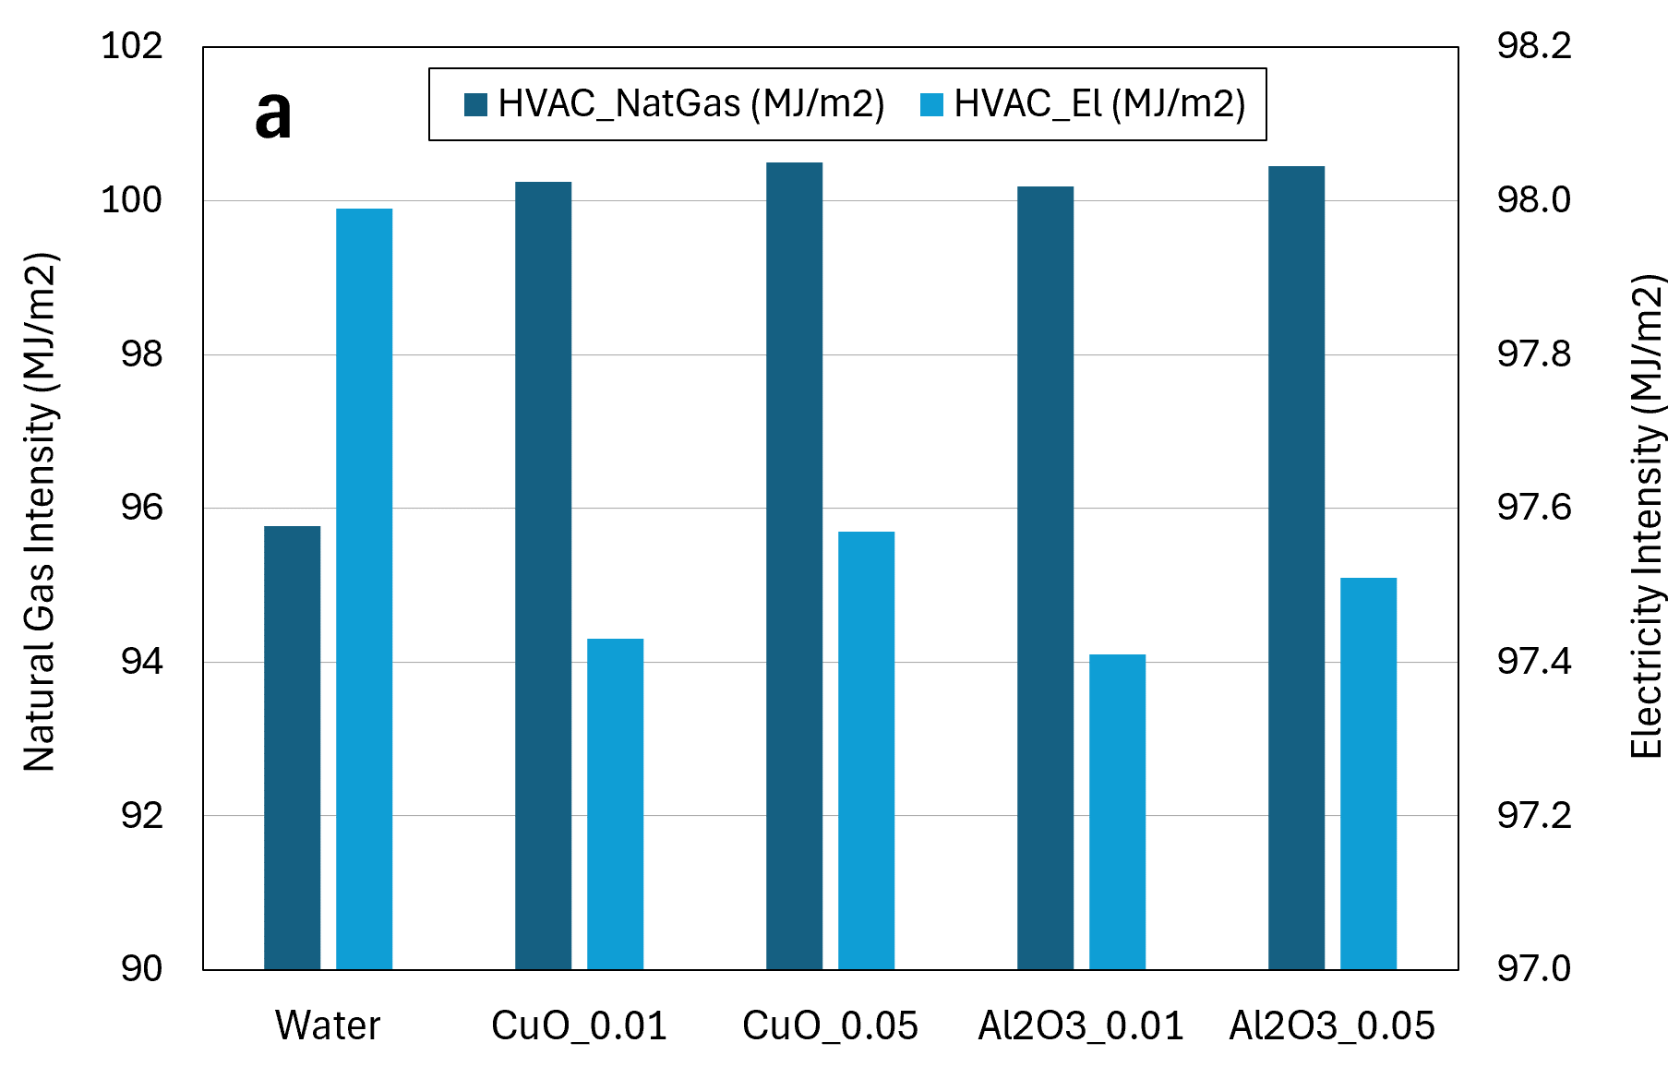 | 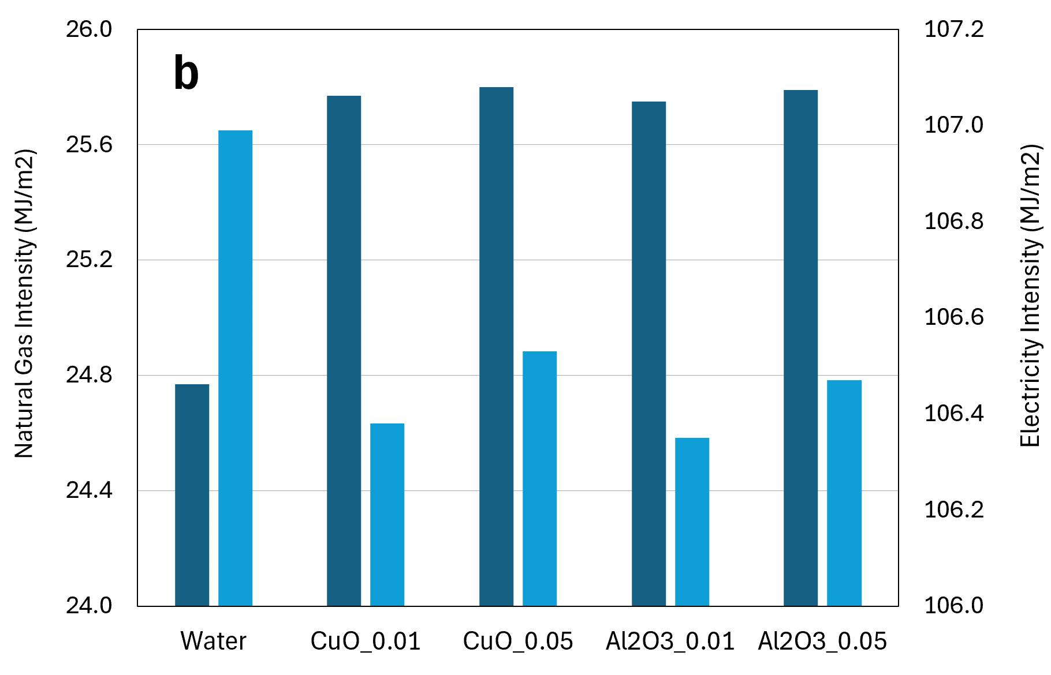
Figure 2: Energy intensity for heating (natural gas) and cooling (electricity) systems using the weather data from Genova (a) and Palermo (b)
Overall, the obtained preliminary results indicate that improvements in heat transfer efficiency and energy savings could be achieved, with variations observed based on nanoparticle type and concentration. CuO nanofluids demonstrate higher thermal conductivity, leading to better energy performance, while Al₂O₃ nanofluids offer a balanced improvement in both thermal and rheological properties. Concerning the maintenance of indoor thermal comfort conditions, the outcomes also highlight the potential of nanofluids to maintain more stable and uniform temperatures.
  - Conclusions
The pursuit of energy-efficient and sustainable building systems has driven research into advanced materials and technologies. In particular, the increased energy demand for building climatization due to climate change poses challenges in terms of energy savings, indoor thermal comfort, and environmental impacts. In this perspective, nanofluids, with their superior thermal conductivity and heat transfer properties, represent a promising alternative to traditional fluids in HVAC systems.
This study provides an initial assessment of the benefits of nanofluids using EnergyPlus software. Although EnergyPlus isn't specifically designed for HVACs assessments, it enabled a quick preliminary evaluation of energy demands, forming a basis for further detailed analyses.
Findings of the performed preliminary research on water-based nanofluids integration in HVAC systems allow to make some considerations on the main significant benefits that they could entail: (i) Energy efficiency: Enhanced thermal conductivity and heat transfer properties could lead to energy savings, maintaining comfortable indoor temperatures with less energy consumption. (ii) Sustainability: Possible improved energy efficiency could reduce buildings' carbon footprint, supporting climate change mitigation efforts. (iii) Cost savings: Achievable energy efficiency could lower operational costs, offsetting initial investments in nanofluid technology. (iv) Indoor comfort: Feasibility of nanofluids to maintain stable and uniform temperatures ensures the needs related to productivity and well-being in both residential and work environments (such as, offices, schools, etc.). (v) Technological advancement: Successful implementation of nanofluids in HVAC systems can drive further research and development in nanotechnology applications like refrigeration and heat exchangers.
In conclusion, this work enhances the understanding of water-based nanofluids in HVAC applications, highlighting their practical benefits. Accordingly, future research, which is currently under evaluation, will focus on experimental and simulative applications to identify the optimal fluid configuration for different HVAC systems, using ad hoc modeling tools. The outcomes suggest that water-based nanofluids can significantly improve the energy efficiency, environmental performance, and cost-effectiveness of building systems, supporting sustainable and resilient practices in line with the United Nations SDGs.
Acknowledgments
This study was developed in the framework of the research activities carried out within the Project “Network 4 Energy Sustainable Transition — NEST”, Spoke 8: Final use optimization, sustainability \& resilience in energy supply chain, Project code PE00000021, Concession Decree No. 1561 of 11.10.2022 adopted by Ministero dell’Università e della Ricerca (MUR), CUP UNIPA B73C22001280006, Project funded under the National Recovery and Resilience Plan (NRRP), Mission 4 Component 2 Investment 1.3 - Call for tender No. 341 of 15.03.2022 of Ministero dell’Università e della Ricerca (MUR); funded by the European Union – NextGenerationEU.
References
Abd El-Samie M.M., Mahmoud O.E., Yang Y., Fatouh M., 2024, Performance evaluation of multifunctional windows for commercial buildings under hot-humid climatic environments, Energy and Buildings, 303, 113816.
Alqaed S., Mustafa J., Sharifpur M., 2022, Annual energy analysis of a building equipped with CaCl₂·6H₂O as PCM and CaCl₂·6H₂O/CsxWO₃ as nano PCM-Useless of adding nanoparticles, Journal of Building Engineering, 53.
Al Shdaifat M.Y., Zulkifli R., Sopian K., Salih A.A., 2020, Thermal and Hydraulic Performance of CuO/Water Nanofluids: A Review. Micromachines, 11(4):416.
ANSI/ASHRAE Standard 140-2017 (2020), available at: https://www.ashrae.org (accessed on 15 April 2025).
ANSI/ASHRAE Standard 55-2023 (2023), available at: https://www.ashrae.org (accessed on 15 April 2025).
Bahiraei M., Rahmani R., Yaghoobi A., Khodabandeh E., Mashayekhi R., Amani M., 2018, Recent research contributions concerning use of nanofluids in heat exchangers: a critical review, Applied Thermal Engineering, 133, 137–159.
Benazzouz A., Ammar M.A.H., Settou B., Marif Y., Djemoui K., 2025, Thermal performance analysis of a domestic-size absorption cooling system incorporating nanofluid with thermal insulation in hot climate of Algeria, International Journal of Refrigeration, 170, 192–213.
Cao X., Li N., Li Y., Che L., Yu B., Liu H., 2023, A review of photovoltaic/thermal (PV/T) technology applied in building environment control, Energy and Built Environment.
Chaichan M.T., Kazem H.A., Mahdi M.T., Al-Waeli A.H., Khadom A.A., Sopian K., 2025, Optimal nanofluid selection for photovoltaic/thermal (PV/T) systems in adverse climatic conditions, Case Studies in Thermal Engineering, 65, 105610.
Choi S.U., Eastman, J.A., 1995, Enhancing thermal conductivity of fluids with nanoparticles, Argonne National Lab. (ANL), Argonne, IL, United States.
Cirrincione L., Malara C., Marino C., Nucara A., Peri G., Pietrafesa M., 2020, Effect of the thermal storage dimensions on the performances of solar photovoltaic-thermal systems, Renewable Energy, 162, 2004–2018.
Cirrincione L., La Gennusa M., Peri G., Rizzo G., Scaccianoce G.,2022, Foster carbon-neutrality in the built environment: A Blockchain-based approach for the energy interaction among buildings, Proceedings in 2022 Workshop on Blockchain for Renewables Integration (BLORIN), IEEE, 167–171.
Cirrincione L., Gennusa M.L., Peri G., Scaccianoce G., Camarda M.C., 2023, Towards the energy optimization and decarbonization of urban settings: Proposal of a strategy at Neighbourhood Level to Foster Nearly Zero and Positive Energy Districts, Proceedings in 2023 IEEE International Conference on Environment and Electrical Engineering.
Du J., Wang W., Lou T., Zhou H., 2023, Resilience and sustainability-informed probabilistic multi-criteria decision-making framework for design solutions selection, Journal of Building Engineering, 71, 106421.
European Commission, 2010, Directive 2010/31/EU of the European Parliament and of the Council of 19 May 2010 on the Energy Performance of Buildings (recast) 18.6. Official Journal of the European Union, 153/13.
European Commission, 2014, A Policy Framework for Climate and Energy in the Period from 2020 to 2030 COM(2014) 15 final.
European Commission, 2018, A Clean Planet for all. A European strategic long-term vision for a prosperous, modern, competitive and climate neutral economy COM(2018) 773 final.
European Commission, 2019, The European Green Deal <ec.europa.eu/info/strategy/priorities-2019-2024/european-green-deal_en> accessed 06.03.2024.
European Commission, 2020, Recovery plan for Europe <commission.europa.eu/strategy-and-policy/recovery-plan-europe_en#nextgenerationeu> accessed 06.03.2024.
EnergyPlus, available at: https://energyplus.net (accessed on 15 April 2025).
González-Prieto D., Fernández-Nava Y., Megido L., Prieto M.M., 2023, Economic and environmental prioritisation of potential retrofitting interventions in electricity decarbonisation scenarios: Application to a heritage building used as offices, Journal of Building Engineering, 72, 106561.
International Energy Agency, 2019, Global Status Report for Buildings and Construction–Towards a Zero-Emission, Efficient and Resilient Buildings and Construction Sector–UN Environment Programme; International Energy Agency (IEA), 2019. ISBN No: 978-92-807-3768-4.
International Organization for Standardization (ISO), 2005, EN ISO 7730 - Ergonomics of the thermal environment — Analytical determination and interpretation of thermal comfort using calculation of the PMV and PPD indices and local thermal comfort criteria, available at: https://www.iso.org/ (accessed on 15 April 2025).
International Organization for Standardization (ISO), 2017, EN ISO 52016-1 -Energy performance of buildings - Energy needs for heating and cooling, internal temperatures and sensible and latent heat loads - Part 1: Calculation procedures, available at: https://www.iso.org/ (accessed on 15 April 2025).
Kottek M., Grieser J., Beck C., Rudolf B., Rubel F., 2006, World Map of the Koppen-Geiger climate classification updated, Meteorol. Z. 15 (2006) 259–263 (https://doi.org/10.1127/0941-2948/2006/0130).
Liu Q., Lv C., Wen M., Wang Y., 2025, Research on the heat transfer performance of a ground heat exchanger under the synergistic effect of nanofluid and phase change material, Energy Conversion and Management, 326, 119490.
Liu X., Shen C., Wang J., 2022, Investigation on the lighting/heating performance of tubular daylighting devices (TDDs) based on nanofluids, Energy and Buildings, 263, 112028.
MIMIT, 2021, Italian Ministry of Enterprises and Made in Italy, PNRR - Piano Nazionale di Ripresa e Resilienza, <www.mimit.gov.it/it/pnrr/piano> accessed: 06.03.2024.
Okonkwo E.C., Wole-Osho I., Almanassra, I.W. et al., 2021, An updated review of nanofluids in various heat transfer devices. J Therm Anal Calorim 145, 2817–2872.
Peri G., Cirrincione L., Mazzeo D., Matera N., Scaccianoce G., 2024, Building resilience to a warming world: A contribution toward a definition of “Integrated Climate Resilience” specific for buildings - Literature review and proposals, Energy and Buildings, 315, 114319.
Saeedmanesh A., Mac Kinnon M.A., Brouwer J., 2018, Hydrogen is essential for sustainability, Current Opinion in Electrochemistry, 12, 166–181.
Sajid M.U., Ali, H.M., 2019, Recent advances in application of nanofluids in heat transfer devices: a critical review, Renewable and Sustainable Energy Reviews, 103, 556–592.
Sathishkumar A., Sundaram P., Cheralathan M., Kumar P.G., 2024, Effect of nano-enhanced phase change materials on performance of cool thermal energy storage system: A review, Journal of Energy Storage, 78, 110079.
Sivakumar V., Visagavel K., Kumaraswamy J. et al., 2024, Performance study and analysis of Al2O3 Nanofluid under different flow conditions. Interactions 245, 213.
Sohel Murshed S.M., Estellé P., 2017, A state of the art review on viscosity of nanofluids, Renewable and Sustainable Energy Reviews, 76, 1134-1152.
UNEP, 2020, United Nations Environment Programme, 2020 Global Status Report for Buildings and Construction: Towards a Zero-emission, Efficient and Resilient Buildings and Construction Sector, Nairobi, 2020.
United Nations, 2024, United Nations, Sustainable Development Goals <www.un.org/sustainabledevelopment/sustainable-development-goals/> accessed: 04.07.2024.
Utpol K.P., Shahriar M., Golam K., Barun K.D, 2024, Nano-material based composite phase change materials and nanofluid for solar thermal energy storage applications: Featuring numerical and experimental approaches, Journal of Energy Storage, 98(B), 113032.
Vocciante M., Kenig E.Y., 2021, Pillow-plate heat exchangers: an overview on advances, limitations and prospects, Chemical Engineering Transactions, 88, 865–870.
Wang L., Li D., Wang Z., Ma A., Lang Y., Jin Y., Fang J., 2024, Indoor dynamic light/thermal environment of smart windows using ATO nanofluids in summer: An experimental study, Renewable Energy, 234, 121210.
Wei X.X., Jia Q., Zheng C., Zhu J.H., Pei C., 2024, Enhancement in durability and performance for cement-based materials through tailored water-based graphene nanofluid additives, Construction and Building Materials, 457, 139455.
Wu Y., Jin M., Liu M., Li S., 2024, Integrated Systems of Light Pipes in Buildings: A State-of-the-Art Review, Buildings, 14(2), 425.
Zhang C., Shen C., Zhang Y., Zheng K., Pu J., Zhao X., Ma X., 2023, Experimental study of indoor light/thermal environment with spectrally selective windows using ATO nanofluids in winter, Energy and Buildings, 278, 112597.

