|  |  |
| --- | --- |
| cetlogo ***CHEMICAL ENGINEERING TRANSACTIONS***  ***VOL. xxx, 2025*** | A publication of  aidiclogo_grande |
| The Italian Association  of Chemical Engineering  Online at www.cetjournal.it |
| Guest Editors: David Bogle, Flavio Manenti, Piero Salatino  Copyright © 2025, AIDIC Servizi S.r.l. **ISBN** 979-12-81206-21-2; **ISSN** 2283-9216 | |

Decarbonizing The Brazilian Truck Transportation Sector Using Green Hydrogen: A Case Study of BR 242 Highway in Bahia

Lucca Bastosa,\*, Leonardo O. S. Santanaa, Gehard Etta, Fernando L. P. Pessoaa, Ana Barbosa-Póvoab

aSENAI CIMATEC University, Department of Computational Modeling, Av. Orlando Gomes 1845, Salvador, Brazil

bCenter for Management Studies(CEGIST), Instituto Superior Técnico, University of Lisbon, Avenida Rovisco Pais 1, Lisbon, Portugal

lucca.bastos@aln.senaicimatec.edu.br

Brazil faces substantial sustainability challenges. In this setting we aim to create a roadmap for the hydrogen (H2) supply network in Brazil, aligning economic and governmental interests. It is a strategic initiative to ensure that the country not only keeps up with but also leads the transition to a hydrogen economy, promoting sustainable economic growth and energy security. Based on this analysis, a case study on the decarbonization of the transportation sector was conducted in the region of Salvador and Barreiras, focusing on the BR-242 highway. Used for transporting agricultural products and fertilizers by trucks that emit large amounts of CO2. The study resulted in the development of a regional roadmap, supplemented by sensitivity analyses that illustrate potential economic impacts under varying carbon or hydrogen price scenarios.

* 1. Introduction

Brazil has potential to become a leader in the global energy transition due to its predominantly renewable energy matrix. Hydrogen (produced from renewable sources) stands out as a key energy source to decarbonize sectors that are difficult to electrify directly, such as heavy transportation, petrochemicals and refining, fertilizer production, and the steel industry (Carvalho, 2011). However, the implementation of a hydrogen refueling network in Brazil still faces substantial challenges. Given that Brazil’s transportation sector is responsible for approximately 9% of CO₂ emissions, one of the primary greenhouse gases, excluding the additional emissions of other environmentally harmful pollutants (Carvalho, 2011), a roadmap was developed in response to this context. This roadmap serves as a strategic planning tool, designed to guide project teams through a structured sequence of stages, effectively functioning as a compass to ensure coordinated progress toward the achievement of the project’s ultimate goals (FIA, 2022).

Considering the context, a case study was undertaken along the route that connects the Cotegipe Port Terminal, a grain (soybean) transport company that exports approximately 3,927,488 tons annually (Embrapa, 2024), located in the Salvador region. The route extends to the city of Barreiras, a prominent soybean-producing and exporting area situated in the western part of Bahia. The total distance covered is approximately 855 kilometers.

An analysis of the BR-242 highway, which connects these two areas, was performed. The study considered the distribution of hydrogen stations along the route, the average number of stations, the costs of diesel and hydrogen, and the financial data required to better understand the economic landscape. Additionally, the consumption rates of hydrogen and diesel trucks, the average lifespan of these vehicles, and the current carbon pricing in Brazil were also considered.

Section 2 outlines the methodology used in this study, including the description of the case study. Section 3 presents the main results, and Section 4 concludes by discussing the key findings and suggesting future work. For clarity and reproducibility, all variables and parameters used in the model formulation are defined in the *Nomenclature* section.

* 1. Methodology

This study evaluates the economic and environmental feasibility of adopting hydrogen fuel cell vehicles (HFCVs) along the BR-242 highway, from Barreiras to Salvador, in Bahia, Brazil. The first step involves assessing the demand for hydrogen, including factors such as tank capacity and vehicle range for HD HFCVs, followed by determining the number of hydrogen refueling stations (HRS) needed to support the truck fleet along the route.

The location of the refueling stations will be determined only for HD HFCVs, as refueling infrastructure already exists for HD diesel vehicles along the BR-242, thus the minimum number and optimal locations of HRS required to ensure safe transportation between the production point (Barreiras) and the demand point (Salvador) were determined using a deterministic optimization model implemented in Python formulated as a binary linear programming (BIP) model, which is a special case of MILP formulation, presented in Equation 1.

Given:

1. A set of 14 discrete candidate locations for HRS along the BR-242 highway, including two fixed stations at the origin and destination. These 14 discrete locations constitute the elements of the set $S\left(i\right)$, where each location $j$ is reachable from point $i$ within the safe driving range $A$
2. The autonomy of HD HFCVs ($A)$, calculated based on a 35 kg tank and a fuel efficiency of 13.16 km/kg, with a safety margin applied to restrict the maximum distance between consecutive HRS to 80% of the full autonomy ( $A=368.48$ km) (Almaraz, 2022).

The model was implemented using the PuLP optimization library and solved using the default CBC solver (Coin-or branch and cut).

|  |  |
| --- | --- |
| $$\min{n_{HRS}=}\sum_{i=0}^{N-1}{x_{i}}$$ $$Subject to:$$ $$x_{0}=1$$ $$x_{N-1}=1$$ $x_{i}≤\sum_{j∈S\left(i\right)}{x_{j}} ∀i∈\left\{0,…, N-2\right\}$, where | (1) |
|  |  |

The objective function minimizes the total number of HRS installed along the route. The first two constraints ensure that HRS stations are installed at both the origin and the destination. The third constraint ensures that each segment between consecutive stations is covered by an HRS within the safe driving range ($A$), which is determined by the HD HFCV autonomy ($A$) with a safety margin.

For comparison between vehicles type f, the analysis considers several factors such as the annual operation distances of the vehicles, the amount of CO₂ emissions, and the cost of hydrogen and diesel-powered trucks. To assess whether hydrogen is the most economically and environmentally viable option, the Total Sustainable Cost of Ownership (TSCO- Equation 2) is calculated, incorporating carbon pricing and considering both operational costs and environmental impacts, for that, the Total Cost of Ownership (TCO- Equation 3) is determined, which includes the vehicle's purchase cost, fuel consumption, and maintenance costs. Also, an analysis of CO₂ emissions is conducted for both vehicle types, focusing on the emission reductions achieved using green hydrogen, as represented by the carbon emissions (CE) formula (equation4).

|  |  |
| --- | --- |
| $${TSCO}^{f}={TCO}^{f}+{CE}^{f}$$ | (2) |

|  |  |
| --- | --- |
|  | (3) |

|  |  |
| --- | --- |
|  | (4) |

To support long-term strategic planning, some sensitivity analysis are performed to (1) determine the levelized cost of hydrogen (LCOH) at which hydrogen fuel cell vehicles (HFCV) become economically competitive with diesel alternatives (breakeven point); and (2) explore future trends in fuel and carbon pricing, simulating how these dynamics influence the comparative performance of diesel and hydrogen technologies across a 20-year horizon. A base case scenario (BC) where LCOH decreases, and Diesel prices increases and an alternative scenario (SC 1) where the LCOH increases over years are evaluated.

* + 1. Study case

The assessment considers the implementation of a small fleet of Heavy-Duty vehicles (HD) operating under two different fuel types f (Diesel and Hydrogen). Data for 4x2 tractor (+ trailer) of 40 tonnes gross vehicle weight (Ruf et al. 2021) have been used to calculate TSCO, TCO and CE.

For each configuration, technical, economic, and environmental parameters were compiled from the literature and institutional sources as described in table 1. The exchange rate values used in the study were 1 BRL = 0.17 USD and 1 EUR = 1.13 USD according to data from the Central Bank of Brazil (BCB, 2025).

Table 1: HD vehicles informations.

|  |  |  |  |
| --- | --- | --- | --- |
| **Information** | **HD HFCV** | **HD Diesel** | **Reference** |
| Purchase Price (€/ vehicle) | 181,000.00 | 167,000.00 | Almaraz et al. (2022) |
| Fuel economy (km/ l (or kgH2)) | 13.16 | 3.28 | Almaraz et al. (2022) |
| GWP (kgCO2eq/km) | 0.48 | 0.99 | Almaraz et al. (2022) |
| Fuel Price (US$/l (or kgH2) | 4.84 | 1.02 | Santana et al. (2024); ANP (2025) |
| Carbon price (US$/tonCO2eq) | 67.69 | | Investing.com (2025) |
| Vehicles load capacity (ton/trip) | 20 | | Almaraz et al. (2022) |
| Vehicles lifetime (years) | 10 | | Ruf et al. (2021) |
| Annual Distance Traveled by Vehicle (km/Year) | 110,000.00 | | Almaraz et al. (2022) |

The case study investigates the annual transportation of soybean from the city of Barreiras to the Cotegipe terminal, located in Salvador, in the state of Bahia, Brazil. This terminal is identified as the primary port for solid bulk exports in the region (SENAI, 2023). The logistical and operational parameters considered in this route are detailed in Table 2.

Table 2: Case study inputs

|  |  |  |
| --- | --- | --- |
| **Information** | **Input** | **Reference** |
| Distance (km) (Barreiras to Cotegipe port -Salvador) | 855.00 | Google Maps |
| Annually transported soybean (ton/year) | 4,233.00 | Embrapa (2025) |
| Number of vehicles (per fuel type f) | 3 |  |
| Total Distance Traveled (km/year) | 362,520.00 |  |
| Annual number of trips (trips/year) | 212 |  |
| Electricity Price (US$/MWh) | 52,43 | Imprensa Nacional (2025) |

* 1. Results and discussion

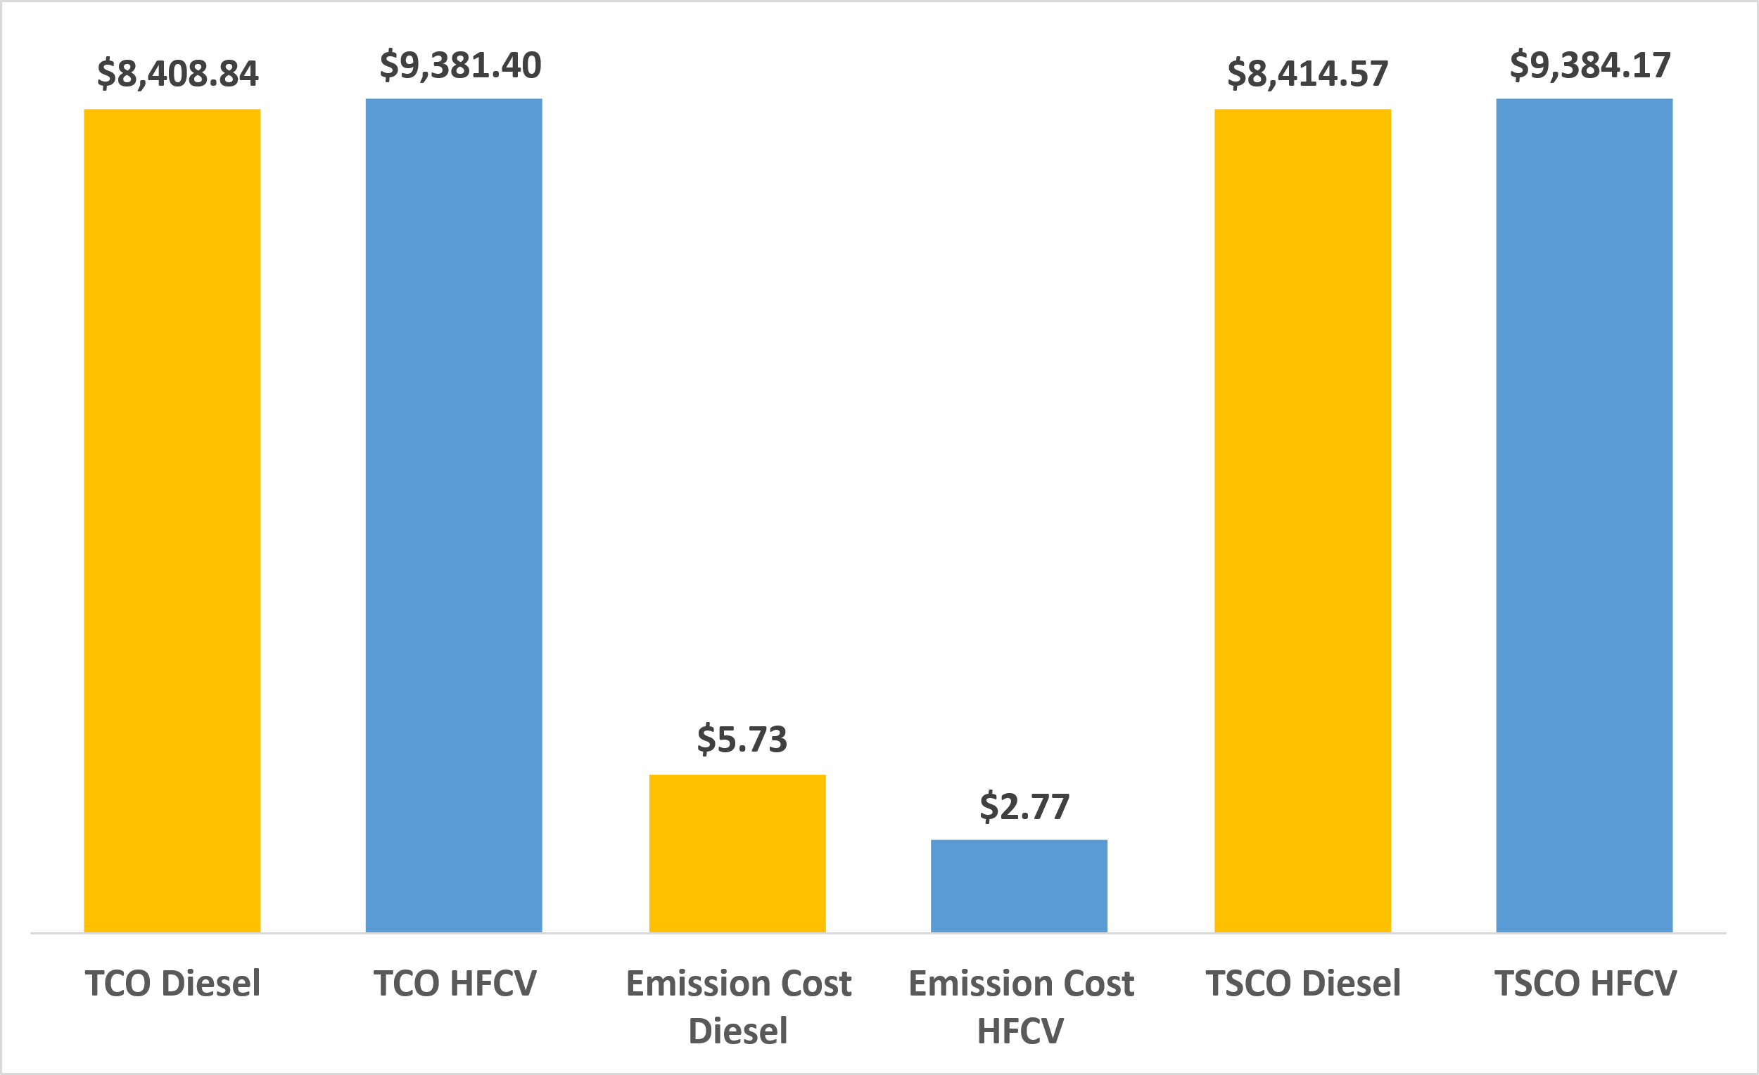Figure 1 summarizes the main economic results of the study. The analysis of the Total Cost of Ownership (TCO) reveals a higher operational cost for hydrogen fuel cell vehicles (HFCVs) compared to diesel vehicles under current market conditions. Despite their superior fuel efficiency and lower carbon emissions, the elevated hydrogen fuel price still positions diesel as the economically preferred option in the short term.

Figure 1: Comparison of economic and environmental performance between Diesel and HFCVs Vehicles.

Regarding environmental performance, Figure 2 demonstrates that HFCVs achieve a substantial reduction in greenhouse gas emissions, with approximately half the emissions per kilometer when compared to HD diesel. This supports the environmental case for adopting hydrogen in long-haul freight, particularly in emission-sensitive supply chains or under stricter regulatory scenarios.

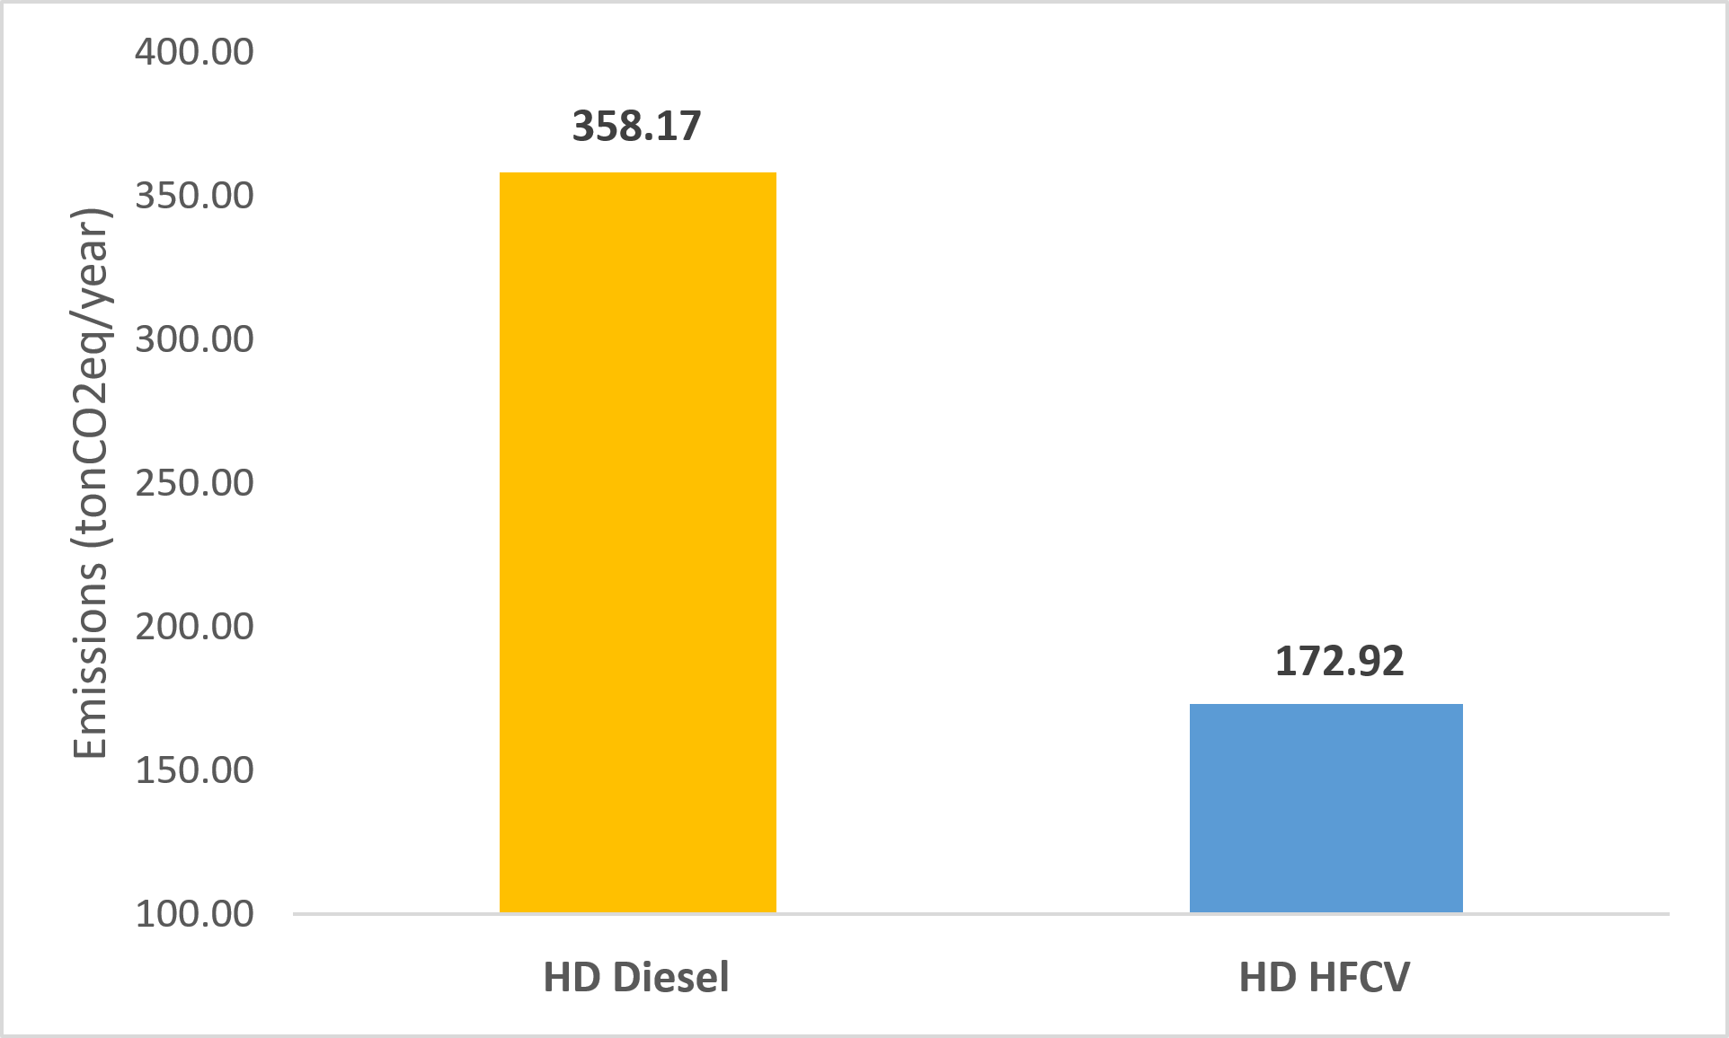

Figure 2: Annual GHG emissions from HD Diesel and HFCVs Vehicles.

A breakeven analysis was conducted to identify the hydrogen price at which TCO for HFCVs becomes equal to that of diesel vehicles. As shown in Figure 3, the breakeven point is reached when the LCOH falls to approximately US$ 3.86 /kg, under the given vehicle and operational assumptions. This benchmark provides a clear signal for policymakers and investors regarding the economic competitiveness threshold for hydrogen adoption in the heavy transport sector.

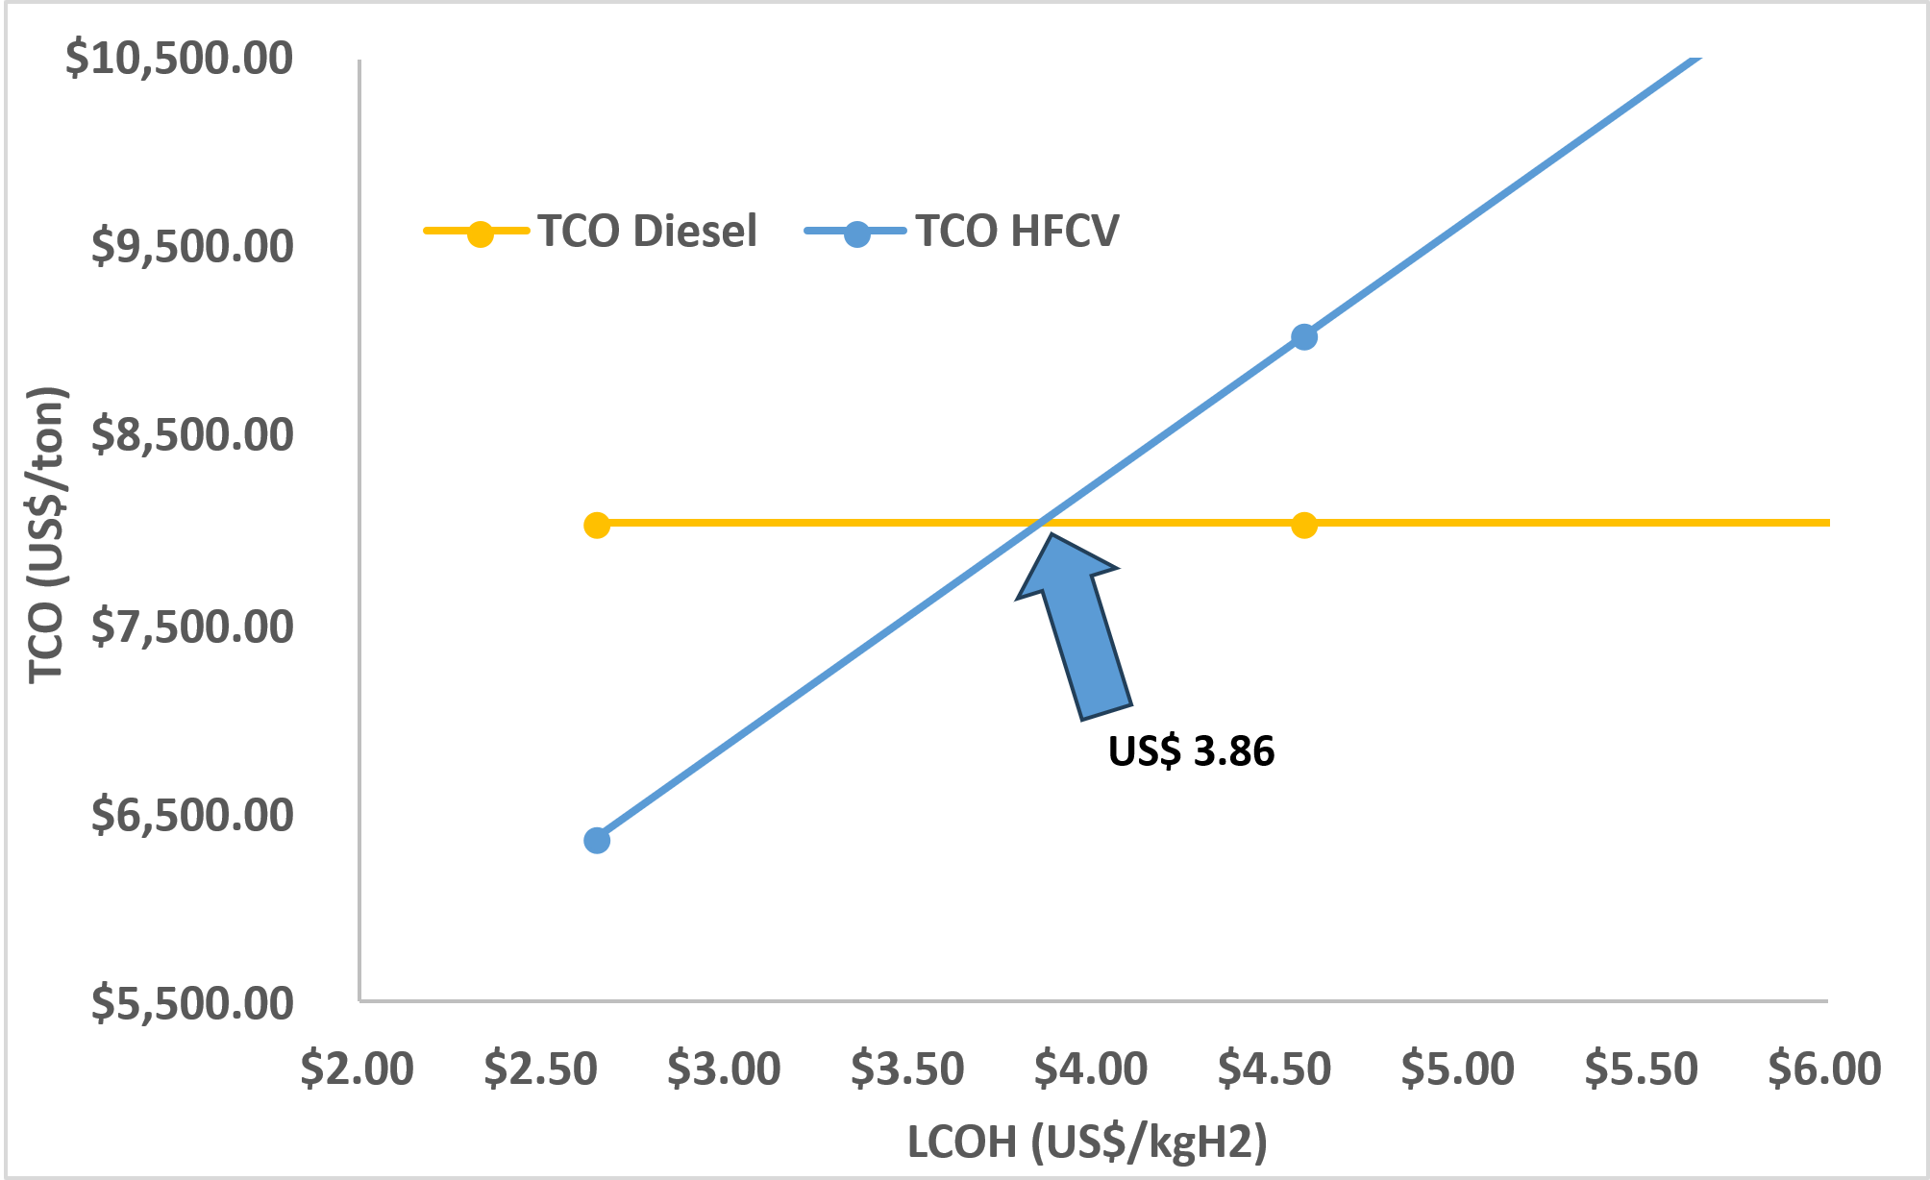

Figure 3: Breakeven analysis between Diesel and HFCV Vehicles based on the LCOH.

To further understand the evolution of this breakeven point, a multiperiod sensitivity analysis was performed. Table 3 and Figures 4 and 5 present projections for diesel prices, carbon prices, and hydrogen costs over a 20-year horizon, under both a base case (BC) and an alternative scenario (SC 1). In the base case—assuming progressive increases in diesel and carbon prices and a decline in LCOH—HFCVs become increasingly viable after 2040. Conversely, in scenario SC 1, where LCOH increases over time, the economic case for hydrogen adoption weakens significantly.

Table 3: Multiperiod sensitivity analysis projections.

|  |  |  |  |  |  |  |
| --- | --- | --- | --- | --- | --- | --- |
|  | **2030** | **2035** | **2040** | **2045** | **2050** | **Reference** |
| Carbon price projections (US$/tonCO2eq) | 90.00 | 110.00 | 130.00 | 142.50 | 155.00 | Almaraz et al. (2022) |
| Diesel Price projections Base Case (R$/ l) | 7.00 | 8.00 | 9.00 | 10.00 | 11.00 |  |
| LCOH projections Base case (US$/kgH2) | 16.12 | 12.27 | 8.42 | 4.58 | 2.65 | Santana et al. (2024) |
| LCOH projections scenario 1 (US$/kgH2) | 2.65 | 4.58 | 8.42 | 12.27 | 16.12 | Santana et al. (2024) |

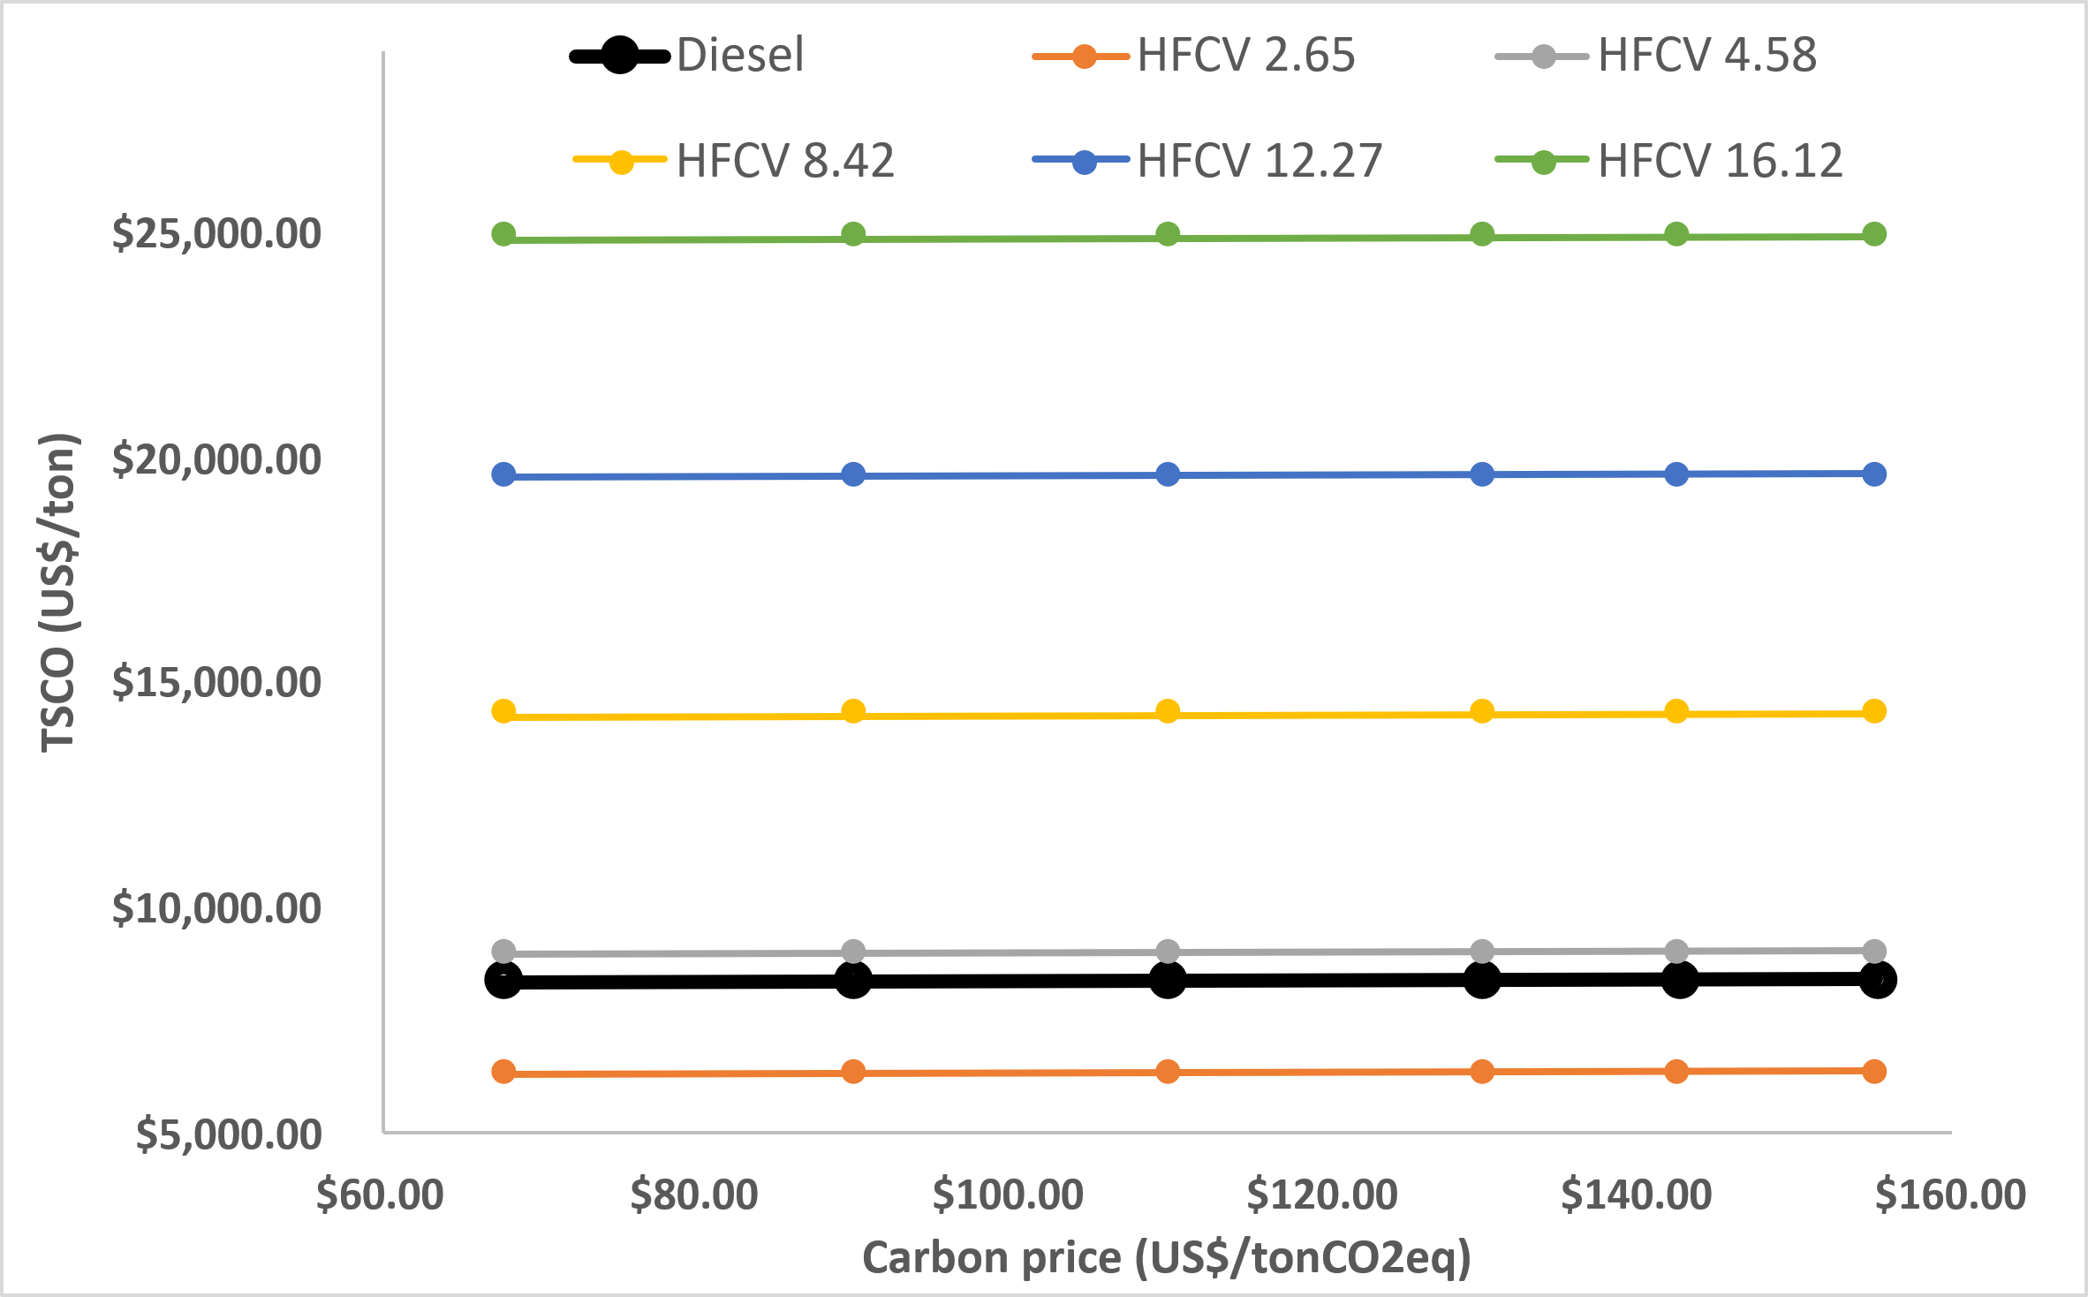

Figure 4: Sensitivity analysis of carbon price future projections for various hydrogen prices.

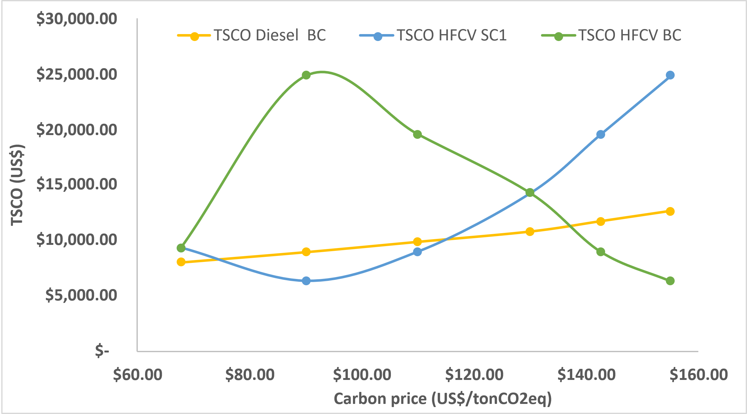

Figure 5: Sensitivity analysis of carbon price future projections for BC and SC 1.

These findings suggest that the cost trajectory of hydrogen production and distribution infrastructure will be a decisive factor in enabling its large-scale deployment. Incentives or regulatory mechanisms that internalize carbon externalities—such as carbon pricing—can accelerate the transition by narrowing the TCO gap between hydrogen and diesel technologies.

For the creation of the roadmap, the optimal HRS locations given by the BIP model are described in figure 6. With a minimum $n_{HRS}=4$. Localized in the cities of Barreiras (0 km); Oliveira dos Brejinhos (340 km); Santo Estevão (700 km); Salvador (855 km).

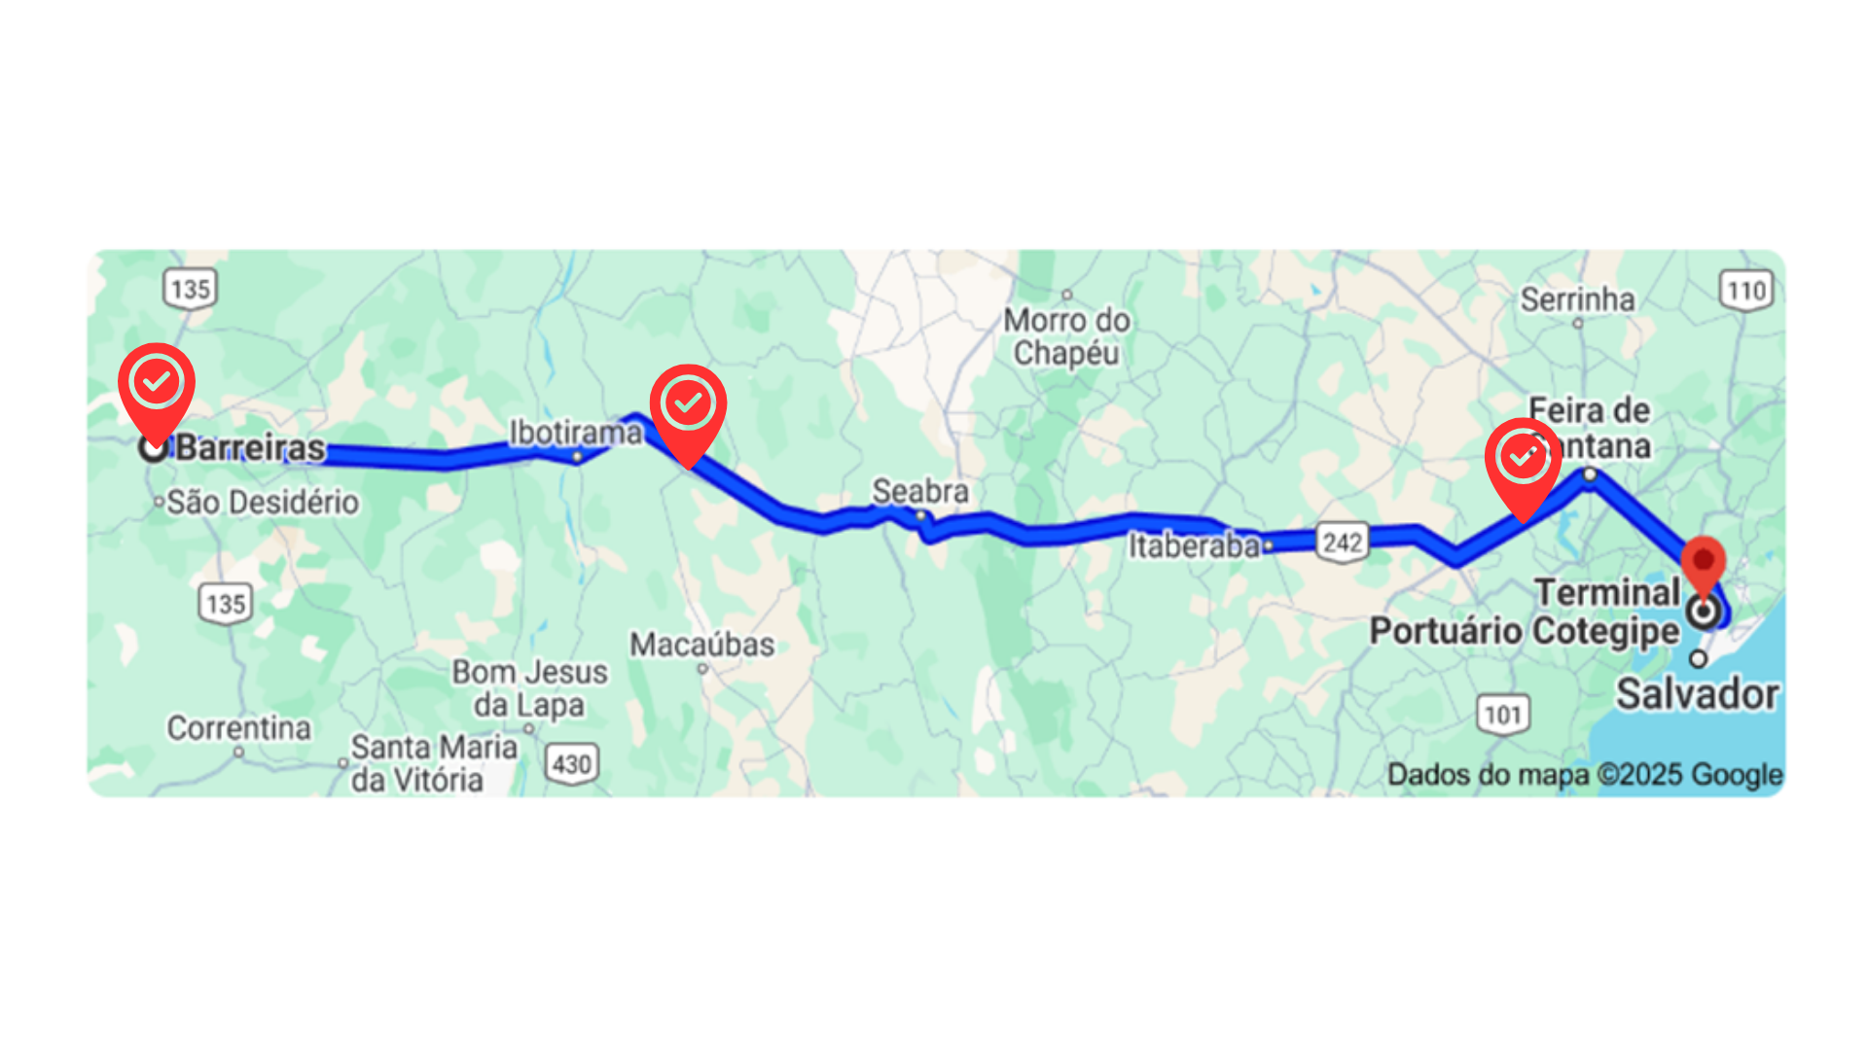

Figure 6: Proposed locations for Hydrogen Refueling Stations (HRS) along the logistics corridor between Barreiras and the Cotegipe Port Terminal in Salvador.

* 1. Conclusions

It can be concluded that hydrogen presents itself as an excellent alternative fuel for large-scale transportation, due to its energy efficiency and low CO₂ emissions—factors that contribute to environmental improvement. Additionally, the decreasing price of hydrogen over time makes it a competitive alternative to diesel in the Brazilian market, offering a promising economic option for the future. The roadmap created for Highway BR 242 supports the distribution of hydrogen fuel for H₂-powered trucks by identifying strategic refueling points that enhance the efficiency of grain exports in the region. However, the country still faces significant challenges in implementing a comprehensive HRS network, given the current underdevelopment of infrastructure.

Future work could enhance the optimization problem by incorporating additional supply chain echelons, considering both centralized and decentralized hydrogen production site options. Moreover, integrating decentralized renewable energy sources (e.g., solar and wind) into hydrogen production systems could be explored to improve sustainability and system autonomy. Alternative scenarios could also be evaluated by varying hydrogen demand at HRS, particularly in the context of large-scale HD freight operations.

Nomenclature

$A$– Autonomy with safe margin of 80%, km

${CE}^{f}$– Carbon emissions, kgCO2eq/ km

– Carbon price, US$/kgCO2eq

– Distance of point $i$ from the origin, km

$d_{j}$– Distance of point $j$ from the origin, km

f - fuel type f

${FP}^{f}$– Fuel price f, US$/ l or kgH2

– Fuel Quantity f, l or kgH2/ year

– Global warming potential of fuel f, kgCO2eq/km

– Vehicle capacity, ton/trip

$i,j$– Indices of candidate points (with $i<j$)

$Lt$– Vehicle Lifetime, years

$n^{f}$– Number of vehicles using fuel type f

$n_{HRS}$– Total number of HRS installed along the route

${PP}^{f}$– Vehicle of fuel type f purchase price, US$

$S(i)$– Set of reachable points $j$ from point $i$, where the distance between points is less than or equal to the safe range

${TCO}^{f}$– Total cost of ownership of fuel type f, US$/ton/year

$x_{i}$– Binary variable: 1 if an HRS is installed at point I, 0 otherwise

${TSCO}^{f}$– Total sustainable cost of ownership of fuel type f, US$/ton/year

Acknowledgments

The authors acknowledge the Green Hydrogen Competence Center of SENAI CIMATEC University, CNPq and FCT - Foundation for Science and Technology, I.P. - under the project UIDB/00285/2020 for its financial support.

References

Almaraz, S., Rácz, V., Azzaro-Pantel, C., Szántó, Z., 2022, Multiobjective and social cost-benefit optimisation for a sustainable hydrogen supply chain: Application to Hungary, Applied Energy, Vol 325, 119882.

ANP, 2025, Historical series of price surveys, National Agency of Petroleum, Natural Gas and Biofuels <https://www.gov.br/anp/pt-br/assuntos/precos-e-defesa-da-concorrencia/precos/precos-revenda-e-de-distribuicao-combustiveis/serie-historica-do-levantamento-de-precos> accessed in 20.03.2025 (In portuguese)

BCB, 2025, Currency Converter, Central Bank of Brazil <https://www.bcb.gov.br/conversao> Accessed 20.03.2025 (In portuguese)

Carvalho, 2011, Relative emissions of pollutants from urban transport, Planning and Research Technician at the Directorate of Regional, Urban and Environmental Studies and Policies (Dirur) of Ipea, Brasília-DF. (in portuguese)

Embrapa, 2025, Agricultural exports, Strategic Territorial Intelligence System: Agricultural Macrologistics <https://www.embrapa.br/macrologistica/sistema/exportacao-agropecuaria> accessed 20.03.2025 (In portuguese)

Fia Business school, 2022, Roadmap: what it is, what it is for, models and how to make yours <<https://fia.com.br/blog/roadmap/#:~:text=Roadmap%20%C3%A9%20uma%20ferramenta>> Accessed in 04.02.2025 (In portuguese)

Imprensa Nacional, 2024, Order No. 3,080, of October 10, 2024 < https://www.in.gov.br/web/dou/-/despacho-n-3.080-de-10-de-outubro-de-2024-589782432> Accessed 20.03.2025 (In portuguese)

Investing.com, 2025, Future Carbon Credit <https://br.investing.com/commodities/carbon-emissions-streaming-chart> accessed 20.03.2025 (In portuguese)

Ruf, Y., Baum, M., Zorn, T., Menzel, A. et al., 2021, Fuel cells hydrogen trucks – Heavy duty’s high performance green solution – Study summary, Publications Office, doi/10.2843/168949

Santana, L., Santos, G., Santos, A., Marinho, C., Bispo, A., Villardi, H., Pessoa, F., 2024, Evaluating the economic influence of water sources on green hydrogen production: A cost analysis approach, International Journal of hydrogen energy, Vol 89, 353-363.

SENAI, 2023, Atlas H2V Bahia. Salvador. (In portuguese)