 CHEMICAL ENGINEERING TRANSACTIONS  VOL. xxx, 2025 | A publication of  
The Italian Association
of Chemical Engineering
Online at www.cetjournal.it

Guest Editors: David Bogle, Flavio Manenti, Piero Salatino
Copyright © 2025, AIDIC Servizi S.r.l.
ISBN 979-12-81206-21-2; ISSN 2283-9216

Monitoring and Control of Integrated Post Combusiton Capture Facilities
Jaleel Valappil ^{a,}*
ªBechtel Energy, Houston, TX, USA
jvalappi@bechtel.com
Global warming and climate change caused by greenhouse gases have received widespread and growing concern in recent years. The challenge of meeting increasing global energy demands while mitigating climate change is an urgent one that the world needs to address. Most of the hydrocarbon facilities (natural gas/refining and others) emit significant amount of CO₂. The carbon capture and storage technology (CCS) is one opportunity to capture CO₂ emissions from flue gases of combustions processes. CCS can be a key enabler for attaining Sustainable Development Goals (SDGs). CCS enables provision of affordable and clean energy and supports the decarbonization industry. Post-combustion CO₂ capture (PCC) has an advantage over other alternatives because the technology can simply be implemented as an ‘end-of-the-pipe’ retrofit without the need for significant changes to existing facilities. The most widely used technology for post combustion CO₂ capture is amine solvent-based process. Any operational disturbances in the hydrocarbon facility can impact the operation of the carbon capture in an adverse way and vice versa. Accounting for these interactions in the design of control strategies for carbon capture facility is important in ensuring reliable facility operation. In addition, recent developments in machine learning and big data have enabled efficient monitoring of these facilities for any abnormal operation. There is also a potential to optimize the integrated facility operation in real time considering the price of energy (for amine regeneration) and the price on carbon emissions. The first case study presented here involves monitoring of the amine unit utilized in PCC facilities using anomaly detection methodologies. In the second case study, the exhaust from Liquefied Natural Gas (LNG) facility is sent to carbon capture unit. The dynamic model of the Waste Heat Recovery Unit (WHRU), duct work and the associated equipment is used to ensure that the various transient scenarios in LNG facility or in the PCC unit does not adversely impact operations.

  - Introduction
Global warming and climate change caused by greenhouse gases have received widespread and growing concern in recent years. The challenge of meeting increasing global energy demands while mitigating climate change is an urgent one that the world needs to address. Most of the hydrocarbon facilities (natural gas/refining and others) use gas turbine drivers which emit significant amount of flue gases with CO₂. In addition, fired heater used in these facilities also emit CO₂. CO₂ is also emitted by acid gas removal processes in the pre-treatment of feed gas prior to further processing in LNG and other facilities. The carbon capture and storage technology (CCS) is one opportunity to capture CO₂ emissions from flue gases of combustions processes. The captured CO₂ can be stored in underground formations afterwards. Most of the hydrocarbon facilities in operation currently are not designed for carbon capture. For this reason, post-combustion CO₂ capture (PCC) has an advantage over other alternatives because the technology can simply be implemented as an ‘end-of-the-pipe’ retrofit without the need for significant changes to existing facilities. The most widely used technology for post combustion CO₂ capture is amine solvent-based process. The retrofitting of existing hydrocarbon facilities with a carbon dioxide capture offers a promising opportunity to achieve the global target reduction in CO₂ emissions. A schematic of integrating PCC with LNG facility is shown in Figure 1.

With the integration of PCC, any operational disturbances in the hydrocarbon facility can impact the operation of the carbon capture in an adverse way and vice versa. Accounting for these interactions in the design of control strategies for carbon capture unit is important in ensuring reliable facility operation. In addition, recent developments in machine learning and big data have enabled efficient monitoring of these facilities for any abnormal situations. This can be very valuable in identifying operational issues well in advance to prevent any unsafe conditions. There is also a potential to optimize the integrated facility operation in real time considering the price of energy (used for amine regeneration) and the penalty for carbon emissions. Also, dynamic simulation can play a pivotal role in developing and verifying suitable control scheme for the integrated hydrocarbon and CO₂ capture plants. The first case study presented here involves monitoring of the amine unit (typically utilized in PCC facilities) using anomaly detection methodologies. In the second case study, the exhaust from Liquefied Natural Gas (LNG) facility is send to carbon capture unit.

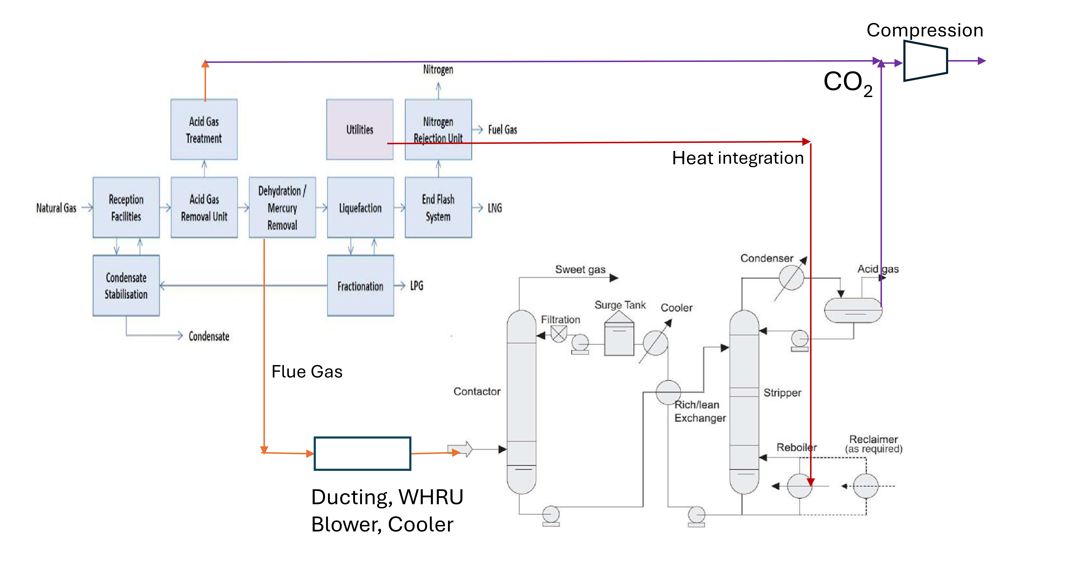
Figure 1. Integration of PCC with an LNG plant showing the sources of CO₂ and heat integration.
  - Experimental and Numerical Methods
The three main options for carbon capture in hydrocarbon facilities are pre-combustion, post-combustion and oxyfuel combustion. When compared to pre-combustion and oxyfuel combustion, post-combustion capture is considered to provide comparable performance with reduced technical risk and process complexity. The use of amine-based solvent for post-combustion CO₂ capture (PCC) has attracted considerable interest in CO₂ capture. The integration of post combustion carbon capture with a hydrocarbon facility is done by directing the flue gas from gas turbines and other CO₂ sources to amine-based carbon capture unit. This will include additional ducting, dampers and possibly a blower to increase flue gas pressure. A Waste Heat Recovery Unit (WHRU) may be used to further recover the heat from flue gas to increase energy efficiency. The heat requirements for the amine regenerator reboiler can be provided by the existing hot oil or steam system in the facility. The captured CO₂ is then compressed and transported for sequestration or other use via pipelines as a dense phase. Centrifugal compressors are usually used for CO₂ compression and integrally geared compressors (IGC) are becoming common for this application. These are multi-stage compressors optimized with intercooling and different speeds for different stages. Integrating post combustion carbon capture into an existing facility must ensure the several operational aspects are considered to ensure reliable and safe operation (Bui et al., 2014).

    - Control and Optimization Approaches
There are several areas of concerns in PCC integration that can be addressed with appropriate control and optimization approaches. Some of the areas of concern and appropriate solutions are discussed below.

Control schemes for turndown and other transitions
The design and integration post combustion carbon capture needs to account for the various operational scenarios and disturbances in the hydrocarbon facility and the carbon capture unit. One of the main concerns with integration is the impact of upsets in PCC facility affecting the plant production rate. Large variations in gas turbine exhaust pressure can cause the turbine driver to trip, stopping the production with a very significant economic cost. The key scenarios that impact the integrated system include facility wide shut down, trip of individual gas turbines and turndown to half rate/standby mode. Startup of gas turbine units/PCC unit is also an important case to consider. The scenarios to consider on the PCC side include trip of flue gas blower, fail closing of flue gas damper and other operational upsets in PCC unit.

One of the concerns with the control of integrated facility is the difference in timescale of the system dynamics. The dynamics of the CO₂ capture plant is relatively slow compared to that of the power plant or other facilities with gas turbine drivers. The CO₂ capture level control directly impacts the operation of the facility as it changes the amount of heat utilized. Hence the control loop tuning is critical, and a tight tuning of CO₂ capture level is not recommended as it impacts the overall facility operation adversely.

CO₂ Compressor anti-surge and capacity control
The protection of centrifugal compressors from surge is critical as reliable operation of these compressors is important for overall plant availability. The main objective of the anti-surge control system is to prevent the compressors operating in the surge region. There are two distinct aspects of surge protection for CO₂ compressors that needs to be considered in design. First one is the ability of the system to maintain safe operation away from surge region during deviations around the normal operating point. This is accomplished by the anti-surge control system. The second is to prevent surge and reverse rotation during shutdown scenarios, where the compressor rapidly coasts down to a stop. This machine protection during shutdown may be done by the safety instrumented system or by other means. One of the main concerns of CO₂ compression is the possibility of reverse rotation of the compressor during coastdown. This is likely if the discharge volume is large due to additional equipment. It is possible to install blow-off valves at the discharge to prevent reverse rotation. Capacity control of CO₂ compressors can be accomplished by IGV (Inlet Guide Vanes) or speed (as available). Suction pressure of these compressors can be controlled by one of these manipulated variables. If the inlet flow changes, the capacity will be adjusted to maintain the suction pressure.

Control of Amine system
The amine process unit is typically used in PCC facilities to remove CO₂. The typical amine unit consists of the absorber and regenerator columns with the associated equipment. Different types of amine solution may be used, including DGA, MDEA and others. The main process control objectives in the amine unit are given below.
Control of CO₂ composition: The CO₂ at the outlet of amine absorber need to be controlled to ensure desired capture level. The main control consideration in a typical amine unit is the effective removal of impurities. It is important to ensure that lean amine circulation is high enough for sufficient CO₂ removal. Flow control is provided for lean amine circulation which can be used to ensure CO₂ capture level. The control of regenerator performance is achieved by the control of overhead pressure and bottoms temperature. Operating at a lower pressure is desirable since this will cause more flashing and separation. Still, the effect of pressure is less pronounced than that of temperature. A better separation effect is achieved by increasing heat input to the column (Though this will increase the energy consumption). The amine solution has to be properly regenerated to leaner amine to ensure removal of CO₂ in the absorber column.

Real-time optimization of the integrated system
The capture of CO₂ is a very energy intensive process, and this energy usually is taken from the steam system or hot oil system in the facility. In power plants, this steam consumption reduces the net power output of the facility. In certain hydrocarbon facilities (LNG plants for example), the use of hot oil or other energy sources can also affect the net production rate if the feed gas rate is constrained. This is due to the fact that the energy required for amine system may be provided from natural gas feed itself. The above tradeoff between capture rate and production rate can be addressed with a real time optimization framework. This has been proposed in power plants in several studies (Arce et al., 2012). A model predictive control framework can be utilized with the economic objective cast in terms of the value of final product, cost of CO₂ emissions and other constraints. This optimization problem can be solved to provide setpoint for the lower-level controls that are designed to attain lower-level control objectives. Model predictive control formulations that handle both optimization and control objectives have been reported for power plants and demonstrated to improve economic performance.

Monitoring of PCC units
Monitoring of plant data for abnormal operating modes is an important application of big data analytics. Abnormal operating scenarios result in lost plant productivity. Identifying these conditions and taking corrective actions early before it results in plant downtime is hence very valuable. The data can be used to build either predictive or unsupervised models to monitor the state of the process and equipment and trigger alarms for operator to take corrective actions. Applications of data analytics for PCC facility include the following: 1. Amine unit monitoring, 2. Monitoring turbomachinery and heat transfer equipment and 3. PID controller monitoring.

    - Design and analysis using Simulation Models
Dynamic simulation utilizing rigorous mathematical models has become an influential tool in the process design, design validation, control system verification, startup support and troubleshooting. The scope of the dynamic modeling for the integrated hydrocarbon-PCC facility can be divided into three areas as shown in Figure 2. Many of the commercially available process simulation software can be used to develop a dynamic model of amine-based CO₂ capture processes (Chukukwa et al., 2012).
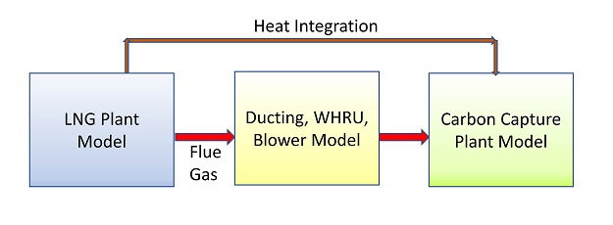
Figure 2. Different sections of an Integrated PCC unit dynamic model.
  - Results and Discussion
    - Case Study 1 - Monitoring of Amine Unit
There are several advantages to using data driven analytics for monitoring industrial systems (Hosseinpour, 2023). Two different approaches can be used for fault detection in process plants: 1. Model based – Which uses fundamental process models to detect deviations from normal operating conditions, 2. Data driven – Which uses historical process data for fault detection. The application of graphed anomaly detection techniques in determining abnormal operating conditions in an amine unit is presented below. This is applied to amine plant in a currently operating LNG facility. A predictive model consisting of statistical probability distribution (Bayesian distribution modeling) is developed form historical data. The distribution is not limited to normal and can have different shapes. A normalized anomaly score is calculated. One of the key steps in the graphed anomaly detection is the clustering of variables for anomaly detection. Statistical methods like k-means and k-medoids can be used for clustering. If design data is available, that can be used to set up clusters based on equipment. Alternately, the clusters can also be developed utilizing the variables selected based on process knowledge.

Systems components and setup

The system components utilized for anomaly detection is shown in Figure 3.
- Splunk is used to index the machine data coming from the LNG process. Splunk is a widely used big data tool and has the ability to index various types of data including streaming data.
- Prelert is used to detect anomalies using machine learning techniques. Prelert is a statistical anomaly detection technique, which develops probability distribution of the variables and updates it as data comes in. A score is determined based on the distribution and the incoming real-time data (Veasy et al., 2014).
- Neo4j is the graph database used to store and analyze the design data from Smartplant Instrumentation database and use it for anomaly detection.

Application to amine system monitoring

Application of above tools for detecting anomalies in amine system used in LNG plant is studied. Amine system removes CO₂ and H₂S from natural gas before it is send for liquefaction. The performance of this unit is very important as any carried over CO₂ from amine unit can freeze in the cold temperatures in liquefaction section causing plant downtime and lost production. The historical data from an operating LNG plant was used for this analysis. The data used corresponded to a seven-month period of operation after startup. The relevant tags were identified, and corresponding data was collected. In addition, design data related to instrumentation and other items were obtained from Smartplant Instrumentation database to aid this project. The analysis for amine plant data was initially performed using all the data (About 300 tags) for the unit to determine an anomaly score. This was found to be unsatisfactory as the score was not capturing changes in the plant operation. The anomaly scores were also calculated using data clustered by key equipment (Amine absorber, amine regenerator etc.). The tags that belong the individual equipment are derived from Smartplant database. A score is calculated for each equipment in this case. As a third approach, data clustered by groups as determined from operational experience was used for determining the scores. Four different groups related to acid gas extraction, acid gas removal, separation performance and amine inventory were identified for this purpose.

An example of data driven anomaly detection performance is shown in Figure 4. During the operation, the CO₂ composition was found to increase to above 100 ppm while the plant feed gas rate was close to the normal rate. This indicated that there was some upset condition that may be causing this. The inlet feed gas CO₂ composition was found to increase during this period, which affected V-1201 operation (Acid gas removal column). The results shown in Figure 4 demonstrates that the anomaly score specifically for the equipment V-1201 did show an increase well before the CO₂ concentration (red line) increased. This could have been used to alert the operators about the impending problem.
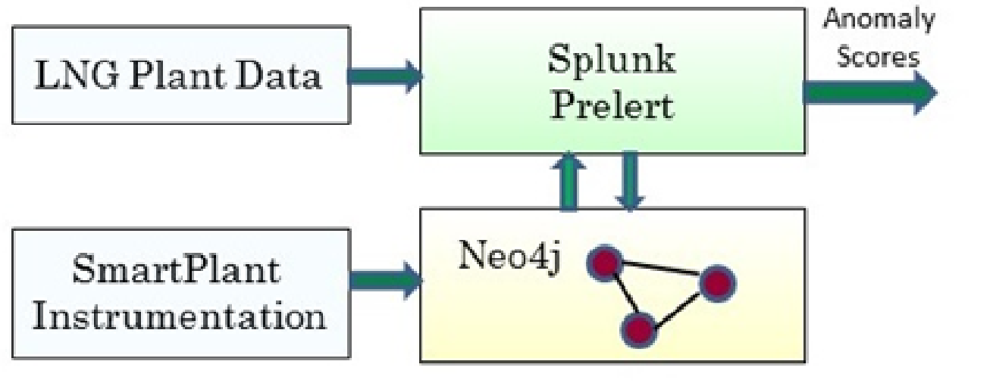
Figure 3. System architecture for anomaly detection.
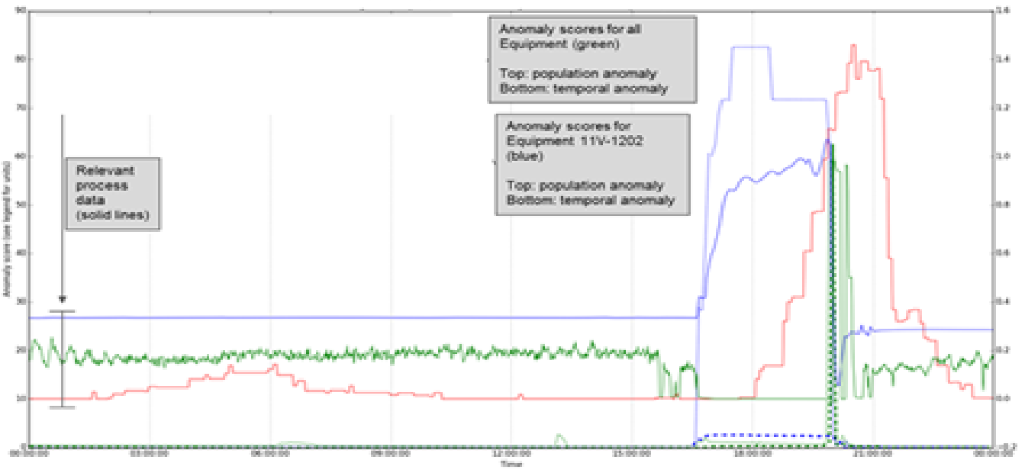
Figure 4. Result of anomaly detection. The dotted blue line shows the score.
    - Case Study 2 – Operability of PCC unit integrated with LNG plant
This case study evaluates the integration of amine-based PCC unit with an LNG facility utilizing gas turbines to drive refrigeration compressors. The original design of the facility had the flue gas from turbines going through WHRU to the exhaust stack and to atmosphere. The addition of the PCC unit involves introduction of additional ductwork, bypass dampers (to atmosphere and to PCC unit) and a flue gas blower to increase pressure. The flue gas is further cooled a heat exchanger and then routed to the Absorber where it is contacted with amine solvent in the Absorber to remove the CO₂ from flue gas. The CO₂ depleted flue gas is then released to atmosphere. The main concern with the addition of PCC unit is the possibility of impacting LNG production during various transient upsets in the PCC unit. The gas turbine exhaust outlet must be maintained within a pressure range to avoid a reduction in power output or a total turbine shutdown. Several scenarios were studied to evaluate the transient impact on the gas turbine outlet conditions.

A dynamic simulation model of the interconnecting unit (WHRU, flue gas blower, other equipment, and associated piping) was developed to perform this study. This is found to be sufficient for this analysis, as the main interest here is to evaluate the effect of upsets on GT outlet pressure (And to identify any mitigations needed). An already existing LNG plant dynamic model was available but was only used to provide appropriate boundary conditions to the model. The following scenarios were studied with this model.
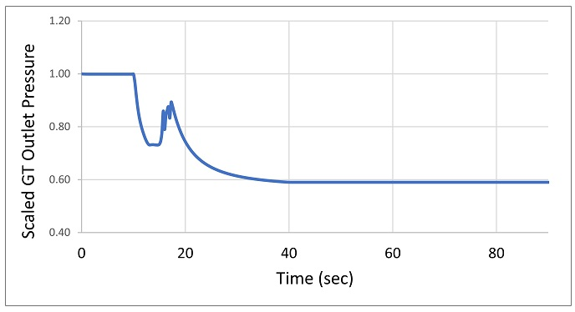
Figure 5. Variation in gas turbine outlet pressure during flue gas blower trip.

Flue gas blower trip
The flue gas blower trip is simulated to verify that the pressure at GT outlet can be maintained within limits so that LNG plant operation is not affected. As soon as the flue gas blower is tripped, the damper to stack is signaled to open to avoid the excessive pressure increase in the system. The blower will coast-down with speed response based on the rotational inertia of the string. The pressure at the GT outlet is shown in Figure 5. As can be seen, the pressure drops rapidly as the damper is opened along with the blower trip. This preemptive action prevented the pressure at gas turbine outlet from increasing due to trip of blower. The pressure stabilizes with the flue gas diverted entirely to the stack. An intermediate increase in pressure is due to the reduction in blower capacity while the damper is still opening.

Trip of gas turbine driver
The trip of a gas turbine will result in rapid change in temperature and flow rate of flue gas at the inlet of WHRU. The performance of the system during this scenario was studied here. The profile of flue gas flow rate and temperature vs. time from turbine vendor was used as the boundary condition here. Once the gas turbine is tripped, the flue gas flow reduces, decreasing the pressure at the inlet of flue gas blower. The flue gas blower must be shutdown to prevent significant vacuum formation at suction. Shutting the flue gas bower too early can result in over pressuring the duct as the flue gas flow continues for some time. The appropriate time to shut down the blower was identified from simulation.
  - Conclusions
The importance of process monitoring, control, and optimization in operation of facilities integrated with post combustions carbon capture facilities is discussed in this paper. Several areas in the integrated facility that could benefit from appropriate control and monitoring schemes are presented. The operability of the integrated facility needs to be verified and can be done with dynamic simulation. This can be done in the conceptual stages of the project. Monitoring of the PCC facilities are geared towards operational stage, where data driven approaches can be utilized. Two industrial case studies on anomaly detection of amine unit and operability verification of an integrated PCC facility are presented here.
References
Arce, A., Mac Dowell, N., Shah, N., Vega, L.F. Flexible operation of solvent regeneration systems for CO2 capture processes using advanced control techniques: Towards operational cost minimization, International Journal of Greenhouse Gas Control, 11, 236-250, 2012.
Bui, M., Gunawan, I., Verheyen, V., Feron, J.P. Dynamic modelling and optimisation of flexible operation in post-combustion CO2 capture plants—A review, Computers and Chemical Engineering, 61, 245-265.
Chukukwa, A., Enasen, N., Kwamsdal, H.M., Hillestad, M., 2012. Dynamic modeling of post-combustion CO2 capture using amines – A review. Energy Procedia. 23, 82-91.
Veasy, J., Dodson, S., 2014. Anomaly detection in application performance monitoring data. International Journal of machine learning and computing. 120-126.
Hosseinpour, M., Shojaei, M., Salimi, M., Amidpour, M., 2023. Machine Learning in absorption-based post-combustion carbon capture systems: A state-of-the-art review. Fuel. 353.

