**Development of a policy evaluation tool for promoting solar photovoltaic**

**(PV) market in Hong Kong: A multi-agent-based modelling approach**

*Ruixiaoxiao Zhang a, Minhyun Lee b, Lijie Huang c, and Shiqi Mei d*

a Postdoctoral Fellow, Department of Building and Real Estate, The Hong Kong Polytechnic University, Hung Hom, Kowloon, Hong Kong, [ruixiaoxiao.zhang@connect.polyu.hk](mailto:ruixiaoxiao.zhang@connect.polyu.hk)

b Assistant Professor, Department of Building and Real Estate, Research Institute for Smart Energy (RISE), The Hong Kong Polytechnic University, Hung Hom, Kowloon, Hong Kong, [minhyun.lee@polyu.edu.hk](mailto:minhyun.lee@polyu.edu.hk) (CORRESPONDING AUTHOR)

c PhD Candidate, Department of Building and Real Estate, The Hong Kong Polytechnic University, Hung Hom, Kowloon, Hong Kong, [li-jie.huang@connect.polyu.hk](mailto:li-jie.huang@connect.polyu.hk)

d PhD Student, Department of Building and Real Estate, The Hong Kong Polytechnic University, Hung Hom, Kowloon, Hong Kong, [shiqi.mei@connect.polyu.hk](mailto:shiqi.mei@connect.polyu.hk)

**Abstract**

The Hong Kong government has set ambitious targets to reduce its carbon intensity by 65% to 70% by 2030, based on 2005 levels, as outlined in the Hong Kong Climate Action Plan 2030+ (HKCAP 2030+). To support renewable energy (RE) development, HKCAP 2030+ aims to achieve a 3-4% share of RE in the total fuel mix by 2030. Consequently, the government has emphasized the adoption of renewable energy sources for electricity (RES-E) through the implementation of the New Scheme of Control Agreements (SCAs). As part of these agreements, utility companies in Hong Kong introduced the Feed-in Tariff (FiT) scheme in 2019 to actively promote the distributed generation (DG) of solar photovoltaics (PV). However, a critical research gap exists in understanding the interconnected roles and relationships among diverse stakeholders, particularly the influence of policymakers (e.g., the government and utility companies) on the decision-making process of PV installers (e.g., building sector). Addressing this gap is essential to comprehensively investigate how these stakeholders influence each other’s decision-making and whether their actions align with the long-term goals of climate change mitigation and RE development. Therefore, this research project aims to fill the identified research gap by developing a policy evaluation tool based on a multi-agent-based modelling (multi-ABM) approach to simulate the behaviours and interactions of three major types of stakeholders (i.e., government, utility companies, and building sector), each acting as an agent in the solar PV market in Hong Kong. Furthermore, the research project will explore the feasibility of achieving the two ultimate goals, the carbon emission per capita and RE installed capacity, specified in HKCAP 2030+ by 2030, by evaluating the PV adoption pattern. This will be achieved by complishing the following research objectives: (i) To establish a comprehensive and holistic understanding of the solar PV market dynamics by modeling the behaviours and interactions of diverse stakeholders, including the government, utility companies, and the building sector; (ii) To develop a multi-ABM that serves as a dynamic and adaptable policy evaluation tool for both government and utility companies, enabling real-time insights and continuous evaluation of policies, including policy reforms and price adjustments; (iii) To evaluate the effectiveness of current RE policies (e.g., the FiT scheme) in achieving the goals of the HKCAP 2030+ by simulating the decision-making processes of key stakeholders (i.e., building sector); (iv) To analyze the impact of policy reform (e.g., adjustments to the FiT scheme and other regulatory changes) on solar PV adoption by quantifying the effectiveness of policy interventions and identifying the most conducive measures for facilitating solar PV deployment; and (v) To formulate strategic insights and policy recommendations for the key stakeholders involved in the solar PV market by providing forward-looking perspectives to assist stakeholders in aligning their actions with long-term targets and assessing the feasibility of achieving the goals of the HKCAP 2030+ by the target year of 2030.

**Nomenclature**

1. **Abbreviations**

|  |  |  |  |
| --- | --- | --- | --- |
| HKCAP 2030+ | Hong Kong Climate Action Plan 2030+ | RE | Renewable Energy |
| SCAs | New Scheme of Control Agreements | FiT | Feed-in Tariff |
| DG | Distributed Generation | PV | Photovoltaics |
| Multi-ABM | Multi-Agent-based Modelling | REC | Renewable Energy Certificate |
| RMSE | Root Mean Square Error | LCOE | Levelized Cost of Electricity |
| NPV | Net Present Value | IRR | Internal Rate of Return |
| WTP | Willingness to Pay | ROR | Rate of Return |

1. **Symbols**

|  |  |
| --- | --- |
|  | Discounted cashflow considering the time value |
| | Amount of annual electricity generated by the PV system (kWh) |
| | Unit capital cost of the PV system |
| | Annual unit operation cost of the PV system (HKD/kW) |
| | Unit decommissioning cost at the end of its service life (HKD/kW) |
| | Simulated installed capacity of the PV system (kW) |
| | Tax expense for medium- and large- scale PV installers |
|,, | Discounted payback period utility, household income utility, social utility as well as media utility, respectively |
| | Four utilities’ associated weight to be considered in the decision-making process. |

1. **Introduction**

Hong Kong contributes to China's efforts in fulfilling its commitments under the Paris Agreement by conducting regular reviews of its climate change initiatives every five years, ensuring they comply with the agreement's requirements and guidelines (Environment Bureau, 2015). Therefore, the Hong Kong government has announced to stipulate a series of climate change mitigation actions, as outlines in Hong Kong’s Climate Action Plan 2030+ (HKCAP 2030+), which targets at three major aspects: renewable energy (RE) development, carbon emission reduction and electricity supply by photovoltaic (PV) systems (Environment Bureau, 2017). It is found that Current research on PV adoption in Hong Kong primarily concentrates on a specific type of stakeholder, particularly small-scale PV installers (e.g., the residential sector). This limited focus has resulted in a significant oversight in understanding the broader dynamics within the entire PV market, which includes various other stakeholders such as policymakers (e.g., government and utility companies), investors (e.g., utility companies), and medium- to large-scale PV installers (e.g., the business sector). This research gap underscores the need for a comprehensive investigation into the interactions among these stakeholders and how these interactions influence their decision-making processes. Understanding these dynamics is crucial in the long term to determine whether the collective actions of these stakeholders align with the ultimate goals of climate change mitigation and RE development. This study aims to bridge this research gap and achieve the following research objectives:

* To develop a multi-agent-based model (multi-ABM) that serves as a dynamic and adaptable policy evaluation tool for both government and utility companies, enabling real-time insights and continuous evaluation of policies, including policy reforms and price adjustments;
* To evaluate the effectiveness of current RE policies (e.g., the feed-in tariff (FiT) and renewable energy certificate (REC) scheme) in achieving the goals of the HKCAP 2030+ by simulating the decision-making processes of key stakeholders (i.e., building sectors); and
* To analyze the impact of policy interventions on goal-achieving trajectories under various policy-screening scenarios and identify the most conducive measures for facilitating goal accomplishment;

1. **Methods** 
   1. **Policy evaluation framework**

The process of establishing the multi-ABM is depicted in Fig. 1 and involves multi-level programming. It begins with defining the agent level, which serves as the foundation for the model, including the attributes and abstractions of each agent. Next, domain knowledge and behavioral characteristics are established at the individual model level based on the agent level. Finally, inter-agent relationships and communication are set up at the multi-ABM level through direct modeling, simulation, and execution. The multi-ABM model is developed using Matlab_R2022b software. Agents are organized by defining their basic characteristics and classifying them according to their attributes. Each agent's domain knowledge includes the necessary information, resources, and action plans to achieve specific goals. For potential PV installers (i.e., building sector), relevant attributes such as installed capacity, performance ratio, and costs are assigned. Major actions that lead to state changes, such as shifts in RE policy targets or changes in the number of households with PV systems, are also defined for each agent. Additionally, agents are equipped with the information and resources needed to meet their targets, and their behavioral characteristics dictate action rules that allow them to adapt to external changes. Regarding agent rules, when one or more agents decide to install a PV system, the algorithm checks if the expected RE development target is met. If it is, the distribution of PV systems can proceed. However, if a policymaker agent alters the RE target, the implications for PV installers, including economic viability and environmental impact, will be taken into account.

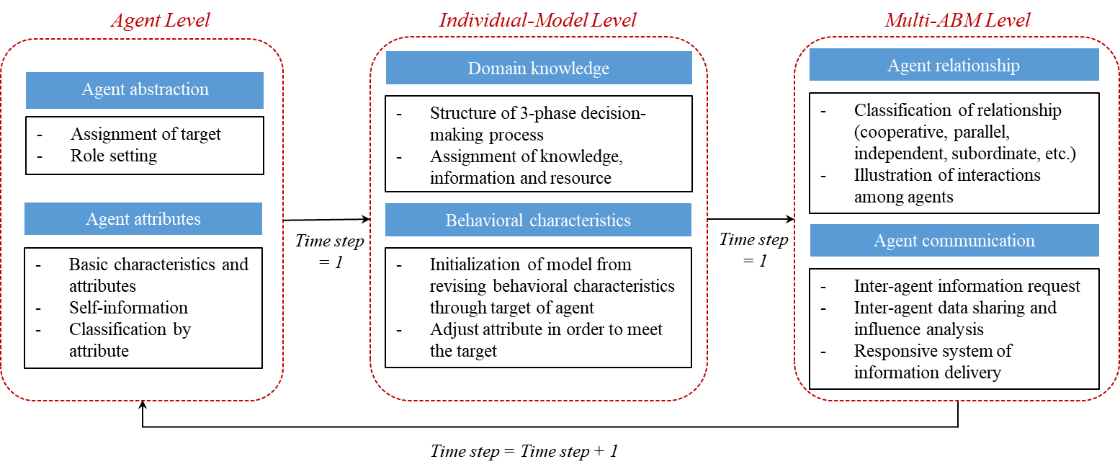

**Figure 1.** Multi-ABM-based policy evaluation framework

* 1. **Stakeholder analysis**

The stakeholder analysis within the ABM framework identifies three key agents: the government, utility company, and building sector, each with specific roles. Each agent follows a process to evaluate their target achievement: if targets are met, no changes are necessary; if not, corrective actions are taken. This framework models the interactions and relationships among these agents to effectively pursue energy-related goals as illustrated by Fig. 2.

* Government: Responsible for setting carbon emissions targets, determining the electricity generation mix, and promoting renewable energy development through initiatives like the FiT and REC schemes.
* Utility company: Focuses on establishing targets for PV adoption, providing incentives for PV-generated electricity, and managing the permitted rate of return.
* Building sector: Considers factors such as internal rate of return (IRR) and willingness to pay (WTP) when deciding on PV system installations.

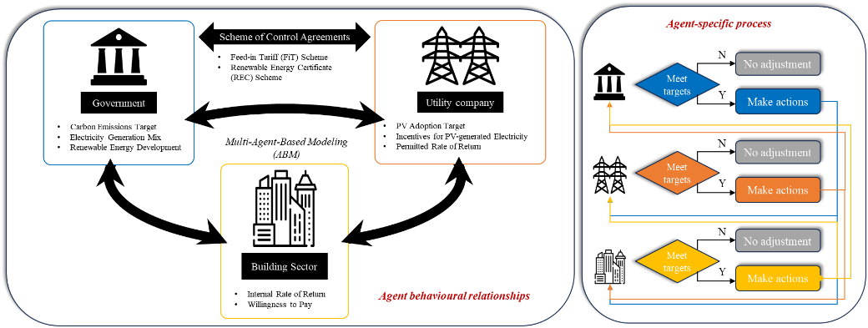

**Figure 2.** Stakeholder analysis flowchart

* 1. **Assessment indicators**

The developed policy evaluation tool applies various assessment indicators to measure if the targets of each agent are met based on each agent’s specific role and characteristics. These include the environmental assessment indicators (e.g., carbon emission per capita), RE installed capacity) from the government’s perspective, the economic assessment indicators (e.g., PV adoption goal, levelized cost of electricity (LCOE), and IRR (Eqs. (1) and (2))) from the utility companies’ and building sector’s (e.g., targeting on commercial buildings) perspectives, respectively, as well as the socio-economic assessment indicators (e.g., WTP (Eq. (3))) from the building sector (e.g., targeting on residential buildings). Some of the assessment indicators are formulated below:

* IRR:

$NPV\left(IRR\right)=\sum_{t=1}^{T}{\frac{G_{t} *FiT -((C_{0}+{OMC}_{t}+D_{t})*I_{t}) +{Tax}_{t} }{{(1+IRR)}^{t}}=0}$ Eq. (1)

$IRR=i_{1}+\frac{NPV\left(i_{1}\right)}{NPV\left(i_{1}\right)+\left|NPV\left(i_{2}\right)\right|}(i_{2}-i_{1})$ Eq. (2)

Where $NPV (HKD)$ measures the discounted cashflow of the solar PV project considering the time value, (kWh) is the amount of annual electricity generated by the PV system, (HKD/kW) is the unit capital cost of the PV system (i.e., 23,670 HKD/kW), (HKD/kW) is the annual unit operation cost of the PV system, including the annual operation and maintenance cost (i.e., 1% of the unit capital cost) as well as the inverter replacement cost (i.e., 9.5% of the unit capital cost) (An et al., 2020); (HKD/kW) is the unit decommissioning cost of the PV system at the end of its service life, which is 5% of the unit capital cost (Ouyang & Lin, 2014), (kW) is the simulated installed capacity of the PV system, ${Tax}_{t} (HKD)$ is the tax expense for medium- and large- scale PV installers. $i_{1}$ and $i_{2}$ are the two estimated IRRs that meet the condition $NPV\left(i_{1}\right)>0$, $NPV\left(i_{2}\right)<0$, and $i_{2}>i_{1}$; A smaller difference between $i_{2} and i_{1}$ ​ is desirable. The iteration and optimization of FiT rates are performed using Matlab with the assistance of the Financial Toolbox.

* WTP:

$u_{t}^{i}=w_{pp}*u_{pp,t}^{i}+w_{inc}*u_{inc,t}^{i}+w_{soc}*u_{soc,t}^{i}+w_{med}*u_{med,t}^{i}$ Eq. (3)

Where $u_{pp,t}^{i}$, $u_{inc,t}^{i}$, $u_{soc,t}^{i}$, and $u_{med,t}^{i}$ refers to the discounted payback period utility, household income utility, social utility as well as media utility, respectively. $w_{pp}, { w}_{inc},{ w}_{soc} and w_{med}$ denote the four utilities’ associated weight to be considered in the decision-making process.

* 1. **Model validation**

To evaluate the reliability and effectiveness of the proposed multi-ABM, the value of the simulation outcomes will be validated against the empirical data collected from the Hong Kong Energy Statistics Annual Report and Environmental Protection Department in year 2022 (Census and Statistical Department, 2023; Electrical and Mechanical Services Department, 2023), by means of using Root Mean Square Error (RMSE). The purpose of applying RMSE is to measure the accuracy of a predictive model by quantifying the difference between predicted values and actual values, as formulated by Eq. (4), and a RMSE lower than 25% indicates a better performance of the model (Kim et al., 2021) As a result, the average RMSE is calculated as 10.64%, 4.44%, 10.23%, 12.50% regarding the total energy consumption, RE installed capacity, per capita carbon emission and FiT rates, respectively.

.

Eq. (4)

* 1. **Policy-screening scenarios**

Upon the validation of the multi-ABM model, five policy-screening scenarios are proposed to simulate the impact of various policy interventions on the goal-achieving trajectory. Launching policy-screening scenarios is capable of providing ex-ante assessment before policy interventions are adopted, thus formulating forward-looking insights regarding the effectiveness and influences of reforming policy. In this study, the baseline scenario is the business-as-usual scenario that is validated by the historical data, and the five proposed policy-screening scenarios are: (i) Policy 1: government accelerate the pace of replacing traditional energy source with the cleaner ones; (ii) Policy 2: government decelerate the pace of replacing traditional energy source with the cleaner ones; (iii) Policy 3: government or utility company provide financial incentives (e.g., subsidize the PV system upfront cost) for building sectors to install PV systems; (iv) Policy 4: utility companies decelerate the pace of decreasing FiT rates for building sectors; and (v) Policy 5: utility companies accelerate the pace of decreasing FiT rates for building sectors. The planning horizon is till 2030. The increasing and decreasing rates of the pace is constrained by satisfying the following conditions (Table 1) each year, as in lined with historical trends:

**Table 1.** Summary of constraints in parameter setting

|  |  |  |  |
| --- | --- | --- | --- |
|  | Government | Utility company | Building sector |
| Constraints | Fluctuation of traditional energy consumption varies in [-10%, 20%] compared to previous year | (i) Permitted rate of return (ROR) not exceed 8%; (ii) FiT rates not lower than LCOE | (i) Fluctuation of the number of medium-scale PV installers varies in [-50%, +50%] compared to previous year; (ii) The number of large-scale PV installers is either 0 or 1; (iii) Installed capacity of large-scale PV system varies from 200 kW to 400 kW; (iv) Payback period utility + household income utility + social utility + media utility not less than the total utility threshold |

1. **Results and discussions**

As stipulated in HKCAP 2030+, the ultimate goals of mitigating the climate change challenge includes developing the RE market with a reinforcement on the PV market, as well as reducing the carbon emissions. Subsequently, the government has specified several the goals regarding the cumulative RE installed capacity, carbon emission per capita and the electricity supplied by PV-generated power as 660 MW, 3.8 tonnes/person and 1% to 1.5%, respectively, by 2030. The corresponding simulation results of the policy-screening scenarios are demonstrated in Figs. 3 to 5 and Tables 2 to 4.

It is observed that the cumulative RE installed capacity goal can be exactly achieved by 2030 in all scenarios except Policy 2, and it is greatly influenced by Policies 1 and 2 by changing the pace of replacing traditional energy source with the cleaner ones. Specifically, Policies 3 to 5 display similar goal-achieving trajectory as the baseline scenario, with Policies 3 and 4 indicating higher outcomes, while Policy 5 indicating slightly lower outcomes. It is remarkable that by implementing Policy 1, the HKCAP 2030+ goal can be accomplished in advance by 2029 with the value of 693 MW. Nonetheless, Policy 2 appears to fail achieving the goal with just 572 MW by 2030.

As for the carbon emission per capita, it is noticed that all policy interventions seem to reveal fluctuating goal-achieving trajectories. This is because that in the ABM, the total energy consumption is constrained and secured by a reasonable range that is determined by the historical trend, which allows the model to automatically adjust the proportion of different energy resources in the total energy mix. As a result, it can be seen that the 3.8 tonnes/person goal can by achieved by all scenarios during 2017 to 2018, with Policy 1 indicating an aggressive achievement comparing to the baseline, while Policies 3 and 4 indicating more consistent and appealing outcomes.

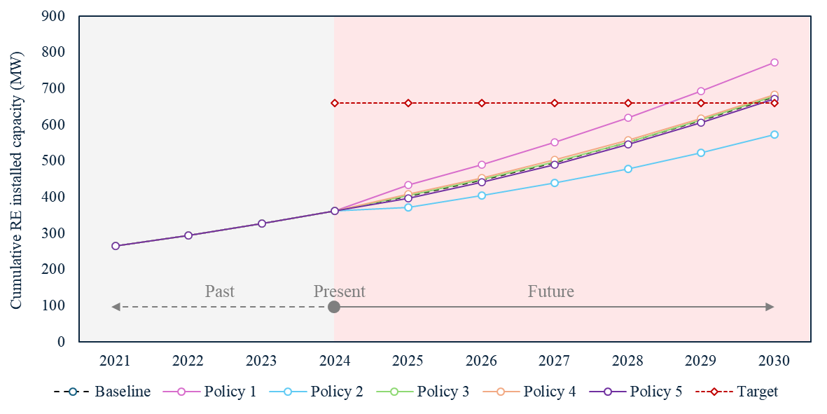

**Figure 3.** Cumulative RE installed capacity under policy-screening scenarios

**Table 2.** Comparison of five policies to baseline scenario regarding cumulative RE installed capacity in future

|  |  |  |  |  |  |  |
| --- | --- | --- | --- | --- | --- | --- |
|  | Baseline | Policy 1 | Policy 2 | Policy 3 | Policy 4 | Policy 5 |
| 2025 | 402.16 | 434.44 | 371.12 | 404.05 | 409.03 | 397.68 |
| 2026 | 446.52 | 490.26 | 403.54 | 448.59 | 453.40 | 441.78 |
| 2027 | 495.97 | 551.82 | 439.14 | 497.96 | 502.46 | 490.36 |
| 2028 | 551.02 | 619.75 | 478.43 | 552.37 | 557.11 | 545.07 |
| 2029 | 611.79 | 693.20 | 522.73 | 612.68 | 617.30 | 605.22 |
| 2030 | 678.41 | 772.16 | 572.05 | 679.47 | 683.95 | 671.70 |

Note: represents value higher than baseline scenario; represents value lower than baseline; value in red represents exceed the HKCAP 2030+ target.

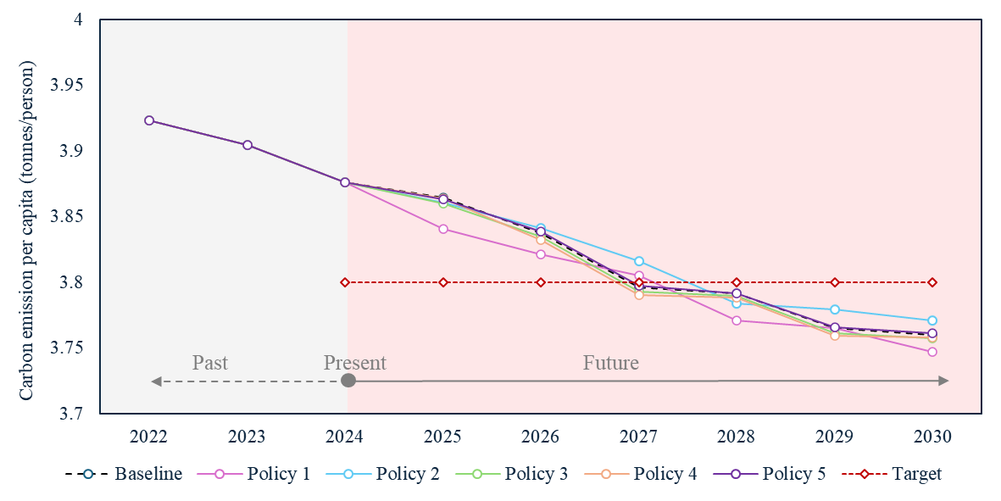

**Figure 4.** Carbon emission per capita under policy-screening scenarios

**Table 3.** Comparison of five policies to baseline scenario regarding carbon emission per capita in future

|  |  |  |  |  |  |  |
| --- | --- | --- | --- | --- | --- | --- |
|  | Baseline | Policy 1 | Policy 2 | Policy 3 | Policy 4 | Policy 5 |
| 2025 | 3.865 | 3.841 | 3.861 | 3.860 | 3.864 | 3.863 |
| 2026 | 3.838 | 3.821 | 3.841 | 3.835 | 3.833 | 3.839 |
| 2027 | 3.796 | 3.805 | 3.816 | 3.793 | 3.790 | 3.798 |
| 2028 | 3.792 | 3.771 | 3.784 | 3.789 | 3.789 | 3.791 |
| 2029 | 3.765 | 3.765 | 3.780 | 3.761 | 3.759 | 3.766 |
| 2030 | 3.760 | 3.747 | 3.771 | 3.758 | 3.758 | 3.761 |

Note: represents value higher than baseline scenario; represents value lower than baseline; value in blue represents under the HKCAP 2030+ target.

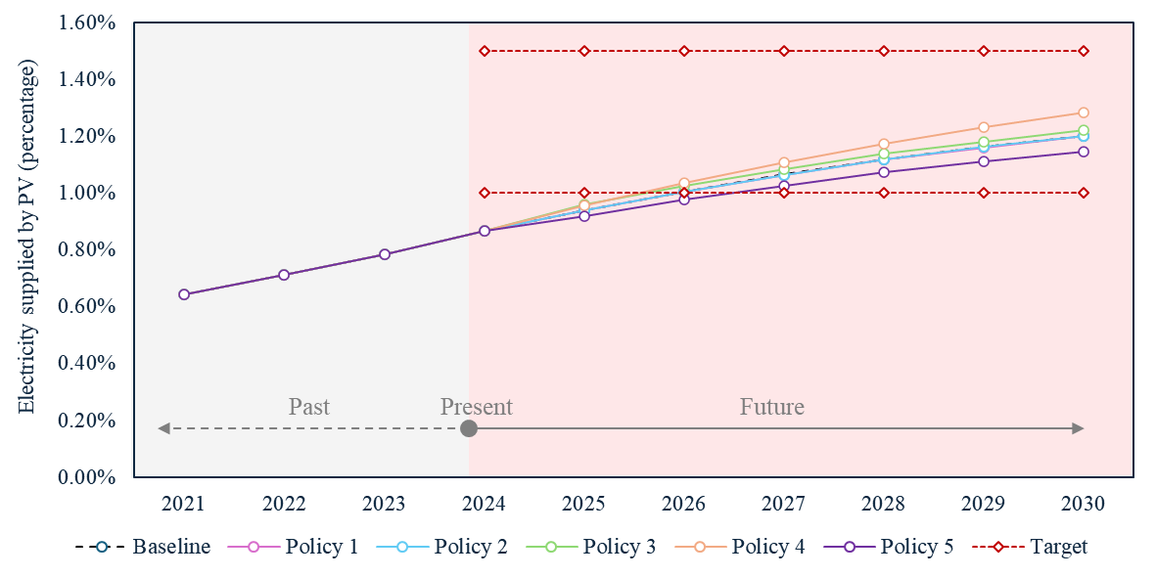

**Figure 5.** Electricity supplied by PV-generated power under policy-screening scenarios

**Table 4.** Comparison of five policies to baseline scenario regarding carbon emission per capita in future

|  |  |  |  |  |  |  |
| --- | --- | --- | --- | --- | --- | --- |
|  | Baseline | Policy 1 | Policy 2 | Policy 3 | Policy 4 | Policy 5 |
| 2025 | 0.94% | 0.94% | 0.94% | 0.96% | 0.96% | 0.92% |
| 2026 | 1.01% | 1.01% | 1.01% | 1.03% | 1.03% | 0.98% |
| 2027 | 1.07% | 1.06% | 1.06% | 1.08% | 1.11% | 1.03% |
| 2028 | 1.12% | 1.12% | 1.12% | 1.14% | 1.17% | 1.07% |
| 2029 | 1.16% | 1.16% | 1.16% | 1.18% | 1.23% | 1.11% |
| 2030 | 1.20% | 1.20% | 1.20% | 1.22% | 1.28% | 1.14% |

Note: represents value higher than baseline scenario; represents value lower than baseline; value in red represents within the HKCAP 2030+ target.

Regarding the electricity supplied by PV-generated power, it is noted that under all scenarios, the PV-generated power will contribute to at least 1% of the electricity supply by 2027, and Policy 4 reveals significant outcome (i.e., 1.28%) compared to other scenarios by 2030. Policy 3, also reveals slightly significant goal-achieving trajectory compared to the baseline scenario, and can realize 1.28% of electricity supply by 2030. This indicates that though the financial support on the upfront cost can stimulate the PV adoption rate by building sector, remaining a favorable FiT rates can significantly boost the PV market.

1. **Conclusion and policy implications**

This study develops an multi-ABM-based policy evaluation tool to dynamically capture and evaluate the stakeholders’ interaction in Hong Kong’s PV market. This tool allows for the simulation of multiple policy-screening scenarios, providing forward-looking insights that help in evaluating potential outcomes before actual policy implementation. The findings from the ABM simulations indicate that various policy interventions can significantly influence the achievement of climate change mitigations outlined in HKCAP 2030+. The analysis of five proposed policy-screening scenarios reveals that aggressive policies, such as accelerating the transition from traditional energy sources to cleaner alternatives (i.e., Policy 1), can lead to the early attainment of cumulative RE installed capacity targets. Conversely, a more conservative approach, as seen in Policy 2, fails to meet the established targets, highlighting the critical importance of proactive policy measures in driving the adoption of RE technologies. The results also show that financial incentives for the building sector, as proposed in Policies 3 and 4, can enhance the adoption of PV systems. Comparatively, though Policy 5 seems conservative, it is still robust to accomplish the final goal. The implications for policymakers are clear: to effectively mitigate climate change and promote the RE market, it is essential to implement forward-looking policies that encourage rapid adoption of renewable technologies. For example, accelerating the transition to cleaner energy sources but also providing financial support and maintaining favorable FiT rates to stimulate investment in PV systems.

**References**

An, J., Lee, M., Yeom, S., & Hong, T. 2020. Determining the Peer-to-Peer electricity trading price and strategy for energy prosumers and consumers within a microgrid. *Applied Energy*, *261*. https://doi.org/10.1016/j.apenergy.2019.114335

Census and Statistical Department. 2023. *Hong Kong Energy Statistics Annual Report Presenting statistics on different forms of energy, including oil products, coal products, electricity, and gas.*

Electrical and Mechanical Services Department. 2023. *Hong Kong Energy End-use Data 2023*.

Environment Bureau. 2015. *Hong Kong Climate Change Report 2015*.

Environment Bureau. 2017. *Hong Kong’s Climate Change Action Plan 2030+*. https://www.enb.gov.hk/sites/default/files/pdf/ClimateActionPlanEng.pdf

Kim, C. H., Kim, M., & Song, Y. J. 2021. Sequence-to-sequence deep learning model for building energy consumption prediction with dynamic simulation modeling. *Journal of Building Engineering*, *43*, 102577. https://doi.org/10.1016/J.JOBE.2021.102577

Ouyang, X., & Lin, B. 2014. Levelized cost of electricity (LCOE) of renewable energies and required subsidies in China. *Energy Policy*, *70*, 64–73. https://doi.org/10.1016/j.enpol.2014.03.030