|  |  |
| --- | --- |
| cetlogo ***CHEMICAL ENGINEERING TRANSACTIONS***  ***VOL. xxx, 2025*** | A publication of  aidiclogo_grande |
| The Italian Association  of Chemical Engineering  Online at www.cetjournal.it |
| Guest Editors: David Bogle, Flavio Manenti, Piero Salatino  Copyright © 2025, AIDIC Servizi S.r.l. **ISBN** 979-12-81206-21-2; **ISSN** 2283-9216 | |

A new digital tool for Crude Processability Evaluation

Egnazio Ollà1, Valentina Stillo1, Michele Celebre1, Francesca Ventimiglia1, Alessandra Saraceno1, Francesca D’Amico1, Fortunato Laganà1

1Milazzo Refinery, 98057 CONTRADA MANGIAVACCA, Milazzo (ME)

1valentina.stillo@ram.it

Recent geopolitical and economic events—such as the COVID-19 pandemic and ongoing global crises—have significantly influenced the crude oil supply market, affecting both cost and availability. In response, Milazzo Refinery (RAM) has broadened and diversified its crude oil sourcing strategy; consequently, RAM has recognised the importance of evaluating crudes more efficiently so as not to miss fleeting market opportunities.

To accelerate the assessment process and, after extensive research for a solution to this particular need, RAM has developed a digital tool called **CRUDOKU, the first of its kind**. When introducing a new crude the tool creates blends using various dilution crudes, aiming to maximize overall processability. CRUDOKU focuses specifically on RAM’s primary conversion units to determine the viability of each blend.

## ****1. Introduction****

Every refinery operates with a specific portfolio of crude feedstocks tailored to its processing set-up. However, since 2019, the availability and profitability of many crude oils on the market have declined sharply. As a result, crude selection played a key economic role. The ability to secure and process the most profitable crudes strongly influences refinery throughput and overall financial performance.

Political and economic situations can affect crude availability and market value, therefore RAM’s shareholders emphasized the need for a more thorough and adaptable approach to evaluating new crudes, which would enable RAM to seize market opportunities.

New crudes require a detailed processability assessment; however, the increasing variability among available crudes requires faster and more efficient evaluation methods. Traditionally, this process required significant time and effort. Recognizing this challenge, RAM initiated the development of a new digital tool—**CRUDoku.**

The CRUDoku tool was designed with three main objectives in mind:

1. **Determine the maximum processability** of a selected new crude, given current plant capabilities.
2. **Reduce the time required** to perform this assessment, in this way accelerating the purchase time.
3. **Identify recurring constraints** that may be overcome through minor plant modifications, allowing the processing of a wider range of crudes.

Why is such an evaluation essential? It involves defining a logical and feasible strategy for introducing a new crude oil into the refinery, considering a range of operational and technical constraints. These may include:

**Catalytic limitations**, such as performance and cycle life of existing catalyst systems;

**Process-related constraints**, which depend on the design and flexibility of specific units;

**Metallurgical restrictions**, related to material compatibility and corrosion risk.

It is important to note that CRUDoku has been set up specifically for RAM’s current refining needs. However, it can be adjusted and developed for any future requirements.

As well as assessing processability, CRUDoku also provides feedback about the **potential instability** of crude blends. While the tool itself does not carry out all the stability checks, it does generate warnings, which are checked through external means such as third-party databases or laboratory analysis.

1. Crude Processability – Evaluation Software

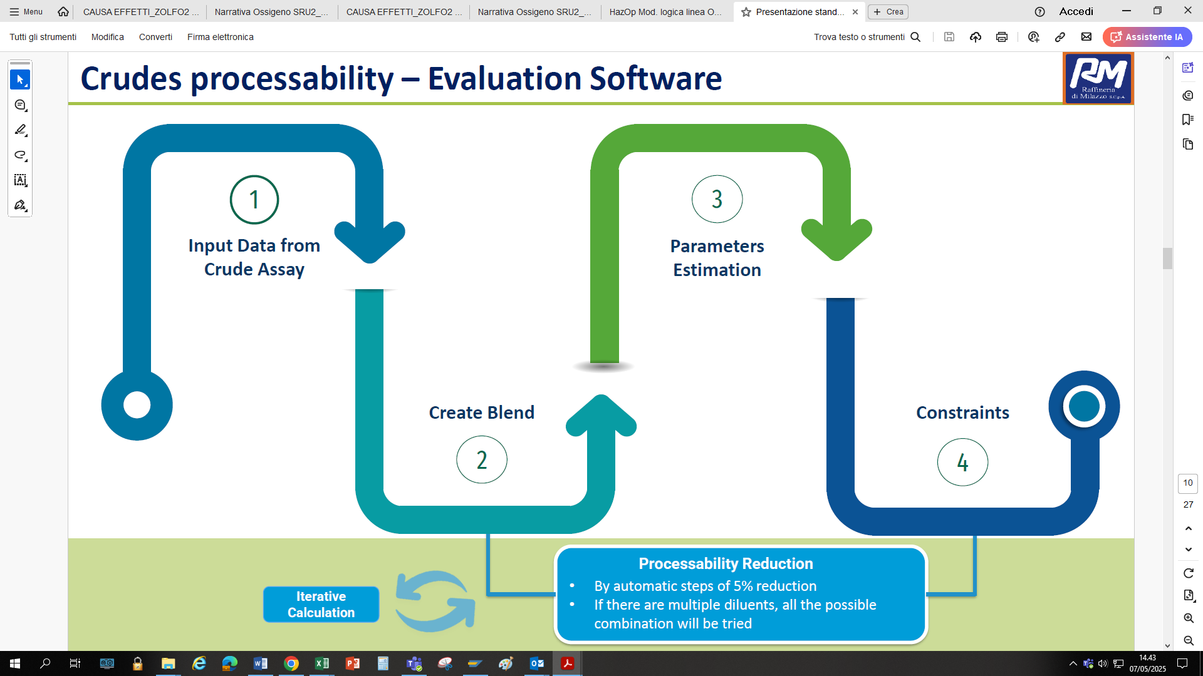

Figure 1. CRUDoku Architecture

### Software Architecture Overview

The CRUDOKU software follows a structured, multi-step workflow designed to assess and optimize the processability of new crude oils. Each phase plays a critical role in ensuring that the final blend meets the operational requirements of the refinery’s processing units. Below is a detailed breakdown of each step:

#### ****Step 1: Input of Crude Assay Data for the Target Crude****

Comprehensive data is collected from Crude Assay, specifically those related to atmospheric residue

#### ****Step 2: Selection of Diluent Crudes for CDU Feed Blend Formation****

In this phase, one or more "diluent crudes" are selected to be blended with the target crude in order to create the feedstock for the Topping Unit. A "diluent crude" is defined as a previously processed crude that has been successfully processed in the plant without issues.

#### ****Step 3: Calculation of Blend Characteristics Based on Target Crude Percentage****

At this point, the software calculates the characteristics of the resulting feed mixture, even starting from 100% crude.

#### ****Step 4: Validation Against Operational Constraints****

The software then compares the calculated parameters of the blend against a predefined set of operational and product constraints. These constraints, embedded within the tool, represent the technical limits of RAM’s process units (e.g., catalytic performance, metallurgy, cycle life).

### Iterative Evaluation and Optimization

If the blend meets all constraint thresholds, the mixture is deemed processable and a processability evaluation is given. If not, the software automatically adjusts the proportion of the diluent crude in 5% increments and re-evaluates the mixture.

This iterative process continues until a processable blend is identified, or all blending possibilities have been exhausted.

If there are multiple dilutents, the software explores all feasible combinations—with a maximum of four diluents in a single blend—to identify the most favorable configuration.

1. Software section: HS – LS

The CRUDoku tool is structured into two sections, each reflecting one of the main processing cycles in the Milazzo Refinery:

**High Sulfur (HS) Cycle which includes** High Sulfur Crude Distillation Unit (CDU), the Vacuum Distillation Unit (VDU), and the LC-Finer unit.

**Low Sulfur (LS) Cycle which comprise of** the Low Sulfur CDU and the Fluid Catalytic Cracking (FCC) unit.

When analysing the Milazzo Refinery cycle, particular emphasis must be placed on the conversion units—such as the FCC and LC-Finer—which play key roles in crude selection.

In the High Sulphur cycle, CRUDoku evaluates the CDU and VDU units, where both crude oil and high-sulphur atmospheric residue can be introduced

Crude oil feeds the Topping, while the Vacuum unit is fed with the Atmospheric Residue, coming from CDU bottom; in the Vacuum column the Atmospheric Residue is divided into VGO, fed to Hydrocracker unit and Vacuum Residue fed to LC-finer unit.

In the Low Sulphur Cycle, the tool focuses on CDU, which processes Low Sulphur Crude, and FCC, which processes the LS AR.

* 1. CDU and VDU - Plant Constraint

For the Vacuum and Atmospheric Distillation Units (VDU and CDU), the tool first evaluates cut yields to determine whether the selected crude is processable from a hydraulic standpoint. For example, a naphtha yield exceeding 30–35 wt% in the CDU can lead to potential clogging in the system overhead. In addition, if the atmospheric residue yield is too low, there may be insufficient heat to maintain efficiency in the preheat train.

Next, the tool assesses crude properties that can affect product quality. Parameters such as total sulphur in the naphtha cut and the presence of oxygenates—commonly found in WTI crudes—are evaluated, as these can influence downstream processing. In addition, total nitrogen in the VGO cut is examined, given its potential to influence the catalysts in the hydrocracker unit (fixed bed).

Properties affecting metallurgy are also important, particularly those linked to corrosion, such as sulphur (which contributes to H₂S formation) and the Total Acid Number (TAN). The unit’s contamination limits are based on its metallurgic design.

To manage high-TAN crudes, RAM implemented a chemical treatment system on both the CDU and VDU. This treatment forms a protective film on internal surfaces, reducing the impact of acid corrosion and enabling the processing of opportunity crudes with higher TAN levels.

* 1. HS Cycle Section: LC-Finer Process

The LC-Finer unit is a specialized hydrotreating system utilizing an ebullated bed catalyst configuration. Licensed by Chevron Lummus Global (CLG), the unit was commissioned at the Milazzo refinery in 1996. Its primary objective is to upgrade Vacuum Residue (VR) into higher-value products such as Naphtha, Atmospheric Gas Oil (AGO), Vacuum Gas Oil (VGO), and Low Sulphur Fuel Oil (LSFO).

Operating at high pressure (approximately 180 bar) and temperature (around 420°C), the process takes place in three ebullated-bed reactors. Within these reactors, multiple reactions occur simultaneously—desulfurization, denitrogenation, demetallation, and the reduction of Conradson Carbon Residue (CCR) and asphaltenes.

For high-sulphur (HS) crudes, CRUDoku creates the mix flowrate and compares its characteristics against historical plant data. Using licensor-provided correlations and current operating parameters, the tool estimates feed and process behaviour, releasing a Processability score.

Key constraints for the LC-Finer include:

* **Sulphur:** This presents two issues. If concentration is too low, the feed lacks the thermal energy required to sustain processing, leading to a bottleneck—especially at the furnace. Conversely, high sulphur levels can exceed the metallurgical limits of the unit.
* **Nitrogen and Metals:** These contaminants cause problems by blocking the catalyst at active sites, reducing overall catalytic activity. Performance can be maintained by increasing the make-up of fresh catalyst
* **CCR, Asphaltenes, P-Value, and K-UOP:** These parameters provide information on the crude matrix’s tendency to precipitate. Elevated values indicate a greater risk of fouling, instability in VTB (LSFO), and failure to meet fuel oil specifications due to excess asphaltenes.
  1. LS Cycle Section: FCC Process

Commissioned in the 1970s, RAM was among the first conversion units. The process consists of catalytic cracking in a fluidized bed, converting Atmospheric Residue (AR) into high-value products such as LPG and Naphtha.

Under partial combustion mode, the FCC feed typically consists of 70% Low sulphur Atmospheric Residue, blended with 30% VGO from the LC-Finer unit and UCO from the Hydrocracker.

Constraints for FCC operations are well defined and have been established through years of historical modelling. These include:

* Metals (e.g., Nickel and Vanadium): These hinder the performance of the catalyst system.
* CCR and Asphaltenes: These properties influence key process limits, such as air blower capacity and maximum regenerator temperature.
* Total and Basic Nitrogen: These affect product yields and selectivity, particularly for more valuable products.
* Sulphur Content: This impacts emissions targets and constrains downstream units like the Light Cycle Naphtha (LCN) treatment plant.

For simulations involving low sulphur crudes, as with high sulphur scenarios, CRUDoku requires the assay of the target crude and a selected diluent crude. In Standard Mode, the tool calculates the blended feed characteristics based on standard feed setups, particularly focusing on AR percentage, and checks compatibility with plant constraints.

In Max Mode, the tool allows for a reduction in AR intake to mitigate the impact of limiting parameters by increasing dilution with VGO. This enables processability even when the target crude poses some challenges.

Two other simulation types are available:

*Spot Simulation:* At a standard feed setup, the tool requires further information, such as ECAT (equilibrium catalyst) characteristics, cargo size, flowrate, catalyst inventory, and Catalyst-to-Oil Ratio (CAR). This mode estimates metal accumulation on ECAT over the processing period and compares these with input constraints.

*Max Spot Simulation:* Similar to Spot Mode, but if convergence is not achieved, the simulator automatically reduces the AR portion of the feed to achieve processability.

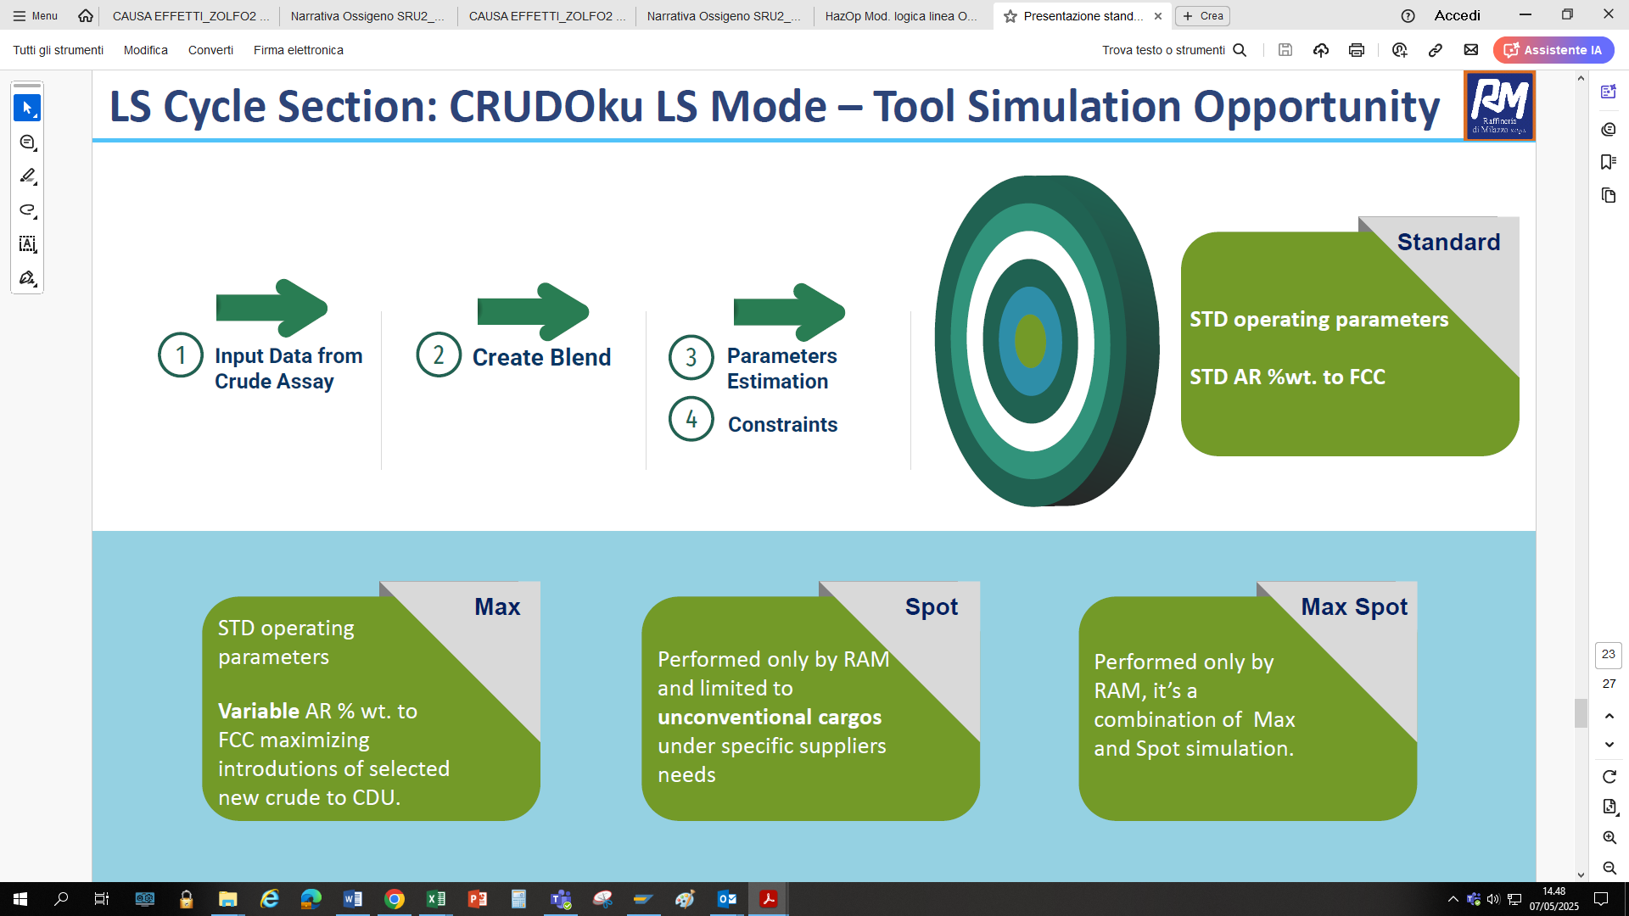

Figure 4. LS simulation opportunity

1. Conclusions

Since the start-up of the tool, approximately 200 new crude assays—80 Low Sulphur (LS) and 120 High Sulphur (HS)—have been assessed.

More than 800 crude blends have been simulated, leading to the identification of 450 processable mixtures. Among these, a significant number achieved processability scores greater than 20%, with a portion exceeding 40%.

At the Milazzo Refinery, a crude is considered a potential diluent if its processability exceeds 40%, which has become a key benchmark for us.

Since 2020, and based on available market offerings, RAM has successfully introduced 22 new crudes into our daily schedule—thanks to evaluations carried out with CRUDoku.

Through this period of successful utilisation, RAM has come to fully appreciate CRUDoku’s potential. Given that the tool has been entirely developed and maintained within RAM, we believe that with minimal upgrades, its capabilities can be significantly expanded. Particularly, in these areas:

* Adding an **Opportunity Evaluation Mode** for HS assessments, similar to the existing LS cycle;
* Creating a **new simulation section** to identify optimal diluent crude combinations within a defined basket, aimed at maximizing target crude intake;
* **Integrating CRUDoku** with existing scheduling software to optimize weekly planning.

Acknowledgements

The authors wish to thank all RAM contributed to development during tool implementation. Their insights were instrumental in shaping the functionality and usability of the CRUDoku tool.