 CHEMICAL ENGINEERING TRANSACTIONS  VOL. xxx, 2025 | A publication of  
The Italian Association
of Chemical Engineering
Online at www.cetjournal.it

Guest Editors: David Bogle, Flavio Manenti, Piero Salatino
Copyright © 2025, AIDIC Servizi S.r.l.
ISBN 979-12-81206-21-2; ISSN 2283-9216

Mobile App suite to improve refinery safety, communication and operations
Michele Celebre*, Giuseppe Caravello, Francesca D’Amico
Raffineria di Milazzo SCPA, C.da Mangiavacca, Milazzo (Me - Italy)]
michele.celebre@ram.it
Over the past two years, the Refinery has developed a suite of mobile applications, used by external operators and specifically designed to improve safety, communication and operations within the plants.
The project involved the distribution of 75 Atex smartphones, certified for use in potentially explosive environments, on which dedicated apps were installed. These smartphones are currently used by approximately 300 shift workers.
The applications cover several key functions, such as real-time management of work permits, monitoring of external companies entering and leaving the plant and immediate reporting of near misses.
In addition, an integrated address book facilitates quick access to contacts for both refinery personnel and external collaborators.
The digitalization of processes has led to greater awareness of risks and a more efficient and traceable exchange of information.
Preliminary results highlight significant improvements in terms of safety.
The project represents a major innovation in the operational management and prevention of accidents within the industrial complex.
  - Introduction
The growing need for safety and optimization of operational processes in refineries has led to the need for advanced digital solutions.
In the context of complex and potentially dangerous industrial environments, the adoption of mobile technologies represents a significant step forward. The project described aimed to integrate digital tools for managing work permits, real-time monitoring of events and facilitating communication between operators. This initiative is part of a broader digital transformation framework, aimed at reducing risks and improving operational efficiency.
  - Implementation
More than 75 Atex smartphones certified for potentially explosive environments (zone 1) were distributed, ensuring compatibility with safety regulations.
A software for MDM (Mobile Device Management) was used to better manage the devices in accordance with IT department policies for secure device management (Dino, 2025, Lautala 2019).
The apps developed are progressive web applications (PWA) with which you can get both the advantages of the web and those of native applications. In fact, PWAs allow users to work offline, receive push notifications, access the GPS coordinates of the smartphone (Kothapalli, 2021).
  - Developed Applications
The applications developed cover the following functional areas:

 | 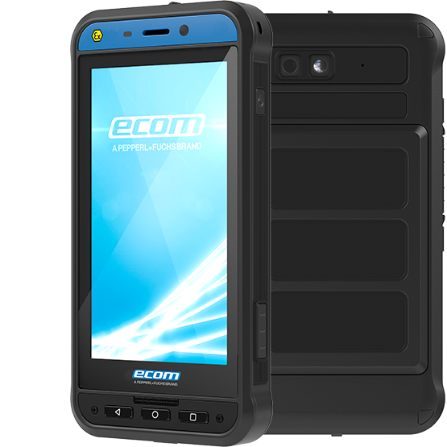
Fig. 1a: Operators in the plant with Atex smartphones | Fig. 1b: Used atex smartphone
    - Management of Work Permits
Function: This application enables the real-time monitoring and control of work permits. The external operators of the refinery verify the work permit and record the relative entry and exit made by the contractors in the plant area. This ensures that only authorized personnel are present on site during specific maintenance activities.
Objective: The primary goal is to ensure a secure and controlled environment during potentially hazardous maintenance activities. Having an up-to-date overview of which personnel are in the plant at any given time minimizes safety risks.
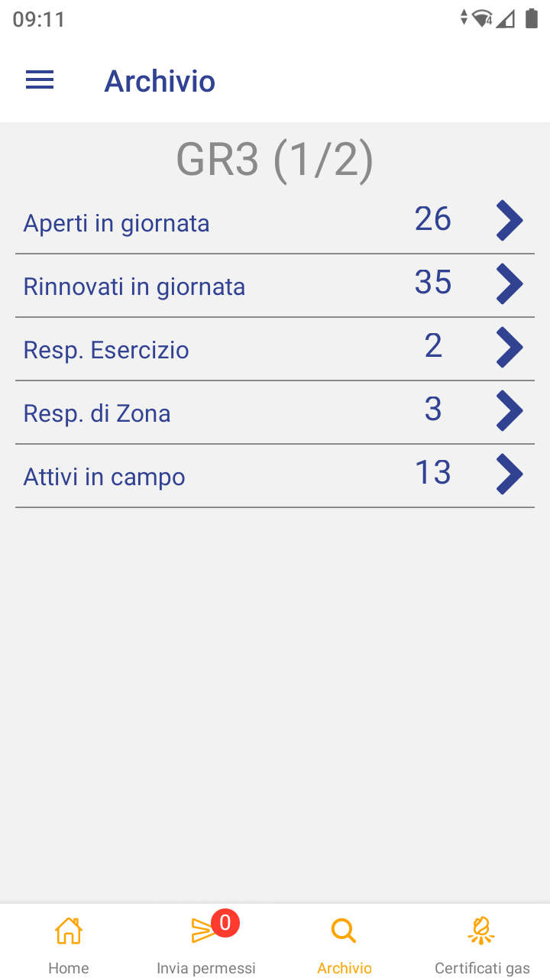
Figure 2a: The following data is reported: number of permits opened for the first time today, number of permits renewed, number of permits awaiting the signature of the facility manager, number of permits requiring authorization from the area manager, number of permits active in the field. | Figure 2b:Visualizzazione permessi e registrazione ingresso e uscita del personale della ditta dall’impianto
    - Near Miss Reporting
Function: This tool enables immediate documentation and reporting of near misses. With an intuitive interface, personnel can quickly submit details of any observed unsafe conditions or behaviors, attaching photos or, if necessary, additional data.
Objective: By encouraging real-time reporting of such incidents, the refinery can undertake timely root cause analysis and implement corrective measures before a major incident occurs. This proactive approach fosters a culture of continuous improvement.
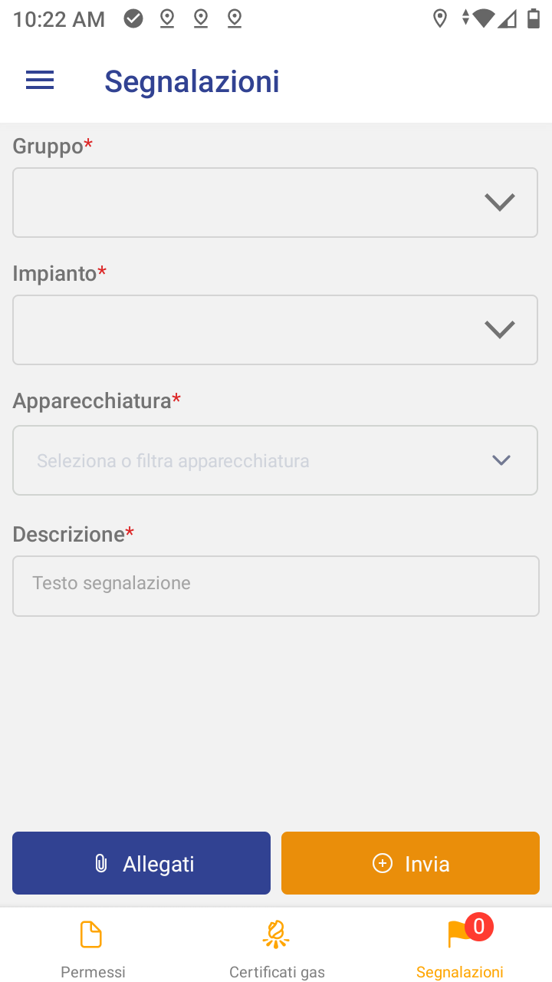
Figure 3 Insertion of near miss report, with the possibility of indicating the affected equipment and attaching a photo
    - Management of Shift Information
Function: Shift-based operations rely heavily on clear communication between outgoing and incoming teams. This application provides a centralized digital log where shift notes, updates, and any observed anomalies can be recorded and reviewed by subsequent personnel.
Objective: The objective is to enhance business continuity by ensuring that critical information is not lost or misunderstood during shift handovers.
    - Daily Checklist
Function: Routine checks are essential to ensure that daily operations comply with established operational and safety standards. The Daily Checklist application guides personnel through standardized inspection points to monitor the health of equipment.
Objective: By digitizing these periodic checks, the system helps prevent equipment failures by ensuring that potential problems are identified early, thereby reducing the likelihood of unexpected downtime or accidents.
    - HSE Audit
Function: Focused on Health, Safety, and Environment (HSE) regulations, this application supports the planning, scheduling, and execution of safety audits within the plant. Auditors can record observations, upload photographs, and assign corrective actions in a unified platform, ensuring that all relevant information is captured efficiently.
Objective: The primary aim is to enhance the overall safety culture by involving both refinery personnel and contractor companies in understanding and following best practices. Systematic auditing improves awareness of potential hazards, and drives continual improvement in workplace safety performance.
    - Phone Book
Function: Timely collaboration requires direct access to the right people, whether they are refinery employees or outside maintenance contractors. This digital phone book provides access to the company phone of anyone who may be involved in the work in progress.
Objective: The central phone directory promotes effective teamwork by allowing staff to quickly locate the right people to contact.
Figure 5a: Refinery Staff Phones | Figure 5b: External phone numbers, useful for work
    - Gas Certificates
Function: Industrial activities often involve working in hazardous atmospheres or require environment-specific testing, such as explosiveness measurements or air quality assessments. This module simplifies the completion, review and issuance of gas certificates. The certificate is signed using a biometric handwritten signature (advanced electronic signature)
Objective: By automating certificate generation and centralizing all test results, the time required to authorize and begin critical work is significantly reduced. It also ensures complete and consistent documentation, aiding in compliance with regulatory bodies and providing verifiable evidence for audits.
Figure 6a: List of gas certificates in progress and completed on the current day | Figure 6b: The operator enters the explosiveness and/or habitability measurements carried out into the APP
    - Monitoring and Analysis Tools
To evaluate the impact of these applications on the way of working of the operators involved, we report, as an example, some usage statistics.

Figure 4: Number of gas free certificates.

Figure 5: Average minutes between requesting a gas certificate and entering the result
From these graphs it is clear that even during turnaround, in which more gas free certificates are carried out, the average execution time remains almost constant.

Figure 6: Number of near miss reports in the last few years
  - Conclusions
The project to implement mobile applications in the refinery has led to significant results in several respects:
- Increased safety: The rapid reporting of near misses has contributed to an improvement in safety in the refinery.
- Improved communication: The centralization of information has optimized the communication flow between the various departments and shifts, promoting better coordination and avoiding misunderstandings.
- Optimization of operational processes: the digitalization of controls and procedures has enabled more efficient management of daily activities, and has helped improve predictive maintenance, reducing the likelihood of unplanned downtime or accidents.
These results underscore the importance of integrating digital solutions in the industrial sector to ensure high standards of safety and operation.
Given the ongoing advances in generative AI, the next logical step in the near future may be the development of AI-based apps that assist field workers in performing critical tasks and retrieving technical documentation or identifying equipment anomalies directly from images (Megahed et al., 2025).
References
Kothapalli M., 2021. Progressive Web Apps: Merging Web Accessibility with Native Performance. European Journal of Advances in Engineering and Technology, 8(4), 60-68.
Dino D., 2025. Incentivizing Cybersecurity Resilience through a Risk-Based Taxation Framework for Critical Infrastructure Protection.
Lautala J. ,2019. Improving mobile device enrollment in corporate environment.
Megahed, F. M., Chen, Y., Colosimo, B. M., Grasso, M., Jones‐Farmer, L. A., Knoth, S., Sun, H., & Zwetsloot, I. M. , 2025. Adapting OpenAI’s CLIP Model for Few-Shot Image Inspection in Manufacturing Quality Control: An Expository Case Study with Multiple Application Examples. https://doi.org/10.48550/arxiv.2501.12596

