|  |  |
| --- | --- |
| cetlogo ***CHEMICAL ENGINEERING TRANSACTIONS***  ***VOL. xxx, 2025*** | A publication of  aidiclogo_grande |
| The Italian Association  of Chemical Engineering  Online at www.cetjournal.it |
| Guest Editors: David Bogle, Flavio Manenti, Piero Salatino  Copyright © 2025, AIDIC Servizi S.r.l. **ISBN** 979-12-81206-21-2; **ISSN** 2283-9216 | |

Semi-quantitative approach on AtEx risk assessment for gaseous hydrogen releases

Andrea Gritti\*, Leonardo Michele Carluccio, Aurora Lafiosca, Maria Elyas

DEKRA Italia s.r.l., Process Safety Business Unit, Via Fratelli Gracchi 27, 20122 Cinisello Balsamo (MI)

andrea.gritti@dekra.com

This paper presents a semi-quantitative approach for evaluating explosion risks in environments where hydrogen gas is present, utilizing a risk matrix as a decision-making tool. This semi-quantitative methodology enables a balanced, evidence-based evaluation of explosion risks, facilitating risk reduction strategies and ensuring compliance with AtEx regulations.

The case study proposed in this article assesses the risks associated with hydrogen gas generation during the charging of lead-acid batteries. The selection of lead-acid batteries as a case study is due to their continued widespread use in process industries, particularly in powering electric vehicles such as forklifts, UPS systems, and emergency lighting. This choice also reflects their significant role in environments where potential hazards, such as the generation of hydrogen during charging, require careful consideration in terms of safety regulations and risk management.

During battery charging, hydrogen is produced as a byproduct of electrolysis, creating a potentially explosive atmosphere in confined or poorly ventilated areas. Given hydrogen's low ignition energy, wide flammability range, and rapid diffusion, even small concentrations pose significant safety risks in AtEx-classified zones.

The method currently being employed is still in the developmental phase, and as a result, its limitations will be carefully identified and discussed. However, addressing these weaknesses will be essential for ensuring that the method evolves into a robust tool. This will allow the structured, semi-quantitative approach for AtEx risk assessments concerning hydrogen hazards to be applied on a broader scale across a wider range of industries, further supporting the safe integration of hydrogen technologies in various sectors.

* 1. Introduction

Hydrogen is emerging as a critical energy carrier capable of storing, transporting, and delivering energy from various sources. Despite hydrogen's carbon-free nature upon production, its diverse production pathways lead to varying environmental impacts, including greenhouse gas emissions. Hydrogen's unique properties, such as low ignition energy and wide flammability range, present significant safety challenges, particularly in industrial settings. Hydrogen holds potential as a versatile and clean energy carrier; however, its production methods and physical properties pose significant challenges related to safety. Understanding the risks associated with hydrogen is essential for developing comprehensive safety measures. Effective management of hydrogen in industrial settings requires careful consideration of its unique characteristics to prevent hazardous situations and ensure safe usage.

* + 1. Ignition Energy and Flammability Range

Hydrogen, low ignition energy, typically ranging from 0.02 to 0.06 mJ (H2Tools.org, 2024), makes it highly sensitive to ignition sources, such as small sparks, heat, or static electricity. Such a low ignition threshold, combined with hydrogen's broad flammability range (from 4% to 75% in air), significantly increases the risks of fire and explosion. Hydrogen holds the highest rating of 4 on the NFPA 704 flammability scale (NFPA 704). This sensitivity to ignition is further compounded in confined or poorly ventilated spaces, where the risk of ignition from minimal energy inputs is elevated.

Table 1: Ignition and combustion properties for air mixtures at 25 °C and 101.3 kPa for Hydrogen compared to other common fuel (ISO/TR 15916:2015)

|  |  |  |  |  |
| --- | --- | --- | --- | --- |
| Fuel | Lower flammability limit (% vol. fraction) | Upper flammability limit (% vol. fraction) | Minimum ignition energy (mJ) | Laminar burning velocity (m/s) |
| Hydrogen H2 | 4 | 77 | 0.017 | 2.70 |
| Methane CH4 | 5.3 | 17 | 0.271 | 0.37 |
| Propane C3H8 | 1,7 | 10,9 | 0,240 | 0,47 |

The ISO/TR 15916:2015 standard provides valuable guidance on the safe use and handling of hydrogen. This document emphasizes the importance of assessing hydrogen’s unique physical properties—such as its low ignition energy and high diffusivity—and stresses the need for robust safety systems to minimize risks, even in scenarios involving hydrogen in both open and confined spaces. A semiquantitative AtEx risk assessment facilitates the identification of hydrogen-related risks and supports the development of effective safety measures for risk mitigation.

* + 1. Diffusivity

Hydrogen has a high rate of diffusion, approximately 3.8 times faster than natural gas. This means that when hydrogen is released, it spreads quickly until its concentration drops below flammable levels due to turbulent convection, drift, and buoyancy, which reduces the duration of the risk. However, it's crucial to note that this quick dispersion also allows hydrogen to form gas mixtures within its broad flammability and explosive limits. As the lightest element, hydrogen behaves according to basic physical principles, not lingering near leaks or people in open areas unless confined. Therefore, industries must account for this factor when designing hydrogen-related structures, ensuring the designs facilitate hydrogen’s upward and outward dispersal to minimize the chances of ignition.

* 1. Methodology

Important information necessary in the development of the study is gathered during site visits and analysis of the plant and process documentation, and then collected into a worksheet, where the first four columns (i.e., Location, Hazardous Area Classification, Ignition Risk Assessment, Consequence Analysis respectively) represent the starting point for the development of the semi-quantitative AtEx risk assessment. In the following table is reported an example of a typical worksheet used for the study.

Table 2: Semi-quantitative AtEx risk assessment worksheet

|  |  |  |  |  |  |  |  |  |  |  |  |
| --- | --- | --- | --- | --- | --- | --- | --- | --- | --- | --- | --- |
| Location | HAC | IRA | Consequences | Risk  Ranking | | Existing Barriers | Risk  Ranking | | Recommendations | Risk  Ranking | |
|  |  |  |  | L | S |  | L | S |  | L | S |
| Pumping station | Zone 1 (External area) | 1. Static electricity | Flash fire […] |  |  |  |  |  | Ensure equipment compliance |  |  |
| 2. Electrical equipment | Flash fire […] |  |  | Grounding and bonding |  |  |  |  |  |
| 3. […] | […] |  |  |  |  |  |  |  |  |

The current methodology was derived from analogous analyses known as Dust Hazard Analysis (DHA), focusing on explosive dusts, as documented in Gritti et al., 2023, which is based on the application of a risk matrix that incorporates levels of severity and likelihood. When transferring this assessment from dust to gases, differences emerge not in the structure of the analysis but primarily regarding the extent of the zones, the ignition risk assessment, the consequences, and the safeguard.

* + 1. Hazardous Area Classification (HAC) and Ignition Risk Assessment (IRA)

The Hazardous Area Classification follows the usual path described in IEC 60079-10-1 (2020), starting from the identification of the possible sources of emission and the characterization of the grade of emission. The key difference in area classification between gases and dusts is that, while no explicit formulas exist for determining the extent of hazardous zones for dusts, standard IEC 60079-10-1 (2020) provides precise formulas for gases, considering the release grade and the ventilation type.

The Ignition Risk Assessment for gases is primarily determined by the presence of an ignition source due to their extremely low minimum ignition energy. This consideration is particularly critical for electrostatic discharges and mechanical sparks, where even minimal energy input can induce ignition. Conversely, for hot surfaces, the assessment must incorporate a comparative analysis between the surface temperature and the gas autoignition temperature to ensure a precise risk evaluation. In contrast, dust ignition assessments also necessitate evaluating the effectiveness of the ignition source, given that dusts possess substantially higher ignition energy thresholds, often exceeding 1000 mJ.

* + 1. Consequence Analysis

For the analysis of the consequences, among all the aspects to be taken into account, the starting point is the pentagon of the explosion, in order to understand the physical effect resulting after the ignition.

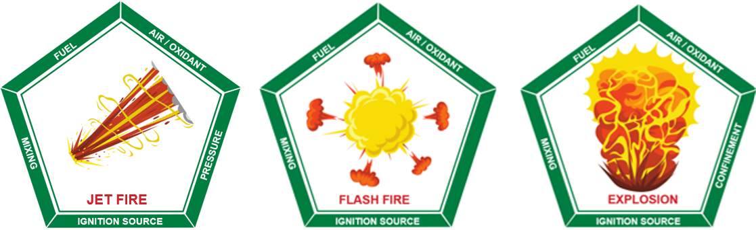

Figure 1: Consequences of ignition, based on the pentagon of fire

As a preliminary consideration, ignition within the internal volume of equipment can be expected to result in an explosion, whereas ignition in an open area is more likely to cause a flash fire or jet fire, in case of pressure release. For instance, during start-up, shutdown, or maintenance operations, the equipment may be nearly empty, and the quantity of flammable gas or liquid inside might be insufficient to trigger an explosion. In such cases, the resulting consequence would likely be an internal flash fire or jet fire, in case of pressure release, rather than a full-scale explosion.

Additionally, in the event of an internal explosion, it is crucial to consider the potential propagation of the flame front to interconnected equipment, as well as the projection of fragments that could pose additional hazards.

* + 1. Safeguard

When referring to safeguards, it pertains to the mitigated risk, which is evaluated by considering the effectiveness and reliability of the existing safeguards (e.g., inerting, ventilation), resulting in a reduction of the scenario frequency.

For instance, the following PFDs can be assigned, as reported in the Guidelines for Initiating Events and Independent Protection Layers in the Layer of Protection Analysis (CCPS, 2015):

* Explosion panels on process equipment: PFD = 10-2;
* Continuous ventilation *with* automated performance monitoring: PFD = 10-2;
* Emergency ventilation initiated by safety controls, alarms, and interlocks (SCAI): PFD = 10-1;

Furthermore, when inerting is employed to eliminate the presence of oxygen within the equipment, it is possible to reduce the hazardous area classification based on the reliability of the inerting control system (Process Control Engineering – PCE). Specifically, the following table, as outlined in VDI/VDE 2180 Blatt 6 (2013), can be applied, utilizing Safety Integrity Levels (SIL) (IEC 61508, IEC 61511).

Table 3: Necessary risk reduction as a function of the initial and the target zone with the use of PCE system

|  |  |  |
| --- | --- | --- |
| Zone | | Required reliability of the PCE system |
| Initial | Target |
| 0 | 1 | SIL 1 |
| 0 | 2 | SIL 2 |
| 0 | nEx | SIL 3 |

Ventilation is a fundamental parameter in AtEx risk assessments for gases, with its significance being particularly pronounced in the case of hydrogen. While previous studies (CCPS, 2015) have highlighted its role as safeguard, the IEC 60079-10-1 (2020), framework inherently integrates ventilation into hazardous area classification, applying a methodology analogous to that used for inerting. Both ventilation and inerting serve to prevent or eliminate the presence of a flammable atmosphere; however, the extent of this risk reduction must be quantitatively justified based on the reliability and performance of the implemented safety systems.

In the context of barriers, it is essential to specify that the basic principles of explosion prevention and protection shall be applied in the following order (EN 1127-1, 2019):

Table 4: Evaluation of existing Basis of Safety (BoS)

|  |  |
| --- | --- |
| Prevention | Protection |
| 1- Avoid or reduce hazardous explosive atmospheres; this objective can mainly be achieved by modifying either the concentration of the flammable/combustible substance to a value outside the explosion range or the concentration of oxygen to a value below the limiting oxygen concentration (LOC).  2-Avoid any possible effective ignition source. | 1-Halting the explosion and/or limiting the range to a sufficient level by protection methods, (e.g., isolation, venting, suppression and containment); in contrast to the two measures described above, here the occurrence of an explosion is accepted. |

It is worth pointing out that the first choice shall always be the avoidance of a hazardous explosive atmosphere.

* 1. Case Study: hydrogen gas generation during the charging of lead-acid batteries

The generation of hydrogen during the charging of lead-acid batteries, through electrolysis, introduces significant risks, including the potential for explosive gas accumulation and ignition, if proper ventilation and safety measures are not implemented. During charge processes, gases are emitted from all secondary cells and batteries using aqueous electrolyte. This is a result of the electrolysis of the water by the overcharging current. Gases produced are hydrogen and oxygen. When emitted into the surrounding atmosphere, an explosive mixture is created if the hydrogen concentration exceeds 4 % hydrogen in air. The case study outlined here investigates the requirements for ventilation and the classification of hazardous areas during the charging of traction batteries, as specified in IEC 62485-3. Two distinct charging scenarios are considered (one with load stabilization and one without) providing an overview of how zone classifications should be determined based on ventilation criteria.

* + 1. Case study: Hazardous Area Classification

For an AtEx assessment, it is advisable to classify the battery charging area of the forklifts in accordance with the relevant regulations IEC 60079-10-1 (2020). The AtEx classification zones for gases are applied to the various cases. The Hazardous Area classification derived from the case study is intrinsically linked to the ventilation dynamics together with essential data such as H2 maximum production (cm3/min); numbers of cells; Ventilation rate (vol/h), room volume (m3) and ventilation characteristic (natural or forced). With insufficient extraction/ventilation, the limited dispersion of hydrogen, combined with its wide flammability limits, results in the formation of a Zone 1 in the immediate vicinity of the charging point. This zone then progressively dilutes, forming a Zone 2 extending from Zone 1 and into the upper regions of the room, as hydrogen tends to accumulate in these areas. In contrast, with adequate extraction/ventilation, hydrogen, due to its high diffusivity, will not form a hazardous zone around the charging point, but will instead lead to the formation of only a Zone 2 in the upper portion of the room. Finally, with optimal extraction/ventilation and a detailed analysis of the airflow patterns or extraction points, hydrogen will not classify any hazardous zones within the charging room, or the identified sources will have a negligible extension.

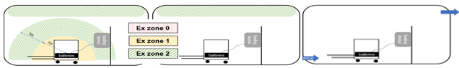

Figure 2: Influence of Ventilation on hydrogen Hazardous Area Classification

A relatively low concentration of hydrogen is sufficient to present a significant explosion risk, which is typically defined by the Lower Explosive Limit (LEL). Safety procedures are primarily focused on detecting flammable gases before they reach this explosive threshold, with gas detection systems designed to trigger alarms prior to the concentration of gases or vapors reaching the LEL.

In order to effectively classify hazardous zones, the following LEL concentration ranges for hydrogen and their corresponding zone classifications are applied:

* 100% LEL H2: Zone 1 or Zone 2 (indicating an immediate risk of explosive atmosphere formation);
* 50% < LEL H2 < 100%: Zone 2 (indicating a potential for hazardous atmosphere under specific conditions);
* 20% < LEL H2 < 50%: Zone 2 (indicating a moderate risk of explosion under certain operational conditions);
* <20% LEL H2: No hazardous zone (declassified, as the concentration is below the threshold for explosion risk).

These classifications ensure that areas are adequately assessed and managed to mitigate the risks associated with hydrogen-related explosions.

* + 1. Ventilation

According to IEC 62485-3, ventilation requirements must be fulfilled regardless of whether the battery is charged on or off the vehicle. The minimum required ventilation airflow, Q, must be determined using the specified formula. This calculation applies to all properly matched battery chargers, whether regulated or unregulated, when charging vented or valve-regulated lead-acid batteries, as well as vented nickel-cadmium batteries.

|  |  |
| --- | --- |
|  | (1) |

Where:

* Q = is the ventilation air flow m3/h;
* v = is the necessary dilution of hydrogen (100%-4%)/4%=24
* q = 0,42\*10-3 m3/Ah generated hydrogen at 0°C. For calculation at 25°C, the value shall be multiplied by factor 1,0915
* s =5 (general safety factor);
* Igas = gassing current value to be used for the calculation of ventilation air flow.
* n = number of cells

Once the minimum required ventilation airflow has been calculated and compared with the actual ventilation conditions in the charging area, a precise and accurate hazardous area classification can be performed, as ventilation plays a fundamental role in the classification process

* 1. Application of semi-quantitative AtEx risk assessment to the case study

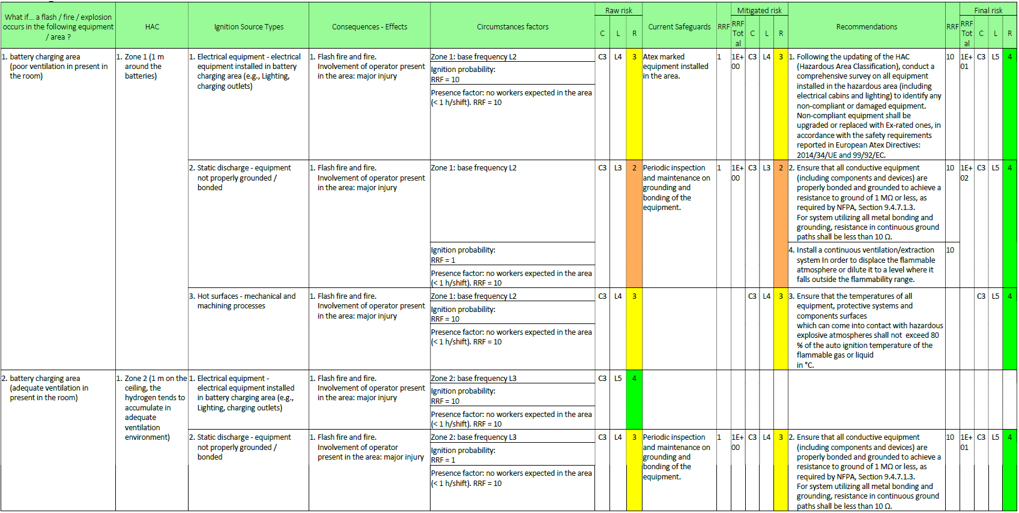

Figure 3: Example of semi-quantitative AtEx risk assessment worksheet

This worksheet exemplifies the output derived from a semi-quantitative ATEX risk assessment methodology, based on the risk matrix (LxC), where L denotes the likelihood and C represents the consequence, as reported in Gritti et al., 2023. The analysis focuses on two scenarios coming from the case study: battery charging in a poorly ventilated environment (Row 1) and in a moderately ventilated environment (Row 2). In the first case, a 1-meter zone is classified around the battery, while in the second case, a Zone 2 is identified in the accumulation area (ceiling). Alongside Hazardous Area Classification (HAC), ignition sources—such as electrical equipment, electrostatic discharge, and hot surfaces—are identified. Circumstantial factors, including personnel presence and ignition probability, are evaluated (typically, to maintain a cautionary approach) set at 1 for hydrogen, though assessed per specific ignition source. The identified zone probabilities serve as the basis for the analysis (Zone 0 = L1, Zone 1 = L2 and Zone 2 = L3). Upon assessing the initial risk ranking, referred to as Raw Risk, the existing barriers are systematically identified. Each safeguard is assigned a risk reduction factor (RRF), which corresponds to the inverse of the Probability of Failure on Demand (PFD). These values are obtained from reliable databases, established standards, and empirical testing performed on the equipment. Where these barriers are deemed inadequate for effective risk mitigation, specific recommendations are proposed to reduce the risk to an acceptable level. The recommendations should be tailored to the specific ignition source under analysis and must be effective in reducing the identified risks to an acceptable level.

* + 1. Mitigation and Action Plan Development

For each scenario where the mitigated risk remains unacceptable, specific corrective actions will be proposed to reduce the risk to an acceptable level. The resulting set of recommendations will serve as the basis for a structured action plan aimed at minimizing explosion hazards. The measures identified through the semi-quantitative AtEx risk assessment can be prioritized based on the mitigated risk level and a cost-benefit evaluation. Upon implementation of the recommended actions—or following significant modifications or incidents—the assessment should be revisited to reassess the updated risk level.

* 1. Conclusions

As outlined in the worksheet presented in Chapter 4, electrostatic discharges pose the most significant ignition hazard in the case study, as any spark can ignite hydrogen, leading to an ignition probability of 1. This highlights the importance of implementing targeted recommendations to mitigate risks such as ventilation, that plays a crucial role in both identifying hazardous areas and serving as a risk reduction measure. The primary goal is to establish a well-calibrated Risk Matrix to ensure consistency in risk evaluation. Achieving an accurate risk assessment requires on-site inspections and qualitative evaluations, as assigning precise numerical values is not practical. Instead, numerical values should indicate the order of magnitude of risk reduction.

Ultimately, the semi-quantitative analysis provides a more structured framework for conducting AtEx risk assessments. Utilizing the Risk Matrix to prioritize recommendations enables direct comparison between the outcomes of the semi-quantitative AtEx assessment and those derived from other semi-quantitative methodologies (e.g., HazOp, HazId). The method currently being employed is still in the developmental phase. In fact, the use of a matrix typically designed for HazOp analyses can sometimes be challenging to apply in the AtEx context. A HazOp study generally involves a greater number of safeguards that can intervene compared to an AtEx study. However, by integrating contingency factors and utilizing HAC zone probability, HazOp-based risk matrices can be systematically applied to semi-quantitative AtEx analysis. This approach facilitates the integration of various assessments into a unified Safety Management System. Consequently, all necessary risk reduction measures can be systematically addressed, fostering a synergistic safety model.

Nomenclature

AtEx – ATmosphères EXplosibles

HAC – Hazardous Area Classification

HazOp – Hazard and Operability analysis

HazId – Hazard Identification analysis

IEC – International Electrotechnical Commission

IRA – Ignition Risk Assessment

nEx – Non Explosion Risk

NFPA – National Fire Protection Association

PCE – Process Control Engineering

PFD – Probability of Failure on Demand

SIL – Safety Integrity Levels

RRF – Risk reduction factor

L – Likelihood

C – Consequence

DHA – Dust Hazard Analysis

References

Center for Chemical Process Safety of the American Institute of Chemical Engineers, 2015, CCPS – Guidelines for initiating events and independent protection layers in layer of protection analysis

Gritti A., Carluccio L.M., Pellegrini L., 2024, Semi-quantitative Dust Hazard Analysis: Advantages and Limitations of Using a Risk Matrix in DHA, Chemical Engineering Transactions, 111, 265-270.

Hydrogen Tools, 2022, www.h2tools.org (last access 12.02.2024).

International Electrotechnical Commission, 2020, IEC 60079-10-1 Explosive atmospheres - Part 10-1: Classification of areas - Explosive gas atmospheres, Geneva, Switzerland.

International Electrotechnical Commission, IEC 61508, Functional safety of electrical/electronic/programmable electronic safety-related systems, Geneva, Switzerland

International Electrotechnical Commission, IEC 61511, Functional safety – Safety instrumented systems for the process industry sector, Geneva, Switzerland

International Electrotechnical Commission, IEC 62485-3, Safety requirements for secondary batteries and battery installations - Part 3: Traction batteries, Geneva, Switzerland

ISO/TR 15916, 2015, Basic considerations for the safety of hydrogen system.

European Committee for Standardization / European Committee for Electrotechnical Standardization, CEN / CENELEC, 2019, EN 1127-1 Explosive atmospheres - Explosion prevention and protection - Part 1: Basic concepts and methodology.

VDI/VDE 2180 Blatt 6, 2013-06, Safeguarding of industrial process plants by means of process control engineering (PCE). Application of functional safety in the context of explosion protection Berlin: Beuth Verlag