|  |  |
| --- | --- |
| cetlogo ***CHEMICAL ENGINEERING TRANSACTIONS***  ***VOL. xxx, 2025*** | A publication of  aidiclogo_grande |
| The Italian Association  of Chemical Engineering  Online at www.cetjournal.it |
| Guest Editors: David Bogle, Flavio Manenti, Piero Salatino  Copyright © 2025, AIDIC Servizi S.r.l. **ISBN** 979-12-81206-21-2; **ISSN** 2283-9216 | |

Carbon-based Composite Materials as Photocatalyst for Photo-Reforming of Organics to Obtain H2

Alberta Gencoa\*, Elisa I. García-Lópezb, Narimene Aouna, Bartolo Megnaa, Conchi O. Aniac , Giuseppe Marcìa

aDepartment of Engineering (DI), Viale delle Scienze, University of Palermo, Palermo, Italy

b Department of Chemistry (STEBICEF) University of Palermo, Italy

c POR2E Group, CEMHTI CNRS (UPR 3079), Université d’Orléans, 45071 Orléans, France

alberta.genco@dottorandi.unipg.it

The photo-reforming of ethanol, glycerol or microplastics (polyethylene terephthalate or polylactic acid) aqueous suspensions of semiconductors have been carried out under UV and natural solar light irradiation to obtain hydrogen. Heterogeneous photocatalysts used in this reaction are pristine Nb2O5 and TiO2 as well as their composites with graphene (G) or graphene oxide (GO). All materials gave rise to hydrogen under both UV and solar radiation and the H2 productivity was found to be higher for the composite materials compared to bare semiconductors and it was further increased in the presence of Pt (1% w/w) used as co-catalyst. Results of H2 productivity show that TiO2 composite photocatalysts are more active than the Nb2O5 ones. The aim of this study is to improve the sustainability of the hydrogen production process by using carbonaceous materials to fabricate heterostructures and identifying the optimal weight ratio between the two constituents. Furthermore, this work aims to study the influence of the type of substrate, used as hole scavenger, in the photo-reforming process for hydrogen production.

The highest performance was achieved under UV light irradiation by using, as photo-catalyst, the composite containing TiO2 and G in a mass ratio of 10:1 w/w, in the presence of Pt and for the photo-reforming of aqueous ethanol solutions. In these conditions, the productivity of H2 was of 311 mmol∙h⁻¹∙g⁻¹ with an apparent quantum efficiency (AQE) of 100% under UV light. Instead, under natural solar irradiation the highest productivity of H2 of 25 mmol∙h⁻¹∙g⁻¹ was reached during the photo-reforming of aqueous glycerol solutions.

* 1. Introduction

Converting solar energy into other energy sources is a promising way of addressing global sustainability challenges. In this context, heterogeneous photocatalysis is a useful method for obtaining hydrogen from biomass derivatives. Heterogeneous photocatalysis is a process in which a redox reaction occurs on the surface of a semiconductor that is irradiated with light of an appropriate wavelength. Excitation of the semiconductors causes electrons to be promoted from the valence band to the conduction band, resulting in the formation of photogenerated pairs (holes in the valence band and electrons in the conduction band) that initiate redox reactions. In the photo-reforming reaction, an organic molecule in an aqueous solution acts as a hole scavenger. It is oxidised, and at the same time, electrons reduce water to produce hydrogen. (García-López et al., 2024).

The current research focuses on the preparation, characterization and use of photocatalysts for photo-reforming of aqueous solutions of organics by using both UV LED and natural solar light as irradiation sources. The photocatalysts are oxide semiconductors (Nb2O5 or TiO2) and their composites with graphene (G) or graphene oxide (GO).

Previous investigations evidenced excellent activity of Nb2O5 in photo-reforming, with results comparable to that obtained in the presence of TiO2, the most used material (Nascimento Nunes et al. 2020). A good strategy for improving the activity of the photo-reforming reaction can be the formation of composites with the semiconductor oxides (Kumar A. et al. 2024) because both TiO2 and Nb2O5 suffer from a rapid recombination of the photogenerated electron/hole couples and they possess low solar-energy utilization, due to the wide band gap of 3.2 eV that limits their excitation under UV radiation, which accounts for only 5% of the solar spectrum reaching the Earth's surface. To enhance the TiO2 and Nb2O5 photo-reforming activity the combination of these semiconductors with carbon materials as graphene (G) or graphene oxide (GO) has been explored. The strategy is addressed for the semiconductor oxide to act as photocatalyst, while G or GO would play the role of electron reservoirs, facilitating the transfer of electrons to the reaction sites by exploiting the remarkable characteristics of graphene such as the large surface area and high carrier mobility that enable it to capture and transfer photoinduced electrons (Yue Z. et al. 2017). GO, obtained from graphite, retains the layered structure of graphene, whereas the interlayer spacing is larger than that in graphite, containing hydroxyl, carbonyl and carboxyl groups absent in graphene.

According to Mills et al. (M. Bowker et al., 2022). alcohols like ethanol or glycerol are the most effective organic hole scavengers for H2 production by photo-reforming, due to the presence of an oxygenated group and a hydrogen atom in the *α*-position. Microplastics as polyethylene terephthalate (PET) or polylactic acid (PLA) have been also tested in this work as hole scavengers in the light of the positive results obtained in the recent literature (Praus 2024). Although these types of substances are more difficult to reform than alcohols, due to both their complex structures and their low water solubility and non-biodegradability, both PLA and PET were chosen due to their widespread occurrence as wastes of environmental concern.

* 1. Preparation and Characterization of photocatalysts. Photo-reforming experiments

The photocatalysts used for the experiments were commercial TiO2 Evonik P25 and Nb2O5 prepared in our laboratory using as a precursor Ammonium Niobium Oxalate (ANbO) (NH4[NbO(C2O4)2]ꞏn H2O) supplied by CBMM (Companhia Brasileira de Metalurgia e Mineração) through a hydrothermal process. Specifically, 1.3 g of ANbO were dissolved in 30 mL of distilled water and placed in a Teflon-sealed autoclave. The autoclave was heated to 175 °C for 3 days, time that was previously determined as the optimum to obtain the best results in terms of photo-reforming for that kind of solid (Genco et al., 2025). Strong differences have been observed by using different Niobium precursors to get Nb2O5 in terms of physico-chemical features and photocatalytic activity (Murayama T. et al, 2014). Composites were prepared with the two oxides and commercial graphene (G) provided by Graphene-XT or graphene oxide (GO) prepared in our laboratory. It was prepared from commercial graphite by a modified Hummer’s method, i.e. 4.68 g of powdered flake graphite (Aldrich, 40 μm) and 2.34 g of NaNO3 were mixed in a 1L flask. The mixture was placed in an ice bath and 105 ml of H2SO4 (98%) was added dropwise under stirring. After 15 minutes, 13.59 g of KMnO4 was added to the suspension in small portions carefully controlling the temperature to prevent overheating beyond 30 °C. After 2 h the mixture became pasty and 215 ml of distilled water was slowly added, maintaining the temperature under 100 °C for ca. 1 h. After cooling the solution, 630 mL of H2O and 13.5 mL of H2O2 (30%) were added to reduce the residual permanganate and MnO2 to colorless soluble MnSO4. The mixture was left at room temperature for 3 days and the obtained material was collected by vacuum filtration, centrifuged, washed with distilled water until natural pH was achieved and dried at 60 °C. The material obtained, labelled as GO, possessed the appearance of black foils.

The composites were obtained by an ultrasonic treatment (59 kHz for 1 h) of a suspension containing the suitable amount of G or GO along with 1 g of the semiconductor oxide in 25 mL of CH3CN. The solid was then separated from the suspension, washed three times with water, and dried at 100 °C overnight (see Scheme 1). The amount of G or GO ranged from 5 to 20 % w/w with respect to the semiconductor oxide. The samples have been labelled as Ti-G 10:X or Nb-G 10:X and Ti-GO 10:X or Nb-GO 10:X, where X (0.5, 1 or 2) stands for the mass of G or GO per 10 g of semiconductor oxide.

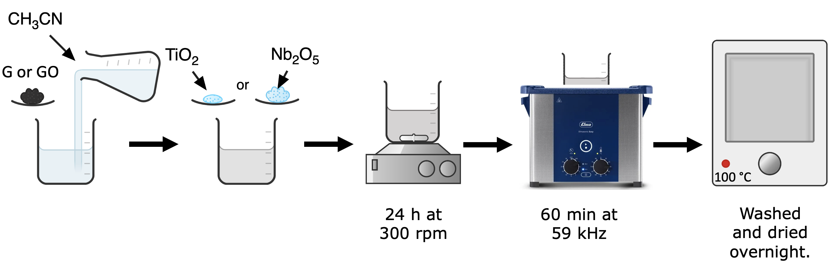

Scheme 1. Steps of composite catalysts preparation.

A chemical-physical characterization of the photocatalysts has been carried out by using several techniques. XRD and specific surface area (SSA) of the samples were measured along with Scanning Electron Microscopy (SEM) and FTIR and Raman, were used to verify the structural features of the solids. FTIR spectra were recorded on KBr pellets of the samples and Raman spectra were registered by using a Renishaw in-via micro-Raman. UV-Vis diffuse reflectance spectroscopy (DRS) was useful to calculate the band gap of the solids. DRS spectra were recorded with BaSO4 as the reference sample. The photoluminescence (PL) of the photocatalysts was studied in the range 200-900 nm using a fluorescence spectrophotometer by exciting the samples with radiation with a wavelength of 200 nm.

Photo-reforming tests were performed by irradiating the solid under UV light in a 50 mL cylindrical Pyrex photoreactor with 35 mL of aqueous suspension of photocatalyst (0.32 g⋅L-1) containing ethanol or glycerol (0.39 M) or PET or PLA. Aqueous suspensions of PET and PLA were prepared by finely grinning PET and PLA, coming from fruit packaging and food containers respectively, into micro-sized particles. Then, 1.7 g of particles were stirred into 50 ml of 3 M KOH keeping the stirring suspension for 3 days until a clear homogenous dispersion was obtained. Illumination was externally provided through both flat sides of the photoreactor by two UV LED IRIS 40 lamps possessing a peak of irradiation centered at 365 nm. The light intensity, measured in the range 315÷400 nm using a UVX Digital radiometer, was 1450 W⋅m⁻². Experiments under natural sunlight were conducted in Palermo between July 2023 and April 2024, using cylindrical Pyrex photoreactor of 125 mL (95 mm in diameter, 18 mm in height), which was irradiated from the top. This reactor was filled with 100 mL of an aqueous ethanol solution (0.39 M) and 0.32 g⋅L⁻¹ of photocatalyst. The photon flux reaching the reactor was recorded in the range 315÷400 nm using the same radiometer mentioned above. To calculate the total energy impinging the system in the range 315-400 nm, measurements were performed every 5 min and multiplying the mean radiation value (in W/m2) in each 5-min interval by the exposed area of ​​the reactor (0.0071 m2) and by the time, the energy value impinging the system for each 5-min interval was obtained. Finally, by summing the various energy contributions reaching the reactor every 5 min, the cumulative photon energy (in Joule) during the reaction time was obtained. Before initiating irradiation, nitrogen gas (N₂) was bubbled through the system for 30 minutes to remove oxygen (O₂) from both the reaction mixture and the reactor headspace. After the deoxygenation step, the reactor was sealed, and irradiation initiated. Both the experiments under UV and sunlight irradiation were carried out in the absence and in the presence of 1% Pt with respect to the mass of catalyst. For that aim 112 μL of aqueous solution of PtCl4 (1 g/L of Pt) was added before the de-oxygenation step. All the experiments were carried out at room temperature.

The Quantum Efficiency (QE) of the reaction is an important parameter to evaluate the performance of a reaction. QE quantifies the number of electrons used to produce hydrogen for each photon absorbed by the photocatalyst over a certain period. Nevertheless, being difficult to measure the amount of photons adsorbed by the solid and hence the QE, a rough estimation of the quantum efficiency can be made by calculating the Apparent Quantum Efficiency (AQE), i.e., the total number of hydrogen molecules produced within a unit of time per 2 (for each H2 molecule 2 electrons are needed) and the total number of photons incident on the catalyst during that time, as reported in Equation (1). The Quantum Efficiency (QE) would certainly be higher than the AQE, as the absorbed photons represent only a fraction of the incident ones.

* 1. Results and discussion

The XRD diffraction pattern of TiO2 shows the presence of anatase and rutile phases, whereas bare Nb2O5 is almost amorphous although it shows some diffractions typical to low-temperature orthorhombic crystal phase. The microstructure of bare Nb2O5 appears as needle-shaped nanostructured material, with needles in the range size 6 to 10 nm, whereas TiO2 is constituted of roundish particles whose size ranged between 25 and 30 nm. The specific surface area of bare Nb2O5 and TiO2 resulted 195 and 45 m2ꞏg-1,respectively (see Table 1). The presence of G or GO in the composites does not influence the crystallinity nor morphology of the samples which was maintained even after the photo-reforming test.

Figure 1 (A) and (B) report the SEM images of the bare photocatalysts, whereas Figure 1 (C) illustrates the FTIR vibrational spectrum of all the solids, both bare and composites, including, for the sake of comparison, the spectrum of the precursor ANbO. The FTIR spectra of all the Nb2O5 based materials showed the characteristic bands between 500 and 900 cm-1. Indeed, niobic acid shows three characteristic bands, at ca. 900 cm-1 assigned to stretching of Nb=O in highly distorted NbO6 octhaedra groups, 655 cm-1 due to the symmetric stretching of the niobia polyhedral, and 510 cm-1, assigned to symmetric Nb–O–Nb stretching in slightly distorted NbO6 octahedra (Pilarek, B. et al. 2017). All the samples containing Nb show the presence of transition bands at 1407, and 1293 cm-1, that can be assigned to the stretching N-H and oxalate vibrations of the niobium precursor, the ammonium niobium oxalate (ANbO), respectively. The composites based on titania evidenced only the cut-off band attributed to the strong transitions Ti-O-Ti of the bulk TiO2. The presence of G and GO is barely evidenced in the FTIR spectra. Conversely, their presence in the composite was proven because they modified the PL emission indicating an enhanced mobility of the photoproduced charge carriers.



Figure 1. SEM images of (A) pristine Nb2O5 prepared by hydrothermal treatment and (B) commercial TiO2; and (C) FTIR of bare and composite photocatalysts.

Figure 2 reports the amount of H2 versus UV irradiation time obtained during the photo-reforming of aqueous solution of (A) ethanol and (B) glycerol. In general, TiO2 based composites were more active than Nb2O5 based ones and better results were obtained with the composites containing a mass ratio 10:1 of semiconductor: G or GO. For this reason, the experiments carried out in the presence of glycerol and microplastics were performed with those materials. The productivity in the absence of Pt is not reported in Figure 2 because the amount of H2 produced was negligible.

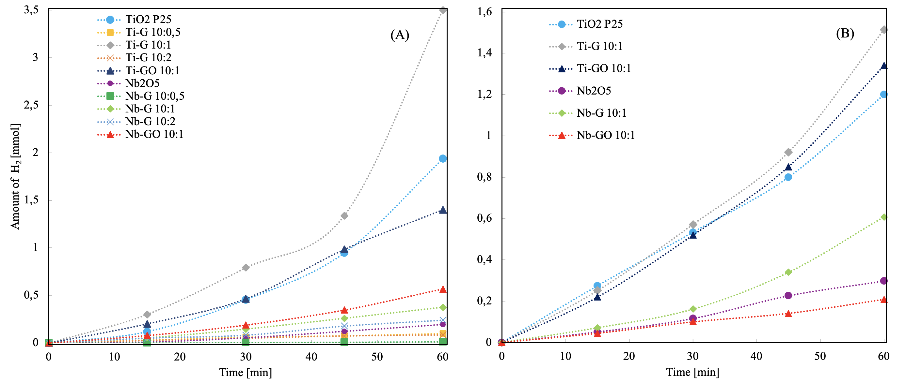

*Figure 2. H2 produced from aqueous solution 0.39 M of (A) ethanol; (B) glycerol versus time of UV irradiation. Amount of photocatalyst 0.32 g/L with 1% Pt w/w.*

TiO2, Ti-G 10:1 and Ti-GO 10:1 were used as photocatalysts for the photo-reforming of PET and PLA aqueous suspensions. The results obtained were significantly lower than those obtained with ethanol or glycerol which can be oxidized more easily due to their simpler structure compared to microplastic which are not soluble in water. Table 1 collect the photo-reforming results along with the specific surface area of all the photocatalysts used. Ti-G 10:1 was the most active material, with a H2 productivity of 1.4 mmol h-1 g-1 that boosted to 311 mmol h-1 g-1 in the presenceof Pt, corresponding to an AQE of 100%. For the glycerol photo-reforming the highest activity was obtained also in this case in the presence of Ti-G 10:1 achieving a productivity of 135 mmol h-1 g-1 (AQE 43%).

Table 1: Specific surface area (SSA), H2 productivity obtained in the photo-reforming of aqueous solution of ethanol and glycerol under UV irradiation with different photocatalysts in the absence or in the presence of Pt along with the Apparent Quantum Efficiency (AQE) in the experiments with Pt.

|  |  |  |  |  |  |  |  |  |
| --- | --- | --- | --- | --- | --- | --- | --- | --- |
| Photocatalyst |  | Ethanol | | | Glycerol | | |  |
|  | SSA  [m2 g-1] | H2  [mmol h-1 g-1] | H2  [mmol h-1 g-1] with Pt | AQE  [%] | H2  [mmol h-1 g-1] | H2  [mmol h-1 g-1] with Pt | AQE  [%] |  |
| Nb2O5 | 195 | 0.15 | 62 | 21 | 1 | 27 | 9 |  |
| Nb-G 10:0.5 | 97 | 0.1 | 1.30 | 0.4 | - | - | - |  |
| Nb-G 10:1 | 170 | 0.45 | 39 | 12 | 1 | 54 | 17 |  |
| Nb-G 10:2 | 88 | 0.26 | 30 | 10 | - | - | - |  |
| Nb-GO 10:1 | 165 | 0 | 51 | 16 | 1 | 19 | 6 |  |
| TiO2 | 45 | 0.1 | 113 | 36 | 3 | 93 | 30 |  |
| Ti-G 10:0.5 | 44 | 0.4 | 11 | 2 | - | - | - |  |
| Ti-G 10:1 | 46 | 1.4 | 311 | 100 | 3 | 135 | 43 |  |
| Ti-G 10:2 | 66 | 1 | 9 | 3 | - | - | - |  |
| Ti-GO 10:1 | 48 | 7 | 130 | 41 | 3 | 120 | 38 |  |

As far as the runs carried out under solar light irradiation are concerned, Figure 3 reports the results obtained during the photo-reforming of aqueous solution of both ethanol and glycerol.

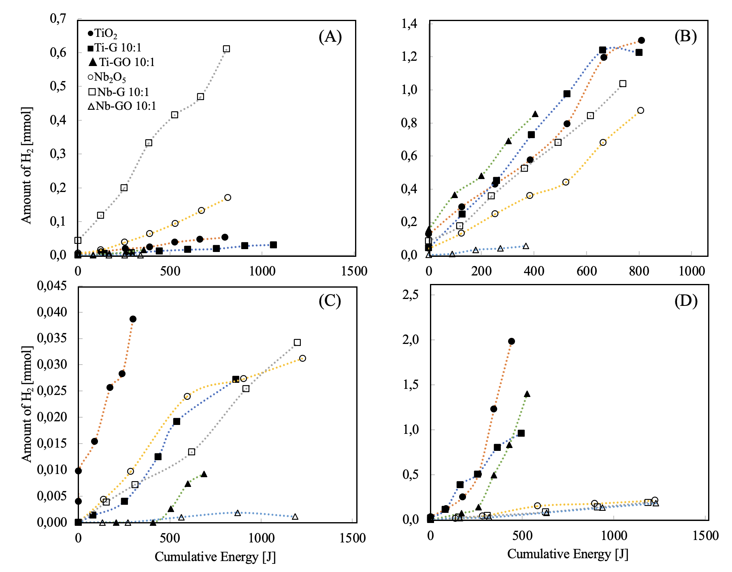

*Figure 3.**Amount of H2 formed versus cumulative energy impinging the photoreactor under natural sunlight irradiation for photo-reforming of aqueous solutions of ethanol (A) in the absence of Pt and (B) in the presence of Pt; and of glycerol (C) in the absence of Pt and (D) in the presence of Pt.*

The results in terms of amount of H2 produced versus the irradiation time evidenced that the activity of the catalysts is very low in the absence of Pt and the difference observed between the various materials are not significant and fall within the experimental error. On the other hand, the activity in the presence of Pt was generally increased indicating that the catalysts based on TiO2 were the most active, particularly in the photo-reforming of aqueous solutions of glycerol.

* 1. Conclusions

Bare Nb2O5 and TiO2 as well as theircomposites with graphene (G) and graphene oxide (GO) have been prepared, physico-chemically characterized and tested as photocatalysts for the photo-reforming of aqueous solutions of ethanol, glycerol and microplastics as polyethylene terephthalate (PET) or polylactic acid (PLA) in the absence and in the presence of Pt as co-catalyst. The photo-reforming was performed both under LED-UV or natural solar irradiation. The TiO2 based composites resulted more active than those based on Nb2O5. Composites with a weight ratio semiconductor: G equal to 10:1 resulted the most active. The composite material with TiO2 and G 10:1 w/w gave rise to the higher productivity for photo-reforming of ethanol, glycerol and microplastics under UV irradiation, achieving a H2 productivity of 311 mmol·h-1 g-1 with an apparent quantum efficiency of 100%, when the ethanol aqueous solution was photo-reformed. On the contrary, under natural solar light irradiation the highest H2 productivity of about 25 mmol·h-1 g-1 was obtained during the photo-reforming of the glycerol aqueous solution.

Acknowledgments

Authors and particularly A.G. acknowledge the University of Perugia, coordinator of the national doctorate in “Photoinduced Processes and Technologies”

References

Bowker M., O’Rourke C., Mills A., 2022, The Role of Metal Nanoparticles in Promoting Photocatalysis by TiO2, Top. Curr. Chem.380, 7.

Genco A., García-López E.I., Megna B., Ania C., Marcì G.,2025, Nb2O5 based photocatalysts for efficient generation of H2 by Photoreforming of aqueous solutions of ethanol, Catal.Today, 447, 11514.

García-López E.I., Palmisano L., Marcì G., 2023, Overview on Photoreforming of Biomass Aqueous Solutions to Generate H2 in the Presence of gC3N4-Based Materials, ChemEng. 7, 11.

Kumar A., Rana S., Dhiman P., Sharma G., Stadler F.J. 2024, Current progress in heterojunctions based on Nb2O5 for photocatalytic water treatment and energy applications, J. Mol. Liq. 399, 124360.

Murayama T., Chen J., Hirata J., Matsumoto K., Ueda W, 2014, Hydrothermal synthesis of octahedra-based layered niobium oxide and its catalytic activity as a solid acid, Catal. Sci. Technol. 4, 4250-4257.

Nascimento Nunes B., Ferreira Lopes O., Patrocinio A.O.T., Bahnemann D.W., 2020, Recent advances in niobium-based materials for photocatalytic solar fuel production, Catalysts 10, 126.

Pilarek, B., Pelczarska, A.J. & Szczygieł, I. 2017, Characterization of niobium(v) oxide received from different sources. J Therm Anal Calorim 130, 77-83.

Praus P. 2024, Photoreforming for microplastics recycling: A critical review, J. Environ, Environ. Chem. Eng. 12, 112525

Yue Z., D. Chu D.,Huang H., Huang J., Yang P., Du Y., Zhu M., Lu C., 2015, A novel heterogeneous hybrid by incorporation of Nb2O5 microspheres and reduced graphene oxide for photocatalytic H2 evolution under visible light irradiation, RSC Adv., 5, 47117-47124