 CHEMICAL ENGINEERING TRANSACTIONS  VOL. xxx, 2025 | A publication of  
The Italian Association
of Chemical Engineering
Online at www.cetjournal.it

Guest Editors: David Bogle, Flavio Manenti, Piero Salatino
Copyright © 2025, AIDIC Servizi S.r.l.
ISBN 979-12-81206-21-2; ISSN 2283-9216

Reuse of Ashes from Digestate Solid Fraction as a catalytic support for the conversion of vegetable oils in Biofuels
D. Mammarella ^{a*}, A. Di Giuliano ª, G. Di Vito Nolfi ^{b}, F. Nespeca ª, K. Gallucci ª, M. Passadoro ª, V. Daniele ª, F. Ferrante ª, P. Campitelli ^{b}, L. Rossi ^{b}
ª Dipartimento di Ingegneria Industriale e dell’Informazione e di Economia, Università degli Studi dell'Aquila, Piazzale E. Pontieri 1., Monteluco di Roio, L'Aquila, 67100, Italia
^{b} Dipartimento di Scienze Fisiche e Chimiche, Università degli studi dell'Aquila, Via Vetoio 42, Coppito, L’Aquila, 67100, Italia
* daniel.mammarella@univaq.it
This experimental preliminary study investigates the reuse of ashes from Solid Fraction of Digestate (SFD) to synthesize catalysts for biofuels synthesis from vegetable oils. The digestate derived from anaerobic digestion of pomace, lees and agrifood waste. SFD pellets were incinerated at 700°C to produce ashes. Ashes were washed with HCl solution and optionally converted into zeolites (alkali fusion method followed by hydrothermal synthesis). These three synthesized supports (ashes, washed ashes, and ash-derived zeolites), were impregnated to produce Ni-Mo supported catalysts. Ni-Mo catalysts were comparatively tested by a laboratory-scale batch reactor, performing DeOxygenation (DO) of commercial rapeseed oil into green diesel (40 bar of H₂ at room temperature and 320°C). The best DO performances were obtained by the Ni-Mo catalysts supported on SFD ashes washed with HCl (80% oil Conversion and 55.1% Diesel Yield). These performances were also associated with a greater specific surface area of Ni-Mo catalysts supported on SFD ashes washed with HCl than the others in this study. Ni-Mo catalyst from SFD can be of interest for developments in the circular-economy approach.
  - Introduction
Anaerobic Digestion (AD) is a biological process that converts putrescible organic matter into biogas (mainly a mixture of CO₂ and CH₄) and a humid solid residue named digestate (Ward et al., 2008). Around 180 million tonnes of digestate per year are produced in the EU28 (Saveyn & Eder, 2014).
In view of new production chains fed with biomass and waste (i.e., the concept of biorefinery), the integration of AD with other unitary processes must be pursued to create virtuous cascades in the circular economy sense (Macarthur, 2017). The digestate may be better exploited before its return to the biosphere, e.g., the Solid Fraction of Digestate (SFD) may be used as a solid fuel for thermochemical processes, such as incineration (to produce heat and power from flue gases (Gao et al., 2020; Mammarella et al., 2024)) or gasification (to produce syngas, a mixture of mainly H₂ and CO, valuable as a gaseous fuel or feedstock (Freda et al., 2019)).
In both those thermochemical processes, ashes form as the main solid by-product, which must also be circularly managed. Ashes may contain heavy metals, metal oxides, and mineral salts, whose composition strongly depends on the feedstock and influences the ashes disposal strategy (Mammarella et al., 2024).
Incineration is widely used in Europe for waste and biomass treatment (Levaggi et al., 2020). It consists of the total oxidation of the feedstock, usually at a temperature above 500°C (Zając et al., 2019), to produce heat and power from flue gases (Gao et al., 2020). In Europe, the incinerated waste amount has grown by 117%, from 32 Mt in 1995 to 70 Mt in 2018, in turn increasing ash production (Levaggi et al., 2020).
Gasification is also used to treat biomass (IEA Bioenergy) and waste: the production of valuable syngas involves the formation of high quantity of ash (Gao et al., 2020). Worldwide, annual production of biomass ash due to gasification is growing fast (almost 500 million tons/year) (Guo et al., 2023).
As to agricultural waste, the related ash production in Europe is about 0.75 Mt/y; this kind of ash generally has significant amounts of potassium, calcium, silicon and aluminum (Mammarella et al., 2024).
The reuse of these ashes to synthesize zeolites is an interesting possibility (Ju et al., 2021), thanks to Si and Al contents (Fukasawa et al., 2017). Zeolites are materials of interest for industrial applications, e.g., as adsorbents and catalytic supports (Ferella et al., 2017). The general reuse of ashes as catalysts or catalytic support is documented in the literature for methane reforming (Wang and Lu, 2007) and biodiesel production by oils (Odude et al., 2019).
Based on these premises, this work presents a preliminary study on the unprecedented reuse of SFD ashes as catalytic support for the DeOxygenation (DO) of vegetable oils in green diesel, according to a circular economy model (Mammarella et al., 2024). DO is a hydroprocessing of oils that leads to the conversion of fatty acids in their triglycerides mainly into normal alkanes (Kumar et al., 2010), which are known overall as green diesel. The main DO reactions are: decarbonylation (DCO), decarboxylation (DCO₂), and hydrodeoxygenation (HDO). DO is usually carried out by a heterogeneous solid catalyst; e.g., the synergistic effect of Ni and Mo with a solid acid support improved conversion from triglycerides to hydrocarbons through DCO, DCO₂ and HDO reactions (Ameen et al., 2017; Lucantonio et al., 2023). Works concerning DO are comprehensively referred to in the recent review by Lucantonio et al., where a comparative analysis of several experimental studies and industrial cases has been reported(Lucantonio et al., 2023).
In this work, the possibility of exploiting SFD to produce effective DO catalysts was explored. Several original Ni-Mo catalysts, derived from SFD ashes, were purposely synthesized, characterized, and tested for the first time for the DO of rapeseed oil in a batch reactor at a laboratory scale. Quantification of DO performances in terms of oil Conversion and Diesel Yield allowed selecting the most promising SFD-derived catalysts.
  - Materials and methods
    - Catalysts synthesis
SFD pellets were produced by BARTIN Distillery (Italy) with digestate from AD of pomace, lees, and waste from the agrifood supply chain.
Ash from SFD (ASFD) was produced at 700°C by air calcination of SFD pellets in a muffle furnace. To increase the content of Si and Al, ASFD underwent acid washing: (i) acid extraction was carried out by treating 30 g of SFD ash in 500 cm³ of HCl 5 M for 5 h; (ii) the resulting suspension was filtered, washed with distilled water near pH 7 and dried at 105 °C for 4 h (Joseph et al., 2019). The resulting solid was named AWSFD.
AWSFD was used for the synthesis of zeolites (named ZSFD), by the alkali fusion followed by hydrothermal treatment: (i) AWSFD was ground by mortar and pestle with 1.2 parts (by mass) of NaOH and treated at 550°C in air for 1 h in a muffle furnace; (ii) the resulting solid was mixed with deionized water (1:10 mass ratio) and transferred to a Teflon-coated reactor for aging at room temperature for 24 h; (iii) after aging, the reactor was placed in a stainless-steel vessel for hydrothermal treatment (120°C for 24 h); (iv) the solid was filtered, washed with deionized water up to pH 8, dried at 105 °C and finely ground (Ferella et al., 2017; Küçük et al., 2023).
ASFD, AWSFD, and ZSFD became the catalytic supports for this study. They underwent conventional wet impregnation (Sietsma et al., 2006) in water (preferred as a green solvent), to obtain DO catalysts with final contents of 5 %wt NiO and 15 %wt MoO₃: (i) Ni(NO₃)₂·6H₂O e (NH₄)₆Mo₇O₂₄·4H₂O precursor salts were solubilized in 5 ml of distilled water ; (ii) the support (ASFD, AWSFD or ZSFD) was added after their solubilization and kept there for 3 h; (iii) the suspension was first dried in a rotavapor and then for 24 h at 105°C in an oven; (iv) the solids were calcined at 400°C for 4 h (heating rate 5°C/min), to obtain three DO catalysts Ni-Mo/ASFD, Ni-Mo/AWSFD and Ni-Mo/ZSFD.
    - Materials characterizations
The moisture and ash content of SFD pellets were quantified according to UNI EN 18134 and UNI EN ISO 18122, respectively. The ultimate analysis of SFD and ASFD was performed through CHNS Perkin Elmer Series II 2400 in order to quantify carbon, hydrogen, nitrogen, and sulphur, according to ISO 16948. The elemental composition of ASFD and AWSFD was determined by X-ray fluorescence (XRF, Spectro Xepos). Crystalline phases in ASFD, and ZSFD were identified by X-ray diffraction (XRD, PANalytical X'Pert PRO) using radiation CuKα (λ = 0,154 nm) with Ni filter.
All three synthesized catalysts (Ni-Mo/ASFD, Ni-Mo/AWSFD and Ni-Mo/ZSFD) were characterized by:
- N₂ adsorption/desorption to quantify specific surface area by Brunauer-Emmett-Teller (BET) method (Physisorption Analyzer NOVA 800 Anton Paar). Before N₂ treatment, each sample was outgassed for 16 h at 150°C.
- Inductively coupled plasma optical emission spectroscopy (ICP-OES, Agilent Technologies 5100) to quantify the elemental amount of Ni and Mo in the synthesized catalysts.
    - Batch reactor catalytic activity tests
Catalyst pre-reductions and DO catalytic activity tests were conducted in a rig consisting of a 100ml Parr batch reactor (4590 Micro Bench Top Reactor, Magnetic drives, and 4848 Controller), fillable with H₂ (grade 5.0) and or N₂ (grade 5.0) from pressurized bottles.
The catalyst was pre-reduced at 320°C for 4 h, under H₂ (60 bar at room temperature in the reactor volume).
The DO catalytic activity tests were prepared by loading the reactor with about 0.2 g of reduced catalyst, 2 g of rapeseed oil (g_{Oil}) and hexane (oil-solvent mass ratio 1:10), blanketing with N₂ and then refilling with H₂ (40 bar at room temperature in the reactor volume). The DO tests were carried out at 320°C for 6 h and stirred at 600 rpm. At the end of each test, the final Organic Liquid Product (OLP) was separated from the catalysts by filtration and weighed (g_{OLP}).
OLP was processed by transesterification (according to standard procedure AOAC (Association of Official Agricultural Chemists) 969.33) to convert the unreacted rapeseed oil into FAME (Fatty Acid Methyl Esters), then analyzed by a Gas Chromatograph with Flame Ionization Detector (GC-FID). The GC-FID used is an Agilent Technologies 7820A GC System equipped with a non-polar HP-5 19091J-413 Capillary column (30 m x 0,32 mm x 0,25 μm, stationary phase = (5%-phenyl) methylpolysiloxane) capable of effectively separating hydrocarbons in the OLP. The chromatographic run lasted 35 minutes, during which the column was initially kept at 50°C for 5 min, then heated to 280°C (10°C/min), and finally kept at 280°C for 7 min. The eluent gas was H₂ at 2 ml/min; the injector was at 250°C and FID at 300°C. Through the comparison with a standard solution of saturated linear alkanes C₇-C₄₀, it was possible to classify and estimate the composition through area percentages of the peaks corresponding specific hydrocarbons and FAME (Area%_{i}) in the OLP and obtain the Conversion of Triglycerides (X) (Eq(1)) and Diesel Yield (DY) (hydrocarbons C₁₅-C₁₈ yield) (Eq(2)).

$$X=Conversion of Triglycerides (\%)=\left[1-\left(\frac{{{Area\%}_{FAME }}/{100} ∙g_{OLP}}{g_{Oil}}\right)\right]∙100$$ | (1)
$$DY= Diesel Yield (\%)=\left(\frac{{{Area\%}_{C_{15}-C_{18}}}/{100} ∙g_{OLP}}{g_{Oil}}\right)∙100$$ | (2)
  - Results
SFD pellets had an ash content on a dry basis of 32.8 wt%, relatively high if compared to lignocellulosic biomasses (typically with ash content on a dry basis below 15 wt% (Mu et al., 2024)).
Table 1 shows the ultimate analysis of SFD pellets and ASFD: the calcination treatment of SFD pellets was carried out effectively since a decrease in carbon content was found, from 34.3 wt% down to 0.5 wt%, i.e., all carbon was combusted.

Table 1: Ultimate analysis of SFD and ASFD
 | C | H | N | S
SFD (wt%) | 33.5 | 4.4 | 4.7 | 1.1
ASFD (wt%) | 0.5 | 0.2 | 0.0 | 0.7

Table 2 shows that the washing process of ASFD into AWSFD led to a very significant removal of Mg, Ca, Fe, Na, and P; a slight decrease in Al and a significant increase in the fraction of Si (from 6.84 to 36.48 wt%) determined an important increase of the Si/Al ratio, a key-parameter for zeolite synthesis (Bukhari et al., 2015). These results are comparable with the literature (Joseph et al., 2019).
Table 2: XRF results of ASFD and AWSFD
 | Si | Al | K | Mg | Ca | Fe | Na | P
ASFD (wt%) | 6.8 | 1.9 | 1.7 | 1.3 | 15.3 | 2.8 | 2.5 | 6.1
AWSFD (wt%) | 36.5 | 1.5 | 1.6 | 0.0 | 0.6 | 0.4 | 0.0 | 0.1

Figure 1 compares the diffractograms of ASFD and ZSFD: different crystalline phases appeared in ASFD, demonstrating the heterogeneity of ash (Figure 1(a)); noteworthy, the zeolitization was successful, as confirmed by analcime phase in ZSFD (Figure 1(b)), a zeolite used as catalyst or catalytic support (Gan et al., 2024; Kochaniec et al., 2024). In the ZSFD sample (Figure 1(b)), two other crystalline phases appeared, ascribable to calcium sodium aluminosilicates and a phase of SiO₂, attributed to the excess of Si in the sample (Table 2).

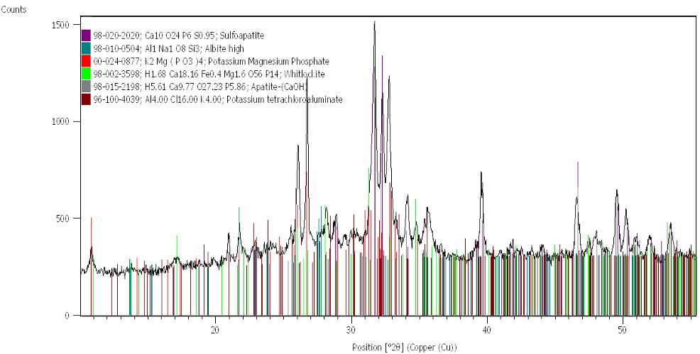
(a)
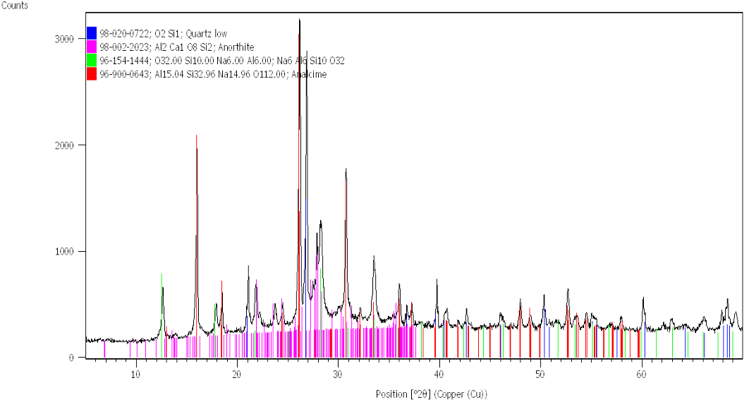
(b)
Figure 1: XRD patterns of ASFD (a) and ZSFD (b)
As to synthesized Ni-Mo catalysts, Table 3 shows the amount of active phases, rescaled as NiO and MoO₃: the impregnation was successful, as experimental amounts were in line with the desired nominal values (5 %wt NiO, 15 %wt MoO₃).
Table 3: ICP-OES results: elemental percentage of NiO and MoO₃ in the DO catalysts
Material |  | Ni-Mo/ASFD | Ni-Mo/AWSFD | Ni-Mo/ZSFD
NiO amount | (wt%) | 4.3 | 3.9 | 4.7
MoO₃ amount | (wt%) | 14.2 | 12.6 | 15.8

Table 4 shows the specific surface area of catalysts, according to the BET method (S_{BET}): the catalyst supported by SFD ash (Ni-Mo/ASFD) had the lowest S_{BET} (24 m²/g), comparable with the ash-supported catalysts from literature (Miladinović et al., 2020); the washed ash-based catalyst (Ni-Mo/AWSFD) had the highest S_{BET} (67 m²/g) outcome ascribable to the acid washing (Joseph et al., 2019); the catalyst supported with ash-zeolites showed an S_{BET} (35 m²/g) mainly relatable to the features of the analcime phase (Figure 1(b)) documented to have S_{BET} of approximately 20 m²/g (Park et al., 2012).
Table 4: Specific surface areas by BET method
Material |  | Ni-Mo/ASFD | Ni-Mo/AWSFD | Ni-Mo/ZSFD
S_{BET} | (m² g⁻¹) | 24 | 67 | 35

Table 5 summarizes the experimental catalytic DO performances: Ni-Mo/AWSFD was the catalyst with the best X (Eq(1)) and DY (Eq(2)) of 79.5% and 55.1%, respectively, with a C₁₅-C₁₈ composition of 64.9 wt%. On the basis of presented characterizations, better performances of Ni-Mo/AWSFD – when compared to the other two investigated catalysts – were attributed to the higher S_{BET}, in agreement with the literature (Horáček et al., 2014; Wang et al., 2013); this may suggest that a better accessibility to active phases was ensured by Ni-Mo/AWSFD, considering that it had the lowest actual content of active phases (Table 3). Ni-Mo/ZASFD has slightly higher DY and X compared to Ni-Mo/ASFD; however, both of them have FAME content greater than 50 wt%, vs. the 24.0 wt% of FAME with Ni-Mo/AWSFD. Despite having an X lower than that of commercial catalysts studied in the literature (e.g., the Ni/Alumina commercial and Ni-Mo/Alumina catalysts, which in experimental conditions similar to those studied show an X between approximately 80-100% (Lucantonio et al., 2023), the most active catalyst of this work (Ni-Mo/AWSFD) traces an interesting perspective for future studies, concerning circular catalyst development from waste material.
Table 5: OLP composition (Alkanes with C number <C₁₄, between C₁₅-C₁₈, >C₁₉; FAME, i.e., unconverted fatty acids; OTHER compounds; unsaturated (UNS) and branched (BRA) hydrocarbons), Diesel Yield (DY) and Conversion (X)
Sample | <C₁₄  (wt%) | C₁₅-C₁₈  (wt%) | >C₁₉  (wt%) | BRA  (wt%) | UNS  (wt%) | FAME  (wt%) | OTHER  (wt%) | DY  (%) | X  (%)
Ni-Mo/ASFD | 1.4 | 14.8 | 1.9 | 1.4 | 23.4 | 56.5 | 0.6 | 14.3 | 44.7
Ni-Mo/AWSFD | 2.7 | 64.9 | 2.3 | 2.7 | 3.4 | 24.0 | 0.0 | 55.1 | 79.5
Ni-Mo/ZSFD | 2.3 | 18.2 | 0.0 | 0.0 | 26.4 | 50.8 | 2.3 | 17.3 | 51.7
  - Conclusions
In this explorative work, the reuse of SFD ash was studied for the synthesis of three Ni-Mo impregnated catalysts, tested for the DO reaction of rapeseed oil for green diesel production. XRF showed the increase in the Si/Al ratio after the acid washing of ashes, fundamental for zeolites synthesis; XRD patterns of the ZSFD confirmed zeolitic phase formation (analcime). Experimental DO results proved that the Ni-Mo/AWSFD catalyst was the best one in terms of DO Diesel Yield (55.1%) and Conversion (79.5%); this result was explained by the higher specific surface area of the catalyst, compared to those of Ni-Mo/ASFD and Ni-Mo/ZSFD. Therefore, AWSFD proved to be the best support, which would lead to avoiding a zeolite synthesis step. As a catalyst circularly produced from by-products, Ni-Mo/AWSFD has interesting perspectives for future studies varying the concentration of the active phase, adding possible promoters, and testing the support with other active phases with the aim of refining and improving the catalytic properties.
Acknowledgments
This work has been funded by Italian Project PERCIVAL (ARS01_00869, (Processi di EstRazione di bioprodotti da sCarti agroIndustriali e VALorizzazione in cascata), funded by PNR 2015-2020 Italian program).
References
Ameen, M., Azizan, M. T., Yusup, S., & Ramli, A. (2017). Hydroprocessing of rubber seed oil over Ni-Mo/γ-Al2O3 for the green diesel production. Chemical Engineering Transactions, 61, 1843–1848.
Bukhari, S. S., Behin, J., Kazemian, H., & Rohani, S. (2015). Conversion of coal fly ash to zeolite utilizing microwave and ultrasound energies: A review. Fuel, 140, 250–266.
Ferella, F., Puca, A., Taglieri, G., Rossi, L., & Gallucci, K. (2017). Separation of carbon dioxide for biogas upgrading to biomethane. Journal of Cleaner Production, 164, 1205–1218.
Freda, C., Nanna, F., Villone, A., Barisano, D., Brandani, S., & Cornacchia, G. (2019). Air gasification of digestate and its co-gasification with residual biomass in a pilot scale rotary kiln. International Journal of Energy and Environmental Engineering, 10(3), 335–346.
Fukasawa, T., Horigome, A., Tsu, T., Karisma, A. D., Maeda, N., Huang, A.-N., & Fukui, K. (2017). Utilization of incineration fly ash from biomass power plants for zeolite synthesis from coal fly ash by hydrothermal treatment. Fuel Processing Technology, 167, 92–98.
Gan, H., Wang, B., Ren, W., Chang, L., Bao, W., Huang, Z., Han, L., & Wang, J. (2024). Synthesis of Cu-SSZ-13 from zeolite analcime derived from solid waste and natural minerals for selective catalytic reduction of NO. Journal of Solid State Chemistry, 337, 124782.
Gao, N., Kamran, K., Quan, C., & Williams, P. T. (2020). Thermochemical conversion of sewage sludge: A critical review. In Progress in Energy and Combustion Science (Vol. 79). Elsevier Ltd.
Guo, Q., Yan, B., Hu, Y., Guo, X., Wu, W., Cheng, Z., Chen, G., & Hou, L. (2023). A novel reutilization of ash from biomass gasification process: Feasibility and products improvement analysis. Fuel, 339, 127386.
Horáček, J., Tišler, Z., Rubáš, V., & Kubička, D. (2014). HDO catalysts for triglycerides conversion into pyrolysis and isomerization feedstock. Fuel, 121, 57–64.
IEA, <task33.ieabioenergy.com/database/> accessed on the 10.02.2025
Joseph, I. V., Roncaglia, G., Tosheva, L., & Doyle, A. M. (2019). Waste peat ash mineralogy and transformation to microporous zeolites. Fuel Processing Technology, 194, 106124.
Ju, T., Meng, Y., Han, S., Lin, L., & Jiang, J. (2021). On the state of the art of crystalline structure reconstruction of coal fly ash: A focus on zeolites. Chemosphere, 283, 131010.
Kochaniec, M. K., Grabias-Blicharz, E., & Franus, W. (2024). Hydrothermal Conversion of Fly Ash into Monomineralic Zeolite Synthesis for Biodiesel Production. Environmental and Climate Technologies, 28(1), 94–106.
Küçük, M. E., Makarava, I., Kinnarinen, T., & Häkkinen, A. (2023). Simultaneous adsorption of Cu(II), Zn(II), Cd(II) and Pb(II) from synthetic wastewater using NaP and LTA zeolites prepared from biomass fly ash. Heliyon, 9(10), e20253.
Kumar, R., Rana, B. S., Tiwari, R., Verma, D., Kumar, R., Joshi, R. K., Garg, M. O., & Sinha, A. K. (2010). Hydroprocessing of jatropha oil and its mixtures with gas oil. Green Chemistry, 12(12), 2232.
Levaggi, L., Levaggi, R., Marchiori, C., & Trecroci, C. (2020). Waste-to-Energy in the EU: The Effects of Plant Ownership, Waste Mobility, and Decentralization on Environmental Outcomes and Welfare. Sustainability, 12(14), 5743.
Lucantonio, S., Di Giuliano, A., Rossi, L., & Gallucci, K. (2023). Green Diesel Production via Deoxygenation Process: A Review. Energies, 16(2), 844.
Macarthur, E. (2017). What is a Circular Economy? | Ellen MacArthur Foundation. In Ellen Macarthur Foundation.
Mammarella, D., Di Giuliano, A., & Gallucci, K. (2024). Reuse and Valorization of Solid Digestate Ashes from Biogas Production. Energies, 17(3), 751.
Miladinović, M. R., Zdujić, M. V., Veljović, D. N., Krstić, J. B., Banković-Ilić, I. B., Veljković, V. B., & Stamenković, O. S. (2020). Valorization of walnut shell ash as a catalyst for biodiesel production. Renewable Energy, 147, 1033–1043.
Mu, Q., Aleem, R. D., Liu, C., Elendu, C. C., Cao, C., & Duan, P.-G. (2024). Oxygen blown steam gasification of different kinds of lignocellulosic biomass for the production of hydrogen-rich syngas. Renewable Energy, 232, 121132.
Odude, V. O., Adesina, A. J., Oyetunde, O. O., Adeyemi, O. O., Ishola, N. B., Etim, A. O., & Betiku, E. (2019). Application of Agricultural Waste-Based Catalysts to Transesterification of Esterified Palm Kernel Oil into Biodiesel: A Case of Banana Fruit Peel Versus Cocoa Pod Husk. Waste and Biomass Valorization, 10(4), 877–888.
Park, S. H., Chung, C. B., & Seo, G. (2012). Preparation of small analcime particles with narrow size distributions from acid-treated larger analcime particles. Microporous and Mesoporous Materials, 155, 201–207.
Saveyn, H.; Eder, P. End-of-waste criteria for biodegradable waste subjected to biological treatment (compost & digestate): Technical proposals.
Sietsma, J. R. A., Jos van Dillen, A., de Jongh, P. E., & de Jong, K. P. (2006). Application of ordered mesoporous materials as model supports to study catalyst preparation by impregnation and drying (pp. 95–102).
Wang, H., Yan, S., Salley, S. O., & Simon Ng, K. Y. (2013). Support effects on hydrotreating of soybean oil over NiMo carbide catalyst. Fuel, 111, 81–87.
Wang, S., & Lu, G. Q. (2007). Effect of chemical treatment on ni/fly-ash catalysts in methane reforming with carbon dioxide (pp. 275–280).
Ward, A. J., Hobbs, P. J., Holliman, P. J., & Jones, D. L. (2008). Optimisation of the anaerobic digestion of agricultural resources. Bioresource Technology, 99(17), 7928–7940.
Zając, G., Szyszlak-Bargłowicz, J., & Szczepanik, M. (2019). Influence of Biomass Incineration Temperature on the Content of Selected Heavy Metals in the Ash Used for Fertilizing Purposes. Applied Sciences, 9(9), 1790.

