|  |  |
| --- | --- |
| cetlogo ***CHEMICAL ENGINEERING TRANSACTIONS***  ***VOL. xxx, 2025*** | A publication of  aidiclogo_grande |
| The Italian Association  of Chemical Engineering  Online at www.cetjournal.it |
| Guest Editors: David Bogle, Flavio Manenti, Piero Salatino  Copyright © 2025, AIDIC Servizi S.r.l. **ISBN** 979-12-81206-21-2; **ISSN** 2283-9216 | |

Exergoeconomic Analysis and Multi-objective Optimization of Biodiesel Production from Waste Cooking Oil Using Genetic Algorithm

José A. Siguenza-Poloa, Karla V. Ajoy-Rendóna, Medelyne B. Mero-Benavidesa, Kelly K. Beltrán-Borbor a, Andrea F. Barcia-Quimia, Diana L. Tinoco-Caicedoa,b,\*

aESPOL Polytechnic University, Escuela Superior Politécnica del Litoral, Facultad de Ciencias Naturales y Matemáticas (FCNM), Campus Gustavo Galindo Km 30.5 Vía Perimetral, P.O. Box 09-01-5863, Guayaquil, Ecuador

bESPOL Polytechnic University, Escuela Superior Politécnica del Litoral, Centro de Energías Renovables y Alternativas (CERA), Campus Gustavo Galindo Km 30.5 Vía Perimetral, P.O. Box 09-01-5863, Guayaquil, Ecuador

dtinoco@espol.edu.ec

The growing global energy demand has increased interest in biodiesel from renewable feedstocks. However, large-scale biodiesel production requires assessment of energy losses and operating costs. This study performed a multi-objective optimization using the NSGA-II algorithm from Platypus in Python. The goal was to minimize exergy destruction cost and maximize yield and exergy efficiency of a batch transesterification process using waste cooking oil (WCO). An exergoeconomic analysis was conducted to evaluate the financial implications of energy degradation. A sensitivity analysis evaluated the effects of temperature, time, and reactant concentrations in the process. From the set of optimal solutions, the one maximizing yield was selected for analysis. The corresponding conditions were 60 °C, 118 min, 10:1 molar ratio, and 1.5 % NaOH. These settings reduced exergy destruction cost to $0.0245/kg and improved exergy efficiency to 20.55 %. A reaction yield of 99.10 % was achieved under optimized conditions. However, the variability in WCO composition poses a significant limitation by affecting both yield and fuel quality. Future work should explore pretreatment strategies to enhance reaction efficiency and mitigate feedstock variability. Furthermore, advanced exergoeconomic and exergoenvironmental analyses are recommended to improve its industrial applicability and sustainability.

* 1. Introduction

Biodiesel is a sustainable, low-carbon energy system widely used in the industrial sector due to its reduced emissions, non-toxicity, biodegradability, and compatibility with diesel engines (Soly Peter et al., 2021). Fats or oils derived from edible and nonedible sources react with alcohol in the presence of a catalyst via transesterification (Mohiddin et al., 2021). Waste cooking oil (WCO) has emerged as a cost-effective and sustainable second-generation feedstock, reducing production costs by 70–85 % while addressing disposal issues (Babadi et al., 2022). Studies have shown that transesterification yield is influenced by several key variables, including temperature, alcohol-to-oil molar ratio, reaction time, stirring speed, and catalyst concentration. Furthermore, the effect of these variables on process performance is often nonlinear and subject to complex two-factor interactions (Costa et al., 2019). For example, increasing the reaction temperature may enhance the reaction rate, but it can also require higher catalyst dosages and longer reaction times to maintain conversion efficiency, thereby increasing energy consumption. Consequently, identifying optimal conditions experimentally might be time-consuming and resource-intensive, highlighting the need for computational optimization.

Genetic algorithms (GAs) have gained prominence for optimizing transesterification processes, offering a robust approach for handling complex, multi-objective functions. Several studies have employed GAs to optimize biodiesel yield, energy efficiency, and cost reduction. For instance, Khan et al. (2022) optimized biodiesel production from microalgae oil, achieving a 97.3 % yield, while Singh et al. (2022) used supercritical methanol to obtain a 95.67 % yield. Other studies have focused on economic and environmental optimization (Gonçalves et al., 2020). However, there is a lack of exergoeconomic optimization aimed at improving the sustainability of large-scale WCO conversion.

Exergy-based methods assess energy system performance by quantifying irreversibilities, while exergoeconomic analysis integrates thermodynamic and economic evaluations to determine the cost of inefficiencies. Aghbashlo et al. (2018) optimized an ultrasound-assisted biodiesel production system using WCO, minimizing product cost per exergy unit. Despite these advancements, no studies have applied exergoeconomic optimization to enhance WCO-based transesterification in large-scale batch processes.

To bridge this gap, this study conducts a multi-objective exergoeconomic optimization to minimize exergy destruction costs and maximize exergy efficiency and reaction yield. Exergy and exergoeconomic analyses are combined with a genetic algorithm to optimize batch reactor conditions. The findings provide valuable insights for the design and optimization of biodiesel biorefineries utilizing WCO.

* 1. Materials and methods

The base case conditions reported by Barcia-Quimi et al. (2023) were 45 °C for temperature, 30 min of reaction time, 1.5 % catalyst concentration, and a methanol-to-oil molar ratio of 3:1. These values were used as the reference scenario to define the lower bounds of the decision variables in the multi-objective optimization model.

* + 1. System description

Figure 1 illustrates the biodiesel production process from WCO. Air (stream 1) and natural gas (stream 2) enter the combustion chamber (CC-101), where a combustion reaction generates high-temperature gases (stream 3). These gases, along with water (stream 5), enter boiler B-101 to produce steam (stream 6), while low-temperature exhaust gases exit as stream 4. The steam is then supplied to the heating jacket of reactor R-101 to maintain a reaction temperature of 60 °C. Methanol (stream 7), sodium hydroxide (stream 8), and WCO (stream 9) are fed into reactor R-101 as the reactant, catalyst, and feedstock, respectively, for the transesterification reaction. At the reactor outlet, three product streams are obtained: crude glycerol (stream 10), biodiesel (stream 11), and excess methanol with catalyst (stream 12).



Figure 1. Process flow diagram of biodiesel production from WCO

The boiler and reactor jacket efficiencies were set at 90%, consistent with values reported by UNEN-EN 12952-15:2004 for water-tube boilers and auxiliary installations. The burner was assumed to have no heat losses based on stoichiometric combustion of natural gas under idealized conditions. The batch reactor was modeled with a phase separation unit and a stirrer, while the specific heat of biodiesel was set at 521.55 J/mol. Additionally, the cost of air and WCO was assumed to be $0/h. The transesterification kinetics were based on the model developed by Barcia-Quimi et al. (2023), which involved WCO as feedstock under similar operating conditions.

* + 1. Exergoeconomic model

The exergy balance equations for each system component follow standard formulations from Bejan et al. (1996). The physical $(e_{i}^{PH})$ and chemical exergy ($e_{i}^{CH}$) of the material streams were calculated using Eq (1) and Eq (2), respectively.

|  |  |
| --- | --- |
| $$e_{i}^{PH}=h_{i}-h_{o}-T_{o}\left(s_{i}-s_{o}\right)$$ | (1) |
| $$e_{i}^{CH}=\sum{x_{i}e_{i}^{°ch}}+RT_{o}\sum{x_{i}\ln\left(x_{i}\right)}$$ | (2) |

Where $h_{i}$ and $s_{i}$ are the specific enthalpy and entropy of stream i, while $h_{o}$ and $s_{o}$ refer to the environmental reference state (25 °C, 1 atm). $T_{o}$ is the temperature of the dead state. In Eq (2), $x_{i}$ and $e_{i}^{°ch}$ denote the molar composition and standard chemical exergy of each compound in stream i. The logarithmic term accounts for mixing effects. The chemical exergy of WCO, biodiesel, and glycerin was calculated using the unified correlation for estimating the specific chemical exergy of organic matter, as proposed by Song et al. (2012). The exergy efficiency for each process component was calculated using Eq (3):

|  |  |
| --- | --- |
| $$η_{e}=\left(\frac{{\dot{E}}_{P,k}}{{\dot{E}}_{F,k}}\right)∙100$$ | (3) |

where ${\dot{E}}_{F,k}$ represents the fuel exergy and ${\dot{E}}_{P,k}$ denotes the product exergy.

The exergoeconomic analysis integrates exergy and economic principles to assess cost distribution within the system. The Total Revenue Requirement (TRR) methodology was applied to evaluate operational and investment costs. The purchase equipment cost (PEC) for each process component was obtained from vendors based on required specifications, and these values are presented in the results section. The costs of methanol, sodium hydroxide, and natural gas were $1.15/kg, $1.64/kg, and $0.11/kg, respectively. The economic parameters used in the analysis were obtained from Bejan et al. (1996).

The total cost rate for operation and investment ${(\dot{Z}}_{k})$ was determined using Eq (4):

|  |  |
| --- | --- |
| $${\dot{Z}}_{k}={\dot{Z}}_{k}^{O\&M}+{\dot{Z}}_{k}^{CI}$$ | (4) |

where ${\dot{Z}}_{k}^{CI}$ is the capital investment cost rate and ${\dot{Z}}_{k}^{O\&M}$ is the operation and maintenance cost rate of the k-th component.

A cost balance was applied to each system component, as expressed in Eq (5):

|  |  |
| --- | --- |
| $${\dot{C}}_{F, k}+{\dot{Z}}_{k}={\dot{C}}_{P, k}$$ | (5) |

where ${\dot{C}}_{F, k}$ and ${\dot{C}}_{P, k}$ are the fuel and the product cost rates of the k-th component, respectively.

The cost associated with exergy destruction ${\dot{C}}_{D, k}$ was determined using Eq (6), based on the additional fuel cost $c_{F,k}$ required to compensate for exergy losses:

|  |  |
| --- | --- |
| $${\dot{C}}_{D, k}=c_{F,k} {\dot{E}}_{D, k}$$ | (6) |

The cost distribution within the system was evaluated using cost balance equations and auxiliary relations, summarized in Table 1.

Table 1: Cost balance equations and auxiliary equations for exergy costs of the overall system

|  |  |  |  |
| --- | --- | --- | --- |
| Component | Fuel cost | Product cost | Auxiliary equations |
| Combustion chamber (CC-101) | $${\dot{C}}_{1}+{\dot{C}}_{2}$$ | $${\dot{C}}_{3}$$ | $$c_{1}=0$$ |
| Boiler (B-101) | $${\dot{C}}_{3}-{\dot{C}}_{4}$$ | $${\dot{C}}_{6}-{\dot{C}}_{5}$$ | $$c_{3}=c_{4}$$ |
| Reactor (R-101) | $$\left({\dot{C}}_{9}+{\dot{C}}_{8}\right)-{\dot{C}}_{12}$$ | $${\dot{C}}_{11}+{\dot{C}}_{10}-{\dot{C}}_{7}$$ | $$c_{7}=0$$ |
| Overall system |  |  |  |

* + 1. Optimization model

A multi-objective optimization algorithm was developed and implemented in Python 3.8.8 to maximize exergy efficiency and reaction yield, and to minimize the exergy cost of destruction, as defined in Eqs (7)-(9):

|  |  |
| --- | --- |
| $$\max{ η_{overall}(\%)=\frac{{\dot{E}}_{11}+{\dot{E}}_{10}-{\dot{E}}_{7}}{{(\dot{E}}_{2}+{\dot{E}}_{1}-{\dot{E}}_{4})+\left({\dot{E}}_{9}+{\dot{E}}_{8}\right)-{\dot{E}}_{12}}∙100}$$ | (7) |
| $$\max{ yield (\%)}={\dot{m}}_{11}/{\dot{m}}_{7}∙100$$ | (8) |
| $$\min{ {\dot{C}}_{D, overal} (\$/kg)=c_{F,overall}∙\left({\dot{E}}_{F,overall}-{\dot{E}}_{P,overall}\right)}$$ | (9) |

The optimization was subject to operational constraints: reactor temperature (30–60 °C), reaction time (0.1–120 min), catalyst percentage (0.5–1.5%), and methanol-to-oil molar ratio (3–10).

The optimization process began by defining an initial population of randomly selected individuals (process conditions). These individuals underwent mutation, selection, and crossover to generate new candidate solutions. Mutation adjusted parameter values based on a predefined mutation rate, while crossover combined characteristics of parent solutions to create offspring with improved performance.

* 1. Results and discussion
     1. Exergoeconomic and sensitivity analysis

The analysis used the operating conditions reported by Barcia-Quimi et al. (2023) as the base case for the sensitivity analysis shown in Figure 2 (45 °C, 30 min, 1.5 % catalyst, and a 3:1 molar ratio). The influence of process parameters on exergoeconomic performance is illustrated in Figure 2. Temperature and reaction time have the most significant impact on the specific cost of biodiesel, followed by the molar ratio and catalyst concentration, mirroring trends observed in energy efficiency. As shown in Figure 2a, the cost of exergy destruction initially decreases with an increasing molar ratio, reaching a minimum at 6.11, after which it rises. This behavior suggests that moderate reactant excess improves energy efficiency, but excessive molar ratios lead to higher exergy destruction costs due to increased energy consumption. Conversely, the specific cost of biodiesel increases by 40 % at higher molar ratios due to excess reactants, leading to higher operating costs.

An increase in catalyst concentration reduces the specific cost of biodiesel as reaction yield improves (Figure 2b). However, this enhancement increases exergy destruction costs, emphasizing that process inefficiencies outweigh cost benefits beyond a certain catalyst threshold. Increasing temperature reduces the cost of exergy destruction while significantly lowering biodiesel production costs by approximately 43.8 % (Figure 2c), aligning with the cost-efficient optimization goal while enhancing energy efficiency.

Similarly, reaction time has a notable impact on economic performance (Figure 2d). While short reaction times (within the first 10 min) contribute to lower biodiesel costs, prolonged reaction durations lead to a 5.93 % increase in production costs due to excessive energy consumption without yield improvement.

Figure 2. Dual-axis sensitivity analysis of specific biodiesel cost and cost of exergy destruction with key operating parameters: a) methanol-to-oil molar ratio, b) catalyst concentration (%), c) temperature (°C), and d) reaction time (min).

* + 1. Exergoeconomic optimization

The transesterification process was optimized using the NSGA-II algorithm in Python to maximize exergy efficiency and reaction yield, while minimizing the specific cost of biodiesel. A total of 100 Pareto-optimal solutions were obtained, reflecting the trade-offs between thermodynamic performance, economic cost, and reaction yield. Figure 3 illustrates the resulting Pareto front, where each point represents a viable compromise among the three objectives. Among these optimal solutions, the configuration with the highest reaction yield (99.10%) was selected for further analysis, as it ensures excellent product quality while maintaining substantial exergoeconomic improvements.

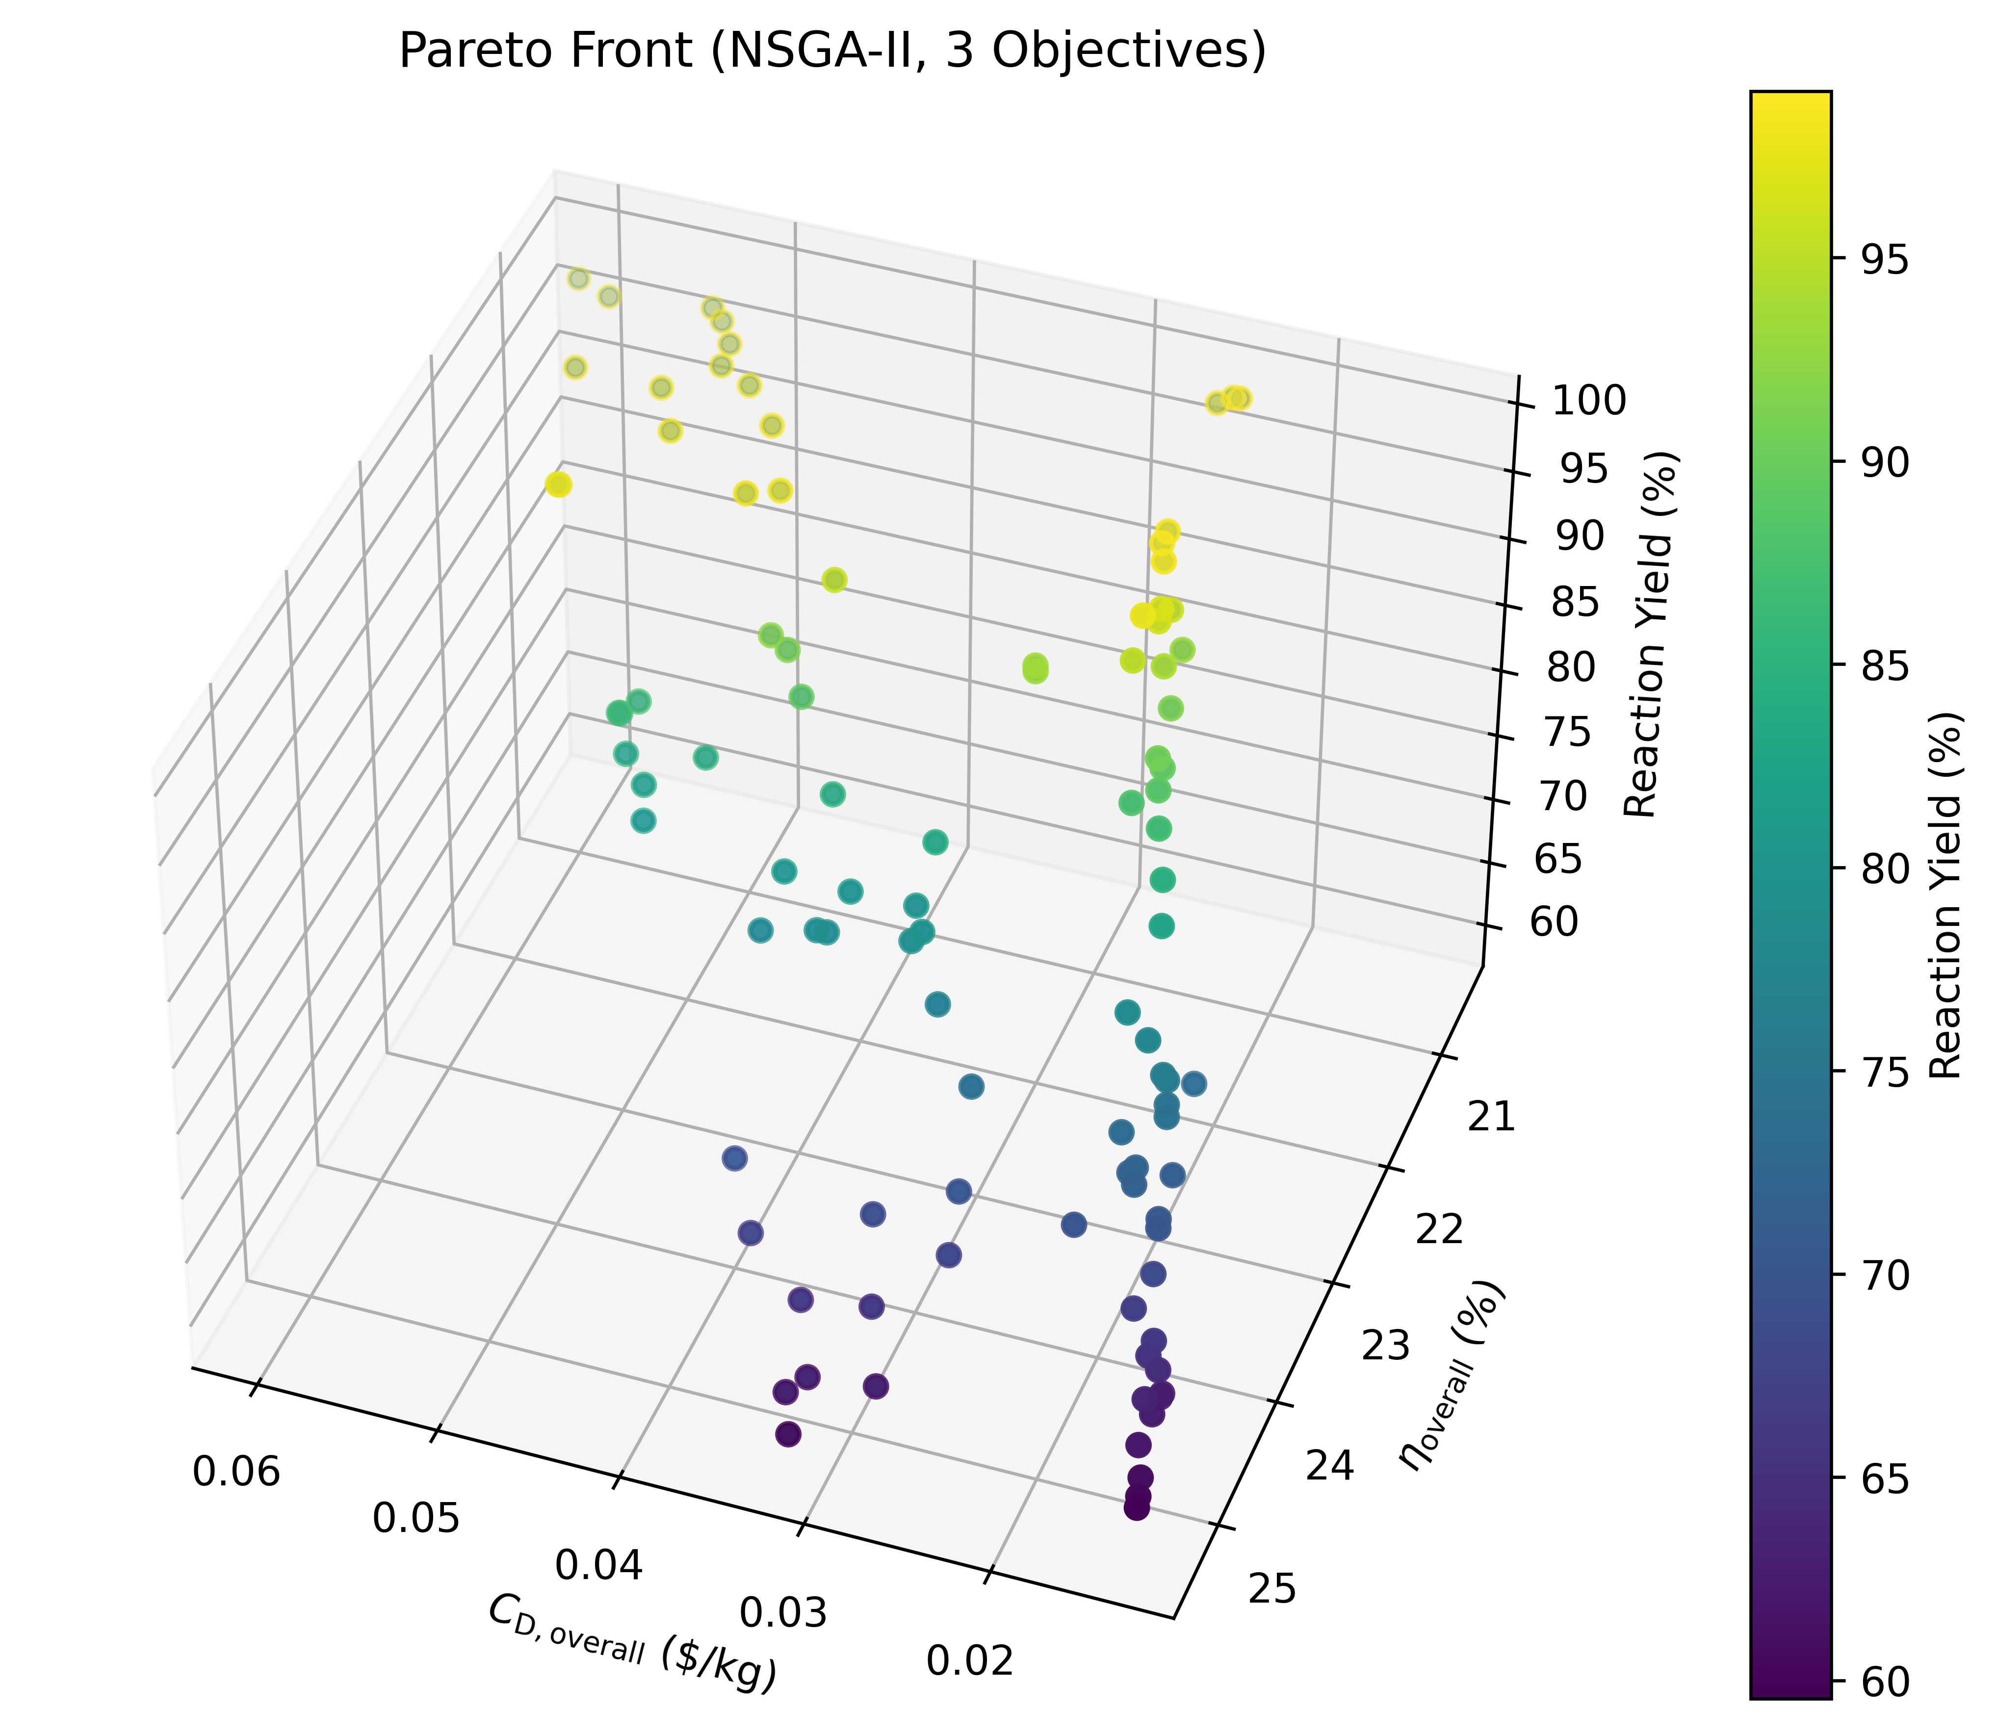

Figure 3. Multi-objective Pareto front obtained from the NSGA-II algorithm showing optimal trade-offs between exergy efficiency, exergy destruction cost, and reaction yield for a batch reactor using WCO

Table 2: Results of optimal exergoeconomic parameters obtained from the NSGA-II algorithm

|  |  |  |  |  |  |
| --- | --- | --- | --- | --- | --- |
| Operating parameters | This work | Base case | Exergoeconomic results | This work | Base case |
| Temperature (°C) | 60 | 45 | Exergy destruction cost [$/kg of product] | 0.0245 | 0.2228 |
| Time (min) | 118 | 30 | Exergy efficiency [%] | 20.55 | 11.54 |
| Catalyst (% wt) | 1.5 | 1.5 | Reactor yield [%] | 99.10 | 80.28 |
| Molar ratio | 10 | 3 | Specific biodiesel cost [$/kg] | 0.1946 | 0.2600 |

Other studies have reported higher exergy efficiencies (< 99.18%) using ultrasound-assisted reactors (Aghbashlo et al., 2019). However, since the scope of this study focused on ensuring economic viability in conventional batch technologies, the optimization was oriented toward balancing cost and efficiency while accepting a moderate yield. Therefore, when directly compared to the base case, the improvements observed in Table 2 demonstrate enhanced performance specifically for this type of technology. Yield-based optimization alone may lead to misleading conclusions, as it overlooks thermodynamic inefficiencies and financial implications associated with high molar ratios and extended reaction times. The integration of exergoeconomic parameters provides a strategic balance between cost, efficiency, and yield, ensuring economic viability while avoiding excessive reagent usage.

* 1. Conclusions

This study developed a multi-objective optimization framework based on the NSGA-II algorithm to minimize exergy destruction costs and to maximize exergy efficiency and performance in a batch transesterification reactor using WCO. The influence of key operational variables—temperature, reaction time, catalyst concentration, and methanol-to-oil molar ratio—was analysed. Among these, molar ratio and catalyst concentration had the most significant impact on exergy efficiency, with diminishing returns at high levels. The optimal conditions (60 °C, 118 min, 10:1 molar ratio, and 1.5% catalyst concentration) led to a 20.55 % exergy efficiency, 99.10 % reaction yield and an exergy destruction cost of 0.0245 $/kg. Compared to the base case, this represents a significant reduction in exergy destruction cost. The proposed approach supports the use of low-cost feedstocks and process optimization for industrial sustainability. Future studies should evaluate scale-up potential and the influence of WCO variability on process performance. Advanced exergoeconomic analysis is highly recommended to identify unit operations with the highest exergy destruction cost rate. Additionally, an exergoenvironmental analysis is recommended to assess the environmental impact of the process.

Nomenclature

c – unit exergy cost, $/MJ

${\dot{C}}_{F, k}$– fuel cost rate of the k-th component, $/h

${\dot{C}}_{i}$– cost rate of stream i, $/h

${\dot{C}}_{D, k}$– exergy destruction cost rate of the k-th component, $/h

${\dot{C}}_{P, k}$– product cost rate of the k-th component, $/h

$e_{i}^{CH}$– chemical exergy of stream i, kJ/kmol

$e_{i}^{°ch}$– standard chemical exergy of each compound in stream i, kJ/kmol

$e_{i}^{PH}$– physical exergy of stream i, kJ/kg

${\dot{E}}_{i}$– exergy rate of stream i, kJ/h

${\dot{E}}_{F,k}$– fuel exergy of the k-th component, kJ/h

${\dot{E}}_{D,k}$– exergy destruction of the k-th component, kJ/h

${\dot{E}}_{P,k}$– product exergy of the k-th component, kJ/h

$h_{i}$– enthalpy of stream i, kJ/kg

$h_{o}$– dead state enthalpy, kJ/kg

$s_{i}$– entropy of stream i, kJ/(kg·K)

$s_{o}$– dead state entropy, kJ/(kg·K)

$T_{o}$– dead state temperature, K

$x_{i}$– molar composition, -

${\dot{Z}}_{k}$– total cost rate for operation and investment of the k-th component, $/h

${\dot{Z}}_{k}^{CI}$– capital investment cost rate of the k-th component, $/h

${\dot{Z}}_{k}^{O\&M}$– operation and maintenance cost rate of the k-th component, $/h

η – exergy efficiency,%

References

Aghbashlo, M., Hosseinpour, S., Tabatabaei, M., Mojarab Soufiyan, M., 2019, Multi-objective exergetic and technical optimization of a piezoelectric ultrasonic reactor applied to synthesize biodiesel from waste cooking oil (WCO) using soft computing techniques, Fuel, 235, 100–112.

Aghbashlo, M., Tabatabaei, M., Hosseinpour, S., 2018, On the exergoeconomic and exergoenvironmental evaluation and optimization of biodiesel synthesis from waste cooking oil (WCO) using a low power, high frequency ultrasonic reactor, Energy Conversion and Management, 164, 385–398.

Babadi, A.A., Rahmati, S., Fakhlaei, R., Barati, B., Wang, S., Doherty, W., Ostrikov, K. (Ken), 2022, Emerging technologies for biodiesel production: Processes, challenges, and opportunities, Biomass and Bioenergy, 163, 106521.

Barcia-Quimi, A.F., Risco-Bravo, A., Alcivar-Espinoza, K., Tinoco-Caicedo, D.L., 2023, Design of a sustainable biodiesel production process by a multi-objective optimization, Computer Aided Chemical Engineering, 52, 519–524.

Bejan, A., Tsatsaronis, G., Moran, M., 1996, Thermal Design & Optimization. John Wiley & Sons, Inc., Canada.

Costa, J.S.A., Ariza, O.J.C., Lima, L.B., 2019, A study on production of biodiesel from waste frying oil, Chemical Engineering Transactions, 74, 157–162.

Gonçalves, P.C., Monteiro, L.P.C., Santos, L. de S., 2020, Multi-objective optimization of a biodiesel production process using process simulation, Journal of Cleaner Production, 270, 122322.

Khan, Tahir Ali, Khan, Tasmeem Ahmad, Kumar Yadav, A., 2022, A hydrodynamic cavitation-assisted system for optimization of biodiesel production from green microalgae oil using a genetic algorithm and response surface methodology approach, Environmental Science and Pollution Research, 29, 49465–49477.

Mohiddin, M.N. Bin, Tan, Y.H., Seow, Y.X., Kansedo, J., Mubarak, N.M., Abdullah, M.O., Chan, Y.S., Khalid, M., 2021, Evaluation on feedstock, technologies, catalyst and reactor for sustainable biodiesel production: A review, Journal of Industrial and Engineering Chemistry, 98, 60–81.

Singh, N.K., Singh, Y., Sharma, A., 2022, Optimization of biodiesel synthesis from Jojoba oil via supercritical methanol: A response surface methodology approach coupled with genetic algorithm, Biomass and Bioenergy, 156, 106332.

Soly Peter, A., Alias, M.P., Iype, M.P., Jolly, J., Sankar, V., Joseph Babu, K., Baby, D.K., 2021, Optimization of biodiesel production by transesterification of palm oil and evaluation of biodiesel quality, Materials Today: Proceedings, 42, 1002–1007.

Song, G., Xiao, J., Zhao, H., Shen, L., 2012, A unified correlation for estimating specific chemical exergy of solid and liquid fuels, Energy, 40, 164–173.