|  |  |
| --- | --- |
| cetlogo ***CHEMICAL ENGINEERING TRANSACTIONS***  ***VOL. xxx, 2025*** | A publication of  aidiclogo_grande |
| The Italian Association  of Chemical Engineering  Online at www.cetjournal.it |
| Guest Editors: David Bogle, Flavio Manenti, Piero Salatino  Copyright © 2025, AIDIC Servizi S.r.l. **ISBN** 979-12-81206-21-2; **ISSN** 2283-9216 | |

Microbial Resilience and Process Optimization in Anaerobic Digestion: The Impact of Temperature Fluctuations and H₂S Inhibition on Biogas Yield and Methane Content

Lungelo Tsabedze, Willie Nicol, Evans Chirwa, Hendrik G Brink\*

Department of Chemical Engineering, University of Pretoria, Lynnwood, South Africa

Deon.brink@up.ac.za

This study investigates the dynamic performance of three parallel anaerobic digestion reactors (G4, G5, and G6) from August to October 2024, focusing on biogas yield, methane content, temperature fluctuations, and the inhibitory effects of hydrogen sulphide (H₂S). Despite operating under identical environmental conditions and feedstock, significant variations in reactor performance were observed, revealing novel insights into microbial adaptability and process stability. G4 demonstrated the highest average biogas yield (4.44 L/day) with consistent output, while G5 reached peak production (11.4 L/day) but exhibited operational instability. Remarkably, G6 maintained comparable yields despite experiencing substantial temperature fluctuations, highlighting the resilience of its microbial community. Transitioning from cow manure to food waste significantly reduced H₂S concentrations, leading to enhanced biogas yield and methane content across all reactors. The study’s novelty lies in its detailed evaluation of microbial responses to temperature variability and H₂S inhibition, underscoring the significance of substrate composition and environmental conditions in optimizing anaerobic digestion. These findings contribute to the development of more robust and adaptable biogas production systems, particularly in settings with fluctuating environmental parameters.

* 1. Introduction

The global shift towards sustainable energy solutions has intensified interest in anaerobic digestion (AD), a biological process that decomposes organic material under oxygen-free conditions to produce biogas. This process not only generates renewable energy but also mitigates environmental issues such as organic waste accumulation and greenhouse gas emissions. Biogas, primarily composed of methane (CH₄) and carbon dioxide (CO₂), is a versatile energy source applicable for heating, electricity generation, and fuel. Additionally, the byproduct of AD, known as digestate, serves as a nutrient-rich fertilizer, enhancing both environmental and economic value (Alharbi, 2024; Amponsem et al., 2023).

Identifying optimal substrates for biogas production is a critical focus in AD research. Food waste emerges as a particularly advantageous substrate due to its high organic content and favourable carbon-to-nitrogen (C/N) ratio, which supports efficient microbial digestion. This aligns with circular economy principles, transforming waste into renewable energy and reducing methane emissions from landfills (Avinash & Mishra, 2023).

The anaerobic digestion process comprises four key stages: hydrolysis, acidogenesis, acetogenesis, and methanogenesis. During hydrolysis, complex organic molecules are broken down into simpler monomers. These are further converted into volatile fatty acids (VFAs), alcohols, and gases like CO₂ and hydrogen during acidogenesis. Acetogenesis transforms these products into acetic acid, hydrogen, and CO₂, while methanogenesis completes the process, producing methane through the activity of methanogenic archaea (Prasad et al., 2024). The efficiency of these stages is influenced by factors such as temperature, pH, substrate composition, and retention time.

Temperature plays a pivotal role, with mesophilic (30-40°C) and thermophilic (50-60°C) conditions supporting different microbial communities. Optimal biogas production often occurs under mesophilic conditions due to the stability of microbial processes (Alharbi, 2024). Hydrogen sulphide (H₂S), a byproduct of protein degradation, poses challenges by inhibiting methanogens and corroding equipment. Managing H₂S concentrations is critical to maintaining biogas quality (Chen et al., 2020).

This study investigates the influence of temperature, H₂S concentration, and biogas yield on methane content in anaerobic digestion processes using food waste as the primary substrate. The research focuses on three reactors (G4, G5, and G6) operated under parallel conditions between August and October, examining how temperature variations within the mesophilic range, H₂S concentrations, and retention time affect biogas yield and methane content. By integrating experimental results with literature insights, this study aims to optimise conditions for enhanced biogas production and sustainability. The work supports the advancement of the United Nations Sustainable Development Goals, particularly SDG 7 (Affordable and Clean Energy) and SDG 12 (Responsible Consumption and Production), by promoting renewable energy generation from organic waste.

* 1. Materials and Methods

The anaerobic digestion process was conducted using a simple setup designed to facilitate biogas production and measurement. The reactor consisted of a thick plastic bag as the primary digestion vessel, equipped with PVC pipes for feeding and extraction of liquids and solids, and a gas pipe for biogas collection (Figure 1). The entire setup was placed on a wooden plank base with heat pads positioned underneath for temperature regulation, intermittently switched on and off to study temperature effects.

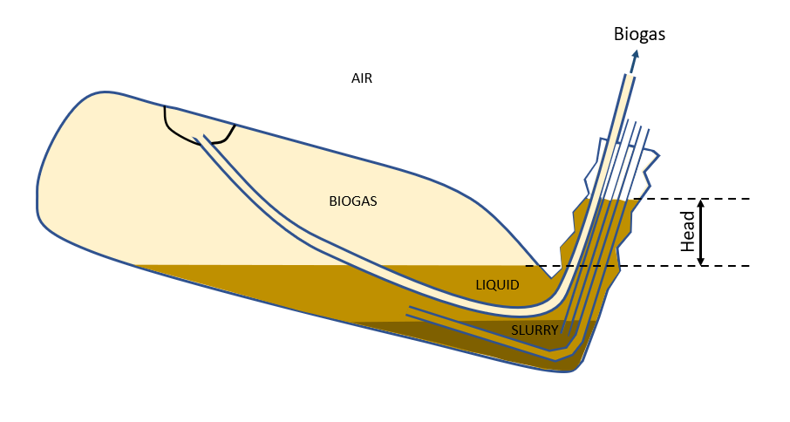

*Figure 1:* Reactor configuration

Feed material, comprising food waste with 3–4% solids, was introduced into the reactor thrice weekly (Monday, Wednesday, Friday). Each feeding involved adding 800 mL of prepared slurry and removing an equal volume of liquid extract. The food waste was composed of approximately 0.5 kg each of potatoes, cabbage, and butternut, along with 0.3 kg of citrus, 0.2 kg each of tomato, banana, onion, and spinach. These components were blended with 7.5 L of water to produce a uniform slurry. Although feeding occurred on fixed days each week (Monday, Wednesday, and Friday), the specific time of day was not held constant. Given the long retention times and the focus on daily production metrics, this was not expected to significantly affect the digestion performance.

Biogas was captured using a gas displacement system with 25 L and 10 L plastic bottles, and the displaced water was measured for volume estimation. Daily biogas composition analysis (excluding Sundays) was performed using a gas analyzer (Optima MRU4u Flue Gas analyser, Neckarsulm, Germany) to measure methane (CH₄), carbon dioxide (CO₂), hydrogen sulfide (H₂S), oxygen (O₂), and nitrogen (N₂). The analyzer was zeroed with atmospheric air before each analysis.

Safety protocols included wearing gas masks to mitigate exposure to H₂S and using laboratory ventilation systems to purge measured biogas. Equipment was tested and calibrated prior to the experiment, ensuring airtight reactor conditions and accurate biogas measurement. Temperature was continuously monitored, with pH checked at the start to confirm optimal conditions for anaerobic digestion. Data on gas composition, volume, and temperature were systematically recorded throughout the experiment.

* 1. Results and Discussions

The performance of three biogas reactors (G4, G5, and G6) was evaluated from 8 August to 26 October 2024. Despite identical feedstock and environmental conditions, notable differences in biogas yield, methane content, and temperature responses were observed, providing insights into the complex dynamics of anaerobic digestion.

* + 1. Biogas Yield and Temperature Measurements

G4 demonstrated the highest average biogas yield (4.44 L/day) with consistent performance, while G5 had a lower mean yield (3.88 L/day) but reached peak values of 11.4 L/day. G6 showed resilience with yields comparable to G4 despite temperature fluctuations. These variations highlight the influence of reactor-specific factors on biogas production, including microbial community dynamics, operational conditions, and environmental influences (Figure 2a).

|  |  |
| --- | --- |
| (a) | A graph with blue lines and orange lines |
| (b) | A graph with blue and orange lines |
| (c) | A graph with blue and orange lines |

*Figure 2:* Biogas yield and temperature measured in (a) G4, (b) G5, (c) G6.

The stable biogas yield in G4 suggests optimal conditions for anaerobic digestion, such as stable pH, consistent substrate availability, and an active microbial consortium. Studies have shown that maintaining mesophilic conditions (30-37°C) supports the growth of methanogenic archaea, leading to efficient biogas production (Alharbi, 2024; Jameel et al., 2024). In contrast, G5, despite lower average yields, exhibited the highest peak biogas production (Figure 2b). This suggests that under optimal conditions, G5 has the potential for high productivity but may suffer from operational instability. Such fluctuations could be attributed to transient environmental conditions or substrate heterogeneity, which can affect microbial activity (Arikan et al., 2015).

G4's consistent performance indicates stable microbial activity and effective substrate utilization, while G6's resilience under fluctuating conditions suggests adaptability in its microbial ecosystem (Figure 2c). This resilience could be due to microbial community shifts that favor temperature-tolerant species, enabling continued biogas production even under suboptimal conditions. Similar findings have been reported in studies on temperature-adaptive anaerobic digestion systems, where microbial consortia adjust to maintain metabolic functions despite environmental stressors (Yilmaz et al., 2018).

Temperature is a critical factor influencing anaerobic digestion efficiency. G4 maintained stable mesophilic conditions (mean 33.7°C), promoting steady biogas production (Figure 2a). Mesophilic digestion typically supports a diverse and robust microbial community, enhancing system stability and biogas yield (Alharbi, 2024).

G5 experienced minor temperature dips, causing fluctuations in biogas yield (Figure 2b). These dips can reduce microbial activity, particularly affecting methanogens, which are sensitive to temperature changes. However, the reactor's ability to recover biogas production after temperature normalization highlights the resilience of the microbial community (Arikan et al., 2015).

G6 faced significant temperature variations (mean 28.0°C) yet maintained good biogas output (Figure 2c). This indicates that certain microbial communities within G6 adapted to temperature changes, maintaining metabolic activity even under suboptimal conditions. Psychrophilic or temperature-tolerant methanogens may have contributed to this resilience, as reported in studies where anaerobic digesters maintained functionality at lower temperatures (Jameel et al., 2024).

The data revealed that temperature fluctuations directly impacted biogas yield, with higher temperatures generally correlating with increased production. This is consistent with the known temperature dependence of methanogenic activity, where metabolic rates increase with temperature up to an optimal point (Yilmaz et al., 2018). However, G6's performance challenges the traditional view, suggesting that microbial adaptation can mitigate the adverse effects of temperature variability.

* + 1. Methane Content

G5 achieved the highest methane content (60.7%) with low variability, indicating efficient methanogenic activity. In contrast, G4 and G6 showed similar methane levels (~58%) but with more fluctuations. Methane content was generally higher during periods of lower biogas yield, reflecting efficient substrate conversion under stable conditions (Figure 3).

The relationship between biogas yield and methane content is complex, influenced by factors such as substrate composition, microbial community structure, and operational conditions. High methane content during low biogas yield periods suggests that methanogenesis dominated during these phases, possibly due to substrate limitation or microbial population shifts. This phenomenon aligns with observations from previous studies, where methane-rich biogas was produced during periods of reduced substrate input or slower microbial turnover rates (Arikan et al., 2015; Alharbi, 2024).

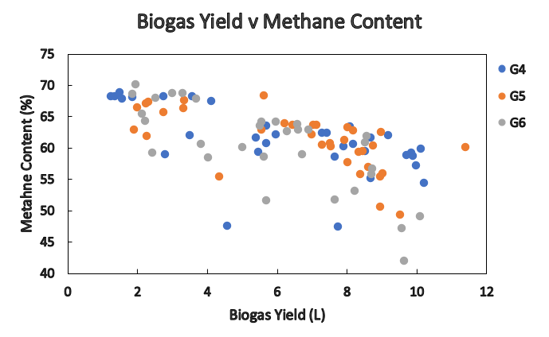

*Figure 3:* Biogas yield vs Methane Content in G4, G5, and G6.

Furthermore, microbial community adaptation plays a crucial role in maintaining methane output. Diverse methanogenic populations, including hydrogenotrophic and acetoclastic methanogens, can adapt to fluctuations in substrate availability, ensuring sustained methane production even under suboptimal conditions (Jameel et al., 2024). The presence of such resilient microbial consortia could explain the observed methane stability in G5, despite fluctuations in biogas yield.

* + 1. H₂S Influence

The initial use of cow manure resulted in high H₂S levels, inhibiting methane production. Transitioning to food waste reduced H₂S concentrations, enhancing biogas yield and methane content across all reactors. This shift highlights the importance of substrate composition in anaerobic digestion, with low-sulfur substrates favoring methanogenic activity (Figure 4).

H₂S inhibition of methanogens underscores the need for careful substrate selection and management to optimize biogas production. High concentrations of H₂S can be toxic to methanogenic archaea, impairing their metabolic functions and reducing methane yield. Research has shown that H₂S concentrations above 200 ppm can significantly inhibit methane production (Vu et al., 2022). By reducing H₂S levels, the reactors experienced improved methane yield and greater stability in biogas production. This emphasizes the critical role of the chemical environment in microbial ecology, where substrate composition directly influences microbial activity and reactor performance (Chen et al., 2020).

The data suggest that reducing H₂S levels not only improves methane yield but also stabilizes reactor performance, emphasizing the role of chemical environment in microbial ecology. Effective management strategies, such as using low-sulphur feedstocks and implementing H₂S scrubbing technologies, are essential for optimizing anaerobic digestion systems.

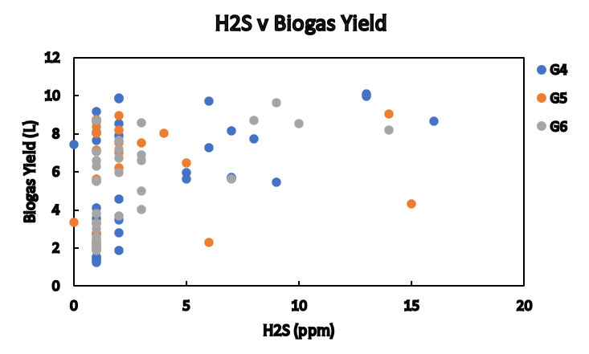

*Figure 4:* Biogas yield vs H2S Content in G4, G5, and G6.

* + 1. Temperature effect on Methane content

Figure 5 illustrates the relationship between temperature and methane content across the three reactors. G4, with its stable mesophilic conditions, showed consistent methane content. G5 displayed moderate fluctuations in methane content corresponding to temperature dips, while G6, despite wider temperature ranges, maintained methane levels comparable to G4. This suggests an adaptive microbial community in G6 capable of withstanding environmental stressors.

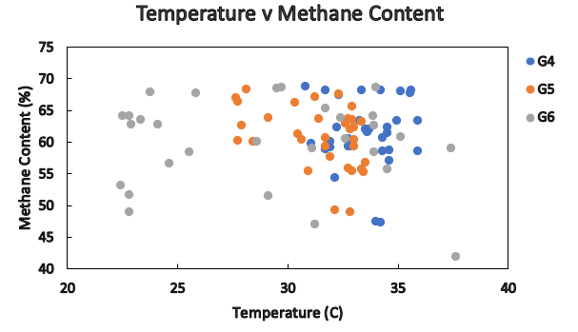

*Figure 5:* Methane content vs Temperature in G4, G5, and G6.

Notably, methane content remained relatively stable within the mesophilic temperature range (30-35°C) but showed greater variability outside this range. Methanogenic archaea are particularly sensitive to temperature shifts, which can alter the metabolic pathways and the efficiency of substrate conversion to methane. The resilience observed in G6 may be attributed to microbial community shifts that favour temperature-tolerant species, supporting consistent methane production even when temperatures deviate from the mesophilic optimum.

* + 1. Reactor-to-Reactor Performance Differences

Despite operating under similar environmental conditions and using the same feedstock, differences in reactor performance (biogas yield and methane content) may be attributed to subtle variations in mixing, temperature distribution, and microbial community development. For example, small differences in how heat was transferred or retained across the reactor bags could have influenced microbial activity, particularly in G6, which showed resilience under fluctuating temperatures. Slight inconsistencies in sealing, gas collection efficiency, or feedstock blending may also have created micro-environmental differences that affected digestion dynamics. Furthermore, even with the same inoculum, the microbial consortia in each reactor may have evolved differently over time, leading to varied metabolic efficiency and stability. These factors highlight the sensitivity of anaerobic systems to minor operational differences, even in controlled experimental setups.

* 1. Conclusions

This study offers critical insights into the operational dynamics of anaerobic digestion, revealing the significant influence of temperature fluctuations, substrate composition, and H₂S concentrations on biogas yield and methane content. The novelty of this work lies in its demonstration of the microbial community’s resilience to environmental stressors, particularly in reactor G6, which maintained stable biogas production despite substantial temperature variations. These findings challenge conventional assumptions about the vulnerability of anaerobic digestion systems to temperature fluctuations, suggesting that microbial communities can adapt and maintain functionality under suboptimal conditions.

The transition from cow manure to food waste not only reduced inhibitory H₂S concentrations but also significantly enhanced biogas yield and methane content, highlighting the critical role of substrate selection in optimizing anaerobic digestion performance. G5’s ability to achieve the highest methane content (60.7%) despite operational variability underscores the potential for optimizing reactor conditions to enhance methane production efficiency.

The study’s significance extends to its implications for real-world biogas production systems, particularly in regions with variable environmental conditions. By demonstrating the adaptability of microbial communities and the importance of substrate management, this research contributes to the development of more resilient and efficient anaerobic digestion technologies. Future research should focus on elucidating the specific microbial mechanisms underlying this adaptability, with the goal of further enhancing the stability and efficiency of biogas production under diverse operational conditions.

References

Alharbi R.M., 2024, Anaerobic co-digestion of cow manure and microalgae to increase biogas production: A sustainable bioenergy source, Journal of King Saud University - Science, 36, 103380.

Amponsem B., Bensah E.C., Antwi E., Ahiekpor J.C., Boahen B., Mensah I., Narra S., 2023, Electricity generation from biogas as resource recovery potential from solid waste composition in a mixed-income municipality, Cleaner Waste Systems, 4, 100067.

Arikan, O.A., Mulbry, W., Lansing, S., 2015. Effect of temperature on methane production from field-scale anaerobic digesters treating dairy manure. Waste Management, 43, 108-113.

Avinash L.S., Mishra A., 2023, Enhancing biogas production in anaerobic digestion of MSW with addition of bio-solids and various moisture sources, Fuel, 354, 129414.

Chen Q., Wu W., Qi D., Ding Y., Zhao Z., 2020, Review on microaeration-based anaerobic digestion: State of the art, challenges, and prospectives, Science of The Total Environment, 710, 136388.

Jameel M.K., Mustafa M.A., Ahmed H.S., Mohammed A.J., Ghazy H., Shakir M.N., Lawas A.M., Mohammed S.K., Idan A.H., Mahmoud Z.H., Sayadi H., Kianfar E., 2024, Biogas: Production, properties, applications, economic and challenges: A review, Results in Chemistry, 7, 101549.

Prasad R.K., Sharma A., Mazumder P.B., Dhussa A., 2024, A comprehensive pre-treatment strategy evaluation of ligno-hemicellulosic biomass to enhance biogas potential in the anaerobic digestion process, RSC Sustainability, 2, 2444-2467.

Vu, H.P., Nguyen, L.N., Wang, Q., Ngo, H.H., Liu, Q., Zhang, X., Nghiem, L.D., 2022. Hydrogen sulphide management in anaerobic digestion: A critical review on input control, process regulation, and post-treatment. Bioresource Technology, 346, 126634.

Yilmaz, A., Ünvar, S., Kocer, A., Aygün, B., 2018. Factors affecting the production of biogas. International Journal of Scientific and Engineering Research, 9, 59-62.