CHEMICAL ENGINEERING TRANSACTIONS  VOL. 76, 2019 | A publication of
The Italian Association
of Chemical Engineering
Online at www.aidic.it/cet
Guest Editors: Sauro Pierucci, Jiří Jaromír Klemeš, Laura Piazza
Copyright © 2019, AIDIC Servizi S.r.l.
ISBN 978-88-95608-73-0; ISSN 2283-9216

Optimization of Oleogel Formulation for Curcumin Vehiculization and Lipid Oxidation Stability by Multi-Response Surface Methodology
José A. Vellido-Pérez^{a,*}, Carlos Rodríguez-Remachoª, Javier Rodríguez-Rodríguezª, Javier M. Ochando-Pulidoª, Edmundo Brito-de la Fuente^{b}, Antonio Martínez-Férezª
ªDepartment of Chemical Engineering, Faculty of Sciences, University of Granada, 18071 Granada, Spain
^{b}Product & Process Engineering Centre, Fresenius Kabi Deutschland GmbH, 61352 Bad Homburg, Germany
javellido@ugr.es
Curcumin is a natural polyphenolic compound with multiple properties such as anticancer, anti-inflammatory, antioxidant, antiviral, and cytoprotective action. It is expected that curcumin has the therapeutic potential to prevent diverse lifestyle-related diseases. However, curcumin is not readily soluble in water and presents low stability under light, heat and physiological pH conditions which, in addition, implies an extremely low level of bioavailability. On the other hand, oleogels are semisolid systems composed of a liquid phase that is physically entrapped by a structurant network, ultimately leading to the formation of a gel. The continuous phase consists of a hydrophobic liquid (e.g., an oil) where a self-assembled network (composed by the structurant) is responsible for the physical entrapment of the liquid. The structural conformation is always dependent on the type of structurant used, which will dictate the desired final application of the oleogels. In this work, the formulation of an oleogel specially designed to stabilize and transport curcumin and to protect the lipid phase –mainly composed of a fish oil concentrate– against oxidation processes has been optimized.
To this end, a Box-Behnken Design was carried out to study the influence of the curcumin amount, the structurant concentration and the manufacturing temperature on the oxidation degree of the oleogelified lipid matrix and on the chemical stability of the curcumin transported by this system. The results were interpreted by using the multi-response surface methodology, obtaining the optimal oleogel formulation to minimize the lipid oxidation and maximize the content of vehiculized curcumin.
The results show that the optimal oleogel formulation –for samples stored at 23 ºC– was achieved for the following values of the variables studied: [Curc.] = 0.150 wt.%, [Struc.] = 4.461 wt.% and T = 64.63 ºC. In contrast, for samples stored at 40 ºC, the optimal formulation obtained changed slightly: [Curc.] = 0.150 wt.%, [Struc.] = 7.000 wt.% and T = 62.82 ºC. Finally, results suggest that oleogels are interesting structured lipid systems to transport and protect bioactive compounds.
1. Introduction
Curcumin is a natural polyphenolic compound present in many types of medicinal herbs, especially in the rhizomes of the commonly known as turmeric (Curcuma longa). In addition to culinary uses, curcumin has also been applied for the treatment of certain lifestyle-related diseases such as cancer, heart diseases, and metabolic syndromes (Bhawana et al., 2011; Choi et al., 2012). In recent years, the FDA (Food and Drug Administration) has approved curcumin as a safe ingredient in food (up to 8g/day) and its consumption and that of its related food products have increased markedly (Chen et al., 2014).
Currently, curcumin is among the most studied natural therapeutic agents –derived from plants– worldwide. Recently, a large number of studies have reported that curcumin has a broad spectrum of physiological effects and therapeutic properties such as anti-inflammatory, anti-infection, antibacterial, antifungal, anticancer, antispasmodic, antioxidant, antiamoebic, anti HIV, anti Alzheimer, antidiabetic, antifertility, etc. (Kumavat et al., 2013; Ma et al., 2017; Naksuriya et al., 2016; Rai et al., 2015). However, due to its poor solubility in water and low stability under heat, light and physiological pH conditions or in the presence of metal ions, the application of curcumin is limited in food manufacturing. In addition to its physicochemical instability, curcumin presents a very low bioavailability after oral administration. The extremely low level of bioavailability, together with its rapid degradation speed under physiological and/or environmental conditions are the major limitations for the clinical or nutritional application of curcumin. This represents an important challenge, both for the scientific community and for the industry, which must design, develop and optimize systems for the encapsulation, protection, vehiculization, and release of curcumin (and other similar bioactive compounds), which will facilitate its application in the food and pharmaceutical industries, among others.
Different authors have tested many methods or systems to encapsulate curcumin. Bisht et al. (2007) synthesized nanocurcumin –polymeric nanoparticle encapsulated formulation of curcumin– using micellar aggregates of cross-linked and random copolymers of N-isopropylacrylamide, with N-vinyl-2-pyrrolidone and poly(ethyleneglycol)monoacrylate. Unlike free curcumin, they observed that nanocurcumin is readily soluble in aqueous solutions and they demonstrated that nanocurcumin formulation had comparable therapeutic efficacy to free curcumin against pancreatic cancer cell lines in vitro, by inhibiting cell viability and colony formation in soft agar. Maiti et al. (2007) developed a new curcumin formulation in combination with phospholipids to explore the protective effect of the curcumin-phospholipid complex on carbon tetrachloride induced acute liver damage in rats. The results obtained showed that the curcumin-phospholipid complex presented better hepatoprotective activity, due to its better antioxidant property, than free curcumin at the same dose level. Thangapazham et al. (2008) incorporated curcumin into liposomes (nanodelivery vehicles primarily composed of phospholipids) coated with prostate membrane specific antigen. The results suggest that liposome formulations are effective nanodelivery vehicles that increase the bioavailability of curcumin and show high therapeutic effects compared with free curcumin. Yu and Huang (2010) proved that hydrophobically modified starch, a food-grade amphiphilic biopolymer, is able to self-assemble to form micelles and to encapsulate curcumin into its hydrophobic core. Encapsulated curcumin revealed increased water solubility by about 1670 folds and the anticancer activity was also enhanced compared to free curcumin. Esmaili et al. (2011) used camel beta-casein, an amphiphilic self-assembling protein, to form micellar nanostructures to encapsulate curcumin. They observed that curcumin encapsulated in beta-casein micelles increased the curcumin solubility up to 2500 folds, its antioxidant activity and bioavailability. Recently, Ma et al. (2017) used oil-in-water nanoemulsions varying the triacylglycerol compositions to incorporate curcumin. These authors concluded that the curcumin nanoemulsion could reach the highest amount of curcumin by choosing medium chain triglycerides as the oil phase, providing an interesting reference to enhance the application of curcumin in the food industry, improving its solubility and bioavailability.
On the other hand, oleogels are examples of alternatively (non-TAG)-structured lipid systems that are recently being a subject of huge research interest due to their applications as fat replacements in a variety of food products and due to their enormous potential in different fields such as lubrication, separation science, pharmaceuticals and foods (Martins et al., 2018; Patel et al., 2013). Oleogels are semisolid systems –soft matter systems– composed of a liquid phase that is physically entrapped by a structurant network, ultimately leading to the formation of a gel. The continuous phase is made of a hydrophobic liquid (like oil or an organic solvent) where a self-assembled network (composed by the structurant or gelling agent) is responsible for the physical entrapment of the liquid (Patel et al., 2013). The structural conformation is always dependent on the type of structurant used, which will dictate the desired final application of the oleogels. Some of the most significant physical properties of oleogels are a consequence of the type of structurant used to induce gelation (fatty acid derivatives, cellulose polymers, shellac, natural waxes –plant and animal– and resins, phytosterols and oryzanol, lecithin, etc.) and the type of the method used (direct or indirect) (Martins et al., 2018). One of the main advantages of this type of systems is that they can modify different physicochemical properties, the rheological behaviour, and texture properties; to control phases separation and decrease the mobility and migration of lipophilic bioactive compounds (such as curcumin, etc.) from the oil phase, providing solid-like properties without using high levels of saturated fatty acids as well as to be a carrier of interesting bioactive compounds for the cosmetic, food and pharmaceutical industries (Osullivan et al., 2017). In addition, by creating a gel-like structure, diffusion of oxygen and pro-oxidant metals inside the oil phase is hindered, thus protecting the polyunsaturated fatty acids contained in the oil.
This study aimed to develop and optimize a physicochemically stable oleogel formulation containing a high content of curcumin and, in turn, minimizing the lipid oxidation of the oleogelified matrix –mainly composed of fish oil enriched in omega-3 polyunsaturated fatty acids.
2. Materials and methods
2.1. Materials
Fish oil enriched in omega-3 polyunsaturated fatty acids (PronovaPure oil containing 36.0 % EPA and 24.0 % DHA TG Deodorized) and Palsgaard® 6111 powder (fully hydrogenated rapeseed oil, kindly supplied by Palsgaard, Denmark) were used as the oil phase and gelling agent for the preparation of all oleogels in this study. Curcumin (E-100, 85 % purity) was received from Solutex, Spain.
2.2. Methods
2.2.1. Preparation of oleogels
All the oleogels were prepared to disperse accurately weighed quantities of Palsgaard® 6111 and curcumin into fish oil to achieve the concentration ranges desired. The samples were premixed for 2 minutes using a magnetic stirrer at maximum agitation speed (1600 rpm). Later, the mixtures were heated using bain-marie at different temperatures (always above the melting point of the Palsgaard® 6111, > 60 ºC) under mild agitation (400 rpm). Heating was performed as quickly as possible to minimize curcumin and fish oil exposure to heat. Dispersions of curcumin were then immediately cooled to room temperature (23 ºC) while being stirred using the magnetic stirrer at maximum agitation speed (1600 rpm), until curcumin was fully dispersed in the oil phase and no specks were visible (~ 3 minutes), resulting in the formation of oleogels. The latter, immediately after formation, were placed in a sealed screw cap glass tube and kept in an oven for 50 days at 23 and 40 ºC to promote potential oxidation processes. The described method ensured that the curcumin was fully dissolved in the oil phase before oleogelified structure formation.
2.2.2. Lipid oxidation measurements
Oleogel chemical stability was determined by measuring the lipid oxidation after its preparation and during storage. To this end, both primary and secondary lipid oxidation products were measured. The first ones were quantified by the peroxide value method (PV) using the colorimetric ferric-thiocyanate method, adapted from Shantha and Decker (1994), and the second ones using the p-anisidine value technique (p-AnV), described in the American Oil Chemical Society (AOCS) CD 18-90 (1998).
2.2.3. Curcumin stability studies
The content of curcumin was determined by UV spectrophotometry. Measurements (wavelength equal to 425 nm) were carried out at 23 ºC after diluting 500 times in 95 % ethanol. A standard curve was used to quantify the content of curcumin in the oleogels.
2.2.4. Statistical analysis
Table 1: BBD matrix for the optimization of the oleogel formulation.
Experiment | [Curc.], wt.% | [Struc.], wt.% | T, ºC
Control | 0.10 | 0.0 | 70
Exp 1 | 0.15 | 5.0 | 80
Exp 2 | 0.10 | 3.0 | 60
Exp 3 | 0.10 | 5.0 | 70
Exp 4 | 0.15 | 7.0 | 70
Exp 5 | 0.10 | 3.0 | 80
Exp 6 | 0.05 | 7.0 | 70
Exp 7 | 0.10 | 7.0 | 60
Exp 8 | 0.05 | 3.0 | 70
Exp 9 | 0.05 | 5.0 | 80
Exp 10 | 0.10 | 7.0 | 80
Exp 11 | 0.10 | 5.0 | 70
Exp 12 | 0.15 | 3.0 | 70
Exp 13 | 0.10 | 5.0 | 70
Exp 14 | 0.05 | 5.0 | 60
Exp 15 | 0.15 | 5.0 | 60
Both the oleogel formulation and the manufacturing conditions were optimized by a statistical experimental design in combination with an analysis of the multi-response surface. In this study, the curcumin content, the amount of structuring agent and the manufacturing temperature were selected as independent variables, and the oxidation degree of the oleogelified lipid matrix and the amount of vehiculized curcumin as response surface (RF). The ranges tested for the selected variables were equal to 0.05-0.15 wt.% for the curcumin content, 3.0-7.0 wt.% for the amount of structurant and 60-80 ºC for the manufacturing temperature. A Box-Behnken Design (BBD) was applied to simultaneously calculate the effect of the change in each of these variables and also their possible interactions. Three levels were considered for each variable, including three repetitions of the central point to verify the reproducibility of the model, which results in a total of 15 experiments (Table 1). In addition to the oleogels obtained by means of the experimental design, a control sample was prepared by dissolving curcumin (0.10 wt.%) directly in fish oil enriched in omega-3 PUFAs at a medium manufacturing temperature (70 ºC), following the procedure described in the section 2.2.1. The reason for preparing this control sample was to be able to compare the beneficial effect provided by the use of oleogels versus ungelled fish oil. The experimental conditions were established randomly combining the minimum, medium and maximum values of each variable studied. The optimization of the model was carried out with the software Statgraphics Centurion XV and the results were interpreted by using the multi-response surface methodology (M-RSM).
3. Results and discussion
3.1. Lipid oxidation stability of the oleogels
Fig. 1 shows the evolution in time of the lipid oxidation measured at two different storage temperatures (23 and 40 ºC) –Fig. 1A corresponds to the concentration of lipid hydroperoxides and Fig. 1B to the concentration of secondary lipid oxidation products.
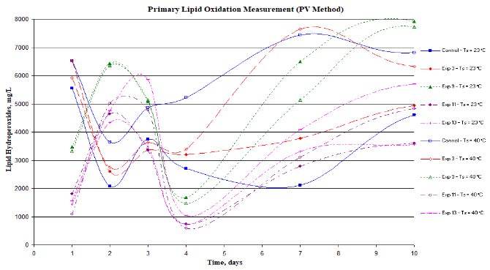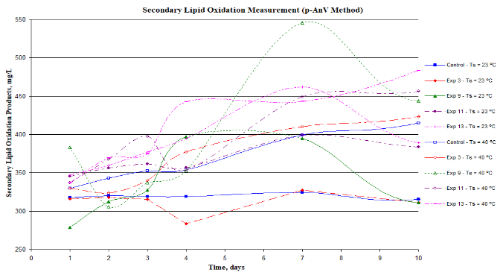
Figure 1: Lipid oxidation measured as a function of time at two different storage temperatures (23 ºC and 40 ºC). (A) Concentration of lipid hydroperoxides and (B) concentration of secondary lipid oxidation products.
As it can be seen, different evolution patterns occurred depending on the studied variables. In Fig. 1A, the appearance of areas in which the concentration of lipid hydroperoxides increases and areas in which decreases is frequent. The former would represent the oxidative processes experienced by the PUFAs when they react with oxygen and produce these primary lipid oxidation products, while the latter would represent the oxidation of these primary oxidation products to give rise to the secondary lipid oxidation products. Therefore, depending on the rates of the primary and secondary oxidation reactions, there will be an increase or a decrease in the concentration of lipid hydroperoxides. In addition, from a careful analysis of the concentration of lipid hydroperoxides of the different samples tested, interesting conclusions can be drawn. It was observed that oleogels 11 and 13 showed the lowest final lipid hydroperoxide concentrations, even lower than that exhibited by the control sample for the same period of time (note that the only difference between samples 11 and 13 and the control is that the former contained a certain amount of structurant and, therefore, formed oleogelified structures, while the control did not carry structurant and, therefore, did not form an oleogel). These results suggest that oleogelified systems offer greater protection against the oxidation processes of PUFAs, probably due to the modification of the rheological properties of the system, especially the increase of its viscosity, which would reduce the oxygen diffusion process through the lipid matrix and, therefore, lead to an increase of their oxidative stability. According to this, oleogel 9, containing the lowest concentration of curcumin and manufactured at the highest temperature, is the one that showed the worst performance against primary oxidation.
On the other hand, unlike what occurred in the study of primary lipid oxidation, in the samples stored at 23 ºC of Fig. 1B it can be noted that the concentration of secondary lipid oxidation products remains relatively constant throughout the time studied; however, in the samples stored at 40 ºC, areas in which the concentration of secondary lipid oxidation products increases and areas in which decreases are again observed. The increase in the concentration of secondary lipid oxidation products is due to the oxidative processes experienced by the primary lipid oxidation products when they react with oxygen, while the decrease in concentration is due to the oxidation of these secondary products that leads to the formation of volatile and low-molecular-weight compounds. Therefore, these results suggest that these secondary lipid oxidation processes require higher storage temperatures or, on another hand, occur at longer storage times. Furthermore, it was observed that oleogels 11 and 13 showed relatively high final secondary lipid oxidation products concentrations compared to the concentration exhibited by the control sample during the same period of time. In view of these results, the lower lipid hydroperoxides concentration of these oleogels could be attributed to the fact that part of their lipid hydroperoxides had already been oxidized and become secondary lipid oxidation products. In contrast, oleogel 9 showed secondary lipid oxidation products concentration values similar to those measured in the control sample and, in any case, lower than those of oleogels 11 and 13. This may be due to the fact that this oleogel formulation retards the oxidation of the primary to secondary lipid oxidation products for a longer time and, consequently, the secondary lipid oxidation products concentration is lower at the expense of the secondary lipid oxidation products concentration, which is higher.
Therefore, as has been reported by Kargar (2014), a lower primary lipid oxidation products concentration usually leads to a higher secondary lipid oxidation products concentration and vice versa. Consequently, a compromise solution must be reached, seeking the optimal oleogel formulation so that the primary and secondary lipid oxidation products concentrations, together, are minimal.
3.2. Optimization study of the oleogel formulation
The M-RSM was applied to achieve the optimal oleogel formulation which, in this case, involved minimizing the lipid oxidation of the oleogel and maximizing the amount of vehiculized curcumin. The results are shown in fig. 2, that represents the estimated response surface for the effect of the amount of structuring agent and the manufacturing temperature on the overall desirability for a constant curcumin content (equal to the optimum reached in each case) at two different storage temperatures (figs. 2A and 2B, respectively).
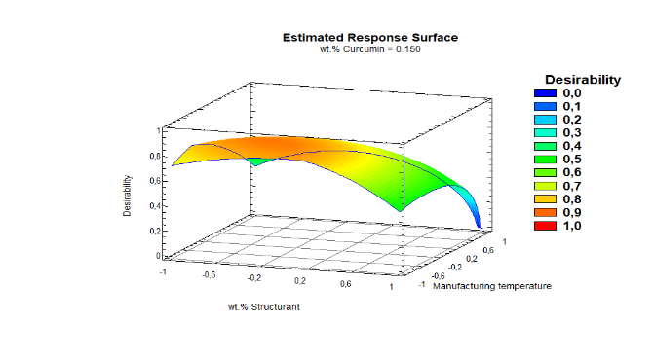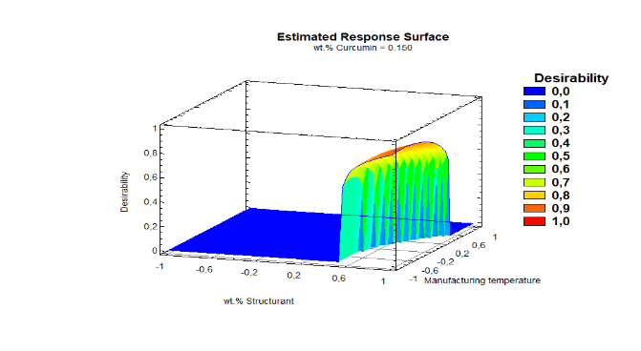
Figure 2: Estimated multi-response surface for the effect of the amount of structurant and the manufacturing temperature on the overall desirability, for a constant curcumin content at two different storage temperatures. (A) 23 ºC and (B) 40 ºC.
As explained before, secondary lipid oxidation takes place from the products generated in primary lipid oxidation; therefore, minimizing the latter will intrinsically reduce the former. On the other hand, curcumin has beneficial therapeutic properties; however, its presence in the oleogel does not deteriorate the quality of the final product, unlike what happens with the oxidative processes of fish oil. According to this, different importance for each of the RFs were considered, assigning different weights. The weighting applied to each of the RFs for the optimization study is 50 % for primary lipid oxidation, 10 % for secondary lipid oxidation and 40 % for the content of curcumin in the oleogel, obtaining the optimal result shown in Table 2.
Table 2: Optimized input parameters for the oleogel formulation.
T_{storage}, ºC | [Curc.], wt.% | [Struc.], wt.% | T, ºC | Desirability
23 | 0.150 | 4.461 | 64.63 | 0.881
40 | 0.150 | 7.000 | 62.82 | 0.911
Table 2 shows that the optimum amount of curcumin is the maximum of those tested. Thanks to its antioxidant capacity, the oxidative processes of fish oil concentrate are minimized, in addition, to maximize its presence in the oleogel. On the other hand, the highest optimal structurant concentration obtained for samples stored at 40 ºC compared to those stored at 23 ºC confirms what was mentioned in the previous section: oleogelified systems offer greater protection against the oxidation processes of PUFAs, favored at higher storage temperatures. Finally, it is known that temperature increases the speed of any reaction so that the optimum manufacturing temperatures are relatively low in both cases and close to the minimum necessary to form the oleogel.
4. Conclusions
By using the M-RSM, the optimal oleogel formulation was determined in order to minimize the lipid oxidation of the oleogel and maximize the content of vehiculized curcumin. The optimum conditions for samples stored at 23 ºC were achieved for the following values of the variables studied: [Curc.] = 0.150 wt.%, [Struc.] = 4.461 wt.% and T = 64.63 ºC; while for samples stored at 40 ºC, the optimal formulation obtained changed slightly: [Curc.] = 0.150 wt.%, [Struc.] = 7.000 wt.% and T = 62.82 ºC. These results suggest that oleogels are very interesting structured lipid systems to transport and protect bioactive compounds.
Acknowledgments
This work was supported by the Research Group TEP025 “Technologies for Chemical and Biochemical Processes” from the Chemical Engineering Department of the University of Granada. The Ministry of Education, Culture and Sport (MECD) is deeply grateful for supporting the grant FPU17/03005 of Mr. Vellido-Perez.
References
AOCS, 1998. p-Anisidine value. In: Official Methods and Recommended Practices of the American Oil Chemists. Method CD 18-90.
Bisht, S., Feldmann, G., Soni, S., Ravi, R., Karikar, C., Maitra, A., Maitra, A., 2007. Polymeric nanoparticle-encapsulated curcumin (“nanocurcumin”): A novel strategy for human cancer therapy. J. Nanobiotechnology 5.
Bhawana, Basniwal, R.K., Buttar, H.S., Jain, V.K., Jain, N., 2011. Curcumin nanoparticles: Preparation, characterization, and antimicrobial study. J. Agric. Food Chem. 59, 2056-2061.
Chen, Z., Xia, Y., Liao, S., Huang, Y., Li, Y., He, Y., Tong, Z., Li, B., 2014. Thermal degradation kinetics study of curcumin with nonlinear methods. Food Chem. 155, 81-86.
Choi, H.A., Kim, M.-R., Park, K.A., Hong, J., 2012. Interaction of over-the-counter drugs with curcumin: Influence on stability and bioactivities in intestinal cells. J. Agric. Food Chem. 60, 10578-10584.
Esmaili, M., Ghaffari, S.M., Moosavi-Movahedi, Z., Atri, M.S., Sharifizadeh, A., Farhadi, M., Yousefi, R., Chobert, J.-M., Haertlé, T., Moosavi-Movahedi, A.A., 2011. Beta casein-micelle as a nano vehicle for solubility enhancement of curcumin; food industry application. LWT - Food Sci. Technol. 44, 2166-2172.
Kargar, M., 2014. Emulsion design for protection of chemically sensitive bioactive. University of Birmingham.
Kumavat, S.D., Chaudhari, Y.S., Borole, P., Mishra, P., Shenghani, K., Duvvuri, P., 2013. Degradation studies of curcumin. Int. J. Pharm. Rev. Res. 3, 50-55.
Ma, P., Zeng, Q., Tai, K., He, X., Yao, Y., Hong, X., Yuan, F., 2017. Preparation of curcumin-loaded emulsion using high pressure homogenization: Impact of oil phase and concentration on physicochemical stability. LWT - Food Sci. Technol. 84, 34-46.
Maiti, K., Mukherjee, K., Gantait, A., Saha, B.P., Mukherjee, P.K., 2007. Curcumin-phospholipid complex: Preparation, therapeutic evaluation and pharmacokinetic study in rats. Int. J. Pharm. 330, 155-163.
Martins, A.J., Vicente, A.A., Cunha, R.L., Cerqueira, M.A., 2018. Edible oleogels: An opportunity for fat replacement in foods. Food Funct. 9, 758-773.
Naksuriya, O., Vansteenbergen, M.J., Torano, J.S., Okonogi, S., Hennink, W.E., 2016. A kinetic degradation study of curcumin in its free form and loaded in polymeric micelles. AAPS J. 18, 777-787.
Osullivan, C.M., Davidovich-Pinhas, M., Wright, A.J., Barbut, S., Marangoni, A.G., 2017. Ethylcellulose oleogels for lipophilic bioactive delivery-effect of oleogelation on: In vitro bioaccessibility and stability of beta-carotene. Food Funct. 8, 1438-1451.
Patel, A.R., Schatteman, D., De, V., Lesaffer, A., Dewettinck, K., 2013. Preparation and rheological characterization of shellac oleogels and oleogel-based emulsions. J. Colloid Interface Sci. 411, 114-121.
Rai, M., Pandit, R., Gaikwad, S., Yadav, A., Gade, A., 2015. Potential applications of curcumin and curcumin nanoparticles: From traditional therapeutics to modern nanomedicine. Nanotechnol. Rev. 4, 161-172.
Shantha, N.C., Decker, E.A., 1994. Rapid, sensitive, iron-based spectrophotometric methods for determination of peroxide values of food lipids. J. AOAC Int. 77, 421-424.
Thangapazham, R.L., Puri, A., Tele, S., Blumenthal, R., Maheshwari, R.K., 2008. Evaluation of a nanotechnology-based carrier for delivery of curcumin in prostate cancer cells. Int. J. Oncol. 32, 1119-1123.
Yu, H., Huang, Q., 2010. Enhanced in vitro anti-cancer activity of curcumin encapsulated in hydrophobically modified starch. Food Chem. 119, 669-674.

