CHEMICAL ENGINEERING TRANSACTIONS  VOL. 76, 2019 | A publication of
The Italian Association
of Chemical Engineering
Online at www.aidic.it/cet
Guest Editors: Sauro Pierucci, Jiří Jaromír Klemeš, Laura Piazza
Copyright © 2019, AIDIC Servizi S.r.l.
ISBN 978-88-95608-73-0; ISSN 2283-9216

Why must jam be so sweet? Using food safety to motivate thermodynamics
Margot Vigeant
ªDepartment of Chemical Engineering, Bucknell University, Lewisburg, PA, 17837, USA
mvigeant@bucknell.edu
Undergraduate chemical engineering students are challenged by many important yet abstract concepts in thermodynamics, such as chemical activity. While examples typically used in these courses center on chemical process industry products such as petroleum, food examples, although more complex, can be much more accessible for students to understand. In this presentation, I will share a class activity that can be used in thermodynamics courses to support learning of chemical activity by applying the concept of water activity in the context of food safety.

Activity is typically introduced in chemical engineering thermodynamics to describe non-ideal solutions in vapor-liquid equilibrium, but this is only the first of many potential applications. Another application is estimation of osmotic pressure, which is useful both medically and to provide drinkable water from seawater. The activity of water in (a_{w}) is the key thermodynamic value computed to determine the relevant osmotic pressure. Food scientists are familiar with water activity as a key variable used to describe a foods’ liability to microbial spoilage and/or staling.

For both thermodynamics and applied food science courses, an assignment was created that focuses on the application of a_{w} to food safety. Prior to widespread availability of refrigeration, extremes of osmotic pressure were used to prevent or reduce microbial spoilage of foods through removal of water and addition of salt, sugar, acid, or a combination thereof. This assignment, which works both in-class and as homework, starts with published food labels and assumed molecular masses for components listed there (ex: carbohydrates) and results in reasonable estimates of whether or not a given food could be expected to be “shelf-stable” without refrigeration. The assignment can also be extended to ask students to invent a recipe for preserving fruits and vegetables that result in answers remarkably similar to traditional recipes for jam, raisins, and pickles. An additional extension can look at which foods could be stored together in a single container and to what extent water would be expected to be exchanged between them.

  - Introduction
Thermodynamics is a core engineering science in the chemical engineering undergraduate curriculum. An important concept within this course is that of “chemical activity,” chiefly considered in terms of its impacts on phase equilibrium (Cole et al, 2019). Activity is useful in describing non-ideal behaviour of boiling mixtures in, for example, the distillation of ethanol / water mixtures. While this example is tied strongly to the future careers of many students for both beverage and fuel production, it is outside of their everyday experience, as are nearly all of the distillation, extraction, or reverse-osmosis examples that hinge on the same concept. To aid learning, it would be beneficial to have at least one example that ties to everyday student experience.

Food scientists have long used the activity of water (a_{w}) as an important metric for food safety and preservation (Barbosa-Canovas, Fontana, and Schmidt, 2007). While water activity is important in describing a myriad of food-related phenomena, from water migration to staling, it is its use in calculation of osmotic pressure that comes closest to both the standard undergraduate chemical engineering curriculum and food science. Osmotic pressure calculation is covered in typical chemical engineering thermodynamics texts (ex: Elliott and Lira, 2010), and is also the key to classical food preservation processes such as drying, salting, curing, and jam-making. It was therefore decided that this example could serve as the needed bridge between the everyday – where students consume fresh and preserved fruits, vegetables, and meats – and the esoteric – chemical activity.

In Approach, the student assignment and its thermodynamic basis will be discussed. In Results and Discussion, the results of the calculations and qualitative observations of student learning will be discussed. The Conclusions will contain recommendations for implementation of this assignment in other contexts. This work is a significant expansion of work discussed in (Vigeant, 2017).
  - Approach
In chemical engineering thermodynamics, activity is typically introduced as a way to capture non-ideal behavior in vapor-liquid equilibrium through “modified Raoult’s law” (equation 1, Elliott and Lira, 2010):

$y_{i}P=x_{i}γ_{i}P_{i}^{sat}$ (1)
Which describes the behavior of vapor/liquid systems near atmospheric pressure, where y is vapor mole fraction, x is liquid mole fraction, P^{sat} is the saturation vapor pressure, and gamma is the activity coefficient. In the case where the activity coefficient is equal to one, the equation reduces back to Raoult’s law, describing an ideal solution. The relation of activity coefficient to activity is as shown in equation 2 (Elliott and Lira, 2010):
$a_{i}≡x_{i}γ_{i}$ (2)
Activity is a dimensionless number which may be thought of as an effective mole fraction for a given compound. Water activity, a_{w}, is the activity of water in a given mixture. Osmotic pressure is the pressure required to prevent water from flowing from an area of higher a_{w} to one or lower a_{w} across a semi-permeable membrane (Elliott and Lira, 2010):
$Π=-\frac{RT}{{\overline{V}}_{w}}lna_{w}$ (3)

This equation finds application in the creation of potable water from seawater and also explains why microbial life can flourish in some environments but not others. As a_{w} decreases, the osmotic pressure increases. At a low enough a_{w}, the pressure difference is greater than can be withstood by the cells and proliferation ceases, resulting in a food system that is likely to be shelf-stable. Because in standard food systems, the term before the natural log in equation 3 does not vary significantly, it is more convenient to work in terms of a_{w} rather than osmotic pressure. According to Fontana (Barbosa-Canovas, Fontana, and Schmidt, 2007), the minimum a_{w} for most bacterial activity is about 0.90, while that for most molds is 0.78. These values are reflected in national guidelines for shelf-stable foods, where United States Food and Drug Administration specifies different regulations for low-acid foods above and below an a_{w} of 0.85 (US FDA, 2015).

To use this in a compelling assignment for chemical engineering undergraduates, the above-mentioned equations are covered in reading prior to class. Students enter the classroom and are asked to consider the possible shelf-stability of a number of common food items – how do they know if a food belongs in the refrigerator or not? The faculty member may bring these items in directly, their labels, or ask the students to locate the nutrition labels of these foods using the internet. Two example food labels are shown in figure 1.

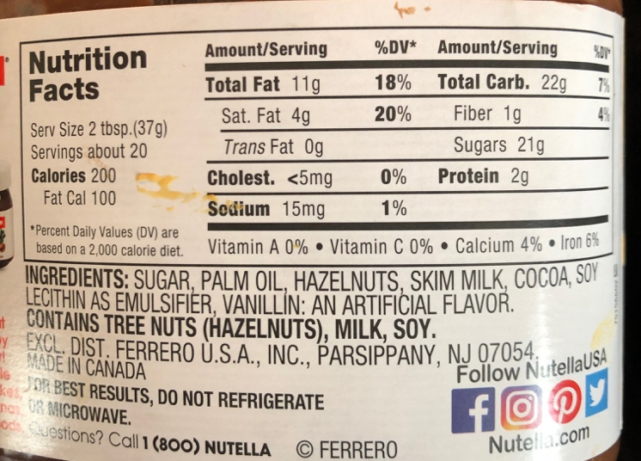  A | B 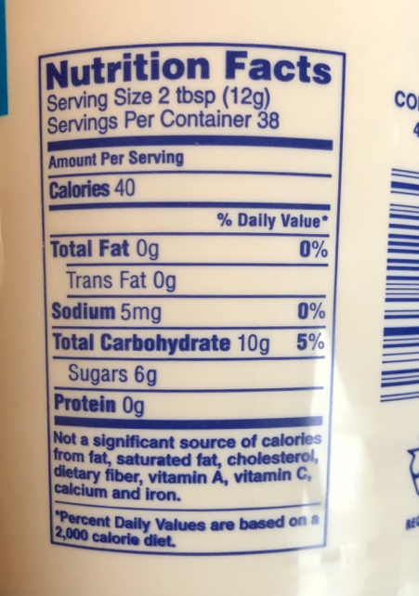
Figure 1: Sample food labels A: Nutella B: Marshmallow Fluff
Students are then asked to calculate the a_{w} for one of the foods, compare that value to the FDA information, and share with the class what they find. In order to calculate a_{w} for a food, students can use the quantities of various compounds given on the nutrition label to determine their mole fractions within a serving of the food. While this does not lead directly to a_{w}, it can with the following simplifying assumptions. First, students are asked to assume that the solution is ideal for non-ionic substances. Second, students are asked to assume that all ionic substances dissociate completely, and therefore have an activity that is equal to the number of ionic species times the concentration. Finally, students are instructed to assume that, after accounting for all species listed on the nutrition label, the balance of the compounds in the serving are all water. That is, because water is not commonly listed on the nutrition label, it is taken to be all of the mass not accounted for otherwise. To aid in calculation, students are given a handout shown in figure 2, giving them median values for compounds commonly found on food labels.

Setup and computation typically requires 15-20 minutes, which is followed by an additional 10 minutes of discussion in class.

As a follow-up for the in-class exercise, students are asked the following as a homework problem: Pick a fresh fruit, vegetable, or meat (not strawberries), and estimate a_{W} for that item, making the same assumptions we made in class. THEN through a combination of the following, propose a self-stable (i.e. a_{w} <0.80) preparation of that food. Keep in mind, even for a food that is somewhat “dehydrated,” the mass fraction of water is bit less than 20%. Therefore, in addition to proposing to dehydrate your food, you should also consider adding compounds such as salt or sugar to further reduce a_{w}. Find an example food that is similar to your proposal; based on the ingredients on its label and its a_{w}, how realistic is your proposal?

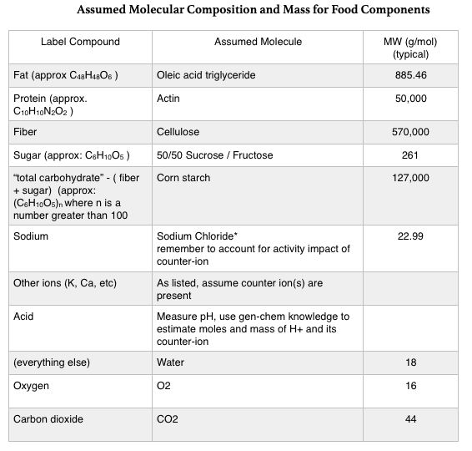
Figure 2: Handout for students giving assumed molecular masses

Results of both of these are considered in the next section.
  - Results and Discussion
A sample calculation of a_{w} for the food shown in figure 1B, using the handout from figure 2, is as follows:

Serving size: 12g
Sodium: 5x10⁻³g / (22.99 g/mol ) = 2.2x10⁻⁴moles therefore salt is 4.4x10⁻⁴
Sugars: 6g / (261 g/mol) = 0.022 moles
Starches: 10g-6g = 4g / (127,000 g/mol) = 3.1x10⁻⁵ moles
Water: 12g – 10.005g = 1.995 g / (18 g/mol) = 0.11 moles

Total moles = 0.133 moles
a_{w} = 0.11 / 0.133 = 0.82

This value suggests that this food is shelf-stable which indeed is the case for Marshmallow Fluff. An even simpler calculation is that for the food shown in figure 1A, where it may be determined by inspection that a_{w} is expected to be approximately zero. Nutella is also shelf-stable.
Using this activity in class, students generally perform well on the in-class activity and report high levels of satisfaction with now understanding better how it is determined that some foods must be refrigerated, some only after opening, and some never.

The associated homework problem has likewise impressive results. For example, students have previously chosen to explore the preservation of strawberries. They find, unsurprisingly, that fresh strawberries have a a_{w} near 0.99, and therefore are expected not to have a very long shelf life. A particular satisfaction arose from their calculation of how to preserve strawberries. Students calculated that to reduce the a_{w} of a strawberry to an acceptable 0.85, not only would it require removal of 1/3 of the water, it requires addition 1.5x as much mass in sugar as strawberries. A student appealed to the instructor that she must have made an error, for the result was plainly ridiculous. The instructor then showed the class the recipe for strawberry jam, which indeed contains that much sucrose. Students were amazed. This provides a valuable context for discussion of the broader problem of sugar and salt in processed foods and that these compounds aren’t there merely because they taste good or because large corporations are ‘bad’, but because they are a necessary part of food preservation.

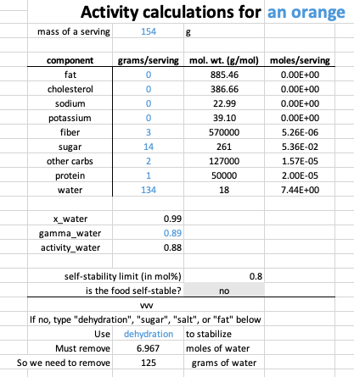
Figure 3: Screenshot of student-developed a_{w} calculation tool
Figure 3 shows a Microsoft Excel-based tool constructed by another student, D. Speer (2018), which automatically solves the homework problem. A benefit of this tool, compared with “by-hand” calculation, is that it allows students to easily experiment with different chemical approaches to food preservation (fat, salt, sugar, dehydration), so they may compare multiple possible outcomes. Future versions of this assignment, using this tool, will ask students to consider how their proposed food will perform with respect to health-related ingredient guidelines.

This approach is a useful compliment to the typical in-class exercises and homework seen in an undergraduate chemical engineering thermodynamics course. The additional use of activity as a food-safety calculation provides a number of benefits not seen in the typical course presentation. First, it connects an invisible quantity, activity, to an everyday experience such as eating chips. Second, it gives students an opportunity to use a thermodynamic calculation in service of product design. Authentic problems such as these have been shown to be more motivational for students, enhancing learning. Finally, it gives students exposure to regulations and standards, something expected by engineering accreditation entities such as ABET.
  - Conclusions
In undergraduate chemical engineering, activity calculation is often presented as a tool to enable design of separation units, such as vapor-liquid equilibria for distillation or reverse osmosis for water purification. Adding to this by sharing the ways a_{w} impacts food safety provides an additional motivation for this important topic. In addition, an assignment where students apply a_{w} provides an authentic experience in which students re-discover why preserved foods have the high sugar or salt concentrations that they have. This exercise is applicable within undergraduate chemical engineering for both introductory and more advanced courses.

References

Elliott, J.R. and Lira, C.T, “Introductory Chemical Engineering Thermodynamics,” New York, USA: Prentice Hall, 2010.
Cole, J., Dahm, K., Ford, L., Landherr, L., Silverstein, D., Vigeant, M., West, C., 2019, “How we teach: Thermodynamics,” American Association for Engineering Education.
Gustavo V. Barbosa-Cánovas, J. F. Anthony J., and A. S. J. Schmidt,(Eds), 2007 “Water activity in foods: fundamentals and applications,” in 13, New York, USA: John Wiley & Sons, Incorporated.
Speer, D., 2018 “Water activity calculation spreadsheet,” personal communication. Shared with permission.
US FDA, 2015, Water Activity (a_{w}) in Foods, US Food and Drug Administration < https://www.fda.gov/ICECI/Inspections/InspectionGuides/InspectionTechnicalGuides/ucm072916.htm> accessed 24.01.2019.
Vigeant, M., 2017, Why is the mustard in the fridge? A fun assignment on the thermodynamics of food safety, abstract, American Institute of Chemical Engineers Annual Meeting, Minneapolis, MN

