CHEMICAL ENGINEERING TRANSACTIONS  VOL. 76, 2019 | A publication of
The Italian Association
of Chemical Engineering
Online at www.aidic.it/cet
Guest Editors: Sauro Pierucci, Jiří Jaromír Klemeš, Laura Piazza
Copyright © 2019, AIDIC Servizi S.r.l.
ISBN 978-88-95608-73-0; ISSN 2283-9216

Fermentation of rice flour supernatant using Lactobacillus Paracasei CBA L74
Dana Salameh ª, Federica Nigro^{b}, Rosa ColucciCante, Francesca Passannanti ª, Marianna Gallo ^{a,b},Andrea Budelli ^{c}, Antonio Marzocchella ª, Roberto Nigroª.

ª University of Naples Federico II, DICMAPI, 80125 Naples, Italy
^{b} University of Rome Niccolò Cusano, Engineering Department, 00166 Rome, Italy
^{c} KraftHeinz Innovation Center, NieuweDukenburgseweg 19, 6534 Nijmegen, Netherlands
*Corresponding Author
Roberto Nigro
e-mail address:
rnigro@unina.it
Abstract:
The concept of functional food has evolved throughout the years. These days we define a food to be functional when it confers a benefit to human health. Lactic acid fermentation is one of the most important and used food processing technologies to produce this type of food. Fermentation of Lactobacillus Paracasei CBA L74 - a homofermentative, gram positive probiotic - on rice flour suspension has been proved to be a successful route to produce functional foods. However, the process was characterized by high energy consumption, low air sparging and complex expensive metabolite separation.
A research program has been developed to carry out L. Paracasei fermentation using a low viscosity medium based on rice flour suspension. Fractionation of rice flour suspension provided a medium characterized by low amounts of solids and nutrients at concentration high that support the microorganism growth. Fermentations were carried in a 1L batch reactor equipped with an agitation systems designed to provide uniform mixing. The composition of the medium; cells, glucose, protein, pH, metabolite production as well as L. Paracasei’ growth trend was analysed throughout the process. Fermentation on supernatant obtained from rice flour and water suspension through centrifugation were possible to produce a potential probiotic functional food with a good bacterial charge.
  - Introduction
The concept of functional food has evolved throughout the years. Nowadays consumers do not consume food only to satisfy hunger and provide nutrients but also to prevent nutrition related diseases, improve the overall quality of life, physical health and mental wellbeing (Kotilainen et al., 2006; Robertfroid, 2000a, 2000b).
In Europe food is considered functional if it has beneficial effects on one or more functions of the human organism, together with the basic nutritional impact, thus either improving the general and physical conditions or/and decreasing the risk of the evolution of diseases. (Siro et al., 2008, Diplock et al., 1999)
Probiotics are part of the functional foods widely used to improve health. With the term “probiotics” we usually refer to lactobacilli or bifidobacteria, both dominant endogenous members of the gut microbiota. The amount of probiotics considered adequate to obtain a temporary colonization of the intestine by lactic acid bacteria is at least 10⁷ living cells per day (International dairy federation, 1997)
Probiotics are usually defined as live microbial feed supplement which beneficially affects the host by improving and/or modifying its intestinal microbial balance, (Fuller, 1989) without the side effects of traditional antibiotics. These advantages have fuelled the industrial interest in the development of systems for their production.
Lactic acid fermentation is a bacterial process that takes place during the production of numerous food products, providing characteristic aroma and texture to the final product and conferring beneficial properties for human health. Most studies found in literature are performed on dairy products and cereals and in this paper a promising process on supernatant obtained from an aqueous rice flour suspension is discussed to promote the growing of Lactobacillus paracasei CBA L74, a gram positive, homofermentative probiotic. Several fermentation tests were usually performed on synthetic minimal cultures (Van der Osten et al., 1989, Martinez et al 2007, Narendranath et al., 2001) but to the best of our knowledge none were performed on food matrices. The choice to use minimal cultures is usually releated to various benefits, reducing feed preparation costs, and in some cases reducing the clogging problems in immobilized cell reactor (Chen et al., 1990).
The aim of the present study was to ferment L. paracasei on a matrix that allowed the extraction of the metabolites. The liquid phase separated by centrifugation of rice flour and water suspension was used as fermentation feedstock: the supernatant was a less complex matrix characterized by low content of nutrients. The centrifugation rate was used as tuning variable to modify the fermentation broth.
  - Materials and Methods
2.1 Microorganism
The strain used as starter culture was Lactobacillus paracasei CBA L74, (Heinz Italia SpA), International Depository Accession Number LMG P-24778. That strain is a gram positive homofermentative, facultative anaerobic bacteria. Stored at -26 ᵒC in animal free Broth (BAF), revitalized through incubation at 37 ᵒC for 24 hours.
2.2 Apparatus:
Fermentation tests were carried out in a batch reactor of 1.5 L. The experimental laboratory system consisted of four components: vessel, mixing system, thermal conditioning system and temperature measurement system.
The vessel was cylindrical Pyrex (20 cm high, 10 cm ID) equipped with an external jacket that allowed the circulation of a service fluid necessary to maintain the entire apparatus at a constant temperature (37 °C). The fluid was thermo regulated through a thermo-stated bath. The reactor is shown in Figure 1 (a)
The mixing system was a stainless-steel impeller equipped with two Rushton turbines, as shown in Figure 1 (b): the first turbine with a diameter of 5 cm and a height/ width/ thickness of blades of 1.2/ 1.7/ 0.1 cm respectively; the second turbine had a diameter of 4 cm and height/ width/ thickness of blades of 0.7/1.0/ 0.1 cm respectively That mixing system was used to guarantee homogeneity of the matrix and avoid gradient temperature and microorganism concentration. The impeller was linked to a motor that allowed the adjustment of the stirring speed and had an input connected to a probe, useful for automatic measurement of temperature simultaneously to the process’ progress. pH and temperature were continuously measured using InPro 3100i Mettler Toledo probe with a diameter of 12 cm and a length of 15 cm as shown in Figure 1 (c).
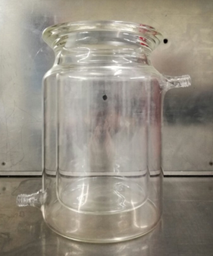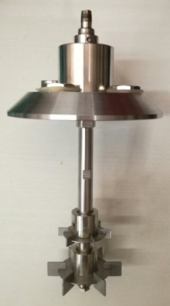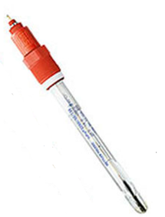
- (b) (c)
Figure (1): the apparatus used to perform the fermentations; (a) the batch reactor with the external jacket for fluid circulation (b) the impeller with two Rushton turbines, (c) the probe used to measure pH and temperature

2.3 Operating conditions and procedure:

The process was divided in three steps: the first step was the preparation of the initial rice flour and water suspension, the second step was its centrifugation to obtain the supernatant, and the third step was the fermentation of supernatant. All processes were carried out under sterile conditions.
The suspension consisting of rice flour (15 %), water (84 %), glucose as an immediate carbon source (1%) was loaded into the reactor (with a working volume of 1 L) and treated with amylase (0.12 %) at pre-set temperature/ time to avoid the gelatinization of the starch and to provide homogeneity of the suspension. The suspension was centrifuged and the supernatant used for successive tests.
To assess the best time/centrifugal force ratio to obtain a suspension containing a low concentration of solid particles but sufficient nutrient content to ensure microorganism growth, several combination of centrifugation rate and centrifugation time were investigated. After centrifugation of the suspension we obtained a supernatant of almost 700 mL that was subjected to heat treatment in autoclave (121°C for 20 min) before the start of fermentation to ensure the sterility of the substrate.
The fermentation of the supernatant was performed in the system described in §2.2. Tests were carried out at 37 °C for 24 h.

2.4 Analytical Methods:

The fermentation process performed was analysed in terms of bacterial growth, glucose concentration, protein content, pH, primary and secondary acids produced. To evaluate L. paracasei CBA L74 growth and the presence of contaminants, spread plate method was used. Lactobacillus’ growth was evaluated on M.R.S. plates (Sigma Aldrich), whereas MacConkey (Sigma-Aldrich) and Gelisate agars (Biolife), were used to evaluate the presence of contaminants. The plates were incubated then at 37 °C for 2 days before reading. Glucose concentrations during the fermentation process was analysed using a colorimetric method: D-glucose Assay kit (GOPOD format). The protein content in the supernatant initially and throughout the fermentation was analysed using the Bradford assay (Sigma-Aldrich). Lactic acid concentration was measured by using an HPLC (Agilent technologies 1100 with visible UV detector). Agilent Zorbax C18 column (4,6 mm x 150 mm and a pore size of 80 A) was used. The flow rate was set at 0.8 mL/ min; the mobile phase was ammonium phosphate with a pH of 2.7 with detection at 218 nm. Butyric, propionic and acetic acids concentration was carried out by gas chromatography (Agilent Technologies 6890). Capillary Poraplot Q column (25m x 0.32mm) was used. The flow rate was 200 ml\ min. The mobile phase was helium gas. The internal standard is esanoic acid at 5 g/L.

  - Results
The fermentation tests were performed using the previously described system.
Centrifugation carried out under severe centrifugation (high centrifugation rotation rate) deprived the liquid phase of suspended nutrients at such extension that no bacteria growth was recorded on the recovered liquid phase (not reported). According to this observation the maximum centrifugation rate was set at 2000 rpm. Presented results regard two conditions: centrifugation at 1000 rpm for 15 minutes; centrifugation at 2000 rpm for 15 minutes.
The two centrifugal speeds gave two matrices different in terms of nutrient content which led to different bacterial growth and production of lactic acid. In figure 2 is reported the growth obtained during 24 hours of fermentation. As shown, both fermentations started with a bacterial charge of 10⁶ CFU/ ml. In the first fermentation condition (1000 rpm) the highest growth was reached at 22 h corresponding to 1.2*10⁸ ± 6.2*10⁷ CFU/ml, while in the second fermenting condition (2000 rpm) the highest charge was reached at 18h corresponding to 2.10⁷ ± 8.5*10⁶ CFU/ ml. pH levels followed the same trend in both conditions, dropping from initial values of 5.2 to 3.47 decreasing as lactic acid production increased.
Lactic acid production was also investigated considering it is the primary metabolite of L. paracasei. In both conditions its production started after 8 hours of fermentation, and the values reached are reported in figure (6). As shown, the highest amounts were measured at 20 hours at 1000rpm corresponding to 486.225 ± 2.06 ppm, while at 2000 rpm 350 ± 4.13 ppm were registered at 20 hours of fermentation. Secondary acids such as butyric, acetic and propionic acids were not detected throughout the fermentations, further confirming the sterility of the process.
The difference on glucose concentration (figure 4) between the two matrices is not very relevant (2.1mg/mL at 1000 rpm and 2.03 mg/mL at 2000 rpm) and in both cases the quantity was enough to allow the growth. Protein content (figure 5) on the other hand was much lower in the suspension obtained at the higher centrifugation speed (2000 rpm) that consented a greater separation of nutrients. In fact, such centrifugation speed gave a protein concentration of 0.085 mg/mL as oppose to 0.38 mg/mL in the supernatant obtained at 1000 rpm.

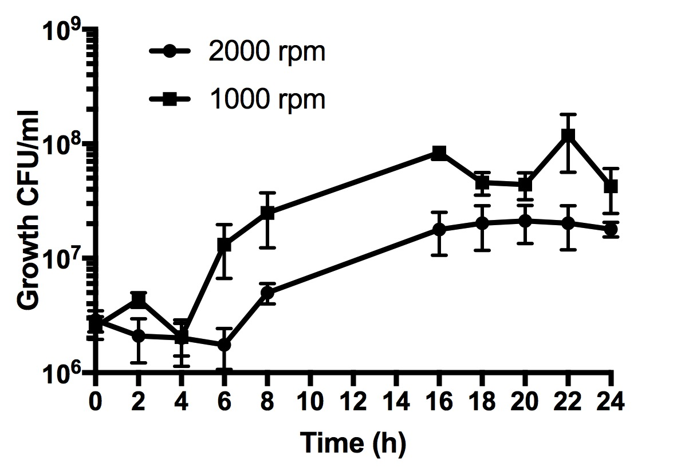
Figure (2): Comparison between the growth of L. paracasei fermented on 1000 rpm supernatant and 2000 rpm supernatant
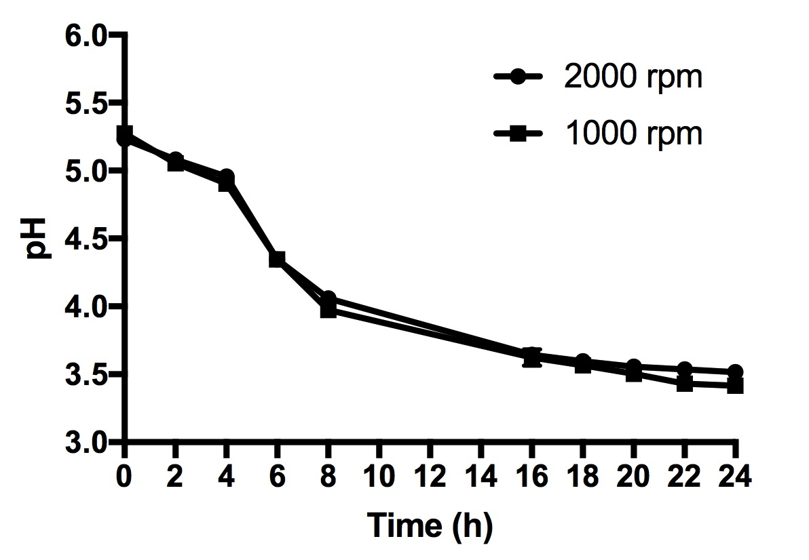
Figure (3): comparison between pH levels during fermentations.
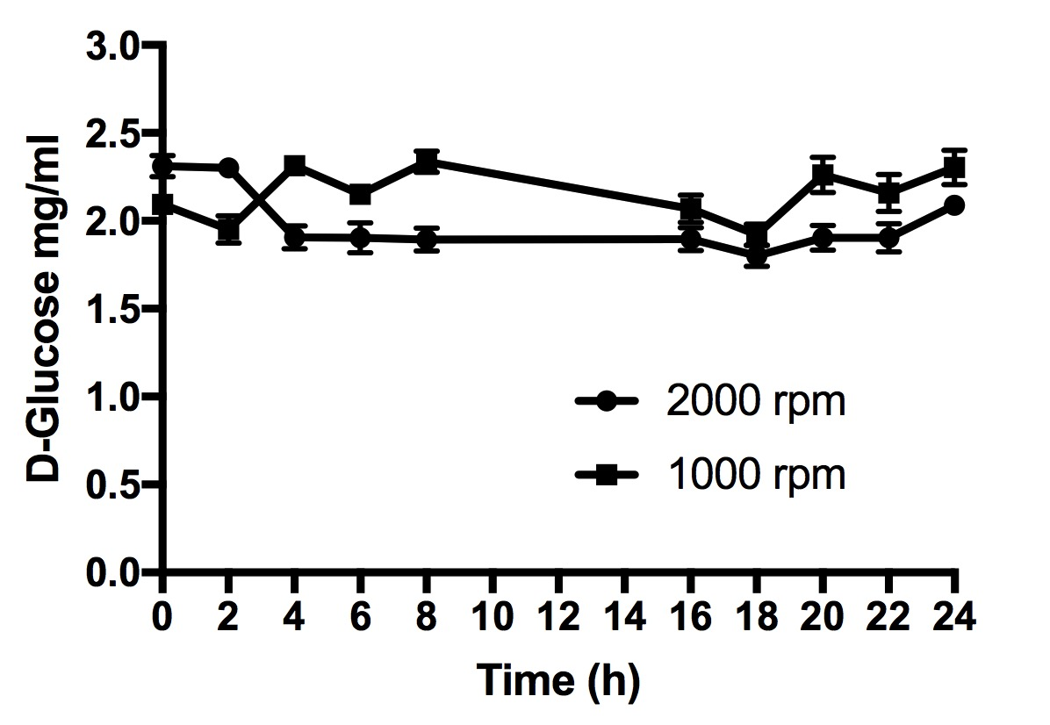
Figure (4): comparison between D-glucose concentrations during fermentations.
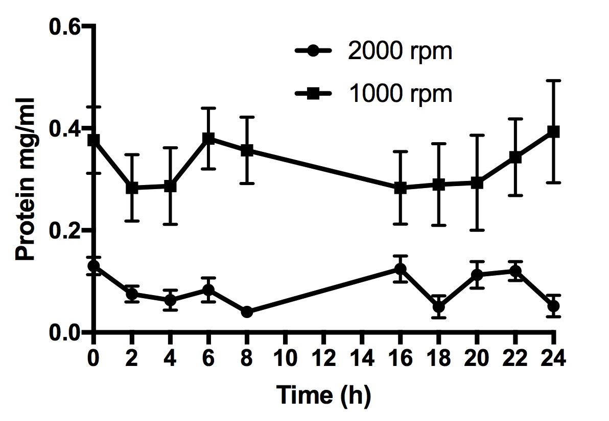
Figure (5): comparison between protein concentration during fermentations.
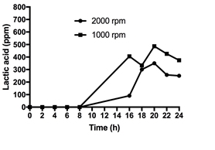
Figure (6): comparison between lactic acids concentration produced during fermentations

  - Conclusions
Both fermentation conditions gave satisfying results in terms of microbial growth and lactic acid production. In the first condition tested (1000 rpm) the lag phase lasted for the first 4 h of fermentation while lasting for 6 hours in the second condition tested (2000 rpm). The exponential phase ended around 16 h for both conditions (1000 rpm and 2000 rpm) with a higher bacterial charge for 1000 rpm (respectively 8.39 *10⁷ CFU/ ml and 5*10⁶ CFU/ ml). Death phase wasn’t detected in both cases considering the tests only lasted for 24 hours and no sampling was done afterwards indicating its start after 24 h. pH levels dropped constantly in both cases from a value of 5.2 to a more acidic level around 3.6 which was consistent with the maximum lactic acid production of about 350 ppm at 2000 rpm (20 h) and about 480 ppm at 1000 rpm (20 h). Regarding glucose and protein concentrations, in both conditions they remained constant during the entire fermentation process even if in the supernatant obtained at 2000 rpm the mean value of proteins was lower than that at 1000 rpm probably due to the stronger centrifugal force. In particular, regarding glucose concentration an explanation could be the fact that the microorganism can use other carbon sources for the growth, while for proteins the constant concentration during the whole process could be explained by a simultaneous consumption and synthesis of proteins, which is not discriminated by the method of analysis.
The aim of this study was testing the possibility of a potential fermentation process on supernatant obtained from a rice flour and water suspension containing minimal amounts of nutrients. The choice of supernatant was made to allow energy savings as the viscosity is similar to water, as well as an easier pre-treatment of the sample for analysis. The lactic acid bacteria chosen was L. paracasei CBA L 74 (depositary accession number LMG P-24778) provided by the Kraft-Heinz company. Two fermentation conditions were studied; supernatant obtained after centrifugation of suspension at 1000rpm and 2000 for 15 minutes in both cases. Fermentation tests done confirmed overall better conditions in the case of supernatant 1000 rpm, providing a higher bacterial charge and a maximum lactic acid concentration at earlier times. Future prospects include understanding the interaction of such obtained probiotics with the digestive system and possible methods of transit / release through the digestive system.

References:
Chen, C., Dale, M.C. and Okos M.R. (1990) Minimal Nutritional requirements for immobilized yeast. Biological industries. Vol 36 p:993-1001
Diplock, A. T., Aggett, P. J., Ashwell, M., Bornet, F., Fern, E. B., & Roberfroid, M. B. (1999). Scientific concepts of functional foods in Europe: Concensus document. British Journal of Nutrition, 81(suppl. 1), S1–S27.
FAO/WHO] Food and Agriculture Organization of the United Nations, World Health Organization. 2001. Evaluation of health and nutritional properties of probiotics in food including powder milk with live lactic acid bacteria. C´ordoba. 34 p.
Fuller 1989. Probiotics in man and animal. Journal of applied bacteriology. 66, 365-378
Koletzko B, Aggett PJ, Bindels JG. 1998. Growth, development and differentiation: a func- tional food science approach. Braz J Nutr 80:35–45
Kotilainen L, Rajalahti R, Ragasa C, Pehu E. 2006. Health enhancing foods: opportunities for strengthening the sector in developing countries. Agriculture and Rural Development Discussion Paper 30.
Martinez, A., Grabar T.B., Shanmugam K.T., Yomano L.P., York, S.W., Ingram, L.O. (2007) Low salt medium for lactate and ethanol production by recombinant Escherichia coli B. Biotechnological letters 29:397-404. Doi10.1007/s10529-006-9252-y.
Narendranath N.V., Thomas K.C. and Ingledew W.M. (2001) Effects of acetic acid on the growth of Saccharomyces cerevisiae in a minimal medium. Journal of industrial Microbiology and biotiechnology. Vol 26, p:171-177
Robertfroid, M. B. (2000a). Concepts and strategy of functional science: the European perspective. American Journal of Clinical Nutrition, 71, 1660e1664.
Robertfroid, M. B. (2000b). A European consensus of scientific concepts of functional foods. Nutrition, 16, 689e691
Sanders ME. 2003. Probiotics: considerations for human health. Nutr Rev 61:91–9.
Siro, Istvan, et al. "Functional food. Product development, marketing and consumer acceptance—A review." Appetite 51.3 (2008): 456-467.
Van der Osten, C.H., Gioannetti, C., Sinskey J. (1989) Design of a defined medium for growth of corynebacteriium glutamicum in which citrate facilitates iron uptake. Biotecnnology letters Vol 11, no1, p 11-16.

