CHEMICAL ENGINEERING TRANSACTIONS  VOL. 76, 2019 | A publication of
The Italian Association
of Chemical Engineering
Online at www.aidic.it/cet
Guest Editors: Sauro Pierucci, Jiří Jaromír Klemeš, Laura Piazza
Copyright © 2019, AIDIC Servizi S.r.l.
ISBN 978-88-95608-73-0; ISSN 2283-9216

Influence of Roasting Process in Six Coffee Arabica Cultivars: analysis of Volatile Components Profiles
Fabrizio Sarghini*ª, Evelina Fasano ª, Angela De Vivo ª, Maria Cristina Tricarico^{b}
ªUniversity of Naples Federico II, Department of Agricultural Sciences, Naples, Italy
^{b} Kimbo Spa, Italy
* fabrizio.sarghini@unina.it

The complex composition of coffee aroma depends on the several factors regarding green coffee such as species and variety of the beans, origin , seeds size, colour (Toci and Farah, 2014). The most important coffee varieties are known to be Coffea arabica with good organoleptic characteristics, and Coffea canephora , known as Robusta of inferior quality. Development of aroma compounds also is greatly dependent upon the degree of roasting (Lopez-Galilea et al., 2006). In the roasting process almost 840 volatile organic compounds (VOC) are evaluated (Saw et al., 2015). The aim of this work is to investigate of the aromatic profile of six Arabica cultivar from Africa, Central and South America at different roasting degrees (light, medium and dark) and to establish odordescriptor categories as indicators for the assessment of flavour differences. The three roasting degrees were obtained in laboratory considering as target the industrial products and coffee roasting intensity was evaluated by a polychromatic colorimeter. The aromatic compounds of espresso coffee were evaluated by static headspace gas mass chromatography. The 67 key odors identified were classified in ten smell groups: floral, ethereal, fruit, chocolate, sweet and sugary, nut, grain and cereals, roast, spice, vegetal and earthy as suggested by Flament (2001). Results showed a consistent difference between different origins, depending on roasting intensity and maturation time, reflecting the possibility to optimize espresso coffee mixtures in an analytic way.
1. Introduction
Coffee beverages may be obtained using several extraction methods, among which espresso coffee (EC) represents now a worldwide adopted system. The grinding process is an essential step of coffee production cycle both for the aromatic profile composition and for the chemical properties of the beverage (Severini, 2015). The comminution process consists of the breaking down particles into smaller fragments; as well-known, its main objective is to increase the overall particle surface area exposed to water leading to a more efficient extraction of soluble substances (Illy,2005). Basically, the coffee brewing process includes two steps: a washing phase concerning the snapshot dissolution of free solubles at the particle surface followed by diffusion phase of solubles within the porous particles (Spiro 1992, Baggenstoss,2008). Espresso Coffee blends are designed using different varieties (Arabica and Robusta), and also in the case of a pure Arabica coffee, several geographic origins are required to provide specific flavours. Among process parameters, roasting grades represent an important discriminant interfering with thermal transformation of precursors in Streicker and Maillard reactions.
2. Methods
The relationship between the absolute quantitative of any aromatic compound and the sensory perception is not completely known (perception thresholds) depending on the sensory system of each individual. Some molecules present in small quantities can cause characteristics to be more pronounced in the gustatory and olfactory system due to different perception thresholds. The purpose of this research lies in the analysis of the contribution of different origins of Coffee Arabica to espresso coffee. For this reason, gas chromatography was chosen as a methodology based on a comparison of the peak areas as already done in previous studies (Maeztu, Sanz, Andueza, De Peña, Bello, & Cid, C., 2001b; López-Galilea, Fournier, Cid, & Guichard, 2006; Akiyama et al., 2008; Caporaso, Genovese, Canela, Civitella, & Sacchi, 2014).
Pure reference standards of acetaldehyde, propanal, 2-methylpropanal, 3-methylbutanal, 2,3-butanedione, butanal, 3-methylbutanal, 2,3 pentanedione, 3-O-caffeoylquinic acid (3-CQA), 4-O-caffeoylquinic acid (4-CQA), 5-O-caffeoylquinic acid (5-CQA), caffeine, trigonelline and nicotinic acid were purchased from Sigma-Aldrich (Milano, Italy), while for others up to 71 aromatic compounds detection was based on NIST 14 library as described in the following lines.
Six different origin samples of Arabica coffee were provided by Kimbo S.p.a., and they were analysed for the evaluation of the aromatic component. In particular the samples’ origin was:
• HONDURAS
• SALVADOR
• PERU’
• RUANDA
• KENIA
• NICARAGUA
They were roasted in order to obtain three degrees of toasting (LIGHT, MEDIUM AND DARK) and therefore the aromatic component was evaluated by gas chromatography associated with an MS detector with the aid of the static headspace. Roasting was carried out by means of a Probatino rotary drum roaster, provided with a display to monitor the roasting time and temperature. For each test, 1 Kg of green coffee was roasted for each batch.
The programmed roasting recipe was divided in the following steps: switching on the roasting drum, heating for 20 min at 200 ° C, raising the temperature to 245 °C, lowering the temperature down to 235 ° C, placing the product in the roaster, monitoring the temperature over time (every 30 seconds) until the required temperature is reached to obtain the three degrees of toasting, emptying the roaster with a suitable door and cooling down the coffee at room temperature.
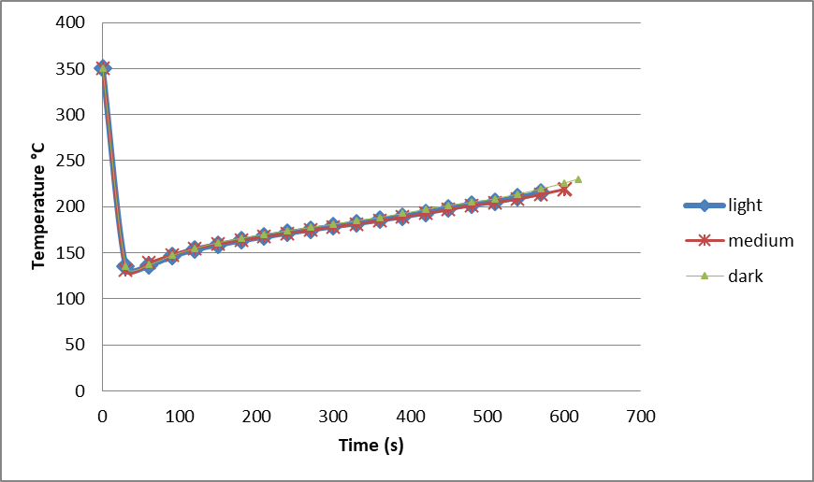
Figure 1. Typical roasting curves for light, medium and dark roasting.
Espresso coffee (EC) was prepared with an EC machine mod. USB Rancilio (Villastanza di Parabiago, Italy) with filter holder single and dual-dose fixed the following experimental conditions: 7.5 g of ground coffee, a 60 mm of holder filter diameter with a minimal tampering to adjust the cake distribution inside, water temperature was set to 92 °C, and pressure was set to 9 bar. In accordance with the literature (Clarke et al., 2001; Andueza, Maeztu, Dean, De Peña, Bello, & Cid, 2002a; Andueza, Maeztu, Pascual, Ibañez, De Peña, & Cid, 2002b), pressure and temperature may be considered as the most common extraction conditions for preparing an espresso coffee. The regular EC of 25 mL in 25 s, from each particle size, was prepared measuring the volume of brew through a graduate cylinder. Twenty ECs of each coffee sample were prepared to be analyzed in triplicate.
The toasting degree was evaluated from time to time with a Tonino polychromatic reflecting LED colorimeter (https://my-tonino.com/). A coffee sample of 15 g was ground, and placed in a coffee filter, lightly pressed and then the relative colorimetric value evaluated; in particular three readings were conducted, each one characterized by three replicas. The values measured by the instrument were then converted, using a software tool, into a Probat scale, commonly used for the classification of coffee roasting in industrial market. Table 1 shows the values found for each colorimetric degree at each different toasting level.
Table 1 – Coffee varieties and roasting
SAMPLE | ROASTING | COLORIMETRIC GRADE
RUANDA | LIGHT | 89-90-92
 | MEDIUM | 71-72-71
 | DARK | 36-37-37
KENIA | LIGHT | 87-86-87
 | MEDIUM | 68-69-68
 | DARK | 33-33-34
ETIOPIA | LIGHT | 92-92-93
 | MEDIUM | 69-70-69
 | DARK | 45-45-43
HONDURAS | LIGHT | 87-87-87
 | MEDIUM | 68-69-68
 | DARK | 33-33-34
SALVADOR | LIGHT | 89-90-89
 | MEDIUM | 67-69-67
 | DARK | 33-34-33
NICARAGUA | LIGHT | 87-86-86
 | MEDIUM | 68-39-70
 | DARK | 35-35-36
The aromatic profiles of volatile compounds were analyzed with the method described by Sopelana et al. (2013), using static headspace gas chromatography/mass spectrometry (SH-GC/MS) and by making some changes. SH-GC analysis was performed with the Thermo Scientific TRACE 1310 Gas Chromatography equipped with the Thermo Scientific TriPlus RSH autosampler configured for static headspace automation.
A 8 mL volume from a homogenized EC cup was introduced into a 20 mL vial, which was immediately sealed with a silicone rubber Teflon cap. Each vial was equilibrated at 70 °C for 30 min in the static headspace sampler and 1 mL of the coffee headspace sample was injected into the Phenomenex ZB-FFAP column (60 m × 0.25 mm, 0.25 μm film thickness). Each EC sample test was performed in five replicates.
The injector temperature was set at 180 °C with split injection mode and the flow of the helium carrier gas was 1 mL/min. The temperature program was set at an initial 40 °C for 6 min, followed by an increase of 3 °C/min to 220 °C (held for 10 min). Mass spectrometry analysis was carried out using the Thermo Scientific TSQ 8000 Evo Triple Quadrupole coupled to the gas chromatograph. The mass spectrometer operated in the electron impact ionization mode (70 eV), with a scan range of 27 to 300 amu. Interface and ion source temperature were set to 230 and 240 °C, respectively. The identification of compounds was confirmed by using pure standards and comparison of their retention times with those of standard compounds. When reference compounds were not available, a tentative identification was given on the basis of the mass spectra stored in NIST14 libraries. Areas of peaks were measured in the SIM (single ion monitoring) by calculation of the total area based on integration of a single ion. These aromatic compounds were grouped into key odorants families: floral, ethereal, fruit, chocolate, sweet and sugary, nut, grain and cereals, roast, spice, vegetal and earthy, as suggested by Flament (2001). Table 2 shows the 67 odorants identified and their “key-odour” characterization.
Table 2- | Volatile Odor Components
FLORAL | 3-Penten-2-one; Acetylfuran; 2-Furanmethanol, acetate
ETHEREAL | Acetaldehyde; Methyl formate; Acetone; 3-Pentanone; Furan, 2-methyl-; 2-Butanone; Furan, 2,5-dimethyl-; Methyl isovalerate; 1-Butanol, 3-methyl-; 2-Propanone, 1-hydroxy-; 2-Furanmethanol, acetate; Acetic acid, methyl ester
FRUIT | Propanal, 2-methyl-; Butanal, 2-methyl-; Butanal, 3-methyl-; Methyl isovalerate; Hexanal; 3-Penten-2-one; 1-Butanol, 3-methyl-; 4-Methylthiazole; Furfuryl propionate
CHOCOLATE | Pyrazine, methyl-; Pyrazine, 2,3-dimethyl-; Pyrazine, 2,5-dimethyl-; Pyrazine, 2,6-dimethyl-
SUGAR | 2,3-Butanedione; 2,3-Pentanedione; Pyrazine, 2,6-dimethyl-; Benzaldehyde; 2(3H)-Furanone, dihydro-; Thiophene; 2,3-Hexanedione; Pyrazine, ethyl-; 2-Furancarboxaldehyde, 5-methyl-; Toluene; 2-Furanmethanol, acetate; 2-Propanone, 1-hydroxy-; Furfural; Furan, 2,2'-methylenebis-
NUT | Furan, 2-(methoxymethyl)-; Pyrazine, methyl-; 4-Methylthiazole; Benzaldehyde; Pyrazine, 2-ethyl-6-methyl-; Pyrazine, ethyl-; Pyrazine, 2-ethyl-3-methyl-; Pyrazine, 3-ethyl-2,5-dimethyl-; Pyrazine, 2,5-dimethyl-; Pyrazine, 2,6-dimethyl-  Pyrazine, 2,3-dimethyl-; 3-Penten-2-one
CEREAL | 2-Vinylfuran; 1H-Pyrrole-2-carboxaldehyde, 1-methyl-; Furan, 2-(methoxymethyl)-; Furfural
ROAST | Propanal; Furan; Butanal, 2-methyl-; Pyrazine, ethyl-; PhenolFumaric acid, dipropargyl ester, 2-methoxy-; 2-Vinylfuran; 1H-Pyrrole, 1-methyl-; Phenol, 3-methyl-; Pyrazine, 2,5-dimethyl-; Pyrazine, 2-ethyl-5-methyl-; Pyrazine, 3-ethyl-2,5-dimethyl-; Pyridine; Pyrazine, methyl-; Pyrazine, 2,3-dimethyl-; Pyrazine, 2-ethyl-3-methyl-; Furan, 2-[(methylthio)methyl]-
SPICY | Furan; Acetic acid; Furan, 2-[(methylthio)methyl]-; 2-Furanmethanol, acetate; 2-Furancarboxaldehyde, 5-methyl-; Furan, 2-(2-furanylmethyl)-5-methyl-; Phenol, 2-methoxy-; Fumaric acid, dipropargyl ester; Furfural
VEGETABLE | Disulfide, dimethyl; Hexanal; 1H-Pyrrole, 1-(2-furanylmethyl)-; Thiophene, 2-methyl-; 3-Penten-2-one; 1H-Pyrrole, 1-methyl-; 4-Methylthiazole; Pyrazine, 3-ethyl-2,5-dimethyl-; 2-Furanmethanol, acetate; Furan, 2-(2-furanylmethyl)-5-methyl-; Pyrazine, 2,3-dimethyl-; Acetylfuran; Pyrrole; 2-n-Butyl furan; Furan, 2,2'-[oxybis(methylene)]bis-; 1H-Pyrrole, 1-butyl-

For each compound, significant differences among different origins were determined by one-way analysis of variation (ANOVA). Tukey’s test was applied a posteriori with a level of significance of 95%. Principal component analysis (PCA) was performed to describe the global effect of different origins on the release of volatile compounds. Statistical analysis was performed using XLSTAT 2014.

3. Results and Discussion
PCA analysis of six coffee origins at different roasting levels are reported in Fig.4, 5 and 6. Results show an evident difference in terms of aromatic complexity, more evident for dark roasting level.
Using a light roasting recipe, differences are attenuated, meaning that the aromatic profile is quite similar for all different coffees. Generally speaking, a significant classification aggregates African and South American coffees into two different zones, with the latter providing a more aromatic complexity in term of key-odorants.
This is in agreement with market prices of the analysed coffees.

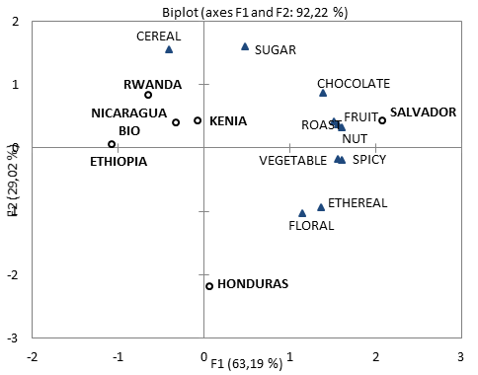
Figure 2: Principal component loadings for the EC light roasted samples.
Usually light roasting is used for drip or filter coffee, while a darker mixture is adopted for espresso coffee. To this purpose, results suggest that using a very high quality coffee does not imply automatically an improvement in the sensory characterization of the beverage. On the other hand results were obtained using espresso brewing, and brewing method has also strong effect on the final result.
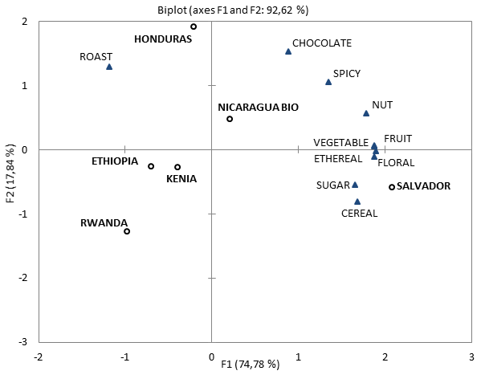
Figure 3: Principal component loadings for the EC medium roasted samples.
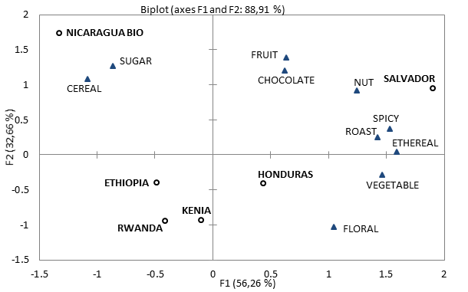
Figure 4: Principal component loadings for the EC dark roasted samples.
Among the six different origins, Salvador coffee seems to provide the most complex profile.
4. Conclusions
In this work a qualitative analysis of aromatic profiles of different Arabica coffee origins for espresso coffee is proposed. Results show a significant characterization of each single origin inside the same variety (Arabica Coffee), suggesting a more evidence complexity for South America coffees respect to African coffees. Moreover, the PCA analysis confirm that, in order of obtain a specific characterization of the aromatic profile, a blend of different origins is always suggested.
5. References

Akiyama, M., Murakami, K., Ikeda, M., Iwatsuki, K., Wada, A., Tokuno, K., Onishi, M., & Iwabuchi, H. (2008). Characterization of headspace aroma compounds of freshly brewed arabica coffees and studies on a characteristic aroma compound of ethiopian coffee. Journal of Food Science, 73, C335–C346.
Andueza, S., Maeztu, L., Dean B., De Peña, M. P., Bello, J., & Cid, C. (2002a). Influence of Water Pressure on the Final Quality of Arabica Espresso Coffee. Application of Multivariate Analysis. Journal of Agricultural and Food Chemistry, 50, 7426-7431.
Andueza, S., Maeztu, L., Pascual, L., Ibañez, C., De Peña, M. P., & Cid, C. (2002b). Influence of extraction temperature of the final quality of espresso coffee cups. Journal of the Science of Food and Agriculture, 83, 240–248.
Baggenstoss, J., Perren, R., & Escher, F. (2008). Water content of roasted coffee: impact on grinding behaviour, extraction, and aroma retention. European Food Research and Technology, 227, 1357–1365.
Caporaso, N., Genovese, A., Canela, M. D., Civitella, A., & Sacchi, N. R. (2014). Neapolitan coffee brew chemical analysis in comparison to espresso, moka and American brews. Food Research International, 61, 152–160.
Clarke, R. J., & Vitzthum, O. G. (2001). Coffee Recent Developments. In Petracco, M., Technology IV: Beverage preparation: Brewing trends for the new millennium. (pp. 140−164). Oxford, U.K.: Blackwell Science.
Flament, I. ,2001. The volatile compounds identified in green coffee beans. In Coffee Flavor Chemistry, Chichester: J. Wiley & Sons, pp. 29–34.

López-Galilea,I., Fournier, N., Cid, C., Guichard, E., 2006. Changes in Headspace Volatile Concentrations of Coffee Brews Caused by the Roasting Process and the Brewing Procedure, J. Agric. Food Chemistry, 54, 8560-8566.
Illy, A., Viani, R., & Suggi Liverani, F. (2005b). Espresso Coffee: The Science of Quality. In Petracco, M., Percolation. (pp. 259−289). San Diego, CA: Elsevier Academic Press.
My Tonino colorimeter <https://my-tonino.com/> accessed 15.04.2019
Maeztu, L., Andueza, S., Ibañez C., de Peña, M. P., Bello, J., & Cid, C. (2001a). Multivariate Methods for Characterization and Classification of Espresso Coffees from Different Botanical Varieties and Types of Roast by Foam, Taste, and Mouthfeel. Journal of Agricultural and Food Chemistry, 49, 4743-4747.
Saw, A.K.C.. Yam, W.S., Wong, K.C. , Lai, C.S., 2015. A Comparative Study of the Volatile Constituents of Southeast Asian Coffea arabica, Coffea liberica and Coffea robusta Green Beans and their Antioxidant Activities, TEOP, 18(1), 64-73.
Severini, C., Ricci I., Marone, M., Derossi, A., & De Pilli, T. (2015). Changes in the aromatic profile of espresso coffee as a function of the grinding grade and extraction time: A study by the electronic nose System. Journal of Agricultural and Food Chemistry, 63, 2321−2327.
Sopelana, P., Pérez-Martínez, M., López-Galilea, I., de Peña, M., & Cid, C. (2013). Effect of ultra high temperature (UHT) treatment on coffee brew stability. Food Research International, 50, 682–690.
Spiro, M. (1993). Modelling the acqueous extraction of soluble substances from ground roasted coffee. Journal of the Science of Food and Agriculture, 61, 371–373
Toci, A.T. , Farah, A. ,2014. Volatile fingerprint of Brazilian defective coffee seeds: corroboration of potential marker compounds and identification of new low quality indicators, Food Chemistry, 153, 298–314.

