CHEMICAL ENGINEERING TRANSACTIONS  VOL. 76, 2019 | A publication of
The Italian Association
of Chemical Engineering
Online at www.aidic.it/cet
Guest Editors: Sauro Pierucci, Jiří Jaromír Klemeš, Laura Piazza
Copyright © 2019, AIDIC Servizi S.r.l.
ISBN 978-88-95608-73-0; ISSN 2283-9216

Physicochemical Properties of Cryoconcentrated Orange Juice
Guillermo Petzold, Patricio Orellana, Jorge Moreno, Prisila Valeria
Department of Food Engineering, Universidad del Bío-Bío, Av. Andrés Bello 720, Casilla 447, Chillán, Chile
gpetzold@ubiobio.cl
Cryoconcentration allows the production of a fruit juice concentrate with retention of the physicochemical properties found in the original fresh raw materials. The objective was to study the physicochemical properties of cryoconcentrated orange juice from a vacuum-assisted cryoconcentration process. The orange juice was frozen in a static freezer and transferred to a suction stage using a vacuum pump (80 kPa) at controlled temperature condition (20 °C). The suction process using the vacuum pump was performed until reaching approximately a concentration of solutes in the concentrate two times the fresh sample. The results show an evident advantage using the vacuum-assisted cryoconcentration technique as compared to evaporation. Thus, in vitamin C from an initial value of around 74 mg/100 ml, the cryoconcentrate and the evaporated sample reached 198 and 124 mg/100 ml, respectively. The vacuum-assisted cryoconcentration is an effective technique to obtain an orange fruit juice concentrated with an important retention of the original physicochemical properties of the fresh juice.
1. Introduction
The concentration of liquid food, such as orange juice is an important food industry unit operation. This unit operation has the objective of water removal and increasing solids. In addition, concentrated products occupy less volume and weight and the consumers only add water to obtain an attractive high-quality final product (Ramaswamy and Marcotte, 2006). In this context, in the recent years, consumer demand for high-quality fruit juices have led to investigating for emerging food technologies such as cryoconcentration (Sandhu and Minhas, 2006).
The concentration of solutions and liquid foods can be performed through three technologies: (1) Evaporation, (2) Cryoconcentration, and (3) Reverse Osmosis (or other membrane technique). Although concentration by evaporation (high temperatures) is widely applied in the food industry, it creates important problems in the food heat-labile components as a result of the high temperature treatment (Deshpande et al., 1982).
Cryoconcentration is an emerging food technology where a solution or liquid food is concentrated via partial or total water freezing and then separating the ice fraction from the concentrated residual solution (Aider and Ounis, 2012). Compared to other conventional technologies, cryoconcentration has some significant potential advantages for producing a high-quality liquid food concentrate because the subzero temperatures used in the process result in a minimal loss of volatiles (Morison and Hartel, 2007; Raventós et al., 2012). In addition, cryoconcentration is an effective technology for protecting the valuable heat-labile components of liquid foods, as noted by Petzold et al. (2016a).
The cryoconcentration is based on the crystallization of water. When an ice nucleus appears and grows from an aqueous solution, the ice crystal expels impurities to build up pure crystal during the freezing process. Thus, the impurities or solutes become segregated on the frozen interphase to increase their concentration as compared to that in the original aqueous solution. This exclusion phenomenon of ice crystals is a major principle of the cryoconcentration techniques (Nakagawa et al., 2010).
Cryoconcentration methods consists of suspension freeze concentration, progressive freeze concentration and block freeze concentration. In suspension freeze concentration, the separation of ice crystals from the concentrated solution is crucial, but, the separation process tends to be more difficult because there are lots of ice crystals with limited size in this method. Progressive freeze concentration on the other hand, involves the formation of a single ice crystal that grows layer by layer from the mother solution (Jusoh et al., 2018). And finally, in block freeze concentration, a solution is completely frozen, thawed, and then the concentrated fraction is separated from the ice by gravitational thawing, sometimes assisted by external forces to enhance the process efficiency (Aider and de Halleux, 2008).
Assisted techniques or external forces that improve the cryoconcentration process are important in achieving commercial viability of this emerging food technology. Alternatives to assisted techniques include the use of external forces such as vacuum. In this way, vacuum (suction by a pump) has been proposed by Hsieh (2008) to get drinkable water from seawater. On the other hand, Petzold et al. (2013) applying a vacuum suction was improved the efficiency over atmospheric conditions in cryoconcentration of sucrose solutions, and Moreno et al. (2013) reported the positive effect of vacuum on the movement of the concentrated liquid fraction in cryoconcentration of coffee brews. Pardo and Sánchez (2015) used a vacuum to the intensification of cryoconcentration applied of sucrose solutions. Petzold et al. (2016b) proposed the application of this assisted technique to cryoconcentration of red wine, orange juice (Petzold et al., 2017) and recently in blueberry (Orellana-Palma et al., 2017a).
In this condition, cryoconcentration assisted by vacuum is similar to the principle used by children to suck the sugar solution containing colorants from popsicles, takes advantage of the hydraulic system that exists in the frozen matrix between the ice crystals occluding the solutes (Petzold et al., 2013). In nature a similar phenomenon is observed in that this frozen hydraulic system is responsible for the differences in the concentration of impurities in the Antarctic ancient polar ice (Rempel et al., 2001).
The aim of this paper to study the physicochemical properties of cryoconcentrated orange juice from a vacuum-assisted cryoconcentration process.
2. Material and Methods
2.1 Materials
Oranges var. Navel were obtained from commercial sources (Chillán, Chile) and were kept under refrigeration (5 °C, overnight) until processing. Oranges were squeezed, and the juice was filtered to separate out the seeds and solids that might interfere with the cryoconcentration process.
2.2 Freezing and concentration procedure
The freezing conditions were performed by Petzold and Aguilera (2013) method, with slight modifications. Orange juice (45 ml) was placed in plastic tubes (internal diameter = 22 mm) and were frozen at -20 ºC for 12 h in a static freezer. To force the separation of solutes (concentrate) from the ice matrix, the frozen juice was rapidly removed from the freezer and transferred to a suction stage (Petzold et al. 2016b).
The external force (suction by vacuum) was generated by connecting a vacuum pump (80 kPa, Medi-pump 1636; Thomas Ind., WI, USA) to the bottom of the frozen sample at controlled temperature (20 °C ± 1, FOC 215E; Velp Scientific Inc., Milano, Italy). The vacuum was controlled visually with a vacuum manometer of the pump and an external manometer. The suction process was performed to collect a sample with a concentration of solutes in the concentrate approximately two times the fresh sample. Separately, the concentration by evaporation was carried out using a rotary evaporator (Büchi Rotavapor model R100, Büchi, Flawil, Switzerland) at 50 °C and 80 mbar to acquire an evaporate orange juice concentrate with the same solute concentration than the final cryoconcentrate juice.
2.3 Physicochemical properties
The solid concentration was analyzed at ambient temperature with a digital refractometer (PAL-1, Atago Inc., Tokyo, Japan). The total acidity was assessed by titration with sodium hydroxide (0.1 N) and expressed in grams of citric acid per liter.
The pH was measured using a pH meter (Hanna model HI 2221, Woonsocket, RI, USA). The density of the samples was determined by the pycnometer methodology.
The instrumental color was determined using a spectrophotometer (Konica Minolta CM-5, Osaka, Japan), and the results were expressed as CIELAB values L*(lightness, black =0, white =100), a*(redness > 0, greenness < 0) and b* (yellowness, b* > 0, blue < 0), and calculating the total difference of color ΔE*. To ΔE* calculation, the individual differences in L*, a*, and b* values of each treatment with respects to the color of the fresh juice were evaluated.
Vitamin C (ascorbic acid) content was determined by titration using 2,6-dichlorophenolindophenol (DCIP) and the vitamin C in fresh and concentrated orange juice was expressed as mg/100 ml.

2.4 Statistical analysis
The results were subjected to an analysis of variance (ANOVA) and the differences among mean values were established by the least significant difference LSD test using Statgraphics Centurion XVI Software with 95% confidence levels (with significance determined by p ≤ 0.05).
As the main sources of variance, the cryoconcentration and evaporation treatments were considered with a completely randomized design.
3. Results and discussion
Figure 1 shows the solids content (ºBrix) of the concentrated as a function of process time under vacuum. In this case, in the figure is noted the final concentration used in this study (at 60 minutes of process), reaching a concentration near of 23 °Brix. In this conditions under vacuum, the solids in the concentrate decreased progressively due to a normal kinetic suction of the solids from a frozen solution matrix (Petzold et al., 2017).
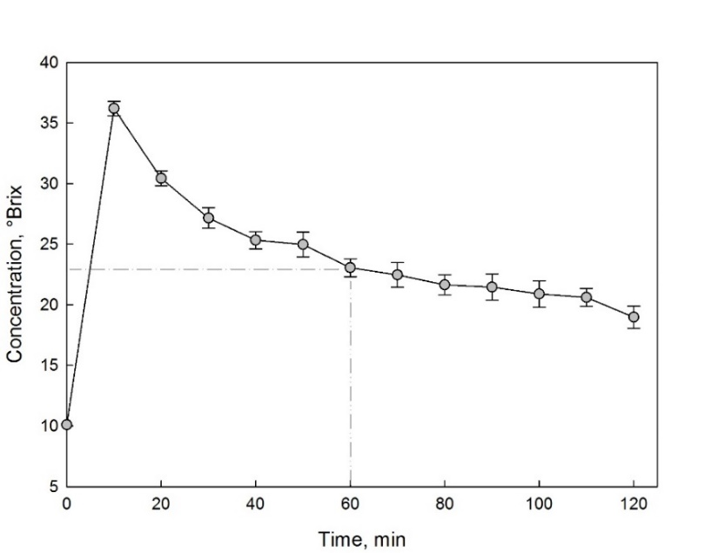
Figure 1: Solid content (ºBrix) of the concentrated as a function of the time under vacuum condition. The concentrated sample used in this study was 23 °Bix at 60 min.

Figure 2 shows the vitamin C content (in mg/100 ml) in the feed orange juice and after cryoconcentration and evaporated process for orange juice. The fresh orange juice had an ascorbic acid content of 74 mg/100 ml, a value close to that reported by Sandhu and Minhas (2006). After the cryoconcentration and evaporation process is evident an important increase in vitamin C content with an important advantage of cryoconcentration over the evaporation, a similar behavior was reported by Aider and de Halleux (2008) who used apricot and cherry juices. In addition, Orellana-Palma et al. (2017b) reported an important vitamin C retention effect using the centrifugation assisted cryoconcentration on orange juice as compared to heat treatment sample. On the other hand, Liu et al. (1999), described that cryoconcentrated tomato juice showed no differences in vitamin C content as compared with fresh tomato juice.
The pH and acidity of the fresh and concentrated samples are shown in Figure 3. The pH of the concentrated samples decreases in relation to the fresh juice, this effect is attributed to the concentration of organic acid in the samples along with an increase in their concentration of solids (10 °Brix in the case of fresh sample and 23 °Brix in cryoconcentrated and evaporated samples, respectively), as was observed in cryoconcentrated pomegranate juice by Khajehei et al. (2015). In the acidity, an opposite effect is observed, which increases as the pH decreases.
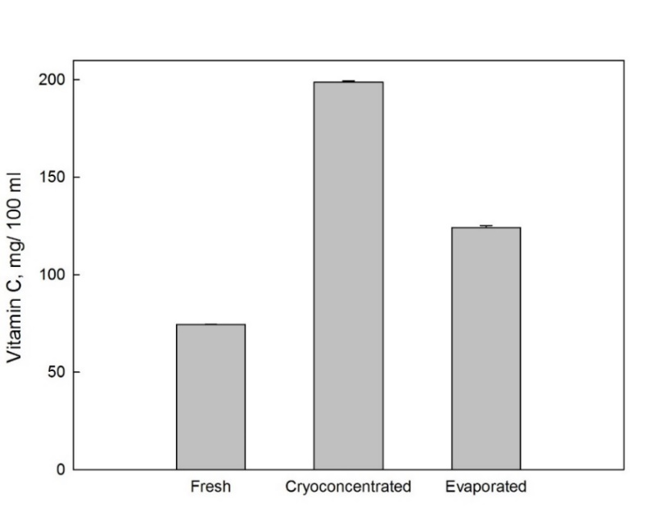

Figure 2: Vitamin C content (mg/ 100 ml) in fresh, cryoconcentrated and evaporated samples of orange juice. 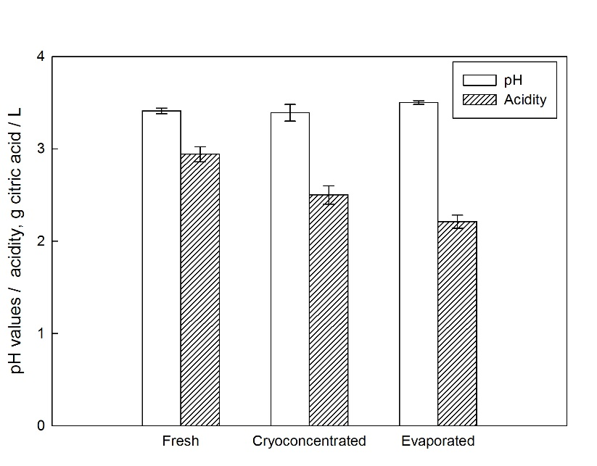
Figure 3: pH and acidity of fresh and concentrated samples.

Figure 4 illustrates the CIELAB values of fresh orange juice and concentrate samples after cryoconcentration and evaporation. As expected, the cryoconcentrated sample important differences in the L* value than fresh juice. This difference was similar to the difference published previously for pomegranate cryoconcentrate as compared with the fresh sample (Khajehei et al., 2015). In a previous research using orange juice cryoconcentrate (equivalent in °Brix at the second cycle using centrifugation) showed an important reduction in the L* value (from 39 to 32 CIELAB units) (Orellana-Palma et al., 2017b).
The differences between the present study with the mentioned research using centrifugation is attributed to the different external forces uses in the studies, where the vacuum is an external force that in the first minutes sucks most of the solutes and that subsequently reduces its efficiency and therefore the concentration of solids in the concentrate (see Figure 1).
In addition, the total color difference (ΔE*) of the concentrate samples showed values higher than the human visual discrimination threshold (ΔE* > 3) (Melgosa et al., 1997) reaching ΔE* values of >40 CIELAB units after the evaporated process. Finally, ΔE* of evaporated sample showed in general higher values than the cryoconcentrated sample, confirming the convenience of the use of cryoconcentration over evaporation in the preservation of the original characteristics of the fresh sample (Petzold et al., 2016a).
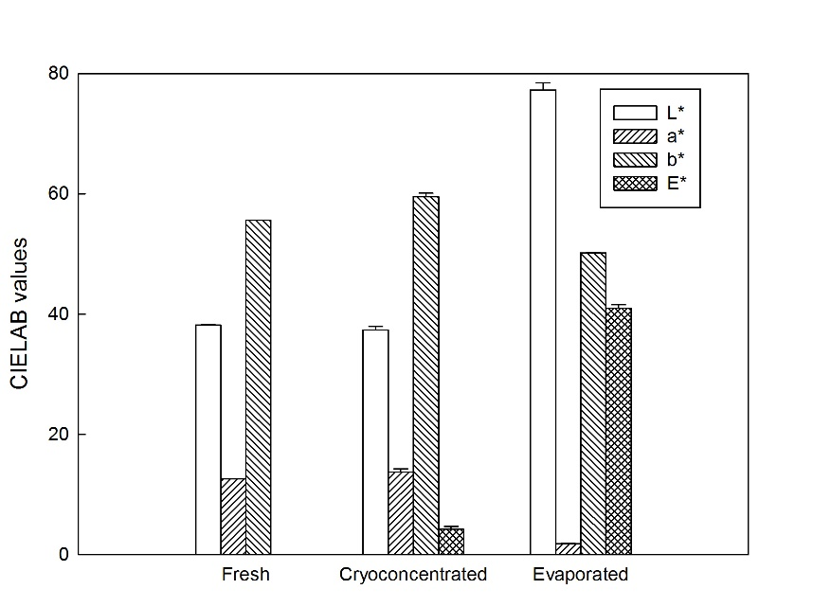
Figure 4: CIELAB values of fresh, cryoconcentrated and evaporated samples from orange juice.
4. Conclusions
Vacuum used as an assisted technique in cryoconcentration of orange juice showed evident advantages as compared to the evaporation process. After the cryoconcentration and evaporated process an important increasing in vitamin C content was reported, however the best vitamin retention was observed using the vacuum-assisted cryoconcentration technique. In addition, the total color difference of evaporated samples showed higher values than the cryoconcentrated. From a practical point of view, vacuum-assisted cryoconcentration technique can be considered as an excellent tool to elaborate a concentrate with an important retention of the original physicochemical properties of the fresh juice.
Acknowledgments
Dr. Guillermo Petzold is grateful for the financial support by Fondo de Apoyo a la Participación a Eventos Internacionales (Universidad del Bío-Bío).

References
Aider M., de Halleux D., 2008. Production of concentrated cherry and apricot juices by cryoconcentration technology. LWT-Food Sci. Technol., 41, 1768–1775.
Aider M., Ounis W.B., 2012. Skim milk cryoconcentration as affected by the thawing mode: gravitational vs. microwave-assisted. Int. J. Food Sci. Technol., 47, 195–202.
Deshpande S.S., Bolin H.R., Salunkhe D.K., 1982. Freeze concentration of fruit juices. Food Technol. 36 (5), 68–82.
Hsieh H.-C., 2008. Desalinating process. US Patent, 7,467,526.
Jusoh M., Mohamed N.N., Yahya N., Musa R., Mohamad Z., Ngadi N., Rahman R.A., Johari A., Zakaria Z.Y., 2018. Process optimisation of effective partition constant in coconut water via progressive freeze concentration. Chemical Engineering Transactions, 63, 403–408. DOI:10.3303/CET1863068
Khajehei F., Niakousari M., Eskandari M.H., Sarshar M., 2015, Production of Pomegranate Juice Concentrate by Complete Block Cryoconcentration Process, Journal of Food Process Engineering, 38(5), 488–498.
Liu L., Miyawaki O., Hayakawa K., 1999, Progressive Freeze-Concentration of Tomato Juice, Food Science and Technology Research, 5(1), 108–112.
Melgosa M., Hita E., Poza A.J., Alman D. H., Berns R. S., 1997, Suprathreshold color-difference ellipsoids for surface colors. Color Research and Application, 22(3), 148–155.
Moreno F.L., Robles C.M., Sarmiento Z., Ruiz Y., Pardo J.M., 2013. Effect of separation and thawing mode on block freeze-concentration of coffee brews. Food Bioprod. Process., 91, 396–402.
Morison K.R. Hartel R.W., 2007. Evaporation and freeze concentration, In Heldman D.R. and Lund D.B. (eds), Handbook of Food Engineering. CRC Press, New York, USA, 495-552.
Nakagawa K., Nagahama H., Maebashi S., Maed, K., 2010. Usefulness of solute elution from frozen matrix for freeze-concentration technique. Chem. Eng. Res. Des. 88 (5), 718–724.
Orellana-Palma P., Petzold G., Pierre L., Pensaben J. M., 2017a, Protection of polyphenols in blueberry juice by vacuum-assisted block freeze concentration. Food and Chemical Toxicology, 109, 1093–1102.
Orellana-Palma P., Petzold G., Andana I., Torres N., Cuevas C., 2017b, Retention of ascorbic acid and solid concentration via centrifugal freeze concentration of orange juice. Journal of Food Quality, 2017, 5214909.
Pardo M., Sánchez R., 2015. Block freeze concentration intensification by means of vacuum and microwave pulses. Ingeniería y Competitividad, 17, 143–151.
Petzold G., Orellana P., Moreno J., Cuevas C., 2017, Process parameters of vacuum-assisted freeze concentration, Chemical Engineering Transactions, 57, 1789-1794 DOI: 10.3303/CET1757299
Petzold G., Aguilera J.M., 2013. Centrifugal freeze concentration. Innov. Food Sci. Emerg., 20, 253–258.
Petzold G., Niranjan K., Aguilera J.M., 2013. Vacuum-assisted freeze concentration of sucrose solutions. J. Food Eng., 115, 357–361.
Petzold G., Orellana P., Moreno J., Junod J., Bugueño G., 2016a. Freeze concentration as a technique to protect valuable heat-labile components of foods, In J.J. Moreno (ed.), Innovative processing technologies for foods with bioactive compounds. CRC Press, Boca Raton, Florida, USA, 184–190.
Petzold G., Orellana P., Moreno J., Cerda E., Parra P., 2016b. Vacuum-assisted block freeze concentration applied to wine. Innov. Food Sci. Emerg., 36, 330–335.
Ramaswamy H., Marcotte M., 2006. Food Processing, Principles and Applications. Taylor & Francis, Boca Raton, Florida, USA.
Raventós M., Hernández E., Auleda J.M., 2012. Freeze Concentration Applications in Fruit Processing, In S. Rodríguez, F.A.N. Fernandes (eds.), Advances in Fruit Processing Technologies. CRC Press, Boca Raton, Florida, USA, 263–286.
Rempel A.W., Waddington E.D., Wettaufer J.S., Worster M.G., 2001. Possible displacement of the climate signal in ancient ice by premelting and anomalous diffusion. Nature, 411, 568–571.
Sandhu K.S., Minhas K.S., 2006. Oranges and Citrus Juices, In Y.H. Hui (ed.), Handbook of Fruits and Fruit Processing. Blackwell Publishing, Iowa, USA. 309.

